Fx Drag as a Function of AoA and Airspeed

Wind Tunnels Test Data Used:
- Aicraft without pusher, wing --> LP3

Modifications to data
- Removing entries with non-zero control surfaces
- Removing entries with non-zero pusher motor
- Removing entries with angle of attack higher than 15 deg --> Remove stall condition (non-linear)
- Select skew = 0 : for current log flight, skew is at 0 deg

Correct for NAN RPM Values
- For all NAN RPM values, the NAN values are replaced by the mean of other RPM values for the hover motors

Isolate Hover Prop Drag
% Fx = body drag + Hover_motors drag
% Hover_motors drag = Fx-body drag
%Drag without hover props (only body drag)
Fx_body = @(alpha,V) (-0.03006145837+0.003497371379286.*alpha+0.14686597133.*alpha.^2).*V.^2

Fit on AoA = 0 deg
Choice of fit function purely by analysis of graph:
Fx_hover = K1*V^2+K2*sqrt(V)*RPM^2

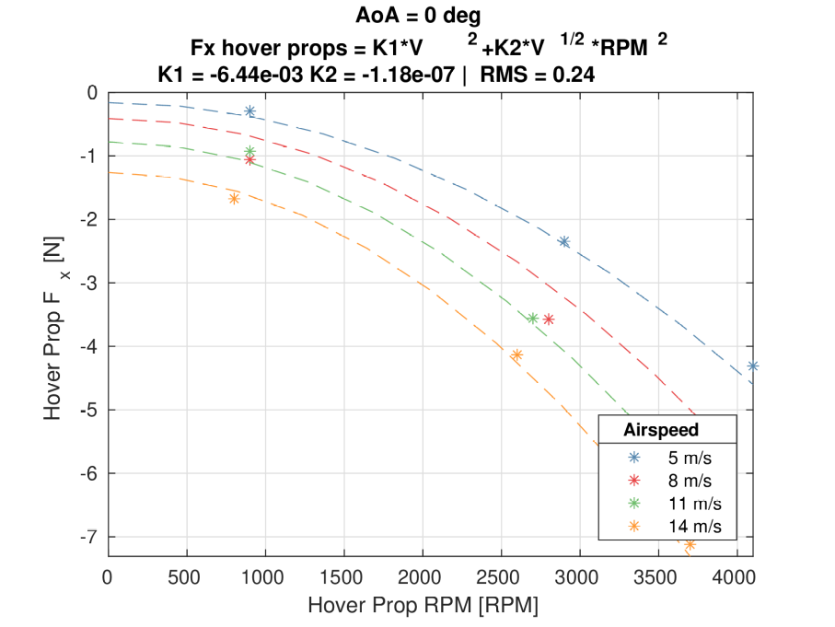
% Fx hover props = -6.435825732350349E-3*V^2+-1.180349532783032E-7*V^{1/2}*RPM^2
% RMS = 0.24 (AoA=0)
% RMS = 0.4 (all AoA)

Verify for all AOA
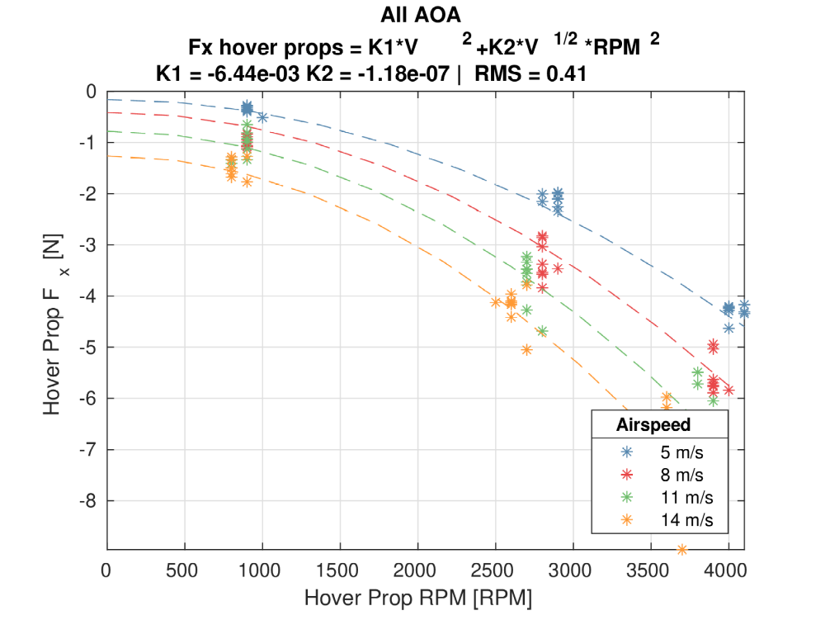

Fit without V^(1/2)
Due to some instability, it is ideal to remove the V^(1/2) term that multiplies RPM^2
Fx = K1*V^2+K2*RPM^2
Fx hover props = -1.188293370185022E-2*V^2+- -3.133468238831906E-7*RPM^2

