Body Fx Lift as a Function of AoA, Skew and Airspeed
Completed on 9/03/2023

Using drag_elevator.m

Wind Tunnels Test Data Used:
- Elevator Stall --> ES

Modifications to data
- Removing entries with non-zero control surfaces (except elevator)
- Removing entries with non-zero pusher motor
- Removing entries with non-zero hover motor command
- Removing entries with angle of attack higher than 15 deg --> Remove stall condition (non-linear)
- Select only skew = 90 deg

PPRZ to elevator angle fit
From data from: https://docs.google.com/spreadsheets/d/1nKS4v60zYIQFt4OwW5pYPQvWePHs4sH8KJB63gLI2ow/edit#gid=1168413276
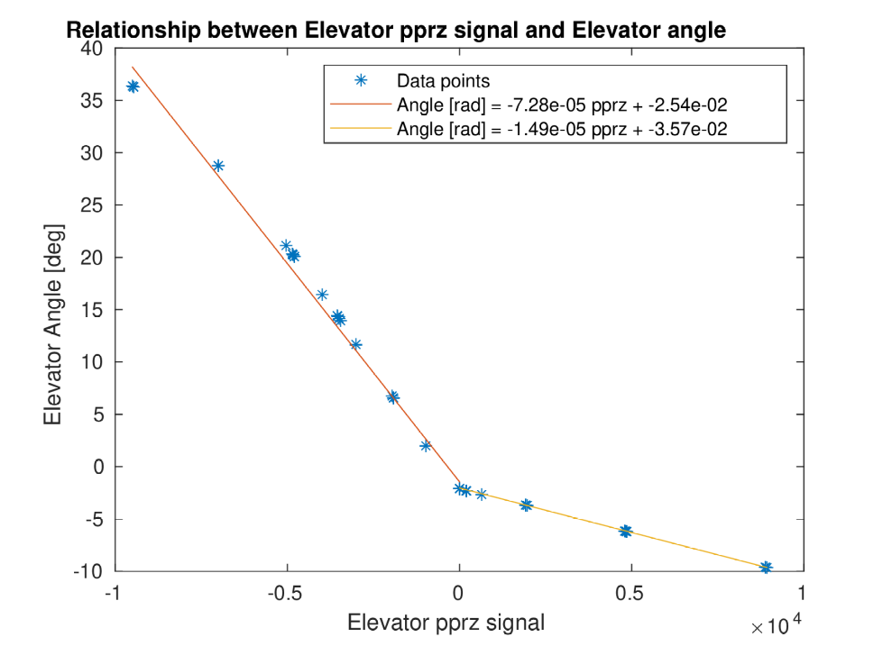

Fit Fx
Completed fit in +-25 deg angle of attack
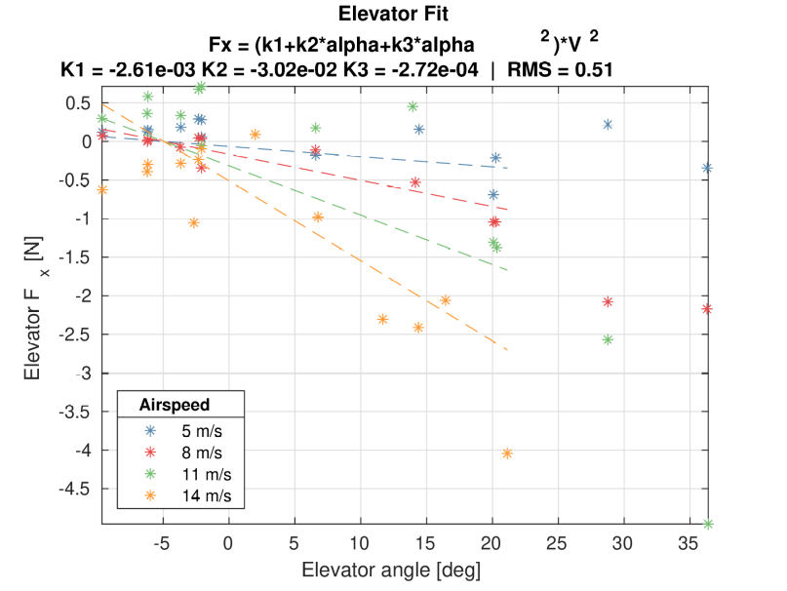
BAD RMS and extremely high error bars (+-1 N)

% Fz = (k1+k2*alpha+k3*alpha^2)*V^2
% s_elev =
%
% -0.002608468213419
% -0.030215146812742
% -0.000271549151544
%
%
% RMS_elev =
%
% 0.512552710574194

%Fx = (-2.608468213419211E-3 + -3.021514681274200E-2*alpha+ -2.715491515441531E4*alpha^2)*V^2

Possible recommendations:
- check for different hover motor usage (different angle of attack on h stab)

