Wing Fz Lift as a Function of AoA, Skew and Airspeed
Completed on 7/03/2023

Using lift_wing.m

Wind Tunnels Test Data Used:
- Aicraft without pusher, elevator, hover props --> LP5

Modifications to data
- Removing entries with non-zero control surfaces
- Removing entries with non-zero pusher motor
- Removing entries with non-zero hover motor command
- Removing entries with angle of attack higher than 15 deg --> Remove stall condition (non-linear)

Obtaining Wing Fx Drag
% Fz = body lift + wing lift
% Wing lift = Fz-body lift
%Drag without hover props (only body drag)

lift_body_coeff = [-1.569286184145456E-3 5.989835400355119E-3 -2.346715949355502E-1 6.611857425073364E-2]; %all airspeeds without hover props with skew

Fz_body = @(alpha,skew,V) (lift_body_coeff(1) .* cos(skew)+...
lift_body_coeff(2)+...
lift_body_coeff(3) .* alpha+...
lift_body_coeff(4) .* alpha.^2).*V.^2;

Quick Analysis Drag in Quad and Forward Flight Mode
Quad Mode
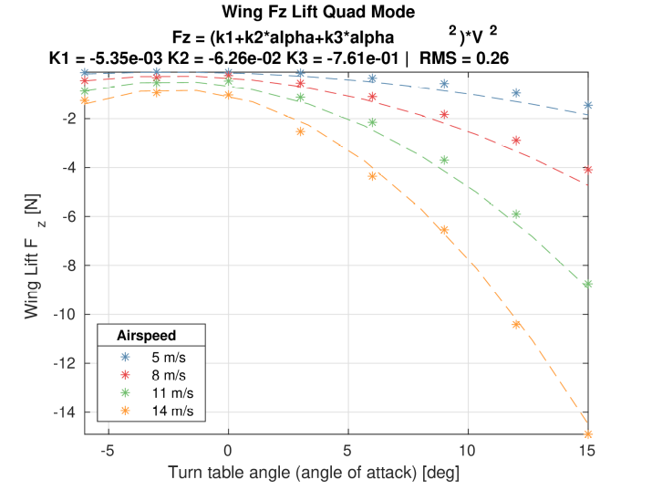
In forward flight
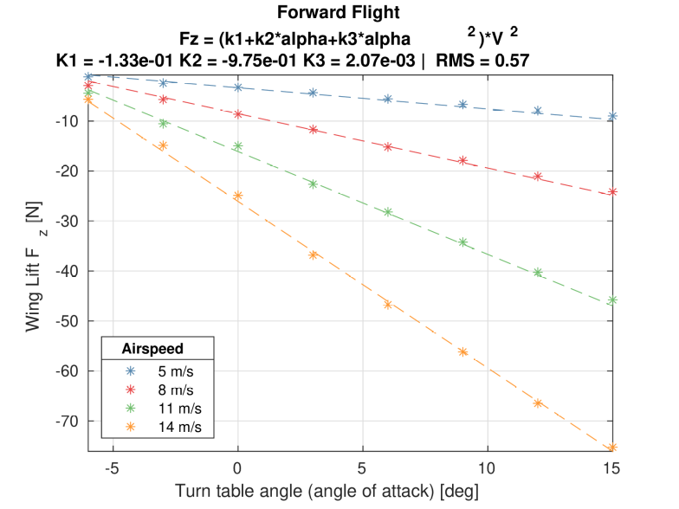

Fit for variable skew
A fit for each skew angle is performed with the equation:
(k1+k2*alpha+k3*alpha^2)*V^2

The values of the different parameters are plotted as a function of the skew:

It can be seen that k2 and k3 follow a squared sinus form while k3 does not.

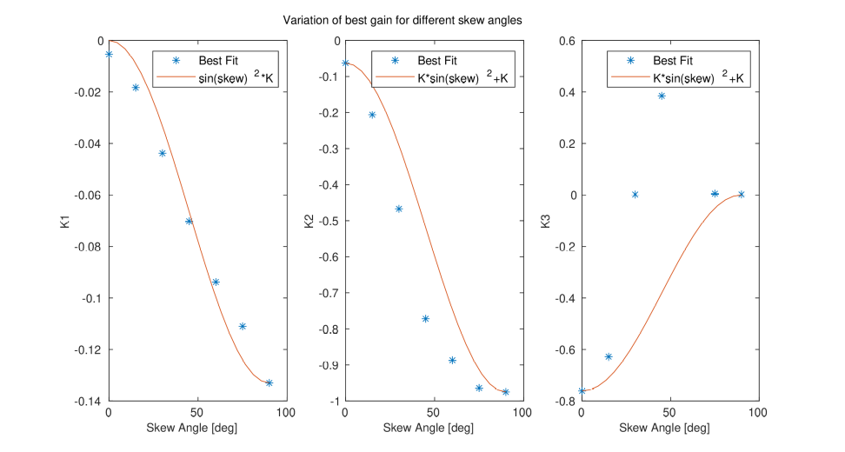

With this in mind, different fit functions can be generated:
% Fx0 = ((k1+k2*alpha+k3*alpha^2)*(k4*sin(skew)^2+k5)*V^2
% Fx1 = (k1*sin(skew)+k1*k4 +alpha*(k2*sin(skew)^2+k2*k4) +alpha^2*(k3*sin(skew)^2+k3*k4))*V^2 = ((k1+k2*alpha+k3*alpha^2)*(sin(skew)^2+k4)*V^2
% Fx2 = (k1*sin(skew)^2 +alpha*(k2*sin(skew)^2+k3) +alpha^2*k4 )*V^2
% Fx3 = (k1*sin(skew)^2 +alpha*(k2*sin(skew)^2+k3) +alpha^2*(k4*sin(skew)^2+k5) )*V^2
% Fx4 = (k1*sin(skew)^2 +alpha*(k2*sin(skew)^2+k3) +alpha^2*(k4*sin(skew) +k5) )*V^2
% Fx5 = (k1*sin(skew)^2 +alpha*(k2*sin(skew) +k3) +alpha^2*(k4*sin(skew) +k5) )*V^2

Summary
Method | Fit on all airspeeds, all skews
Method | RMS Error on all airspeeds, all skews | RMS Error on all airspeeds, skew > 30deg
0 | 1.22 | 1.035
1 | 1.22 | 1.035
2 | 1.33 | 1.098
3 | 1.12 | 1.00
4 | 1.25 | 0.98
5 | 1.34 | 1.29

Selected is 1:
% Fx1 = ((k1+k2*alpha+k3*alpha^2)*(sin(skew)^2+k4)*V^2
% s_all_1 =
%
% -0.100077872757405
% -0.869647996437125
% 0.145783145637766
% 0.218539487824641
%
%
% RMS_all_1 =
%
% 1.227204499687460

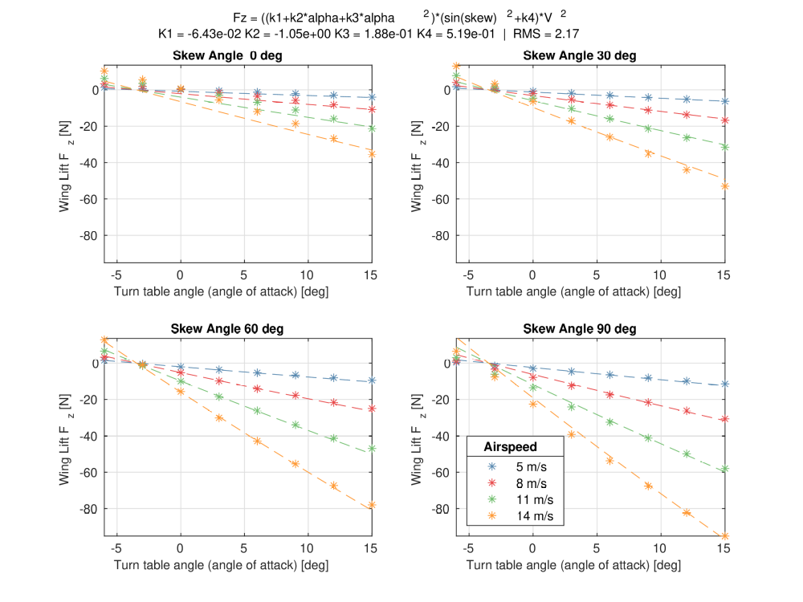
More issues at lower skew angle and high airspeed. This impact should be limited as this is not a part of the enveloppe the aircraft goes into often. High airspeed is with the wing in forward flight.

As an alternative, method 2 can also be chosen:

% Fx2 = (k1*sin(skew)^2 +alpha*(k2*sin(skew)^2+k3) +alpha^2*k4 )*V^2
% s_all_2 =
%
% -0.112965901222621
% -0.749189625262820
% -0.710563262512707
% 0.045305428048873
%
%
% RMS_all_2 =
%
% 1.128976161776015

