Q. Compare the results you obtained in this task with the ones from the previous task. What are the respective pros and cons of each solution?

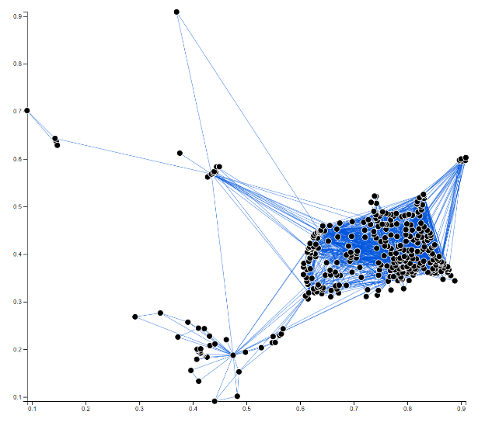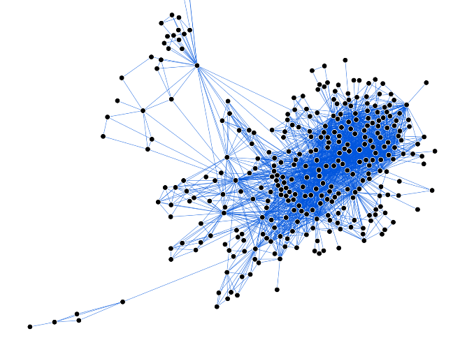

Figure 1 xy layout

Figure 2 Force layout

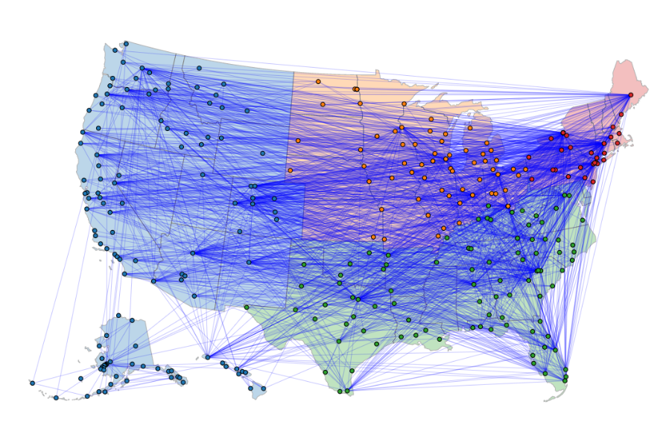

Figure 3 Geospatial visualization

Figure 1 and figure 2 are the results of previous task. Comparing with figure 3, in figure 1 user can get a help of scales for reading values, whereas it’s hard to put horizontal and vertical lines representing longitude and latitude because of the projection which put Alaska and Hawaii under western area of continent. Also, figure 2 is much more effectively using space to represent the topology of data than figure 3, though it doesn’t show the exact location of each node and the exact length of links. So, if only purpose of visualization is representing the topology of nodes and links, using force layout can be a better solution. However, these figure 1 and figure 2 do not preserve the exact context of the data, which is geospatial.

Figure 3 is representing the nodes and links with the geospatial context of data. It clearly shows each airport, the states on which the airports are, and the flights among airports. Also, because the region information is color coded – blue for western region, green for south, orange for midwest, and red for northeast – user can figure out which airports are in which region. However, even though the network has geospatial context, if this exact context is not needed, representing the graph using geospatial layout can be a waste of space. If only the topology of the graph is needed, figure 2 can be a better choice in that it use less space making sure that the nodes are not overlapped.