Q. Compare the results that you obtained in each case. What are the pros and cons of the layout you obtained with and without using the provided coordinates? Which one do you find superior and why?

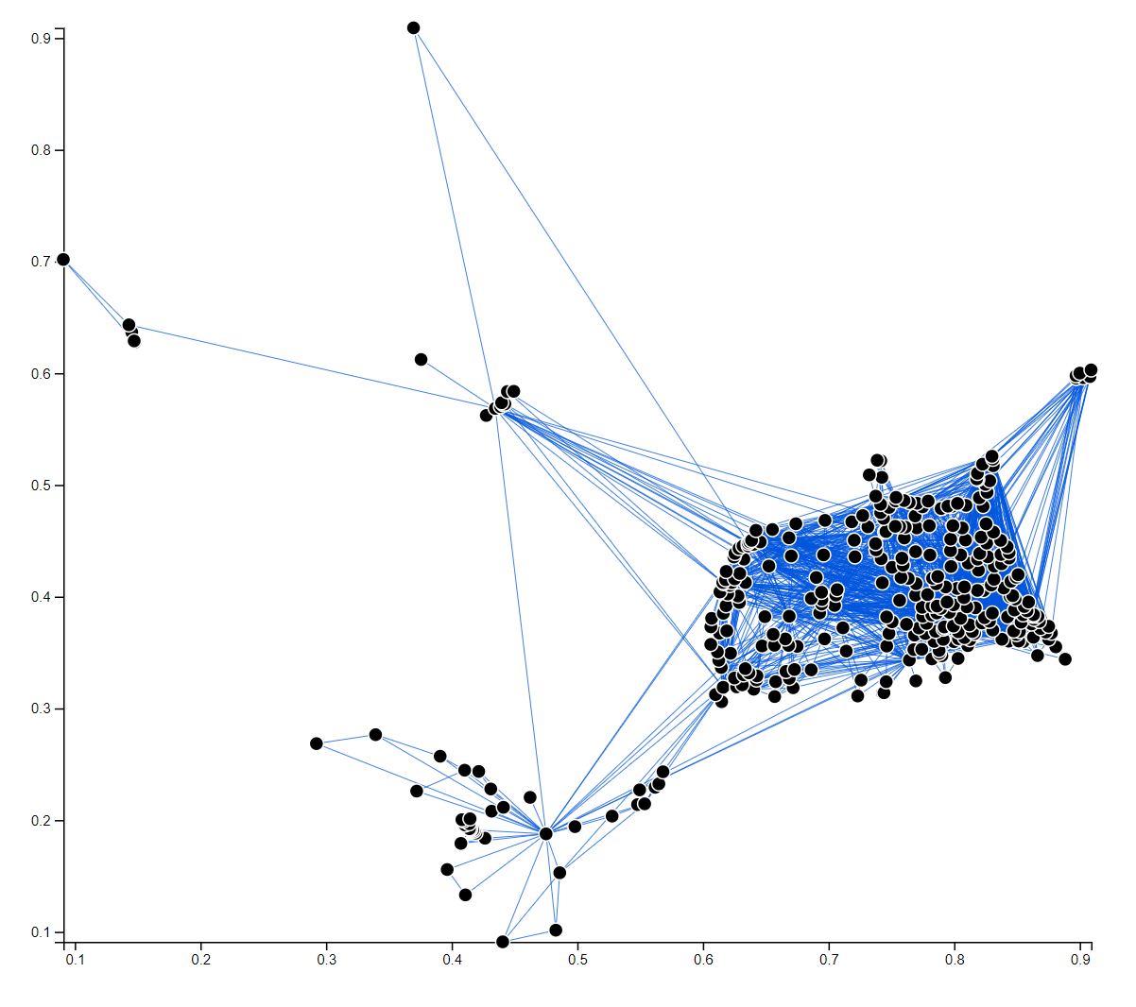

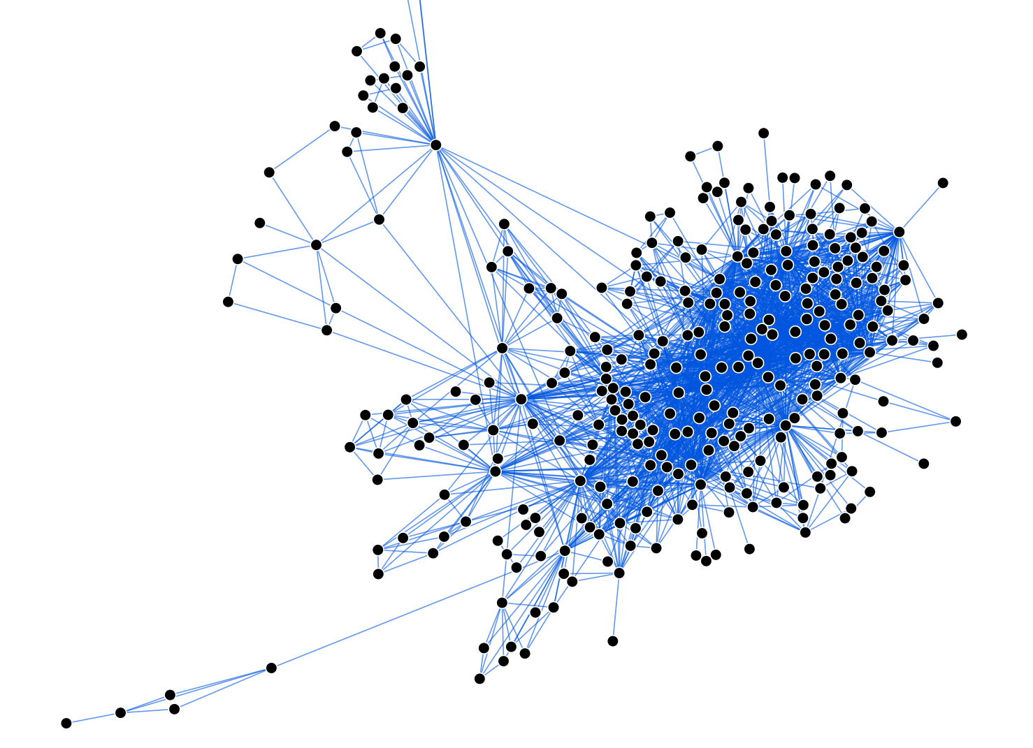

The first image above is the result of using “posx” and “posy” coordinates on linear scales for its x, y axis. This visualization represents the location of nodes and the links connecting them accurately. The nodes are at the exact points of (posx, posy) coordinates. With the help of x, y scales at the bottom and left, we can easily check approximate coordinate of each node. Also, the lengths of links are reflecting on the exact distance between two points. However, there are so many overlaps of nodes and links because the coordinates of nodes are clustered. These overlaps make hard to figure out nodes and links around clustered area, even though the clustering is a meaningful information from the visualization.

The second image is the result of using force layout. This layout does not use given coordinates in the data and only use the topology of the nodes and links, which are id information of each node and source and target information of each link. Though two images look somewhat similar each other, it’s because they represent the graphs with same topology. In this case, no nodes are overlapped, so that no occlusion in the first image happens. Also, because nodes are not overlapped, the links between two nodes are less overlapped. This can allow us more accessibility to each node when the relevant features such as tooltip for detail information of nodes are implemented. However, using this layout, the exact location of the visualization does not mean anything because x and y values are calculated only using the id of nodes and source, target information of links. It only shows the topology of graph, not the exact coordinates of nodes and the lengths of links. Though it shows some clustering, it does not match to the exact point where the clustering happens.