Task 3 : Work Breakdown Structure

Villanueva, Francis Michael - **Leader**

De Paz, Marcaleb - **Developer**

Alday, Gabriel Angelo - **Database Developer**

Christian Jay N. Alvez - **Documentation**

1. **Research title:** Implementing efficient logistics and delivery system of medical supply chains.  
     
    The "Supply Chain Optimization" phase focuses on designing and implementing an efficient logistics and delivery system for medical supply chains. This phase is crucial for ensuring that medical supplies, including critical equipment and pharmaceuticals, are delivered promptly and efficiently to healthcare facilities.

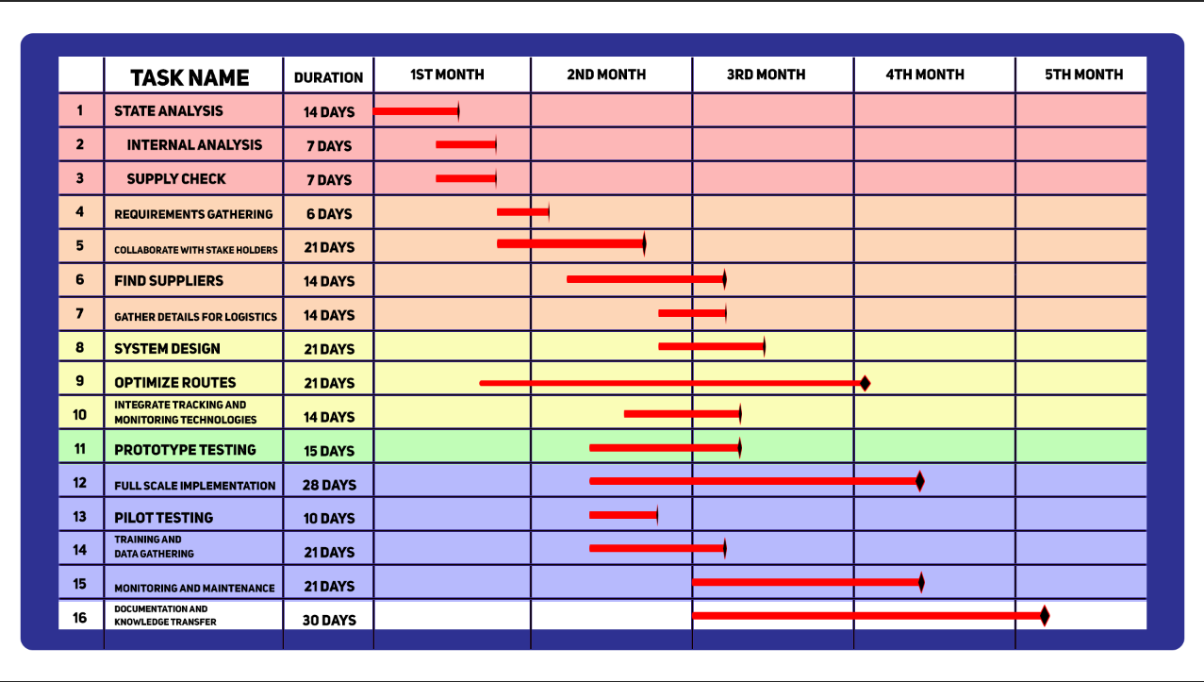

1. **Research title:** Development of a Web-Based Survey Platform for Data Collection and Analysis

This research project focuses on creating a web-based survey platform that can be used for data collection and analysis. I will be using web application and database for this specific research title.

Development Steps:

**Requirement Analysis**: Define the specific requirements of the research project and the survey platform. This includes identifying the types of questions, response options, and any branching logic needed.

**Web Application Development**: Build the web application according to the defined requirements. You can use online tutorials and documentation for guidance, and there are many free resources available for learning web development.

**Database Setup**: Set up the chosen database system and create tables to store survey questions and responses.

**User Interface Design**: Design the survey creation and data analysis interfaces. Keep the design simple and user-friendly.

**Testing**: Thoroughly test the web-based survey platform to ensure it works as intended, with no major bugs.

**Deployment**: Host the web application on a low-cost hosting platform, such as Heroku, Netlify, or Vercel, which offer free plans for small-scale projects.

**Data Collection**: Use the platform to create and distribute surveys to participants. Collect and store the survey responses in the database.

**Data Analysis**: Use the integrated data analysis tools or export the data for further analysis as needed for your research.

1. **Research title**: Accessible Healthcare w/ Schedule Management System  
   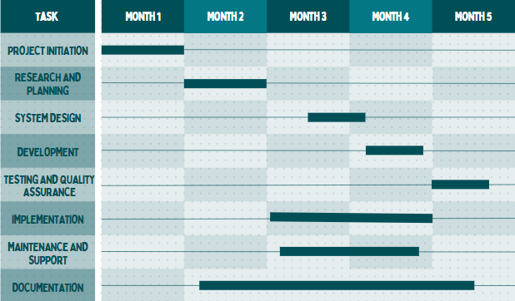
2. **Research title:** Job ordering with inventory management system

