BCDR Microhack instructions

Azure Portal access:
http://portal.azure.com

Your Login for the hack:
Username: «Username»
Password: «Password»
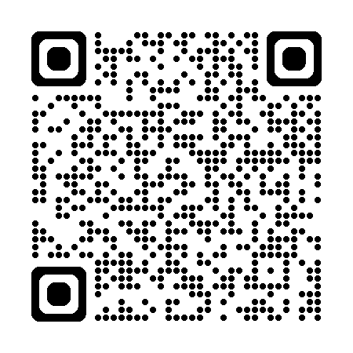
Lab instructions:
https://aka.ms/bcdrMicroHack

Challenge | Duration
Challenge 1 - Prerequisites and landing zone preparation | ⏰ Duration: 20 minutes
Challenge 2 - Regional Protection and Disaster Recovery (DR) | ⏰ Duration: 1 Hour
Challenge 3 - Protect in Azure with Disaster Recovery (Inter-regional) | ⏰ Duration: 1 hour 15 minutes
Challenge 4 - Protect your Azure PaaS (Azure SQL Database and Storage Account) with Disaster recovery | ⏰ Duration: 50 minutes
Challenge 5 - Failback to the primary region (France Central) | ⏰ Duration: 50 minutes
Extra Challenge 6 - Protect to Azure with Azure Backup & Restore

Lab architecture:
