**PREMISE**

The underlying premise: that we as individual human beings vibrate at specific frequencies which have correllating musical notes and visual colors. My system presumes that a person will unconsciously and naturally hum their natural note of vibration when and only when their rational and conscious mind is displaced away from the matter. Removing the conscious mind by luring its attention elsewhere affords the unconscious intelligence of the person to respond instinctively and without interference.

**PRE-REQUISITES**

The interviewee should express eagerness to discover their natural note. Their sincere participation and following directions -- no matter how seemingly odd -- are essential to success. Given the nature of the method I employ to dispense with the interviewee’s reasoning, my system also requires that they believe in the possibility of Extra-Sensory Perception.

**CONCLUSIONS**

I ennumerate here my conclusions, 30 years since the inception of my system, and after hundreds of personal interviews with individuals.

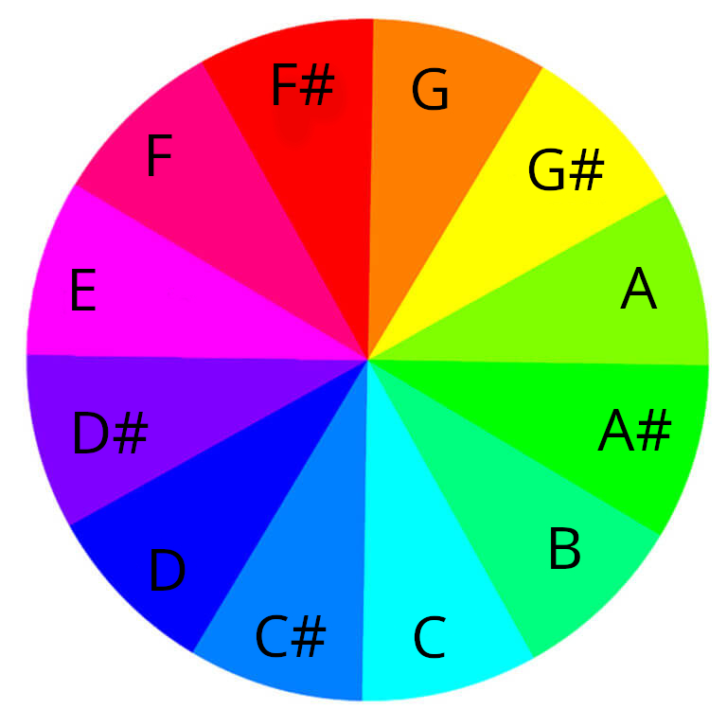

The vast majority of a person’s favorite songs all through their life tend to be composed in the key of that individuals note.

In reference to the color / note correspondence above, the predominant, two colors a person sees when they close their eyes or are in the dark for a period of time are the color attributed to their individual note in my system and its exact opposite, or the color representing the tritone of their note. The person’s eyes must be deprived of any light whatsoever and in absolute darkness for a period of at least 15 minutes or such time as to allow the optics to adjust to pure darkness. It seems that we perceive through the lens of our own vibration, and this colors everything.

That one’s individual vibration is mostly commonly -- **yet not always** -- genetic. Within families I discovered the predominance of a certain note, or a pair of notes which seemingly also indicate genetic-affinity within the family group. Knowing this, I could map hidden alliances and know what groups of individuals would have friction within the family.

There have been some exceptional individuals whose families I also interviewed, who were completely divergent notes. In every case it became clear that these exceptions were self-defining individuals -- non-conformists -- often spiritually gifted, who had something odd regarding their birth or conception or gestation. The mother of one remarkable individual told me that of all her 5 pregnancies, that particular person’s was unique in that she knew the exact moment he was conceived, felt an electric shock in her ovaries and instantly knew that he would be a boy, and would be a gifted musician. This all turned out to be true and although the two genetic lineages within that family were the note ‘B’ and the note ‘F#’, the individual I speak of had a note of ‘D#’ and was the only divergence in the family. I had interviewed father, mother, siblings, and maternal grandmother. It seems that the exceptional soul overrides genetic determination.

I also note, regarding the hundreds of interviews that I have done, that the vast majority of people I interviewed seemingly are grouped near the note ‘C’, in the blue-color range. If my understanding of Pythagorean mysteries is correct, and the note ‘C’ be roughly 8 hertz, an explanation for this tendency might well be the Schumann resonances themselves, which, although magnetic and not aural, might be influencing vibratory rates at birth and through the inception cycle. I encourage some future adept and wizard to investigate better the astronomical occurences, solar and lunar magnetic polarities, cycles, eclipses, as well the relative influence of other celestial objects by their position in the heavens during conception and birth of an individual as possible influences. Perhaps there might exist an annual influence, such as in Chinese astrology.

Inter-personal interactions, affinities, and tensions seemingly correlate perfectly with musical harmonics. Two people whose note / color interval is that of the tritone rarely get along, mistrust each other, and generally have little affinity. One seeks in life union with a person who represents the interval of the perfect fifth, from the perspective of the same individual’s note / color. The next best union is the perfect fourth. For the imaginary individuals X and Y, where individual Y has a note/color which is the interval of the perfect fifth (3/2) from individual X, that individual Y seemingly is the ideal mate and object of desire for individual X.

And here I discovered that oddity of love which proves an imperfection and the cause of the ‘love triangle’ so popular in ancient works of theatre: for the same individuals X and Y, I am able by my system to predict the tendency within said couple that individual Y will be the one who strays from the union, given for individual Y, the individual X represents by nature of the octave the less consonant harmonic of the perfect fourth (4/3). Strange it might seem, yet proven in my experience.

**ORIGIN**

My system originated in a simple question I asked myself after having heard on a radio broadcast of National Public Radio that scientists had just discovered that 60 seconds of humming produced a greater reduction of physiological stress in a person than 20 minutes of meditation. Being a graduate of the Silva Mind Control method, as well having been trained in Transcedental Meditation at the age of 16, I was intrigued. Being a classically-trained pianist since the age of 4 years old, I naturally wondered: ‘DOES IT MATTER WHAT NOTE I HUM?’. Which then lead to a subsequent question to myself: ‘IS IT POSSIBLE THAT EVERYONE HAS A **NATURAL NOTE OR NATURAL VIBRATION** WHICH WOULD BE THE IDEAL NOTE FOR THAT PERSON TO HUM?’ Having just learned about additive and subtractive synthesis in electronic music production, I wanted to discover, if it were at all possible, if I myself had a natural note, which would then be the ideal note for me to hum, as it would strengthen and enhance me by way of additive synthesis of a reinforcing and **constructive, sympathetic vibration.**

To find my ‘root note’ began the experimentations and explorations that blossomed into my system which I divulge here.

**METHODS**

From its inception 30 years ago, I realized the absolute necessity of dispensing with a person’s reason during the interview process. This became clear to me, when, in attempting to determine my own personal note, I incidentally interfered with the proper determination of my own note by asking myself what note should I hum, in attempting to find that note by way of referencing it on a piano at home. I quickly determined that it would be easier for me to determine someone else’s note than my own and observed that in order to prevent the same difficulties I faced in attempting to determine my own note, that I needed to introduce a ruse into the interview process which intended to dispense with a person’s reasoning, which would lead them to ask the same questions I stated in the previous sentences and which proved impediments to natural discovery. I devised the following interview process.

I falsely state to a person that the interview is a simple series of 3 questions whose analysis will determine their natural vibration. I then add that before I can ask those three questions and before we begin the interview, that I must first compensate for any psychic ability that the individual might possess, as Extra Sensory Perception ability will skew their answers to the subsequent, three questions which comprise the interview. I explain that if that individual is able to know the correct answer to the questions because they are reading my mind, that will ruin the attempt to find their natural note. I further explain that I need to calibrate how I will ask the questions depending upon the result of the initial ESP test.

The ESP test: I explain that I have just picked a certain number in my mind on the scale of the numbers 1 through 10. I state that I want them to focus on receiving the correct number which I have picked, and that I will attempt to ‘beam’ that number to them with my intent. I tell them to close their eyes, relax, and that in order to better sense the correct number, I need them to hum out loud, as the sound of their humming will connect with my mind and allow them to know the correct number much easier. I tell them to keep humming for 60 seconds, even though they might feel like they already know the number, to not open their eyes or stop humming or tell me the number until at least a minute has gone by.

We begin the ruse of the ESP test, I tell them I am intently focusing on the number, and close their eyes and they must hum to open up the portal of perception to my mind to know the correct number better. As they begin humming, I quietly and quickly move to the piano or tuned instrument in the room and locate the same note they are humming.

I then explain that I had lied: there are no subsequent, three questions, and that they had already completed perfectly the interview. I ashamedly apologize and confess that I had not even picked any number, and was not really trying to ‘beam’ it into their heads via telepathy, and explain that without the trickery I had employed, I could not be certain that they were humming the right note because they might confound the process by wondering what note to hum. Instead, I dispensed with their reasoning by way of distracting their rational mind.

I then emphatically request that they keep the interview process a complete and absolute secret and tell nobody, as it serves nobody else’s best interests to know until after their proper and natural vibration has been determined.

The reference piano or musical instrument has always been tuned to the modern convention of equal-temperament and A=440 hertz.

Frank O’Neill

[xorxecor@gmail.com](mailto:xorxecor@gmail.com)

https://www.github.com/froeberger