Virtual CPU Tests

Truth tables – Basic Gates

2 input – AND Gate
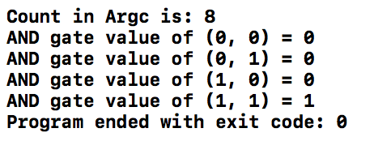
A | B | O
0 | 0 | 0
0 | 1 | 0
1 | 0 | 0
1 | 1 | 1

Test pattern = 0 0 0 1 1 0 1 1

3 input – AND Gate

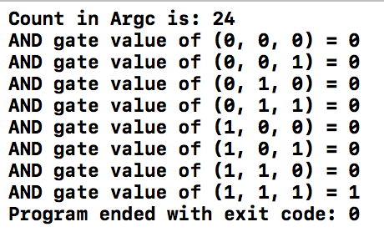  A | B | C | O
0 | 0 | 0 | 0
0 | 0 | 1 | 0
0 | 1 | 0 | 0
0 | 1 | 1 | 0
1 | 0 | 0 | 0
1 | 0 | 1 | 0
1 | 1 | 0 | 0
1 | 1 | 1 | 1

Test pattern = 0 0 0 0 0 1 0 1 0 0 1 1 1 0 0 1 0 1 1 1 0 1 1 1

2 Input – OR Gate
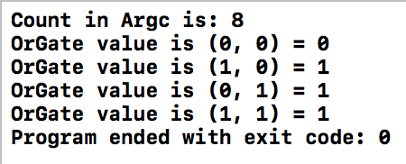
A | B | O
0 | 0 | 0
1 | 0 | 1
0 | 1 | 1
1 | 1 | 1

Test pattern = 0 0 1 0 0 1 1 1

3 Input – OR Gate

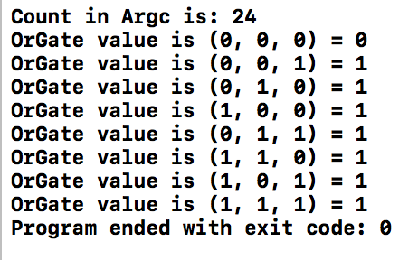  A | B | C | O
0 | 0 | 0 | 0
0 | 0 | 1 | 1
0 | 1 | 0 | 1
1 | 0 | 0 | 1
0 | 1 | 1 | 1
1 | 1 | 0 | 1
1 | 0 | 1 | 1
1 | 1 | 1 | 1

Test pattern = 0 0 0 0 0 1 0 1 0 1 0 0 0 1 1 1 1 0 1 0 1 1 1 1

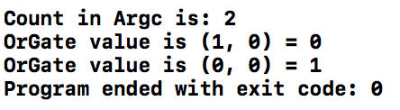
NOT Gate
A | O
1 | 0
0 | 1

Test pattern = 1 0

2 Input – NAND Gate
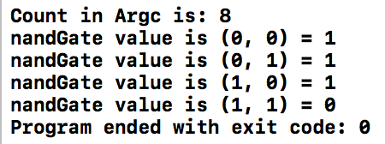  A | B | O
0 | 0 | 1
0 | 1 | 1
1 | 0 | 1
1 | 1 | 0

Test pattern = 0 0 0 1 1 0 1 1

2 Input – NOR Gate
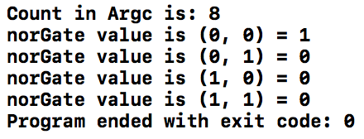  A | B | O
0 | 0 | 1
0 | 1 | 0
1 | 0 | 0
1 | 1 | 0

Test pattern = 0 0 0 1 1 0 1 1

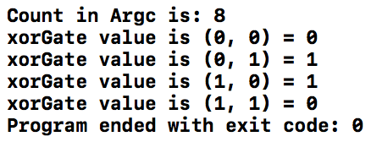
2 Input – XOR Gate
A | B | O
0 | 0 | 0
0 | 1 | 1
1 | 0 | 1
1 | 1 | 0

Test pattern = 0 0 0 1 1 0 1 1

2 Input – XNOR Gate
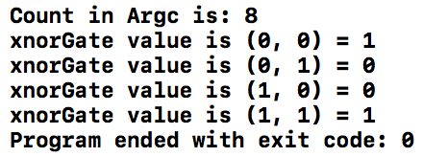
A | B | O
0 | 0 | 1
0 | 1 | 0
1 | 0 | 0
1 | 1 | 1

Test pattern = 0 0 0 1 1 0 1 1

