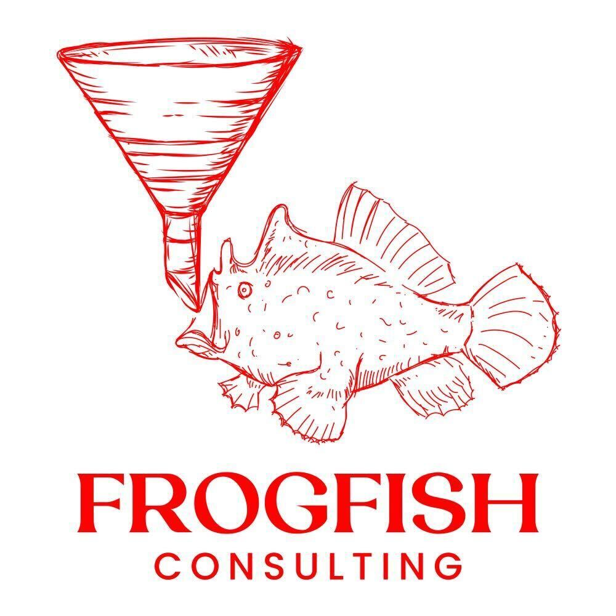

Brand Asset Kit
Logo system · Color palette · Typography · Voice
Version 1.1 · May 2026
Prepared for internal team distribution

About this kit
This document is the single source of truth for FrogFish Consulting brand assets. Share it with anyone producing materials on behalf of the company — agencies, contractors, designers, internal team members, or partners.
Everything in this kit derives from one positioning idea: the frogfish doesn’t chase. It studies, positions, and waits — then strikes with precision. The mark itself encodes this: the funnel is the lure, drawing prospects in; the fish is the patient operator waiting for the right moment.

Files in this package
- /logos/ — Every approved logo variation in high-resolution PNG
- /colors/ — Visual color system swatch (PNG + SVG)
- /docs/ — This brand guide (.docx), quick reference (.txt), and design tokens (.json)

Logo
The FrogFish logo pairs a hand-drawn frogfish — luring with a funnel instead of the natural anglerfish bulb — with a serif wordmark in matching red. The hand-drawn quality is intentional. It signals craft, not committee work.

Primary lockup
Vertical / stacked lockup. The default. Use this whenever the placement is roughly square or vertical — pitch deck covers, business card fronts, posters, profile photos.

Primary lockup on dark
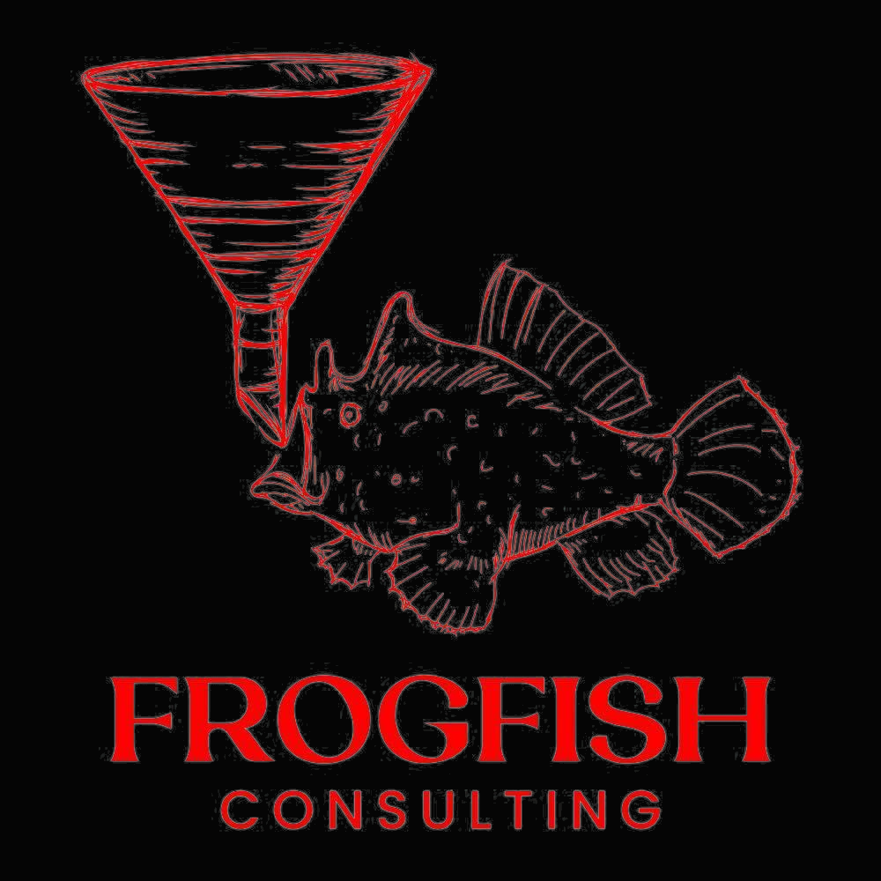
Same lockup, used on Abyss Black backgrounds. The red glows, the fish recedes into dark with red linework. This is the dominant treatment for digital surfaces.

Horizontal lockup
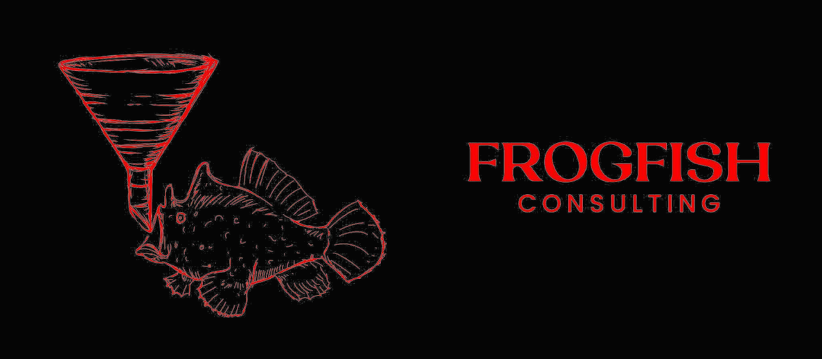
Mark on left, wordmark on right. Built for email signatures, website headers, business card backs, and other wide placements where the stacked lockup would feel cramped.

All-white reversed
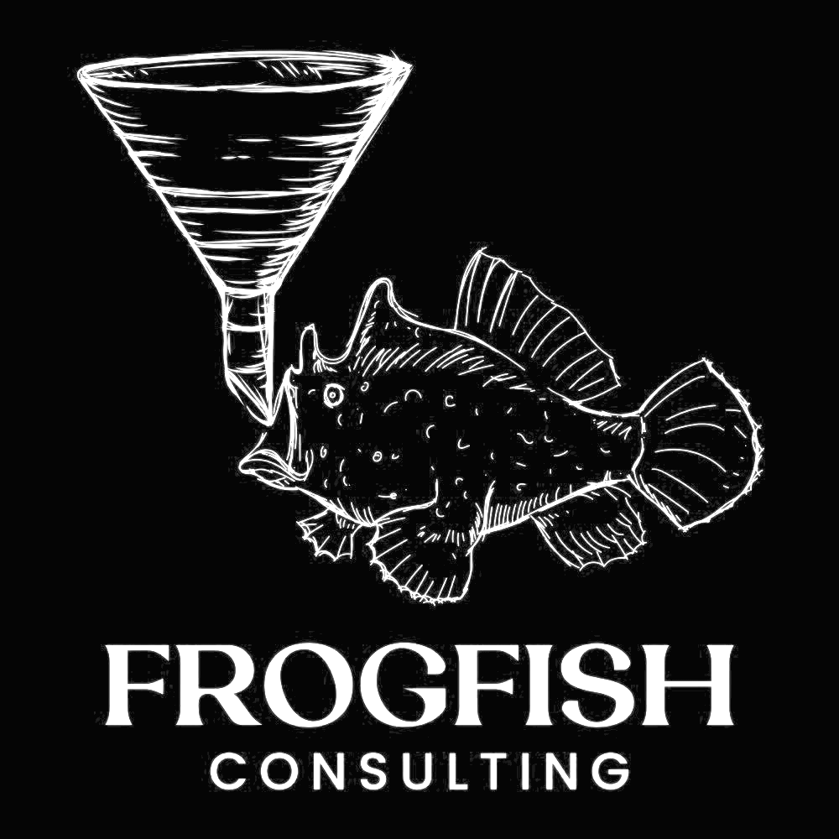
When placed on photography or colored backgrounds where the red treatment would clash, use the white-reversed monochrome version. Shown here composited on Abyss Black so the white linework is visible — the file itself is white-on-transparent.

Mark only
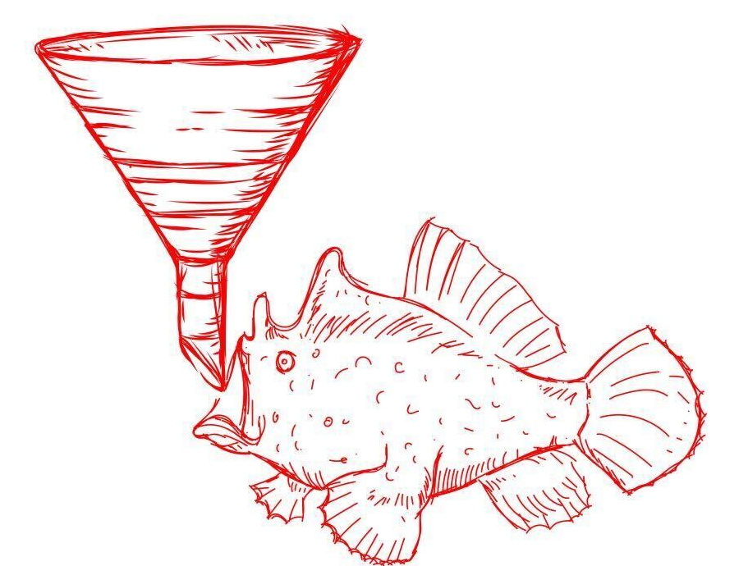
The mark (fish + funnel) without the wordmark. Use for favicons, app icons, social avatars, watermarks, and anywhere the lockup would be illegibly small.

Approved variations — complete list
- Primary stacked — red on white (default)
- Primary stacked — red on Abyss Black (digital surfaces)
- Horizontal — red on white (email signatures, headers)
- Horizontal — red on Abyss Black
- Horizontal — all white on Abyss Black (alternative for dark backgrounds)
- All-white reversed — for photography or colored backgrounds
- All-black monochrome — for single-color print, embossing, low-fi
- Mark only — favicon, app icon, avatar, watermark (5 sizes provided)
- Wordmark only — when mark would be illegibly small
- Hero composition (1920x1080, 1080x1080 square) — title cards, social, LinkedIn covers

Clear space
Always maintain clear space around the logo equal to the height of the "F" in FROGFISH. Nothing — text, edges, other logos, image elements — should encroach on this margin.

Minimum size
Digital: 32px tall for the mark, 120px wide for the horizontal lockup.
Print: 0.5 inch tall for the mark, 1.5 inches wide for the horizontal lockup.

Do not
- Recolor the logo outside the approved palette
- Stretch, skew, rotate, or distort the logo
- Add drop shadows, bevels, gradients, or other effects beyond the approved Strike Glow
- Place the logo on busy photography without a solid scrim or dark overlay
- Retype the wordmark in a different font — the wordmark is custom artwork
- Redraw the fish or funnel — always use the supplied files
- Use the JPG as a master — request the highest-res PNG from this kit, or the original vector source if available

Color
Four colors carry the brand. The vivid red from the master logo for the strike moments. A near-black for the dark we hunt from. White for clarity. And a soft red glow for atmosphere. Everything else is a neutral.

FrogFish Red
FrogFish Red  #E10600 | RGB 225, 6, 0 CMYK 0, 97, 100, 12 PMS 185 C  The hero color, extracted from the master logo file. CTAs, accent lines, the strike moment. Use sparingly — overuse dilutes the impact.

Abyss Black
Abyss Black  #050505 | RGB 5, 5, 5 CMYK 0, 0, 0, 98 PMS Black 6 C  Primary background. The dark, watchful space the brand operates from. Used in dominant proportion across digital surfaces.

Pure White
Pure White  #FFFFFF | RGB 255, 255, 255 CMYK 0, 0, 0, 0 PMS —  Primary type color on dark surfaces. Provides clarity, contrast, and breathing room.

Strike Glow
Strike Glow  #FF4D63 | RGB 255, 77, 99 @ 40% opacity CMYK screen blend only PMS —  Atmospheric glow only. Use as a blurred radial gradient (80px+ blur) behind hero elements. Never use as a solid fill.

Neutral scale
Use neutrals for body type, UI surfaces, dividers, and supporting text. The scale runs from near-black (Ink 950) to near-white (Ink 100).
Ink 950  #0A0A0A | Ink 900  #171717 | Ink 700  #404040 | Ink 500  #6B7280 | Ink 400  #9CA3AF | Ink 300  #D1D5DB | Ink 200  #E5E7EB | Ink 100  #F3F4F6

Usage proportions
- Abyss Black: ~70% of any composition (backgrounds, dominant surfaces)
- White and Ink neutrals: ~25% (type, UI, supporting elements)
- FrogFish Red: ~5% (accents, CTAs, the moment of strike)
- Strike Glow: atmospheric only — never as a solid

Typography
The wordmark in the logo uses a custom-set serif and should always be used as artwork, never retyped. For all supporting communication — body copy, UI, headlines, captions — FrogFish uses one typeface system: Inter.

Communication typeface — Inter
Family | Inter
Source | https://rsms.me/inter/ or Google Fonts
License | SIL Open Font License — free for all commercial use
Display weights | 800 (ExtraBold) — H1, hero, large display
Subhead weights | 700 (Bold) — H2, H3, emphasis
Body weights | 400 (Regular) — body copy · 500 (Medium) — UI, captions
Letterspacing (display) | -2% to -3% (tighten large display sizes)
Letterspacing (caps) | +8% to +20% (loosen all-caps labels)
Line height (body) | 1.5 to 1.7
Line height (display) | 1.0 to 1.1

Type hierarchy
Hero / H1
54pt+ · Inter ExtraBold (800) · -2% letterspacing · 1.05 line height
Section heading / H2
30–40pt · Inter Bold (700) · -1% letterspacing · 1.2 line height
Subheading / H3
18–22pt · Inter Bold (700) · FrogFish Red accent · 1.3 line height
Body copy at a comfortable reading size — Inter Regular delivers strong legibility from 14 to 18pt across screens and print.
14–18pt · Inter Regular (400) · 1.6 line height · max 75 characters per line
EYEBROW LABEL OR CATEGORY TAG
11–13pt · Inter Bold (700) · ALL CAPS · +20% letterspacing · neutral gray

Voice
Patient. Strategic. Lethal at the right moment.
FrogFish doesn’t shout. The voice is confident, technical, and slightly understated — the way a senior operator talks to another senior operator. Never hyped. Never desperate. Always specific.

We sound like
- A board-ready strategist explaining the move in plain English
- Confident in numbers — every claim earns its place
- Slightly dry, occasionally surgical, never theatrical
- More interested in pipeline that closes than dashboards that look good

We do not sound like
- A growth-hacker (no "rocket fuel," "10x," "ninjas," "secrets")
- A motivational speaker (no "transform," "unleash," "unlock potential")
- An agency pitch deck ("award-winning," "passionate team")
- A corporate consultant ("synergy," "leverage," "ecosystem")

Reference phrases from our site
- "Engineered for revenue, not vanity metrics."
- "Most agencies burn budget on motion. We invest yours in leverage."
- "Real-time reporting access. No monthly PDFs, no black boxes."
- "30 minutes. We’ll review your funnel, identify the highest-leverage move, and tell you whether we’re the right fit, or who is."

Contact & file requests
Need a logo file in a format not included in this package? Need brand approval on a piece of creative? Contact the brand owner directly.
Website | frogfishconsulting.com
Strategy calls | calendly.com/frogfishconsulting/discovery
Brand approval | Direct request to the brand owner before public use

© 2026 FrogFish Consulting · All rights reserved

