HALO效应：AI时代的重资产与低过时性
The HALO effect: Heavy Assets, Low Obsolescence in the AI era
Repricing scarcity: Higher real yields, geopolitical fragmentation and supply chain rewiring have shifted equity leadership back toward tangible productive assets. Markets are rewarding capacity, networks, infrastructure and engineering complexity—assets that are costly to replicate and less exposed to technological obsolescence.
重估稀缺性：更高的实际收益率、地缘政治碎片化和供应链重构已将股票领导力转回有形生产性资产。市场正回报产能、网络、基础设施和工程复杂性——这些资产复制成本高昂，且技术过时风险较低。

AI delivers an additional dual shock:The AI revolution questions margins and terminal values in Software and IT Services while simultaneously turning some of the most iconic "Capital Light" winners into the largest capital spenders in history.
AI带来额外的双重冲击：AI革命质疑软件和IT服务的利润率及终值，同时将一些最具标志性的“轻资产”赢家转变为历史上最大的资本支出者。

Focus on HALO — Heavy Assets, Low Obsolescence: HALO businesses pair substantial physical capital (barriers to replication via cost, regulation, time to build or engineering complexity) with long-lived economic relevance. Examples include grids, pipelines, utilities, transport infrastructure, critical machinery and long cycle industrial capacity.
聚焦HALO——重资产、低过时性：HALO企业兼具大量有形资本（通过成本、监管、建设周期或工程复杂性形成复制壁垒）和长期的经济相关性。例如电网、管道、公用事业、运输基础设施、关键机械和长周期工业产能。

Markets are rewarding HALO: Our new Capital Intensive basket (GSST CAPI) has outperformed Capital Light (GSST CAPL) by 35% since 2025, as asset intensity becomes a key driver of valuations and returns.
市场正回报HALO：我们的新资本密集型篮子（GSST CAPI）自2025年以来跑赢资本轻型篮子（GSST CAPL）达35%，资产密集度正成为估值和回报的关键驱动因素。

Valuation convergence: The valuation gap between Capital Intensive and Capital Light has narrowed sharply. The two baskets now trade almost in line as investors reprice resilience and the strategic value of real economy assets.
估值趋同：资本密集型与资本轻型之间的估值差距已大幅收窄。两个篮子目前交易估值几乎持平，投资者正在重估韧性和实体经济资产的战略价值。

Macro tailwinds support HALO: Fiscal expansion, higher replacement costs,re-regionalisation and a manufacturing rebound all support Capital Intensive sectors. In Europe, the capex-to-sales ratio is at a 10-year high, reversing a decade of under-investment.
宏观顺风支持HALO：财政扩张、更高的重置成本、再区域化和制造业反弹均支持资本密集型行业。在欧洲，资本支出与销售之比达到10年高点，扭转了十年投资不足的局面。

Flows favour HALO — but positioning remains light: Strong inflows into Value strategies and a desire to diversify away from crowded US Tech exposures are reinforcing the rotation toward Capital Intensive, yet long-term allocations remain far from stretched.
资金流向青睐HALO——但仓位仍偏轻：价值策略的大幅资金流入以及对分散拥挤的美国科技股敞口的渴望，强化了向资本密集型的轮动，但长期配置仍远未达到过度。

Earnings momentum is turning: Consensus now expects faster EPS growth and improving ROE for Capital Intensive companies, while Capital Light ROE is forecasted to remain flat—raising questions about the durability of this group's long-held premium.
盈利动能正在转变：一致预期现在预计资本密集型公司的EPS增长更快、ROE改善，而资本轻型ROE预计持平——引发对这类公司长期溢价持续性的质疑。

Repricing Scarcity: The Return of Heavy Assets

The decade following the Global Financial Crisis was defined by an extraordinary combination of zero interest rates and abundant liquidity. In that environment, equity leadership shifted toward long-duration Growth stocks and business models built on scalability rather than physical capital. Technology companies and other Capital Light industries - which also took advantage of the expansion in the digital economy and smartphone usage - commanded persistent valuation premia.
全球金融危机后的十年，以零利率和充裕流动性的非凡组合为特征。在这种环境下，股票领导力转向长久期成长股和基于可扩展性而非实物资本的商业模式。科技公司和其他资本轻型行业——同时受益于数字经济和智能手机使用的扩张——享有持续的估值溢价。

By the early 2020s, this regime had pushed the MSCI Growth Index to more than twice the valuation of the MSCI Value Index. In Europe, the Growth factor traded at roughly a 150% premium to Value - reflecting a market that viewed many short-duration "old-economy" companies as structural value traps (Exhibit 1).
到2020年代初，这种格局使MSCI成长指数估值达到MSCI价值指数的两倍以上。在欧洲，成长因子相对价值因子的溢价约为150%——反映市场将许多短久期“旧经济”公司视为结构性价值陷阱（图表1）。
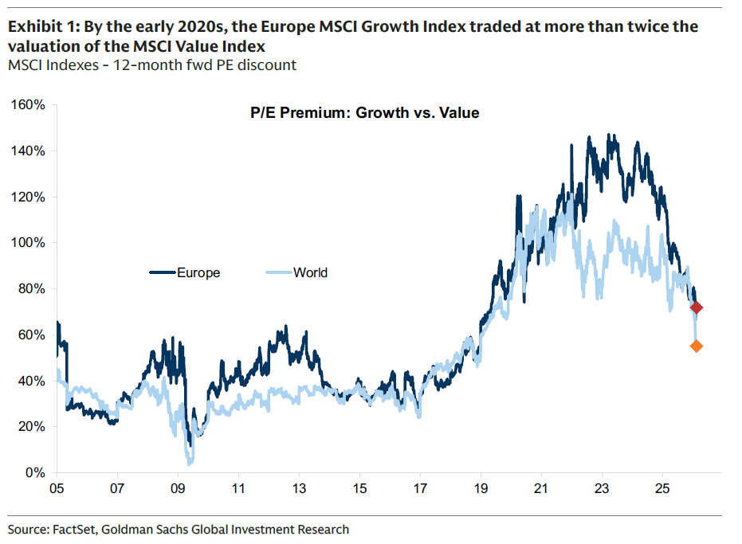

That equilibrium broke with the post-COVID inflation shock. The combination of supply-chain disruption, the invasion of Ukraine, and a structural rethink of globalisation pushed the cost of capital sharply higher and restored the importance of economic resilience. Energy systems, supply chains, infrastructure and national security capabilities are no longer treated as peripheral assets; they have become strategic and scarce, and increasingly priced as such.
这一均衡随着疫情后通胀冲击而打破。供应链中断、乌克兰入侵以及对全球化的结构性反思，共同推高了资本成本，并重新确立了经济韧性的重要性。能源系统、供应链、基础设施和国家安全能力不再被视为边缘资产；它们已成为战略性和稀缺性资产，并日益被如此定价。

As a result, the valuation gap between Capital Intensive and Capital Light businesses has narrowed materially (Exhibit 2). Exhibit 3 shows that the two groups now trade almost in line with one another - and, importantly, this convergence has been driven more by a re-rating of Capital Intensive companies than by a broad de-rating of Capital Light firms. Outside a few pockets of weakness in software and other Capital Light segments directly exposed to AI disruption, it is the Capital Intensive businesses that have re-rated to meet the valuations of their Capital Light peers, not the reverse.
因此，资本密集型与资本轻型企业之间的估值差距已显著收窄（图表2）。图表3显示，两组目前估值几乎持平——重要的是，这种趋同更多来自资本密集型公司的重估，而非资本轻型公司的广泛降级。除了软件和其他直接受AI冲击的资本轻型细分领域出现一些疲软外，是资本密集型企业的估值上升以匹配资本轻型同行，而非相反。

Exhibit 2: Capital Intensive valuations have re-rated (12-month fwd P/E)
图表2：资本密集型估值已重估（12个月远期市盈率）
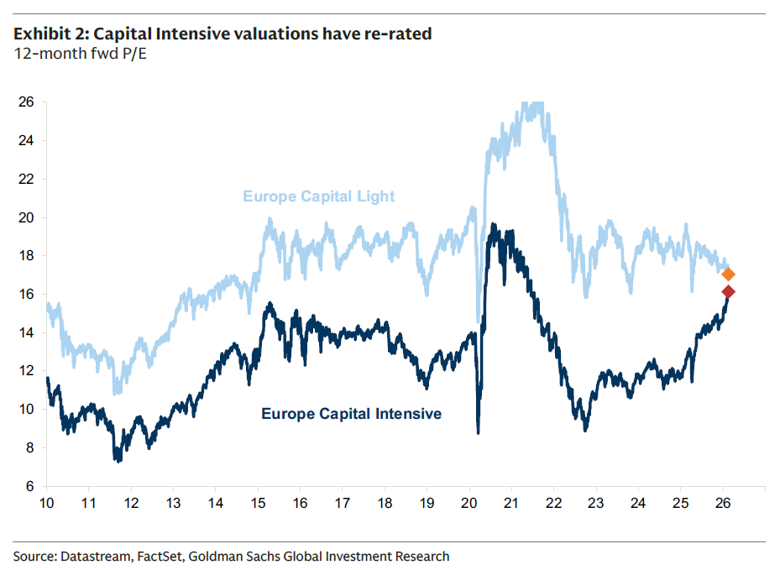
Exhibit 3: Capital Intensive and Capital Light stocks are now trading at broadly the same valuation (12-month fwd P/E discount)
图表3：资本密集型与资本轻型股票目前估值大致持平（12个月远期市盈率折价）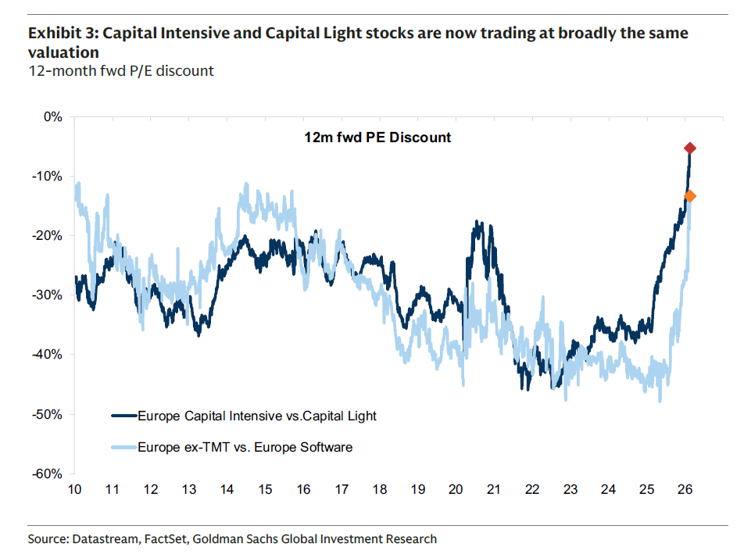
The shift is consistent with our broader "Postmodern Cycle" framework: higher structural inflation risk, more active governments, geopolitical fragmentation, the re-regionalisation of supply chains and persistently higher real rates—all reinforcing the value of tangible productive capacity.
这一转变与我们的“后现代周期”框架相一致：更高的结构性通胀风险、更积极的政府干预、地缘政治碎片化、供应链再区域化以及持续较高的实际利率——所有这些都强化了有形生产能力的价值。

Exhibit 4:Reverse Gear - The decade following the Global Financial Crisis saw the dominance of long-duration Growth assets. That equilibrium broke with the post COVID inflation shock. Total Return performance (annualised) - European sectors and styles.
图表4：倒挡——全球金融危机后的十年见证了长久期成长资产的主导地位。这一均衡在疫情后通胀冲击中被打破。总回报表现（年化）——欧洲行业与风格。
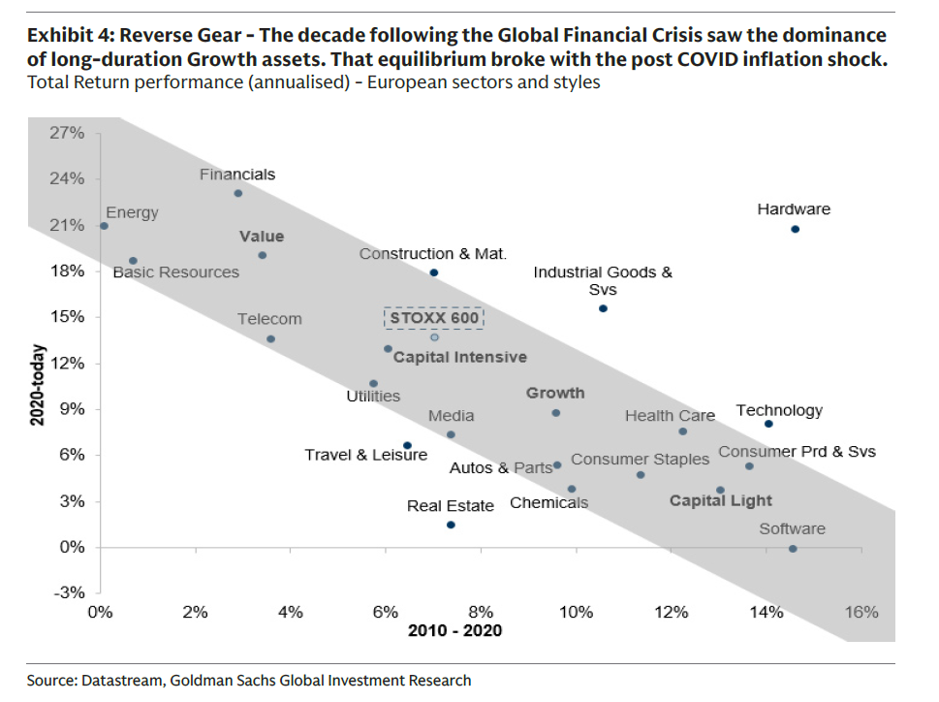

At the same time, the rapid rise of Artificial Intelligence is exerting a powerful dual pressure on equity markets:
与此同时，人工智能的快速崛起正对股票市场施加强大的双重压力：

First, AI is disrupting many of the traditional "new-economy" business models that dominated the past decade. Software, IT Services, publishers, gaming companies, logistics platforms and even asset managers are seeing their competitive moats questioned as AI lowers the cost of information processing and compresses differentiation. The sharp de-rating of Software & IT Services in recent months reflects not a collapse in near-term earnings, but a repricing of terminal value and margin durability, as historically elevated profitability is increasingly viewed as vulnerable to competitive erosion.
第一，AI正在颠覆过去十年主导的许多传统“新经济”商业模式。软件、IT服务、出版商、游戏公司、物流平台甚至资产管理公司的竞争护城河都受到质疑，因为AI降低了信息处理成本并压缩了差异化。近几个月软件与IT服务的大幅降级并非反映近期盈利的崩溃，而是对终值和利润率持续性的重新定价，因为历史高位的盈利能力日益被视为易受竞争侵蚀。

Second, AI is simultaneously turning some of the market's most iconic "Capital Light" winners into "Capital Intensive" industrials. To remain at the frontier of foundational models and compute capacity, the five US hyperscalers have embarked on an unprecedented spending cycle. Since the launch of ChatGPT in 2022, they are set to deploy around $1.5 trillion in capex between 2023 and 2026 - well above the roughly $600 billion they invested in their entire history prior to 2022. In 2026 alone, these hyperscalers' capex is on track to exceed $650 billion, meaning this single year of spending could surpass their total capex invested pre-AI. This marks one of the fastest and largest capex cycles in technology history, with broad implications for the investment landscape.
第二，AI同时将一些市场上最具标志性的“资本轻型”赢家转变为“资本密集型”工业企业。为了保持在基础模型和算力前沿，美国五家超大规模企业已开启前所未有的支出周期。自2022年ChatGPT推出以来，它们预计在2023年至2026年间投入约1.5万亿美元的资本支出——远高于2022年之前整个历史上约6000亿美元的投资。仅2026年一年，这些超大规模企业的资本支出就有望超过6500亿美元，意味着单年支出可能超过AI之前的总资本支出。这标志着科技史上最快、最大的资本支出周期之一，对投资格局具有深远影响。

Focus on HALO: Heavy Assets, Low Obsolescence
After more than a decade of under-investment (particularly in Europe), corporates are shifting decisively back toward physical assets. As highlighted in Europe's Uses of Cash: Returning to Investing, the capex-to-sales ratio has reached a 10-year high, reflecting renewed investment in capacity, infrastructure and long-cycle assets.
经过十多年的投资不足（特别是在欧洲），企业正果断地转向实物资产。正如《欧洲现金用途：回归投资》所述，资本支出与销售之比已达到10年高点，反映出对产能、基础设施和长周期资产的新一轮投资。

This pivot, combined with rising uncertainty around the terminal value of Growth stocks, has repriced scarcity across markets. Equity leadership is increasingly favouring companies built on hard-to-replicate physical assets — capacity, networks, resources and infrastructure — where technological obsolescence is limited. Year to date, physical asset businesses have outperformed sharply, while Software and other Capital Light models have lagged.
这一转向，加上成长股终值不确定性上升，已重新定价了市场中的稀缺性。股票领导力日益青睐那些建立在难以复制的实物资产——产能、网络、资源和基础设施——之上的公司，这些资产的技术过时性有限。年初至今，实物资产企业大幅跑赢，而软件和其他资本轻型模型则落后。

Exhibit 5 shows that the level of capital intensity is now a key driver of returns and valuation changes. Most Capital Intensive sectors (right-hand side) have materially re-rated since early 2025, whereas Capital Light sectors (left-hand side) have seen their valuation either de-rate or remain broadly flat.
图表5显示，资本密集度水平现已成为回报和估值变化的关键驱动因素。大多数资本密集型行业（右侧）自2025年初以来已显著重估，而资本轻型行业（左侧）的估值要么下降，要么基本持平。
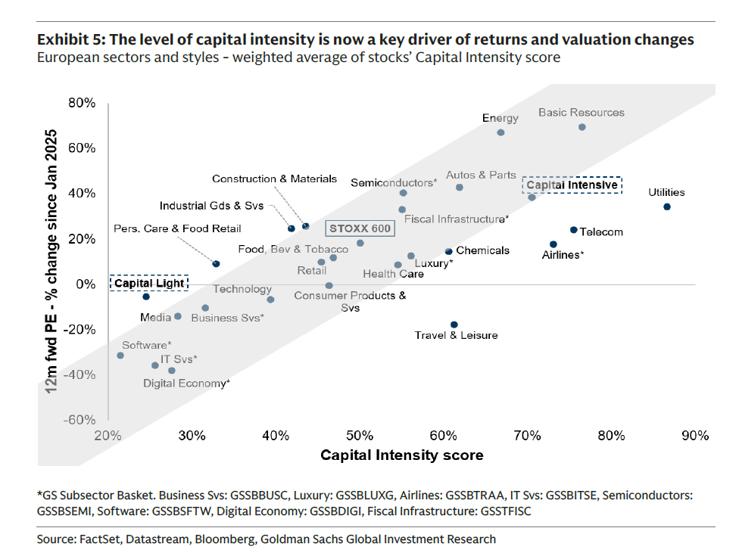
To capture this dynamic, we introduce the HALO framework—Heavy Assets, Low Obsolescence. HALO companies combine two defining characteristics: (1) Heavy Assets: Business models grounded in substantial physical capital with high barriers to replication — cost, regulation, time-to-build, engineering complexity or network integration. (2) Low Obsolescence: Assets whose economic relevance persists across technological cycles. Examples include transmission grids, pipelines, utilities, transport infrastructure, critical equipment, and categories of industrial capacity where replacement cycles are slow relative to digital innovation.
为捕捉这一动态，我们引入HALO框架——重资产、低过时性。HALO企业具备两个定义性特征：（1）重资产：基于大量实物资本的商业模式，具有高复制壁垒——成本、监管、建设周期、工程复杂性或网络整合。（2）低过时性：资产的经济相关性在技术周期中持续存在。例如输电网络、管道、公用事业、运输基础设施、关键设备以及替换周期相对于数字创新较慢的工业产能类别。

Capital Intensive vs. Capital Light—Who's Who?
资本密集型 vs. 资本轻型——谁是谁？

We construct a Capital Intensity Score blending six metrics to classify companies beyond traditional sectors: (1) Tangible Asset Intensity, (2) Fixed Asset Intensity, (3) Fixed Asset Share, (4) Capital-Labour Ratio, (5) Capex Intensity, and (6) Capex Load (see more details in the Appendix). Taken together, these measures identify companies whose economic value derives from physical assets, as opposed to firms reliant on human or digital capital that AI may increasingly commodify.
Exhibit 6 ranks all sectors on this score.
图表6按此评分对所有行业进行排名。
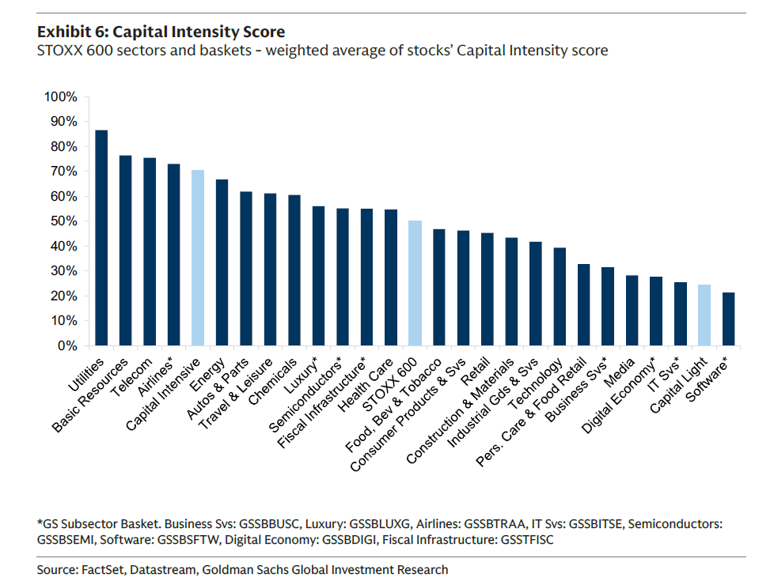
我们构建了一个资本密集度评分，融合六项指标以超越传统行业分类：（1）有形资产密集度，（2）固定资产密集度，（3）固定资产占比，（4）资本-劳动比率，（5）资本支出强度，（6）资本支出负担（详见附录）。这些指标共同识别那些经济价值来源于实物资产的公司，而非依赖人力或数字资本的企业——后者可能日益被AI商品化。

Some groups are straightforward. Utilities, Basic Resources, Energy and Telecoms stand out as unambiguously Capital Intensive, characterised by regulated infrastructure, high fixed-capital requirements and long-duration assets with low obsolescence. At the opposite end, Software & IT Services, Internet, Media and other digital-content or platform businesses sit firmly in the Capital Light, human-capital-intensive category.
某些类别一目了然。公用事业、基础资源、能源和电信无疑属于资本密集型，其特征为受监管的基础设施、高固定资本要求和低过时性的长久期资产。另一端，软件与IT服务、互联网、媒体和其他数字内容或平台企业则明确属于资本轻型、人力资本密集型类别。

Other areas require more nuance. For example, "Consumer" stocks straddle both regimes. Autos and Airlines are clearly Capital Intensive, and Luxury Goods and Beverages fall into a Low-Obsolescence asset class owing to brand equity, production know-how and long-cycle investment in craftsmanship. By contrast, Consumer Services, Gaming and most Retailers are structurally Capital Light, with economics driven more by labour, marketing and operating leverage than by physical capital.
其他领域需要更细致的区分。例如，“消费”股横跨两种体制。汽车和航空公司显然是资本密集型，而奢侈品和饮料则因品牌资产、生产专有技术和工艺方面的长周期投资而属于低过时性资产类别。相比之下，消费者服务、游戏和大多数零售商在结构上属于资本轻型，其经济驱动力更多来自劳动力、营销和经营杠杆，而非实物资本。

The Industrial sector is a complex case. It spans everything from very heavy-asset categories such as Trucks to ultra-light sub-segments like Staffing and other Business Services. Moreover, many classic capital-goods manufacturers have deliberately migrated toward service-led, asset-lighter models over the past decade — bundling maintenance and aftermarket contracts into their offering. While we generally find that long-cycle industrials tend to be more Capital Intensive than short-cycle industrials, this is not universally true and requires bottom-up inspection.
工业行业是一个复杂案例。它涵盖从卡车等重资产类别到人事服务和其他商业服务等超轻细分领域。此外，许多经典资本品制造商在过去十年中有意转向服务主导、资产更轻的模式——将维护和售后合同捆绑到其产品中。虽然我们通常发现长周期工业通常比短周期工业更具资本密集性，但并非普遍成立，需要自下而上的检验。

A similar ambiguity exists in Construction and Materials. Cement producers are unequivocally Capital Intensive; however, most construction and infrastructure-service firms are not. Their revenues are tied to heavy-asset cycles, yet the businesses themselves often do not own the underlying assets—whether buildings, toll-roads, or delivery services.
建筑和材料领域也存在类似模糊性。水泥生产商无疑是资本密集型；然而，大多数建筑和基础设施服务公司则不然。它们的收入与重资产周期相关，但企业本身往往不拥有基础资产——无论是建筑物、收费公路还是配送服务。

Because the classification cuts across traditional sectors, we have constructed two baskets: Capital Intensive (GSSTCAPI) and Capital Light (GSSTCAPL) - see methodology in Appendix.
由于这种分类跨越传统行业，我们构建了两个篮子：资本密集型（GSSTCAPI）和资本轻型（GSSTCAPL）——方法论见附录。
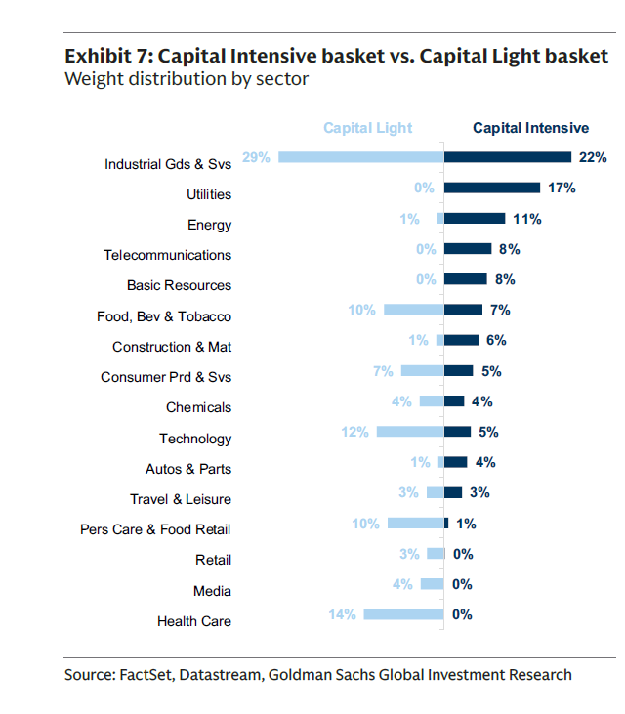
The Capital Intensive basket (GSSTCAPI) includes the expected names from Utilities, Energy, Basic Resources and Industrials, but also a much broader set of firms across Aerospace & Defense, Transport, Long-Cycle Industrials, Luxury and selective Consumer subsectors (Exhibit 7). Its Capital Intensity Score places it around the 75th percentile of the STOXX 600.
资本密集型篮子包括公用事业、能源、基础资源和工业中的预期名称，也包括航空航天与国防、运输、长周期工业、奢侈品和部分消费子行业中更广泛的企业（图表7）。其资本密集度评分位于STOXX 600约第75百分位。

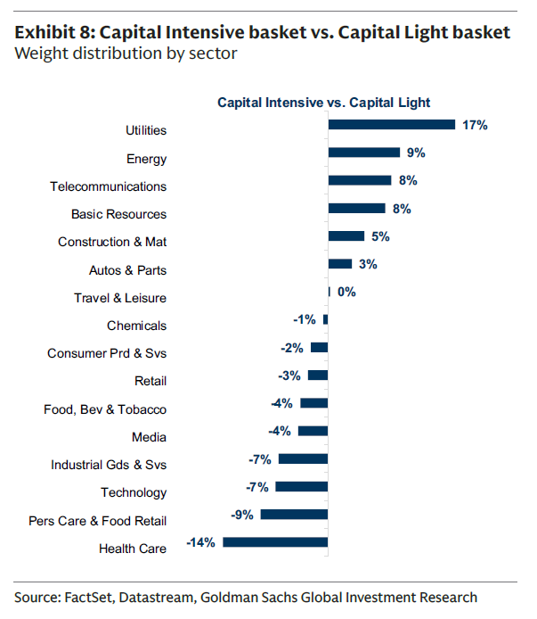
The Capital Light basket (GSSTCAPL) includes the usual candidates from Software, Media, Internet and Business Services, but also a broader set of human-capital or scalability-driven models across Consumer Services, Retail, MedTech (Exhibit 8). Its Capital Intensity Score sits around the 25th percentile of the STOXX 600.
资本轻型篮子包括软件、媒体、互联网和商业服务中的常见候选者，也包括消费者服务、零售、医疗科技等更广泛的人力资本或可扩展性驱动型模型（图表8）。其资本密集度评分位于STOXX 600约第25百分位。
What drives Capital Intensive vs. Capital Light stocks ?
Several forces shape the relative performance of Capital Intensive and Capital Light equities:
塑造资本密集型与资本轻型股票相对表现的几股力量：
- Structural shifts. The global environment has turned decisively more supportive for Capital Intensive sectors. A new capex cycle — driven by greater fiscal intervention, higher structural inflation, geopolitical fragmentation, supply-chain re-regionalisation and the AI-driven surge in physical compute infrastructure — is lifting demand for tangible assets (Exhibit 9). These factors simultaneously support Capital Intensive businesses and challenge Capital Light models, particularly where AI compresses differentiation or margin durability.

- 结构性转变。全球环境已决定性地转向更有利于资本密集型行业。新的资本支出周期——由更大的财政干预、更高的结构性通胀、地缘政治碎片化、供应链再区域化以及AI驱动的实物算力基础设施激增所推动——正在提升对有形资产的需求（图表9）。这些因素同时支持资本密集型业务，并挑战资本轻型模型，尤其是在AI压缩差异化或利润率持续性的领域。
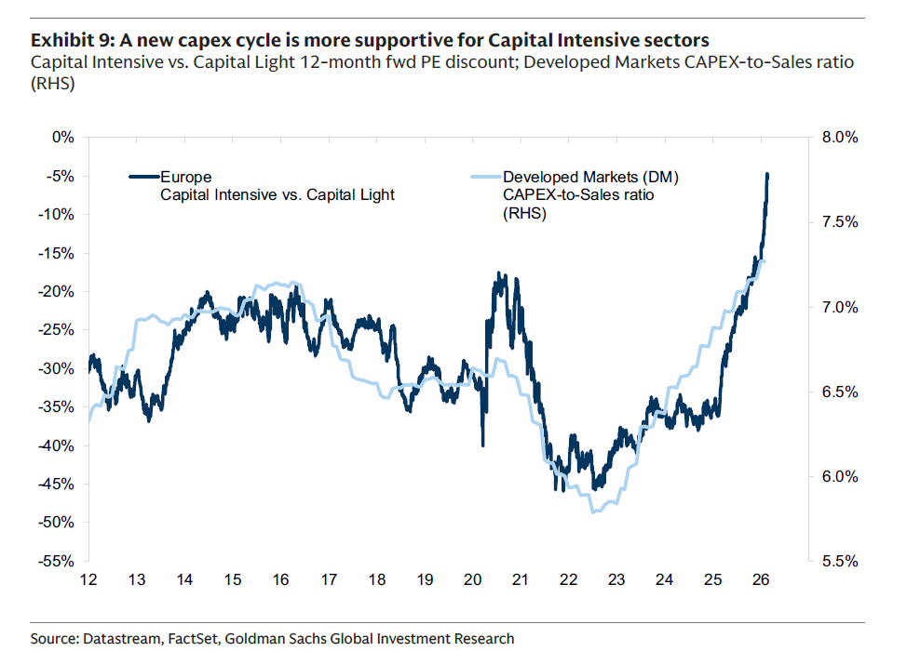

- Interest rates. Capital Intensive stocks tend to outperform in periods of higher interest rates because elevated yields compress the valuations of long-duration, Capital Light growth models, while sectors tied to tangible capacity benefit from stronger nominal activity and fiscal spending (Exhibit 10). Today's policy mix reinforces this: governments are directing capital towards physical assets, creating a structural tailwind for Capital Intensive firms (despite higher rates). Still, the effect is not uniform. Our US colleagues highlight that some Capital Intensive companies rely heavily on affordable financing, and therefore perform best when the cost of capital is low or falling — something partly cushioned today by tight credit spreads.

- 利率。资本密集型股票往往在利率较高时期跑赢，因为较高的收益率压缩了长久期资本轻型成长模型的估值，而与有形产能相关的行业则受益于更强的名义活动和财政支出（图表10）。当前的政策组合强化了这一点：政府正将资本导向实物资产，为资本密集型公司创造结构性顺风（尽管利率较高）。不过，这种影响并非统一。我们的美国同事指出，一些资本密集型公司严重依赖廉价融资，因此在资本成本较低或下降时表现最佳——而当前紧张的信用利差在一定程度上缓冲了这一影响。
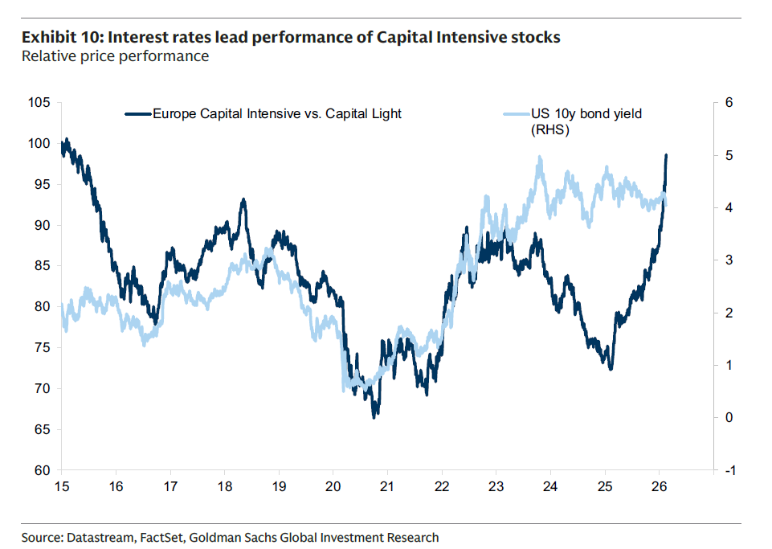

- Manufacturing vs. Services. Capital Intensive stocks outperform when Manufacturing PMI exceeds Services PMI, particularly when the Future Business Expectations component turns higher. Because Capital Intensive sectors are geared to industrial production, capex cycles and physical output, they respond more positively to an improving manufacturing outlook. With Manufacturing PMIs recently moving back above Services (at least the Future Business Expectations component), the macro backdrop has shifted in favour of Capital Intensive industries once again (Exhibit 11).
- 制造业 vs. 服务业。当制造业PMI超过服务业PMI时，资本密集型股票跑赢，尤其是当未来商业预期分项上升时。因为资本密集型行业与工业生产、资本支出周期和实物产出相关，它们对制造业前景改善的反应更为积极。随着近期制造业PMI再次回升至服务业之上（至少未来商业预期分项如此），宏观背景再次转向有利于资本密集型行业（图表11）。
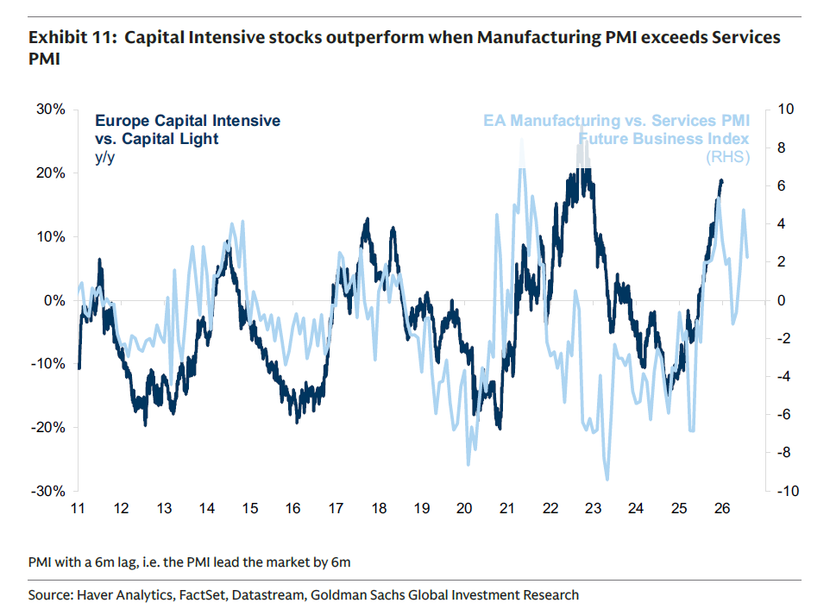

- Value vs. Growth. The Capital Intensive vs. Capital Light dynamic closely tracks the Value vs. Growth rotation (Exhibit 12). Recently, Capital Intensive sectors such as Energy, Materials and Utilities have re-rated as investors rediscover the scarcity value of physical assets. This convergence has been driven far more by Value outperformance than by a collapse in Growth multiples, signalling a genuine change in leadership rather than a simple de-rating of Growth.

- 价值 vs. 成长。资本密集型 vs. 资本轻型的动态紧密跟踪价值 vs. 成长的轮动（图表12）。近期，能源、材料和公用事业等资本密集型行业已重估，因为投资者重新发现实物资产的稀缺价值。这种趋同更多是由价值跑赢而非成长倍数崩溃所驱动，表明领导力的真正转变，而非简单的成长降级。
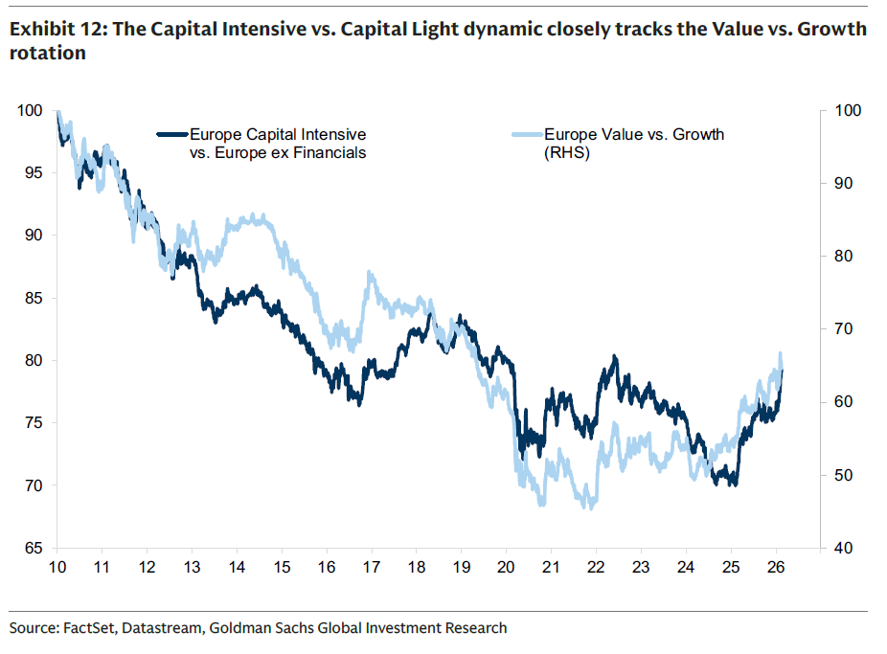

The rotation has also coincided with a broader search for diversification away from crowded, expensive US/Tech positions. Exhibit 13 shows a strong correlation between the outperformance of Asset Heavy stocks and inflows into Value strategies. Over the past 12 months, Value funds have seen +3% AuM inflows, while Growth funds have experienced 9% outflows, according to EPFR — likely an understatement of the full trend given that many "Blend" funds have also shifted towards Value.
这一轮动也与寻求分散拥挤、昂贵的美国/科技仓位的广泛努力相吻合。图表13显示重资产股票跑赢与价值策略资金流入之间存在强相关性。根据EPFR数据，过去12个月价值基金录得+3%的管理资产流入，而成长基金则遭遇9%流出——由于许多“混合”基金也转向价值，这很可能低估了整体趋势。

Is the move overdone? Near term, the rotation has been sharp. But longer-term positioning suggests further room: cumulative flows into European Value vs. Growth funds remain around -40% (as a percentage of AuM), meaning investors are still heavily under-allocated to Value (Exhibit 14). On that basis, the structural case for Capital Intensive over Capital Light remains firmly intact.
这一轮动是否过度？短期内，轮动已经剧烈。但更长期仓位表明仍有进一步空间：欧洲价值 vs. 成长基金的累计资金流入仍约为-40%（占管理资产百分比），意味着投资者仍大幅低配价值（图表14）。基于此，资本密集型优于资本轻型的结构性理由依然稳固。
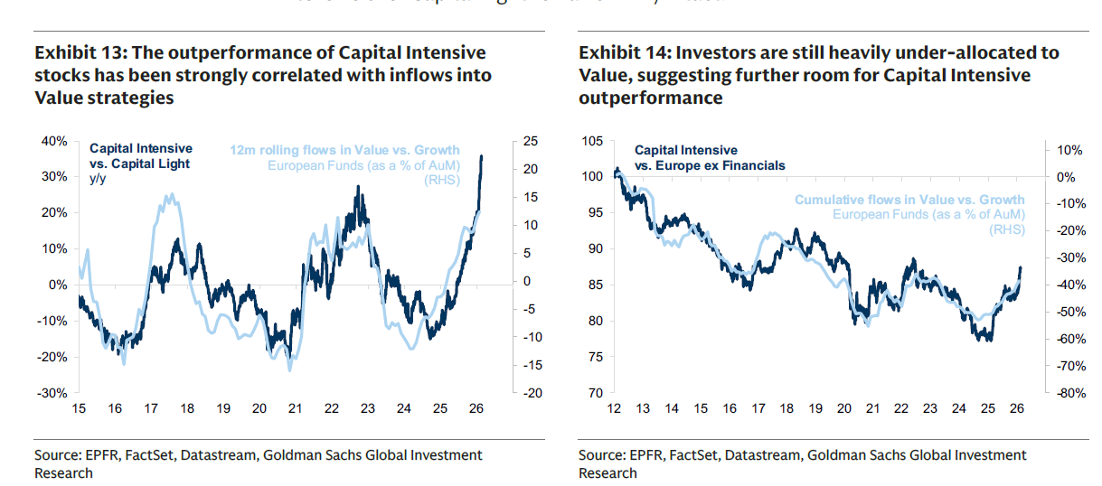

- Earnings Momentum. Over the past cycle, the earnings of Capital Light businesses have consistently outpaced those of Capital Intensive sectors, explaining much of their long-term relative performance. Exhibit 15 shows the relative earnings of our European Capital Intensive vs. Capital Light baskets. Since January 2025, Capital Intensive earnings have again underperformed, but this appears almost entirely tariff-related: the downgrades came immediately after Liberation Day, reflecting the fact that Capital Intensive sectors tend to be more cyclical, more export-oriented, and — as goods producers — more exposed to tariffs than services, which are rarely taxed at the border.

- 盈利动能。在过去周期中，资本轻型企业的盈利持续超越资本密集型行业，这解释了其长期相对表现的很大一部分。图表15显示我们欧洲资本密集型 vs. 资本轻型篮子的相对盈利。自2025年1月以来，资本密集型盈利再次落后，但这几乎完全与关税相关：降级发生在“解放日”之后立即出现，反映出资本密集型行业往往更具周期性、更偏出口导向，且作为商品生产者比服务（很少在边境征税）更容易受关税影响。

Stripping out this short-term tariff effect, the picture is becoming more constructive for Capital Intensive. Earnings momentum for Capital Intensive companies has recently turned positive, with consensus upgrades coming through, while Capital Light earnings have been revised down. Looking ahead, consensus expects the divergence to wid our Capital Intensive basket is forecast to deliver a 14% EPS CAGR over the next few years, compared with around 10% for Capital Light (Exhibit 16).
剔除这一短期关税效应，资本密集型的前景正在变得更具建设性。资本密集型公司的盈利动能近期已转正，一致预期上调，而资本轻型盈利则被下调。展望未来，一致预期预计分化将扩大：我们的资本密集型篮子预计未来几年EPS年复合增长率为14%，而资本轻型约为10%（图表16）。
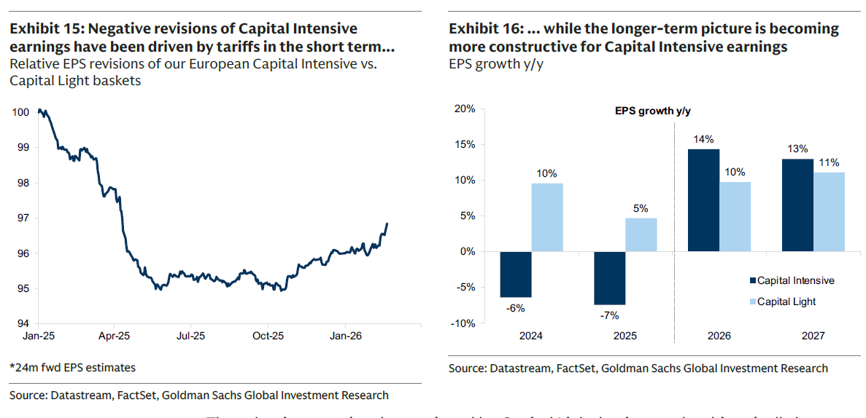
The valuation premium long enjoyed by Capital Light businesses has historically been supported by superior margins and higher returns on equity — much as the US market has traded at a premium to the rest of the world. But the structural changes now underway have increased uncertainty around the durability of these advantages. Markets are increasingly questioning whether the elevated profitability of Capital Light models can be sustained. The ROE gap between Capital Light and Capital Intensive remains wide, but consensus forecasts now expect flat ROE for Capital Light companies, while Capital Intensive ROE is projected to improve (Exhibit 17).
资本轻型业务长期享有的估值溢价，历史上由更高的利润率和更高的股本回报率所支撑——正如美国市场相对世界其他地区的溢价交易。但当前正在发生的结构性变化增加了这些优势持续性的不确定性。市场日益质疑资本轻型模型的高盈利能力能否维持。资本轻型与资本密集型之间的ROE差距仍然较大，但一致预期现在预计资本轻型公司ROE持平，而资本密集型ROE预计将改善（图表17）。

The outlook for both groups remains inherently uncertain. What is clear is that the landscape is reshaping the balance between physical assets and human or digital capital models. Whether this marks a lasting change in market leadership or simply a re-balancing within a still evolving cycle remains open, but for now, the forces supporting Capital Intensive businesses are strengthening.
两组公司的前景本质上仍不确定。明确的是，格局正在重塑实物资产与人力或数字资本模型之间的平衡。这是否标志着市场领导力的持久变化，还是仅仅在仍在演变的周期中的再平衡，尚待观察，但就目前而言，支持资本密集型企业的力量正在加强。
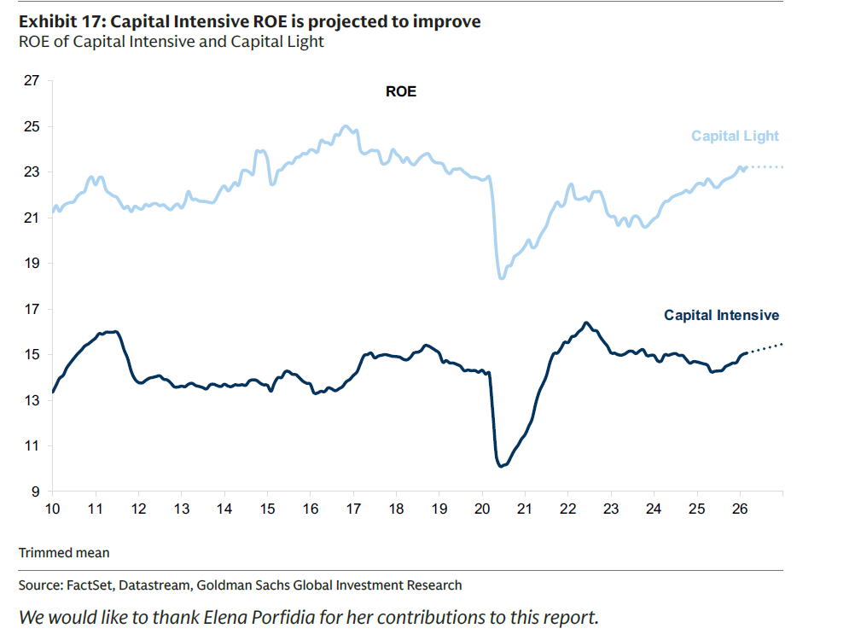
Exhibit 17: ROE trends (trimmed mean) – Capital Light vs. Capital Intensive. Source: FactSet, Datastream, Goldman Sachs Global Investment Research.
We would like to thank Elena Porfidia for her contributions to this report.
图表17：ROE趋势（修剪均值）——资本轻型 vs. 资本密集型。来源：FactSet，Datastream，高盛全球投资研究。
我们感谢Elena Porfidia对本报告的贡献。

补充材料
Our Capital Intensity Score uses six metrics that capture how dependent a company is on physical capital rather than human or intangible inputs:
我们的资本密集度评分使用六项指标，衡量公司对实物资本（而非人力或无形资产）的依赖程度：

Tangible Asset Intensity = (Assets - Cash - Intangibles)/Sales. It measures the level of net physical operating assets required to generate each dollar of revenue. Higher values indicate business models dependent on substantial physical asset bases; lower values indicate scalable, Capital Light operations.
有形资产密集度 = (资产 - 现金 - 无形资产) / 销售额。衡量产生每美元收入所需的净有形经营资产水平。较高数值表示依赖大量实物资产基础的商业模式；较低数值表示可扩展的资本轻型运营。

Fixed Asset Intensity = PPE/Sales. It measures the amount of Property, Plant & Equipment needed to support current revenue generation. High ratios reflect "brick-and-mortar"-heavy models, while low ratios suggest limited reliance on fixed infrastructure.
固定资产密集度 = PPE / 销售额。衡量支持当前收入生成所需的PPE金额。高比率反映“实体”重型模型，低比率表示对固定基础设施的依赖有限。

Fixed Asset Share = PPE/Assets. It measures the share of a company's balance sheet accounted for by long-term physical assets. A large proportion of assets tied up in PPE indicates a structurally Capital Intensive footprint; a smaller share implies operational flexibility and a lighter economic base.
固定资产占比 = PPE / 资产。衡量公司资产负债表中长期实物资产所占比例。大量资产用于PPE表明结构性资本密集型特征；较小比例意味着运营灵活性和更轻的经济基础。

Capital-Labour Ratio = Tangible Assets/Employee. It measures the tangible asset base deployed per employee. Higher levels imply machine- or asset-driven production processes; lower levels emphasize labour-driven, people-centric business models.
资本-劳动比率 = 有形资产 / 员工人数。衡量每名员工配置的有形资产基础。较高水平意味着机器或资产驱动的生产过程；较低水平强调劳动力驱动、以人为本的商业模式。

CAPEX Intensity = CAPEX/Sales. It measures the proportion of revenue that must be reinvested annually to maintain or expand the company. High reinvestment needs reflect heavy asset maintenance and expansion burdens; low requirements indicate businesses that scale with modest incremental capital.
资本支出强度 = 资本支出 / 销售额。衡量每年必须再投资以维持或扩大公司的收入比例。高再投资需求反映沉重的资产维护和扩张负担；低要求表示以适度增量资本实现规模扩张的业务。

CAPEX Load = CAPEX/EBITDA. It measures the share of operating cash profits consumed by capital expenditure. A high ratio shows cash flows are absorbed by asset upkeep or growth, characteristic of Capital Intensive sectors; a low ratio signals strong cash conversion for shareholders.
资本支出负担 = 资本支出 / EBITDA。衡量经营现金利润中被资本支出消耗的份额。高比率表明现金流被资产维护或增长吸收，为资本密集型行业特征；低比率则表明股东现金转换能力强。

We compute the overall score for each company as the Capital Intensive average percentile rank of these six metrics relative to all the constituents of the main index. The result is a 0-100% scale that identifies how Capital Intensive (100%) or Capital Light (0%) a company is compared with its peers. Taken together, these metrics distinguish firms whose economic value is grounded in physical assets from those reliant on human or intangible capital, the latter being increasingly exposed to AI-driven commodification.
我们计算每家公司的总体得分，即这六项指标相对于主指数所有成分股的资本密集型平均百分位排名。结果在0-100%的尺度上，标识公司与同行相比属于资本密集型（100%）还是资本轻型（0%）。综合来看，这些指标区分了经济价值根植于实物资产的公司与依赖人力或无形资本的公司，后者日益面临AI驱动的商品化风险。
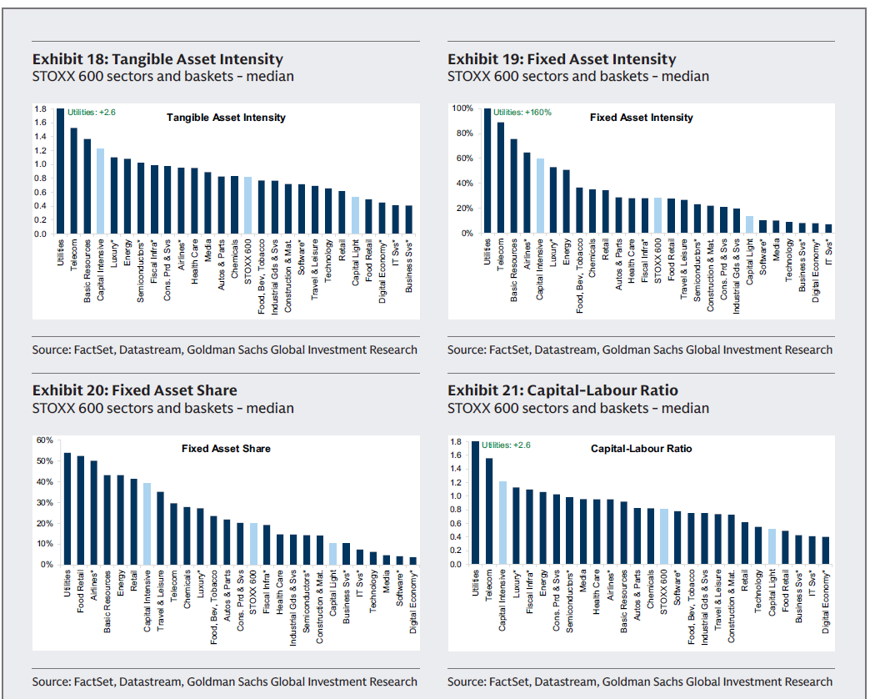
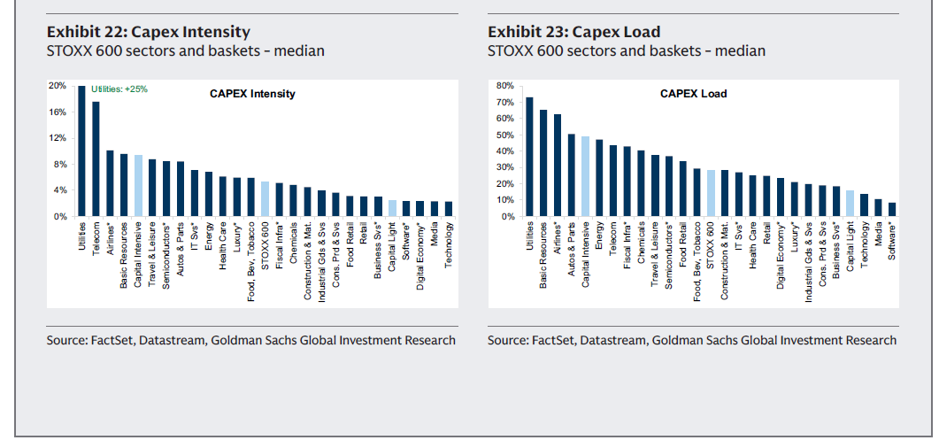

Exhibits 18-23 show the median values for each metric across STOXX 600 sectors and our baskets. Source: FactSet, Datastream, Goldman Sachs Global Investment Research.
图表18-23展示了STOXX 600各行业及我们篮子在各项指标上的中位数。来源：FactSet，Datastream，高盛全球投资研究。

附录及法律声明，因内容标准化，概述如下
The remainder of the report contains standard regulatory disclosures, conflict of interest statements, and legal disclaimers regarding the use of this research, analyst compensation, trading restrictions, and distribution policies. These are consistent with global financial research practices and are available in full on Goldman Sachs’ official disclosure website.
报告剩余部分包含标准的监管披露、利益冲突声明以及关于本研究使用、分析师薪酬、交易限制和分发政策的法律免责声明。这些内容与全球金融研究惯例一致，完整版可在高盛官方披露网站查阅。

