Each of the 8 DAOs are within each of the docs

AssessmentDAO

BatchDAO

CategoryDAO

GradeDAO

NoteDAO

SalesforceDAO

TraineeDAO

TrainerDAO

Caliber-Master

Nov 6, 2018

Packages

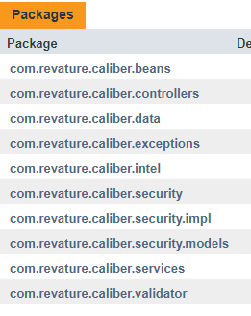

DAOs

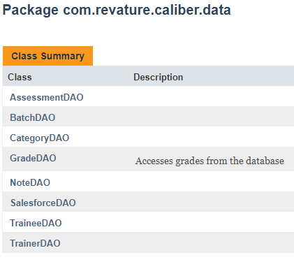

caliber-mehrab-1712-dev

 Jan 18, 2018

packages:

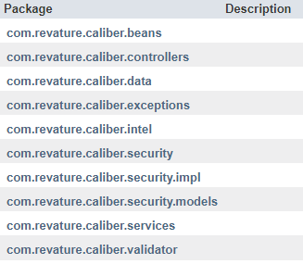

DAOs (within data)

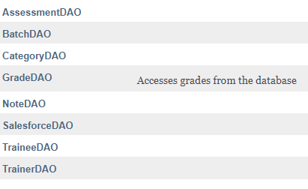

8DAOs

caliber-ninja

 Sep 5, 2018

packages:

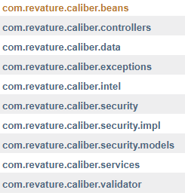

DAOs:

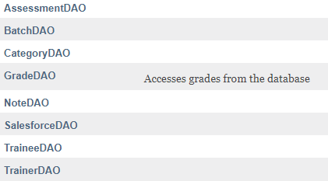

caliber-presentation-1711

Jan 26, 2018

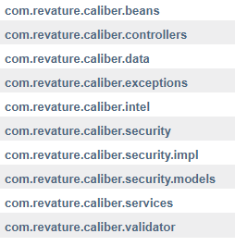

DAOs:

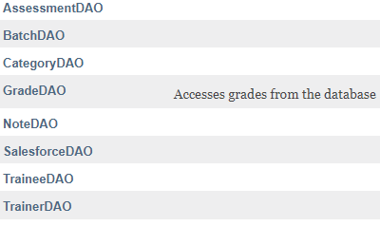

caliber-revpro

 Jul 16, 2018

packages:

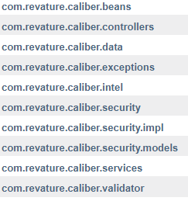

DAOs:

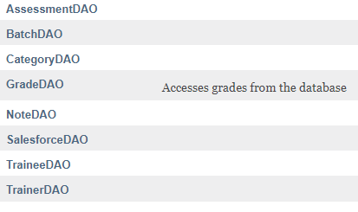

caliber-team-bug-dev

Jan 22, 2018

packages:

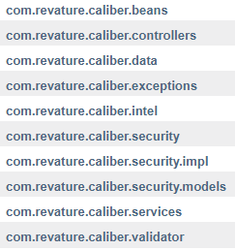

DAOs:

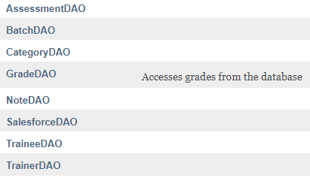

caliber-team-bug-dev2

Jan 24, 2018

packages:

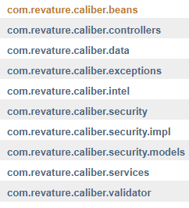

DAOs:

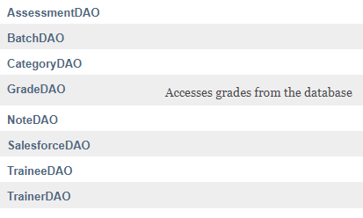

caliber-2-cross-origin-update

Jan 4, 2018

packages:

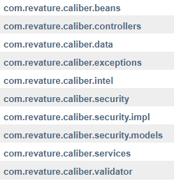

DAOs:

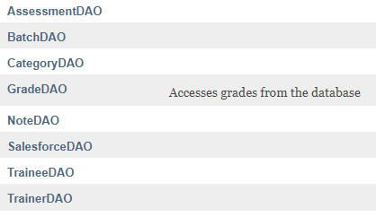

caliber-2

Mar 17, 2018

packages:

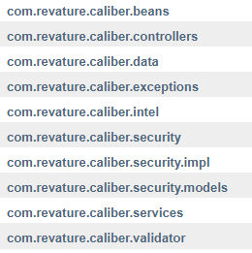

DAOs:

