Week 1

**第一节**

**Social impact**

定义：social impact refers to the positive change organisations or individuals cause in a community, whether on a small local scale or a grand global one. Social impact is the effect an individual or organisation's actions have on the social fabric of a community.

指标：It's a measure of the influence of an individual or group on the well-being of society as a whole.它是衡量个人或群体对整个社会福祉影响的指标

**Positive social impact examples**

|  |  |
| --- | --- |
| * Providing access to clean drinking water in a community that does not have it * Building a school in a society that does not have one * Providing job training to unemployed people * Planting trees in a community to improve air quality and reduce pollution * Supporting local businesses and farmers by purchasing their goods and services * Providing access to education for underprivileged children * Developing and implementing sustainable energy solutions * Creating programs and initiatives to address homelessness and poverty * Promoting equal rights and opportunities for marginalised groups * Advocating for policies that protect the environment and combat climate change * Supporting mental health services and reducing stigma around mental illness * Providing access to healthcare for underserved populations * Developing technologies and innovations that improve people's lives and well-being. | * 在没有清洁饮用水的社区提供清洁饮用水 * 在没有学校的社会中建立一所学校 * 为失业人员提供职业培训 * 在社区植树以改善空气质量并减少污染 * 通过购买当地企业和服务来支持当地企业和农民 * 为贫困儿童提供受教育的机会 * 开发和实施可持续能源解决方案 * 制定解决无家可归和贫困问题的计划和倡议 * 促进边缘化群体的平等权利和机会 * 倡导保护环境和应对气候变化的政策 * 支持精神卫生服务并减少对精神疾病的污名化 * 为服务不足的人群提供医疗保健服务 * 开发技术和创新，改善人们的生活和福祉。 |

**Negative social impact examples**

|  |  |
| --- | --- |
| * Building a factory that pollutes the air and water in a community * Cutting down trees in a society without replanting them * Failing to provide safe working conditions for employees * Discriminating against certain groups of people, such as based on race or gender * Not paying employees a fair wage or providing them with adequate benefits. | 负面社会影响示例   * 建设污染社区空气和水的工厂 * 在社会中砍伐树木而不重新种植树木 * 未能为员工提供安全的工作条件 * 歧视某些人群，例如基于种族或性别 * 没有向员工支付公平的工资或为他们提供足够的福利。 |

**What is a Social impact organisation?**

定义：Social impact organisations refer to organisations that are specifically focused on creating positive social impact. These organisations can include nonprofits, social enterprises, and impact investing firms. Social impact organisations are typically mission-driven, focusing on achieving specific social or environmental goals.

企业怎么做？

They work to create positive change by addressing social issues and promoting positive change in their communities and society. They often use a variety of strategies and approaches, such as providing services and support, advocating for policy change, and investing in social impact projects.

**Social Impact of Business（积极）**

* Providing products or services that address social or environmental issues: Many businesses focus on delivering products or services that address specific social or environmental challenges. For example, a company that sells solar panels is helping to promote renewable energy, while a business that sells organic produce is helping to support sustainable agriculture.（环境，可持续性）
* Creating jobs and supporting the local economy: Businesses can help improve the community's well-being by providing employment opportunities. This can include providing jobs directly and supporting local businesses and suppliers.（就业）
* Giving back to the community: Many businesses support their local communities through charitable giving and other forms of philanthropy. This can include financial support to local organizations, volunteering time and resources, and sponsoring community events.（回馈社会，慈善）
* Promoting diversity and inclusion: By fostering diversity and inclusionLinks to an external site. within their organizations, businesses can help to promote equal opportunities and create a more inclusive society.（多样性 包容性）
* 提供解决社会或环境问题的产品或服务：许多企业专注于提供解决特定社会或环境挑战的产品或服务。例如，一家销售太阳能电池板的公司正在帮助推广可再生能源，而一家销售有机农产品的企业正在帮助支持可持续农业。
* 创造就业机会和支持当地经济：企业可以通过提供就业机会来帮助改善社区的福祉。这可能包括直接提供就业机会以及支持当地企业和供应商。
* 回馈社区：许多企业通过慈善捐赠和其他形式的慈善事业来支持当地社区。这可以包括对当地组织的财政支持、志愿服务时间和资源以及赞助社区活动。
* 促进多样性和包容性：通过培养[多样性和包容性指向外部站点的链接。](https://www.sopact.com/dei-dashboard" \t "https://canvas.insearch.edu.au/courses/5895/pages/_blank)在他们的组织内，企业可以帮助促进机会平等，创造一个更具包容性的社会。

**Why is it important to manage and measure your social impact?**

Firstly, your service users, supporters, funders, and stakeholders will want to know how you're helping improve lives. So it's not just a nice-to-do activity. Measuring impact for social investment is important as social investors consider both financial and social return. Social investors want to use their money to create impact, so they want to know how their money will make a difference. They want to know your social impact. Many social investors are even social businesses themselves, so their money may also come from organizations and individuals motivated by social change.

**What is the definition of a Business?**

The term business refers to an organisation or enterprising entity engaged in commercial, industrial, or professional activities. The purpose of a business is to organize some sort of economic production of goods or services. Businesses can be for-profit entities or non-profit organisations fulfilling a charitable mission or furthering a social cause. (Investopedia, 2023)

**SDG**

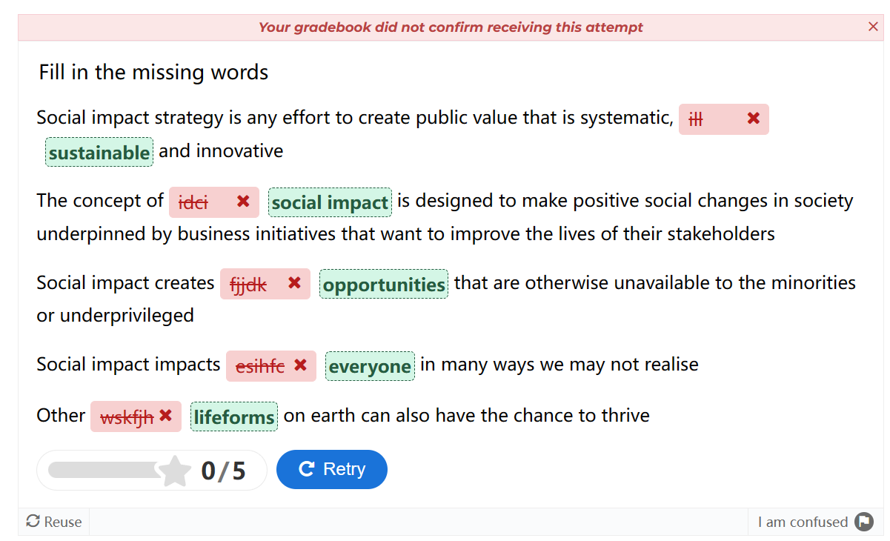

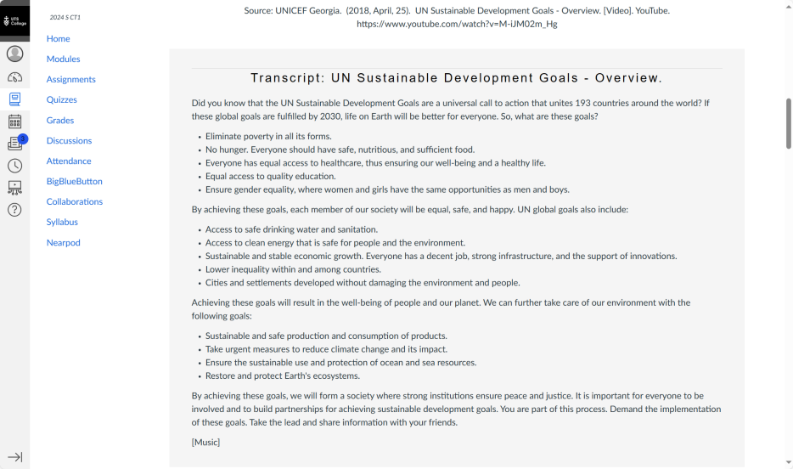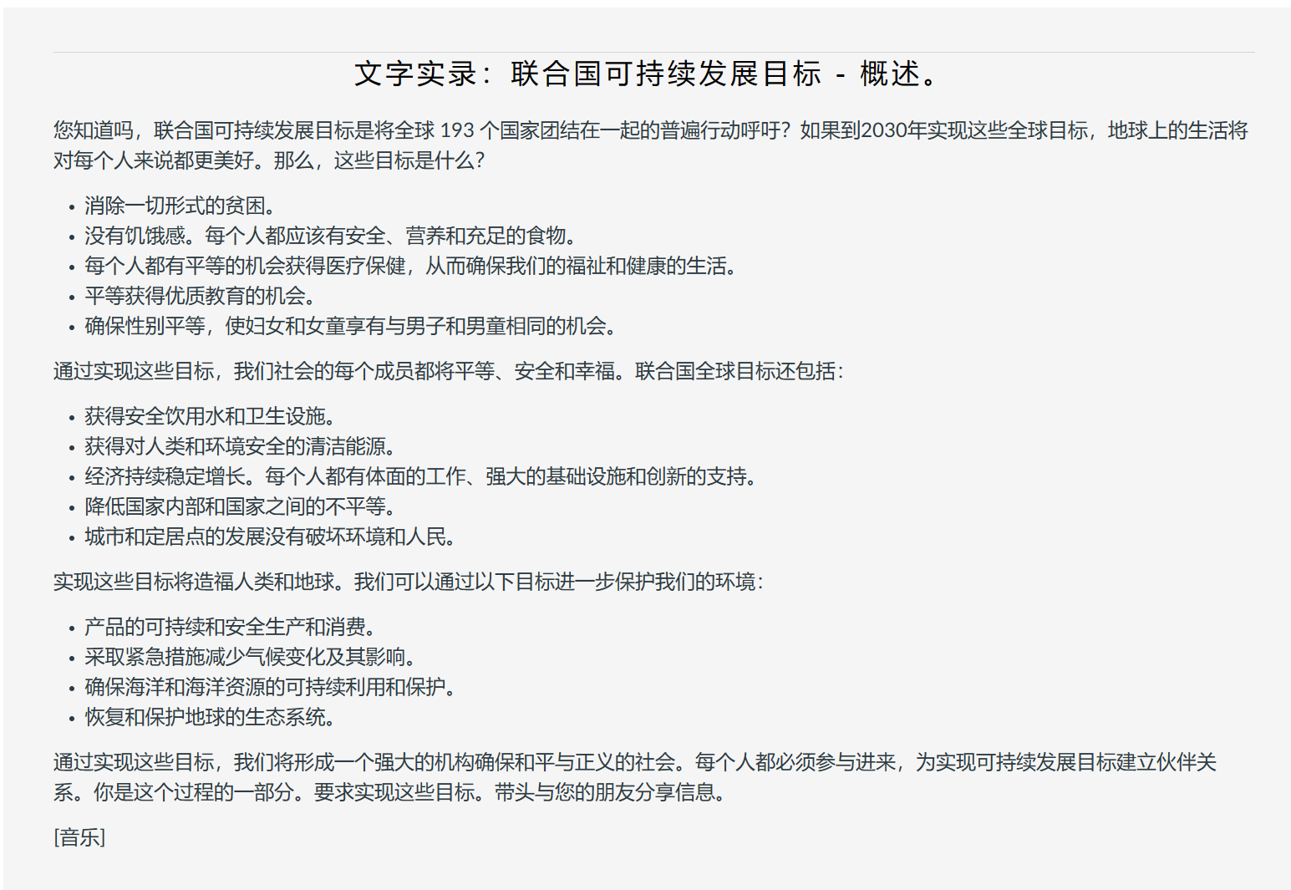

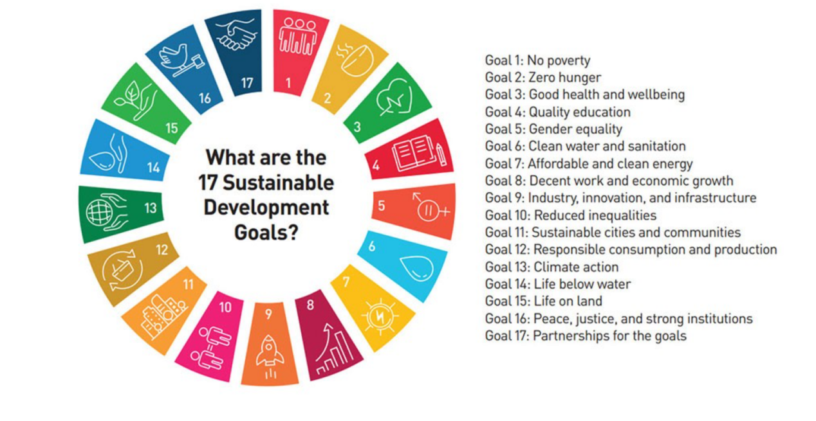

**变革理论 Theory of change**

定义：企业应该怎么做The Theory of Change advocates that firstly, a business needs a clear mission statement that states exactly what impact the business was to have on people or the environment, then, measures these impacts by breaking the impact down into categories: Inputs activities, outputs, short term outcomes, and long-term outcomes. As we have discovered, companies are under growing pressure to improve their performance on social impacts. To gain investor confidence they should be encouraged to establish effective ways of reporting on social impact to remain competitive’ (Jackson, 2013, n.p.).

**Measuring ‘social impact’**

1. **Funding and Sustainability资金和可持续性**

Demonstrating the effectiveness of social programs through rigorous impact measurement is vital for attracting and retaining funding from various sources, including government grants, philanthropic foundations, and private sector investments. By evidencing the positive outcomes of their interventions, organizations can secure ongoing financial support to continue and expand their activities.

1. **Resource Allocation资源分配**

Impact measurement enables organizations to identify successful initiatives and those that are not meeting their intended goals. This knowledge allows for informed decision-making and ensures that limited resources are reallocated to the most impactful projects.

1. **Learning and Improvement学习和改进**

By keeping track of outputs and outcomes, organizations can learn from their experiences, refine their approaches, and replicate successful models. This leads to improved efficiency and the ability to scale up positive interventions.

1. **Accountability and Transparency问责制和透明度**

Measuring social impact provides transparency to stakeholders, including beneficiaries, donors, and regulators, ensuring that organizations are held accountable for delivering on their promises and fulfilling their mission.

1. **Decision Support Tool决策支持工具**

The Theory of Change model is a widely accepted methodology that helps structure and visualize how an organization's activities lead to the desired social impact. By mapping out inputs, activities, outputs, short-term outcomes, and long-term outcomes, it guides planning, evaluation, and communication of social impact.

1. **Competitive Advantage竞争优势**

As businesses face increased scrutiny regarding their social and environmental footprints, measuring and reporting on social impact becomes a key component of corporate responsibility and competitiveness. Investors and consumers alike are more likely to trust and support organizations that can substantiate their claims of creating positive change.

1. **Long-Term Change长期变化**

For long-lasting and systemic change, understanding the causal pathways between interventions and outcomes is crucial. Social impact measurement through frameworks like the Theory of Change enables organizations to build a road-map to achieve enduring social transformation.

What is the meaning business and social impacts? Give some examples of positive and negative social impacts that companies can have through their actions and decisions. Choose a business you are familiar with and outline two positive and two negative social impacts they have contributed to.

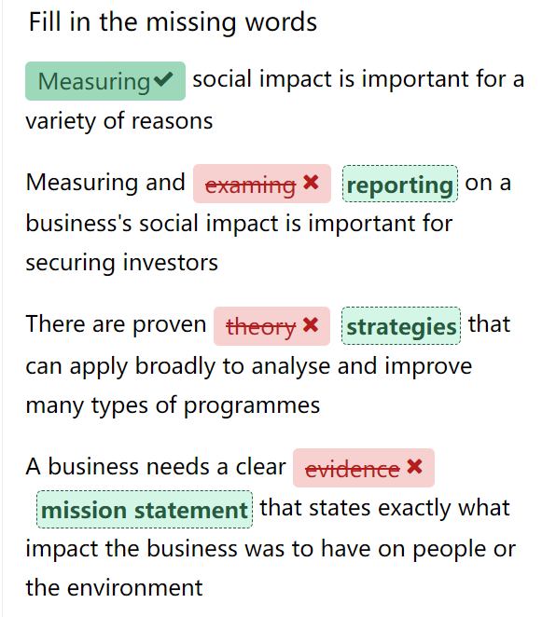

**Practice quiz （定义关系 举例积极消极）**

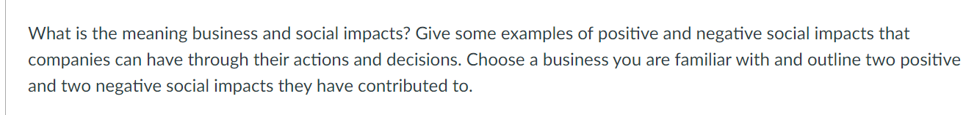

标准答案：

商业和社会影响的关系定义：Business and social impacts are the effects that companies have on people and the environment through their actions and decisions. The term business refers to an organisation or enterprising entity engaged in commercial, industrial, or professional activities. Social impact refers to the positive change organisations or individuals cause in a community, whether on a small local scale or a grand global one. Think of it as the footprint of kindness and change we leave behind.

Positive social impact refers to the positive effects of an individual or organisation's actions on people and the planet. This can include improving people's health, increasing access to education, promoting equality, and supporting the local economy. Organisations and individuals striving for positive social impact generally focus on improving the world by addressing social issues and promoting positive change.

Negative social impact refers to the adverse effects of an individual or organisation's actions on the well-being of a community. This can include pollution, crime, inequality, and economic decline.

特定举例：One business that has both positive and negative social impacts is Apple. On the positive side, Apple has invested in renewable energy, improved labour conditions, and donated to various causes. On the negative side, Apple has faced criticism for its tax avoidance, environmental footprint, and data privacy issues.

**Week2**

**Stakeholders**

**定义：**A ****stakeholder**** is an individual or group that has a legitimate interest in a company, organisation, or business. The Stanford Research Institute defines stakeholders as “those groups without whose support the organisation would cease to exist."

**内部利益相关者：**Internal stakeholders are groups or people who work directly within the business, such as managers, employees, and owners.

* Managers and employees want to earn high wages and keep their jobs, so they have a vested interest in the financial health and success of the business.
* Owners want to maximise the profit the business makes as compensation for the risks they take in owning or running a business.

**外部利益相关者:**External stakeholders are groups outside a business or people who don’t work inside the business but are affected in some way by the decisions and actions of the business. Examples of external stakeholders are customers, suppliers, creditors, the local community, society, and the government.

* Customers want the business to produce quality products at reasonable prices.

Shareholders have an interest in business operations since they are counting on the business to remain profitable and provide a return on their investment in the business.

* Creditors that supply financial capital, raw materials, and services to the business want to be paid on time and in full.
* Federal, state, and local governments need businesses to thrive in order to pay taxes that support government services such as education, police, and fire protection.
* The local community has a stake in the business because it provides jobs, which generate economic activity within the community.
* Society as a whole (as well as the local community) is concerned about the impact that business operations have on the environment in terms of noise, air, and water pollution. Society also has an interest in the business with regard to the safety of the goods and services produced by the business.
* Suppliers need the business to continue to buy their products in order to maintain their own profitability and long-term financial health

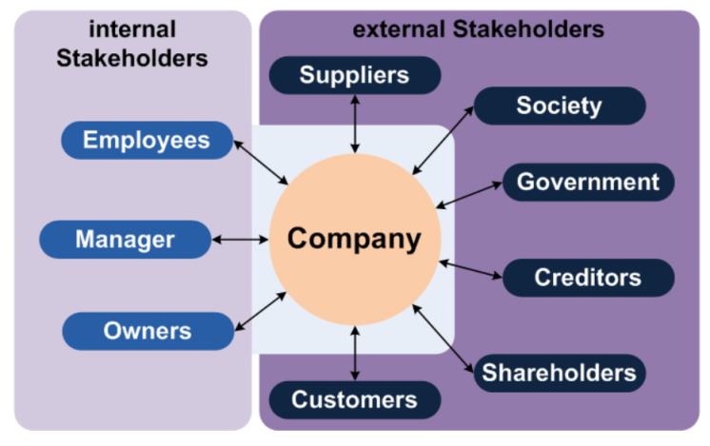

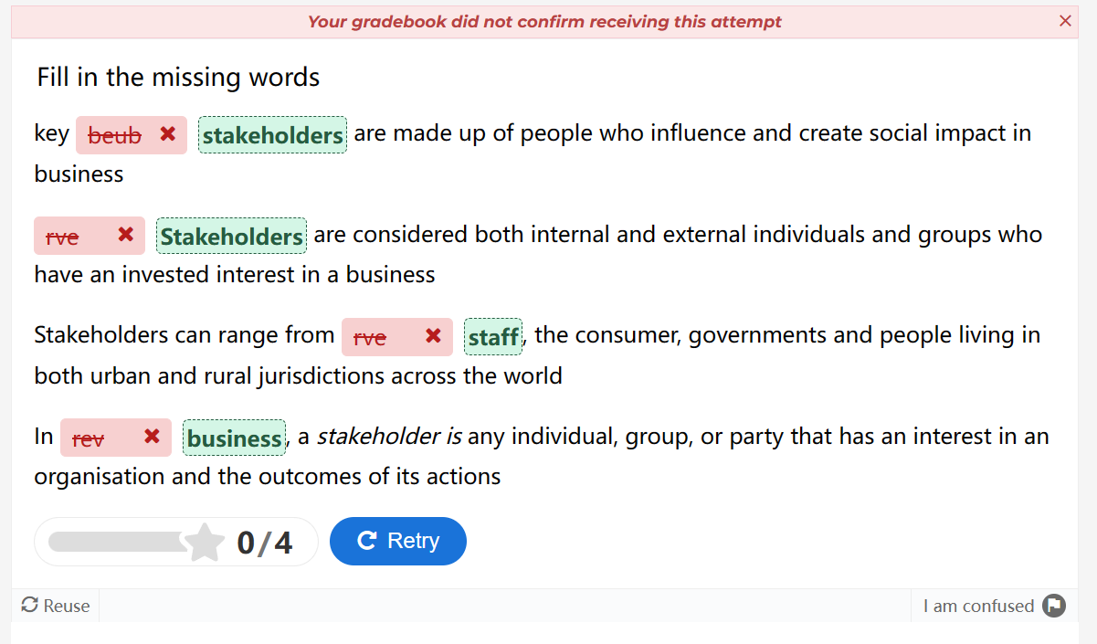

|  |  |
| --- | --- |
| **What is Stakeholder Engagement?**  Stakeholder engagement refers to the process of involving and interacting with stakeholders in decision-making, planning, and implementation processes related to a business or project. The most important part of engaging with stakeholders is to listen to their concerns. It involves actively seeking input, feedback, and collaboration from stakeholders to ensure their perspectives are considered and their interests are addressed.  **Why is Stakeholder Engagement important?**  Stakeholder engagement helps organisations to proactively consider the needs and desires of anyone who has a stake in their organisation, which can foster connections, trust, confidence, and support for key social impact initiatives. When done well, stakeholder engagement can mitigate potential risks and conflicts with stakeholder groups, including uncertainty, dissatisfaction, misalignment, disengagement, and resistance to change.  **How do you identify key stakeholders for social impacts?**  Stakeholder engagement is a crucial aspect of any project, but especially for those that aim to create a positive social impact. Stakeholders are the individuals, groups, or organisations that have an interest or influence in the project's outcomes, such as beneficiaries, donors, partners, staff, or communities. Engaging them effectively can help you understand their needs, expectations, and perspectives, as well as build trust, collaboration, and support for your project. | 什么是利益相关者参与？  利益相关者参与是指在与业务或项目相关的决策、规划和实施过程中参与利益相关者并与之互动的过程。与利益相关者接触最重要的部分是倾听他们的担忧。它涉及积极寻求利益相关者的意见、反馈和协作，以确保他们的观点得到考虑并解决他们的利益。  为什么利益相关者参与很重要？  利益相关者的参与有助于组织主动考虑与其组织有利害关系的任何人的需求和愿望，这可以促进对关键社会影响计划的联系、信任、信心和支持。如果做得好，利益相关者的参与可以减轻潜在的风险和与利益相关者群体的冲突，包括不确定性、不满、错位、脱离和抵制变革。  您如何确定社会影响的关键利益相关者？  利益相关者的参与是任何项目的一个重要方面，尤其是对于那些旨在创造积极社会影响的项目。利益相关者是对项目成果感兴趣或有影响力的个人、团体或组织，例如受益人、捐助者、合作伙伴、员工或社区。有效地与他们互动可以帮助您了解他们的需求、期望和观点，并为您的项目建立信任、协作和支持。 |

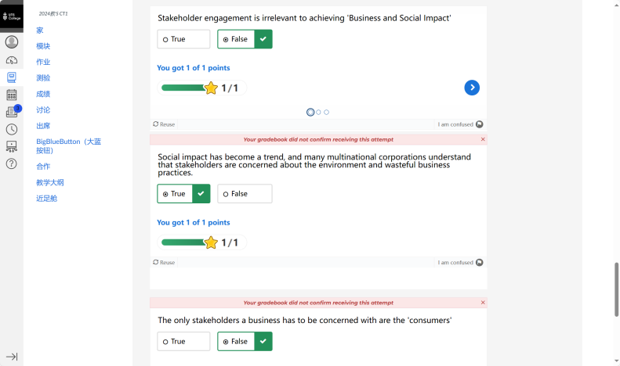

Political, Economic, Social, and Environmental trends are important factors that influence the Stakeholders of social impact and business. Social impact is the effect of an organisation’s actions on the well-being of the community and society at large. Business is the activity of making, buying, or selling goods or services for money. Hence, organisations must formulate a systematic perspective on business and social impacts. This perspective has to reflect all critical challenges faced by Stakeholders, which range from the political, economic, social and environmental trends noted below:

政治、经济、社会和环境趋势是影响社会影响和商业利益相关者的重要因素。社会影响是指一个组织的行为对社区和整个社会的福祉的影响。商业是制造、购买或销售商品或服务以换取金钱的活动。因此，组织必须对商业和社会影响形成系统的观点。这一观点必须反映利益攸关方面临的所有关键挑战，包括以下政治、经济、社会和环境趋势：

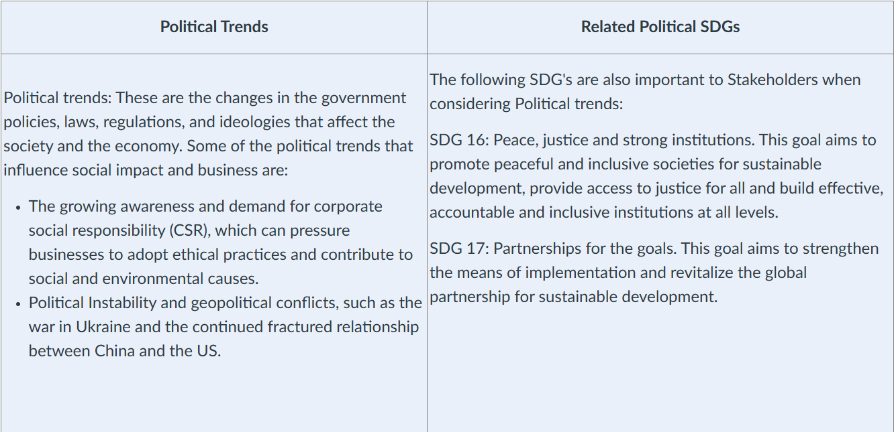

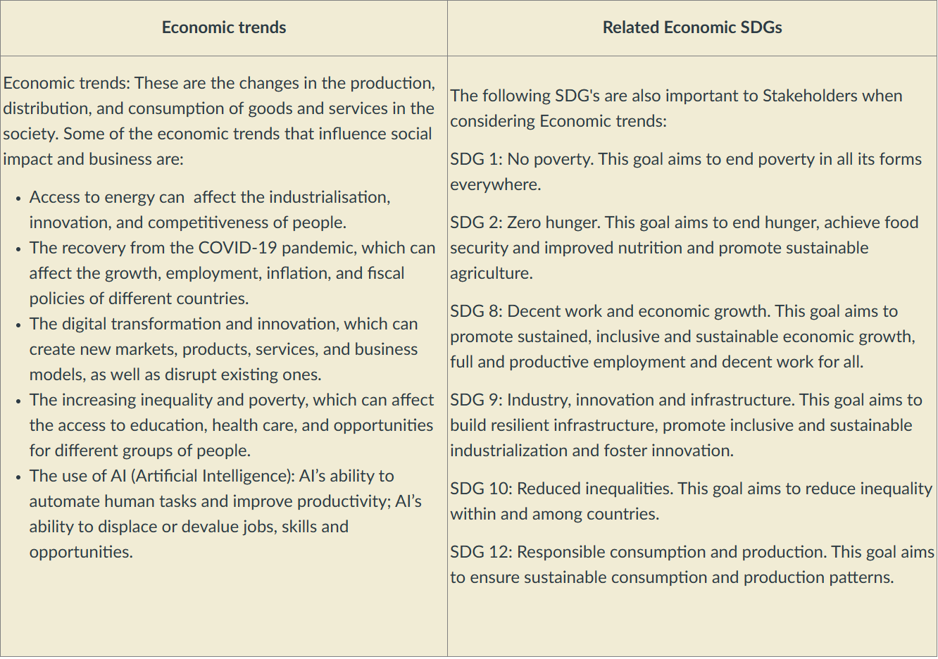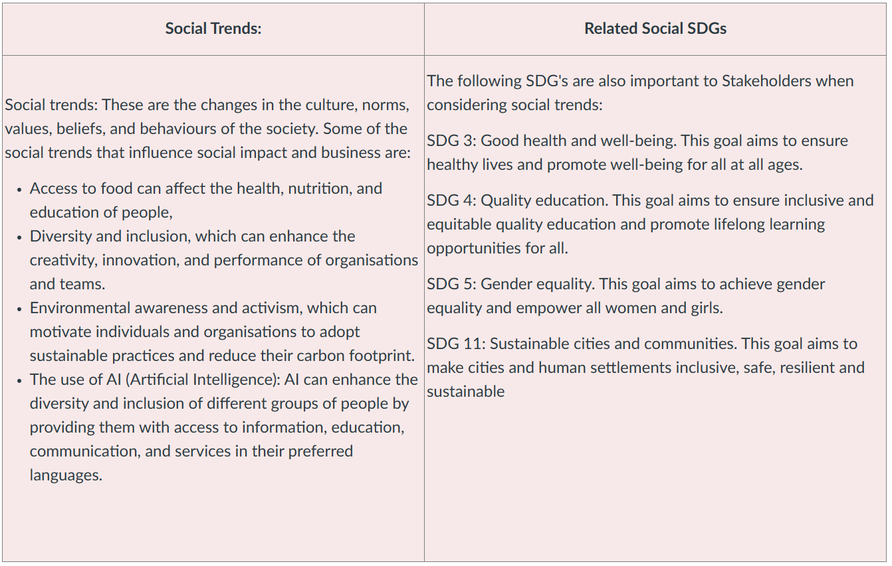

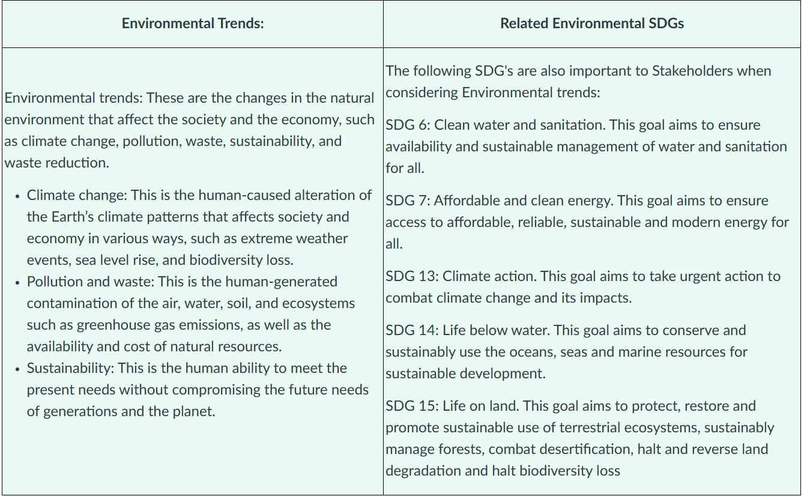

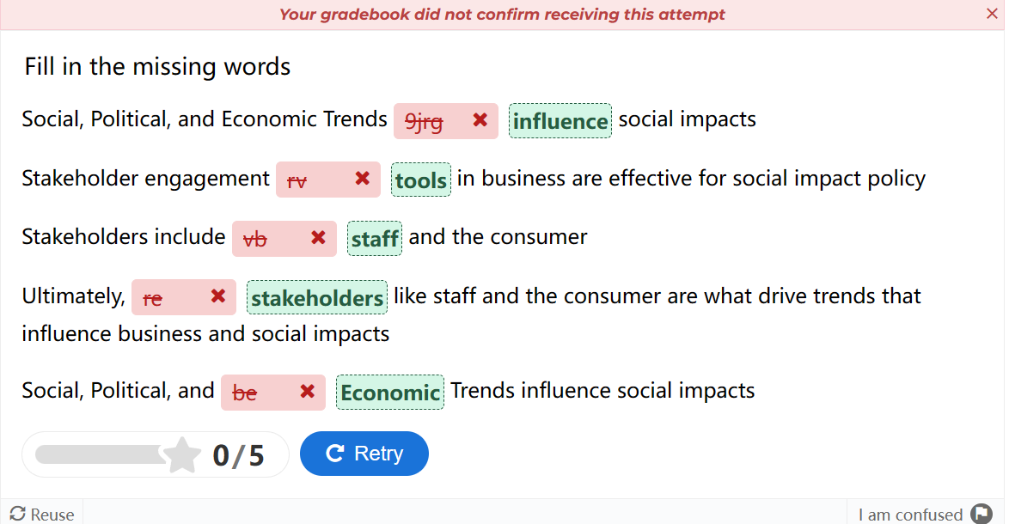

**Practice quiz（定义 分析内外部利益相关者）**

What is a Stakeholder analysis? You are planning on opening up a clothing store around Haymarket. Complete a stakeholder analysis for one Internal stakeholder and one External stakeholder of your choice. Hint: Refer to the Stakeholder Analysis we completed for Starbucks in Week 2, Tutorial A.

**我的答案：**A Stakeholder Analysis is a strategic tool used by businesses to identify and understand the stakeholders involved in a project, decision, or initiative, and assess their interests, influence, and potential impact on the organization. This analysis helps businesses prioritize stakeholders and effectively manage relationships to achieve their objectives.

Internal Stakeholder:

Employees: Internal stakeholders are individuals or groups within the organization who are directly affected by its decisions and actions. In the context of opening a clothing store around Haymarket, employees would be one of the key internal stakeholders. They include store managers, sales associates, designers, and other staff involved in the day-to-day operations of the store.

Interests: Employees are interested in job security, fair wages, career development opportunities, a positive work environment, and recognition for their contributions.

Influence: Depending on their roles and positions within the organization, employees can have varying levels of influence on decision-making processes. Store managers, for example, may have significant influence over store operations and customer service standards.

Impact: Engaged and motivated employees can contribute to the success of the clothing store by providing excellent customer service, driving sales, and fostering a positive brand image. Conversely, issues such as low morale, high turnover rates, or dissatisfaction among employees can negatively impact productivity, customer satisfaction, and overall business performance.

External Stakeholder:

Local residents and community members: External stakeholders are individuals or groups outside the organization who are interested in or influenced by their activities. In the context of opening clothing stores around the hay market, local residents and community members will be important external stakeholders.

Interest: Local residents and community members are interested in factors such as the store's impact on the community, traffic congestion, noise levels, employment opportunities for local residents, and the availability of affordable sustainable fashion options.

Influence: While individual residents may have limited influence, community organizations, neighborhood associations, and local government agencies can work together to influence the decision-making process through advocacy, public opinion, and regulatory measures.

Impact: The presence of clothing stores can have both positive and negative impacts on the local community. For example, it can stimulate economic activity, attract tourists to the region, and create jobs. However, issues such as increased traffic, noise pollution, or changes in community characteristics may arise, requiring stores to engage with residents and address their concerns through community outreach, collaboration, and responsible business practices.

**标准答案：**

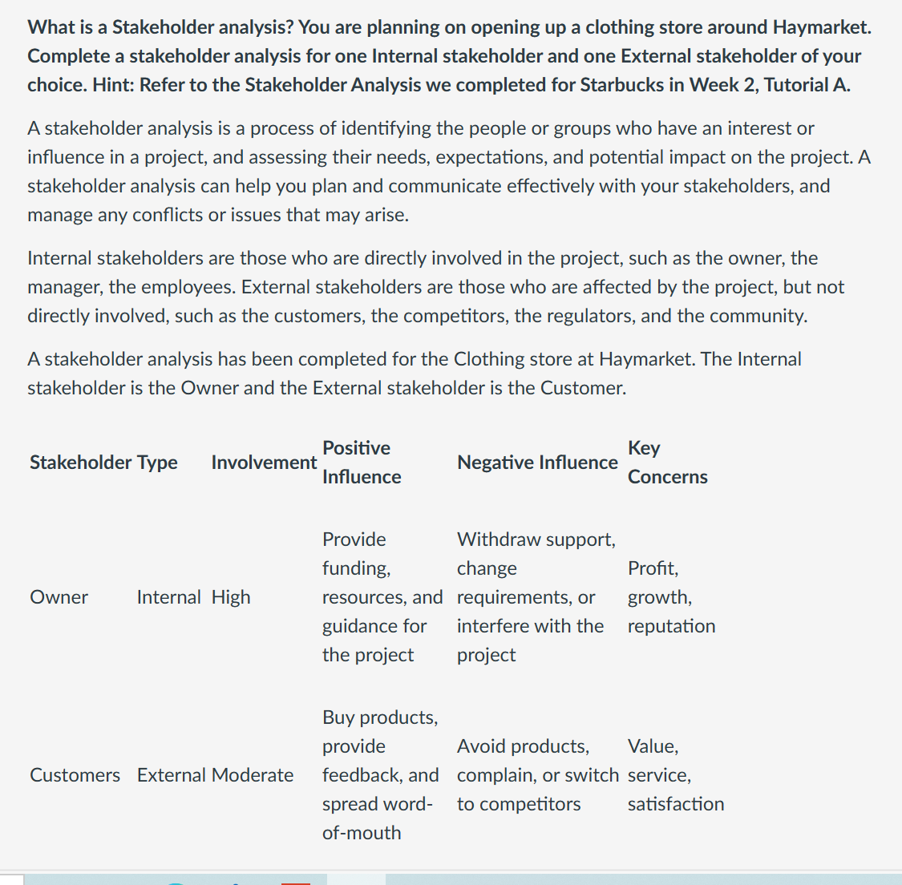

**Week3 Leadership in Business and Social Impact**

|  |  |
| --- | --- |
| ****What is Leadership?****  Leadership is the action of leading a group of people or an organisation. It involves guiding and impacting outcomes, enabling groups of people to work together to accomplish what they couldn’t do working individually.  Leadership theories have evolved significantly since the early 20th century when the trait theory was first introduced.  Let's take a look at some of these theories:   * ****The Trait theory:**** Suggests that leaders were born with certain innate characteristics that made them effective leaders. This theory was criticised for being too simplistic and failing to account for the complexities of leadership. * 举例Charisma: Possessing apresence and communicationstyle that captivates othersexuding confidence andauthority. * Inspiration: The ability toinspire others through upliftingspeeches and captivating * communication. * ****The Behavioural Theory:**** Emerged as a response to the limitations of the trait theory. This theory focused on the behaviours of leaders rather than their innate characteristics. It suggested that leadership was a set of learned behaviours that could be developed over time.   优势The key premise of this theory is thatleadership can be trained. ltchallenges the Great Man Theorywhich sees leaders as born, notmade. The idea that leaders can betrained is appealing to businessopening the door to the possibilitythat any and all employees canattend some and walk out the doorbeing an effective leader.   * ****The Contingency Theory:**** Suggested that there was no one-size-fits-all approach to leadership.  This theory emphasised the importance of situational factors in determining effective leadership.  It suggested that different situations required different leadership styles and that effective leaders were those who could adapt their style to fit the situation.   **举例**Task Structure: lf a task is clear, adirective leadership style might bemore effective; converselyunstructured tasks may require amore participative approach.  Team Relations: A leader withstrong rapport within the teammight succeed with a moredemocratic style, while distrustmight necessitate a moreauthoritative approach.   * ****The Transformational Theory:**** Emphasised the importance of inspiring and motivating followers to achieve a shared vision.  This theory suggested that effective leaders were those who could create a sense of purpose and direction that motivated people to work together to achieve a shared objective.   举例Mahatma Gandhi, the leader of theIndian independence movement, wasa transformational leader. Through hisinspirational vision of nonviolentresistance, Gandhi motivated andmobilized millions of people to fightfor freedom and social justice. Histransformative leadership styleempowered individuals to believe intheir own ability to effect change. | ****什么是领导力？****  领导力是领导一群人或一个组织的行为。它涉及指导和影响结果，使一群人能够一起工作，完成他们无法单独完成的工作。  自 20 世纪初首次引入特质理论以来，领导力理论发生了重大变化。让我们来看看其中的一些理论：   * ****特质理论：****表明领导者天生具有某些先天特征，使他们成为有效的领导者。这一理论被批评为过于简单化，未能解释领导力的复杂性。   **举例**   * 魅力:拥有吸引他人的存在感和沟通风格，散发出自信和权威。 * ·灵感:通过令人振奋的演讲和引人入胜的交流来激励他人的能力。 * ****行为理论：****作为对特质理论局限性的回应而出现。该理论侧重于领导者的行为，而不是他们的先天特征。它表明，领导力是一套可以随着时间的推移而发展的习得行为。 * **优势**这一理论的关键前提是领导力是可以培养的。它挑战了伟人理论，认为领导者是天生的，而不是后天培养的。领导者可以接受培训的想法对企业很有吸引力，为任何和所有员工都可以参加一些培训并走出门成为有效领导者的可能性打开了大门。 * ****权变理论：****建议没有一种放之四海而皆准的领导方法。该理论强调了情境因素在确定有效领导力方面的重要性。它表明，不同的情况需要不同的领导风格，有效的领导者是那些能够调整自己的风格以适应情况的人。 * **举例：任务结构:如果一个任务是明确的，一个指令性的领导风格可能会更有效;相反，非结构化的任务可能需要更多的参与方式。** * **团队关系:一个在团队中关系融洽的领导者可能会以更民主的方式取得成功，而不信任可能需要一个更权威的方法。** * ****转型理论：****强调了激励和激励追随者实现共同愿景的重要性。该理论表明，有效的领导者是那些能够创造目标感和方向感的人，这种目标感和方向感激励人们共同努力实现共同目标。 * **举例** 印度独立运动的领袖圣雄甘地是一位变革性的领袖。通过他非暴力抵抗的鼓舞人心的愿景，甘地激励和动员了数百万人为自由和社会正义而战。他的变革型领导风格使个人相信自己有能力实现变革。 |

|  |  |
| --- | --- |
| The scope and complexity of social and environmental challenges we face today require a new kind of leadership that is more responsible, accountable, and sustainable. Responsible leadership is about creating long-term mutual benefits for society, partners, the economy, the environment, and local communities. It acknowledges that businesses have a shared and significant responsibility in tackling these problems.  Responsible leaders are those who recognise the importance of addressing social and environmental challenges and take proactive steps to address them. They understand that their actions have a significant impact on society and the environment and are committed to creating positive change. They also recognise that they have a responsibility to their stakeholders, including employees, customers, shareholders, and the wider community.  Responsible leadership is important for businesses because it helps them create long-term value for all stakeholders while also achieving their business objectives. By adopting responsible leadership practices, businesses can improve their reputation, build trust with stakeholders, reduce risk, increase innovation, attract talent, and create new business opportunities.  Responsible leadership is also important for social impacts because it helps address some of society's most pressing problems, such as poverty, inequality, climate change, or pandemics. By working collaboratively with stakeholders such as governments, NGOs, communities, or customers, responsible leaders can create positive social impacts while also achieving their business objectives. | **领导力的未来：负责任的领导力**  **我们今天面临的社会和环境挑战的范围和复杂性需要一种更负责任、更负责任和更可持续的新型领导。负责任的领导是为社会、合作伙伴、经济、环境和当地社区创造长期的互惠互利。它承认企业在解决这些问题方面负有共同的重大责任。**  **负责任的领导者是那些认识到应对社会和环境挑战的重要性并采取积极措施应对这些挑战的人。他们明白自己的行为会对社会和环境产生重大影响，并致力于创造积极的变化。他们还认识到，他们对利益相关者（包括员工、客户、股东和更广泛的社区）负有责任。**  **负责任的领导对企业很重要，因为它可以帮助他们为所有利益相关者创造长期价值，同时实现他们的业务目标。通过采用负责任的领导实践，企业可以提高声誉，与利益相关者建立信任，降低风险，增加创新，吸引人才并创造新的商机。**  **负责任的领导对社会影响也很重要，因为它有助于解决一些社会最紧迫的问题，如贫困、不平等、气候变化或流行病。通过与政府、非政府组织、社区或客户等利益相关者合作，负责任的领导者可以创造积极的社会影响，同时实现他们的业务目标。** |

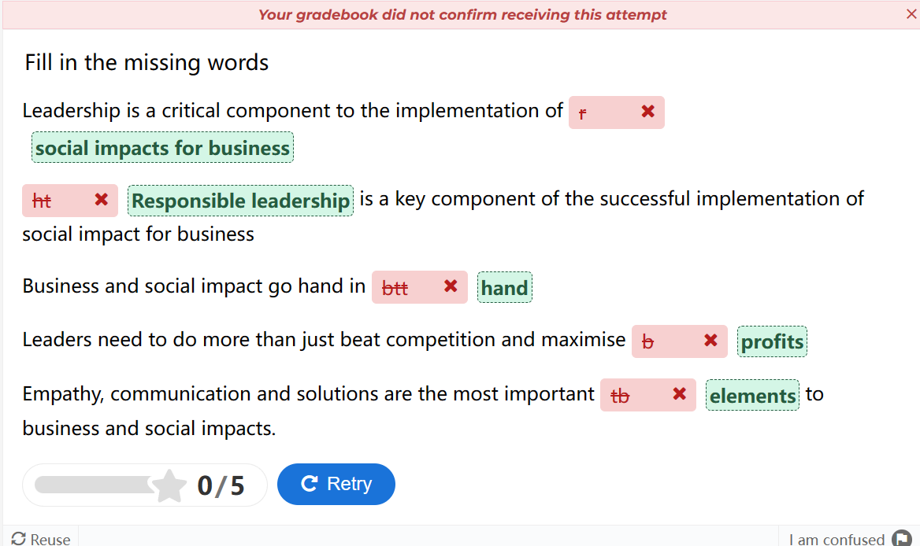

**可持续性领导力**

|  |  |
| --- | --- |
| ****Defining Sustainability leadership****  Sustainability leadership is a process of influence that delivers direction, alignment and commitment aimed at addressing social, environmental and economic issues to create a better world. It reminds us that leadership is not a position – it is a process of influence that involves a group of people working together to build a shared vision of change for collective success. In this context, leaders are likely to need specific skill sets such as systems thinking, creative thinking and facilitation to be effective.  (Taylor, 2020)  Commitment to sustainability is at an all-time high. Ninety-two per cent of CEOs believe the integration of sustainability will be important to the future success of their business. However, there is a gap between rhetoric and reality. Only 48 per cent of CEOs say they are implementing sustainability in their operations and only 21 per cent of CEOs feel that business is currently playing a critical role in achieving the SDGs.  ****The business case for sustainability****  Businesses are under growing pressure to look beyond profits and quarterly performance to deliver genuine long-term value for all stakeholders: your employees, customers, suppliers, and the communities in which you operate.  Experience shows that corporations that integrate the sustainability agenda into their business enjoy substantial benefits to their bottom line such as access to favorable financing, ability to attract top talent, unlocking new market opportunities and growing the customer base.  ****Are sustainable leaders born, or are they made?****  Sustainable leadership is not a castle in the sky. There are clear examples of leaders across the business spectrum who already deliver tangible sustainability outcomes alongside financial success. It can be easy to assume that these leaders have always had an innate passion for sustainability.  Research shows this is not always true. Sustainable leaders are not just born. They are also made.  ****Inside the mind of a sustainable leader****  Sustainable leaders combine a sustainable mindset with four critical leadership attributes, which include multi-level systems thinking, stakeholder inclusion, disruptive innovation and long-term activation.  Let's take a look at each of these. | ****定义可持续发展领导力****  可持续发展领导力是一个影响过程，它提供方向、一致性和承诺，旨在解决社会、环境和经济问题，以创造一个更美好的世界。它提醒我们，领导力不是一个职位，而是一个影响的过程，涉及一群人共同努力，为集体成功建立共同的变革愿景。在这种情况下，领导者可能需要特定的技能组合，如系统思维、创造性思维和促进才能有效。（泰勒，2020 年）  对可持续发展的承诺空前高涨。92%的CEO认为，可持续发展的整合对其业务未来的成功至关重要。然而，言辞与现实之间存在差距。只有48%的CEO表示他们正在运营中实施可持续发展，只有21%的CEO认为企业目前在实现可持续发展目标方面发挥着关键作用。  ****可持续发展的商业案例****  企业面临着越来越大的压力，需要超越利润和季度业绩，为所有利益相关者提供真正的长期价值：您的员工、客户、供应商和您经营所在的社区。经验表明，将可持续发展议程融入其业务的公司可以享受到实质性的利润，例如获得有利的融资、吸引顶尖人才的能力、解锁新的市场机会和扩大客户群。  ****可持续发展的领导者是天生的，还是后天培养的？****  可持续领导力不是天空中的城堡。各行各业的领导者在取得财务成功的同时，已经取得了切实的可持续发展成果。人们很容易认为，这些领导者一直对可持续发展有着与生俱来的热情。研究表明，这并不总是正确的。可持续发展的领导者不是天生的。它们也是制造的。  ****可持续发展领导者的内心深处****  可持续领导者将可持续思维与四个关键领导力属性相结合，包括多层次系统思维、利益相关者包容、颠覆性创新和长期激活。让我们来看看其中的每一个。 |

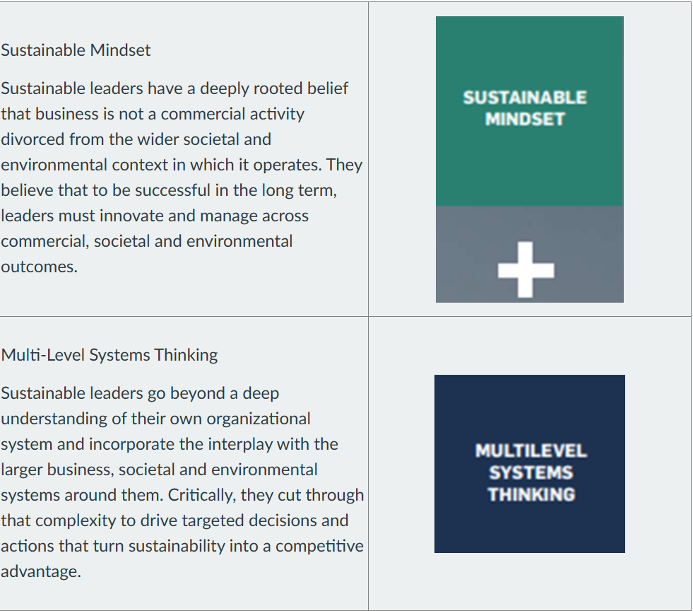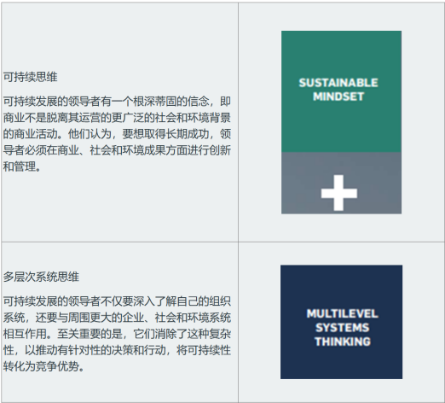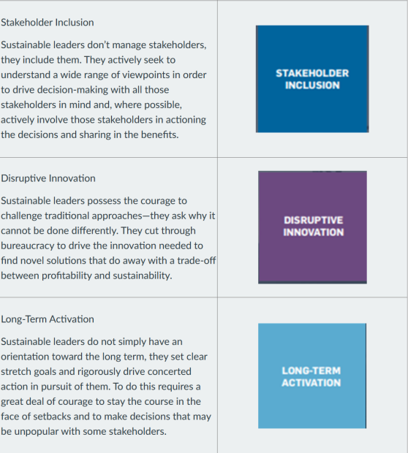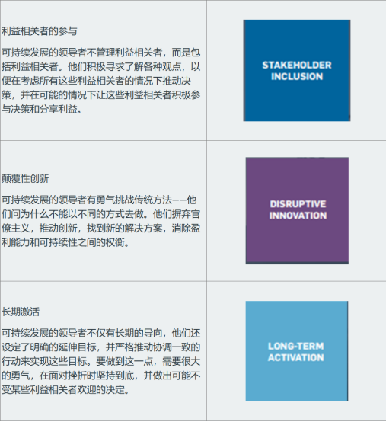

**Practice quiz（定义 怎么做）**

What does it mean to be a responsible leader? How does Melanie Perkins demonstrate responsible leadership? If you wanted to open a coffee shop around Haymarket to cater to students and business workers, how could you show that you are responsible leader?

**标准答案**

To be a responsible leader means to manage a corporation’s interactions with society in a way that addresses the concerns of various stakeholders and contributes to the economic, social, and environmental performance of the organization. Responsible leaders also make informed ethical judgments, engage in long-term thinking, and communicate effectively with stakeholders.

Melanie Perkins demonstrates responsible leadership by creating a design software platform that empowers millions of people to express their creativity and communicate their ideas. She also values diversity, innovation, and social impact, as shown by her pledge to donate more than 80% of her stake in Canva to charitable causes.

If I wanted to open a coffee shop around Haymarket to cater to students and business workers, I could show that I am a responsible leader by:

* Providing high-quality products and services that meet the needs and preferences of my customers. For instance, I would encourage my customers to bring their own coffee cups in and provide them with a discount when they did.
* Treating my employees fairly and respectfully, and offering them opportunities for learning and development. For instance, I could offer to provide my staff with time off to study during the exam period.
* Supporting local suppliers and producers and using environmentally friendly practices and materials. For instance, I would use ethically sourced coffee beans or fairtrade products.
* Engaging with the community and contributing to social causes that align with my values and mission. For instance, I could help the less fortunate around the area by providing food to the homeless once a week.

**Week4**

Leading Social Impact Initiatives in the Workplace

|  |  |
| --- | --- |
| ****How do we ensure the next generation of workers isn’t worse off than the last?****  The emerging 'Gig Economy', an 'economy that is leading the development of inadequate working conditions for many contract workers, especially in North America. Unless action is taken, workers will be destined to experience a lower standard of living to their parents – the opposite of the so called ‘American dream’. To improve workers conditions, it is necessary to update employment policies to ensure improved working conditions for future generations' (Kochan, 2015, n.p.).  We have to address the fact that so many young people have been put off by starting their careers in the 'lost decade' when wages weren’t rising even for college graduates and 40% of those with bachelor’s degree cannot find adequate employment working in jobs that neither utilise their education nor provide further training and development opportunities (Kochan, 2015, n.p.).  Evidence shows workers who start their careers this way have a very hard time getting on track to higher-paying job opportunities.  Here are three of the tough questions that need to be front and centre in these discussions, each of which will call for big changes in labour, business and government strategies (Kochan, 2015, n.p.).  ****How do we rebuild worker bargaining power?****  The primary challenge facing workers and the economy is how to end the 30 years of wage stagnation and reverse the income inequality that is holding back economic growth.  ****How do we get more employers to pay their staff better wages?****  The American economy can no longer afford to let corporations fixate on maximising short-term shareholder returns at the expense of other stakeholders, particularly employees. | ****我们如何确保下一代工人的境况不会比上一代更糟？****  新兴的“零工经济”，这种经济正在导致许多合同工工作条件不足的发展，尤其是在北美。除非采取行动，否则工人将注定要经历比父母更低的生活水平——这与所谓的“美国梦”相反。为了改善工人条件，有必要更新就业政策，以确保改善子孙后代的工作条件“（Kochan，2015，n.p.）。  我们必须解决这样一个事实，即如此多的年轻人在“失去的十年”开始他们的职业生涯时被推迟了，当时即使是大学毕业生的工资也没有上涨，40%的拥有学士学位的人无法找到足够的工作，从事既不能利用他们的教育，也不能提供进一步的培训和发展机会的工作（Kochan， 2015 年，n.p.）。  有证据表明，以这种方式开始职业生涯的工人很难走上通往高薪工作机会的轨道。  以下是这些讨论中需要摆在首位和中心的三个棘手问题，每个问题都需要对劳工、商业和政府战略进行重大变革（Kochan，2015，n.p.）。  ****我们如何重建工人的议价能力？****  工人和经济面临的主要挑战是如何结束30年的工资停滞，扭转阻碍经济增长的收入不平等。  ****我们如何让更多的雇主向员工支付更高的工资？****  美国经济不能再让企业以牺牲其他利益相关者，特别是员工的利益为代价，执着于实现股东回报的最大化。 |

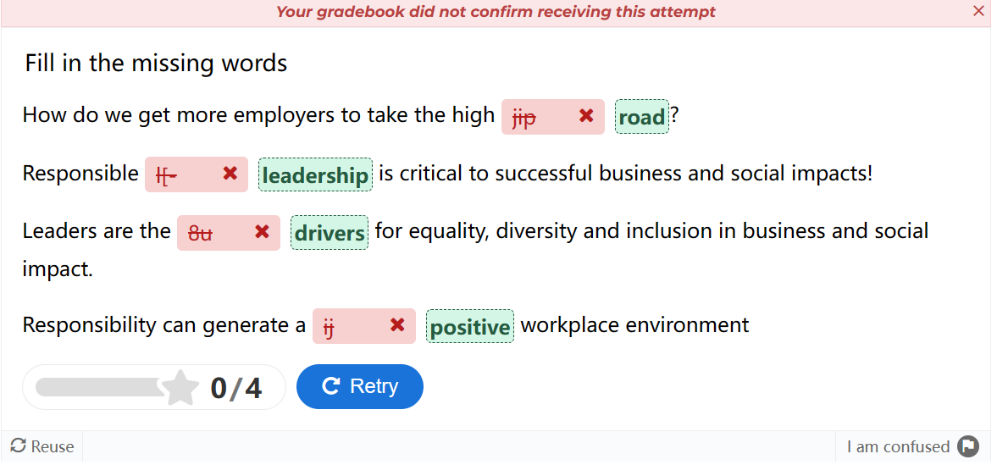

Equality, Diversity and Inclusion平等、多样性和包容性

|  |  |
| --- | --- |
| What is Diversity, Inclusion and Equality?  Diversity, inclusion and equality are three related but distinct concepts that aim to promote the fair treatment and full participation of all people, especially those who have historically been underrepresented or subject to discrimination because of their background, identity, disability, etc. Here is a brief explanation of each term:   * Diversity means the condition or fact of being different or varied. Diversity can refer to the differences among people, such as their race, culture, gender, sexual orientation, religion, etc. Diversity can also refer to the differences among things, such as ideas, opinions, styles, methods, etc.  Diversity is often seen as a positive value that enriches society and promotes inclusion and equality. * Inclusion means creating an environment where everyone feels welcome and valued. Inclusion is a measure of how safe and welcome people feel in their environment. Inclusion requires awareness and management of unconscious biases, as well as respect and appreciation for diversity. Inclusion also means ensuring that everyone has equal access to opportunities and resources. * Equality means making sure everyone can access the same opportunities, regardless of their personal characteristics or circumstances. Equality also means ensuring everyone is treated fairly and equitably, without discrimination or prejudice. Equality differs from equity in that equity focuses on addressing the specific needs and barriers of different groups or individuals, while equality focuses on providing the same level of support and resources to everyone. | 什么是多样性、包容性和平等？  多样性、包容性和平等是三个相关但截然不同的概念，旨在促进所有人的公平待遇和充分参与，特别是那些历史上因背景、身份、残疾等原因而代表性不足或受到歧视的人。以下是每个术语的简要说明：   * 多样性是指不同或变化的条件或事实。多样性可以指人与人之间的差异，例如他们的种族、文化、性别、性取向、宗教等。多样性也可以指事物之间的差异，如想法、观点、风格、方法等。多样性通常被视为一种积极的价值观，可以丰富社会并促进包容和平等。 * 包容性意味着创造一个让每个人都感到受欢迎和重视的环境。包容性是衡量人们在环境中感到安全和受欢迎程度的指标。包容性需要对无意识偏见的认识和管理，以及对多样性的尊重和欣赏。包容性还意味着确保每个人都能平等地获得机会和资源。 * 平等意味着确保每个人都能获得相同的机会，无论他们的个人特征或情况如何。平等还意味着确保每个人都得到公平和公正的对待，没有歧视或偏见。平等与公平不同，公平侧重于解决不同群体或个人的具体需求和障碍，而平等侧重于为每个人提供相同水平的支持和资源。 |
| In what ways can businesses create more accessible and inclusive workplaces for those with a disability?   * Physical accessibility: Ensure that the physical environment of the workplace is accessible for individuals with mobility impairments, such as wheelchair ramps, accessible desks, and adjustable workstations. * Assistive technologies: Provide assistive technologies and accommodations to employees with disabilities, such as screen reading software for individuals with visual impairments or speech recognition software for individuals with motor disabilities. * Flexibility: Offer flexible working arrangements, including flexible schedules or remote work options, to accommodate the diverse needs of employees with disabilities. * Inclusive recruitment: Actively promote job opportunities to individuals with disabilities and make it clear that the company values diversity and inclusivity. Consider partnering with disability employment organizations or networks to attract qualified candidates. * Career development: Provide equal opportunities for career development and advancement for employees with disabilities. Offer training programs, mentoring, and support to help individuals with disabilities progress in their careers. * Disability disclosure: Create a supportive and open environment where employees feel comfortable disclosing their disabilities if they choose to do so. Respect the privacy and confidentiality of individuals who disclose their disabilities. * Training and awareness: Conduct disability awareness training for all employees to promote understanding, empathy, and inclusive attitudes. Educate staff on accessibility best practices, etiquette, and communication strategies when interacting with colleagues with disabilities. * Inclusive policies and practices: Review and revise company policies, procedures, and practices to ensure they are inclusive and accommodate the needs of employees with disabilities. This may include accessibility in meetings, events, communication, and decision-making processes. * Inclusive leadership: Foster an inclusive culture from top management down. Leadership should demonstrate a commitment to diversity and inclusion, promote a supportive work environment, and lead by example. * Collaboration and feedback: Involve employees with disabilities in decision-making processes and seek their input on accessibility and inclusion initiatives. Regularly gather feedback from employees to identify areas for improvement and address specific needs.  1. **How do businesses benefit from creating a diverse and inclusive culture that is equal and fair?**  * Enhanced innovation and creativity: Diverse teams bring together a variety of perspectives, experiences, and ideas, which can lead to greater innovation and creativity. Different backgrounds and viewpoints foster unique approaches to problem-solving and decision-making. * Expanded talent pool: Embracing diversity and inclusivity allows businesses to access a broader range of talent. By attracting and retaining diverse employees, organizations can tap into the skills, expertise, and perspectives of individuals from various backgrounds. * Improved decision-making: Inclusive cultures promote diverse voices and perspectives in decision-making processes. When diverse opinions are considered, it can lead to better-informed and more effective decisions. * Increased employee engagement and retention: When employees feel valued, respected, and included, they are more likely to be engaged and committed to their work. Inclusive cultures contribute to higher job satisfaction, increased loyalty, and reduced turnover rates. * Enhanced reputation and brand image: Companies that prioritize diversity and inclusion are often seen as progressive, socially responsible, and attractive to customers, clients, and partners who value diversity. A positive reputation can enhance a company's brand image and attract a diverse customer base. * Expanded market reach: Having a diverse workforce can provide valuable insights into different customer segments and markets. Companies that understand and reflect the diversity of their customers can better meet their needs and preferences, leading to increased customer satisfaction and market share. | **企业可以通过哪些方式为残障人士创造更方便、更具包容性的工作场所？**   * 物理无障碍：确保工作场所的物理环境对行动不便的个人开放，例如轮椅坡道、无障碍办公桌和可调节的工作站。 * 辅助技术：为残障员工提供辅助技术和便利，例如为视障人士提供的屏幕阅读软件或为运动障碍人士提供的语音识别软件。 * 灵活性：提供灵活的工作安排，包括灵活的时间表或远程工作选项，以满足残疾员工的不同需求。 * 包容性招聘：积极向残障人士提供就业机会，并明确表示公司重视多样性和包容性。考虑与残疾人就业组织或网络合作，以吸引合格的候选人。 * 职业发展：为残疾员工提供平等的职业发展和晋升机会。提供培训计划、指导和支持，以帮助残障人士在职业生涯中取得进步。 * 残疾披露：创造一个支持性和开放的环境，让员工在选择披露他们的残疾时感到自在。尊重披露其残疾的个人的隐私和保密性。 * 培训和意识：对所有员工进行残疾意识培训，以促进理解、同理心和包容态度。在与残障同事互动时，对员工进行无障碍最佳实践、礼仪和沟通策略方面的教育。 * 包容性政策和实践：审查和修订公司政策、程序和实践，以确保它们具有包容性并满足残疾员工的需求。这可能包括会议、活动、沟通和决策过程中的可访问性。 * 包容性领导：培养自上而下的包容性文化。领导层应表现出对多样性和包容性的承诺，促进支持性的工作环境，并以身作则。 * 协作和反馈：让残障员工参与决策过程，并就无障碍和包容性计划征求他们的意见。定期收集员工的反馈，以确定需要改进的领域并满足特定需求。   **企业如何从创造平等和公平的多元化和包容性文化中受益？**   * 增强创新和创造力：多元化的团队汇集了各种观点、经验和想法，可以带来更大的创新和创造力。不同的背景和观点培养了解决问题和决策的独特方法。 * 扩大人才库：拥抱多样性和包容性使企业能够获得更广泛的人才。通过吸引和留住多元化的员工，组织可以利用来自不同背景的个人的技能、专业知识和观点。 * 改善决策：包容性文化促进了决策过程中的不同声音和观点。当考虑不同的意见时，它可以导致更明智和更有效的决策。 * 提高员工敬业度和保留率：当员工感到受到重视、尊重和包容时，他们更有可能参与并致力于他们的工作。包容性文化有助于提高工作满意度、提高忠诚度并降低离职率。 * 提高声誉和品牌形象：优先考虑多样性和包容性的公司通常被视为进步的、对社会负责的，并且对重视多样性的客户、客户和合作伙伴具有吸引力。良好的声誉可以提升公司的品牌形象并吸引多元化的客户群。 * 扩大市场范围：拥有多元化的员工队伍可以为不同的客户群和市场提供有价值的见解。了解并反映客户多样性的公司可以更好地满足他们的需求和偏好，从而提高客户满意度和市场份额。 |

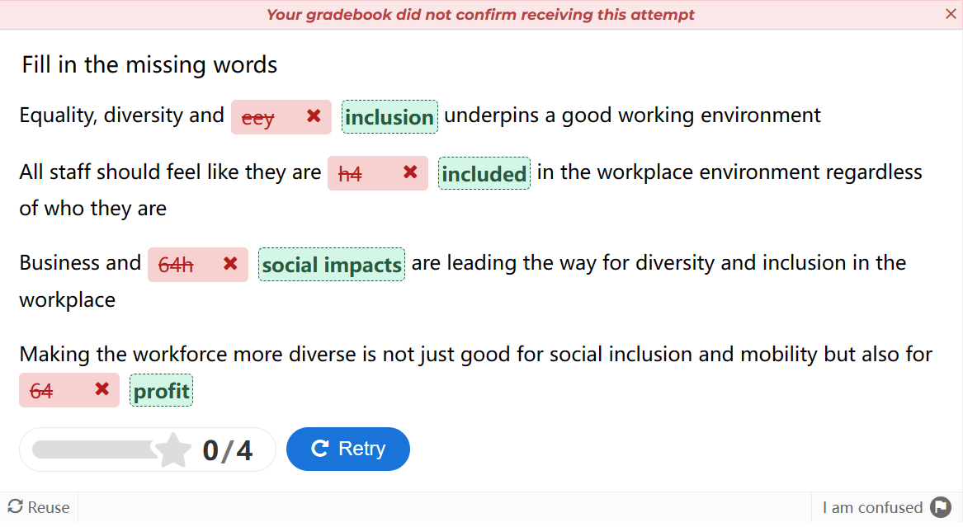

从多角度评估商业与社会的影响

|  |  |
| --- | --- |
| ****Accounting Perspective:**** Accounting is the process of measuring, recording, and communicating financial information about an entity’s activities and performance. Accounting can have social impacts by influencing the decisions and behaviours of various stakeholders, such as investors, managers, employees, customers, regulators, and society at large.  There are different frameworks that organisations can use to report on their environmental, social, and governance (ESG) performance, which reflects their social impacts. ESG reporting is a form of sustainability reporting that discloses how an organisation manages its ESG risks and opportunities, and how it contributes to sustainable development.  The three frameworks that you need to consider when looking at the relationship between accounting and social impacts are:   * SASB (Sustainability Accounting Standards Board): SASB Standards identify the sustainability-related issues most relevant to investor decision-making in 77 industries. They provide industry-specific metrics and guidance for disclosing material ESG information in financial filings. * GRI (Global Reporting Initiative): GRI is an independent, international organisation that helps businesses and other organisations take responsibility for their impacts, by providing them with a global common language to communicate those impacts. GRI Standards are the most widely used sustainability reporting standards in the world. They cover a range of topics, such as economic, environmental, social, governance, and ethics. * TCFD (The Task Force on Climate-related Financial Disclosures): TCFD provides information to investors about what companies are doing to mitigate the risks of climate change, as well as be transparent about the way in which they are governed. TCFD recommendations are based on four pillars: governance, strategy, risk management, and metrics and targets.   ****Economics Perspective:**** Economics is the study of how people make choices under conditions of scarcity and uncertainty. Economics can have social impacts by affecting the allocation of resources, the distribution of income and wealth, the production and consumption of goods and services, and the well-being of individuals and society.  There are different economic activities that organisations can engage in to create social impacts. Economic activities are actions that involve producing, distributing, or consuming goods or services. Some examples of economic activities that can have social impacts are:   * Job creation: This refers to generating employment opportunities for people who are willing and able to work. Job creation can have positive social impacts by reducing unemployment, increasing income, enhancing skills, improving living standards, and stimulating economic growth. * Income distribution: This refers to how income is divided among different groups or individuals in a society. Income distribution can have positive or negative social impacts depending on how fair or equitable it is. A more equal income distribution can reduce poverty, improve social mobility, enhance human development, and foster social cohesion. A more unequal income distribution can increase poverty, increase social exclusion, reduce human development, and undermine social cohesion. * Poverty reduction: This refers to decreasing the number or proportion of people who live below a certain level of income or consumption. Poverty reduction can have positive social impacts by improving health, education, nutrition, sanitation, security, dignity, and empowerment of poor people. * Community development: This refers to enhancing the social, economic, cultural, and environmental conditions of a specific community or group of people. Community development can have positive social impacts by strengthening social capital, promoting civic engagement, fostering local identity, addressing local needs, and empowering marginalized groups. * Economic empowerment: This refers to increasing the ability of individuals or groups to participate in, influence, or benefit from economic activities. Economic empowerment can have positive social impacts by enhancing self-reliance, increasing income, expanding choices, improving access to resources and opportunities, and challenging discrimination and oppression.   ****Finance Perspective:**** Finance is the study of how money is managed and invested. Finance can have social impacts by affecting the availability, cost, and use of capital or funds for various purposes.  Sustainable Finance can be used to consider the relationship between finance and social impacts. Sustainable finance integrates environmental, social and governance (ESG) considerations into investment decisions. It aims to align financial activities with broader societal and environmental goals, ensuring long-term sustainability. A business should consider the following ESG issues:   * Environmental: this involves financing projects and activities that contribute positively to the environment.  This includes supporting clean energy, conservation efforts, and carbon-neutral initiatives. * Social: Social values play a crucial role in sustainable finance. Investments are evaluated based on their impact on society. Examples include promoting fair labour practices, human rights, and social inclusion. Companies with diverse boards (including more women) are considered positively. * Governance: Good governance is essential for sustainable finance. It ensures transparency, accountability, and ethical behavior. Investors assess how companies manage risks, handle conflicts of interest, and make decisions.   ****Management Perspective****: Management is the process of planning, organising, leading, and controlling an organisation’s resources and activities to achieve its goals. Management can have social impacts by influencing the culture, strategy, structure, operations, performance, and stakeholder relations of an organisation.  There are different management practices and policies that organisations can adopt or implement to create social impacts. Management practices and policies are actions or rules that guide or regulate how an organisation operates or behaves. Some examples of management practices and policies that can have social impacts are:   * Community engagement programs: These are initiatives that involve interacting with, consulting with, collaborating with, or supporting local communities or groups that are affected by or interested in an organisation’s activities. Community engagement programs can have positive social impacts by building trust, enhancing communication, fostering partnerships, addressing concerns, and creating shared value. * Employee welfare initiatives: These are measures that aim to improve the physical, mental, emotional, or financial well-being of employees. Employee welfare initiatives can have positive social impacts by increasing employee satisfaction, motivation, productivity, loyalty, and retention. * Environmental sustainability: This is the ability to meet the needs of the present without compromising the ability of future generations to meet their own needs. Environmental sustainability can have positive social impacts by reducing environmental degradation, preserving natural resources, mitigating climate change, improving public health, and enhancing quality of life. * Ethical practices: These are actions that conform to moral principles or standards of conduct that govern an organisation’s behaviour. Ethical practices can have positive social impacts by preventing corruption, ensuring fairness, respecting human rights, protecting privacy, and promoting integrity.   ****Marketing Perspective****: Marketing is the process of creating, delivering, and exchanging value for customers, clients, partners, and society at large. Marketing can have social impacts by influencing the needs, wants, preferences, behaviours, and satisfaction of various stakeholders, such as consumers, competitors, suppliers, distributors, and regulators.  There are different marketing strategies and tactics that organisations can use to create social impacts. Marketing strategies and tactics are actions or methods that aim to achieve specific marketing objectives or goals. Some examples of marketing strategies and tactics that can have social impacts are:   * Social marketing: This is the application of marketing principles and techniques to influence a target audience to voluntarily accept, reject, modify, or abandon a behaviour for the benefit of individuals, groups, or society as a whole. Social marketing can have positive social impacts by addressing social problems, such as health, safety, environment, or human rights. * Cause-related marketing: This is a type of marketing that involves a partnership between a for-profit organisation and a non-profit organisation to promote a social cause or issue. Cause-related marketing can have positive social impacts by raising awareness, generating funds, enhancing reputation, and creating loyalty for both partners. * Green marketing: This is a type of marketing that involves selling products or services that are environmentally friendly or have minimal negative impact on the environment. Green marketing can have positive social impacts by reducing environmental degradation, preserving natural resources, mitigating climate change, improving public health, and enhancing quality of life. * Philanthropy: This is a type of marketing that involves donating money, goods, or services to a charitable organisation or cause. Philanthropy can have positive social impacts by supporting the missions and values of the beneficiaries, improving the well-being of the recipients, and demonstrating social responsibility and goodwill. * Corporate social responsibility (CSR): This is a type of marketing that involves a self-regulating business model that helps a company be socially accountable to itself, its stakeholders, and the public. CSR can have positive social impacts by addressing economic, social, and environmental issues, enhancing reputation and trust, and creating value for both the company and society. | ****会计观点：****会计是衡量、记录和传达有关实体活动和绩效的财务信息的过程。会计可以通过影响各种利益相关者（如投资者、经理、员工、客户、监管机构和整个社会）的决策和行为来产生社会影响。   * 组织可以使用不同的框架来报告其环境、社会和治理 （ESG） 绩效，以反映其社会影响。ESG报告是可持续发展报告的一种形式，它披露了组织如何管理其ESG风险和机遇，以及它如何为可持续发展做出贡献。 * 在研究会计与社会影响之间的关系时，您需要考虑的三个框架是：  1. SASB（可持续发展会计准则委员会）：SASB标准确定了77个行业中与投资者决策最相关的可持续发展相关问题。它们为在财务文件中披露重要的ESG信息提供了行业特定的指标和指导。 2. GRI（全球报告倡议组织）：GRI是一个独立的国际组织，通过为企业和其他组织提供一种全球通用语言来传达这些影响，帮助他们对其影响负责。GRI标准是全球使用最广泛的可持续发展报告标准。它们涵盖了一系列主题，例如经济、环境、社会、治理和道德。 3. TCFD（气候相关财务信息披露工作组）：TCFD向投资者提供有关公司正在采取哪些措施来减轻气候变化风险的信息，并对其治理方式保持透明。TCFD的建议基于四大支柱：治理、战略、风险管理以及指标和目标。   ****经济学观点：****经济学是研究人们在稀缺和不确定的条件下如何做出选择的学科。经济学可以通过影响资源分配、收入和财富的分配、商品和服务的生产和消费以及个人和社会的福祉来产生社会影响。  组织可以从事不同的经济活动来创造社会影响。经济活动是涉及生产、分销或消费商品或服务的行为。可能产生社会影响的经济活动的一些例子是：   * 创造就业机会：这是指为愿意和能够工作的人创造就业机会。通过减少失业、增加收入、提高技能、提高生活水平和刺激经济增长，创造就业机会可以产生积极的社会影响。 * 收入分配：这是指收入如何在社会中的不同群体或个人之间分配。收入分配可以产生积极或消极的社会影响，这取决于它的公平程度或公正程度。更平等的收入分配可以减少贫困，改善社会流动性，促进人类发展，促进社会凝聚力。更不平等的收入分配会加剧贫困，增加社会排斥，降低人类发展，并破坏社会凝聚力。 * 减贫：这是指减少生活在一定收入或消费水平以下的人口数量或比例。通过改善穷人的健康、教育、营养、营养、卫生、安全、尊严和赋权，减贫可以产生积极的社会影响。 * 社区发展：这是指改善特定社区或人群的社会、经济、文化和环境条件。社区发展可以通过加强社会资本、促进公民参与、培养地方认同、满足当地需求和赋予边缘化群体权力来产生积极的社会影响。 * 经济赋权：这是指提高个人或群体参与、影响或从经济活动中受益的能力。经济赋权可以通过加强自力更生、增加收入、扩大选择、改善获得资源和机会的机会以及挑战歧视和压迫来产生积极的社会影响。   ****财务视角：****金融学是研究资金如何管理和投资的学科。金融可以通过影响资本或资金的可用性、成本和用于各种目的的使用来产生社会影响。  可持续金融可用于考虑金融与社会影响之间的关系。可持续金融将环境、社会和治理（ESG）因素纳入投资决策。它旨在使金融活动与更广泛的社会和环境目标保持一致，确保长期可持续性。企业应考虑以下ESG问题：   * 环境：这涉及为对环境做出积极贡献的项目和活动提供资金。这包括支持清洁能源、保护工作和碳中和倡议。 * 社会：社会价值观在可持续金融中起着至关重要的作用。投资是根据其对社会的影响来评估的。例子包括促进公平的劳动实践、人权和社会包容。拥有多元化董事会（包括更多女性）的公司被积极考虑。 * 治理：良好的治理对于可持续金融至关重要。它确保透明度、问责制和道德行为。投资者评估公司如何管理风险、处理利益冲突和做出决策。   ****管理视角****：管理是计划、组织、领导和控制组织资源和活动以实现其目标的过程。管理可以通过影响组织的文化、战略、结构、运营、绩效和利益相关者关系来产生社会影响。  组织可以采用或实施不同的管理实践和政策来创造社会影响。管理实践和政策是指导或规范组织运营或行为方式的行动或规则。可能产生社会影响的管理实践和政策的一些例子是：   * 社区参与计划：这些计划涉及与受组织活动影响或感兴趣的当地社区或团体互动、咨询、合作或支持。社区参与计划可以通过建立信任、加强沟通、促进伙伴关系、解决问题和创造共享价值来产生积极的社会影响。 * 员工福利计划：这些措施旨在改善员工的身体、心理、情感或财务状况。员工福利计划可以通过提高员工满意度、积极性、生产力、忠诚度和保留率来产生积极的社会影响。 * 环境可持续性：这是在不损害子孙后代满足其自身需求的能力的情况下满足当前需求的能力。环境可持续性可以通过减少环境退化、保护自然资源、缓解气候变化、改善公共卫生和提高生活质量来产生积极的社会影响。 * 道德实践：这些是符合管理组织行为的道德原则或行为标准的行为。道德实践可以通过预防腐败、确保公平、尊重人权、保护隐私和促进诚信来产生积极的社会影响。   ****营销视角****：营销是为客户、客户、合作伙伴和整个社会创造、交付和交换价值的过程。营销可以通过影响消费者、竞争对手、供应商、分销商和监管机构等各种利益相关者的需求、愿望、偏好、行为和满意度来产生社会影响。  组织可以使用不同的营销策略和策略来创造社会影响。营销策略和战术是旨在实现特定营销目标或目标的行动或方法。可以产生社会影响的营销策略和策略的一些例子是：   * 社会营销：这是营销原则和技术的应用，以影响目标受众自愿接受、拒绝、修改或放弃一种行为，以造福个人、群体或整个社会。社会营销可以通过解决健康、安全、环境或人权等社会问题产生积极的社会影响。 * 与事业相关的营销：这是一种涉及营利性组织和非营利组织之间的合作伙伴关系以促进社会事业或问题的营销。与事业相关的营销可以通过提高知名度、筹集资金、提高声誉和为双方创造忠诚度来产生积极的社会影响。 * 绿色营销：这是一种营销类型，涉及销售环保或对环境负面影响最小的产品或服务。绿色营销可以通过减少环境退化、保护自然资源、缓解气候变化、改善公共卫生和提高生活质量来产生积极的社会影响。 * 慈善事业：这是一种涉及向慈善组织或事业捐赠金钱、商品或服务的营销方式。慈善事业可以通过支持受益人的使命和价值观、改善受助者的福祉以及展示社会责任和善意来产生积极的社会影响。 * 企业社会责任 （CSR）：这是一种涉及自我调节商业模式的营销方式，可帮助公司对自己、利益相关者和公众承担社会责任。企业社会责任可以通过解决经济、社会和环境问题，提高声誉和信任，为公司和社会创造价值，产生积极的社会影响。 |

Practice quiz

What is the meaning business and social impacts? Give some examples of positive and negative social impacts that companies can have through their actions and decisions. Choose a business you are familiar with, and outline two positive and two negative social impacts they have contributed to.

**我自己的答案**Your answer:

Business and social impacts refer to the effects that a company's activities, decisions, and operations have on society, beyond their direct economic outcomes. These impacts can be both positive and negative, influencing various aspects of social well-being, including environmental sustainability, community development, public health, and social equity.

**Positive Social Impacts:**

****Job Creation****: Companies that create employment opportunities contribute to economic growth and poverty reduction, improving livelihoods and enhancing the standard of living for individuals and families. For example, Starbucks, a coffeehouse chain, has created thousands of jobs globally, providing employment opportunities for diverse populations.

****Corporate Philanthropy****: Companies that engage in philanthropic activities, such as donating to charities, sponsoring community events, or supporting social causes, positively impact society by addressing pressing social issues and improving the quality of life for disadvantaged groups. For instance, Microsoft, a technology company, has established various philanthropic initiatives, including grants for education, healthcare, and environmental conservation.

**Negative Social Impacts:**

****Environmental Degradation****: Companies that engage in unsustainable practices, such as pollution, deforestation, or resource depletion, can have detrimental effects on the environment, leading to habitat destruction, air and water pollution, and climate change. For example, ExxonMobil, an oil and gas corporation, has faced criticism for its role in contributing to greenhouse gas emissions and environmental pollution.

****Labor Exploitation****: Companies that exploit labor, engage in unethical labor practices, or violate workers' rights can harm individuals and communities by perpetuating exploitation, inequality, and social injustice. For instance, Nike, a multinational sportswear company, has faced allegations of sweatshop labor and poor working conditions in its overseas manufacturing facilities.

Examples of Positive and Negative Social Impacts by Starbucks:

**Positive Social Impact:**

****Community Development****: Starbucks has contributed to community development by supporting local economies, revitalizing neighborhoods, and providing spaces for community gatherings. Through initiatives such as the Starbucks Community Stores program, the company has invested in underserved communities, creating opportunities for economic empowerment and social inclusion.

****Ethical Sourcing****: Starbucks has prioritized ethical sourcing practices, including fair trade, sustainable agriculture, and farmer support programs, to ensure the well-being of coffee farmers and promote environmental sustainability. By sourcing ethically produced coffee beans, the company supports small-scale farmers, reduces environmental impact, and fosters social responsibility within its supply chain.

**Negative Social Impact:**

****Environmental Footprint****: Despite its efforts to promote sustainability, Starbucks' operations still contribute to environmental issues, such as waste generation, water consumption, and carbon emissions. The company's reliance on single-use disposable cups and packaging has raised concerns about waste management and pollution, highlighting the need for more sustainable alternatives and waste reduction strategies.

****Labor Practices****: Starbucks has faced criticism and controversies related to its labor practices, including allegations of low wages, inadequate benefits, and scheduling practices that negatively impact employees' work-life balance. Despite implementing initiatives such as the Starbucks College Achievement Plan and offering benefits like healthcare and stock options, the company continues to face scrutiny over its treatment of workers and labor conditions in its stores and supply chain.

**标准答案：**

Business and social impacts are the effects that companies have on people and the environment through their actions and decisions. The term business refers to an organisation or enterprising entity engaged in commercial, industrial, or professional activities. Social impact refers to the positive change organisations or individuals cause in a community, whether on a small local scale or a grand global one. Think of it as the footprint of kindness and change we leave behind.

Positive social impact refers to the positive effects of an individual or organisation's actions on people and the planet. This can include improving people's health, increasing access to education, promoting equality, and supporting the local economy. Organisations and individuals striving for positive social impact generally focus on improving the world by addressing social issues and promoting positive change.

Negative social impact refers to the adverse effects of an individual or organisation's actions on the well-being of a community. This can include pollution, crime, inequality, and economic decline.

One business that has both positive and negative social impacts is Apple. On the positive side, Apple has invested in renewable energy, improved labour conditions, and donated to various causes. On the negative side, Apple has faced criticism for its tax avoidance, environmental footprint, and data privacy issues.