Maximum size of my encrypted payload in the LoRaWAN data frame

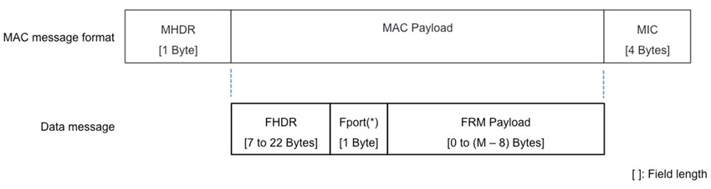

**Fig.1 : Size of the fields in bytes [1]**

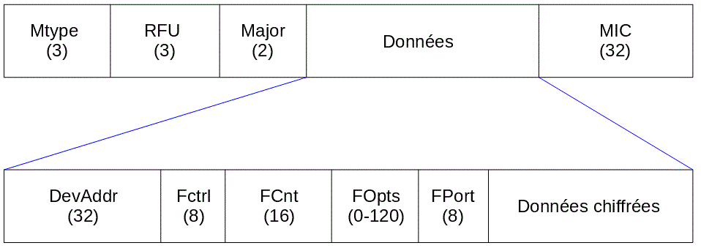

**Fig. 2 : Size of the fields in bits (Wikipedia)**

Usually, 13 bytes are added to the packet (if the user didn’t specify any options) [2] [3] :

* MHDR (Mac Header) : 1 byte
* MIC (Message Integrity Code) : 4 bytes
* DevAddr (Device Address) : 4 bytes
* FCtrl (Control Field): 1 byte
* FCnt (Counter Field) : 2 bytes
* FPort (Port Field): 1 byte

The encrypted payload’s size varies from 0 to (M-8) bytes, where M is the maximum size of the MAC payload that changes with the data rate (the faster it is, the higher the value M is).

In the figure 3, we see the correspondence between the DataRate and the spreading factor. It is good to remind that when the spreading factor increases, the range increases but the data rate is slower.

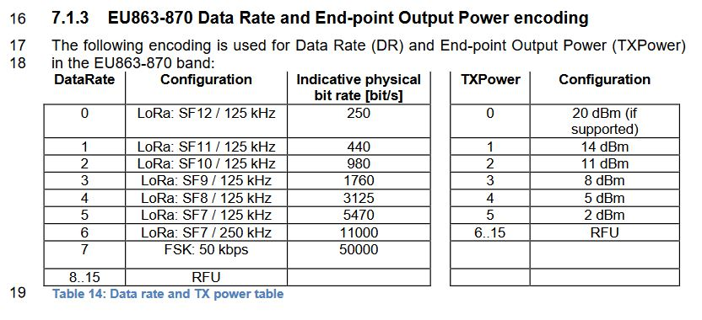

**Fig. 3 : Correspondence between Data Rate and physical configuration [4] (page 35)**

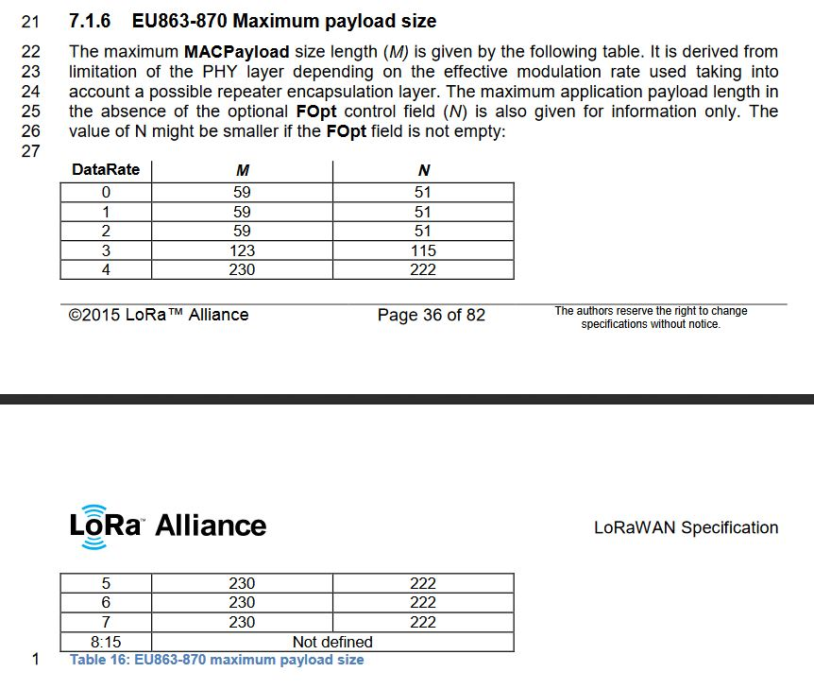

**Fig. 5 : Maximum MACPayload size length (M) for a given data rate [4] (page 36 and 37)**

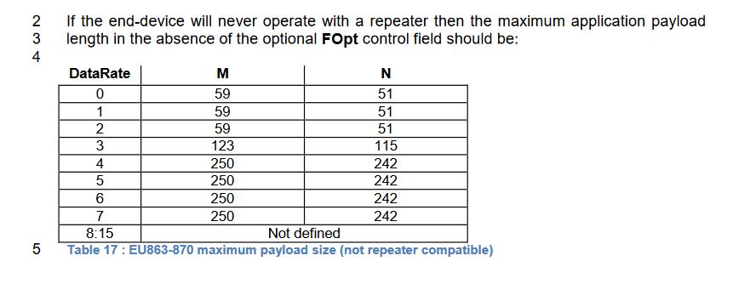

**Fig. 6 : Maximum MACPayload size without using repeaters [4] (page 37)**

However, since we will send data through The Things Network, we will be limited by the “fair-access policy” value of 11 bytes for our non-encrypted payload. It is our limiting parameter.

Focusing on the super-node

For our project, a super-node will be used and will have to include multiple sensors to measure the environmental parameters, such as the temperature, barometric pressure, humidity, …The first sensor is the “Pysense”, which is an expansion board packed with multiple sensors, that will be exposed further below. The LoPy that is used for this project can be easily attached to this expansion board, which makes the physical implementation easy [5].

**Humidity and temperature sensor (SI7006A20)**

According to the Pycom documentation [6], this sensor will return float values of humidity (%) and temperature (°C). One can use SI7006A20.humidity() or SI7006A20.temperature() to return a float value of the parameter to measure. According to the datasheet [8] of this component, the float values are coded with 16 bits (or 2 bytes). This means that 4 bytes are required for transmission in order to get the temperature and relative humidity from this sensor.

**Barometric pressure sensor with altimeter (MPL3115A2)**

According to the Pycom documentation [7], this sensor can return values of pressure, altitude and temperature (the last one will not be retrieved by this sensor). The command to retrieve the barometric pressure is MPL3115A2.pressure() (in Pa). The returned value is a float. The datasheet [9] says that the pressure is a 20-bit measurement, so the float value will be encoded on 32 bits. This means that 4 bytes are required to get the barometric pressure from this sensor.

If the LoPy module is attached to the Pysense expansion board, a total of 8 bytes will be required to send the temperature, the relative humidity and the barometric pressure. This size can fit in the data frame and complies with The Things Network fair-access policy.

Bibliography

[1] Modeling the Energy Performance of LoRaWAN (by Lluís Casals, Bernat Mir, Rafael Vidal and Carles Gomez) : <https://www.researchgate.net/publication/320435869_Modeling_the_energy_performance_of_LoRaWAN> (Viewed the 22.03.2019 at 19h45)

[2] <https://docs.allthingstalk.com/tutorials/lora-payload/> (Viewed the 22.03.2019 at 20h15)

[3] <https://www.thethingsnetwork.org/forum/t/spreadsheet-for-lora-airtime-calculation/1190/4> (Viewed the 22.03.2019 at 20h15)

[4] LoRaWAN specification V1.0 (by LoRa Alliance) : <https://www.rs-online.com/designspark/rel-assets/ds-assets/uploads/knowledge-items/application-notes-for-the-internet-of-things/LoRaWAN%20Specification%201R0.pdf> (Viewed the 22.03.2019 at 20h45)

[5] <https://docs.pycom.io/pytrackpysense/introduction.html#pysense> (Viewed the 23.03.2019 at 13h45)

[6] <https://docs.pycom.io/pytrackpysense/apireference/pysense.html#humidity-and-temperature-sensor-si7006a20> (Viewed the 23.03.2019 at 13h45)

[7] <https://docs.pycom.io/pytrackpysense/apireference/pysense.html#barometric-pressure-sensor-with-altimeter-mpl3115a2> (Viewed the 23.03.2019 at 13h45)

[8] Datasheet of the SI7006A20 sensor : <https://www.silabs.com/documents/public/data-sheets/si7006-a20.pdf> (Viewed the 23.03.2019 at 14h00)

[9] Datasheet of the MPL3115A2 sensor : <https://www.nxp.com/docs/en/data-sheet/MPL3115A2.pdf> (Viewed the 23.03.2019 at 14h00)