HUMBER FILM 304 / CLASS REVIEW EDITION
Toon Materials
& Character Handoff
A production bible for the Humber Toon Spine project
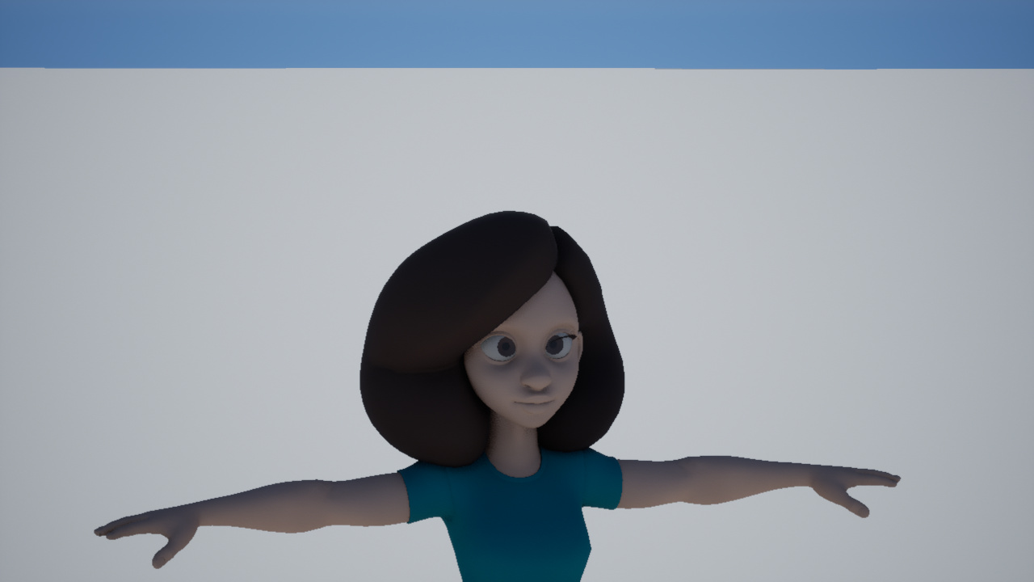
Dana material and lighting preview. Static source pose; this image does not prove rig deformation.
Prepared for the Film 304 group review | 16 October 2026

01 / START HERE

Project snapshot
This is a working guide to the Unreal toon materials, the film look, and the character handoff. It records what is built, what has been seen in a render, and what still needs a clean export.
The build rule
Material assets are generated from the Python builders in this repository. Change the builder, rebuild the asset, then read it back in Unreal. An editor-only graph edit will be lost on the next rebuild.

Step | What the artist chooses | Where it lives
1. Pick a family | Skin, hair, face, glass, cloth, ground, or sky. | M_* master
2. Make a look | Tint, roughness, line weight, or a surface pattern. | MI_* instance
3. Set the bands | Choose the light and shadow response for the subject. | TP_* profile
4. Review the shot | Check the look under the shot's actual light and grade. | Saved still + review notes

Working rules
- One person owns each Unreal binary while it is being edited. Material instances are the place for look variations.
- Keep changes in the builder that creates the asset. Record a still and the build report with the change.
- Use the SM6 workstation for final shader judgement. The Oct 8 laptop record says Substrate surfaces rendered black on that machine.
Status in one sentence
The six film utilities and static deep-night preset have build and fresh-load compile records; visual approval of the sky and a final Dana deformation export remain open.

02 / LOOK DEVELOPMENT

The material map
The spine keeps light response in a master, subject bands in a profile, and the visible variation in an instance. Outlines and the final film grade have their own place in the stack.
Surface | Start with | Use it for
Shared surfaces | M_Master_Toon_Universal + MI_Toon_* | Office props, masonry, and surfaces that share the main band response.
Character body | M_Master_Toon_Character | Clothing and broad body shading.
Face and hair | M_Master_Toon_Face / M_Master_Toon_Hair | Face shadow shape, scalp, and hair response.
Eyes and cornea | DanaFilm eye instances | Separate sclera, iris, eye interior, and cornea controls.
Landscape | M_Master_Toon_Landscape | Ground and broad terrain variation.
Sky | M_Master_Toon_Sky + MI_Toon_Sky_DeepNight | One fixed deep-night look.
Final grade | M_Master_Toon_PostComposite | One shared neutral grade, before per-shot tint.
Line work | M_Outline_InvertedHull + MI_Outline_Thin/Heavy | Thin lines on characters; heavier lines on large architecture.

Keep the image readable
- Keep the darkest toon band above pure black so shadowed shapes still read.
- Use the toon profile to shape the light bands; use the material instance for color and surface detail.
- Keep one final grade in the post-composite material. Avoid stacking separate grades shot by shot.
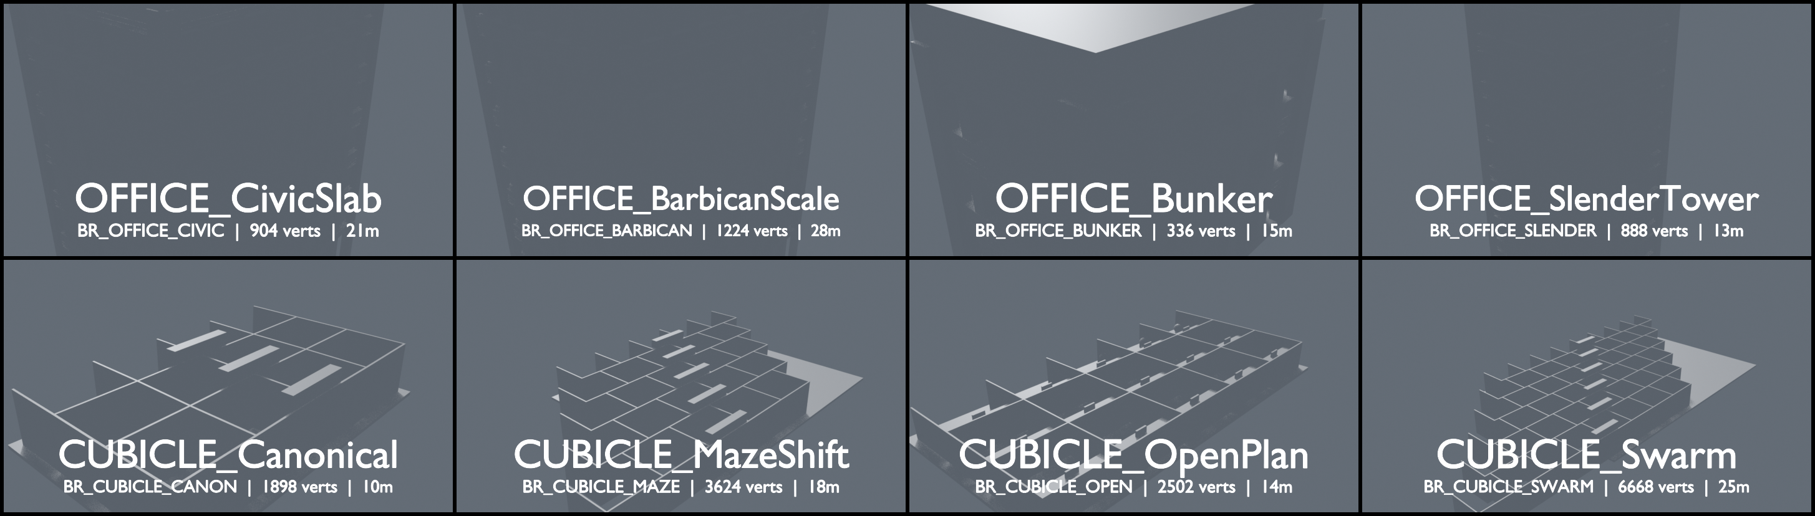
Office and cubicle model families from the class staging scaffold.

03 / REUSABLE CONTROLS

Six film tools and one sky preset
Each utility is quiet at its default. Open a control only when the shot needs it, then judge the change in the final lighting.
Function | Useful for | Artist controls and safe start
MF_NormalAdjust | Soften or sharpen toon bands across curved forms. | NormalStrength 1.0 is identity; below 1 softens, above 1 tightens.
MF_SurfaceWear | Small worn patches and crack marks on walls or floors. | WearStrength 0; CrackStrength 0. WearScale 0.02 is about a 50 cm tile. CrackWidth 0.01-0.08.
MF_DF_ContactBlend | Dirt and roughness close to contact points. | DFContactStrength 0. Tint and roughness stay unchanged until strength is raised.
MF_Impasto | Raised, directional paint strokes. | ImpastoStrength 0. BrushScale 0.02-0.09; 0.045 gives broad strokes.
MF_ClothWindDrape | Subtle motion in cloth and stage fabric. | WindStrength 0-1 cm; 0.05-0.15 for a drift, 0.2-0.35 for a walk breeze. Speed 0.2-1.5 cycles/sec.
MF_FilmGrade | A small neutral finish across the image. | Contrast 1, Warmth 0, Saturation 1, Lift 0. GradeTint remains the shot tint.

Deep-night sky
MI_Toon_Sky_DeepNight sits on M_Master_Toon_Sky. It uses an indigo-black zenith, a city-glow horizon, four value bands, and sparse stars. It is a fixed preset; there is no time-of-day control.

Keep iridescence, sparkle, vein glow, and radial rings out of this film set. Add a new function only when a shot has a named, visible need for it.

04 / FILES AND HANDOFF

Names that travel
Inside Unreal, use the prefixes in Docs/CONTENT_CONVENTIONS.md. In the Humber staging folders, use the role prefixes from GROUP_STAGING_GUIDE.md. The staging name describes the incoming file; the Unreal name describes the asset people will use.
Unreal asset | Prefix | Example
Master material | M_ | M_Master_Toon_Universal
Material instance | MI_ | MI_Toon_Stone
Material function | MF_ | MF_RampLUT
Toon profile | TP_ | TP_Hero
Texture | T_ | T_Concrete_N
Static mesh | SM_ | SM_Brutalist_Lot_A
Blueprint | BP_ | BP_Brutalist_Kit
Level / sequence | L_ / LS_ | L_Toon_Lookdev / LS_Shot010

Staging folder examples
Incoming work | Folder and prefix
Character model | 02_Assets/Models/Characters/CH_*
Character rig | 02_Assets/Rigs/Character/RIG_CH_*
Environment model | 02_Assets/Models/Environments/EN_*
Prop model | 02_Assets/Models/Props/PR_*
Material work | 02_Assets/Materials/M_*, MI_*, TP_*, T_*

- For imported textures, use _D for diffuse, _N for normal, _R for roughness, and _M for masks.
- Use a word for a real variant, such as _Thin or _Heavy. Do not make Stone2 or final_final.
- The staging guide uses _v01 for versioned source drops. Keep Unreal asset names stable and meaningful.
- The local UE naming guide does not set a SkeletalMesh prefix. Agree that prefix with the group before the final Dana import.
Before importing
Confirm the file owner, source path, units, up axis, material slots, skin weights, and intended Unreal name. Keep the source FBX beside its import notes.

05 / CHARACTER HANDOFF

Dana: what the preview proves
Current daylight preview. It is a static pose and the upper lash line is not reading in this image.
Readback | Current finding
Material stage | The DanaFilm preview has one Dana actor and 11 assigned material slots in the build record.
Body deformation | The source FBX body has zero skin clusters. The still does not prove a working body or face rig.
Upper/lower lashes | 39 vertices and 48 triangles per side; all vertices weighted to FaceUpperRegion_M.
Visibility | Both intended lash transforms and their FaceDeformationSystem parent are exported hidden.
Alternate squint pair | The two squint meshes have no skin weights. Keep them out of the render export.
Material slot | The lash geometry uses danaHair_mat. The slot is mapped to the hair instance; the missing lash line is not a shader assignment fault.

Next source export
In Maya, unhide the intended upper/lower pair, repair the face/head export hierarchy so its influence bones belong to the same exported skeleton as the body, and add the body skinCluster. Then test blink, close, look-up, and squint before replacing the Unreal preview.

A filtered FBX preview preserved the lashes, but the body still had no skin cluster. That file is useful for diagnosis, not as the production rig export.

06 / SHOT-FACING NOTES

Materials by part of the film
These are material references from the Office Spider shot plan. Use the storyboard and the current shot owner to confirm any change before promoting a look.
Shot range | Material work | Status in the handoff notes
SH010, SH030 | Brutalist exterior, landscape, stone, foliage, sky, and outline weight. | Exterior kit is staged. Deep-night sky still needs its SH010/SH020 review.
SH020-SH060 | Cubicle plastic, carpet, laminate, paper, steel, screen, face, hair, and glass. | Interior pieces are staged. Character and spider rig binds remain a dependency.
SH070-SH120 | Kitchen and hallway surfaces, glass, coffee props, spider and character materials. | Work is deferred until the required rigs and set build-out are ready.

Examples from the prop shelf
- Paper uses a matte finish and paper grain. Donut boxes use the cardboard surface.
- The coffee machine uses brushed metal; VCT floor grout and carpet loops should still read at the final shot scale.
- Frosted glass belongs on the door glazing. Keep outlines thinner on characters and heavier on architecture.
A material check is visual
A green build report says the graph loaded and the parameters exist. It does not tell us whether the band, outline, shadow, or texture reads well in the shot.

07 / GATES AND NEXT STEPS

Review before calling it done
Gate | Evidence on record | Still needed
Material build | Six film utilities and the static sky preset were built through Python; the Oct 7 fresh-process compile record was clean. | Refresh the gate after any builder changes.
Look review | Dana day and night stills exist; the capture report records three fresh images. | Judge final Substrate materials on the SM6 workstation. One Oct 13 render-queue attempt reported a stale image.
Dana rig | FBX anatomy, lash filter, and pose-clean reports are saved. | Maya source export with body skin weights and a working head/face chain.
Sky preset | Static parameters and preset are present in the spine. | View it in SH010 and SH020, then approve or adjust it.

Next four actions
- Re-export Dana from Maya with one body skinCluster, visible upper/lower lashes, and the final face/head deformation chain.
- Import the export into a clean preview, check one character only, and read back every material slot.
- Refresh the stills on the SM6 workstation and review the sky preset in SH010 and SH020.
- After those reviews, stage the next shot range when the kitchen, hallway, and remaining rigs are ready.

Records used
Docs/CONTENT_CONVENTIONS.md; Docs/GROUP_WORKFLOW.md; Humber_FinalYear_Prep/GROUP_STAGING_GUIDE.md; Docs/TOON_SPINE.md; Docs/MELODIA_TOON_CONVERGENCE.md; Docs/HANDOFF_2026-10-08_NEXT_PHASE.md; Docs/OFFICE_SPIDER_SHOT_PLAN.md; Showcase/Dana/README.md; Saved/Audit/dana_fbx_raw_anatomy.json; Saved/Audit/dana_fbx_geometry_filter_Dana_Film_EyelashFiltered.json; Saved/Audit/dana_fbx_deform_prune_Dana_Film_EyelashPreview.json; Saved/Audit/dana_refined_uds_build.json; Saved/Audit/dana_rig_preview_capture.json; Saved/Audit/dana_refined_uds_render_results.json.

