## Task №1. Access settings

**grant select on all tables in schema** public **to** planadmin;

**grant select, update, insert, delete on** plan_data **to** planadmin;

**grant select, update, insert, delete on** plan_status **to** planadmin;

**grant select, update, insert, delete on** country_managers **to** planadmin;

**grant select on all tables in schema** public **to** planmanager;

**grant select, update, insert, delete on** plan_data **to** planmanager;

**grant select, update on** plan_status **to** planmanager;

**grant select on** country_managers **to** planmanager;

**grant select, update on** v_plan_edit **to** planmanager;

**grant select on** v_plan **to** planmanager;

**create** **user** ivan **with** **password** 'sql1';

**create** **user** sophie **with** **password** 'sql2';

**create** **user** kirill **with** **password** 'sql3';

**grant** planadmin **to** ivan;

**grant** planmanager **to** sophie;

**grant** planmanager **to** kirill;

**insert** **into** country_managers (username, country)

**values** ('sophie', 'US'),

('sophie', 'CA'),

('kirill', 'FR'),

('kirill', 'GB'),

('kirill', 'DE'),

('kirill', 'AU');

## Task №2. product2 & country 2 materialized views

**create** **materialized** **view** product2 **as**

**select**

productcategory.productcategoryid **as** pcid,

product.productid,

productcategory.**name** **as** pcname,

product.**name** **as** pname

**from** product

**join** productsubcategory **using** (productsubcategoryid)

**join** productcategory **using** (productcategoryid);

**create** **materialized** **view** country2 **as**

**select** **distinct** address.countryregioncode **as** countrycode

**from** address **join** customeraddress **using** (addressid)

**where** addresstype = 'Main Office';

**grant** **select** **on** product2 **to** planadmin;

**grant** **select** **on** product2 **to** planmanager;

**grant** **select** **on** country2 **to** planadmin;

**grant** **select** **on** country2 **to** planmanager;

## Task №3. Loading data into the company table

**insert** **into** company (cname, countrycode, city)

**select** customer.companyname, address.countryregioncode, address.city

**from** customer

**join** customeraddress **using** (customerid)

**join** address **using** (addressid)

**where** addresstype = 'Main Office';

## Task №4. Company classification

**insert** **into** company_abc (cid, salestotal, cls, **year**)

**select**

cid,

salestotal,

**case**

**when** **sum**(salestotal) **over** (**partition** **by** **year**

**order** **by**

salestotal **desc**) <= 0.8 * **sum**(salestotal) **over** (**partition** **by** **year**) **then** 'A'

**when** **sum**(salestotal) **over** (**partition** **by** **year**

**order** **by**

salestotal **desc**) <= 0.95 * **sum**(salestotal) **over** (**partition** **by** **year**) **then** 'B'

**else** 'C'

**end** **as** cls,

**year**

**from**

(

**select** co.id **as** cid, **sum**(soh.subtotal) **as** salestotal, **date_part**('y', soh.orderdate) **as** **year**

**from** company **as** co

**join** customer cs **on** co.cname = cs.companyname

**join** salesorderheader **as** soh **using** (customerid)

**where** **date_part**('y', soh.orderdate) **in** ('2012', '2013')

**group** **by** co.id, **date_part**('y', soh.orderdate)

) **as** sel

**order** **by** salestotal **desc**

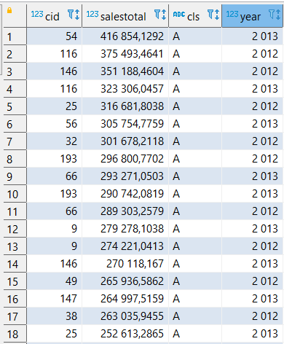

## Task №5. Finding quarterly sales amount by company, and product category

**insert** **into** company_sales (cid, salesamt, **year**, quarter_yr, qr, categoryid, ccls)

**select** cid, **sum**(linetotal) **as** salesamt, **year**, quarter_yr, qr, categoryid, ccls

**from**

(**select** company.id **as** cid, s.linetotal, **extract**(**year** **from** s2.orderdate) **as** **year**,

**extract**(**quarter** **from** s2.orderdate) **as** quarter_yr, **to_char**(s2.orderdate, 'YYYY.Q') **as** qr,

product2.pcid **as** categoryid,

company_abc.cls **as** ccls

**from** salesorderdetail s

**join** salesorderheader s2 **using** (salesorderid)

**join** customer **using** (customerid)

**join** company **on** customer.companyname = company.cname

**join** company_abc **on** company.id = company_abc.cid

**join** product2 **using** (productid)

**where** **year** **in** (2012, 2013)

**and** company_abc.**year** = **extract**(**year** **from** s2.orderdate)) **as** sel

**group** **by** **year**, quarter_yr, qr, cid, categoryid, ccls

**order** **by** salesamt **desc**

## Task №6. Initial data preparation

import psycopg2

def start_planning(year, quarter, user, pwd):

conn = psycopg2.connect(database="2022_plans_Maria", user=user, password=pwd, host="127.0.0.1")

cursor = conn.cursor()

DelPlanData = """delete from plan_data where quarterid in ('%s.%s')"""

DelStatusData = """delete from plan_status where quarterid in ('%s.%s')"""

PlanStatRec = """insert into plan_status (quarterid, status, modifieddatetime, author, country)

select %s.%s as quarterid, 'R' as status, now() as modifieddatetime,

%s as author, country2.countrycode as country from country2 order by country"""

PlanDataN = """insert into plan_data (versionid, country, quarterid, pcid, salesamt)

select 'N' as versionid, sel2.countrycode as country, %s.%s as quaterid,

sel2.pcid as pcid, coalesce(avg(sel1.salesamt), 0) as salesamt

from (select co.countrycode, cs.qr, cs.categoryid as pcid, sum(cs.salesamt) as salesamt

from company as co

join company_sales as cs on co.id = cs.cid

where cs.ccls in ('A', 'B') and cs.qr in ('%s.%s', '%s.%s')

group by co.countrycode, cs.qr, cs.categoryid) as sel1

right join

(select distinct p2.pcid, co2.countrycode

from country2 as co2

cross join product2 as p2) as sel2 using(countrycode)

where sel1.pcid = sel2.pcid

group by 2, 4

order by country, pcid"""

PlanDataP = """insert into plan_data(versionid, country, quarterid, pcid, salesamt)

select 'P' as versionid, country as country, quarterid as quarterid, pcid as pcid, salesamt as salesamt

from plan_data where versionid = 'N' and quarterid = '%s.%s'"""

cursor.execute(DelPlanData, (year, quarter))

cursor.execute(DelStatusData, (year, quarter))

cursor.execute(PlanStatRec, (year, quarter, user))

cursor.execute(PlanDataN, (year, quarter, year-1, quarter, year-2, quarter))

cursor.execute(PlanDataP, (year, quarter))

conn.commit()

conn.close()



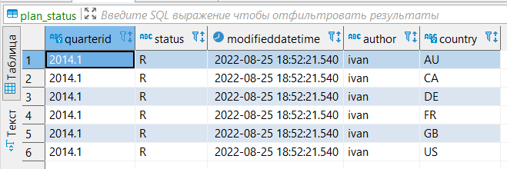

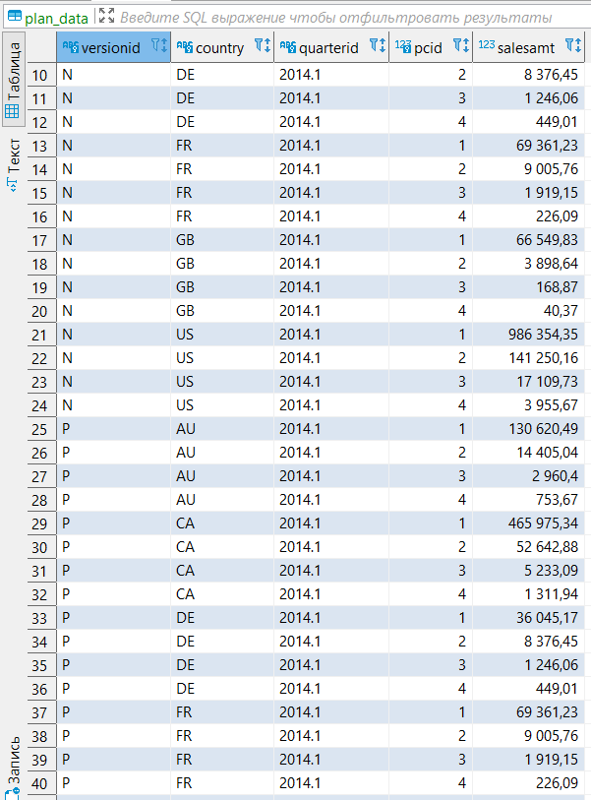

## Task №7. Changing plan data

def set_lock(year, quarter, user, pwd):

conn = psycopg2.connect(database="2022_plans_Maria", user=user, password=pwd, host="127.0.0.1")

cursor = conn.cursor()

setlock = """update plan_status

set status = 'L', modifieddatetime = now(), author = current_user

where quarterid = '%s.%s'

and status = 'R'

and country in (select country

from country_managers

where username = current_user)"""

cursor.execute(setlock, (year, quarter))

conn.commit()

conn.close()

def remove_lock(year, quarter, user, pwd):

conn = psycopg2.connect(database="2022_plans_Maria", user=user, password=pwd, host="127.0.0.1")

cursor = conn.cursor()

remlock = """update plan_status

set status = 'R', modifieddatetime = now(), author = current_user

where quarterid = '%s.%s'

and status = 'L'

and country in (select country

from country_managers

where username = current_user)"""

cursor.execute(remlock, (year, quarter))

conn.commit()

conn.close()

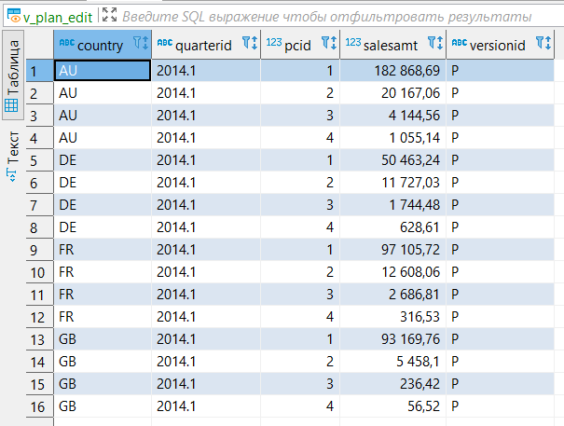

## Task №8. Plan data approval

def accept_plan(year, quarter, user, pwd):

conn = psycopg2.connect(database="2022_plans_Maria", user=user, password=pwd, host="127.0.0.1")

cursor = conn.cursor()

clearA = """delete from plan_data as pd

where pd.versionid = 'A' and pd.quarterid = '%s.%s'

and country in (select country from country_managers

where username = current_user)

and exists (select * from plan_status as ps

where ps.status = 'R'

and pd.quarterid = ps.quarterid

and pd.country = ps.country)

"""

fromPtoA = """insert into plan_data(versionid, country, quarterid, pcid, salesamt)

select

'A' as versionid,

pd.country as country,

pd.quarterid as quarterid,

pd.pcid as pcid,

pd.salesamt as salesamt

from plan_data as pd

where pd.versionid = 'P'

and pd.quarterid = '%s.%s'

and country in (select country from country_managers

where username = current_user)

and exists (select * from plan_status as ps

where pd.quarterid = ps.quarterid

and ps.status = 'R'

and ps.country = pd.country)"""

fromRtoA = """update plan_status as ps

set status = 'A', modifieddatetime = now(), author = current_user

where ps.status = 'R'

and ps.quarterid = '%s.%s'

and country in (select country from country_managers

where username = current_user)"""

cursor.execute(clearA, (year, quarter))

cursor.execute(fromPtoA, (year, quarter))

cursor.execute(fromRtoA, (year, quarter))

conn.commit()

conn.close()

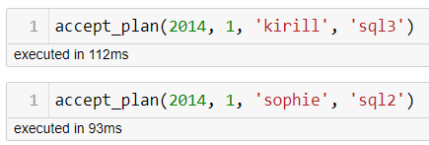

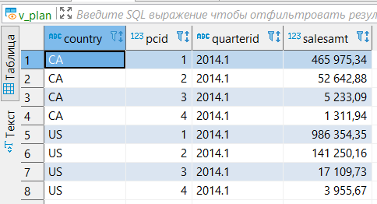

## Task №9. Data preparation for plan-fact analysis in Q1 2014

I used the 2nd approach: “Calculate actual data using salesorderheader and ordersalesdetail tables without using company_sales.”

**create** **materialized** **view** mv_plan_fact_2014_q1 **as**

**select** v.quarterid **as** "Quarter",

v.country **as** "Country",

p2.pcname **as** "Category name",

**case** **when** fact **is** **null** **then** **null** **else** v.salesamt-lj.fact **end** **as** "Dev.",

**case** **when** fact **is** **null** **then** **null** **else** (v.salesamt-lj.fact)*100/v.salesamt **end** **as** "Dev., %"

**from** v_plan **as** v

**join** (**select** **distinct** pcid, pcname **from** product2) **as** p2 **using** (pcid)

**left** **join** (

**select** co.countrycode, **sum**(sod.linetotal) **as** fact, p2.pcid **as** catid, p2.pcname **as** catname

**from** company **as** co

**join** customer **as** cs **on** co.cname = cs.companyname

**join** salesorderheader **as** soh **using**(customerid)

**join** salesorderdetail **as** sod **using**(salesorderid)

**join** product2 **as** p2 **using**(productid)

**where**

**extract**(**year** **from** soh.orderdate) = '2014'

**and** **extract**(**quarter** **from** soh.orderdate) = '1'

**and** co.id **in** (**select** co2.cid

**from** company_abc **as** co2

**where** co2.cls != 'C' **and** co2.**year** = '2013')

**group** **by** 1, 3, 4

) **as** lj **on** lj.catid=v.pcid **and** lj.countrycode=v.country

