**WEEK 1**

Building Blocks for Problem Solving - Practice quiz on Sets (3 questions)

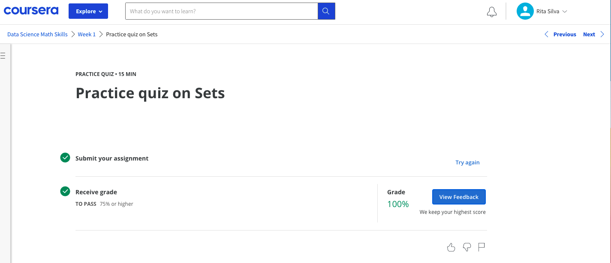

The infinite World of Real Numbers - Practice quiz on the Number Line, including Inequalities (8 questions)

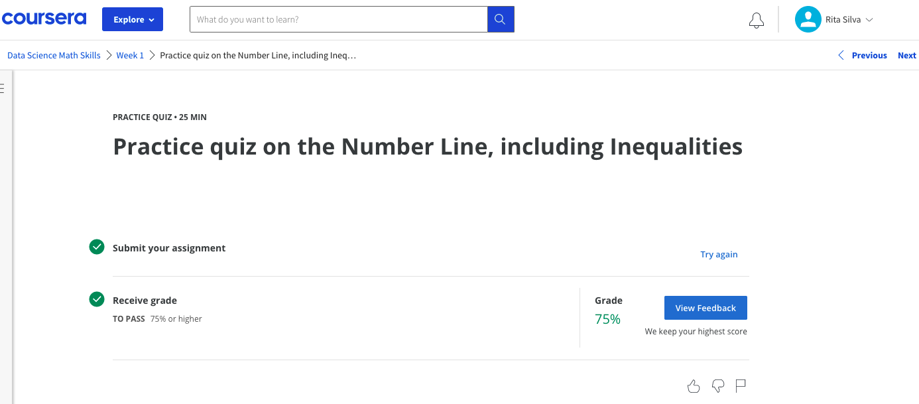

That Jagged S Symbol - Practice quiz on Simplification Rules and Sigma Notation (6 questions)

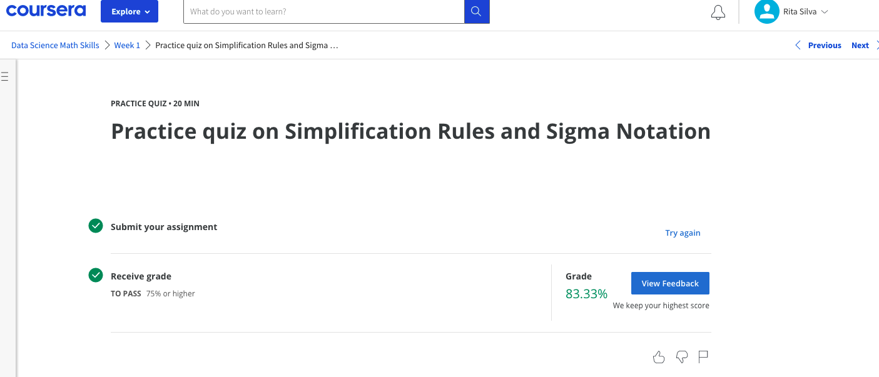

That Jagged S Symbol - Graded quiz on Sets, Number Line, Inequalities, Simplification, and Sigma Notation (13 questions) 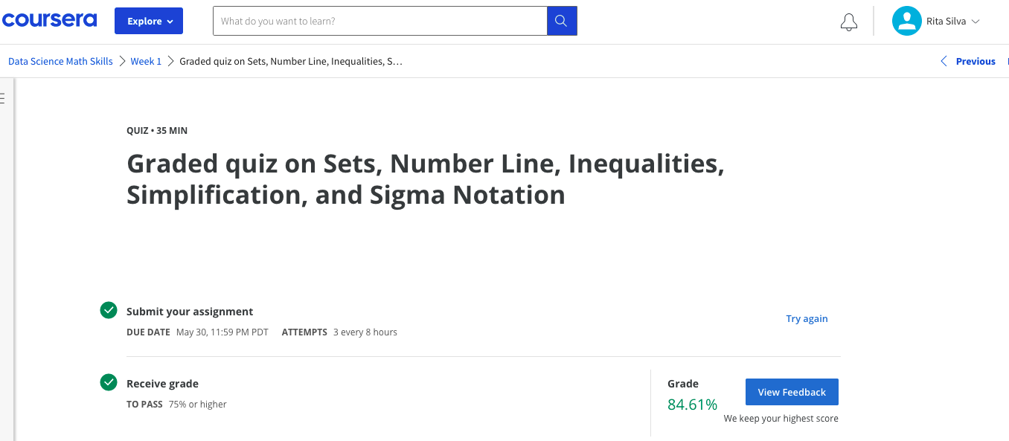

WEEK 2

Descartes Was Really Smart - Practice quiz on the Cartesian Plane (5 questions)

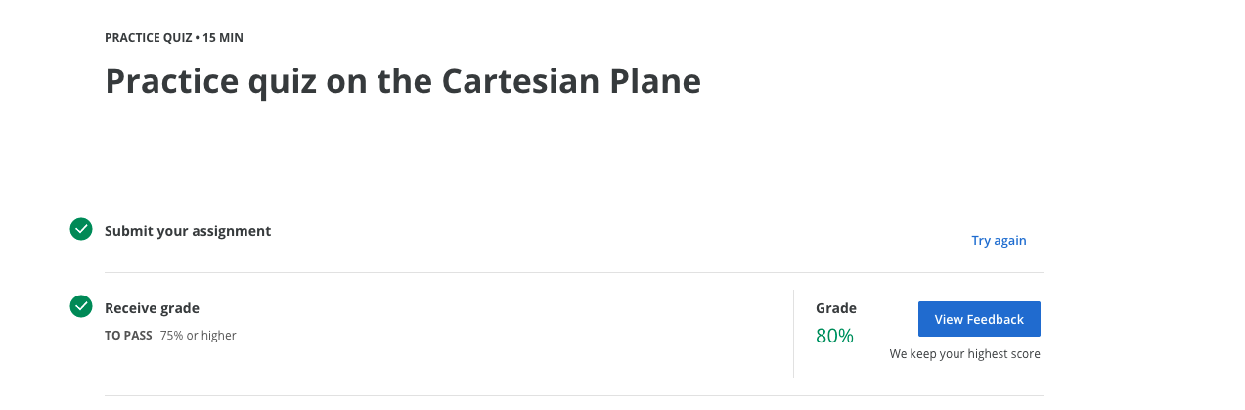

Input-Output Machines - Practice quiz on Types of Functions (6 questions)

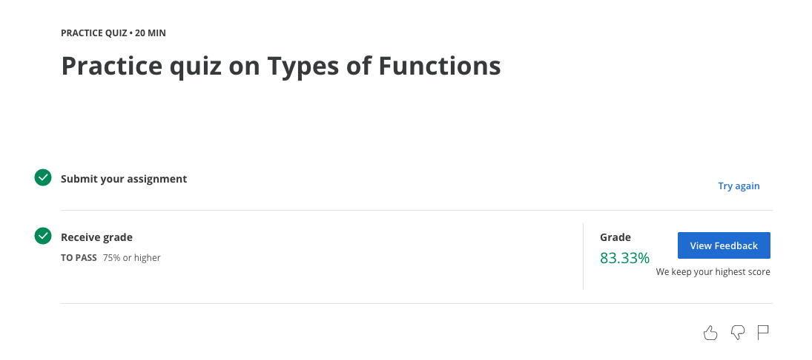

Input-Output Machines - Graded quiz on Cartesian Plane and Types of Function (13 questions)

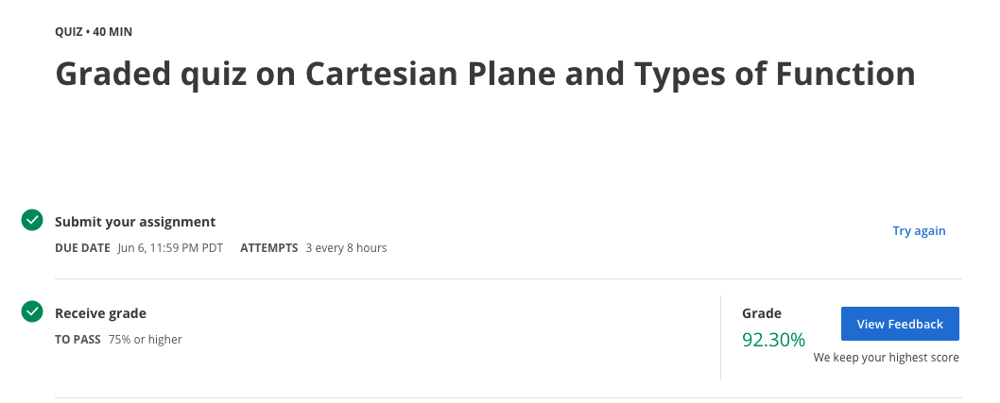

WEEK 3

This is about that derivative stuff - Practice quiz on Tangent Lines to Functions (2 questions)

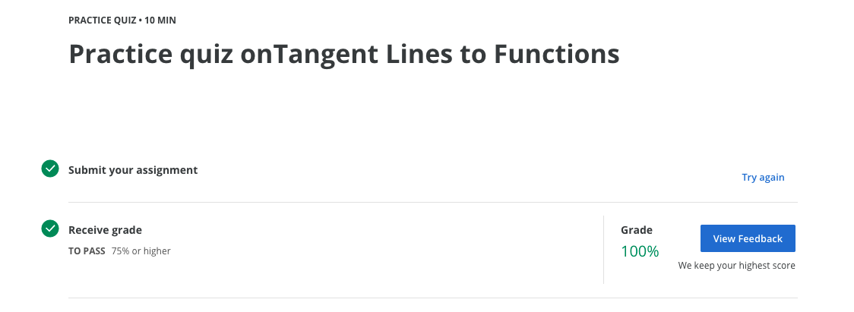

Fast Growth, Slow Growth - Practice quiz on Exponents and Logarithms (12 questions)

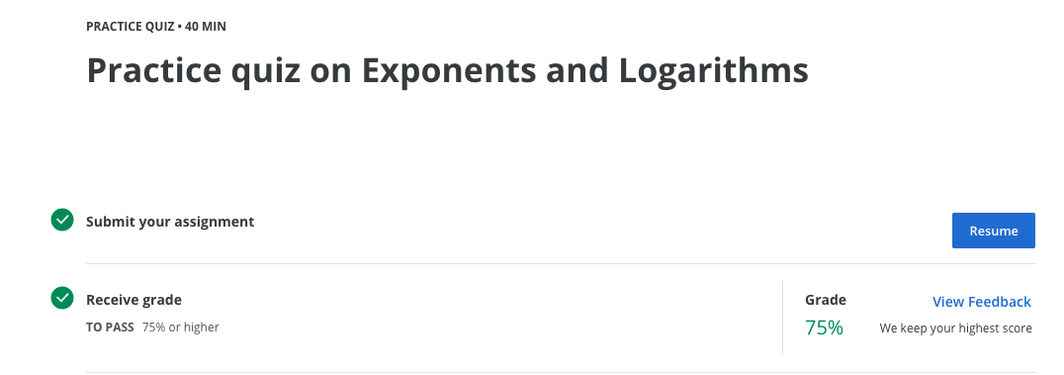

Fast Growth, Slow Growth - Graded quiz on Tangent Lines to Functions, Exponents and Logarithms (13 questions)

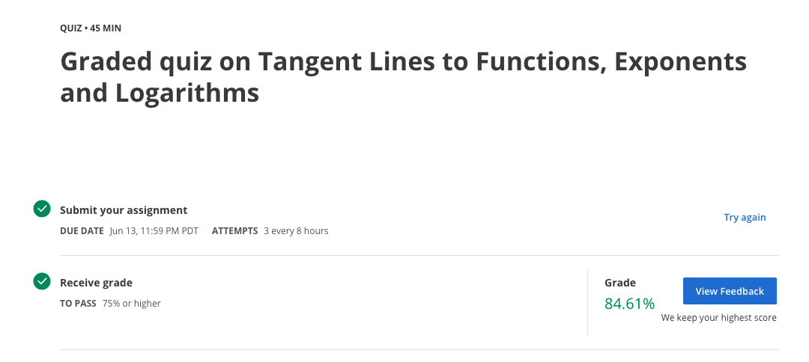

WEEK 4

Basic Probability Definitions - Practice quiz on Probability Concepts (9 questions)

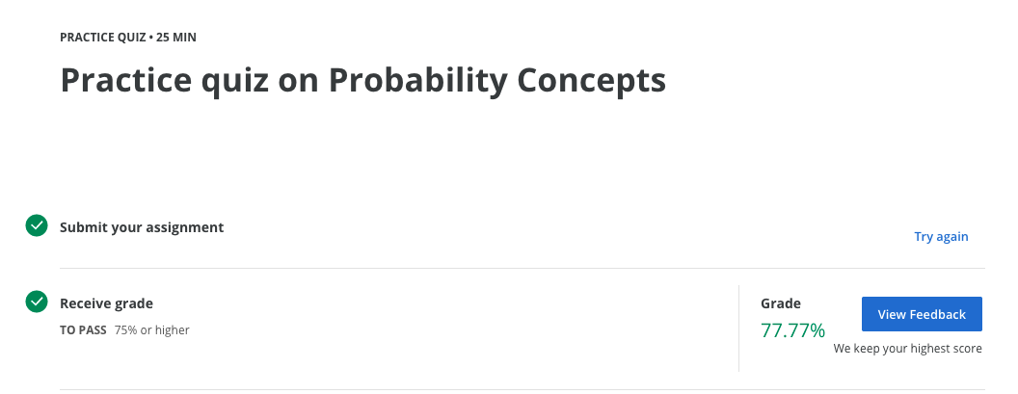

Problem Solving Methods - Practice quiz on Problem Solving (9 questions)

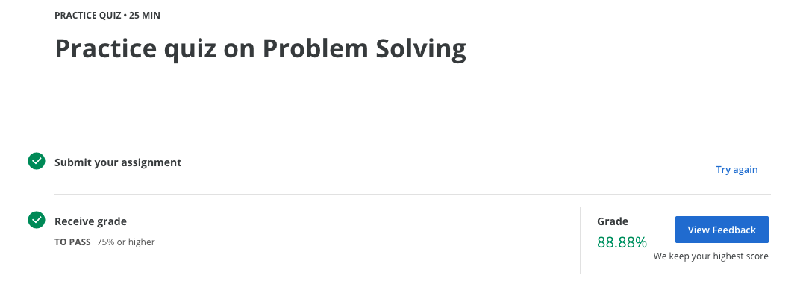

Practice quiz on Bayes Theorem and the Binomial Theorem

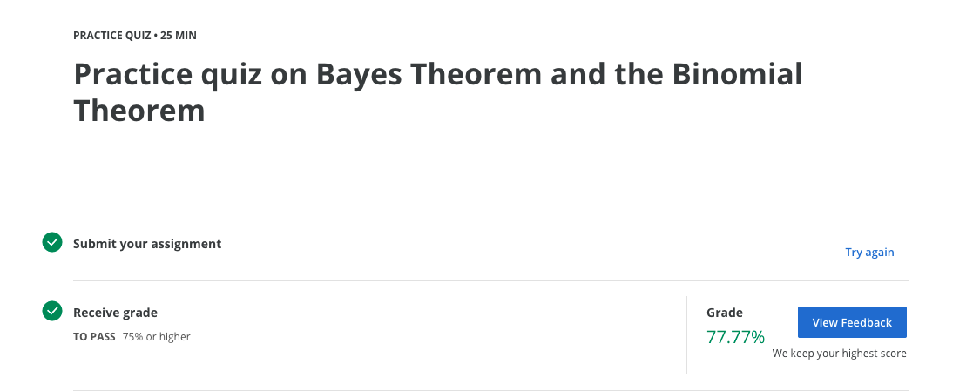

Probability (basic and Intermediate) Graded Quiz

