#protobuf
1安装node.js
2npm 安装pb

3修改文件
C:\Users\pc\AppData\Roaming\npm\node_modules\@egret\protobuf\out目录下的index.js
case 14:
_a.sent();
args = ['-t', 'static', '--keep-case', '-p', protoRoot, protoList.join(" "), '-o', tempfile];
if (pbconfig.options['no-create']) {
args.unshift('--no-create');
}
if (pbconfig.options['no-verify']) {
args.unshift('--no-verify');
}
if (pbconfig.options['no-convert']) {
args.unshift('--no-convert');
}
if (pbconfig.options["no-delimited"]) {
args.unshift("--no-delimited");
}
if (pbconfig.options['no-encode']) {
args.unshift('--no-encode');
}
if (pbconfig.options['no-decode']) {
args.unshift('--no-decode');
}
if (pbconfig.options['force-long']) {
args.unshift('--force-long');
}
if (pbconfig.options['force-number']) {
args.unshift('--force-number');
}
return [4 /*yield*/, shell('pbjs', args)];

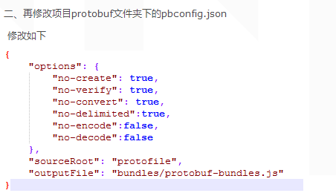
(工程已经修改 svn更新即可)

#修改对应编译引擎
HtmlTextParser
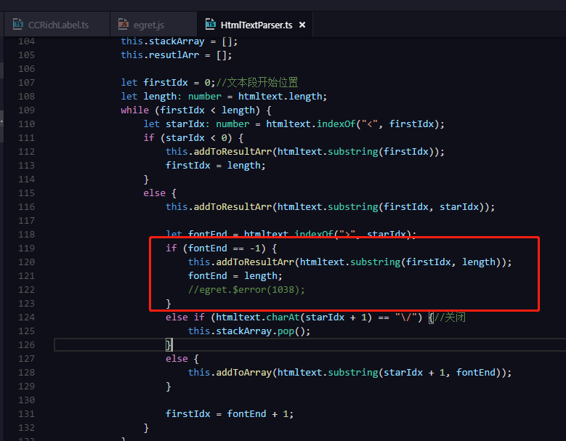
在cmd下执行 (对应版本号)
egret make –egretversion 5.2.26

#修改引擎插件代码
EmitResConfigFilePlugin
地址参考：C:\Users\pc\AppData\Roaming\Egret\engine\5.2.26\tools\tasks\resConfig.js

EmitResConfigFilePlugin.prototype.executeFilter 函数
替换

EmitResConfigFilePlugin.prototype.executeFilter = function (file) {
var fileOptions = file.options;
var filename = file.origin;
var url = file.relative.split('\\').join("/");
var config = this.config;
var options = this.options;
if (filters.indexOf(filename) >= 0) {
return null;
}
var type = options.typeSelector(filename);
if (!type) {
return null;
}
var name = options.nameSelector(filename);
if (fileOptions && fileOptions.subkeys && Array.isArray(fileOptions.subkeys)) {
fileOptions.subkeys = fileOptions.subkeys.map(function (p) { return options.nameSelector(p); }).join(",");
}
var groupName = options.groupSelector(filename);
if (groupName) {
if (!config.groups[groupName]) {
config.groups[groupName] = [];
}
var group = config.groups[groupName];
if (group.indexOf(name) == -1) {
group.push(name);
}
}
/**添加私有代码begin */
if (file.extname === ".json") {
var data = JSON.parse(file.contents.toString());
if (data.file && data.frames) {
data.file = data.file = data.file.replace(".", "_");
file.contents = new Buffer(JSON.stringify(data));
var subkeys = [];
for (var key in data.frames) {
subkeys.push(key);
}
return __assign({ name: name, url: url, type: type,subkeys:subkeys.join(",") }, fileOptions);
}
}
/**添加私有代码end */
return __assign({ name: name, url: url, type: type }, fileOptions);
};

