Demo Stylish Article
Félix Romiguière
Résumé
Ce document est un test d’utilisation de git pour le projet Tahiti Soundscape
Table des matières

package 'sys' successfully unpacked and SHA256 sums checked
package 'bit' successfully unpacked and SHA256 sums checked
package 'ps' successfully unpacked and SHA256 sums checked
package 'RcppEigen' successfully unpacked and SHA256 sums checked
package 'R.oo' successfully unpacked and SHA256 sums checked
package 'R.methodsS3' successfully unpacked and SHA256 sums checked
package 'sp' successfully unpacked and SHA256 sums checked
package 'future.apply' successfully unpacked and SHA256 sums checked
package 'globals' successfully unpacked and SHA256 sums checked
package 'iterators' successfully unpacked and SHA256 sums checked
package 'listenv' successfully unpacked and SHA256 sums checked
package 'parallelly' successfully unpacked and SHA256 sums checked
package 'plyr' successfully unpacked and SHA256 sums checked
package 'tensor' successfully unpacked and SHA256 sums checked
package 'askpass' successfully unpacked and SHA256 sums checked
package 'bit64' successfully unpacked and SHA256 sums checked
package 'otel' successfully unpacked and SHA256 sums checked
package 'processx' successfully unpacked and SHA256 sums checked
package 'proxy' successfully unpacked and SHA256 sums checked
package 'interp' successfully unpacked and SHA256 sums checked
package 'R.utils' successfully unpacked and SHA256 sums checked
package 'sgeostat' successfully unpacked and SHA256 sums checked
package 'splancs' successfully unpacked and SHA256 sums checked
package 'cubature' successfully unpacked and SHA256 sums checked
package 'doFuture' successfully unpacked and SHA256 sums checked
package 'foreach' successfully unpacked and SHA256 sums checked
package 'future' successfully unpacked and SHA256 sums checked
package 'progressr' successfully unpacked and SHA256 sums checked
package 'reshape2' successfully unpacked and SHA256 sums checked
package 'spatstat.utils' successfully unpacked and SHA256 sums checked
package 'generics' successfully unpacked and SHA256 sums checked
package 'tidyselect' successfully unpacked and SHA256 sums checked
package 'pkgconfig' successfully unpacked and SHA256 sums checked
package 'rbibutils' successfully unpacked and SHA256 sums checked
package 'spatstat.data' successfully unpacked and SHA256 sums checked
package 'spatstat.univar' successfully unpacked and SHA256 sums checked
package 'spatstat.sparse' successfully unpacked and SHA256 sums checked
package 'goftest' successfully unpacked and SHA256 sums checked
package 'deldir' successfully unpacked and SHA256 sums checked
package 'polyclip' successfully unpacked and SHA256 sums checked
package 'backports' successfully unpacked and SHA256 sums checked
package 'blob' successfully unpacked and SHA256 sums checked
package 'data.table' successfully unpacked and SHA256 sums checked
package 'gargle' successfully unpacked and SHA256 sums checked
package 'uuid' successfully unpacked and SHA256 sums checked
package 'curl' successfully unpacked and SHA256 sums checked
package 'ids' successfully unpacked and SHA256 sums checked
package 'rematch2' successfully unpacked and SHA256 sums checked
package 'openssl' successfully unpacked and SHA256 sums checked
package 'timechange' successfully unpacked and SHA256 sums checked
package 'utf8' successfully unpacked and SHA256 sums checked
package 'systemfonts' successfully unpacked and SHA256 sums checked
package 'textshaping' successfully unpacked and SHA256 sums checked
package 'clipr' successfully unpacked and SHA256 sums checked
package 'crayon' successfully unpacked and SHA256 sums checked
package 'vroom' successfully unpacked and SHA256 sums checked
package 'tzdb' successfully unpacked and SHA256 sums checked
package 'callr' successfully unpacked and SHA256 sums checked
package 'selectr' successfully unpacked and SHA256 sums checked
package 'stringi' successfully unpacked and SHA256 sums checked
package 'rematch' successfully unpacked and SHA256 sums checked
package 'prettyunits' successfully unpacked and SHA256 sums checked
package 'e1071' successfully unpacked and SHA256 sums checked
package 'wk' successfully unpacked and SHA256 sums checked
package 'jpeg' successfully unpacked and SHA256 sums checked
package 'png' successfully unpacked and SHA256 sums checked
package 'farver' successfully unpacked and SHA256 sums checked
package 'labeling' successfully unpacked and SHA256 sums checked
package 'Rcpp' successfully unpacked and SHA256 sums checked
package 'alphahull' successfully unpacked and SHA256 sums checked
package 'ape' successfully unpacked and SHA256 sums checked
package 'dbmss' successfully unpacked and SHA256 sums checked
package 'dplyr' successfully unpacked and SHA256 sums checked
package 'igraph' successfully unpacked and SHA256 sums checked
package 'EntropyEstimation' successfully unpacked and SHA256 sums checked
package 'RColorBrewer' successfully unpacked and SHA256 sums checked
package 'RcppParallel' successfully unpacked and SHA256 sums checked
package 'Rdpack' successfully unpacked and SHA256 sums checked
package 'spatstat.explore' successfully unpacked and SHA256 sums checked
package 'spatstat.geom' successfully unpacked and SHA256 sums checked
package 'spatstat.random' successfully unpacked and SHA256 sums checked
package 'tibble' successfully unpacked and SHA256 sums checked
package 'tidyr' successfully unpacked and SHA256 sums checked
package 'broom' successfully unpacked and SHA256 sums checked
package 'conflicted' successfully unpacked and SHA256 sums checked
package 'dbplyr' successfully unpacked and SHA256 sums checked
package 'dtplyr' successfully unpacked and SHA256 sums checked
package 'forcats' successfully unpacked and SHA256 sums checked
package 'googledrive' successfully unpacked and SHA256 sums checked
package 'googlesheets4' successfully unpacked and SHA256 sums checked
package 'haven' successfully unpacked and SHA256 sums checked
package 'hms' successfully unpacked and SHA256 sums checked
package 'httr' successfully unpacked and SHA256 sums checked
package 'lubridate' successfully unpacked and SHA256 sums checked
package 'magrittr' successfully unpacked and SHA256 sums checked
package 'modelr' successfully unpacked and SHA256 sums checked
package 'pillar' successfully unpacked and SHA256 sums checked
package 'purrr' successfully unpacked and SHA256 sums checked
package 'ragg' successfully unpacked and SHA256 sums checked
package 'readr' successfully unpacked and SHA256 sums checked
package 'reprex' successfully unpacked and SHA256 sums checked
package 'rstudioapi' successfully unpacked and SHA256 sums checked
package 'rvest' successfully unpacked and SHA256 sums checked
package 'stringr' successfully unpacked and SHA256 sums checked
package 'xml2' successfully unpacked and SHA256 sums checked
package 'permute' successfully unpacked and SHA256 sums checked
package 'cellranger' successfully unpacked and SHA256 sums checked
package 'cpp11' successfully unpacked and SHA256 sums checked
package 'progress' successfully unpacked and SHA256 sums checked
package 'classInt' successfully unpacked and SHA256 sums checked
package 'DBI' successfully unpacked and SHA256 sums checked
package 's2' successfully unpacked and SHA256 sums checked
package 'units' successfully unpacked and SHA256 sums checked
package 'rosm' successfully unpacked and SHA256 sums checked
package 'abind' successfully unpacked and SHA256 sums checked
package 'scales' successfully unpacked and SHA256 sums checked
package 'glue' successfully unpacked and SHA256 sums checked
package 'viridisLite' successfully unpacked and SHA256 sums checked
package 'gridExtra' successfully unpacked and SHA256 sums checked
package 'gtable' successfully unpacked and SHA256 sums checked
package 'isoband' successfully unpacked and SHA256 sums checked
package 'S7' successfully unpacked and SHA256 sums checked
package 'vctrs' successfully unpacked and SHA256 sums checked
package 'withr' successfully unpacked and SHA256 sums checked
package 'divent' successfully unpacked and SHA256 sums checked
package 'tidyverse' successfully unpacked and SHA256 sums checked
package 'vegan' successfully unpacked and SHA256 sums checked
package 'readxl' successfully unpacked and SHA256 sums checked
package 'sf' successfully unpacked and SHA256 sums checked
package 'ggspatial' successfully unpacked and SHA256 sums checked
package 'viridis' successfully unpacked and SHA256 sums checked
package 'ggplot2' successfully unpacked and SHA256 sums checked
The downloaded binary packages are in
/var/folders/36/tjdph2t965j8snz9_vkdnw0r0000gn/T//RtmpB5eoIO/downloaded_packages

Méthode pour la prise de mesure Google Earth
- La date des images de Google Earth varie entre le 15/07/2023 et le 02/03/2025.
- Un cercle de 100m de rayon est créé autour de chaque enregistreur, égalant une surface de 31416 m². Pour les mesures des polygones (HSA et HERB) on zoom pour représenter 1/3-1/4 du cercle avec un angle de plan en zénithal.
- On accumule ensuite les zones délimitées en sommant les valeurs de surface (m²) de nos polygones. Attention à bien refaire les polygones pour les sites se chevauchant entre eux (ex: ILM)
- Attention à bien prendre en compte les canopées, même surplombants une route car importants pour les oiseaux.
- Flou entre les routes d’accès en terre et celles en graviers Flou pour les surfaces HERB et la fougère en altitude. Doit-elle être considérée dedans ? (Oui car zone vraiment herbacée peut ne pas représenter les mêmes habitats et communautés aviaires que les fougères (zone agricole/parc vs versant de vallée)), parfois séparation pas claire entre les deux.
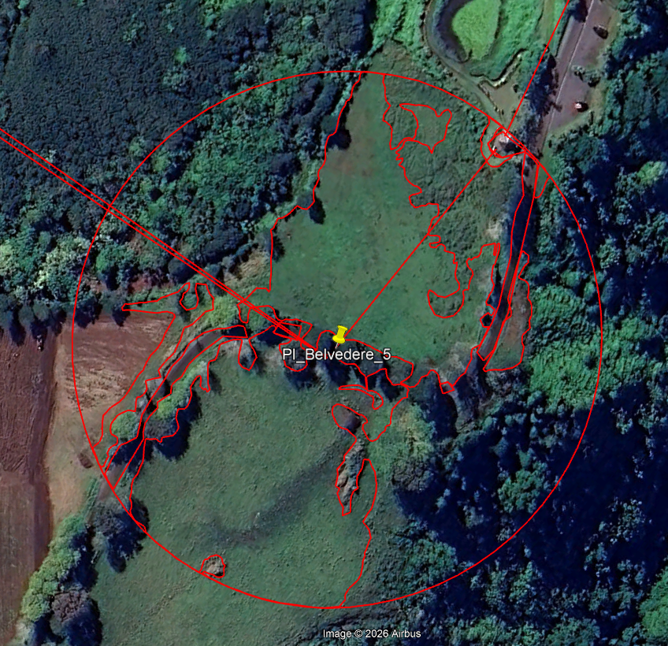
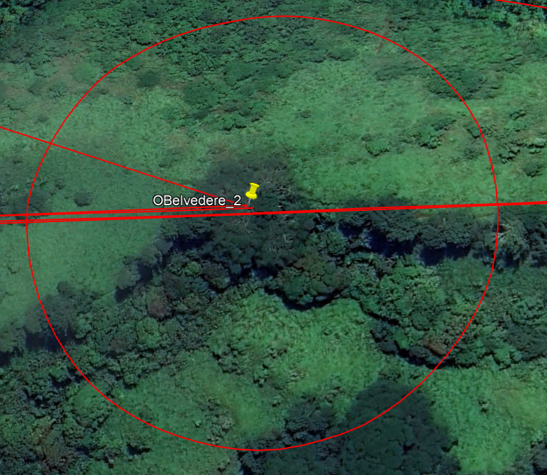

Figure 1: Séparation parfois complexe entre les vraies zones herbacées et les végétations de fougère (PI_Belvedre_5). Les fougères peuvent représenter des surfaces importantes (OBelvedere_2).

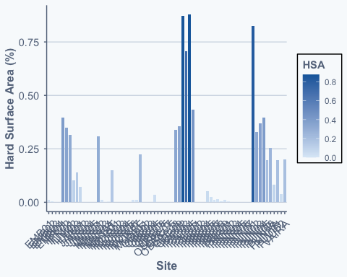
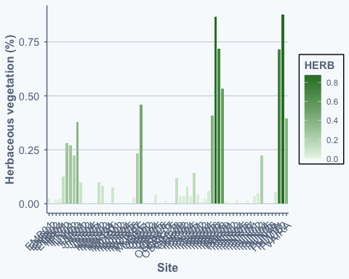

Figure 2: Proportion de HSA et de couvert herbacé par site. Ces deux variables ne sont pas corrélées entre elles: “cor(HSA,HERB)” = 0.03168

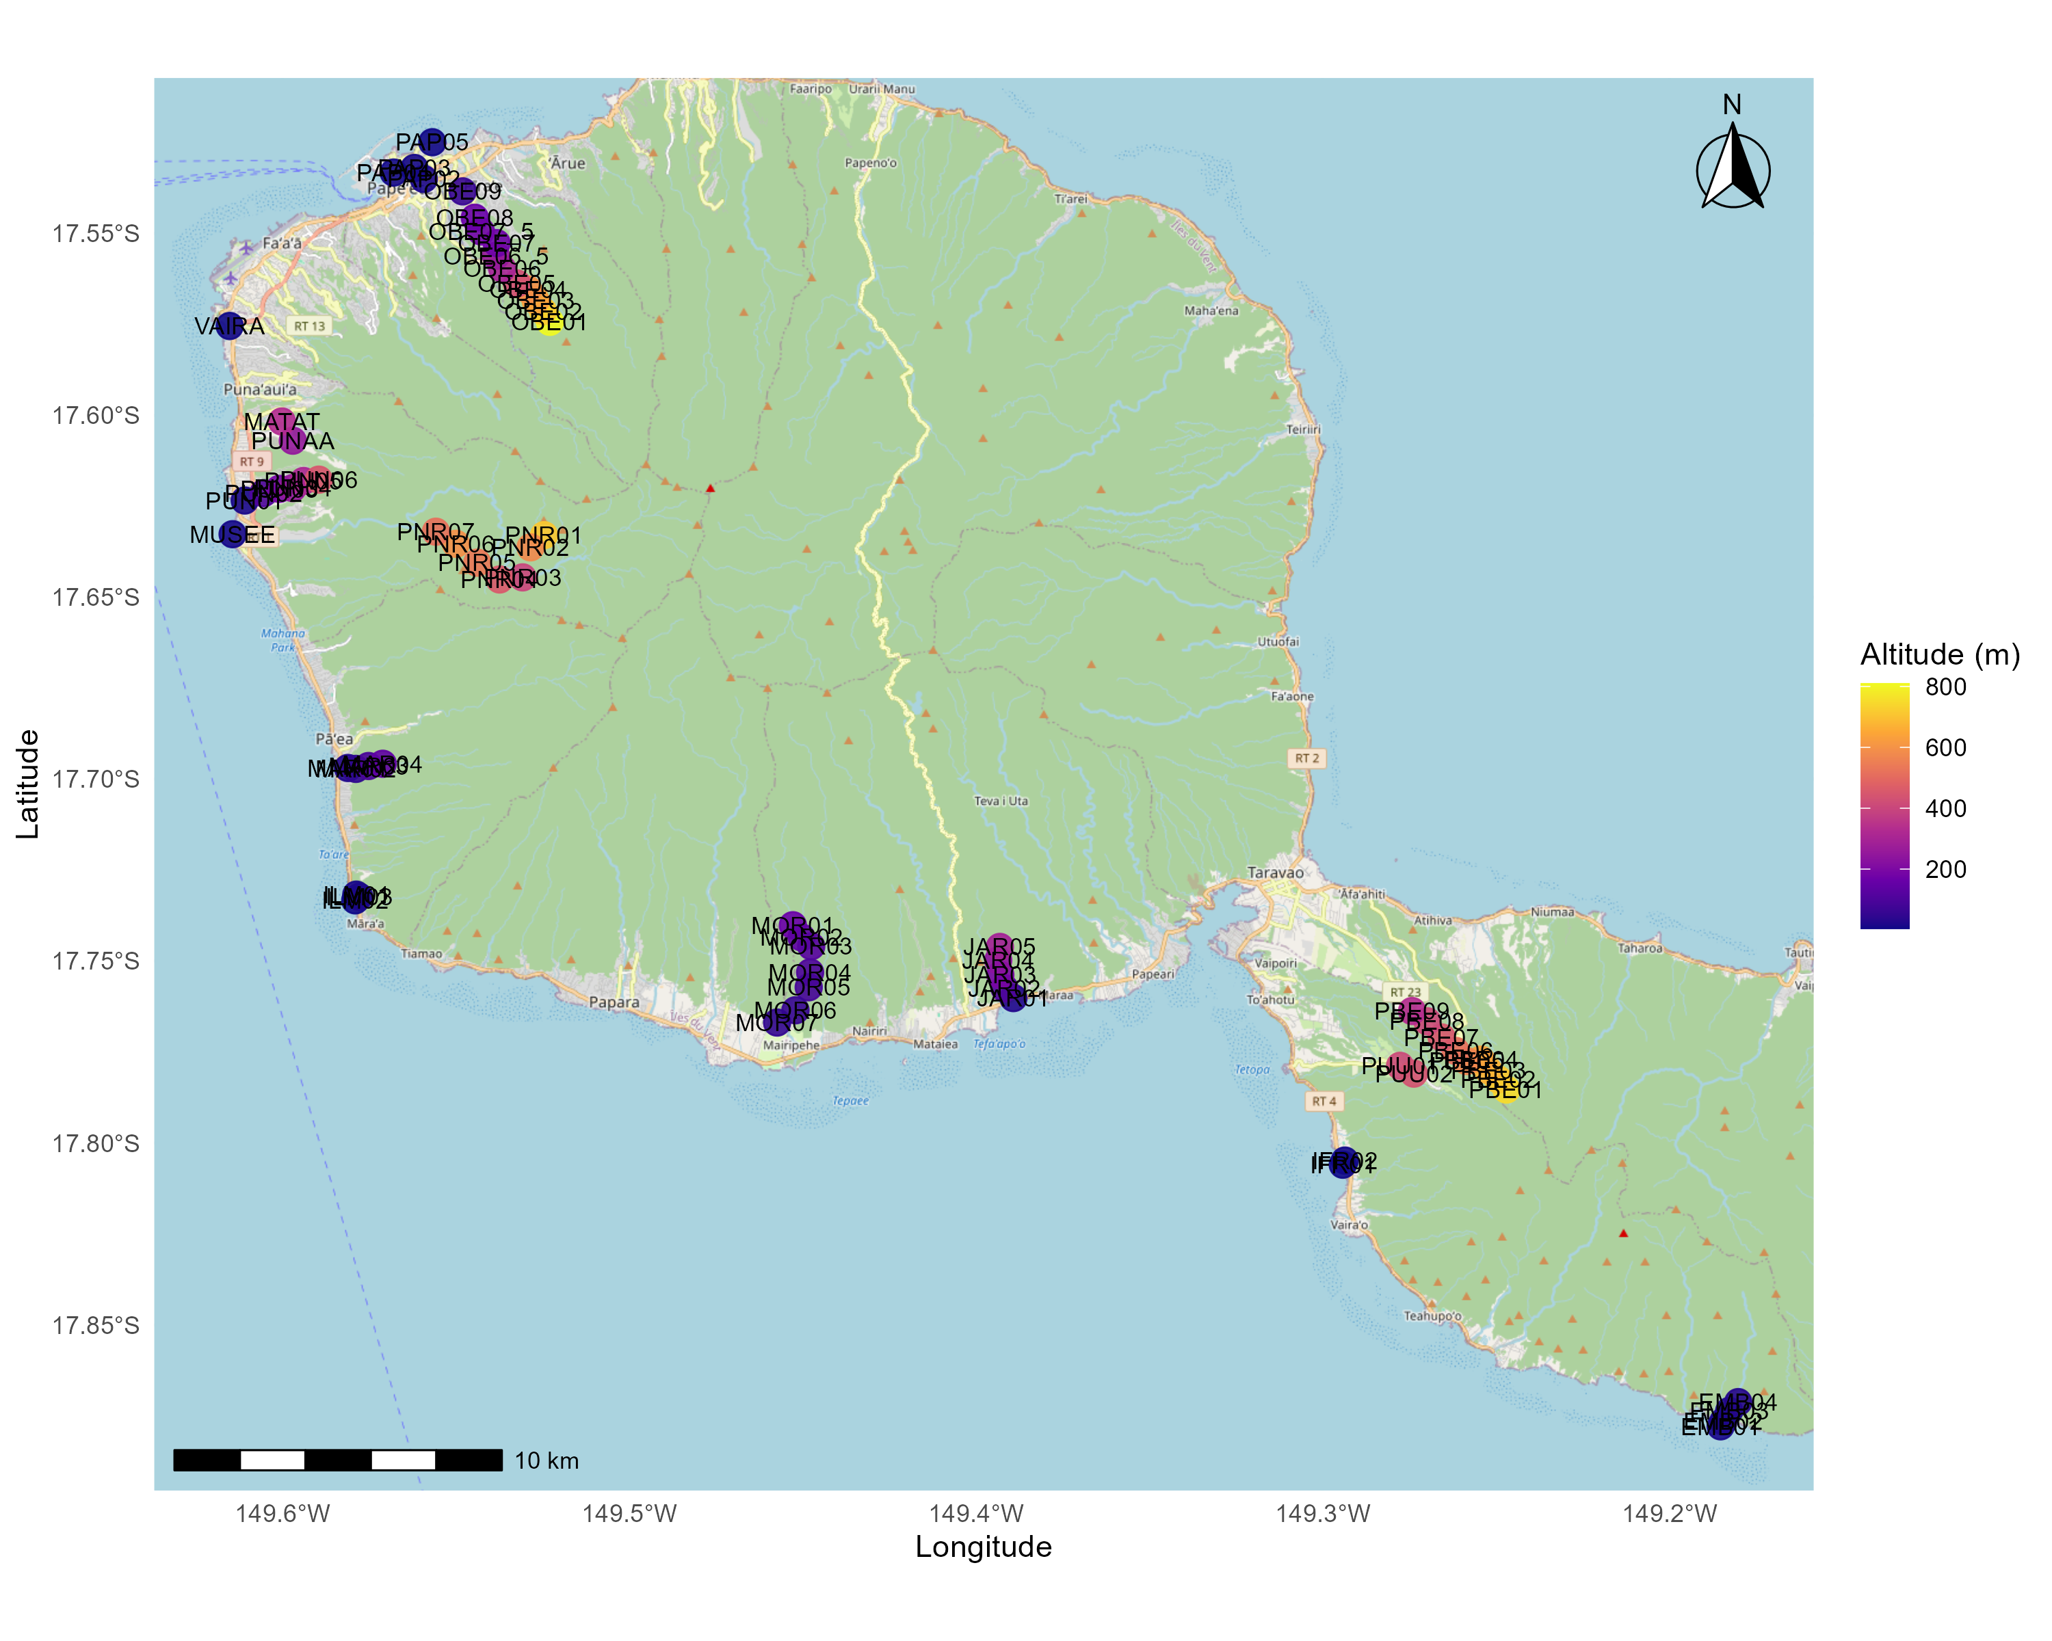

Figure 3: Carte des 69 sites intégrés dans les enregistrements de paysage sonore. Les couleurs chaudes représentent les sites de plus haute altitude.

