High Efficient Pitch Tracking Method for Tonal Feature Extraction

Li Ming, Yu Tiecheng, Wen Yuan
Speech Processing Lab, Institute of Acoustics, Chinese Academy of Sciences

P.O.Box 2712, Beijing 100080, P.R.CHINA
LiMing@mail.ioa.ac.cn

For tonal languages lexical tone is an important phonemic element. Robust pitch tracker is the basis of the good tonal feature extraction. Sub-harmonics Summation (SHS) is a known robust pitch tracking algorithm. But there are some difficulties to implement it to real time speech recognition system because of its expensive computation required by the high-resolution spectrum. This paper presents a simple and effective method called Efficient Sub-harmonics Summation (ESHS) which overcomes this bottleneck. Dynamic Programming (DP) is a popular postprocessing technique to smooth out gross errors. In this paper, we also put forward Spectrum Band Dynamic Programming that reduces the DP effort by a factor of 25 at very little loss.

Keywords: Pitch tracking, Sub-harmonics summation, Dynamic programming

Introduction

For tonal languages such as mandarin, lexical tones play a critical role to disambiguate confusable words. Pitch tracking is the basis of characterization of tone models. So, it’s necessary to implement a robust and efficient pitch tracker to a real time mandarin speech recognition system. In the past decades, a wide variety of pitch detection methods have been proposed in the speech processing literature [1][2][3][4]. In [5], it presented a comprehensive comparison between several pitch detection algorithms.

The method proposed in this paper is mainly based on Sub-Harmonics Summation (SHS) [6]. We consider several crucial reasons to take it as our pitch tracker basis. Firstly, because our pitch tracker will be used for tonal feature extraction for the speech recognition system, so it will save a lot of computation if we can take advantage of the front-end processing result. At present speech feature based on MFCC (Mel Frequency Cepstrum Coefficient) is the most popular feature used in speech recognition systems. Spectrum obtained from fast Fourier transformation (FFT) is the byproduct of MFCC. So it’s convenient to exploit the spectrum to detect fundamental frequency. Secondly, our goal is to implement a telephone speech recognition system, but pitch detection is particularly difficult for telephone speech since the pitch is often weak or missing. Because of the nature of SHS, this method is quite robust for telephone speech (we will explain it later). Considering the above reasons, we adopted SHS as our main approach to extracting fundamental frequency.

Sub-Harmonic Summation method proposed in [6] measures the periodicity by an equation that is similar with equation (1).

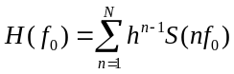 (1)
Where, f₀ is the frequency to be measured, h is the compression factor, S(.) is the amplitude spectrum derived from FFT, N is the number of harmonics which are taken into account.

It is obvious that we need the spectrum values at f₀, 2f₀, 3f₀,…,N f₀ if we want to get the periodicity measurement of f₀. But usually the spectrum resolution derived from front-end processing is too low to provide accurate spectrum values at those points. In [6] they took several measurements to improve the spectrum resolution, such as down sampling speech signals before FFT, increasing FFT size, spectrum interpolation and so on. But for a practical system, pitch detection is not allowed to cost too much time. All methods to increase spectrum resolution mentioned in [6] are not feasible since they are inapplicable or too time consuming for a real time speech recognition system. We found a very simple and efficient method that can detect fundamental frequency effectively at quite low-resolution spectrum.

In order to accelerate pitch detection, we also put forward Spectrum Band Dynamic Programming which decreases the DP effort significantly. At the final part, some experiment results verify the effectiveness of our proposals.

Efficient Sub-harmonics Summ-ation Approach

SHS method is mainly based on the fact that frequencies which are the integer multiples of the fundamental frequency will be reinforced. Since the additive noise and formant don’t have such characteristics, this method is especially resistant to additive noise and formant [11]. Furthermore, according to pitch perception theories [9] people perceive fundamental frequency not only by itself but also by its harmonics. It can be proved by the pitch perception of the telephone speech in which pitch is missing. Therefore, SHS is more robust than other pitch tracking methods for the telephone speech.

However, the biggest obstacle to apply SHS to real time recognition system is its request of high-resolution spectrum that is very time consuming to get by interpolation or high resolution FFT. In the following we will present a simple and efficient method which can get high resolution fundamental frequency at low-resolution spectrum. The main idea is to increase the fundamental frequency resolution by taking advantage of its high harmonics. Assume f₀₁, f₀₂ are two fundamental frequencies and f₀₁ is higher m Hz than f₀₂, then their n^{th} harmonics will differ mn Hz. If we have the spectrum whose resolution is mn Hz, we can distinguish f₀₁ and f₀₂ by their n^{th} harmonics.

Generally, if we apply SHS to the low-resolution spectrum directly, it will be like

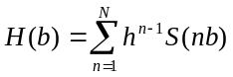 (2)

Where, b is the band index of spectrum. In our system the resolution of spectrum derived from front-end processing is 31.5Hz. Because this resolution is too low to detect fundamental frequencies effectively, we got very bad result when using equation (2).

Fortunately, we found a effective and low cost method that can be briefly described by

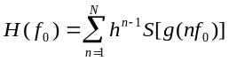 (3)

Where, f₀ is the fundamental frequency f_{0min}< f₀< f_{0max} , N is the harmonic number which is given by

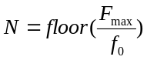 (5)

Where, F_{max} is the maximum harmonic frequency, floor(x) is the function which returns a value representing the largest integer that is less than or equal to x, g(.) is the function outputting the spectrum band that the harmonic frequency belongs to. It is defined by

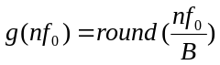 (4)

Where, round(.) is the function which rounds a number to its nearest integer, B is the resolution of spectrum.

In the following we will give the theoretical deduction that what fundamental frequency resolution we can achieve by this approach.

Since f₀₁ and f₀₂ are very close, some of their harmonics would belong to the same band. Namely,

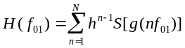 (6)

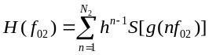 (7)

Where,

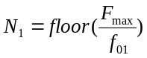 (8)

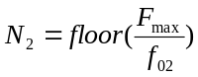 (9)

If N₁ and N₂ are not equivalent, it is safe to think H(f₀₁) and H(f₀₂) are impossible equivalent. In the following we only consider the case that N₁ and N₂ are equivalent.

Since f₀₁ and f₀₂ are very close, some of their harmonics would belong to the same band. Namely,

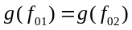

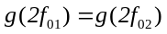

• • • • • • • • • • • •

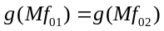

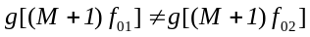

• • • • • • • • • • • •

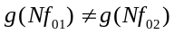

Where, N equals to N1 and N2, M is the maximum harmonic number that the harmonics of f₀₁ and f₀₂ belong to the same band.

If it is satisfied that H(f₀₁) doesn’t equals to H(f₀₂), at least we have

(10)

Since f₀₁> f₀₂ and g(.) is a ascending function, thus

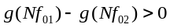 (11)

Furthermore, g(.) function only outputs integers, hence

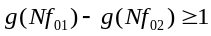 (12)

Namely,

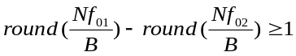 (13)

Guaranteeing equation (13) is satisfied, we have

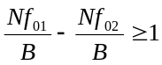 (14)

According to equation (5)

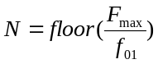 (15)

If we ignore the floor function in equation (15) and substitute (15) into (14), we obtain

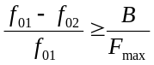 (16)

The left side of equation (16) is the relative resolution of fundamental frequency. In our case B equals to 31.5Hz and F_{max} equals to 1250Hz, therefore the relative resolution of fundamental frequency of our pitch tracker is 2.5%.

Reduction of Dynamic Progra-mming Effort

Usually we use dynamic programming as an important postprocessing technique that can filter out some doubled and halved errors. Because the search space of dynamic programming grows with the square of number of candidates, we should reduce the candidate number as smaller as possible. Taking advantage of the characteristics of pitch that pitch doesn’t change rapidly in short time, we present Spectrum Band Dynamic Programming (SBDP) which does dynamic programming for spectrum band candidates instead of pitch candidates. In [7] they proposed a similar idea to reduce DP effort by decreasing DP resolution. Since the number of bands is quite smaller than that of pitch candidates, the search space is reduced dramatically. After dynamic programming for band candidates, we obtain an optimal band path. Then we can select the most possible pitches in the optimal bands. Our approach can be described as follows.

Initialization:

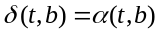 t = 0 (17)

Where, t is the frame index, b is the band index, α(t,b) is the maximum harmonics sum for the band b at frame t, which is given by

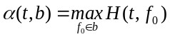 (18)

Iteration:

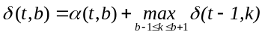 (19)

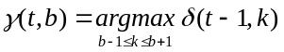 (20)

Where, 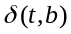 is the cumulative score of band b at frame t, 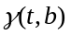 records the trace back path.

Backtracking:

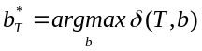 (21)

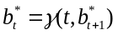 (22)

After tracing back, we get the optimal band path 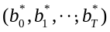. Then we use equation (23) to obtain the optimal fundamental frequency in the optimal band.

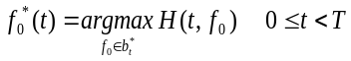 (23)

After dynamic programming, we also used median smoothing technique and linear smoothing technique [10] to improve the pitch contour further.

Experiment Results

We used about 300 sentences as the test data that contained simultaneous electroglottograph. The speech data were recorded in quiet office and sampled at 8K rate. One track of the recordings contained speech, the other track contained the electroglottograph signal providing larynx closures as a reference for pitch evaluation.

Fig.1 is an example of the result of pitch tracking. The black line is the reference pitch contour derived from electroglottograph signal. The gray line is the pitch contour given by our pitch tracker. It is obvious that the pitch contour provided by our pitch tracker almost always follows the reference contour.
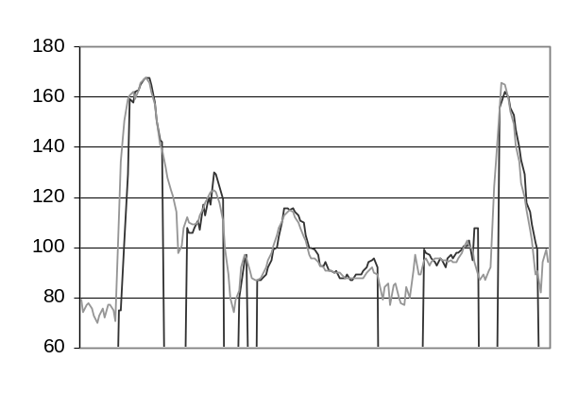Figure 1. An example of pitch contour, the black line is the reference pitch contour, the gray line is the pitch contour provided by our pitch tracker. x axis is frame index and y axis is fundamental frequency. The unvoiced section in gray pitch contour is concatenated smoothly by DP technique.

In order to compare the speed and performance between ESHS proposed by us and the classical SHS, we implemented another pitch tracker which complied with the procedure of classical SHS[6]. First the sample rate was reduced from 8K to 2K by averaging four consecutive samples. Because the downsampled signal was different from the original signal, we couldn’t take advantage of the spectrum result from MFCC any more. We had to do another FFT on the downsampled signal. Then we interpolated the spectrum at 48 points per octave. In this case we could use equation (1) directly to calculate subharmonics summation. As for the following procedure such as Dynamic Programming and smoothing we adopted the same method used in our pitch tracker.

Table 1 is the performance comparison between ESHS and the classical SHS. The pitches which deviate more than an octave are regarded as gross errors. Consumed time is the ratio of time spent by the pitch tracker and the speech duration. It is obvious that ESHS has the similar gross error rate as SHS does but the speed of ESHS is about 32 times faster than that of SHS, which shows that our proposal is very effective.

In order to verify the effectiveness of Spectrum Band Dynamic Programming, we also made an experiment with the full search dynamic programming. Table 2 is the comparison of two methods. The search space of classical DP is 70×15 which means there are 70 pitch candidates and 15 optional pitch backtracking paths per frame. Likewise for SBDP 15×3 means 15 band candidates and 3 optional band backtracking paths per frame. It can be found that the search space is reduced by a factor of 25 at 0.01% loss when SBDP is applied.

Table 1. Comparison between SHS and ESHS

 | Gross Errors Rate | Consumed Time
SHS | 0.42% | 0.93
ESHS | 0.43% | 0.029

Table 2. Search space reduction by SBDP

 | Search Space | Gross Error Rate
DP | 70×15 | 0.42%
SBDP | 15×3 | 0.43%

In order to explore the suitability of our pitch tracker for telephone speech, we applied it to the same speech data but high-pass filtered at 300Hz(-6dB, 18dB/oct). Table 3 is the experiment results. In this situation the pitch is quite weak or even eliminated, the pitch detection is much more difficult than before.

Table 3. Experiment results for the speech data high-pass filtered at 300 Hz

Gross Error Rate | Consumed Time
1.96% | 0.029

Conclusions

SHS is a robust method to detect fundamental frequency, but there are some difficulties to apply it to real time speech recognition system caused by the expensive computation of high-resolution spectrum. In this paper we propose a simple and effective way to solve this problem which can provide accurate pitch estimate at low-resolution spectrum. By exploiting the characteristics of pitch, we put forward Spectrum Band Dynamic Programming, by which DP effort is reduced dramatically. Our experiment results support the effectiveness of our proposals.

Acknowledgements

We would like to thank Dr. Hoege Harald for his good advice for this paper. We would also like to thank Dr. Tropf Herbert, Marschall Erwin, Christian Geissler, Josef G. Bauer and Ute Ziegenhain for their kind help in this research.

References

[1] A.M. Noll, “Cepstrum pitch determination Journal of Acoustics of Society of America, vol. 41, pp. 293-309, Feb. 1967
[2] B. Gold and L.R. Rabiner, “Parallel processing techniques for estimating pitch periods of speech in the time domain”, Journal of Acoustics of Society of America, vol. 46, pp. 442-448, Aug. 1969
[3] J.D. Markel, “The SIFT algorithm for fundamental frequency estimation”, IEEE Trans. Audio Electroacoustics, vol. AU-20, pp. 367-377, Dec. 1972
[4] M.J. Ross, H.L. Shaffer, A. Cohen, R. Freudberg, and H.J/ Manley, “Average magnitude difference function pitch extractor”, IEEE Trans. Acoustics, Speech and Signal Processing, vol. ASSP-22, pp. 353-362, Oct. 1974
[5] L. R. Rabiner, Michael J. Cheng, Aaron E. Rosenberg, Carol A. McGonegal, “A comparative performance study of several pitch detection algorithms”, IEEE Trans. On Acoustics, Speech and Signal Processing, 24(5), Oct. 1976, pp.. 399-418
[6] Dik Hermes, “Measurement of pitch by subharmonics summation”, Journal of Acoustics of Society of America, Am 83(1), Jan.. 1988, pp. 257-264
[7] Hank Huang and Frank Seide, “Pitch tracking and tone features for Mandarin speech recognition”, ICASSP2000, vol. 3 pp. 1523-1526
[8] Talkin D., “A robust algorithm for pitch tracking(RAPT)”, Speech Coding and Synthesis, W. B. Kleign and K.K. Paliwal, eds., Elsevier Science, Amsterdam, pp. 495-518, 1995
[9] De Boer, E. “Pitch theories unified”, in Psychophysics and Physiology of Hearing, edited by E.F Evans and J.P. Wilson (Academic, London), pp. 323-334, 1977
[10] L.R. Rabiner, M.R. Sambur and C.E. Schmidt, “Application of a Nonlinear Smoothing Algorithm to Speech Processing”, IEEE Trans on Acoustics, Speech and Signal Processing, pp. 552-557, Vol. ASSP-23, No. 6, Dec 1975
[11] L.R. Rabiner, R. W. Schafer, Digital Processing of Speech Signals, Prentice-Hall, Inc. Engleword Cliffs, New Jersey 07632

