A PROJECT REPORT

On

UNIFIED ONLINE LEARNING PLATFORM

Submitted by

Abira Mandal (10831122046) Deep Pati (10831122028)
Rohit Mahato (10831122038)

Shubham Chakraborty (10831122021)

Submitted to Asansol Engineering College in partial fulfilment of the

Requirements for the degree of

Bachelor of Technology
in
Computer Science and Business Systems

Under the guidance of

Mr. Amit Chakraborty
(Assistant Professor)


Computer Science and Business Systems
Asansol Engineering College
Asansol

Affiliated to
MAULANA ABUL KALAM AZAD UNIVERSITY OF TECHNOLOGY


CERTIFICATE

Certified that this project report on “UNIFIED ONLINE LEARNING PLATFORM” is the bonafide work of “Abira Mandal (10831122046), Deep Pati (10831122028), Rohit Mahato (10831122038), Shubham Chakraborty (10831122021)” who carried out the project work under my supervision.

__________________________________

_________________________________

Dr. Sheuli Chakraborty
Assistant Professor & HOD
Department of CSBS
Asansol Engineering College

Mr. Amit Chakraborty
Assistant Professor
Group Mentor, CSBS
Asansol Engineering College

Computer Science and Business Systems

Asansol Engineering College

Asansol

ACKNOWLEDGEMENT

It is our great privilege to express our profound and sincere gratitude to our Project Supervisor Mr. Amit Chakraborty, Group Mentor for providing us with very cooperative and precious guidance at every stage of the present project work being carried out under his supervision. His valuable advice and instructions in carrying out the present study have been a very rewarding and pleasurable experience that has greatly benefitted us throughout our work.

We would also like to pay our heartiest thanks and gratitude to Dr. Sheuli Chakraborty, HoD, and all the faculty members of Computer Science and Business Systems, Asansol Engineering College for various suggestions being provided in attaining success in our work.

Finally, we would like to express our deep sense of gratitude to our parents for their constant motivation and support throughout our work.

_____________________________________

(Abira Mandal (10831122046))

_____________________________________
(Deep Pati (10831122028))

_____________________________________
(Rohit Mahato (10831122038))

_____________________________________
(Shubham Chakraborty (10831122021))

Date: 4th Year
Place: Asansol Dept. of Computer Science and Business Systems
CONTENT

Certificate …………………………………………………………………….. | ii
Acknowledgement ……………………………………………………………. | iii
Content ...……………………………………………………………………... | iv
List of Figures ...……………………………………………………………… | v
Project Synopsis ……………………………………………………………… | vi
Preface ………………………………………………………………………... | 1
Features of the Project ...……………………………………………………… | 5
Project Technologies …………………………................................................. | 7
Workflow of the Project ………………………................................................ | 12
System Architecture ………………………………………………………….. | 20
Software Requirements Specification…………................................................ | 22
Project Output…………………………………................................................ | 23
Conclusion and Future Enhancements………………………………………... | 27
References…………………………………………………………………….. | 28

LIST OF FIGURES
Figure No. | Figure Name | Page No.
Figure 1 | Block Diagram of tools used | 3
Figure 2 | Use Case Diagram | 4
Figure 3 | DFD level 0 | 13
Figure 4 | DFD level 1 | 16
Figure 5 | ERD | 19
Figure 6 | Student Dashboard | 23
Figure 7 | Real-Time Messaging through Web Sockets | 23
Figure 8 | Video Conferencing through WebRTC | 24
Figure 9 | Courses section | 25
Figure 10 | Assignments section | 25
Figure 11 | Grades section | 26

PROJECT SYNOPSIS

Problem Statement: Unified Online Learning System with Live Streaming, RealTime Chat, and University Integration.

Objective and Scope: The primary objective is to develop a comprehensive, scalable and interactive online learning platform while also integrating capabilities tailored towards offline institutions like colleges, universities, and educational boards.

The system allows:

INSTRUCTORS TO | STUDENTS TO
1. Upload pre-recorded lectures and educational materials. | 1. Enrol in courses.
2. Conduct live streamed classes | 2. Join chat rooms for real-time discussion.
3. Assign quizzes, projects, tests. | 3. Attempt assignments and tests.
4. Evaluate and track student performance. | 4. View analytics, dashboards and progress reports.

Utility: Our proposed online learning platform serves as a modern, scalable, and inclusive solution for addressing a lot of challenges faced by traditional and existing e-learning platforms.
Key improvements:
- Combines flexibility of self-paced learning with interactive features like chat rooms and live sessions, enhancing larger engagement.
- Reduces dependency on multiple platforms (e.g., Google Meet for live class, WhatsApp for notes and discussion, Google Classroom for assignments, etc.) by centralizing all activities in one system.
- Offers real time analytics and score tracking, empowering students to monitor progress and instructors to evaluate performance instantly.
- Makes online education more accessible and structured for institutions wanting to standardize their curriculum.
Our project can benefit:
- Students, by allowing them to gain access to diverse array of courses, real-time doubt solving, progress tracking, and verifiable certificates.
- Instructors, by helping them manage course content, communicate with learners, conduct assignments, and track student performance from a single platform.
- Educational Institutions, by providing them a ready-to-integrate digital system to extend or supplement their offline curriculum delivery.
Resources (Tech Stack):
- Frontend: React.js, Tailwind CSS
- Backend: Spring Boot
- Database: PostgreSQL
- Video Streaming: WebRTC / Wowza / RTMP
- Storage: AWS S3 / Azure Blob Storage
- DevOps: Docker, Kubernetes, GitHub Actions
- Cloud: AWS / Azure

CHAPTER 1: PREFACE

- Introduction
Online learning today suffers from fragmentation, where teaching, communication, assessment, and collaboration are spread across multiple disconnected tools such as Google Meet for classes, WhatsApp for discussions, and Google Classroom for assignments. This scattered ecosystem forces students and teachers to constantly switch between platforms, leading to inefficiencies, missed information, reduced engagement, and poor coordination. Existing tools primarily focus on isolated functionalities and fail to provide a unified environment that supports seamless interaction, structured evaluation, and centralized user management. Moreover, the lack of proper role-based access often blurs responsibilities between students, teachers, and administrators, making system control and scalability difficult. Communication gaps between teachers and students, limited real-time collaboration, and disjointed test management further weaken the overall learning experience. There is also a need for a system that can scale effectively while maintaining organized data storage and secure access control.
The Unified Online Learning System addresses these challenges by providing an integrated online learning platform which combines real-time communication, chat groups, video interactions, test creation and management, and user administration within a single system. Such a platform streamlines workflows, enhances interaction, improves evaluation processes, and provides a structured, scalable solution that bridges the gaps present in current online learning tools.

- Objective of the Project
Online learning today relies on multiple separate tools for classes, communication, assignments, and assessments, which often leads to confusion, inefficiency, and reduced engagement for both students and teachers. Constantly switching between platforms disrupts the learning flow and creates gaps in interaction, communication, and evaluation. To address these challenges, this project aims to build a unified online learning platform that brings all essential academic activities into a single, well-structured system.

The key objectives of the project are:
  - To develop an integrated online learning platform that combines teaching, communication, and assessment features
  - To provide role-based access for students, teachers, and administrators, ensuring secure and organized system usage
  - To enable chat groups, video communication, and real-time messaging for effective collaboration and interaction
  - To allow teachers to create, manage, and evaluate tests within the platform
  - To design a structured and scalable system using modern database practices
By achieving these objectives, the platform seeks to overcome the limitations of existing tools and provide a more seamless, interactive, and efficient online learning experience.

- Motivation of the Project
The motivation for this project comes from firsthand experience as a student struggling to manage academic requirements spread across multiple online platforms. Attending classes on one application, receiving updates on another, submitting assignments elsewhere, and communicating through separate messaging tools made it difficult to stay organized and focused. This fragmentation often led to missed deadlines, lost information, and unnecessary stress, taking attention away from actual learning.
The need for a centralized solution became even more evident during the COVID-19 pandemic, when education shifted almost entirely to online platforms. While digital tools enabled continuity in learning, the absence of a unified and well-structured education system exposed serious limitations in accessibility, coordination, and effective interaction. Students and teachers were forced to rely on a collection of disconnected tools rather than a single cohesive platform designed specifically for education. These challenges highlighted the importance of building a centralized online learning system that can support all academic needs in one place, ensuring smoother communication, better organization, and a more effective learning experience—both during emergencies and in the future of digital education.

4.Figures

4.1 Block diagram of tools used

FRONTEND USER INTERFACE

)
REACT
(

USERS

WEBSOCKET

(
CHAT
)

WEBRTC

)
VIDEO CONF.
(

REST API

(
OTHERS
)

SQL
DATABASE

)
POSTGRES
(

BACKEND (SPRING BOOT)

Figure 1: Block Diagram

of tools used

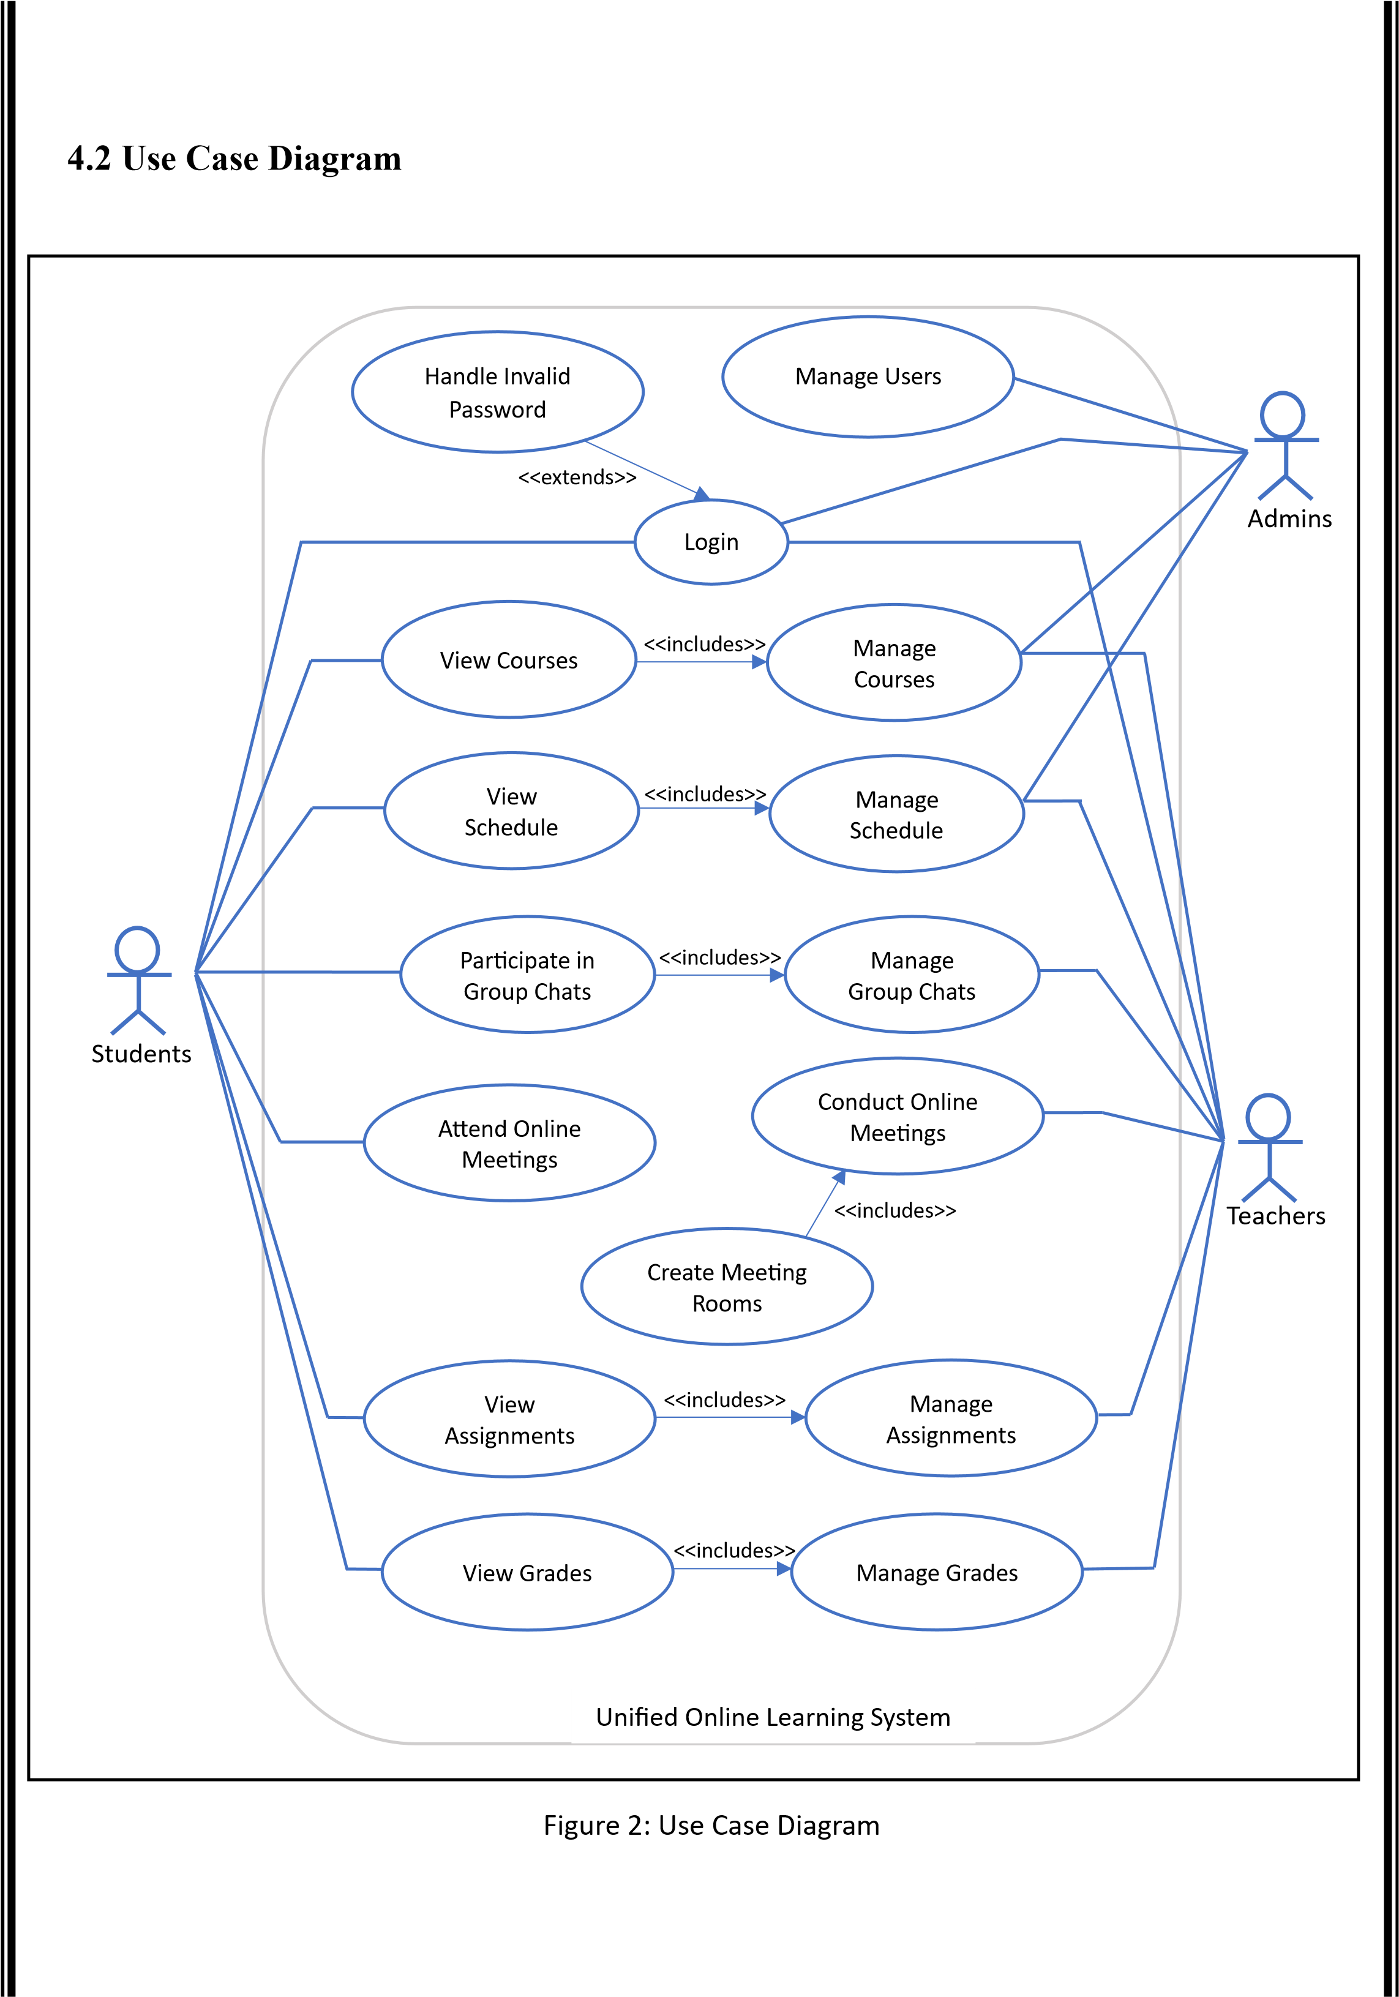

Figure 2 : Use Case Diagram

CHAPTER 2: FEATURES OF THE PROJECT

The Unified Learning System is designed with multiple features that collectively improve the teaching-learning experience of both teachers and students. The system integrates online video conferencing, real time chatting, a centralized backend, and an interactive user interface with dashboards to ensure smooth communication between students and instructors.
The major features of the project are explained below in detail.

2.1 Online Video Conferencing
The platform provides built-in online video conferencing to support live classes, meetings, and discussions between teachers and students. Using real-time video and audio communication, users can attend lectures, interact with instructors, ask questions, and participate in group discussions without relying on external tools. This feature ensures a smooth and uninterrupted virtual classroom experience within the same platform.

2.2 Real-Time Group Chats
Real-time group chat functionality allows students and teachers to communicate instantly within dedicated chat groups. These chats can be used for class discussions, doubt clarification, announcements, and collaborative learning. Messages are delivered instantly, enabling active participation and continuous interaction beyond scheduled class hours.

2.3 Viewing and Submitting Assignments
Students can easily view assigned tasks, submission deadlines, and instructions through the platform. Assignments can be submitted directly in digital format, reducing manual effort and confusion. Teachers can upload assignments, review submissions, and provide feedback in a centralized and organized manner.

2.4 Viewing Grades
The platform allows students to securely view their grades and performance reports for tests and assignments. This transparency helps students track their academic progress and identify areas for improvement. Teachers can update grades efficiently, ensuring timely access to evaluation results.

2.5 Keeping track of schedule
An integrated scheduling feature displays class timings, test dates, assignment deadlines, and important academic events. This helps students and teachers manage their time effectively and stay informed about upcoming activities, reducing the chances of missed classes or submissions.

2.6 Ease of Use
The system is designed with a user-friendly interface that is easy to navigate for all users. Clear layouts, intuitive controls, and centralized access to features minimize the learning curve. This ensures that users can focus on learning and teaching rather than managing multiple tools or complex workflows.

2.7 Data Storage and Management
All system data, including user details, reports, images, locations, and task statuses, are stored in a centralized database. This allows secure and efficient storage and retrieval of data and support for future expansion

CHAPTER 3: PROJECT TECHNOLOGIES

The Unified Online Learning System is developed using modern, reliable, and widely adopted technologies. The selected technology stack ensures scalability, security, cross-platform compatibility, and efficient system performance. Each technology used in the project is explained in detail in this chapter.

3.1 React
React is a popular JavaScript library used for building fast, interactive, and scalable user interfaces, especially for single-page applications. It allows developers to create reusable UI components and efficiently update the user interface when data changes, resulting in a smooth user experience.
- Component-based architecture for reusable and maintainable UI
- Uses a virtual DOM for efficient rendering and performance
- Supports unidirectional data flow for better state management
- Widely used with strong community and ecosystem support

Role in the project:
React was used as the technology on which the front end of the project was created. It allowed us to create an efficient and easy to use user interface.

3.2 Java
Java is a powerful, object-oriented programming language known for its reliability, security, and platform independence. It is widely used for building robust and scalable applications, making it well suited for large systems that require long-term maintainability.
- Object-oriented and modular, promoting clean and structured code
- Platform independent through the Java Virtual Machine (JVM)
- Strong support for multithreading and concurrency
- Extensive libraries and frameworks for enterprise applications

Role in the project:
In this project, Java is used as the backend programming language, handling core business logic, data processing, authentication, and communication between the frontend and the database.

3.3 Spring Boot
Spring Boot is a Java-based framework that simplifies the development of standalone, production-ready applications. It reduces boilerplate configuration and allows developers to quickly build scalable and maintainable backend services.
- Provides rapid application development with minimal configuration
- Built-in support for RESTful APIs and microservice architecture
- Integrated security, dependency injection, and data access support • Easy integration with databases and third-party services

Role in the Project:
In this project, Spring Boot is used to develop the backend services, expose REST APIs, manage authentication and authorization, handle business logic, and support real-time communication features.

3.4 JavaScript
JavaScript is a versatile, high-level programming language primarily used to create dynamic and interactive web applications. It enables real-time updates, user interactions, and seamless communication between the frontend and backend systems.
- Enables interactive and responsive user interfaces
- Supports asynchronous operations for real-time features
- Works seamlessly with modern frontend frameworks like React
- Widely supported across all web browsers

Role in the Project:
In this project, JavaScript is used on the frontend to implement user interactions, handle real-time messaging, and communicate with backend services through REST APIs, Web Sockets, and WebRTC.

3.5 PostgreSQL
PostgreSQL is a powerful, open-source relational database management system known for its reliability, performance, and support for complex queries. It is widely used in applications that require strong data integrity and scalability.
- Supports advanced SQL features and complex relationships
- Ensures data consistency with strong transactional support

- Highly scalable and efficient for large datasets
- Open-source with strong community support

Role in the Project:
In this project, PostgreSQL is used as the primary database to store and manage user data, roles, messages, assignments, grades, schedules, and other academic information securely and efficiently.

3.6 WebRTC
WebRTC (Web Real-Time Communication) is an open-source technology that enables real-time audio, video, and data communication directly between web browsers without the need for external plugins. It is designed for low-latency, high-quality communication.

- Supports real-time video and audio streaming
- Enables peer-to-peer communication for live interactions
- Provides secure communication through built-in encryption
- Works seamlessly across modern web browsers

Role in the Project:
In this project, WebRTC is used to enable online video conferencing and live classes, allowing students and teachers to interact in real time within the platform.

3.7 Web Sockets
Web Sockets is a communication protocol that enables full-duplex, bidirectional communication between the client and server over a single persistent connection. It is ideal for applications that require real-time data exchange.

- Enables instant, low-latency message delivery
- Maintains a persistent connection between client and server
- Efficient for real-time updates and live interactions
- Reduces overhead compared to repeated HTTP requests

Role in the Project:
In this project, Web Sockets are used to implement real-time group chats and instant messaging, ensuring smooth and responsive communication between users.

3.8 Tailwind CSS
Tailwind CSS is a utility-first CSS framework that allows developers to build modern, responsive user interfaces quickly and efficiently. Instead of writing custom CSS, developers use predefined utility classes to style components directly within the markup.
- Utility-first approach for rapid UI development
- Highly customizable and responsive by design
- Promotes consistent and clean user interfaces
- Reduces the need for large custom CSS files

Role in the Project:
In this project, Tailwind CSS is used to design a clean, responsive, and user-friendly frontend interface, ensuring ease of use and a consistent visual experience across the platform.

3.9 Web Technologies (HTML, CSS, JS)
Web technologies such as HTML, CSS, and JavaScript form the foundation of modern web applications. Together, they define the structure, appearance, and interactivity of a website, enabling rich and engaging user experiences.

- HTML provides the basic structure and content of web pages
- CSS controls layout, design, and responsiveness of the interface
- JavaScript adds interactivity, dynamic behaviour, and real-time functionality

Role in the Project:
In this project, these web technologies are used to build the core frontend structure, ensuring the platform is interactive, visually appealing, and seamlessly connected to backend services.

3.10 Development Tools
Development tools such as Visual Studio Code and Eclipse play a crucial role in efficiently building and maintaining software applications. They provide a powerful environment for writing, debugging, and managing code across different technologies.
- Visual Studio Code (VS Code) is used for frontend development with support for JavaScript, React, and web technologies, along with extensions for debugging and version control
- Eclipse is used for backend development, especially for Java and Spring Boot applications, offering strong tooling for project management and debugging

Role in the Project:
In this project, these development tools are used to streamline frontend and backend development, improve productivity, and ensure code quality throughout the development process.

3.11 Testing Tool (Postman)
Postman is a widely used API testing tool that allows developers to send requests to RESTful APIs, inspect responses, and automate testing of backend services. It simplifies testing and debugging by providing a user-friendly interface for interacting with APIs.
- Enables sending GET, POST, PUT, DELETE, and other HTTP requests
- Allows inspection of request headers, parameters, and responses
- Supports automated testing and collection of API requests
- Helps debug and validate backend functionality before integration

Role in the Project:
In this project, Postman is used to test and verify backend APIs, ensuring that features like user authentication, assignment submission, schedules, and messaging work correctly before connecting them to the frontend.

CHAPTER 4: WORKFLOW OF THE PROJECT

4.1 Student Workflow
4.1.1. Student registers/logs into the platform
4.1.2. Views available courses and enrols
4.1.3. Accesses pre-recorded video lectures and study materials
4.1.4. Joins scheduled live classes using video streaming
4.1.5. Participates in real-time chat for discussions
4.1.6. Receives scores, feedback, and progress analytics
4.1.7. Downloads certificate after course completion

4.2 Instructor Workflow
4.2.1. Instructor logs in using authentication
4.2.2. Creates and manages courses
4.2.3. Uploads lecture videos, notes, assignments
4.2.4. Conducts live sessions using integrated streaming
4.2.5. Monitors chat and interact with students
4.2.6. Views student analytics and performance reports

4.3 Institution / Admin Workflow
4.3.1. Manages users (students, instructors) 4.3.2. Verifies courses and content
4.3.3. Handles institution-level integrations
4.3.4. Generates system-wide analytics reports

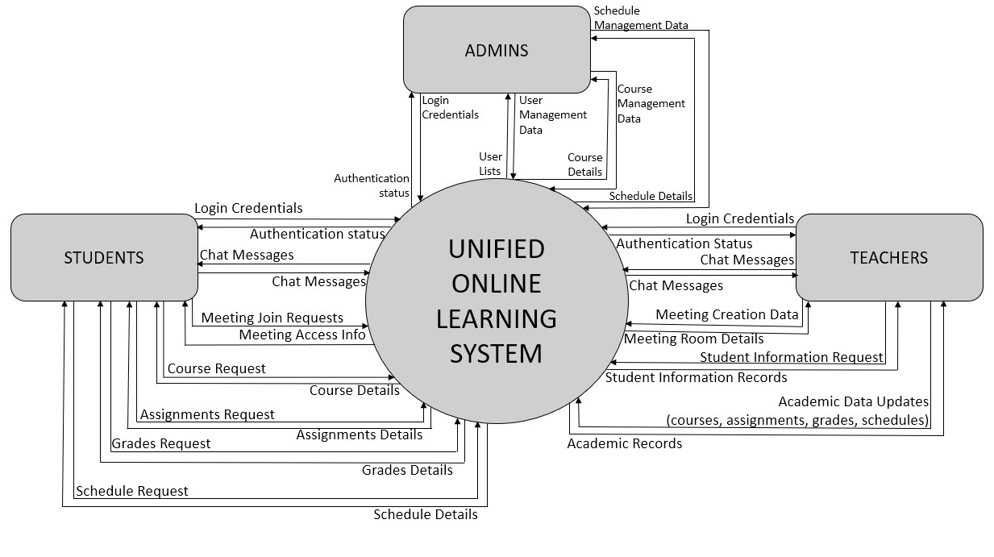
)
4.4
Data Flow Diagram (DFD

4.4.1

Level 0 DFD

External Entities:

•

Students

•

Teachers

•

Admins

Main System (Single Process):

•

Unified Online Learning System

Figure
3:
Level
–

0
Data Flow Diagram

4.4.2 Level 1 DFD

External Entities:
- Students
- Teachers
- Admins
Data Stores:
- D1 User Data
- D2 Chat Data
- D3 Academic Data

Process 1.0: User Authentication and Access Controle
Inputs:
- Login Credentials (Student, Teacher, Admin)
Data Store Interaction:
- Read User Records (D1 User data)
Outputs:
- Authentication Status (Student, Teacher, Admin)
- Access Rights (Other processes)

Process 2.0: Messaging and Group Management
Inputs:
- Chat Messages (Student, Teacher)
- Group Management Data (Teacher)
- Access Rights (Process 1.0) Data Store Interaction:
- Store Chat (D2 Chat Data)
- Retrieve Chat (D2 Chat Data)
Outputs:
- Chat Messages (Student, Teacher)
- Group Information (Student, Teacher)

Process 3.0: Online Meeting Management
Inputs:
- Meeting Join Request (Student)
- Meeting Creation Data (Teacher)
- Access Rights (Process 1.0)
Outputs:
- Meeting Access Information (Student)
- Meeting Room Details (Teacher)

Process 4.0: Academic Information System Inputs:
- Academic Data Requests (Student)
- Academic Data Updates (Teacher)
- Courses and Schedules Data (Admin)
- Access Rights (Process 1.0)
Data Store Interaction:
- Read Academic Data (D3 Academic Data)
- Store Academic Data (D3 Academic Data) Outputs:
- Academic Records (Student, Teacher)
- Courses and Schedule Information (Admin)

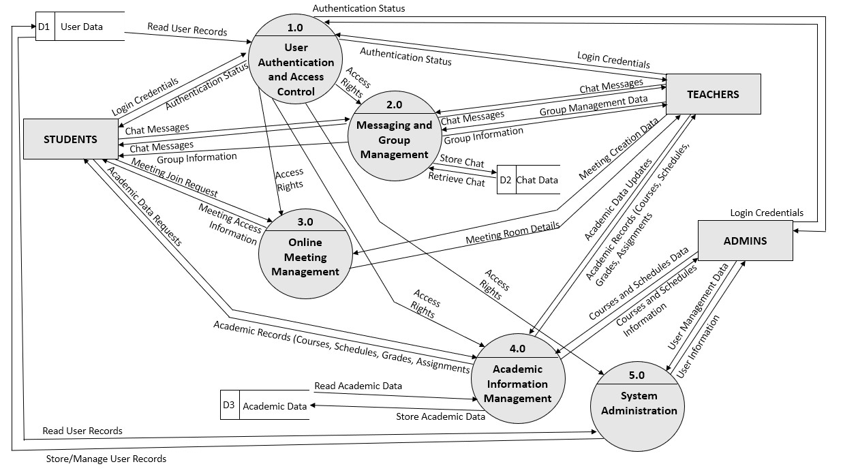
Process 5.0 System Administration

Inputs

•

User Management Data (Admin)

•

Access Rights (Process 1.0)

Data Store Interaction:

•

Read User Records (D3 Academic Data)

•

Store/Manage User Records (D3 Academic Data)

Outputs:

•

User Information (Admin)

Figure
4:
Level 1 Data Flow Diagram

4.5 Entity Relationship Diagram (ERD)

Overview
The ERD models the core entities and relationships of a unified online learning system that supports user authentication, academic management, communication, and online collaboration among students, teachers, and administrators.

User and Role Structure
- The User entity represents all system users.
- Student, Teacher, and Admin are subtypes of User using an ISA (inheritance) relationship.
- Each subtype has a one-to-one relationship with User and inherits all common user attributes.
- This structure ensures role-based access and avoids redundancy.

Course and Academic Management
- Courses are managed by Admins and taught by Teachers.
- A Teacher can teach multiple courses, and a course can have multiple teachers (M: N).
- A Student can enrol in multiple courses, and a course can have multiple students (M: N).

Assignments and Grades
- Assignments are reviewed by Teachers and submitted by Students.
- A Teacher can review multiple assignments (1:M).
- A Student can submit multiple assignments (1:M).
- Grades represent academic evaluation.
- Teachers update grades (1:M) and students view their grades (1:M).

Schedules
- Schedules represent academic timetables or events.
- Schedules are managed by Admins and Teachers (M: N).
- Students follow schedules (M: N).
- Separate relationships are used to clearly distinguish role-based interactions.

Meetings
- Meetings represent online sessions.
- Teachers conduct meetings (1:M).
- Students attend meetings (M: N).
- Meetings are modelled independently and are not associated with chat groups.

Chat Groups and Messaging
- Chat Groups facilitate group communication.
- Teachers manage chat groups, while students participate through membership.
- Group Membership is modelled using an associative entity to support many-to-many relationships and role attributes.
- Chat groups contain multiple messages (1:M).
- Both Students and Teachers can send multiple messages (1:M).

Design Considerations
- Only conceptual attributes are included in entities to maintain abstraction.
- Foreign keys are represented through relationships, not as attributes.
- Derived and system-generated attributes are intentionally excluded.

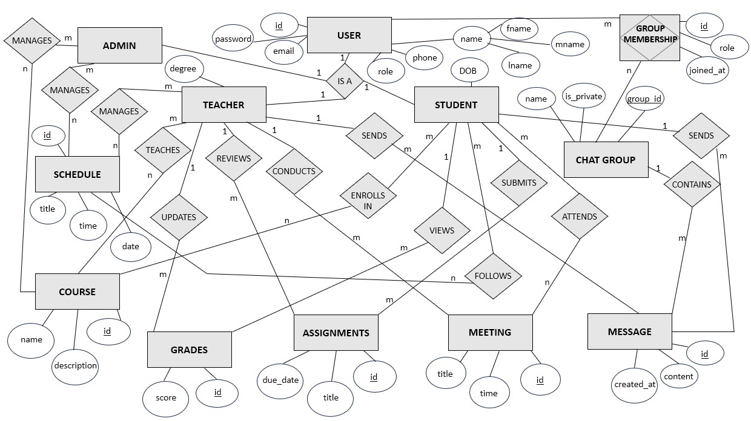

Figure
5:
Entity
–

Relationship diagram

CHAPTER 5: SYSTEM ARCHITECTURE OUTLINE

5.1 Architecture Overview
The Unified Online Learning Platform follows a modular, scalable, and cloud-based architecture designed to support online courses, live streaming, real-time communication, assessments, and institutional integration.

The system uses a three-layer architecture consisting of:
5.1.1: Presentation Layer
- Built using React.js and Tailwind CSS
- Handles user interface, dashboards, live class UI, chat interface
- Communicates with backend using REST API calls

5.1.2: Application Layer (Backend Services)
- Developed using Spring Boot
- Handles all business logic such as authentication, course management, assessment evaluation, analytics
- Integrates with streaming server for live classes
- Provides APIs consumed by frontend and mobile clients

- 1.3: Data & Storage Layer
Includes:
  - PostgreSQL Database for storing user data, courses, tests, chats (if saved), and analytics
  - Cloud Storage (AWS S3 / Azure Blob) for videos, documents, and media files
  - Streaming Server (WebRTC / Wowza / RTMP) for low-latency live class delivery
5.2 Supporting Services
  - Real-time Communication Layer: WebRTC-based chat and streaming
  - Authentication & Security Layer: JWT Authentication, Role-based access control

CHAPTER 6: SOFTWARE REQUIREMENTS SPECIFICATION (SRS)

6.1 Introduction
Purpose
To define the complete functional and non-functional requirements of the Unified Online Learning Platform.
Scope
The system provides online learning through pre-recorded lectures, live streaming, real-time chat, assignment management, analytics, and institutional support.

6.2 Functional Requirements (FR)
6.2.1. User Management
- Users can register, login, and reset password
- Supports 3 roles: Student, Instructor, Admin
6.2.2. Course Management
- Instructor can create/update/delete courses
- Students can enrol and access course materials
- Platform stores videos, PDFs, and notes
6.2.3. Live Streaming
- Real-time live classes using WebRTC/RTMP
- Students can join, leave, and interact
- Instructors can share screen and audio
6.2.4. Real-time Chat
- Students can send and receive messages
- Instructor/moderator can manage chat
- Optional: Store chat logs
6.2.5. Assignment & Test Module
- Instructor creates quizzes
- Students attempt quizzes/tests
- Instructor evaluates subjective answers
6.2.6. Analytics & Reports
- Students view their progress
- Instructors view batch performance
- Admin views system-wide analytics

6.3 Non-Functional Requirements (NFR)
6.3.1. Performance
- Should support 1000+ concurrent users
- Response time < 2 seconds for most operations
6.3.2. Security
- JWT Authentication
- Encrypted data storage
- Secure video streaming
6.3.3. Usability
- Clean UI
- Mobile-responsive
- Easy navigation
6.3.4. Scalability
- Horizontal scaling using Kubernetes
- Microservices-ready backend
6.3.5. Availability
- 24/7 uptime on cloud

CHAPTER 7: PROJECT OUTPUT

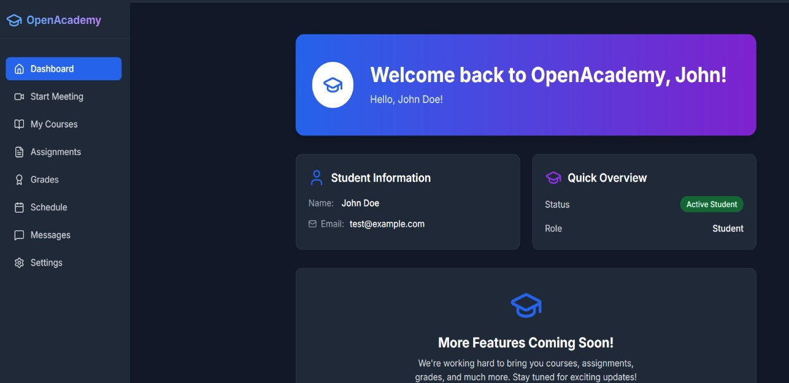
1
. Student Dashboard
:

Figure 6: Student Dashboard
The above figure shows the Students’ Dashboard that will greet the students once they log in with their respective credentials. The dashboard will allow students to get a quick overview of the important topics that deserve their attention and help them to navigate to separate tabs for separate activities.

- Messages:

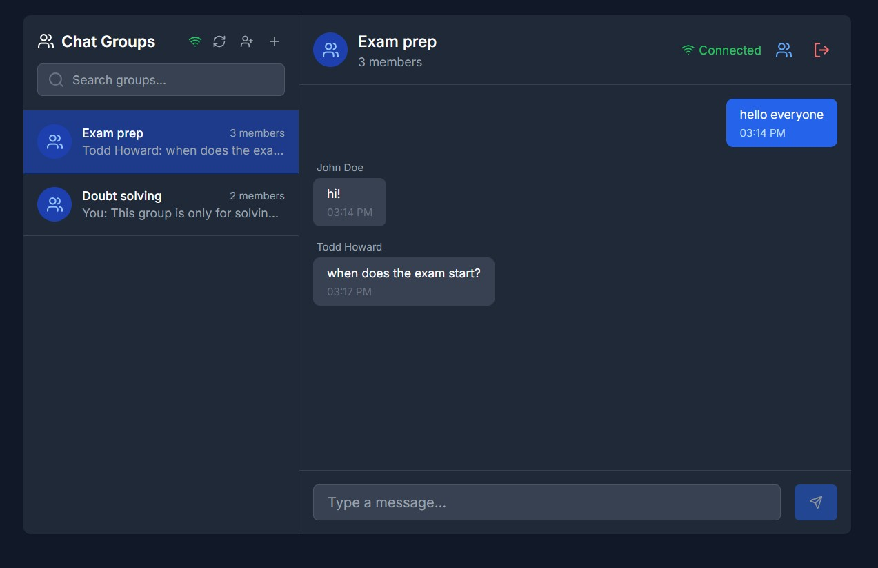

Figure 7: Real-Time Messaging through Web Sockets

The Messages tab allows students to converse with other students and teachers from their institution. This tab allows students to create groups, join groups, leave groups, send messages and delete messages. The decision to include a dedicated messages tab was made to prevent students and teachers from having to deal with distractions which may creep in if they have to constantly switch to other messaging apps.

- Video Conferencing:
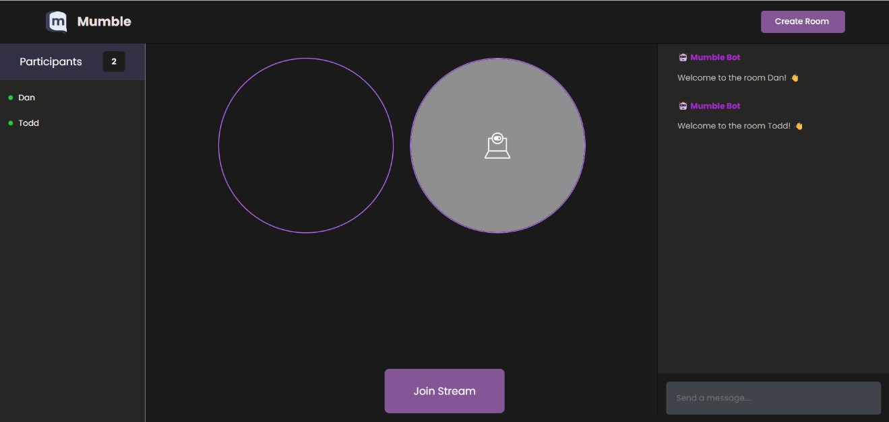

Figure
8:
Video Conferencing through WebRTC

The Meetings tab allows users to create online meeting rooms and/or jump into already existing ones with just a few clicks. This makes the workflow of both instructors and students extremely easy as they no longer have to depend on other tools and services for video conferencing.

4.Courses, Assignments and Grades:
The forthcoming tabs are currently under development and have not yet been fully finalized. Nevertheless, for the purposes of this report, they are included with placeholder data to illustrate their intended structure and anticipated outputs.

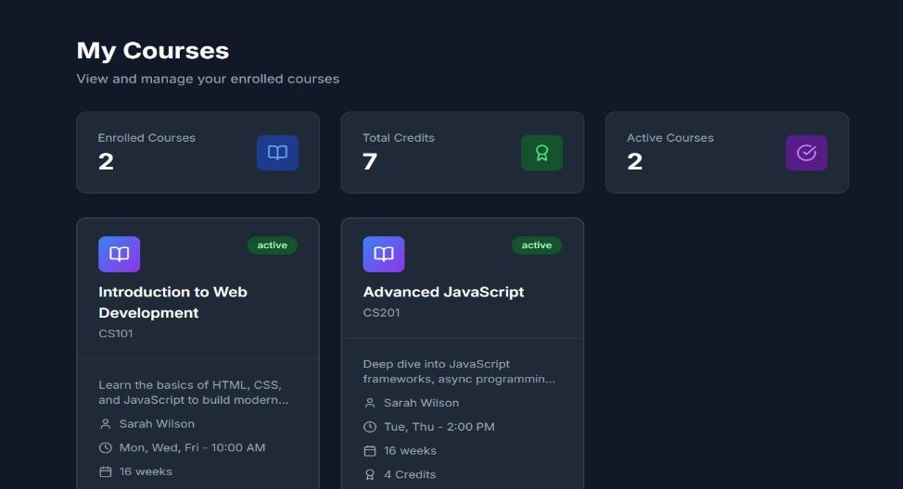
Figure 9: Courses section

The Courses tab showcases a blue print for knowing at a glance which all courses the student is currently enrolled in.

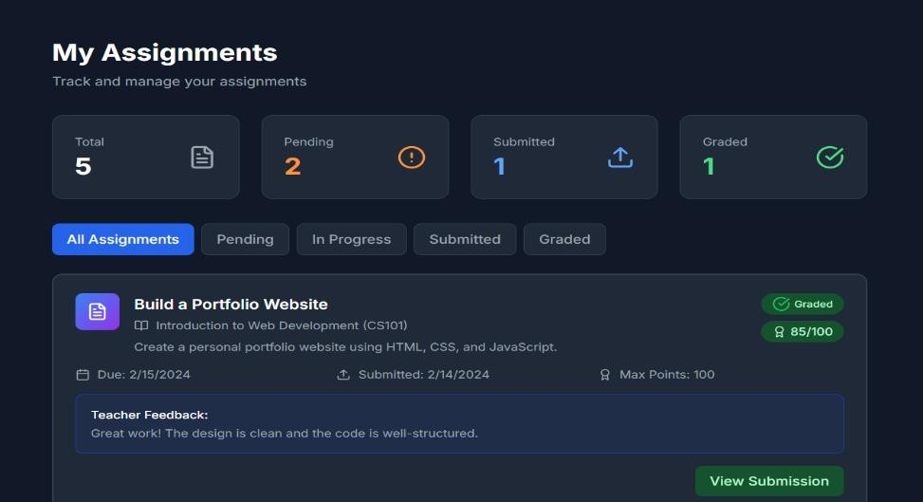

Figure 10: Assignments section

The Assignment tab is helpful in submitting assignments, reviewing them if needed and keeping in track upcoming assignments in the near future.

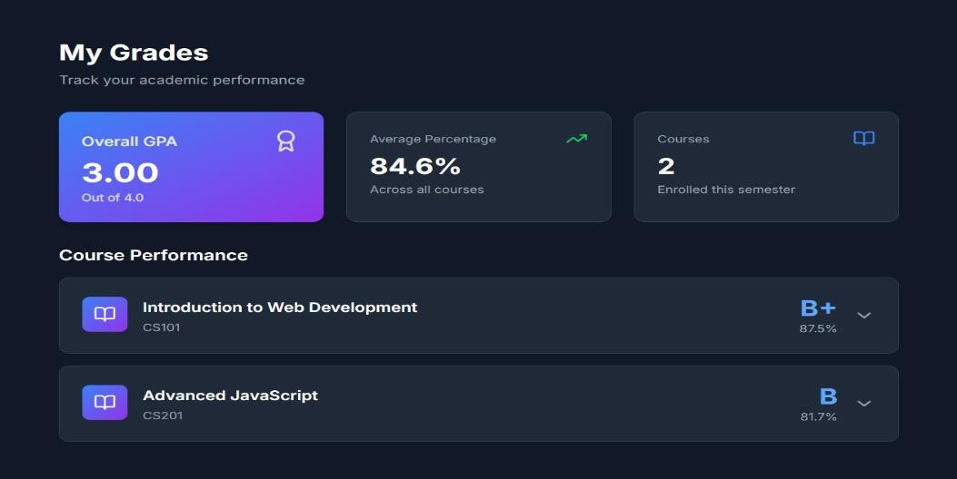
Figure 11: Grades section

The Grades tab contains all relevant information regarding the students’ performance in their enrolled course. This tab is also responsible for housing the respective result cards, grade cards and other existing reports regarding their performances.

CHAPTER 8: CONCLUSION AND FUTURE ENHANCEMENTS

Conclusion: This project proposes a novel fusion of e learning platforms with interactive communication tools and institutional integration, addressing modern-day educational needs. By integrating DevOps practices, this project aims to be both technically sound and user-centric, capable of supporting thousands of users concurrently.

Our project can benefit:
- Students, by allowing them to gain access to diverse array of courses, real-time doubt solving, progress tracking, and verifiable certificates.
- Instructors, by helping them manage course content, communicate with learners, conduct assignments, and track student performance from a single platform.
- Educational Institutions, by providing them a ready-to-integrate digital system to extend or supplement their offline curriculum delivery.

Future Enhancements
In future iterations, the Unified Online Learning System can be enhanced in the following ways:
  - Implement advanced security mechanisms, including encryption of sensitive user and academic information before storing it in the database.
  - Enhance the messaging module to support role-based permissions and customizable communication features similar to platforms like Discord.
  - Integrate the system with universities and educational institutions to support institutional onboarding, centralized course management, and authentication.
  - Extend the platform to conduct secure online examinations and automatically generate digital certificates upon successful completion.
  - Add support for file attachments in chat messages to enable richer communication.
  - Enable sharing of academic resources such as documents, PDFs, presentations, and multimedia files.
  - Deploy the application on cloud infrastructure to improve scalability, availability, performance, and ease of maintenance.

CHAPTER 9: REFERENCES

- React Official Documentation. Available at: React Official Website

- Spring Boot Official Documentation. Available at: Spring Boot Official Website

- PostgreSQL Official Documentation. Available at: PostgreSQL Official Website

- WebRTC Official Documentation. Available at: WebRTC Official Website

- Tailwind CSS Official Documentation. Available at: Tailwind CSS Official Website

- Postman Official Documentation. Available at: Postman Official Website

- Association for Computing Machinery, Chen, Y., Lasecki, W.S., & Dong, T. (2020). Towards Supporting Programming Education at Scale via Live Streaming. Proceedings of the ACM Conference on Computer-Supported Cooperative Work and Social Computing (CSCW ’20).

- Software Development, Kokinda, E., & Rodeghero, P. (2023). Streaming Software Development: Accountability, Community, and Learning. arXiv Research Paper.

- COVID-19 Pandemic, Chen, Z., Cao, H., Deng, Y., et al. (2020). Learning from Home: A Mixed-Methods Analysis of Live Streaming Based Remote Education Experience in Chinese Colleges During the COVID-19 Pandemic. arXiv Research Paper.

- GitHub Official Documentation. Available at: GitHub Official Website

