CC Assignment 1

Steps to create Azure Virtual Machine

- Create azure for student account to get free credits
- Login to azure with your credentials
- Create a virtual machine
  - Create new resource group if not available
  - Select appropriate region and available zone
  - Select preferred image (OS) for the VM
  - For authentication SSH Key is prefered, name the key_pair
  - Select inbound ports permission
  - Further options can be selected as per requirement
  - Review and Create VM

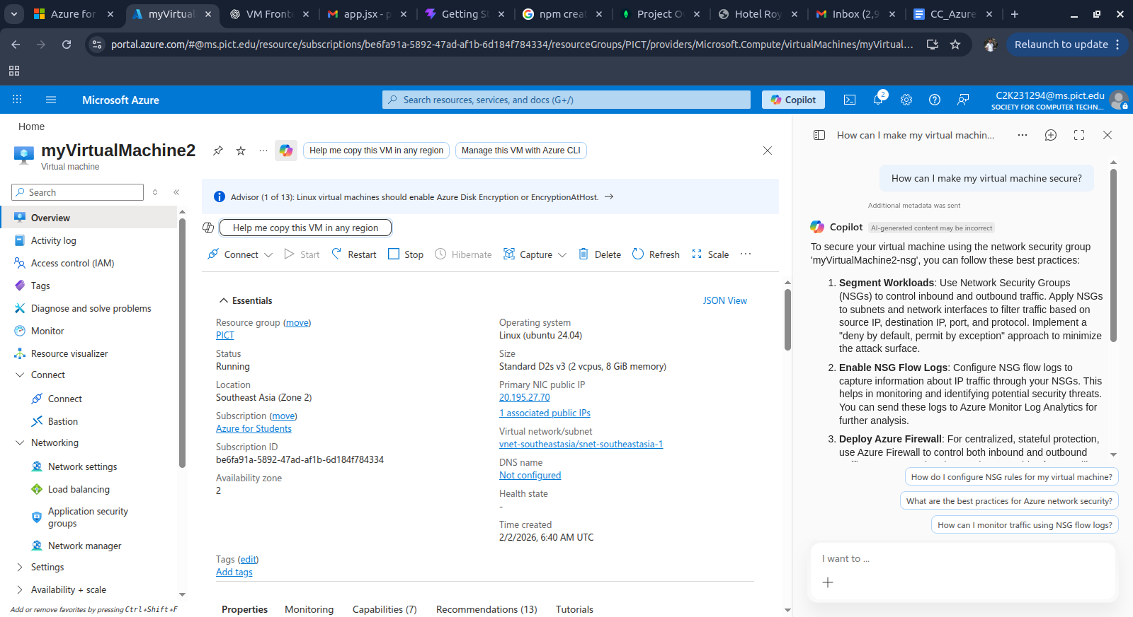

- Download private key when pop up appear

- Go in connect section of VM and copy SSH command
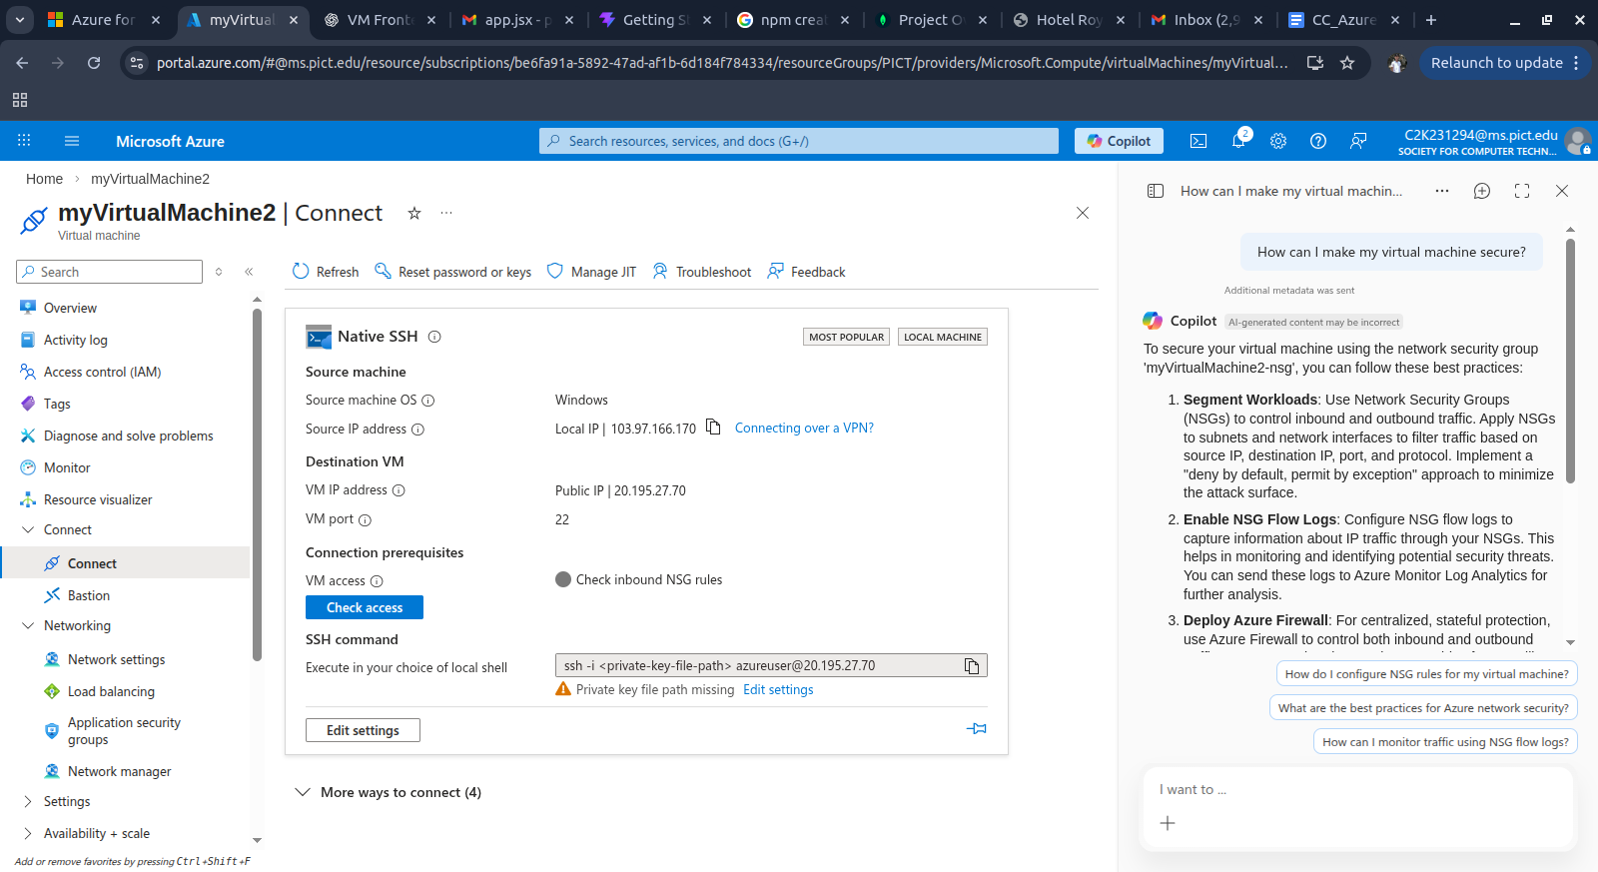

- Change permission of private key pair file to owner access for Linux use
chmod 400 <file-path>
- Use the SSH command in local terminal
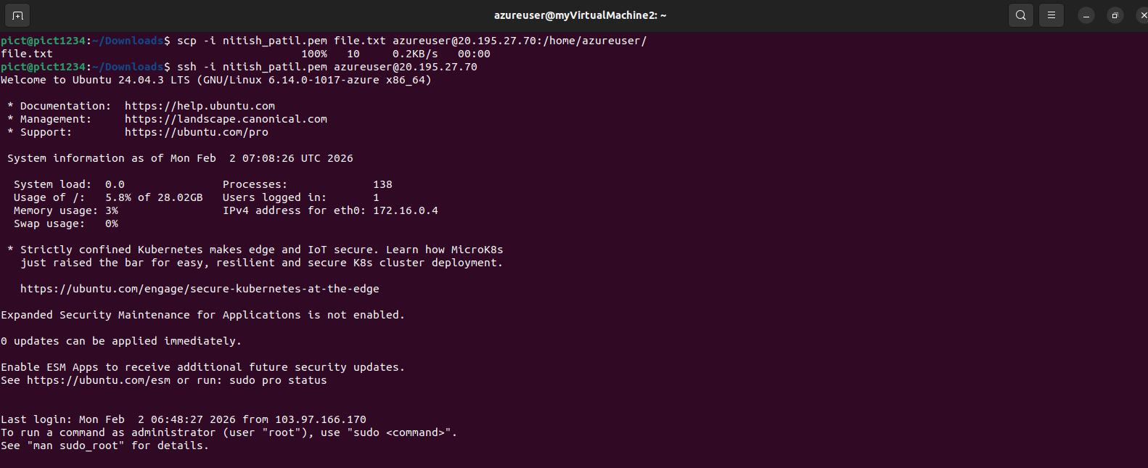

Steps to HOST simple web server

- Create a virtual machine and connect it in local terminal
- Install webserver apache2 on VM -> sudo apt-get install -y apache2
- The service should start automatically. You can check its status using sudo service apache2 status

- Open a web browser on your local machine and type public ip address of your VM.
It should show default apache2 ubuntu home page.

- Now upload your index.html from local machine to virtual machine.
  - Transfer single file
scp -i <path-to-your-private-key> index.html <username>@<public-ip-address>:/var/www/html/index.html
  - Transfer entire folder
scp -i <path-to-your-private-key> -r my_website_folder <username>@<public-ip-address>:/var/www/html/
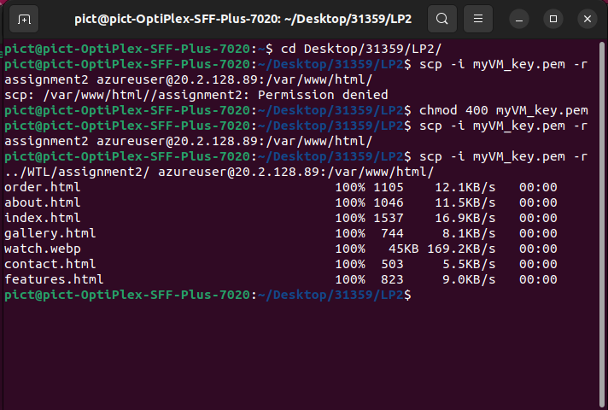

- Move default index.html out of the way
mv /var/www/html/index.html /var/www/html/index-default.html

- Move the contents of your folder up one level to the main html folder
mv /var/www/html/<folder-name>/* /var/www/html/

- Remove your empty folder -> rmdir /var/www/html/<folder-name>

- Open your VM’s public IP address on browser and verify the change
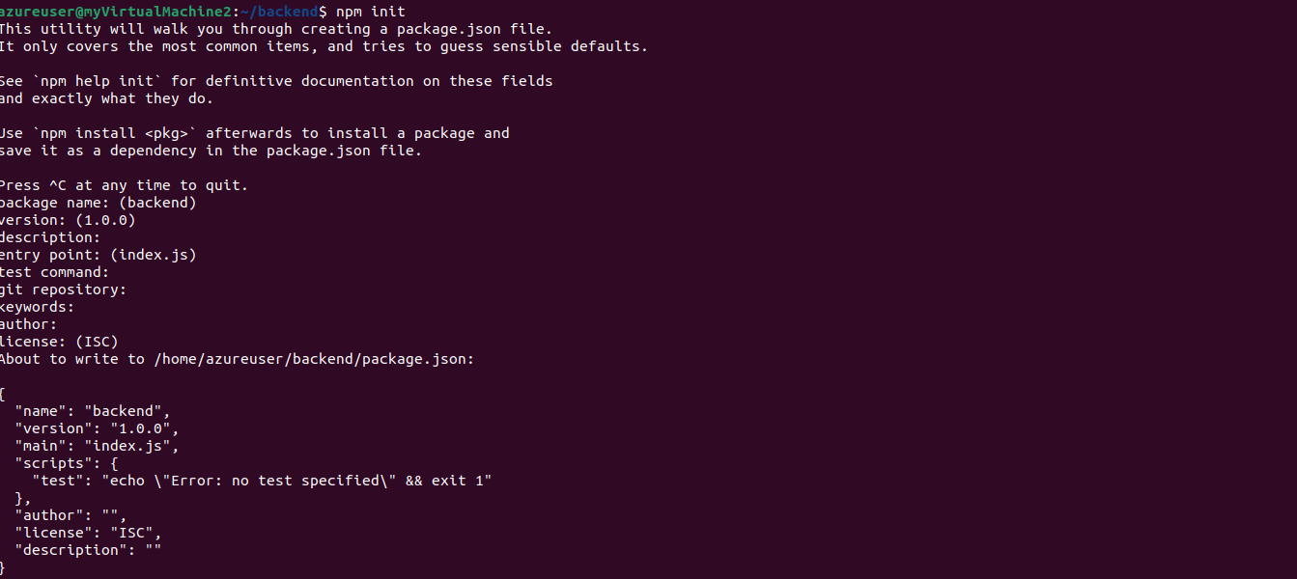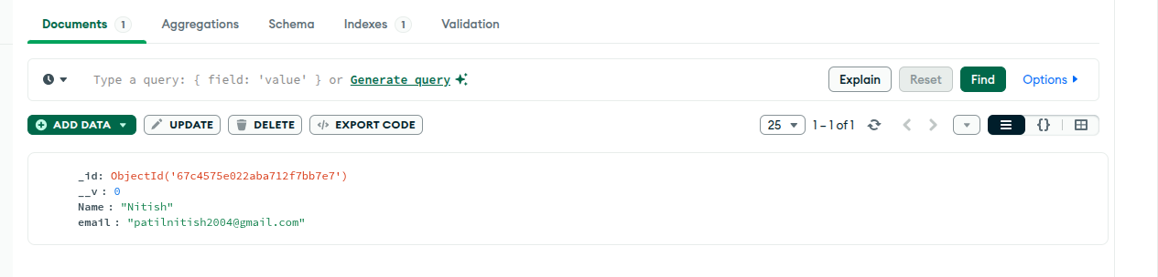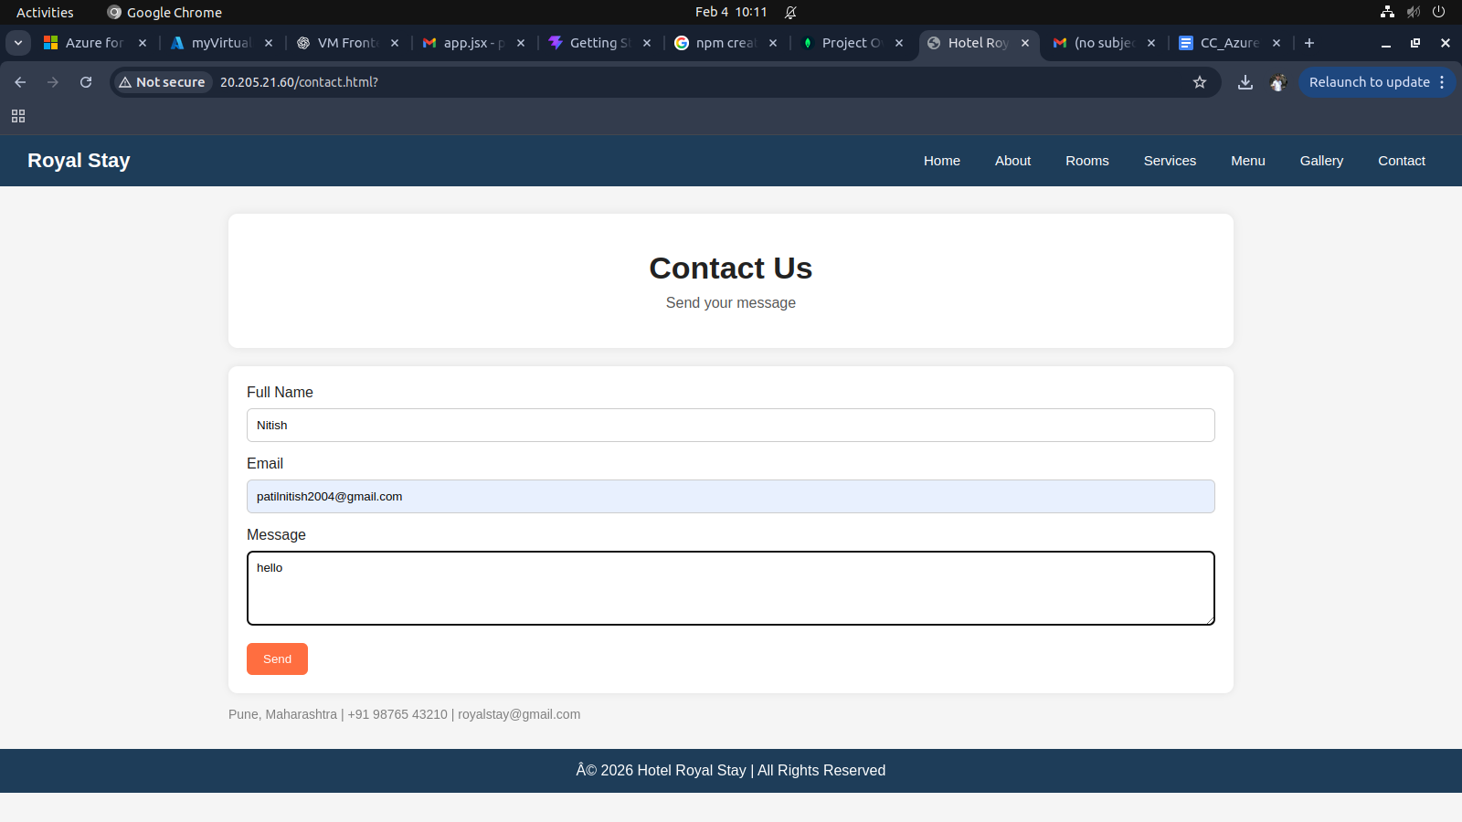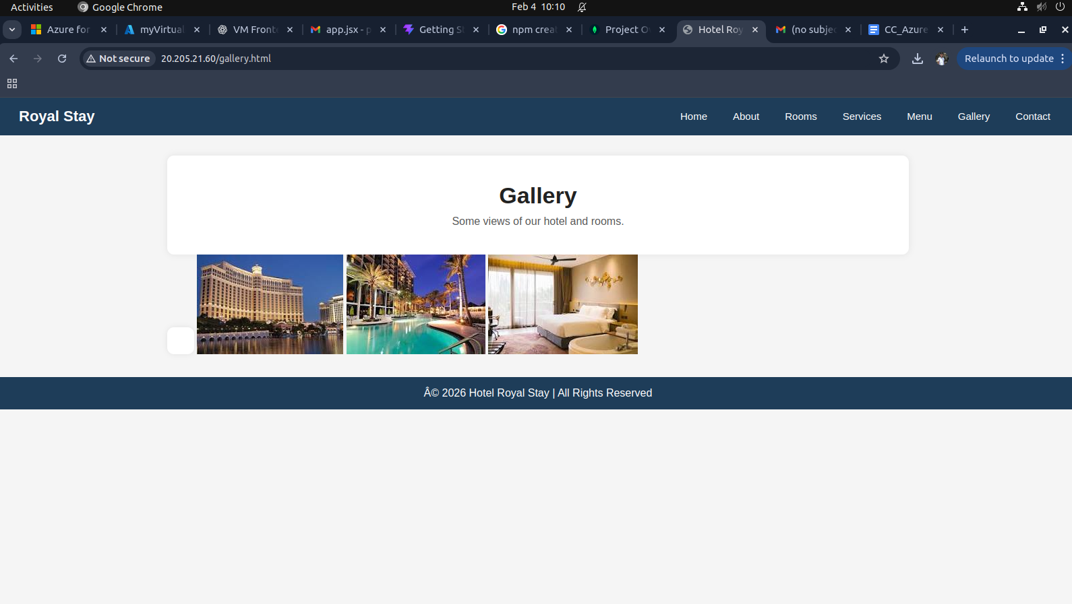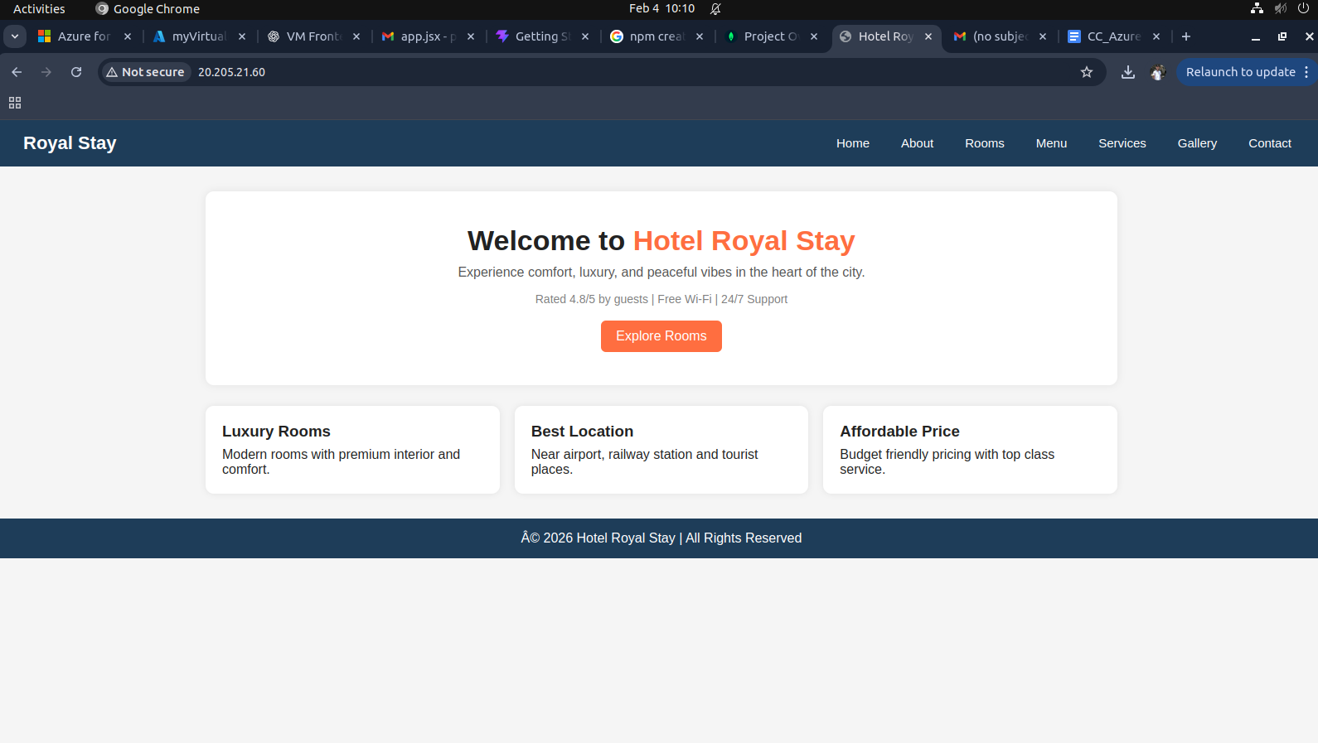

Hosting Backend
1)Connect to Backend VM
ssh azureuser@20.195.27.70
2)Install Required Software: Update system
sudo apt update && sudo apt upgrade -y
Install Node.js 20 (Required)
curl -fsSL https://deb.nodesource.com/setup_20.x | sudo -E bash -
sudo apt install -y nodejs

3)Configure cors and mongodb URI
4)Start BAckend Server

Steps to create virtual network and file sharing
- Create multiple virtual machine
- Make sure that you select same virtual network and subnet while creating this virtual machines
- Run these VM on different terminal windows
- Use scp command to share files across, private IP will be used here
- Use ls command to verify the file has been recieved
