Salesforce Rule Validaton on Fields

Create a custom object with all required fields

Go to Validation Rules section of that custom object

Mark Validation
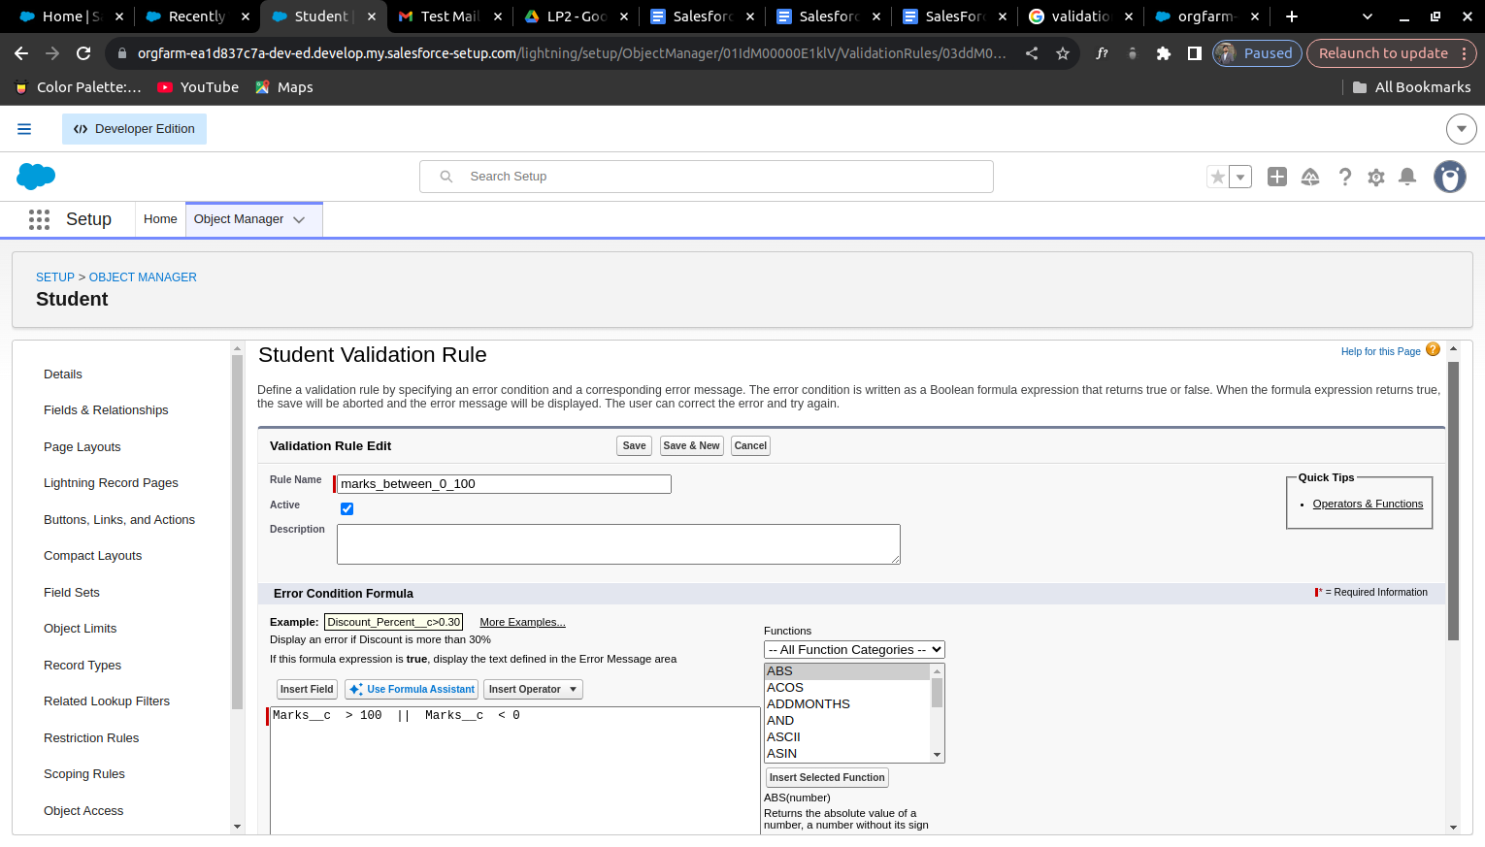

Roll No validation
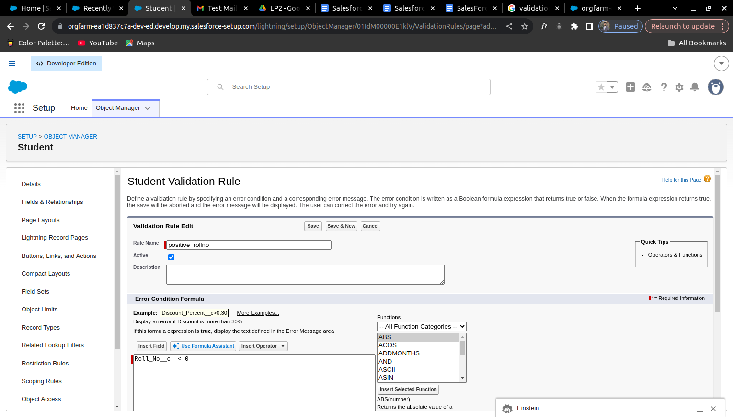

Field Dependency can also be added
Go to Fields & Relationship -> Click Field Dependencies
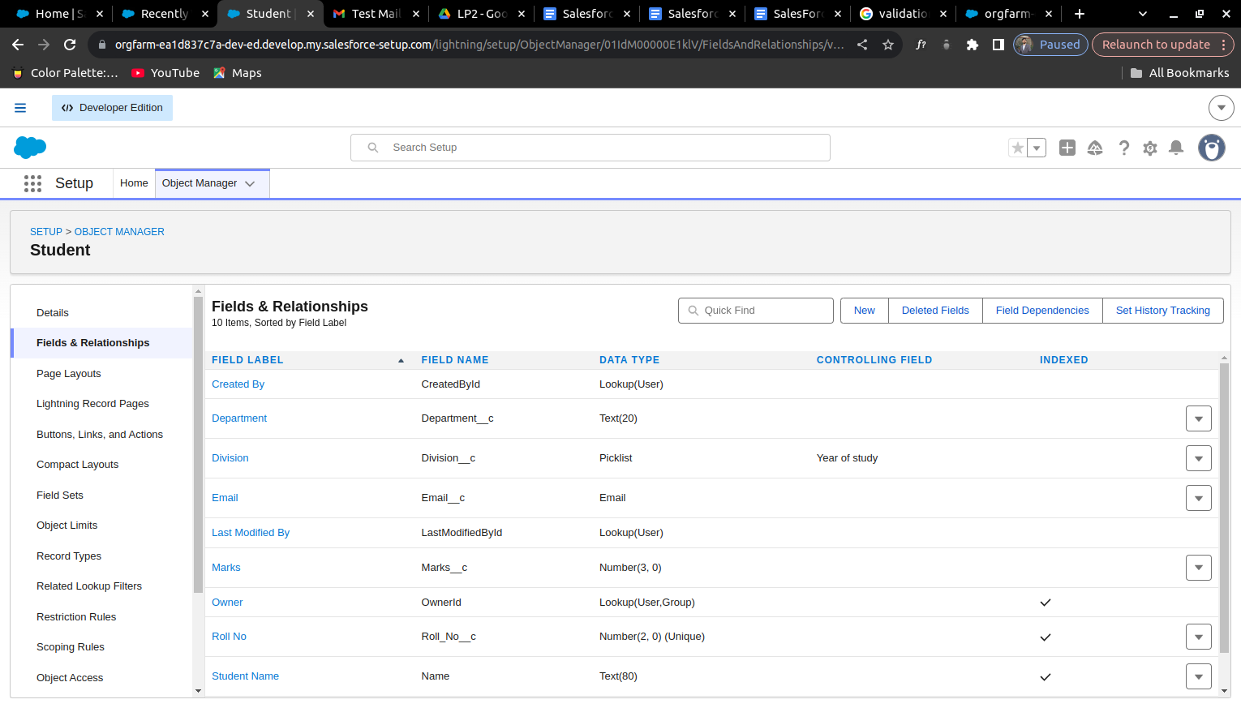

Create new and select Controlling and Dependent Fields

Select the depending field values
