Notes: Lecture 0 - CS50's Web Programming with Python and JavaScript (harvard.edu)

Basic HTML file:

<!DOCTYPE html>
<html lang="en">
<head>
<title>Hello!</title>
</head>
<body>
Hello, world!
</body>
<html>

DIV: a particular section on a screen
ID: a unique element on a web page
CLASS: a set of elements in a web page

SPECIFICITY: ID > DIV

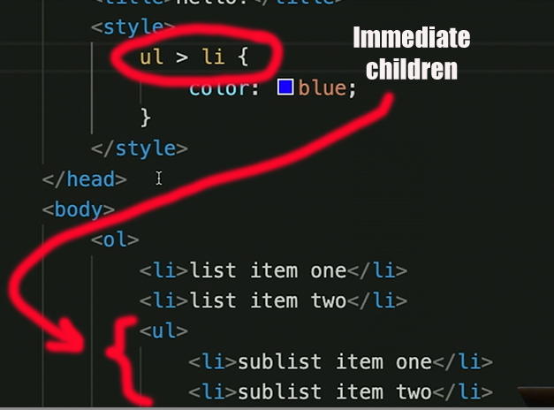

Responsiveness:

<meta name="viewport" content="width=device-width, initial-scale=1.0">

