Kali Linux (formerly known as BackTrack Linux) is an open-source, Debian-based Linux distribution aimed at advanced Penetration Testing and Security Auditing. Kali Linux contains SEVERAL HUNDRED TOOLS targeted towards various information security tasks, such as:
Penetration Testing,
Security Research,
Computer Forensics, and
Reverse Engineering.

We can install Kali as a virtual machine on:

Windows
Apple Mac OS
M1 on Apple Computers
Linux

Installing on Linux:
$ cd Downloads/
$ ls
$ chmod +x Vmware-Player-16.1.2
$ ls
$ sudo apt-get update
$ sudo apt-get install build-essential
$ sudo ./VMware-Player-16.1.2-17966106.x86_64.bundle

Over VMware we add the downloaded Kali machine.

C:\Users\franc\Desktop\hacking\kali_Linux_Virtual_Machine_On_Windows\Kali 2021 x64 Customized by zSecurity v1.0.5.vmwarevm\Kali 2021 x64 Customized by zSecurity v1.0.5.vmwarevm

C:\Users\franc\Desktop\hacking\kali_Linux_Virtual_Machine_On_Windows\Kali 2021 x64 Customized by zSecurity v1.0.5.vmwarevm\Kali 2021 x64 Customized by zSecurity v1.0.5.vmwarevm

Installing on Windows:
Open: Kali 2021 x64 Customized by zSecurity v1.0.5.vmwarevm with 7zip (extract the files)
Open VMware add a new machine (from the files extracted)

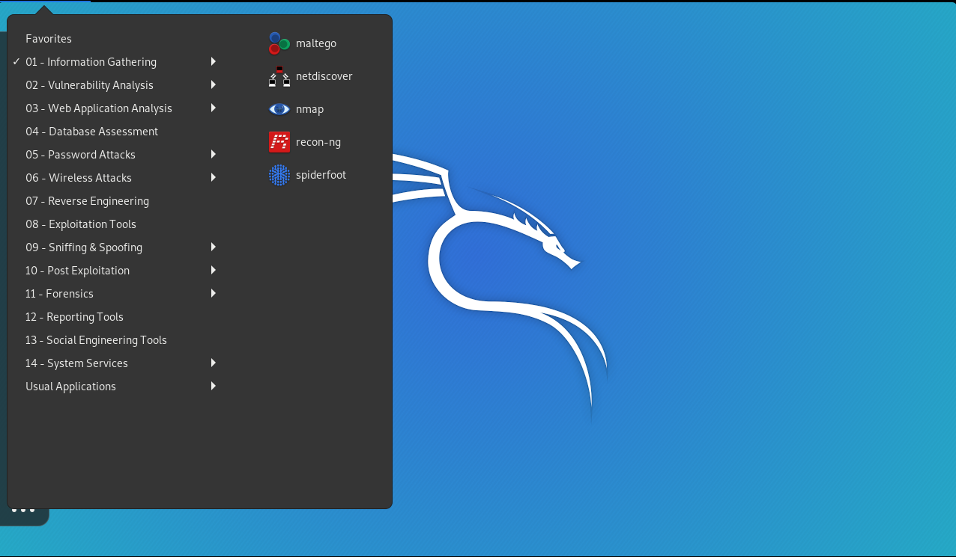

*Note: if we RENAME or MOVE the Virtual Machine: VM ware will not be able to locate it.

User: ROOT
Pwd: TOOR

The Kali Terminal:

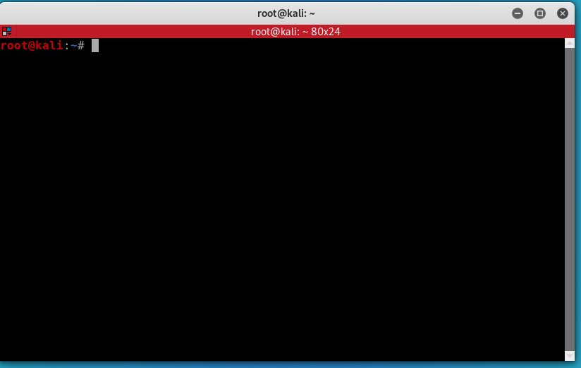
$ ls
$ pwd
$cd Downloads
$ man ls
$ apt-get update (list all the app we can install)
$ apt-get install terminator

List of LINUX COMMANDS
Linux Commanhttps://www.mediacollege.com/linux/command/linux-command.htmlds (mediacollege.com)

Wireless Adapter

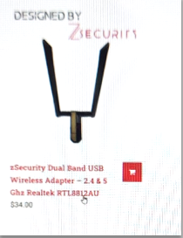

We must install it on the Virtual machine:

- Settings
- Add
- New USB controller

USB compatibility devices: 3.1
Show all USB input devices (check)

Connect the wireless adapter to the laptop
A window will appear:

- Connect it to the virtual machine

Run:

$ ifconfig

It will show a new device: wlan0
Never connect the adapter to a wifi network.

MAC Address

Media Access Control:
-Permanent
-Physical
-Unique

Changing a MAC address:

$ ifconfig (shows all the divices connected)
ether 08:00:27:59:1b:51 (example of a MAC)

$ if config wlan0 down (down the adapter)
$ if config wland hw ether 00:11:22:33:44:55
$ ifconfig wlan0 up (enabled)
$ ifconfig (to verify)

This change is done only on memory. It’ll be gone when restarting the Laptop.

