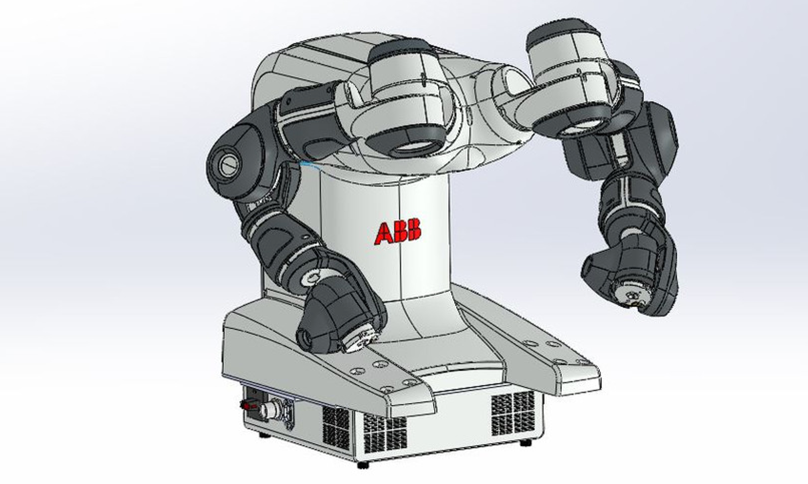

Documentation for downloading***RobotStudio Online Yumi*** and ***Duplo*** on your user interface of the robot controller.

First, ***Duplo***:

**Step 1:** Under the documents tab, create a new folder called “duplo”.

**Step 2:** Locate the “T7(D:)” external SSD storage, inside you will find a folder called “app”.

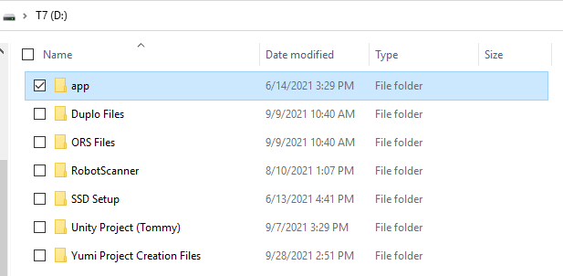

**Step 3:** Copy the “app” folder into the previously created “duplo” folder.

**Step 4:** Open VisualStudio 2019. If you do not have a VisualStudio account you will need to create one at this point.

**Step 5:** Inside VisualStudio you now need to locate the correct project file. First, you will select “Open a local folder”. Next, you will go to the “app” folder you copied earlier. Lastly, you will select the project file called “VCUProject.sln”.

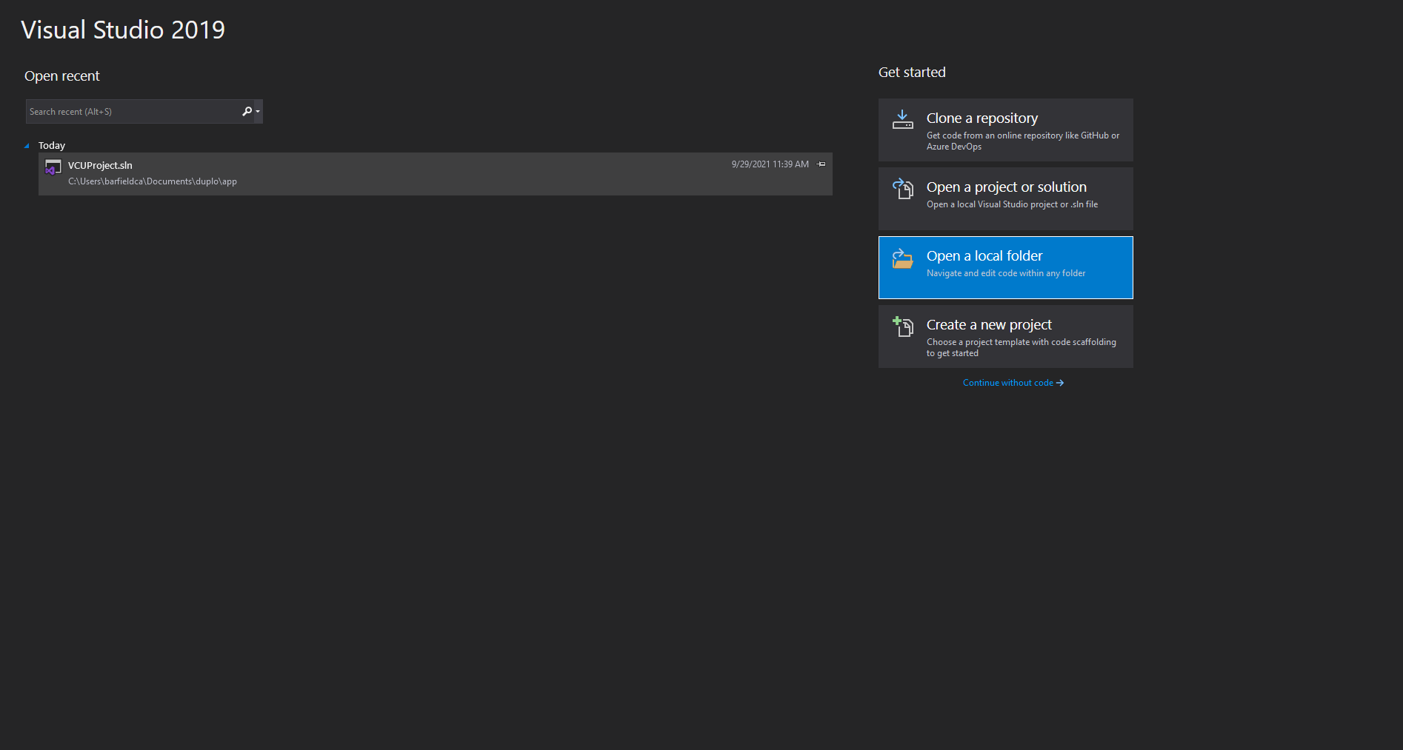

**Step 6:** Now, after the project file has opened, you will start debugging the file by pressing the start button at the top of the screen.



This should load up the duplo web page, next image, if everything was set up correctly.

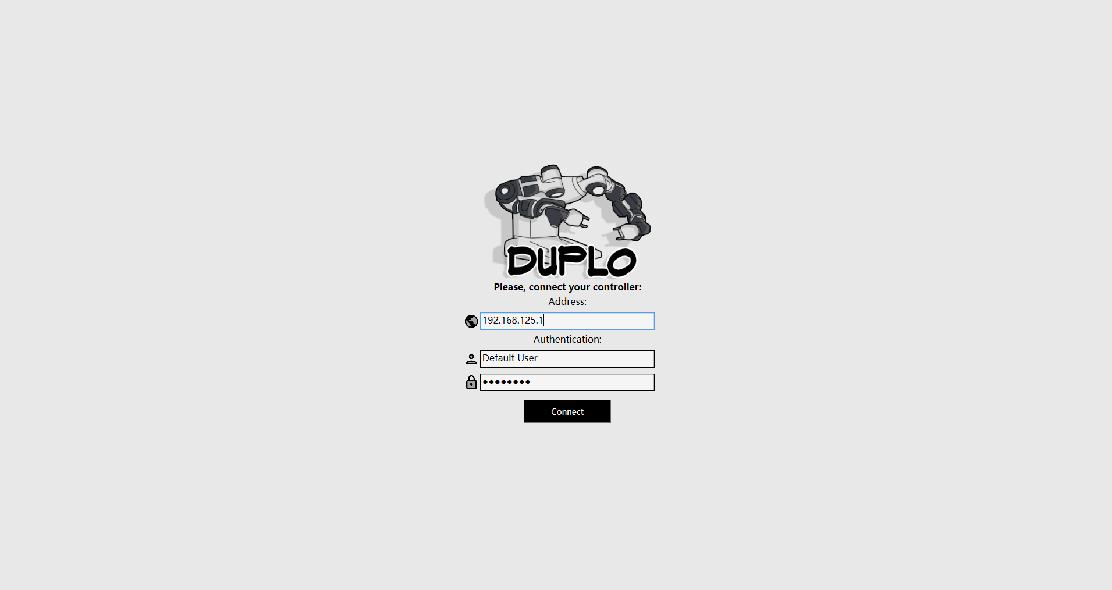

**Step 7:** You will now type in the controllers IP address, in our case this is ***192.168.125.1*** and press “Connect”.

At this point the duplo web page should load two workspace screens and you should be able to program the robot, test that it is working properly now.

in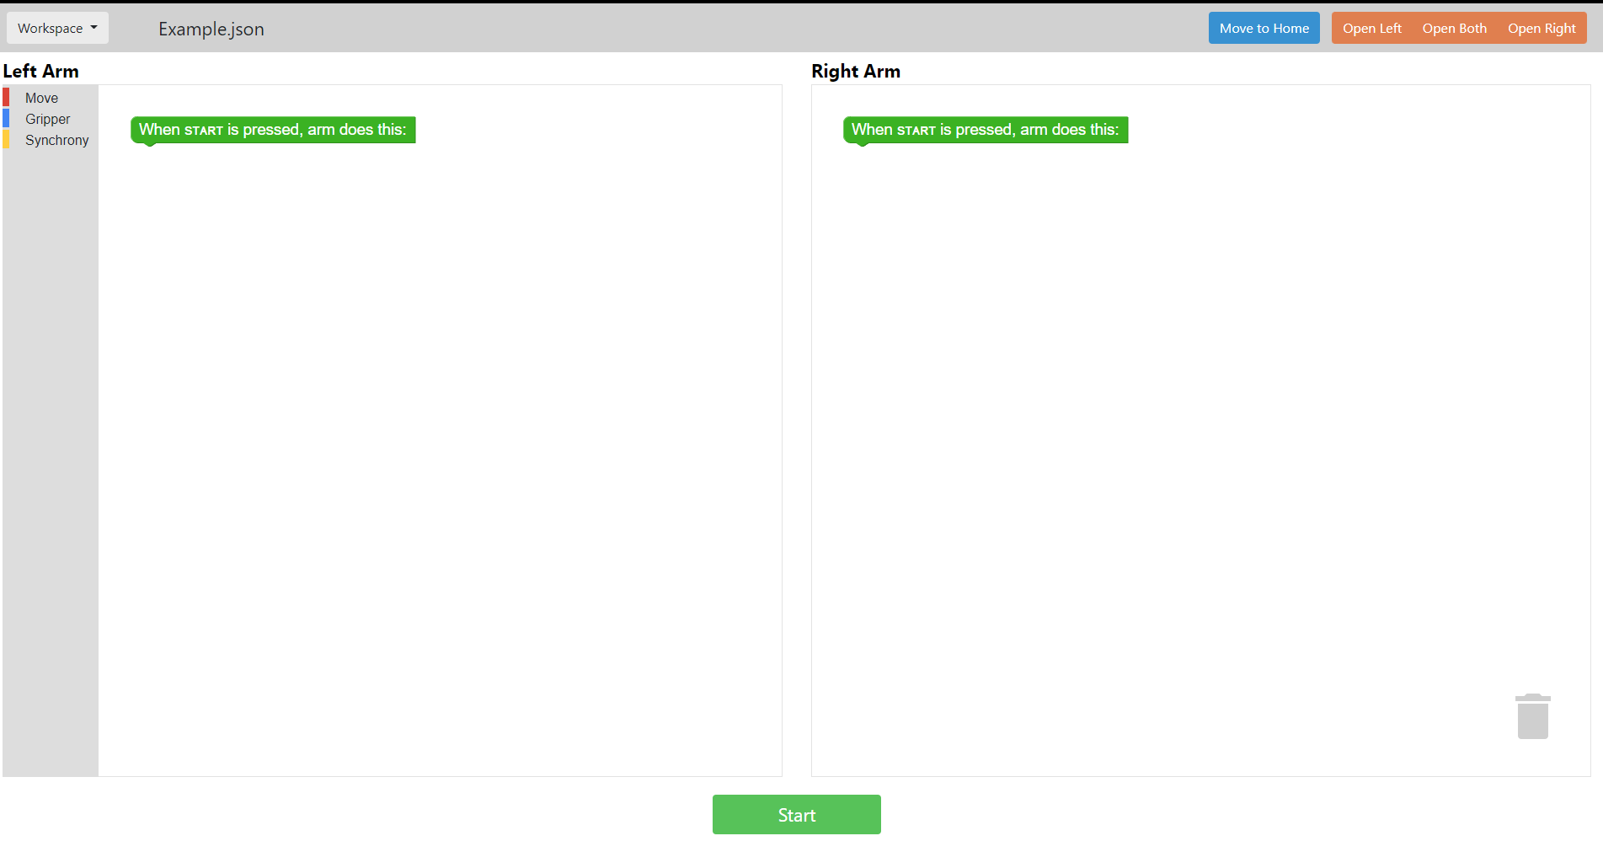

_____________________________________________________________________________________

Next, ***RobotStudio Online Yumi***:

**Step 1:** Under the documents tab, create a new folder called “abb”.

**Step 2:** Locate the “T7(D:)” external SSD storage, inside you will find a folder called “ABB-Yumi”.

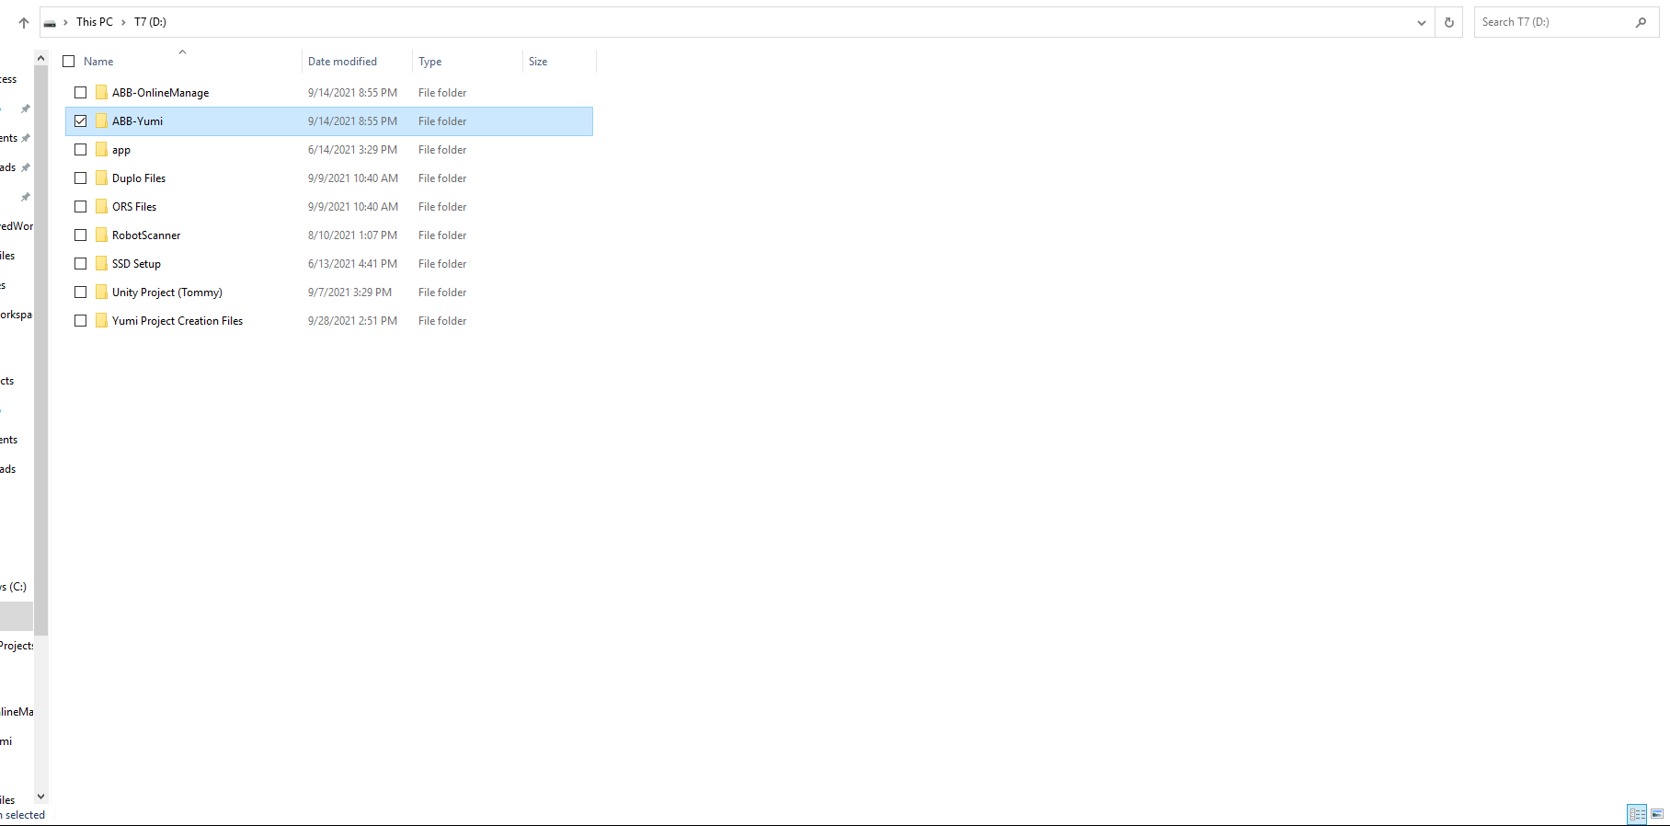

**Step 3:** Copy the “ABB-Yumi” folder along with the “ABB-OnlineManage” into the previously created “abb” folder.

**Step 4:** Open the “ABB-Yumi” folder inside you’ll find a file called “RightClickAndClickRunWithPowerShell”, furthermore as the name suggests you will right click this file and run with powershell.

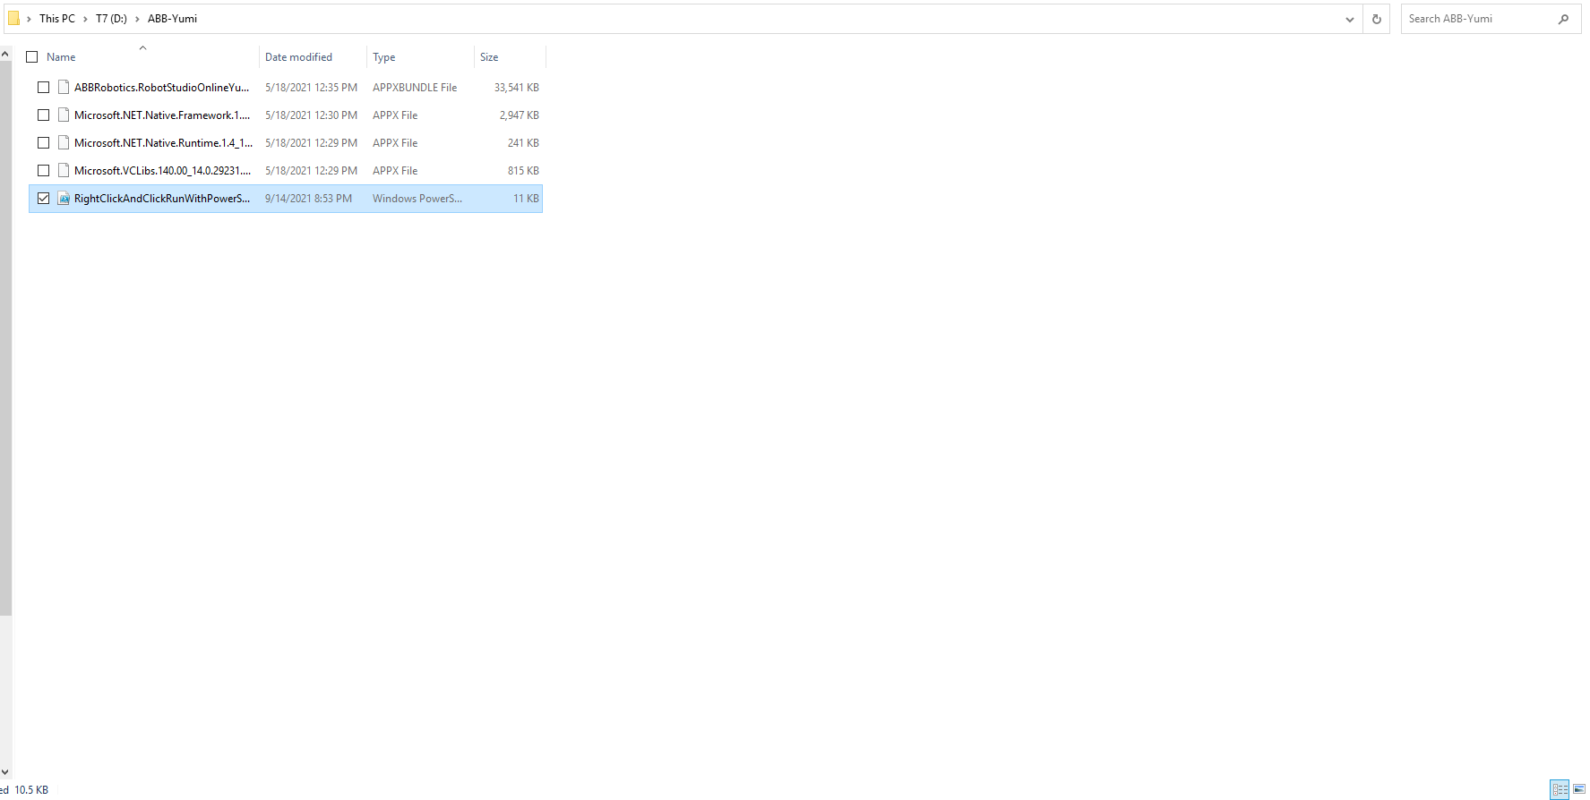

Let the file completely run its script and close itself.

**Step 5:** In the search bar you can now search for “RobotStudio Online Yumi” and open it.

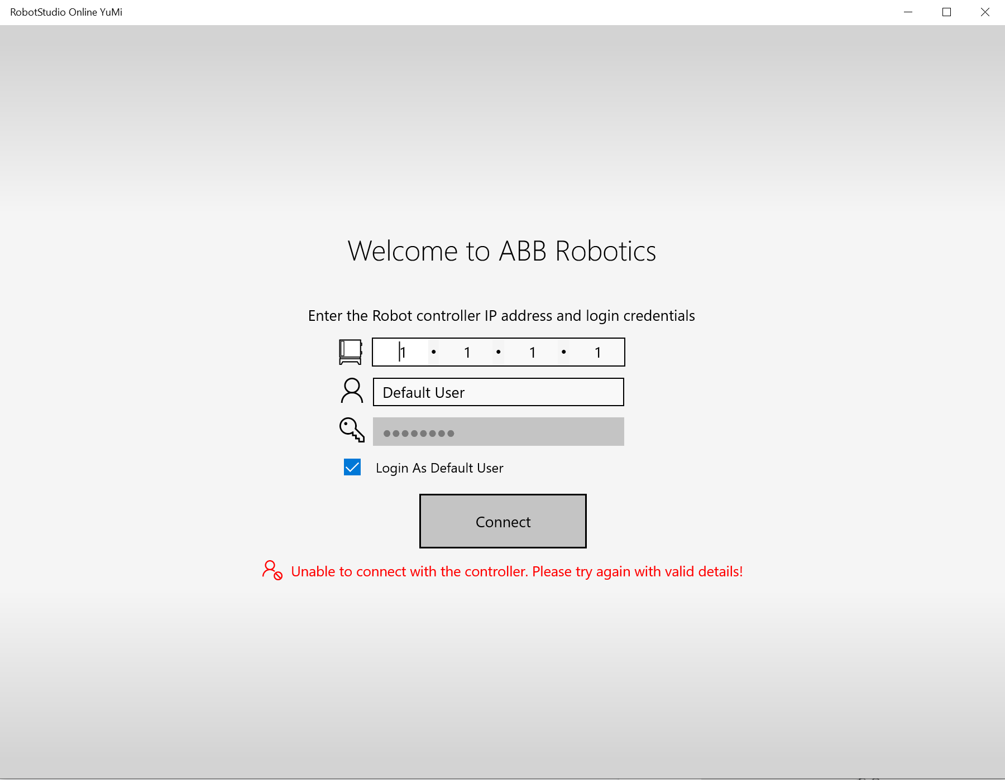

**Step 6:** You will now type in the controllers IP address, in our case this is ***192.168.125.1*** and press “Connect”.

Please note that the red text stating “unable to connect with the controller” is only because the pc the screen was captured on was not connected to the controller. At this point the RobotStudio Online Yumi should load two workspace screens and you should be able to program the robot, test that it is working properly now.

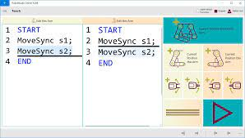

**_____________________________________________________________________________________**

Lastly, set your screen to operate in tablet mode:

**Step 1:** In your search bar look for “Tablet mode settings”.

**Step 2**: Inside the settings tab, you will change the top box labeled as “When I sign in” to “Use Tablet Mode”.

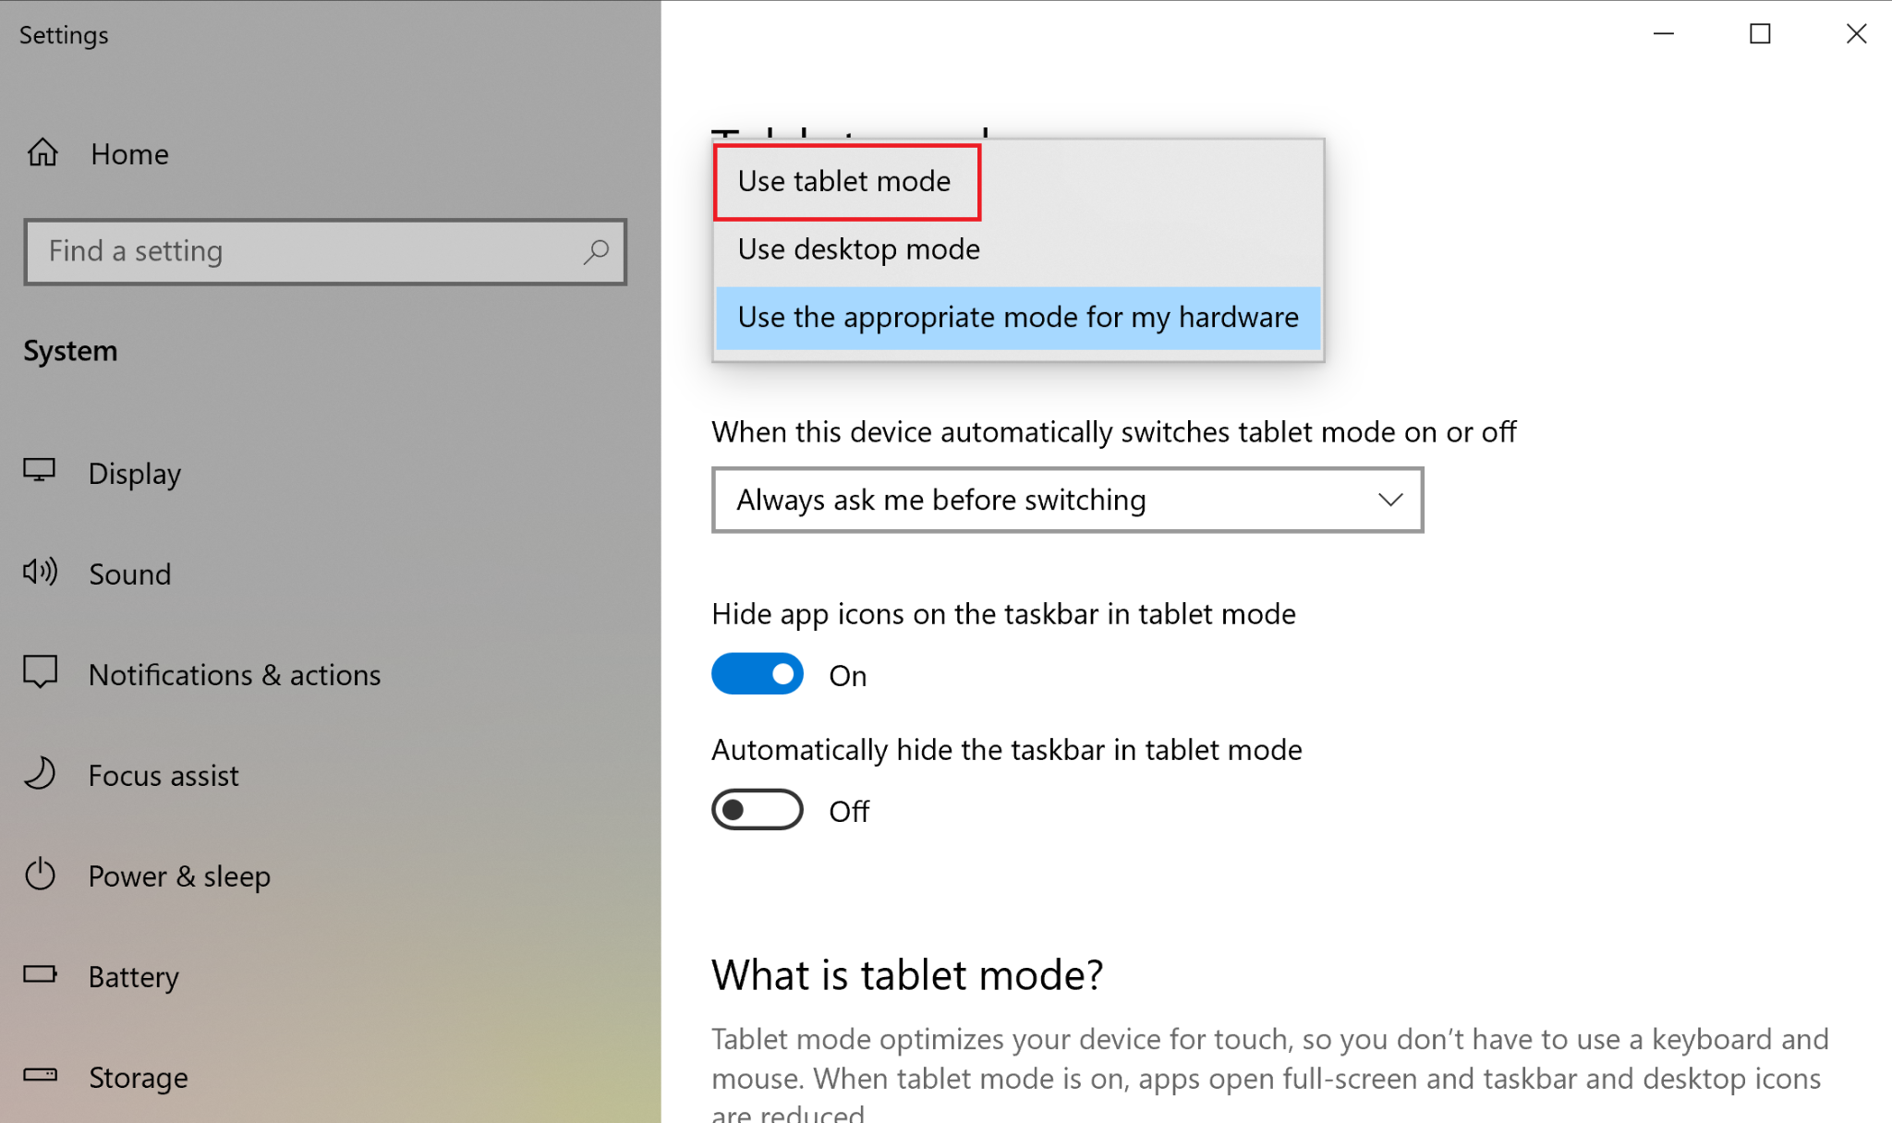

**Step 3:** Now log out and log back into your account on the controller and you will have tablet mode activated.