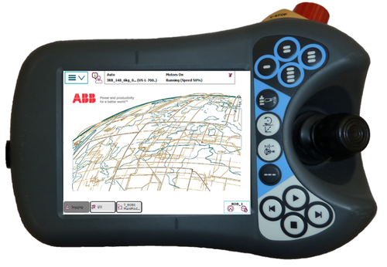

Documentation for YuMi setup on the ***Flex Pendant*** robot controller. Each time you reset the robot you will need to follow the following steps.

Also, in case you ever need to restart the robot I will list how to do that first.

**Step 1:** Press the 3 lines located in the top left of the screen. Opening the menu selection, in the bottom right press the “Restart” button. See below figure.

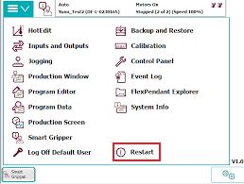

**Step 2:** Next, press the “Advanced…” button on the bottom right of the screen.

**Step 3:** Now, select the “Restart” option and then hit “Next”.

**Step 4:** Lastly, press the confirmation button, this button will be named the type of reset you are performing i.e. “Reset system”. This will start the resetting process.

**Step 5:** Repeat this for both “Reset system” and “Restart RAPID”

Setting up the Flex Pendant correctly before experiments.

General Settings Setup,



**Step 1:** First thing to do, press the following button in the bottom right corner.

**Step 2:** Now you’re going to want to make sure the following settings are correct.

* Second from bottom (speed): set to 50-percent.
* Third from bottom (step mode): Step into.
* Fourth from bottom (run mode): Single Cycle.

*Note: RobotStudio Online Yumi will not allow single cycle*

* Top (operator panel): Motors set to on and operator mode set to auto.

Gripper Setup,

**Step 1:** Press the 3 lines located in the top left of the screen. Opening the menu selection, open the “Inputs and Outputs” page. See below Figure.

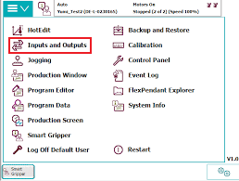

**Step 2:** After opening “Inputs and Outputs” open the “I/O Devices” from the “View” menu.

**Step 3:** Now, to activate the grippers look on the leftmost column, this will be the names of each I/O device. You should see two devices called “Hand_L” and “Hand_R”. On the rightmost column is the state of each I/O device.

**Step 4:** If the rightmost column is listed as “Deactivated”, it needs to be activated. Click on each row for “Hand_L” and “Hand_R” and it should become highlighted in blue. Then, activate the hand by pressing the “Activate” button on the bottom left corner.

**Step 5:** Now back to the main menu selection, switch to the “Smart Gripper” tab.

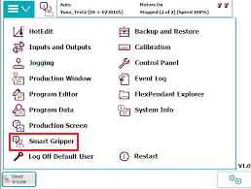

**Step 6:** Inside “Smart Gripper” you should see a page come up like the following, click on the “Configuration” button.

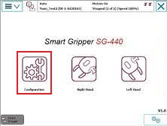

**Step 7:** Inside Configuration you will find a power switch for both grippers. You will need to make sure these grippers are on and supplied power, if they are on and operational the dots will be green instead of red.

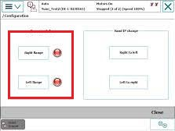

Enabling Lead-through Mode,

**Step 1:** Back to the main selection menu, open the “Jogging” tab.

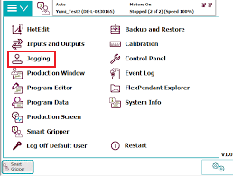

**Step 2:** Enable Lead-through.

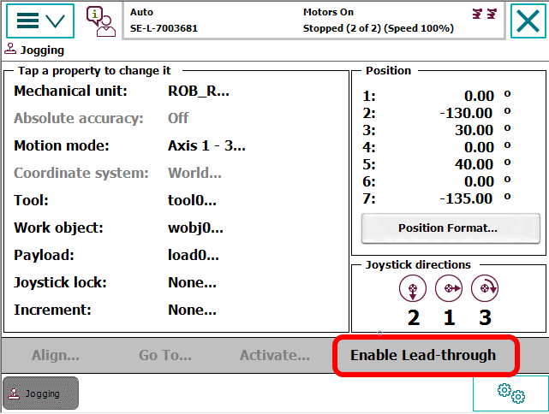

Now your YuMi robot is set up and ready to run programming experiments in either Duplo or ABB.