Limited Room-Temperature Pseudoelasticity in an AI-Hypothesized Fe-Mn-Al-Si-Ni-C Alloy: Synthesis, Microstructure, and Cyclic Response
Frank Cai¹
S. Cai²
J. Yan³

Abstract
Iron-based shape memory alloys (Fe-SMAs) are a promising low-cost alternative to Nitinol for civil-infrastructure and biomedical applications, but their pseudoelastic response is sensitive to composition and processing in ways that remain difficult to predict in advance. Large language model (LLM) deep-research agents, coupled with thermodynamic-stability databases, can now propose candidate compositions in seconds, which raises the practical question of whether such proposals survive physical synthesis. Here we report what may be the first synthesis and mechanical characterization of a novel Fe-Mn-Al-Si-Ni-C composition hypothesized by an LLM deep-research agent, benchmarked against the established Omori Fe-Mn-Al-Ni alloy processed under identical conditions; both compositions were verified by ICP-AES. The AI-hypothesized alloy (measured carbon 0.105 wt%, roughly ten times the 0.010 wt% of the benchmark) was readily castable but, on unloading from 2% applied strain, recovered only ≈0.5% strain — a value consistent with elastic springback alone, with no transformation plateau — across all four heat treatments examined. The benchmark recovered up to ≈0.9% under the same conditions, with a stress plateau characteristic of stress-induced α↔γ transformation. Synchrotron X-ray diffraction at the Shanghai Synchrotron Radiation Facility indicated that the AI alloy was a dual-phase mixture of γ-FCC austenite and an ordered B2/DO₃ Fe-Al phase rather than the single transforming matrix that pseudoelasticity requires, and its pattern was essentially unchanged by 10% applied strain. We attribute the absence of pseudoelasticity primarily to the formation of a competing ordered B2/DO₃ Fe-Al phase rather than the single transforming matrix, with the alloy’s elevated carbon content promoting this BCC/B2-type ordering over the FCC austenite. These observations suggest that compositions proposed by this kind of LLM-agent route may benefit from explicit pre-synthesis screening of competing phases and interstitial content. A secondary, more tentative observation from the benchmark alloy is that shorter-residence continuous strand annealing may yield refined-grain microstructures with improved pseudoelastic recovery; this would warrant systematic study.
Keywords: Fe-based shape memory alloy; pseudoelasticity; AI-guided alloy design; synchrotron XRD; abnormal grain growth

1. Introduction

1.1 Motivation: low-cost shape memory alloys
Shape memory alloys (SMAs) exhibit reversible martensitic transformations that enable two technologically important behaviors: the shape memory effect, in which thermally induced phase changes recover macroscopic deformation, and pseudoelasticity (superelasticity), in which stress-induced martensite reverts upon unloading (Otsuka and Wayman 1998; Lagoudas 2008). Nitinol (Ni-Ti) is the dominant commercial SMA, with recoverable strains of 6–8%, excellent cyclic stability, and biocompatibility, and it accounts for the majority of SMA use in medical devices, aerospace actuators, and damping applications (Duerig et al. 1999; Mohd Jani et al. 2014). However, Nitinol is expensive: titanium extraction is energy-intensive, and high-quality SMA wire requires vacuum-arc or vacuum-induction processing to avoid embrittling oxide and nitride phases (Otsuka and Wayman 1998).
Iron-based shape memory alloys offer a path to lower cost. Iron is one of the most abundant metals in the Earth’s crust, and Fe-SMA processing can in principle leverage established steel-industry infrastructure (electric-arc melting, hot rolling, strand annealing) without strict vacuum requirements (Omori et al. 2011; Abuzaid et al. 2019). Replacing scarce alloying elements with abundant Mn, Al, Si, and minor Ni may reduce both raw-material and processing costs (Omori and Kainuma 2017). The lower modulus and higher damping capacity of Fe-SMAs also make them attractive as structural-engineering prestressing tendons for concrete and as seismic dampers, applications where Nitinol’s price has historically been prohibitive (Cladera et al. 2014).

1.2 The Omori benchmark
The work that established polycrystalline Fe-SMAs as practical materials was Omori et al.’s 2011 demonstration of room-temperature superelasticity in Fe-Mn-Al-Ni following abnormal grain growth (AGG) (Omori et al. 2011). A central microstructural feature of that work was bamboo-like grains, single-crystal-diameter grains spanning the wire cross-section, produced by cyclic heat treatments across the γ↔α phase boundary. Subsequent studies have associated such large grains with reduced inter-granular constraint and improved transformation reversibility in the BCC α / FCC γ system (Vollmer et al. 2016; Abuzaid et al. 2019). We adopt this alloy, processed under matched conditions, purely as a benchmark against which to interpret the AI-hypothesized composition.

1.3 AI-guided alloy discovery and the prediction–processability question
Materials discovery has been reshaped by deep-learning models trained on first-principles thermodynamics. DeepMind’s GNoME predicted more than 2.2 million previously unreported crystal structures with high precision against DFT validation (Merchant et al. 2023), and agentic large language models with deep-research capabilities can ingest decades of metallurgical literature and propose novel compositions in seconds (Google DeepMind 2025; Xu and Peng 2025). Together these tools point toward alloy design that moves from intuition-guided iteration toward AI-proposed, thermodynamically screened candidates.
An open practical question is whether such AI-proposed compositions survive contact with physical processing. Current generative materials models typically optimize for thermodynamic stability (formation energy, convex-hull distance) but do not, in general, explicitly model the kinetic barriers governing which phases actually form during quenching and annealing, the interstitial chemistry arising from realistic carbon contents, or the processing-rate constraints that shape grain morphology (Merchant et al. 2023). A composition whose target phase lies on the DFT convex hull might still be difficult to realize in practice. To our knowledge this question has not previously been examined for an LLM-hypothesized SMA composition.

1.4 Aim and expectations
This work addresses a primary question and a secondary, exploratory one:
- Pseudoelastic response of an AI-hypothesized alloy. When an LLM deep-research agent proposes a novel Fe-Mn-Al-Si-Ni-C composition targeting room-temperature pseudoelasticity, does the synthesized alloy exhibit that behavior, and if not, what microstructural features appear to be responsible?
- Processing observation in the benchmark (exploratory). As a side observation in the Omori benchmark, we examine whether continuous strand annealing with shorter hot-zone residence times might produce refined-grain microstructures with pseudoelastic recovery comparable to, or better than, longer treatments.
Our expectation at the outset was that the AI-hypothesized alloy would be thermodynamically stable per first-principles data but might nonetheless fail to show pseudoelasticity owing to process–structure–property couplings that are not captured by formation-energy optimization. The results below are broadly consistent with that expectation, although they should be read as a single case study rather than a general conclusion.

1.5 Contributions
This work reports what we believe to be the first physical synthesis and mechanical characterization of an Fe-SMA composition hypothesized by an LLM deep-research agent, benchmarked directly against the Omori reference alloy under identical processing. Prior AI-driven SMA work has used graph neural networks, Bayesian materials selection, and GAN-based inverse design, largely on NiTi-family alloys (Trehern et al. 2022; Li et al. 2025), and LLM-hypothesized compositions have been explored for high-entropy alloys and halide solid electrolytes (Hu et al. 2024); the intersection of LLM deep-research alloy design and Fe-based SMA synthesis appears not to have been reported previously. We also note, cautiously and as a secondary observation, that continuous strand-anneal processing rate may influence pseudoelastic recovery in the benchmark alloy.

2. Materials and Methods

2.1 Alloy design
The AI-hypothesized composition was generated by an LLM deep-research agent (Gemini 2.5 with the Deep Research tool (Google DeepMind 2025)) prompted to propose an Fe-Mn-Al-based composition optimized for room-temperature pseudoelasticity. The agent was instructed to (i) reason from the Fe-Mn-Al-Ni family established by Omori and co-workers (Omori et al. 2011; Omori and Kainuma 2017) as a starting point, (ii) consult thermodynamic-stability data, (iii) target β-NiAl/carbide precipitation as a strengthening pathway, and (iv) minimize cost by excluding cobalt and tantalum. The agent’s output, after constraint-prompted refinement, is the composition designated here as the “AI alloy.”
For direct benchmarking, a second composition based on the Omori Fe-Mn-Al-Ni reference (Omori et al. 2011) was synthesized under identical conditions. The compositions of both heats were verified after casting by inductively coupled plasma atomic emission spectroscopy (ICP-AES), with carbon and oxygen by inert-gas fusion (ASTM E1019); the measured chemistries are listed in Table 1. Measured Mn (31.78 wt% for the AI alloy) is consistent with the nominal target, indicating that evaporative Mn loss during arc melting was not significant.
Table 1. Measured chemical compositions (ICP-AES; C and O by ASTM E1019) of the AI-hypothesized alloy and the Omori benchmark, in wt%. “n.r.”: not reported in that analysis.
Element | AI alloy | Omori benchmark
Fe | balance (55.83) | balance (46.51)
Mn | 31.78 | 36.49
Al | 6.24 | 8.00
Si | 1.11 | <0.01
Ni | 4.81 | 8.94
P | n.r. | 0.062
C | 0.105 | 0.010
O | 0.0004 | <0.001
Co, Ta, Ti, Cr, and Mo were each below 0.01 wt% in the benchmark, confirming the cost-driven exclusion of cobalt and tantalum. The most consequential difference between the two alloys is carbon: the AI composition contains 0.105 wt% C, roughly ten times the 0.010 wt% of the working benchmark (Sec. 4.1).

2.2 Synthesis
Alloy ingots were produced by arc-melting elemental constituents of nominal purity ≥99.9% under an argon atmosphere. Each ingot was inverted and remelted a minimum of five times to ensure compositional homogeneity. Following arc melting, ingots were hot-rolled at 850 °C in multiple passes to reduce thickness, and subsequently cold-drawn to a final wire diameter of 0.014 in. (≈0.36 mm). Severe work hardening during cold drawing necessitated intermediate annealing at 900–1000 °C under flowing H₂/Ar to restore ductility between draw passes.
Surface oxidation during high-temperature processing was mitigated by encapsulating samples in evacuated quartz tubes prior to anneal cycles. For samples that experienced oxidation despite encapsulation, a dilute acid bath was used to chemically strip the oxide layer before mechanical testing.

2.3 Heat treatments
Four distinct heat-treatment conditions were applied across the two alloys to probe the microstructural and pseudoelastic response (Table 2).
Table 2. Heat-treatment conditions.
Condition | Description | Hot-zone residence | Applied to
Standard anneal | 1200 °C / 1 min, water quench | — | AI, Omori
3-cycle AGG | (1200 °C / 30 min + RT / 10 min) × 3, followed by 1200 °C / 1 h, water quench | — | AI, Omori
Strand anneal (≈5 min) | Continuous strand furnace, 1200 °C | ≈5 min | AI, Omori
Strand anneal (≈1 min) | Continuous strand furnace, 1200 °C | ≈1 min | AI, Omori
Strand anneal (≈12 s) | Continuous strand furnace, 1200 °C | ≈12 s | AI, Omori
The 3-cycle AGG condition follows the abnormal-grain-growth protocol of Omori et al. (Omori et al. 2011), designed to produce bamboo-like single-crystal-diameter grains. The strand-anneal conditions span a range of hot-zone residence times — ≈5 min, ≈1 min, and ≈12 s in the ≈4 ft continuous hot zone used here — and are intended to probe the range over which conventional industrial throughputs might replace the slow batch AGG cycle.

2.4 Metallography
Wire cross-sections were embedded in cold-mount epoxy and ground sequentially with silicon-carbide papers from 180 grit through 800 grit. Final polishing used a 0.25 µm OP-S aluminum-oxide suspension on an automated polishing wheel until a scratch-free mirror finish was achieved. Polished cross-sections were imaged on a Clemex Vision PE optical microscope under bright-field illumination at magnifications between 100× and 1000×.

2.5 Mechanical testing
Cyclic tensile tests were performed on an Instron servohydraulic testing frame in displacement control. Wire specimens were tested with a 6 mm gauge length using pneumatic grips. Each specimen was loaded to a target tensile strain (8% for the Omori benchmark, 10% for the AI alloy) at a nominal strain rate of 1 × 10⁻³ s⁻¹, held briefly at peak strain, and then unloaded to zero force. Pseudoelastic recovery was quantified as the ratio of recovered strain on unloading to applied peak strain.
To characterize the AI alloy more broadly, monotonic incremental-cyclic tensile tests to failure were also performed on the final 0.36 mm AI-alloy wire after continuous strand annealing (≈1 min hot-zone residence) at strand-anneal temperatures from 600 to 1200 °C. Tensile strength and elongation were taken directly from the recorded curves; yield strength (0.2% offset) and elastic modulus (initial loading slope) were extracted from the calibrated stress–strain data. Strain was computed from crosshead displacement over a 5 in gauge length. Extended 1250 °C holds and the 3-cycle AGG treatment were also run but are excluded from the monotonic dataset (Table 4) because surface oxidation, and grip compliance at 1250 °C, made those specimens’ data unreliable.

2.6 Synchrotron X-ray diffraction
Synchrotron XRD measurements were performed at the ultra-hard X-ray multifunctional application beamline BL12SW of the Shanghai Synchrotron Radiation Facility (SSRF) (Yan et al. 2024), in collaboration with co-author J. Yan. The incident wavelength was λ = 0.125870 Å (photon energy ≈98.5 keV), and the sample-to-detector distance was 1827.486 mm with a 100 µm × 100 µm pixel area detector. Two-dimensional Debye–Scherrer patterns were collected from each specimen before and after tensile deformation to test for a stress-induced phase transformation. Each 2D pattern was azimuthally integrated to produce a one-dimensional intensity-versus-2θ profile, and reflections were indexed by comparison with reference Fe, Fe-Al, and γ-austenite phases.

3. Results

3.1 Microstructure
Optical micrographs of polished wire cross-sections for the four most informative heat-treatment conditions are shown in Fig. 1.
After the standard 1200 °C / 1 min anneal, the AI alloy (Fig. 1a) exhibits a highly refined dual-phase morphology with irregular grain boundaries and no single dominant phase. Following the 3-cycle AGG treatment (Fig. 1b), the AI alloy continues to show a dual-phase structure: grain growth occurred only in one of the two phases, while the second phase remained as fine, dispersed regions. The dual-phase character persisted across every AI-alloy condition examined, which suggests that the AI’s predicted composition did not support single-phase austenite formation under any of the heat treatments tested in this study.
The Omori benchmark behaves differently. After 3-cycle AGG (Fig. 1c), it develops the bamboo-like grain morphology consistent with the established Fe-Mn-Al-Ni literature (Omori et al. 2011; Vollmer et al. 2016), with grain diameters spanning a substantial fraction of the wire cross-section. The 1200 °C / 1 min condition (Fig. 1d) yields an acicular ferrite microstructure.
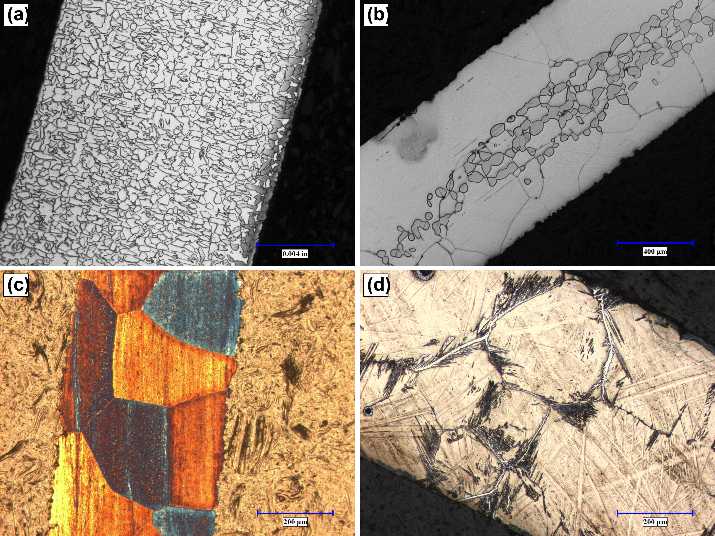
Fig. 1. Optical micrographs of polished wire cross-sections under four representative heat-treatment conditions. (a) AI alloy after the standard 1200 °C / 1 min anneal: highly refined dual-phase morphology with irregular grain boundaries (scale bar ≈100 µm). (b) AI alloy after 3-cycle AGG: grain growth in one phase only; the dual-phase structure persists (scale bar 400 µm). (c) Omori benchmark after 3-cycle AGG: bamboo-like grain morphology (scale bar 200 µm). (d) Omori benchmark after 1200 °C / 1 min strand anneal: acicular ferrite microstructure (scale bar 200 µm). All images acquired on a Clemex Vision PE optical microscope under bright-field illumination.

3.2 Cyclic stress–strain response
Cyclic tensile stress–strain curves for representative specimens are shown in Fig. 2.
Representative recovered-strain and peak-stress values, read from the incremental cyclic curves at a common 2% reference cycle, are summarized in Table 3. The AI alloy in both the 1200 °C / 1 min (Fig. 2a) and 3-cycle AGG (Fig. 2b) conditions recovered only ≈0.5% strain on unloading from the 2% cycle (a recovery ratio of ≈25%). Loading exhibited a monotonically rising stress with no defined transformation plateau, and the recovered strain is comparable to the elastic strain σ/E expected at the unload stress (≈0.4–0.5% at ≈650 MPa for E ≈ 150 GPa). In other words, the recovery is consistent with elastic springback alone, with no resolvable pseudoelastic contribution; this behavior was the same across all AI-alloy heat treatments examined, including loading as far as ≈24% total strain (Table 3).
The Omori benchmark shows a stress plateau and greater recovery in the conditions that develop bamboo or refined-grain microstructures (Fig. 2c, d). At the same 2% reference cycle, the 1200 °C / 12 s condition recovered ≈0.92% strain (≈46%), roughly twice the ≈0.49% (≈25%) of the 1200 °C / 5 min condition, and exceeding the elastic strain — indicating a genuine pseudoelastic component. We treat this comparison cautiously, as it rests on single specimens (n = 1 per condition); it is considered further in Sec. 4.4.
Table 3. Cyclic-tensile metrics for both alloys, computed from the calibrated incremental stress–strain curves of Fig. 2. Recovered strain and recovery ratio are reported at a common 2% applied-strain cycle present in all tests; peak stress is the maximum stress reached over the full test. Values are single-specimen (n = 1 per condition); a statistically resolved study is identified as future work (Sec. 4.5).
Alloy | Condition | Max applied strain (%) | Peak stress (MPa) | Recovered strain at 2% (%) | Recovery at 2% (%)
AI | 1200 °C / 1 min | 23.9 | 938 | 0.45 | 22.5
AI | 3-cycle AGG | 9.2 | 817 | 0.50 | 25.0
Omori | 1200 °C / 5 min | 9.6 | 805 | 0.49 | 24.7
Omori | 1200 °C / 12 s | 7.1 | 1201 | 0.92 | 45.9
For the AI alloy the recovered strain at 2% matches the elastic springback and there is no transformation plateau; the Omori 12 s condition is the only case in which recovery clearly exceeds the elastic strain.
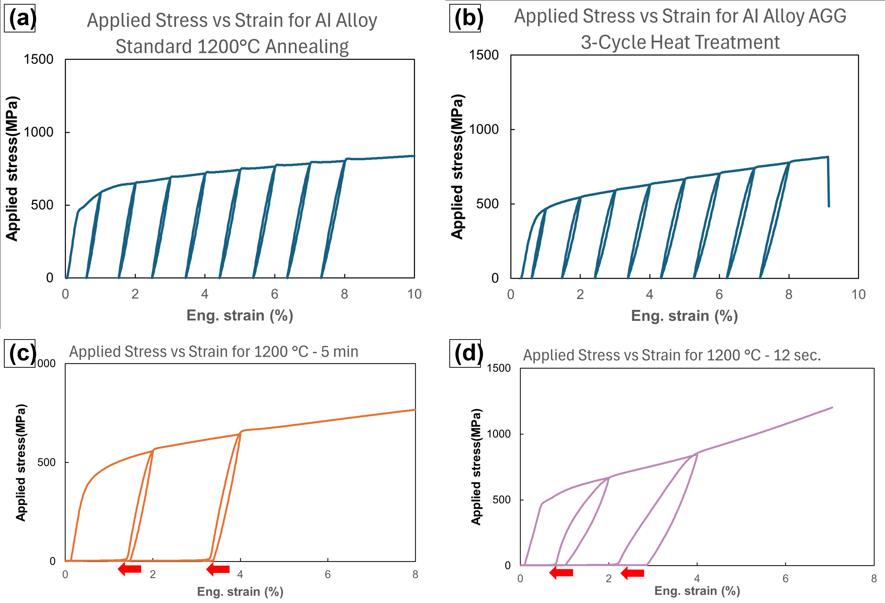
Fig. 2. Cyclic tensile stress–strain response. (a) AI alloy after the standard 1200 °C / 1 min anneal: monotonic loading with no transformation plateau; recovered strain on unloading (≈0.5% at the 2% cycle) is consistent with elastic springback alone (Table 3). (b) AI alloy after 3-cycle AGG: response qualitatively identical to (a), indicating that AGG processing did not restore pseudoelasticity in the AI composition. (c) Omori benchmark after 1200 °C / 5 min strand anneal: partial pseudoelastic recovery with developing hysteresis. (d) Omori benchmark after 1200 °C / 12 s strand anneal (refined small-grain microstructure): pronounced pseudoelastic hysteresis and a distinct stress plateau. Red arrows in (c, d) mark the residual unrecovered strain after unloading. Panels (c) and (d) are the ≈5 min and ≈12 s strand-anneal specimens of the Omori benchmark, respectively; one representative specimen per condition.
Beyond the cyclic conditions of Table 3, monotonic tensile-to-failure tests on the final 0.36 mm AI-alloy wire give a broader picture of how heat treatment governs its mechanical properties (Table 4). The response is strongly anneal-dependent: low strand-anneal temperatures (600–700 °C) leave the wire high-strength but brittle (tensile strength up to ≈2010 MPa at only ≈2% elongation, reflecting incomplete recrystallization of the cold-drawn wire), whereas annealing at 800–1200 °C progressively softens the wire and restores ductility, with elongation peaking near 33% at 1000 °C. The elastic modulus stays in the ≈150–165 GPa range across the well-annealed conditions. Importantly, none of these treatments altered the cyclic behaviour of Sec. 3.2 — the AI wire deforms plastically with no pseudoelastic plateau regardless of anneal temperature — consistent with the dual-phase structure identified below (Sec. 3.3).
Table 4. Monotonic tensile properties of the AI-alloy wire (0.36 mm diameter) as a function of strand-anneal temperature (600–1200 °C). Tensile strength and elongation are read directly from the stress–strain curves; yield strength (0.2% offset) and modulus (initial elastic slope) are extracted from the same calibrated data. Values are single-specimen (n = 1) measurements; strain is crosshead-displacement based, so the absolute moduli should be read as approximate. Higher-temperature 1250 °C holds and the 3-cycle abnormal-grain-growth (AGG) condition were also imposed but are excluded here: surface oxidation (and grip-compliance effects at 1250 °C) rendered those specimens’ data unreliable. None of the conditions produced a pseudoelastic plateau (cf. Table 3).
Anneal temperature | Yield strength (MPa) | Tensile strength (MPa) | Elongation (%) | Modulus (GPa)
600 °C | 1379 | 1948.4 | 2.3 | 157
700 °C | 1330 | 2009 | 2.2 | 163
800 °C | 1164 | 1221 | 24.0 | 154
900 °C | 944 | 1078 | 29.7 | 152
1000 °C | 673 | 967 | 33.4 | 156
1100 °C | 556 | 947 | 29.7 | 157
1200 °C | 502 | 938 | 23.9 | 163

3.3 Synchrotron diffraction and phase identification
The mechanical result above — a dual-phase microstructure (Sec. 3.1) with no resolvable pseudoelastic recovery (Sec. 3.2) — is the primary evidence that the AI alloy does not undergo a stress-induced transformation. Synchrotron XRD (Fig. 3) was used to corroborate this and to identify the constituent phases.
The AI alloy (Fig. 3a) exhibits a multi-peak pattern indexable to coexisting FCC γ-austenite and an ordered B2/DO₃ Fe₃Al phase, confirming the dual-phase character inferred from the micrographs and confirming that the targeted single transforming matrix did not form. Comparison of the ex-situ 0% and 10% strain patterns shows that peak positions and relative intensities are essentially unchanged: no new reflections appear and none disappear. We note that an ex-situ measurement made after unloading cannot, on its own, exclude a fully reversible transformation that reverts on unloading; here, however, the absence of any mechanical recovery (Table 3) together with the unchanged dual-phase pattern points consistently to deformation by dislocation slip rather than transformation. The presence of an ordered B2/DO₃ Fe-Al phase rather than the single transforming matrix is itself consistent with the absence of recovery (Sec. 4.1).
The Omori benchmark (Fig. 3b) presents a BCC α-dominated pattern with ordered β-NiAl (B2) precipitate reflections in the undeformed state. After 8% applied strain, the {111}γ reflection intensifies and the overlapping {200}α / {200}B2 cluster redistributes in intensity, consistent with stress-induced γ formation and partial variant activation.
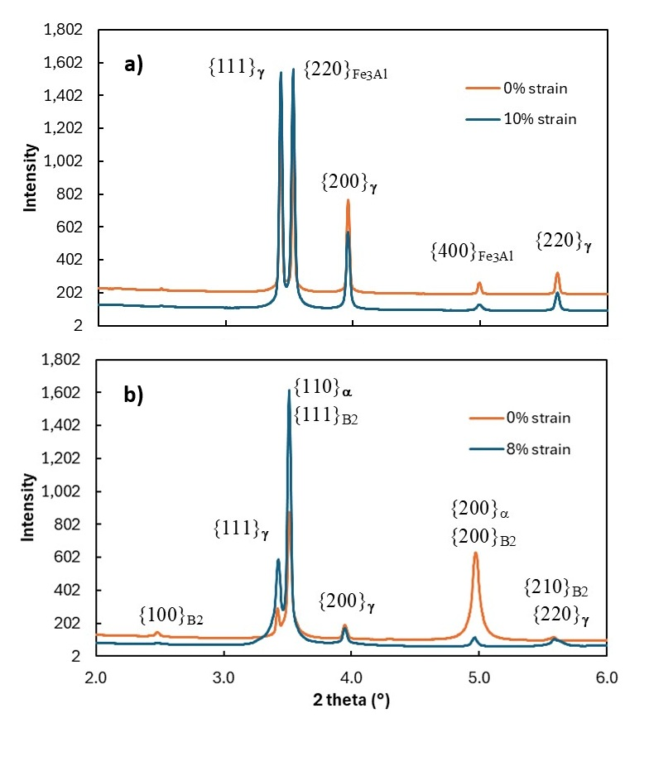
Fig. 3. Azimuthally integrated synchrotron XRD patterns comparing the undeformed (0% strain) and deformed (post-tensile-test) states. (a) AI alloy: pattern indexable to coexisting FCC γ-austenite ({111}γ, {200}γ, {220}γ) and ordered B2/DO₃ Fe₃Al phase ({220}Fe₃Al, {400}Fe₃Al); the 0% and 10% strain patterns are essentially superimposed, indicating deformation by dislocation slip rather than phase transformation. (b) Omori benchmark: BCC α-dominated pattern with ordered β-NiAl (B2) precipitate reflections; after 8% strain the {111}γ reflection intensifies and the {200}α / {200}B2 cluster redistributes, consistent with stress-induced γ formation. Data collected at SSRF beamline BL12SW with λ = 0.125870 Å.
Two-dimensional Debye–Scherrer patterns recorded directly on the SSRF area detector are shown in Fig. 4. The AI alloy rings (Fig. 4a, b) are virtually identical before and after deformation: ring positions, widths, and azimuthal intensity distributions are preserved, again indicating the absence of a transformation. The Omori benchmark rings shift from sharp, discrete spots in the undeformed state (Fig. 4c) to broader, partially arced rings after deformation (Fig. 4d), a signature of variant activation and increased mosaic spread accompanying partial martensitic transformation.
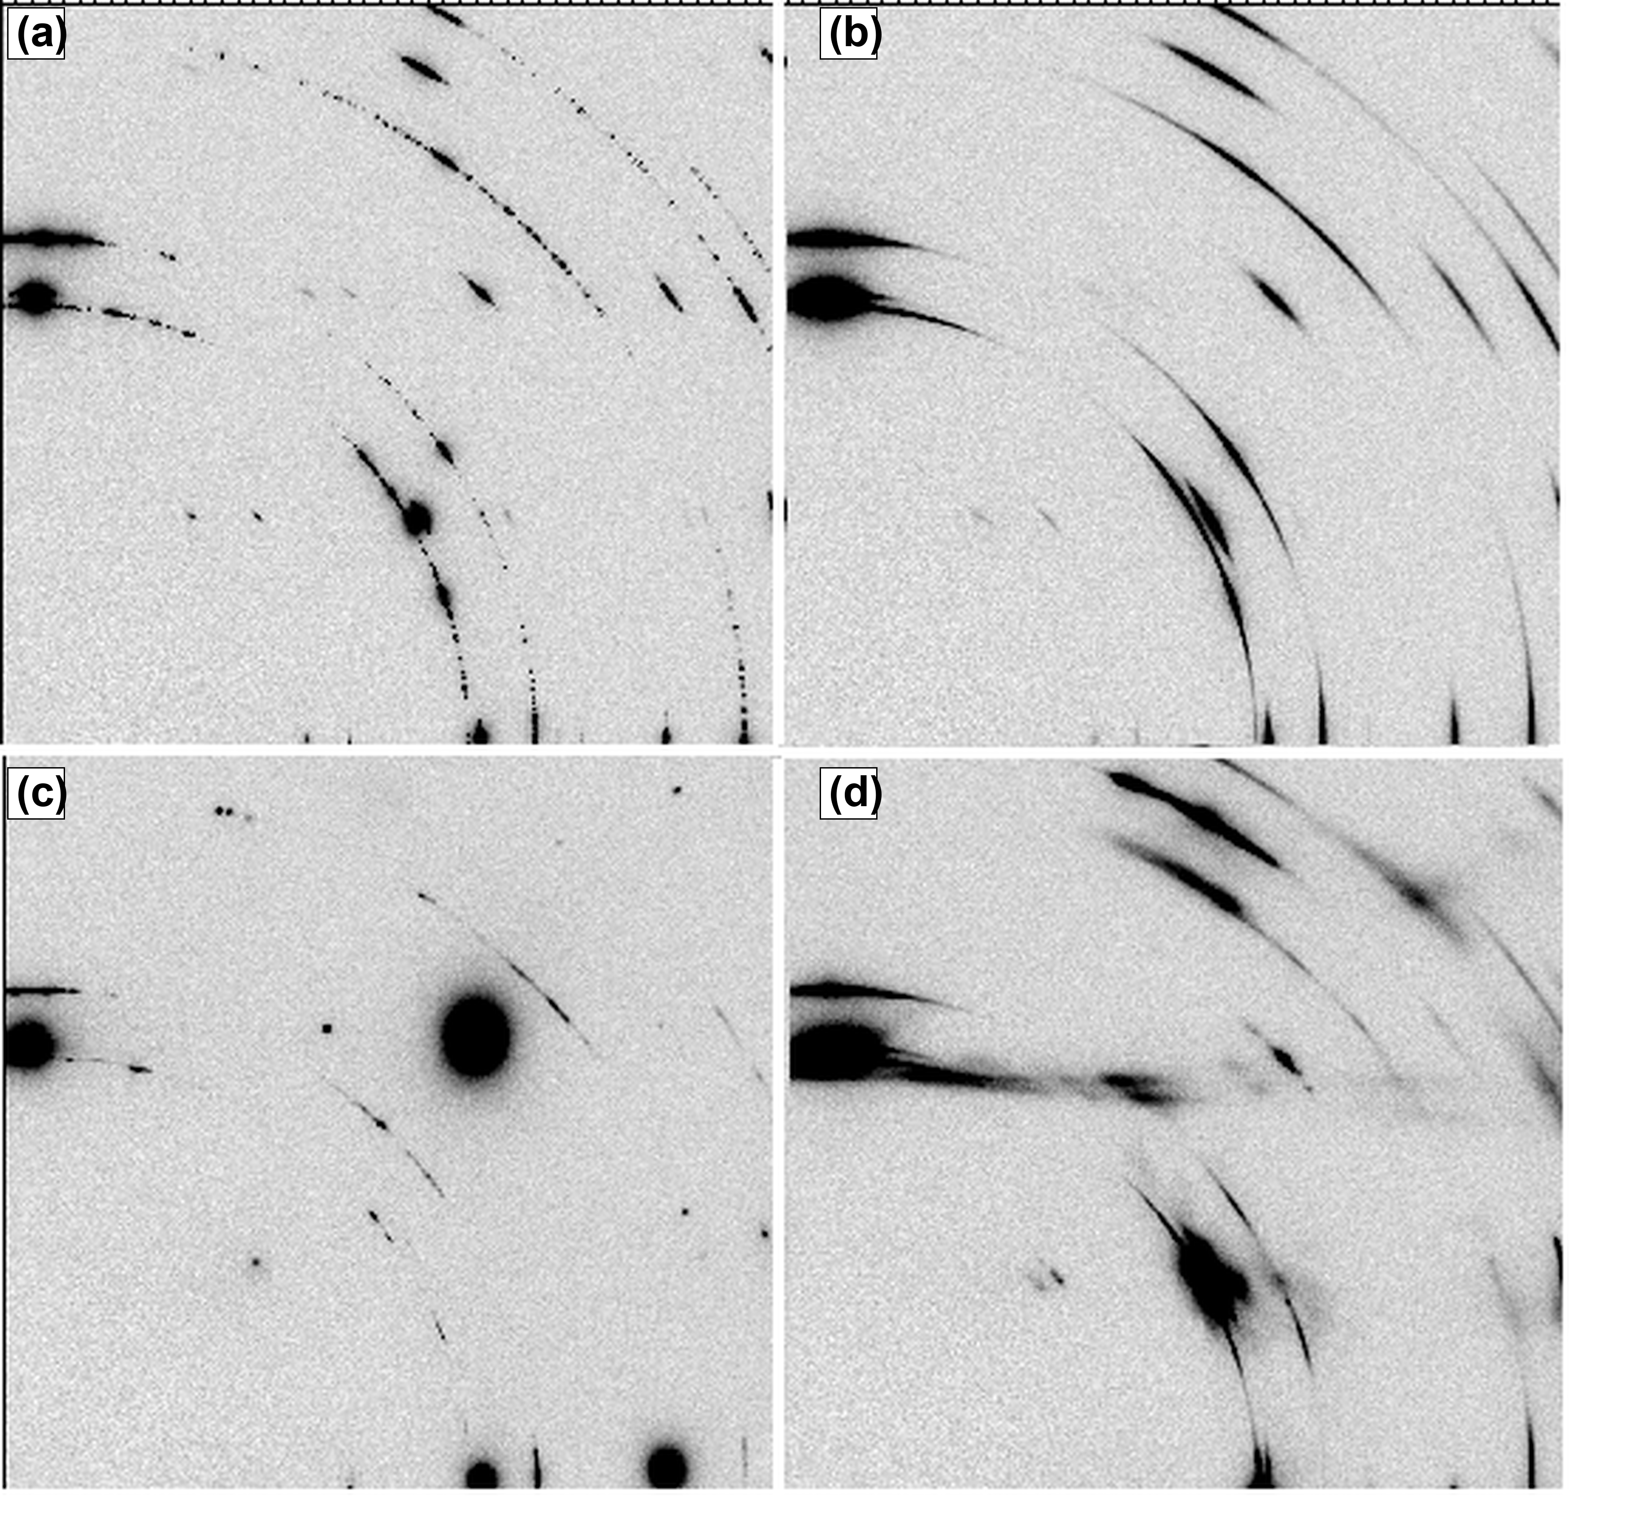
Fig. 4. Two-dimensional Debye–Scherrer synchrotron diffraction patterns recorded directly on the SSRF area detector. (a) AI alloy at 0% strain: sharp, discrete diffraction spots indexed to {111}γ, {200}γ, {220}γ on the γ-FCC subpattern and {220}Fe₃Al, {400}Fe₃Al on the DO₃ subpattern. (b) AI alloy at 10% strain: ring positions, widths, and azimuthal intensity distributions are preserved with no detectable redistribution, consistent with the absence of phase transformation indicated by Fig. 3a. (c) Omori benchmark at 0% strain: discrete spots indicating coarse, well-oriented grains. (d) Omori benchmark at 8% strain: spots transition to broader, partially arced rings, the signature of variant activation accompanying partial martensitic transformation.

4. Discussion

4.1 Why the AI alloy may not have transformed: carbon-stabilized ordering
The most likely explanation is the formation of a competing ordered phase. The AI alloy formed an ordered B2/DO₃ Fe-Al phase rather than the single transforming matrix that pseudoelasticity requires. For the alloy’s Fe-Al-rich chemistry this ordered constituent is thermodynamically favoured, so under the processing conditions used here the intended transforming matrix does not win the phase competition; the available aluminium partitions into the ordered Fe₃Al (B2/DO₃) phase, producing the dual-phase γ-FCC + Fe₃Al structure seen in every condition (Sec. 3.1) and in the diffraction patterns (Sec. 3.3). The targeted β-NiAl/carbide strengthening constituents did not form; the alloy is dominated instead by ordered Fe-Al.
A key contributing factor is the alloy’s carbon content, which at 0.105 wt% is roughly ten times the 0.010 wt% of the benchmark. Carbon occupies octahedral interstitial sites of BCC iron and the B2 sublattice and lowers their free energy through Zener-style interstitial ordering (Zener 1946; Bhadeshia and Honeycombe 2017); even modest carbon contents are known to stabilize the BCC/B2 constituent relative to FCC austenite, compounding the preference for the observed dual-phase microstructure. A full confirmation would require CALPHAD modelling of the Fe-Mn-Al-Ni-Si-C system and quantitative carbon-partitioning measurements, neither of which was performed here. (Magnetic effects during high-temperature processing may also play a minor role but are not constrained by our data.)
Taken together, these factors are consistent with the macroscopic response of Fig. 2a, b and Fig. 3a: with no transformable matrix available, the critical stress for stress-induced transformation in the AI alloy is not reached before dislocation slip, so the wire accommodates strain plastically and recovers only its elastic strain on unloading.

4.2 Anneal-temperature dependence of the AI alloy’s tensile properties
Although the AI alloy never showed pseudoelastic recovery, its monotonic tensile behaviour (Table 4) varies strongly and systematically with strand-anneal temperature, and the trends are exactly those expected for a cold-drawn wire passing through recovery, recrystallization, and grain growth. Reading these as a single-specimen survey, three regimes emerge.
At the lowest temperatures (600–700 °C) the wire is very strong but essentially brittle: tensile strengths of ≈1950–2010 MPa and yield strengths of ≈1330–1380 MPa, but elongation of only ≈2%. These temperatures are below the recrystallization range of the heavily cold-drawn wire, so annealing here drives only recovery — relief of residual drawing stresses and partial rearrangement of the dislocation substructure — without nucleating new strain-free grains. The high dislocation density retained from cold drawing is what sustains the high strength, and the small ductility gains in this window reflect stress relief rather than any genuine restoration of formability; the wire still fractures soon after yield.
The abrupt change near 800 °C marks the onset of recrystallization. Elongation jumps from 2.2% at 700 °C to 24.0% at 800 °C while tensile strength falls from 2009 to 1221 MPa and yield from 1330 to 1164 MPa. The discontinuity — rather than a smooth softening — is the signature of recrystallization: new equiaxed, strain-free grains nucleate and consume the deformed matrix, removing most of the stored dislocation content and abruptly restoring ductility. It is this recrystallization threshold, not a gradual process, that makes ductility appear only above ~800 °C.
From 800 to 1200 °C the wire is fully recrystallized and the dominant process is grain growth. Yield strength falls monotonically with temperature (1164 → 502 MPa) in a manner consistent with Hall–Petch behaviour ($σ_{y}∝d^{−1/2}$): as grains coarsen there are fewer grain boundaries to impede dislocation motion, lowering the flow stress, while the more uniform slip that coarser grains permit raises elongation to a peak of ≈33% near 1000 °C. In other words, across this regime increasing grain size simultaneously decreases strength and increases ductility — the classic strength–ductility trade-off of a single-phase-controlled structural metal. Above 1000 °C elongation eases back slightly (29.7% at 1100 °C, 23.9% at 1200 °C), which we attribute to excessive coarsening — likely including coarsening of the brittle ordered Fe₃Al constituent — reducing uniform elongation even as the matrix continues to soften. Throughout the whole sweep the elastic modulus stays within ≈150–165 GPa, as expected for a structure-insensitive property of an essentially unchanged dual-phase mixture.
Two higher-energy conditions — extended 1250 °C holds and the 3-cycle AGG treatment — were also imposed on this wire, but their data are not reported in Table 4: surface oxidation (and, at 1250 °C, grip-compliance artefacts) made the measured strengths and moduli unreliable. We note them for completeness because, even where curves could be read, they showed the same plastic, non-recovering response as every other condition. The overall picture is therefore of a conventional dual-phase structural alloy whose strength and ductility are tunable across a wide range purely by anneal temperature, but which carries no pseudoelastic plateau at any condition — reinforcing the conclusion of Sec. 4.1 that the alloy lacks a transforming matrix.

4.3 A pre-synthesis screening loop for the LLM-agent route
We are cautious about generalizing from a single composition, and we restrict the following to the specific LLM-deep-research route used here rather than to AI-guided design in general. For that route, the failure mode we observed — the intended transforming matrix that never formed because a competing ordered Fe-Al phase, promoted by the alloy’s chemistry and elevated carbon content, dominated instead — could plausibly have been caught before any metal was melted. We suggest a short, deterministic screening loop to run on the agent’s output prior to synthesis:
- Phase-stability check. For the proposed chemistry, compute the equilibrium (or near-equilibrium) phase assemblage by CALPHAD over the full element set, and confirm that the targeted strengthening phase is actually stable at the proposed composition and is not displaced by a competing ordered phase (here, Fe₃Al/B2).
- Stoichiometry check. Verify that the proposed level of each targeted strengthening or precipitate-forming element is sufficient, relative to established working alloys, for the intended phase to form rather than a competing ordered phase, flagging proposals that fall outside the literature range.
- Interstitial check. Evaluate the effect of the proposed interstitial content (C, N, O) on the matrix phase balance at the concentrations actually specified.
- Processing-route check. Confirm that the intended anneal/residence-time schedule can plausibly reach the target microstructure.
Only compositions that pass these checks would proceed to synthesis. Each step uses information already available in standard thermodynamic databases and the Fe-SMA literature; what was missing in the present case was the step connecting the agent’s proposal back to that information.

4.4 A tentative processing observation in the benchmark
As a secondary observation (Sec. 3.2, Table 3), the 1200 °C / 12 s strand-anneal condition on the Omori benchmark recovered ≈0.92% strain at the 2% reference cycle, against ≈0.49% for the 1200 °C / 5 min condition on the same chemistry — roughly a factor of two, with only the shorter-residence condition exceeding the elastic strain. This is consistent with the possibility that, within a bounded processing window, sufficiently refined grains embedded in a coherent matrix may aid favorable variant selection, and that faster strand-anneal conditions may retain a finer, more shearable precipitate dispersion. We emphasize that this rests on single specimens (n = 1 per condition) and three residence times and should be regarded as preliminary; it is not, on its own, evidence against the role of large grains established in the Fe-Mn-Al-Ni literature (Omori et al. 2011; Vollmer et al. 2016). A systematic residence-time study with replicates would be needed to assess whether it reflects a reproducible processing window.

4.5 Limitations
Several limitations should be noted before drawing broader conclusions.
First, the mechanical metrics in Table 3 are single-specimen reads (n = 1 per condition) taken from calibrated cyclic curves; recovered strains are approximate (±0.2% strain). A statistically resolved study with replicates and error bars is needed before any value is treated as a design figure.
Second, phase fractions are reported qualitatively rather than quantitatively. Full Rietveld refinement on the SSRF data would convert the qualitative diffraction comparisons into absolute phase fractions; this refinement is in progress and will be reported separately.
Third, the diffraction comparison is ex situ (measured before and after testing, not under load). While the combination of zero mechanical recovery and an unchanged dual-phase pattern is internally consistent, in-situ loading would more directly exclude a reversible transformation; this is planned future work.
Fourth, the processing observation in Sec. 4.4 rests on a limited set of hot-zone residence times (≈5 min, ≈1 min, and ≈12 s) and single specimens per condition; it should not be elevated from observation to design rule without a systematic study. Electron backscatter diffraction (EBSD) was also not performed, and would directly resolve variant selection and grain-boundary character in the refined-grain Omori specimens.
Fifth, the AI’s composition was not iterated. The behavior reported here is for a single LLM-proposed composition; whether iterative feedback would converge to a successful Fe-SMA composition is an open question that this study does not address.

5. Conclusions
We synthesized and mechanically tested an Fe-Mn-Al-Si-Ni-C composition proposed by an LLM deep-research agent, alongside the established Omori Fe-Mn-Al-Ni benchmark, in a single experimental campaign with identical processing. Three cautious conclusions follow.
- The AI-hypothesized alloy was readily castable but, on unloading from 2% applied strain, recovered only ≈0.5% — consistent with elastic springback alone and with no transformation plateau — across all four heat treatments examined, including loading as far as ≈24% strain. Its cyclic response is consistent with deformation by dislocation slip rather than stress-induced martensitic transformation.
- The absence of pseudoelasticity is attributed primarily to the formation of a competing ordered B2/DO₃ Fe-Al phase rather than the single transforming matrix, with the alloy’s elevated carbon content (0.105 wt%, roughly ten times the benchmark) promoting BCC/B2-type ordering over the FCC austenite. Synchrotron XRD confirms the resulting dual-phase γ-FCC + Fe₃Al structure and shows its pattern essentially unchanged by 10% applied strain. Full confirmation of the carbon contribution awaits CALPHAD modelling of the Fe-Mn-Al-Ni-Si-C system.
- As a secondary, preliminary observation, refined-grain (shorter-residence strand-anneal) processing of the benchmark recovered roughly twice the strain of the longer-residence condition (≈0.9% vs ≈0.5% at 2% applied); this would warrant systematic investigation before any design conclusion is drawn.
More broadly, for the specific LLM-deep-research route used here, this single case study suggests that proposed compositions may benefit from a short pre-synthesis screen (Sec. 4.3) — checking competing phases, key-element stoichiometry, and interstitial content — before synthesis. We present these findings as a starting point rather than a general result, and note that further replication and characterization are needed.

Acknowledgments
The authors thank Fort Wayne Metals for providing access to arc-melting, hot-rolling, cold-drawing, and metallography facilities, and for technical guidance throughout alloy synthesis. The authors also thank the Shanghai Synchrotron Radiation Facility for beam time at BL12SW.

Declarations
Funding. No external funding was received for this work.
Competing interests. The authors declare no competing interests.
Data availability. ICP-AES and interstitial-gas (ASTM E1019) chemistry certificates for both heats, raw synchrotron diffraction data, Instron cyclic-tensile export data, and metallographic images are available from the corresponding author on reasonable request.

Abuzaid W, Wu Y, Sidharth R, et al (2019) FeMnNiAl iron-based shape memory alloy: Promises and challenges. Shape Memory and Superelasticity 5:384–396. https://doi.org/10.1007/s40830-019-00230-9
Bhadeshia HKDH, Honeycombe RWK (2017) Steels: Microstructure and properties, Fourth. Elsevier Butterworth-Heinemann, Oxford
Cladera A, Weber B, Leinenbach C, et al (2014) Iron-based shape memory alloys for civil engineering structures: An overview. Construction and Building Materials 63:281–293. https://doi.org/10.1016/j.conbuildmat.2014.04.032
Duerig T, Pelton A, Stöckel D (1999) An overview of nitinol medical applications. Materials Science and Engineering: A 273–275:149–160. https://doi.org/10.1016/S0921-5093(99)00294-4
Google DeepMind (2025) Gemini 2.5: Pushing the frontier with advanced reasoning, multimodality, long context, and next-generation agentic capabilities
Hu Q, Han R, Buehler MJ (2024) Beyond designer’s knowledge: Generating materials design hypotheses via large language models
Lagoudas DC (ed) (2008) Shape memory alloys: Modeling and engineering applications. Springer, New York
Li C, Dang P, Xian Y, et al (2025) Generative inversion for property-targeted materials design: Application to shape memory alloys
Merchant A, Batzner S, Schoenholz SS, et al (2023) Scaling deep learning for materials discovery. Nature 624:80–85. https://doi.org/10.1038/s41586-023-06735-9
Mohd Jani J, Leary M, Subic A, Gibson MA (2014) A review of shape memory alloy research, applications and opportunities. Materials & Design 56:1078–1113. https://doi.org/10.1016/j.matdes.2013.11.084
Omori T, Ando K, Okano M, et al (2011) Superelastic effect in polycrystalline ferrous alloys. Science 333:68–71. https://doi.org/10.1126/science.1202232
Omori T, Kainuma R (2017) Martensitic transformation and superelasticity in fe-mn-al-based shape memory alloys. Shape Memory and Superelasticity 3:322–334. https://doi.org/10.1007/s40830-017-0129-9
Otsuka K, Wayman CM (1998) Physical metallurgy of titanium-nickel-based shape memory alloys. Cambridge University Press, Cambridge, UK
Trehern W, Ortiz-Ayala R, Atli KC, et al (2022) Data-driven shape memory alloy discovery using artificial intelligence materials selection (AIMS) framework. Acta Materialia 228:117751. https://doi.org/10.1016/j.actamat.2022.117751
Vollmer M, Krooß P, Kriegel MJ, et al (2016) Cyclic degradation in bamboo-like Fe-Mn-Al-Ni shape memory alloys: The role of grain orientation. Scripta Materialia 114:156–160. https://doi.org/10.1016/j.scriptamat.2015.12.007
Xu R, Peng J (2025) A comprehensive survey of deep research: Systems, methodologies, and applications
Yan J, Liu P, Lin J, et al (2024) Ultra-hard X-ray multifunctional application beamline at the SSRF. Nuclear Science and Techniques 35:73. https://doi.org/10.1007/s41365-024-01468-4
Zener C (1946) Kinetics of the decomposition of austenite. Transactions of the AIME 167:550–595

