Experimental Validation of an LLM-Hypothesized Fe-Mn-Al-Ni-Si-C Alloy: Phase Stability Governs the Absence of Super-elasticity
Frank Y. Cai¹*, S. Cai², X. Wang¹, J. Yan³
¹School of Engineering Technologies, Purdue University, West Lafayette, Indiana 47907, USA
²Fort Wayne Metals, Fort Wayne, Indiana, USA
³Shanghai Synchrotron Radiation Facility, Shanghai, China
*Corresponding author. E-mail: cai485@purdue.edu

Abstract
Iron-based shape memory alloys (Fe-SMAs) offer a low-cost alternative to Nitinol, but their super-elastic response is highly sensitive to composition and processing. Large language model (LLM) deep-research agents can now propose alloy compositions in seconds, raising the question of whether such proposals survive contact with a furnace. We report what is, to our knowledge, the first experimental test of an LLM-hypothesized shape memory alloy carried from proposal through processing to mechanical and synchrotron characterization. The LLM-alloy reached good mechanical properties — 0.2% proof stress from 1908 to 519 MPa across the anneal series, elongation peaking at 33% — but showed no super-elasticity in any condition reported here (1-minute anneals at 600–1200 °C, a 200 °C/3 h age, and a loading–unloading–heating test): strain recovery on unloading was indistinguishable from elastic springback, against ≈0.5% recoverable transformation strain in the benchmark. Synchrotron diffraction attributes this to a phase-stability mismatch — a stable FCC γ + BCC α duplex with a minor ordered Fe₃Al phase, unchanged by deformation. Equilibrium CALPHAD calculations across three independent databases, validated against the benchmark, indicate the cause. The benchmark solution-treats to single-phase BCC α at 1200 °C, whereas the LLM-alloy is two-phase there and, in all three databases, begins to melt (≈1240–1300 °C) before any single-phase α field opens; deleting carbon alone from the measured chemistry opens that field at ≈1130–1160 °C. A carbon addition of ≈0.10 wt% — ten times the benchmark’s 0.010 wt% — is thus sufficient to close the processing window on which super-elasticity depends. LLM-proposed compositions should be screened for competing phase stability and interstitial content before synthesis — a check costing minutes with open databases, which the agent’s own report recommended and the workflow omitted.
Keywords: Fe-based shape memory alloy; super-elasticity; AI-guided alloy design; CALPHAD; synchrotron XRD; abnormal grain growth

1. Introduction
Materials discovery has been advanced by deep-learning models trained on first-principles thermodynamics. For example, DeepMind’s GNoME predicted more than 2.2 million previously unreported crystal structures with high precision against DFT validation [1], and agentic large language models with deep-research capabilities can ingest decades of metallurgical literature and propose compositions in seconds [2,3]. Together these tools raise the possibility of alloy design that supplements intuition-guided iteration with AI-proposed, thermodynamically screened candidates. Computational alloy design of this kind is not a single technique but a family of them, and the family is broader than the LLM agents examined here. Property-targeted screening searches an existing database or surrogate model for compositions meeting a specification, as in the AIMS framework for shape memory alloys [4]; generative inverse design instead learns the composition–property mapping and samples new candidates directly from a target property [5]; and LLM-based hypothesis generation reasons over the published literature in natural language, producing candidates together with a stated rationale [6]. These approaches differ in what they take as input and in how much of their reasoning is inspectable, but they share a common output: a composition that has never been made.
That shared output is where the difficulty lies, and it defines the gap this study addresses. Generating candidate compositions is now cheap and fast, and the literature reporting such candidates is growing quickly. Physically synthesizing one and testing whether it does what was claimed is neither cheap nor fast, and is correspondingly rare. Rarer still is the publication of a candidate that failed, even though a diagnosed failure constrains the design space at least as usefully as a success and is the only way to learn what these workflows systematically miss. Current generative materials models typically optimize for thermodynamic stability (formation energy, convex-hull distance) but may not, in general, explicitly consider the kinetic barriers governing microstructure evolution during processing [1]; nor need they check that the phase fields their target microstructure requires are reachable by any processing route the laboratory can actually run. A composition whose target phase lies on the DFT convex hull might still be difficult to realize in practice. To the best of our knowledge, experimentally validated studies of LLM-hypothesized alloys remain very rare.
SMAs exhibit reversible martensitic transformations that enable two technologically important behaviors: the shape memory effect, in which thermally induced phase changes recover macroscopic deformation, and super-elasticity, in which stress-induced martensite reverts upon unloading [7,8]. As the dominant commercial SMA, Nitinol, a near 50Ni-50Ti alloy, offers large recoverable strains of 6–8%, excellent cyclic stability, and biocompatibility, which make it widely used in medical devices, aerospace actuators, and damping applications [9,10]. However, due to its relatively high manufacturing cost, the application of Nitinol in structural engineering such as prestressing tendons for concrete and seismic dampers remains very limited.
Fe-based shape memory alloys offer a path to lower cost [11]. The work of Omori et al. found that certain Fe-Mn-Al-Ni alloys were capable of large strain recovery at room temperature after abnormal grain growth (AGG) [12], where a bamboo-like grain structure, or single-crystal-diameter grains spanning the wire cross-section, is produced by cyclic heat treatments across the FCC γ ↔ BCC α phase boundary. Subsequent studies have associated such large grains with reduced inter-granular constraint and improved transformation reversibility in the BCC α / FCC γ system [13,14]. However, achieving a bamboo-like grain structure poses significant challenges, especially at industrial scale. In this study, we adopted this alloy system and asked an LLM deep-research agent — which retrieves and reads sources at query time rather than being trained on a curated corpus — for lower-cost alternatives with the potential to exhibit super-elasticity; its report draws on 76 published and web sources (Sec. 2.1). We processed one of the LLM-hypothesized compositions alongside the alloy reported by Omori et al. [12]. Both alloys were then put through the same nominal processing route. Identical nominal parameters do not guarantee identical recrystallization, grain size, texture or precipitation state in two different compositions, so what follows is a comparison of how each alloy responds to a common route rather than a controlled isolation of composition; the limits of that comparison are stated in Sec. 4.1.
The hypothesis under test is the agent’s own, and it is worth stating in its own terms before it is examined. Reasoning from the Fe-Mn-Al-Ni family, the agent proposed that Ni could be reduced from 7.5 to 4 at% to lower cost, that ≈4 at% Si would compensate by stabilizing the BCC α parent and strengthening it in solid solution, and that ≈1000 ppm C would strengthen the parent further and, through fine carbides, raise the resistance to dislocation slip enough to favour stress-induced transformation over plasticity — all while retaining the α parent phase and the β-NiAl precipitation on which super-elasticity in this family depends, and without requiring the bamboo grain structure that makes the benchmark difficult to produce industrially. Each of these expectations is individually reasonable, and the composition that results is chemically unremarkable. Our objective is to determine not merely whether that hypothesis holds but where precisely it fails: Secs. 3.1–3.3 establish what the alloy did, Secs. 3.4 and 4.2 establish why, and Sec. 4.4 asks what a design workflow would have had to do differently to catch it before any metal was melted.

2. Materials and Experiments

2.1 Alloy design and synthesis
The LLM-hypothesized composition originated in a Gemini Deep Research session [2] asked for iron-based compositions that might approach Nitinol-like pseudo-elasticity at substantially lower cost, reasoning from the Fe-Mn-Al-Ni family established by Omori and co-workers [12,15] and excluding expensive additions such as cobalt and tantalum. Its report — New Fe-SMA Alloy Hypotheses, 41 pages drawing on 76 sources, all accessed 19 May 2025, compiled 4 June 2025 — is supplied in full as Supplementary Material. It is supplied rather than summarized because the verbatim prompt was not preserved and the report does not embed it, so the report is the whole of the recoverable record; that gap is itself worth reporting, since provenance is the first thing an AI-assisted design claim needs and it is easily lost. The report proposes six candidate families and ranks them for experimental priority: three Fe-Mn-Al-(Ni) variants, two Fe-Mn-Si-Cr variants, and one Fe-Al-Cr-Mn interstitial alloy.
The composition made here was drawn from Hypothesis A2, Fe-Mn-Al-Si-Ni-(B/C), which the report ranked joint second of the six; its first-ranked candidate, an Fe-Mn-Si-Cr-V-C alloy, was not synthesized. A2’s proposed range is Fe (bal.), Mn 20–30, Al 8–12, Si 1–4, Ni 3–6, and either B 0.005–0.05 or C 0.1–0.3, all in wt%. The alloy melted — 54.5Fe-32.3Mn-6.4Al-4.6Ni-2.2Si-0.1C (wt%), equivalently 50Fe-30Mn-12Al-4Ni-4Si (at%) with 1000 ppm C — lies inside that range in silicon, nickel and carbon and outside it in manganese and aluminum: 32.3 wt% Mn against a ceiling of 30, and 6.4 wt% Al against a floor of 8. The aluminum shortfall is the larger of the two, and larger than the weight percentages make it look, because in this alloy A2’s 8–12 wt% Al corresponds to 14.9–21.5 at% while the melt carries 12.1 at%. Since aluminum is the strongest ferrite stabilizer present, the deviation runs in the austenite-forming direction — that is, toward the outcome actually observed — so it cannot simply be noted and set aside. Whether it is responsible for that outcome is tested directly in Sec. 3.4.
The intended roles of the elements are those the report assigns them in A2: Fe, Mn, Al and Ni to form a BCC parent phase and coherent 5–15 nm β (NiAl-type) precipitates, with Ni kept moderate to lower cost; Si to strengthen the parent BCC matrix by solid solution, Si being also known to increase resistance to slip in ferritic structures and to potentially modify the stability or morphology of β precipitates or influence stacking-fault energy; and C for interstitial strengthening of the parent phase and possible formation of very fine, dispersed carbides. The report’s stated performance target for A2 was 5–8% recoverable strain at a transformation stress of 400–700 MPa. For direct comparison, a second alloy of composition 43.5Fe-34Mn-15Al-7.5Ni (at%), based on the work of Omori et al. [12], was synthesized and processed alongside it. These alloys are hereafter named the LLM-alloy and benchmark alloy, respectively.
Using high-purity raw elements, about 2 kg of each alloy was melted in a vacuum induction furnace and cast into ø50 mm ingots. Measured chemistries, determined by inductively coupled plasma atomic emission spectroscopy (ICP-AES) with carbon by ASTM E1019, are listed in Table 1. The benchmark alloy came out close to its nominal target (42.7Fe-34.1Mn-15.2Al-7.8Ni at% measured against 43.5-34-15-7.5 nominal). The LLM-alloy did not: silicon was recovered at only ≈50% of intent — 1.11 wt% against a nominal 2.2 wt%, or 2.04 at% against 4 at% — a shortfall consistent with oxidation loss during vacuum induction melting. For this reason the LLM-alloy is identified throughout this paper by its measured composition, 51.5Fe-29.8Mn-11.9Al-4.2Ni-2.0Si-0.45C (at%), rather than by the nominal target it was drawn from. It should be recognized at the outset that this composition, whether taken as nominal or as measured, does not lie in the Fe-Mn-Al-Ni shape-memory field alone. At 55.8Fe-31.8Mn-6.2Al-4.8Ni-1.1Si-0.105C (wt%) it carries essentially the same Ni-Al pairing, at essentially the same Ni level, as the Ni-alloyed Fe-Mn-Al-C low-density structural steels — Fe-15Mn-10Al-0.8C-5Ni [16] and Fe-16Mn-9Al-0.9C-5Ni [17] are representative of that family — differing from them chiefly in roughly twice the manganese and about an eighth of the carbon. That the same four principal elements support two quite different design intentions, one transformational and one purely structural, is central to the interpretation developed in Sec. 4.2. The benchmark alloy additionally carries 0.06 wt% (≈0.10 at%) phosphorus; its source is unknown, the most plausible origin being a residual from the commercial melting stock. This is below the level at which grain-boundary embrittlement is normally reported in Fe-Mn austenitic and duplex alloys, and the benchmark showed both good ductility and clear stress-induced transformation, so the phosphorus did not preclude the reference behaviour; any effect it had could only have degraded the benchmark, which makes the comparison drawn below conservative. Several ø13 mm rods were cut from the cast ingots by electrical discharge machining (EDM). These rods were homogenized at 1000 °C for 16 hours in argon atmosphere, then hot-rolled at 850 °C in multiple passes to reduce thickness, and subsequently cold-drawn to a final wire diameter of 0.36 mm. Severe work hardening during cold drawing necessitated intermediate annealing at 1000 °C under argon to restore ductility between draw passes. The amount of cold drawing was ≈85% area reduction after the last process anneal.
Table 1. Chemistries (in wt%) of the two alloys as measured by inductively coupled plasma atomic emission spectroscopy (ICP-AES). Carbon was measured by ASTM E1019. Elements present at less than 0.01 wt% are not listed.
Element | LLM-alloy (nominal) | LLM-alloy (actual) | benchmark alloy (nominal) | benchmark alloy (actual)
Fe | 54.5 | 55.83 | 47.08 | 46.51
Mn | 32.3 | 31.78 | 36.43 | 36.49
Al | 6.4 | 6.24 | 7.9 | 8.00
Ni | 4.6 | 4.81 | 8.59 | 8.94
Si | 2.2 | 1.11 | – | <0.01
C | 0.1 | 0.105 | – | 0.01
P | – | – | – | 0.06

2.2 Heat treatments
To test the effect of heat-treating temperature on mechanical properties, cold-drawn 0.36 mm wires were heat treated in a strand furnace filled with argon at temperatures between 600 and 1200 °C for a dwell time of 1 to 40 minutes, followed by fast cooling to room temperature; the 1-minute conditions of Table 2 and Fig. 2 were strand passes at 4 ft min⁻¹ through the hot zone, and the 40-minute condition a static hold. Wire was also exposed above 1200 °C — static holds at 1250 °C for 5 and 20 minutes (one specimen each, 12.5% and 6.3% elongation on the 127 mm gauge of Sec. 2.4) and a cyclic exposure at 1300 °C (three holds; one specimen, fractured below 4% strain) — and heat treatment above 1200 °C caused severe oxidation or furnace contamination. Those conditions are not reported further, and 1200 °C was taken as the practical upper limit of the processing window; it is the ceiling referred to in Secs. 3.4 and 4.1.
Cyclic heat treatments of the type used to induce abnormal grain growth in this alloy family were applied to both alloys. The schedule differed with the stock treated, and the schedules whose results are reported in Sec. 3.5 are stated here. LLM-alloy rod of ≈1–1.3 mm diameter was held at 1200 °C for 30 minutes, water quenched, and re-heated to 900 °C for 15 minutes; this cycle was applied twice, followed by a final 1200 °C/30 min hold and water quench (the two-cycle schedule), or three times, followed by a final 1200 °C/60 min hold and water quench (the three-cycle schedule), and the three-cycle specimens tested mechanically also received the 200 °C/3 h age. In a separate run, 0.36 mm LLM-alloy wire and 0.64 mm benchmark wire were sealed together in a quartz tube under argon and given four 30-minute holds at 1200 °C, each of the first three followed by 10 minutes in the cold zone of the furnace, with a water quench after the fourth; this run had no 900 °C step, and the LLM-alloy wire of Fig. 1d is, on the processing log, the wire of this run. The 0.64 mm benchmark wire was also cycled under argon between 1200 °C (30 min) and 900 °C (10 min) five times and then held for 60 minutes at 1200 °C. These are treatments of the same type as the cyclic treatment of Omori et al. [18], which carries the alloy repeatedly between the single-phase α field and the α + γ two-phase field; the rod schedule shares its 900 °C lower step and three cycles with that of Viebranz et al. [19]. What a cycle of this kind does in an alloy whose calculated constitution is α + γ at 1200 °C and, in the primary database, fully γ at 900 °C (Sec. 3.4) is taken up in Sec. 3.5.

2.3 Metallography
Wire cross-sections were embedded in cold-mount epoxy and ground sequentially with silicon-carbide papers from 180 grit through 800 grit. Final polishing used a 0.25 µm OP-S aluminum-oxide suspension on an automated polishing wheel until a scratch-free mirror finish was achieved. Polished cross-sections were imaged on a Clemex Vision PE optical microscope under bright-field illumination at magnifications between 100× and 1000×. In addition, scanning electron microscopy (SEM) and energy-dispersive spectroscopy (EDS) were used to study microstructure and local chemistry.

2.4 Mechanical testing
Room-temperature cyclic tensile testing was performed on an Instron in displacement control. During the test, each specimen was cyclically loaded to fracture with a 1% strain increment for each cycle. Specimen handling and the monotonic-tension elements of the procedure broadly follow ASTM E8/E8M; the cyclic protocol itself is not a standardized test but a purpose-designed method for evaluating reversible transformation and maximum strain recovery in fine superelastic wire, used in our previous work [20], and every parameter needed to reproduce it is specified here. Engineering strain is reported throughout as crosshead extension divided by the gauge length recorded by the instrument for that test, without extensometry, so the elastic portion of each curve carries the compliance of the load train and the moduli in Table 2 are apparent rather than true. This test reveals the material’s super-elasticity. The gauge length was not the same for every dataset, and because crosshead strain over a short gauge is dominated by load-train and grip compliance, elongations measured on different gauges are not compared as strains in this paper. The gauge for each dataset is as follows. The anneal sweep of Table 2 and Fig. 2, on 0.36 mm wire, was run at a gauge length of 127 mm (5.000 in) and a crosshead speed of 0.25 in min⁻¹ (nominal strain rate 8.3 × 10⁻⁴ s⁻¹); three specimens were tested for each heat-treatment condition, every value in Table 2 is the mean of three measurements, and the quoted uncertainty is one standard deviation over those three specimens. The loading–unloading–heating test of Fig. 3, described next, was run on the same 127 mm gauge. The prolonged-anneal wires and the cyclically heat-treated specimens of Sec. 3.5 (Fig. 10) were tested at three gauges — 127 mm for the 40- and 80-minute wires and for the ≈1–1.3 mm rod specimens, 6.0 mm (0.236 in) for one further three-cycle rod specimen, and 25.4 mm (1.000 in) for the quartz-tube-cycled 0.36 mm wire — and the gauge is stated with each curve. A special loading–unloading–heating cyclic tensile test was also conducted to evaluate any potential shape-memory response. In this case, the samples reported here — one condition per alloy, 1200 °C for 1 minute (Fig. 3) — were loaded to 3% strain and unloaded to zero stress, after which the crosshead was returned to its starting position (nominal zero strain). At the same time, the sample was heated to ≈200 °C at a rate of ≈50 °C s⁻¹ and held for ≈10 s to trigger any potential reversal of martensite to austenite; at a diameter of 0.36 mm the wire reaches temperature through its full cross-section well within this hold. In this test, any shape-memory effect would be revealed during the heating stage, which causes the reloading stress to rise at a lower deformation strain.

2.5 Synchrotron X-ray diffraction
To identify phase constitution and potential phase change, synchrotron XRD measurements were performed at the ultra-hard X-ray multifunctional application beamline BL12SW of the Shanghai Synchrotron Radiation Facility (SSRF) [21,22]. The incident wavelength was λ = 0.12587 Å with a beam size of 0.5 × 0.5 mm². Two-dimensional Debye–Scherrer patterns were collected from each specimen before and after tensile deformation to test for any potential phase transformation. These 2D images were processed using FIT2D [23], where diffraction data were sliced at 5-degree intervals along the 360-degree azimuth and integrated to generate 72 diffraction spectra, which were then fitted by Rietveld refinement [24] in MAUD version 2.33 [25] to identify phase constitutions, volume fractions, and crystal orientations of the different phases. All azimuthal spectra were refined simultaneously against a three-phase model — γ (Fm-3m), α (Im-3m) and D0₃ Fe₃Al (Fm-3m) — with lattice parameters a = 3.6366, 2.8865 and 5.7734 Å respectively. Crystallographic texture was treated explicitly by the E-WIMV orientation-distribution-function algorithm rather than by a preferred-orientation correction; this is necessary here because the cold-drawn wire carries a strong fibre texture, so that no single azimuthal slice is representative of the bulk and the azimuthal dimension must be retained in the fit. Profile residuals are quoted with the corresponding patterns in Sec. 3.3. Quantitative refinement proved feasible for the LLM-alloy only; the reason is microstructural and is given in Sec. 3.3.

2.6 Equilibrium thermodynamic calculations
Equilibrium phase fractions were computed with the CALPHAD method [26] using pycalphad 0.11.2, an open-source Python implementation of the Gibbs-energy-minimization formalism [27]. Isoplethal step diagrams were calculated at 1 atm from 400 to 1400 °C in 10 °C increments, with the liquid phase included in every calculation; a first pass on a 20 °C grid reproduced every shared point exactly, so the results do not depend on the temperature step. They can depend on the density of the composition grid from which the global Gibbs-energy minimisation starts: near the solidus of the LLM-alloy, different densities converged to different states, and for those temperatures the state of lowest Gibbs energy across a ladder of densities was retained. The procedure and every such arbitration are recorded with the archived scripts. Input compositions were the ICP-AES chemistries of Table 1 converted to atomic percent, so that the calculations describe the alloys as actually cast rather than as nominally specified: Fe–29.8Mn–11.9Al–4.2Ni–2.04Si–0.45C for the LLM-alloy and Fe–34.1Mn–15.2Al–7.8Ni–0.10P–0.04C–0.02Si for the benchmark alloy. A third, virtual composition was also evaluated — the measured LLM-alloy chemistry with carbon removed and every other element held at its measured value. This is an in-silico control that isolates the effect of carbon alone, which no pair of physically cast heats can do.
No single publicly available thermodynamic database assesses Fe–Mn–Al–Ni–Si–C simultaneously and models the B2, D0₃ and κ ordered phases relevant here, so three independent assessments were used and only their points of agreement are reported. Agreement between separately assessed databases is stronger evidence than a single calculation. The primary database was mpea-02b [28,29], the only one covering Fe–Mn–Al–Ni–C together, in which B2 is treated as an ordered partition of the disordered A2 lattice; it does not contain Si. PrecHiMn-04 [30] was used as a cross-check because it is the only one that models D0₃ (through a four-sublattice bcc description) and κ-(Fe,Mn)₃AlC while also carrying Si, though it contains no Ni. mc_fe v2.059 [31] provided the broadest element coverage and is the only database able to carry Si, C and the benchmark alloy’s 0.06 wt% P at once, at the cost of the least detailed ordering description. Where a database does not assess an element that is present in the alloy, that element was omitted and the remaining composition renormalized to unity; this shifts the modelled elements by at most 0.6 at% from the chemistries quoted above, so that the composition solved in mpea-02b for the LLM-alloy is Fe–30.5Mn–12.2Al–4.3Ni–0.46C. For partitioned phases the degree of long-range order was evaluated from the refined sublattice site fractions rather than assumed from the phase name, and an ordered structure was reported only where the substitutional sublattice occupancies differed by more than 0.05.
Four limitations should be borne in mind when reading these calculations. First, they describe equilibrium, whereas the wires were annealed for 1 to 40 minutes and cooled rapidly; equilibrium is the destination, not the as-quenched state. Second, Si is absent from the primary database. Because Si is a ferrite stabilizer, omitting it biases that database toward γ, which is the same direction as the conclusion drawn below; the omission is therefore not conservative and must be checked rather than argued away. Both of the other databases carry Si at its measured 2.04 at%, and both return less α at 1200 °C than the Si-free primary database does (Sec. 3.4), so the calculated duplex constitution of the LLM-alloy is not an artifact of the missing element. Third, pycalphad reports that the magnetic contribution to the partitioned B2 description is not fully substituted into the disordered part, so B2 fractions were cross-checked against mc_fe, which models B2 as an independent phase. Fourth, PrecHiMn-04 is assessed for high-Mn steels at far lower Al than the 12 at% present here and returns an unphysical β-Mn-dominated result below ≈600 °C; its use is therefore restricted to the D0₃ and κ questions and to the high-temperature α field. All calculation scripts, database provenance and raw output are archived with the data for this paper.

3. Experiment Results

3.1 Microstructure
Fig. 1a shows the microstructure of the LLM-alloy after heat treatment at 1200 °C for 1 minute. The material exhibits a highly refined, fine-grained equiaxed microstructure with average grain diameters well under 20 µm. Scanning electron microscopy (Fig. 1b) resolves this morphology as an intimately interlocked two-phase mixture of a darker grey constituent and a brighter, blockier one. EDS detected higher Al in the darker constituent and higher Mn in the brighter one, consistent with a duplex structure in which the Al-rich regions are BCC α-phase and the Mn-rich regions are FCC γ-phase. We do not assign either constituent as the matrix and the other as a dispersed second phase: the phase fractions of Sec. 3.3 place γ in the majority, and a two-dimensional section through an interpenetrating duplex structure does not on its own establish which constituent is continuous in three dimensions. Prolonging the annealing duration to 40 minutes at the same temperature (Fig. 1c) induces drastic grain-boundary migration driven by the reduction of total interfacial free energy, resulting in severe grain growth and structural coarsening: the initial fine network is completely replaced by a coarse morphology with individual grains exceeding 100 µm in width. However, the dual-phase nature remains unchanged even after prolonged heat treatment at this temperature, as discussed further below. Fig. 1d shows the wire after the cyclic abnormal-grain-growth treatment of Sec. 2.2; the response to that treatment is analysed in Sec. 3.5. One feature of the panel belongs here, because it concerns identification rather than grain growth. The structure in Fig. 1d reads more as a transformation-refined lamellar or lath α + γ morphology than as a simply finer equiaxed grain structure. Whether this alloy undergoes a martensitic or Widmanstätten-type γ ↔ α transformation during quenching is not established by the present data (Sec. 4.1); if it does, the apparently fine “grain size” may largely reflect fine transformation packets or colonies inside larger parent grains, not a reduction in the true parent grain size. EBSD grain-boundary mapping would settle the distinction and is recommended as future work. The morphology is noted here because it bears on the question left open in Sec. 4.1 — whether either constituent formed in part during the quench — and does not by itself decide it.
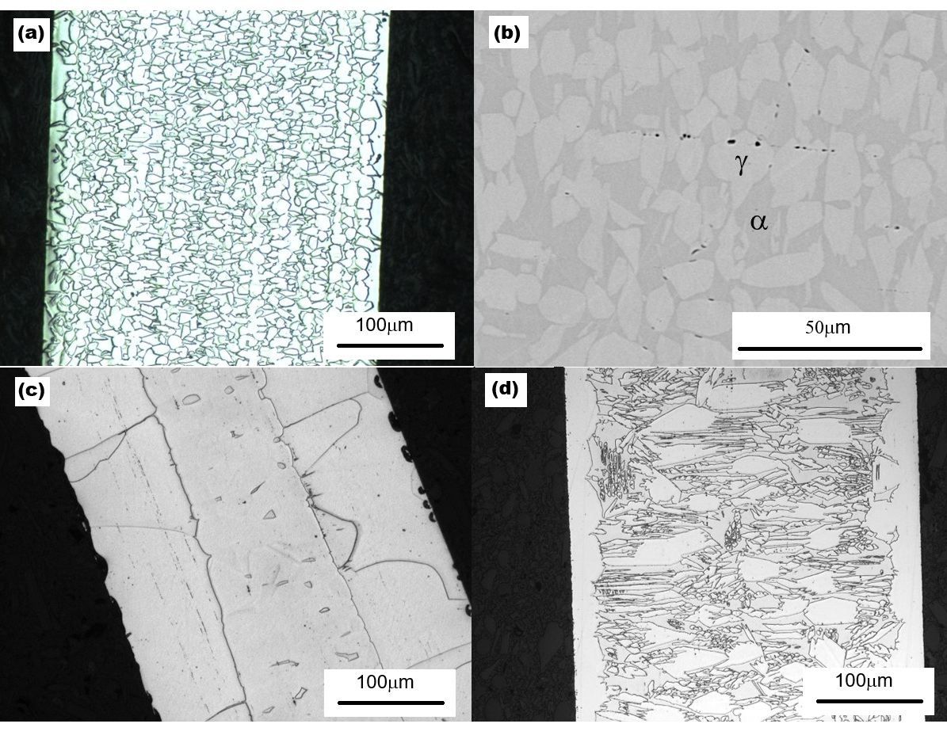
Fig. 1. Microstructure of the LLM-alloy after heat treatment: (a) 1200 °C, 1 min, optical; (b) 1200 °C, 1 min, SEM; (c) 1200 °C, 40 min, optical; (d) 0.36 mm wire after cyclic heat treatment (Sec. 2.2), optical.

3.2 Cyclic stress–strain response
Cyclic tensile stress–strain curves for the LLM-alloy after heat treatment at different temperatures are shown in Fig. 2, and the corresponding data are listed in Table 2. This information reveals a broad picture of how heat treatment governs the alloy’s mechanical properties. The response is strongly anneal-dependent: low strand-anneal temperatures (600–700 °C) leave the wire with high strength but brittleness (tensile strengths of ≈1876–2254 MPa and yield strengths of ≈1635–1908 MPa, but elongation of only ≈2%), reflecting incomplete recrystallization of the cold-drawn wire, whereas annealing at 800–1200 °C progressively softens the wire and restores ductility, with elongation peaking near 33% at 1000 °C. The elastic modulus, E, stays in the ≈150–162 GPa range across the well-annealed conditions. Across all LLM-alloy heat treatments examined, the stress–strain curves rose monotonically with no defined transformation plateau, and the recovered strain on unloading is comparable to the elastic strain (σ/E) expected at the unload stress. In other words, the strain recovery is consistent with elastic springback alone, with no resolvable pseudo-elastic contribution. It has been reported that aging at 200 °C can improve the pseudo-elasticity of Fe-Mn-Al-Ni alloy [32,33]; this was not the case for the LLM-alloy (Fig. 2h).
Fig. 2 shows the following. After the 600 °C anneal (Fig. 2a) the wire is stronger even than in the as-drawn state, reaching ≈2250 MPa, yet fails at ≈2.2% strain: the treatment has relieved drawing stresses without restoring formability. The 700 °C condition (Fig. 2b) is barely different. At 800 °C (Fig. 2c) the behaviour changes character — a well-defined yield plateau appears near 1200 MPa and the specimen sustains cycling to 10% strain — and 900 °C (Fig. 2d) continues the same softening. At 1000 °C (Fig. 2e) yielding falls to ≈675 MPa and is followed by steady work hardening, easing further at 1100 °C (Fig. 2f) and reaching ≈520 MPa at 1200 °C (Fig. 2g). Fig. 2h repeats the 1200 °C condition with the 200 °C / 3 h age applied and is indistinguishable from Fig. 2g. The feature common to all eight panels, and the one that matters here, is the geometry of the unloading segments: in every case they are straight and parallel to the initial elastic loading line, returning toward zero stress without a hysteresis loop and without strain recovery beyond σ/E. This is what a stress–strain curve looks like when no stress-induced transformation is occurring. All seven annealed conditions of Table 2 are therefore shown in full; the eighth row of Table 2, the as-drawn state, fractures at 2.0% with essentially no plastic range and its properties are read from the table.
Table 2. Mechanical properties of the LLM-alloy (0.36 mm wire) after heat treatment for 1 minute at different temperatures, tested on a 127 mm gauge (Sec. 2.4); E is the apparent modulus from crosshead strain. Each data point is the average of three samples; the uncertainty is one standard deviation.
Temp. (°C) | σ₀.₂ (MPa) | UTS (MPa) | Elong. (%) | E (GPa)
As drawn | 1587.9 ± 63.7 | 1936.6 ± 19.2 | 2.0 ± 0.1 | 138.5 ± 5.1
600 | 1908.0 ± 29.2 | 2254.3 ± 27.3 | 2.2 ± 0.1 | 155.7 ± 2.2
700 | 1635.3 ± 35.9 | 1876.0 ± 9.4 | 2.2 ± 0.0 | 156.1 ± 2.0
800 | 1151.1 ± 11.3 | 1208.6 ± 5.2 | 26.1 ± 1.7 | 151.4 ± 2.9
900 | 936.3 ± 5.5 | 1081.5 ± 2.5 | 30.6 ± 0.6 | 153.1 ± 1.4
1000 | 674.8 ± 1.5 | 977.8 ± 7.7 | 33.0 ± 0.3 | 156.0 ± 2.0
1100 | 570.6 ± 10.3 | 970.3 ± 16.5 | 29.1 ± 0.6 | 161.9 ± 3.6
1200 | 518.7 ± 11.8 | 968.3 ± 21.4 | 25.6 ± 1.2 | 161.2 ± 5.5
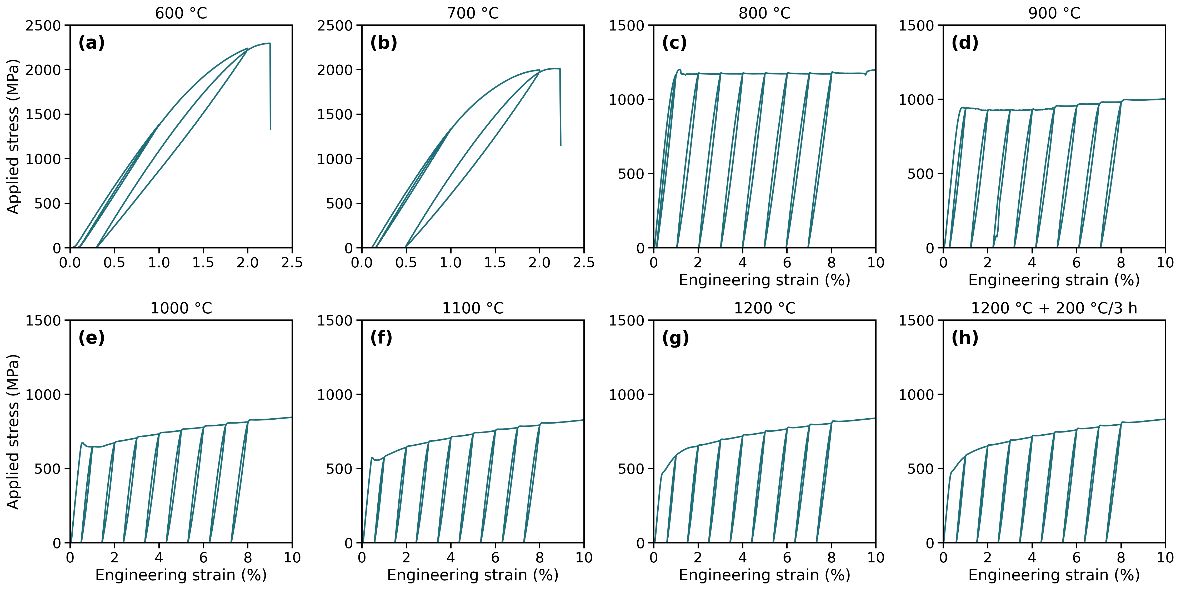
Fig. 2. Cyclic stress–strain curves of the LLM-alloy after annealing for 1 minute at (a) 600, (b) 700, (c) 800, (d) 900, (e) 1000, (f) 1100 and (g) 1200 °C, and (h) at 1200 °C followed by the 200 °C/3 h age. Nominal wire diameter 0.36 mm; the plotted spools measured 0.348–0.359 mm. Stress is computed from the measured per-spool diameter and strain from crosshead extension over the 127 mm gauge (Sec. 2.4). Each panel shows a single representative specimen; the values in Table 2 are means of three specimens per condition. Curves are shown to 10% strain (2.5% for the two brittle conditions); elongations to failure are listed in Table 2.
Fig. 3 compares the stress–strain behavior of the LLM- and benchmark alloys during cyclic loading–unloading–heating deformation. In this test, any residual stress-induced martensite present at zero stress should transform back to austenite upon heating, causing the reloading stress to rise at a strain lower than the last unloading strain. This is exactly what happened in the benchmark alloy: Fig. 3b shows that its residual strain after unloading from 3% deformation is ≈2.2%, and upon reloading, stress rises at a strain of ≈1.7%. This 0.5% strain recovery caused by heating is evidence of stress-induced martensite transformation in the benchmark alloy — the stress-induced martensite was stable enough to survive unloading but transformed back to austenite upon heating. By contrast, Fig. 3a shows no strain recovery of the LLM-alloy during this test. The test is reported for one condition of the LLM-alloy, 1200 °C for 1 minute — the same anneal as the benchmark panel — and what it establishes is confined to that state, the γ-majority γ + α duplex quantified in Sec. 3.3: no stress-induced martensite stable enough to survive unloading was present to revert on heating. The unloading evidence is broader, since in each of the eight conditions of Fig. 2 the unloading segment returns no strain beyond the elastic σ/E. Within the conditions reported here, then, the LLM-alloy deforms plastically with no resolvable pseudo-elastic contribution, shows no shape-memory recovery in the one state given the heating test, and stress-induced phase transformation is not among its active deformation mechanisms as processed here.
The claim made here is the narrow one it should be: no detectable transformation in the LLM-alloy under a route that produced measurable transformation in the benchmark. The comparison is conservative in the LLM-alloy’s favour, because the LLM-alloy additionally received the 200 °C/3 h age reported to develop pseudo-elasticity in this family (Fig. 2h) and the benchmark received no age at all.
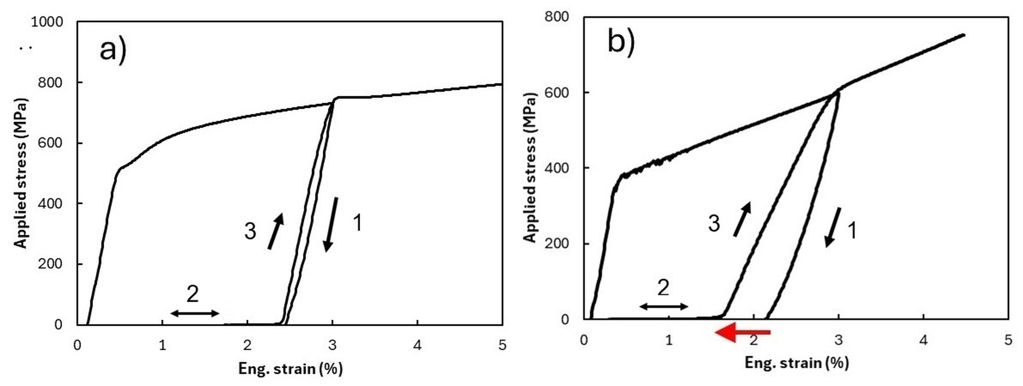
Fig. 3. Loading–unloading–heating tests of (a) the LLM-alloy and (b) the benchmark alloy, both heat treated at 1200 °C for 1 minute. Wire diameters 0.35 mm (a) and 0.54 mm (b); strain is crosshead extension over the 127 mm gauge (Sec. 2.4). Black arrows show the deformation path; the red arrow highlights the strain recovery caused by heating.

3.3 Synchrotron diffraction and phase identification
Synchrotron XRD of samples before and after deformation is shown in Fig. 4. Fig. 5 shows good overall agreement between the experimental data (lower half of each panel) and the results of Rietveld refinement (upper half), both before deformation (Fig. 5a) and after unloading from 10% strain (Fig. 5b). The fit is measurably better for the deformed specimen (R_wp = 12.5% against 21.4%), and the reason is visible in the patterns themselves: the undeformed wire gives a beaded, spotty ring pattern in which relatively few grains satisfy each Bragg condition, whereas deformation subdivides those grains and produces the more continuous rings on which powder averaging depends. The same grain-statistics argument recurs in a far stronger form for the benchmark alloy, below. Based on this result, the LLM-alloy is estimated to consist of ≈62% FCC γ-phase, ≈34% BCC α-phase, and ≈4% D0₃ Fe₃Al phase. Its diffraction patterns before and after deformation are essentially the same (Fig. 4a, b), and relative peak intensities (Fig. 6a) are essentially unchanged: no new diffraction peaks appear and none disappear. An ex-situ measurement made after unloading cannot, on its own, exclude a fully reversible transformation that reverts as the load is removed. The diffraction data are not what carry this conclusion, however, and the order of the evidence should be stated plainly. A transformation reversible enough to leave no diffraction signature after unloading would still have had to produce recoverable strain during that unloading, and the unloading segments of Fig. 2 are straight, parallel to the elastic line, and return no strain beyond σ/E in any of the eight conditions shown there (1-minute anneals at 600, 700, 800, 900, 1000, 1100 and 1200 °C, and 1200 °C followed by the 200 °C/3 h age). The loading–unloading–heating test of Fig. 3a closes the remaining route by which a transformation could hide in the 1200 °C/1 min state — the one condition for which that test is reported — since any retained martensite stable enough to survive unloading would revert on heating and show up as strain recovery, as it does for the benchmark in Fig. 3b. The mechanical measurement is therefore the primary evidence here and the unchanged multi-phase diffraction pattern is corroboration, not the other way round. What ex-situ diffraction genuinely cannot do is observe the material while it is loaded; a loading-stage or in-situ synchrotron measurement is the direct test of that remaining possibility and is named as future work in Sec. 4.4. Together the two lines of evidence point consistently to deformation by dislocation slip rather than stress-induced phase transformation. The shift from sharp, discrete spotty patterns in the undeformed state (Fig. 4a) to broader, partially arced rings after deformation (Fig. 4b) can be attributed to dislocation activity, which results in peak broadening and/or the formation of tiny sub-grains. In comparison, the benchmark alloy presents a BCC α-dominated pattern with FCC γ-phase and ordered β-NiAl (B2) precipitate diffractions in the undeformed state (Fig. 4c); after 8% applied strain, the {111}γ reflection intensifies and the overlapping {200}α redistributes in intensity (Fig. 4d), consistent with stress-induced γ formation and partial variant activation. The change in peak intensity after deformation of the benchmark alloy is also clearly shown in Fig. 6b.
Two points of nomenclature should be made explicit here, because the convention in this alloy family is the reverse of the one familiar from carbon steels. In Fe-Mn-Al-Ni alloys the parent phase is BCC α and the martensite formed from it is FCC γ. The γ phase is therefore the transformation product, not the parent, and an alloy rich in γ is one in which less parent phase remains available to transform, not one that is closer to transforming. Second, the refinement resolved γ, α and D0₃ Fe₃Al and nothing else: no ε-HCP martensite and no α′ were required to fit any pattern from either alloy, and the γ present in the annealed LLM-alloy is thermally stable and present before loading, rather than a stress-induced product.
No B2 superlattice reflection was resolved in the LLM-alloy above the detection limit of the present measurement, and that limit can be quantified rather than merely asserted. At the B2-allowed {200} superlattice position the LLM-alloy carries 0.50–1.06% of maximum intensity, against 3.83–7.17% in the benchmark; and the LLM-alloy’s intensity at that position is itself fully accounted for by D0₃, which produces the same reflection. The discriminating measurement is the D0₃-only {111} reflection, present in the LLM-alloy at 0.49–1.02% of maximum with a signal-to-noise ratio of 16–27 across four independent patterns, and absent from the benchmark (0.19–0.28%, S/N 2.3–2.9). The benchmark thus carries the B2-allowed reflection without the D0₃-only one, and the LLM-alloy carries both at comparable strength — the signatures of B2 and D0₃ respectively. Any B2 present in the LLM-alloy is therefore at least four times less abundant than in the benchmark and may be absent altogether. This bounds the claim without over-reaching it: a coherent dispersion finer or more dilute than this limit cannot be excluded by diffraction alone, and transmission electron microscopy or atom-probe tomography would be required to do so.
The two alloys are not equally amenable to quantitative diffraction analysis, and the reason is itself microstructural. After the identical 1200 °C anneal the LLM-alloy retains a fine equiaxed structure with grain diameters well under 20 µm (Fig. 1a), so that a large number of grains is illuminated and the powder-averaging assumption underlying Rietveld quantification is satisfied. The benchmark alloy instead undergoes pronounced grain growth at this temperature: its Debye–Scherrer rings break up into a small number of discrete, intense spots rather than continuous rings (Fig. 4c, d), too few grains contribute to each reflection, and no Rietveld model could be brought into satisfactory agreement with the measured pattern. Phase fractions are therefore reported for the LLM-alloy only, and no attempt is made here to quantify the extent of transformation in the benchmark alloy.
This restriction does not affect the comparison on which the present work rests. That the benchmark alloy undergoes a stress-induced transformation is not in question: the diffracted intensities change markedly with deformation (Fig. 6b), the alloy recovers strain on heating (Fig. 3b), and the transformation behaviour of this composition is well established in the literature [12–14]. What the coarse grain structure withholds is a number for how much of the parent phase transformed, not the fact that it transformed. The question addressed here is the converse one: why the LLM-alloy, given the same 1200 °C anneal, shows no corresponding change (Fig. 6a) and is instead dominated by the γ phase.
The refinement also quantifies the crystallographic texture that Sec. 2.5 anticipated. The LLM-alloy developed strong fiber textures during wire drawing: the inverse pole figures extracted from the E-WIMV orientation distribution (Fig. 7) show pronounced {111} and {100} fiber components in the γ phase and a strong {110} fiber component in the α phase, the components characteristic of cold-drawn FCC and BCC metals respectively [34]. These textures are the reason the azimuthal dimension was retained in the refinement (Sec. 2.5).
It is worth noting that the LLM-alloy after the abnormal-grain-growth heat treatment of Sec. 2.2 showed an X-ray diffraction pattern (Fig. 8) containing the same phases as Fig. 4a, but with the intensity along the Debye rings resolved into markedly more discrete spots. Two things follow, and they are separate. The phase constitution is unaffected by the treatment: the same γ, α and D0₃ are present after the cyclic treatment as after the single anneal, which is what a duplex equilibrium at 1200 °C (Sec. 3.4) leads one to expect, although phase fractions were not refined from this pattern and it therefore cannot say whether the γ excess over the calculated equilibrium noted in Sec. 4.1 is also unchanged; and the spottier rings place fewer, larger crystallites in the diffracting volume, so the grains coarsened. Coarsening without a change of constitution — and, as Sec. 3.5 shows, without the bamboo structure the treatment exists to produce — is the combination that matters here. The drawing texture also survives the treatment: the strong {111} + {100} γ and {110} α fiber components of Fig. 7 remain evident in the intensity distribution of Fig. 8.
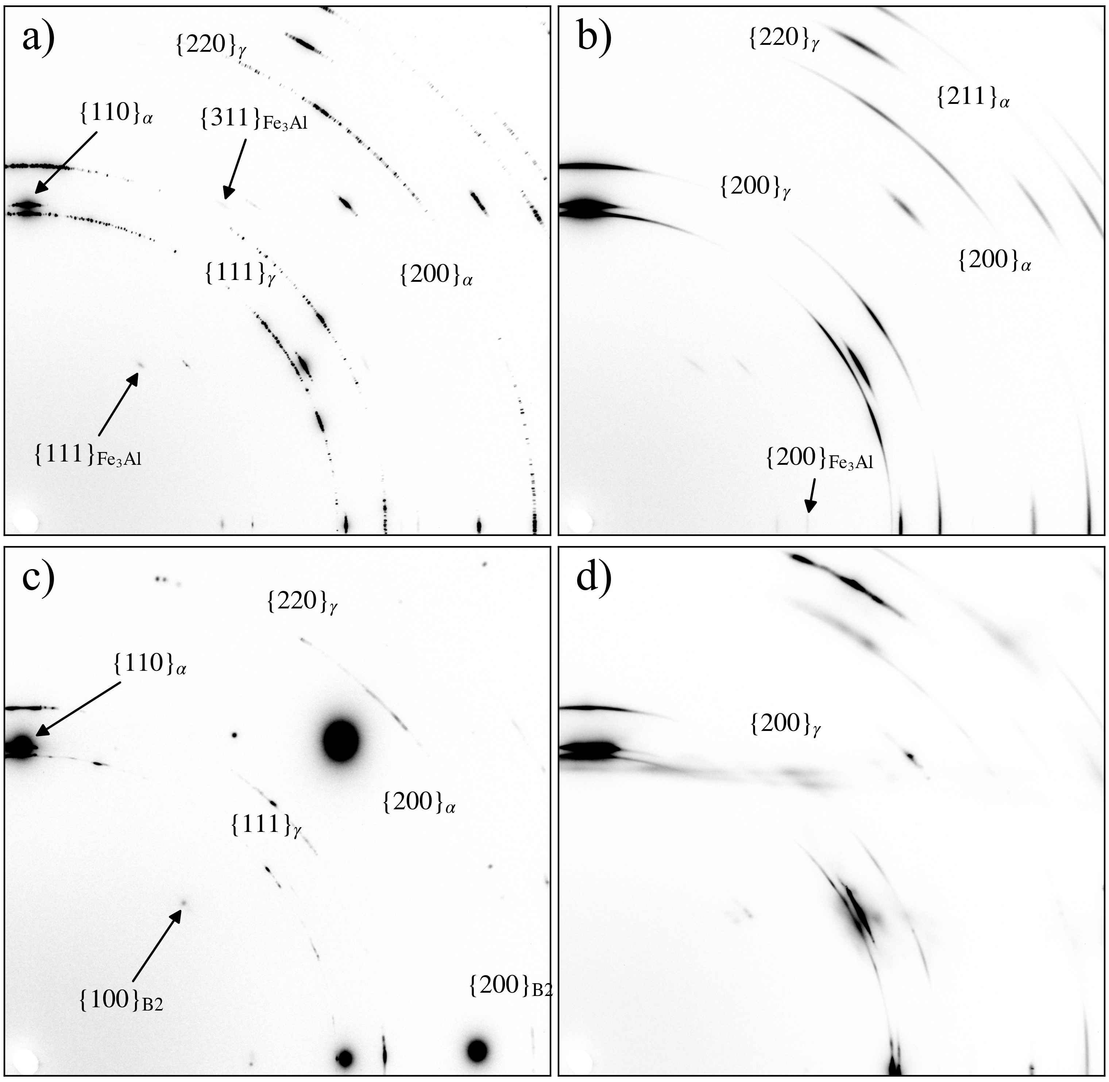
Fig. 4. 2D synchrotron X-ray diffraction images of (a) LLM-alloy annealed at 1200 °C for 1 min, (b) annealed LLM-alloy after 10% tensile strain, (c) benchmark alloy annealed at 1200 °C for 1 min, and (d) annealed benchmark alloy after 8% tensile strain.
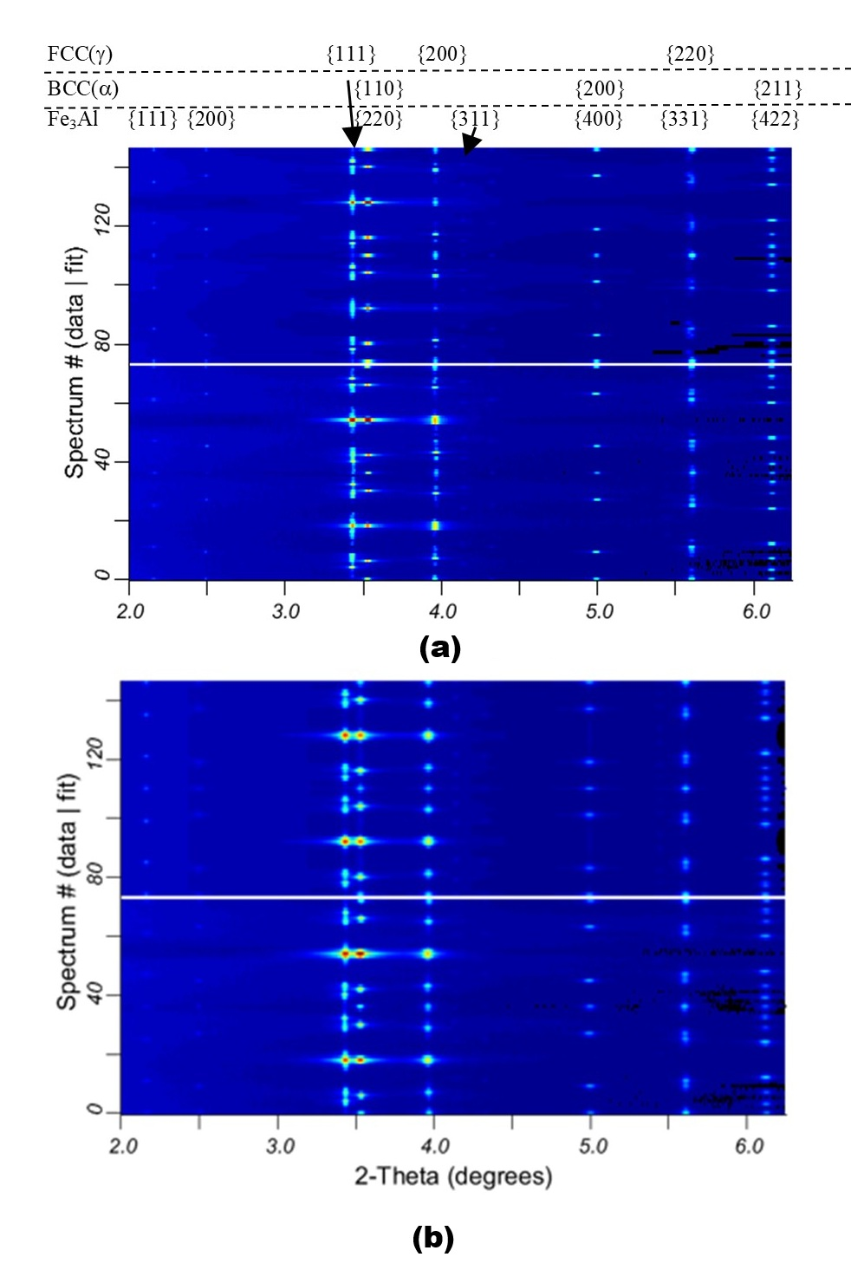
Fig. 5. Comparison between synchrotron X-ray diffraction data (lower half of each panel) and results of Rietveld refinement (upper half of each panel) for the LLM-alloy: (a) heat-treated at 1200 °C for 1 minute (R_wp = 21.4%, R_p = 8.7%), and (b) after unloading from 10% strain (R_wp = 12.5%, R_p = 5.9%). Both refinements used the three-phase model of Sec. 2.5, with lattice parameters fixed at a = 3.6366 Å (γ) and 2.8865 Å (α) in both cases, and 5.7734 Å (a) and 5.7801 Å (b) for D0₃.
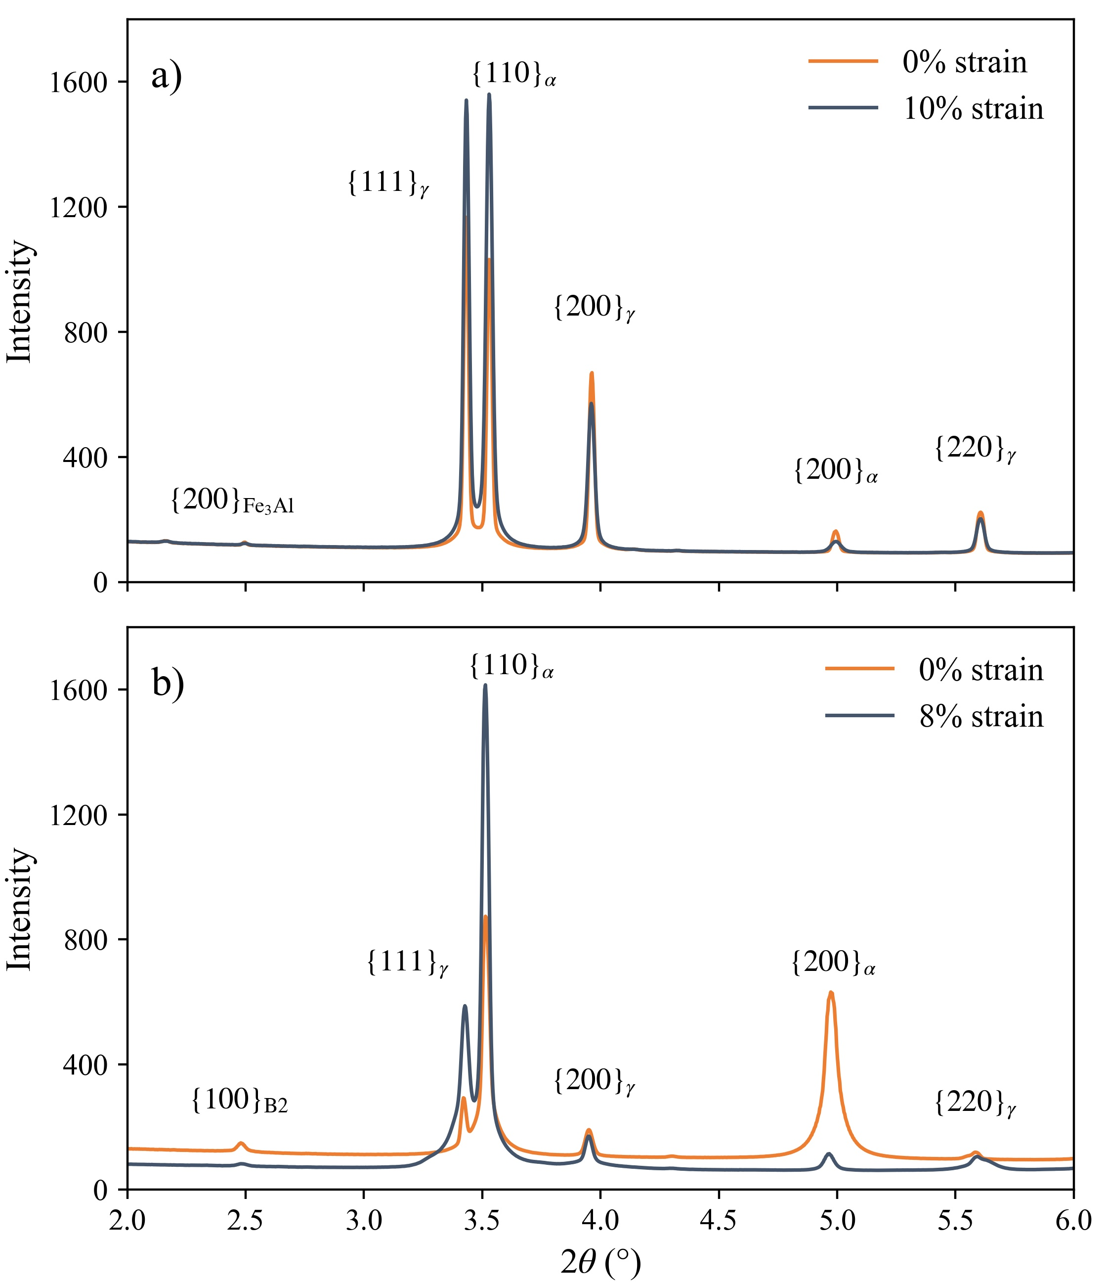
Fig. 6. Azimuthally integrated X-ray diffraction spectra of (a) the LLM-alloy and (b) the benchmark alloy before and after deformation. Samples were heat treated at 1200 °C for 1 minute before deformation.
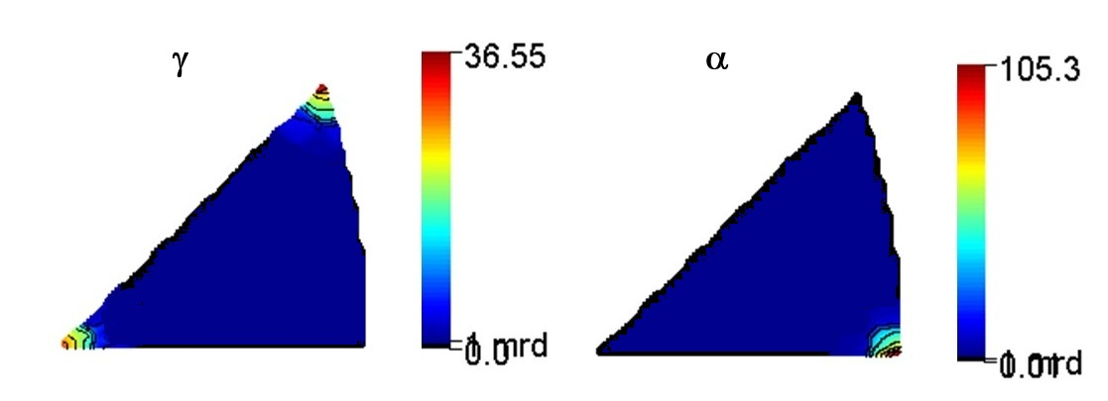
Fig. 7. Inverse pole figures of the γ and α phases of the LLM-alloy along the wire axis, extracted from the E-WIMV orientation-distribution refinement of Sec. 2.5. The sample was heat treated at 1200 °C for 1 minute. Intensities are in multiples of a random distribution.
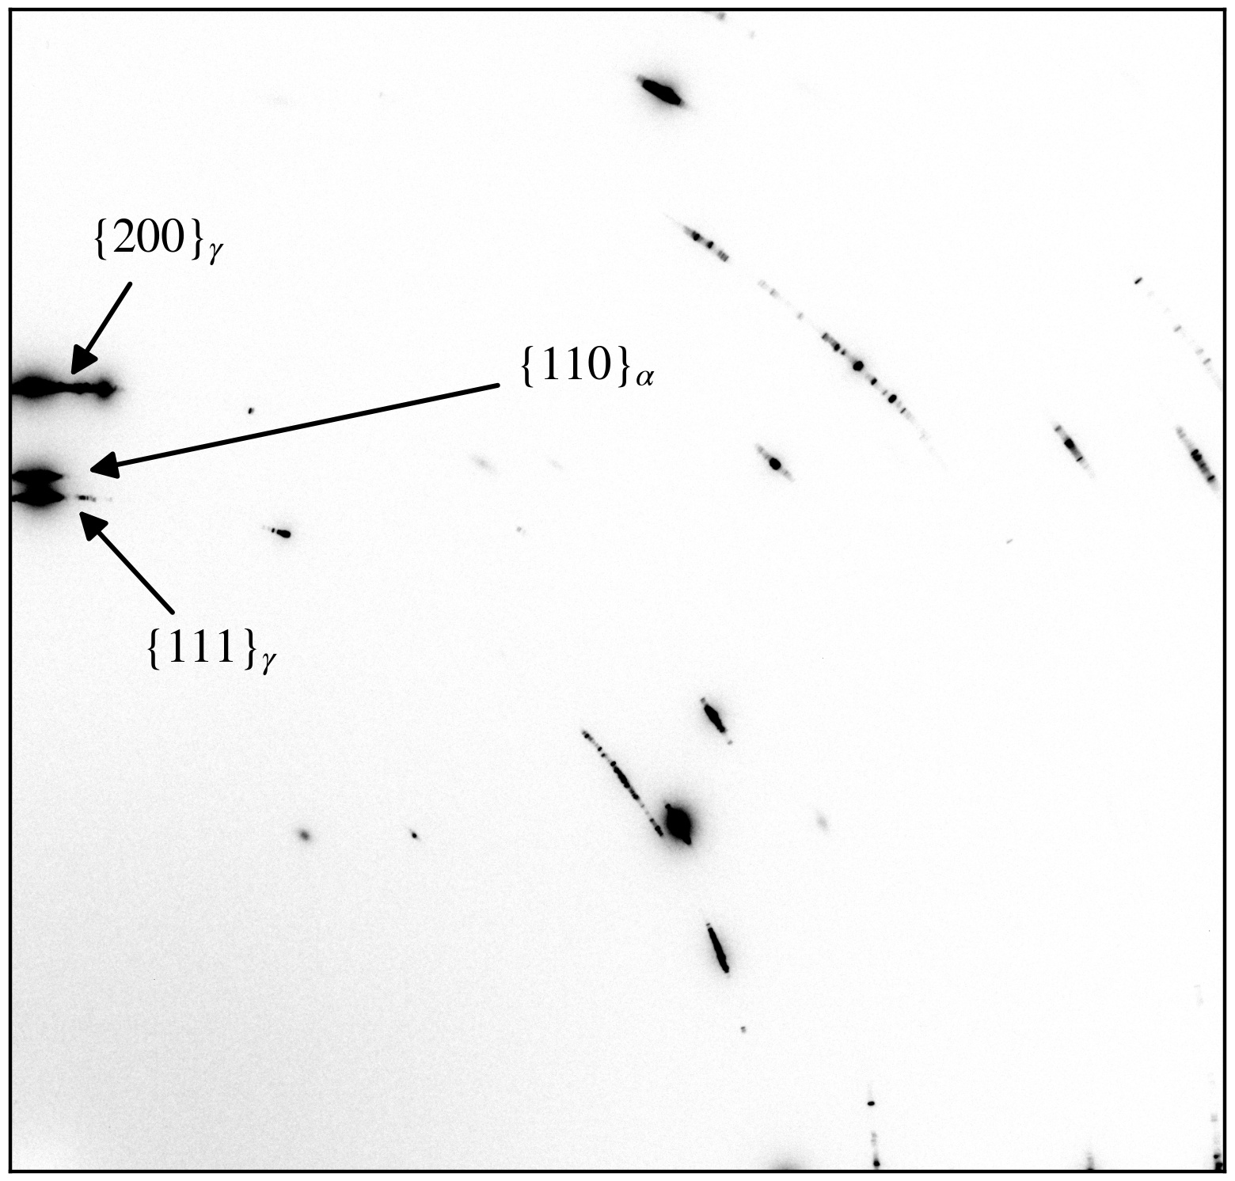
Fig. 8. Synchrotron X-ray diffraction image of the LLM-alloy after the abnormal-grain-growth heat treatment of Sec. 2.2. The vertical direction from the beam center corresponds to the wire axis. The pattern contains the same γ, α and D0₃ reflections as Fig. 4a, with the ring intensity resolved into discrete spots.

3.4 Equilibrium phase stability
Fig. 9 shows the calculated equilibrium step diagrams for the two alloys as cast, using the measured chemistries of Table 1. The virtual carbon-free composition described in Sec. 2.6 was evaluated on the same basis and is plotted beside them in Fig. 9c; because all three databases agree on it, it is also reported numerically in Table 3.
The benchmark alloy (Fig. 9a) reproduces the phase sequence its processing route assumes. A single-phase disordered bcc α field opens at ≈1140 °C and extends to the onset of melting at ≈1325 °C, so the 1200 °C solution treatment of Sec. 2.2 lies inside it with a margin of more than 100 °C on either side. On cooling below ≈1090 °C the bcc orders: between ≈700 and 1000 °C the calculated bcc is fully B2-ordered and accounts for 19–21% of the alloy, the balance being γ. The equilibrium state below ≈1090 °C is thus B2 + γ, and not the coherent B2-in-α nanostructure on which the benchmark’s super-elasticity actually rests; that nanostructure is a kinetically arrested approach to this equilibrium, obtained by quenching the single-phase α and ageing it where B2 can order but γ cannot yet nucleate. What the calculation establishes is that both conditions the processing route requires are available and contiguous: a temperature at which the alloy is single-phase α, and a range immediately below it in which that α has a thermodynamic driving force to order. Nothing about this alloy was fitted here; the calculation is a control, and it recovers the ≈20% ordered bcc that is observed directly in Fig. 4c.
The LLM-alloy behaves differently in every respect that matters (Fig. 9b). At 1200 °C it is not single-phase but a duplex mixture of 71.1% α and 28.9% γ, and raising the temperature never removes the γ before the alloy melts: at 1290 °C it still holds 7.4% γ, and at 1300 °C the first liquid appears with γ gone into it, so that the alloy passes directly from α + γ to α + liquid. There is no temperature at which this composition is single-phase α in the solid state. The other two databases return the same sequence by different numbers: PrecHiMn-04 keeps the alloy two-phase at least to 1250 °C and melts it from ≈1295 °C, and mc_fe — the only database here carrying all six elements plus P — keeps it two-phase to 1230 °C and melts it from ≈1240 °C. The three assessments differ on where melting begins, by ≈60 °C, and agree on what matters here: the single-phase α state that the processing route requires does not exist below this composition’s melting point, quite apart from the 1200 °C ceiling that oxidation and furnace contamination impose in practice (Sec. 2.2). This is a statement about the solid state rather than about the solidus, and it does not rest on any one database’s melting temperature (Table 4). Between ≈850 and ≈1050 °C the alloy is calculated to be fully austenitic. Ordered bcc appears only below ≈850 °C, reaches at most ≈11% at 400 °C, and forms within a γ matrix rather than an α one. There is thus no temperature at which this composition can be solution-treated to single-phase α and subsequently aged into coherent ordered precipitates within that α — the sequence on which the benchmark relies.
Removing carbon and holding every other element fixed creates the missing field (Fig. 9c), and does so in all three databases. The single-phase α window opens at ≈1150 °C in mpea-02b, ≈1160 °C in PrecHiMn-04 and ≈1130 °C in mc_fe, and in each it extends up to the solidus of the carbon-free composition (≈1375, ≈1295 and ≈1245 °C respectively): a window between 130 and 220 °C wide where the carbon-bearing alloy has none. The 1200 °C solution treatment therefore lands inside the single-phase field once carbon is removed, and the alloy reaches 100% α exactly as the benchmark does, in all three databases and despite their covering different element sets (Tables 3 and 4).
Table 3. Calculated equilibrium phase fractions (mol%) at 1200 °C, the solution-treatment temperature. The benchmark alloy cannot be evaluated in PrecHiMn-04, which contains no Ni.
Alloy | mpea-02b | PrecHiMn-04 | mc_fe v2.059
benchmark alloy | 100 α | – | 100 α
LLM-alloy | 71.1 α + 28.9 γ | 64.5 α + 35.5 γ | 61.9 α + 38.1 γ
LLM-alloy, C removed | 100 α | 100 α | 100 α
Table 4. Calculated single-phase α field in the solid state and calculated solidus (°C). “None” means that liquid appears before the last γ dissolves. Values are read from a 10 °C temperature grid and carry that resolution; the solidus is the first temperature at which the liquid fraction exceeds 0.5%.
Alloy | mpea-02b | PrecHiMn-04 | mc_fe v2.059
benchmark alloy | α 1140–1320; solidus ≈1325 | – | α 950–1360; solidus ≈1370
LLM-alloy | none; solidus ≈1295 | none; solidus ≈1295 | none; solidus ≈1240
LLM-alloy, C removed | α 1150–1370; solidus ≈1375 | α 1160–1290; solidus ≈1295 | α 1130–1240; solidus ≈1245
Because the LLM-alloy also carries less nickel than the benchmark — 4.2 against 7.8 at% — the calculation was repeated in mpea-02b, the only database here carrying both Ni and C, with nickel stepped across that interval in 0.4 at% increments, iron taking up the difference while Mn, Al, Si and C stayed at their measured values. The two elements separate cleanly. With carbon at its measured 0.45 at%, no single-phase α field exists in the solid state at any nickel content from 4.2 to 7.8 at%: the alloy is still α + γ when melting begins, at ≈1300 °C, at every point in the scan. With carbon removed, the field opens between 1150 and 1190 °C over the same nickel range, 160–230 °C below the solidus, and the alloy is 100% α at 1200 °C at every point in it. Carbon decides whether the field exists at all; nickel moves the carbon-free solvus by ≈40 °C — upward, in the unhelpful direction — and creates no field where carbon has removed one.
The endpoints were re-run in mc_fe as a cross-check, and they agree on everything that matters. With carbon present, mc_fe finds no single-phase α field in the solid state at either nickel content: melting begins at ≈1240 °C (4.2 at% Ni) and ≈1230 °C (7.8 at% Ni) while γ is still present, so the field never opens before the alloy starts to melt. With carbon removed the solvus falls to ≈1130 and ≈1070 °C respectively, well below the corresponding solidus (≈1250 and ≈1270 °C), and 1200 °C again lies inside a fully single-phase α field. The two databases do differ on one secondary point, and it is reported rather than reconciled: at 1200 °C with carbon present, added nickel makes the alloy slightly more austenitic in mpea-02b (bcc 71.1 → 59.6%) and slightly more ferritic in mc_fe (bcc 61.9 → 75.8%). The defensible statement is therefore that nickel does not open the solution-treatment window, not that it measurably closes it further.
Nickel is not inert, however. In mpea-02b it governs how much ordered bcc the alloy can form: at 700 °C the ordered fraction rises monotonically from 5.5% at 4.2 at% Ni to 13.9% at 7.8 at%, as expected of a NiAl-based B2. In every case that ordered bcc coexists with 86–94% γ rather than sitting within an α matrix. Five of the 1240 points in the mpea-02b scan failed to converge, all at 400–425 °C in the carbon-bearing series at the three lowest nickel contents; they are reported as gaps rather than as zeros. At the measured nickel content the scan reproduces the ordering curve of Fig. 9b, which is the internal check that it is consistent with the primary calculation.
A third question follows from Sec. 2.1. Because the composition melted lies outside the aluminum and manganese range of the hypothesis it was drawn from, the outcome reported here might be an artifact of that deviation rather than a property of what was proposed. It is not, and the point is worth settling by calculation rather than argument. Compositions inside the proposed window were evaluated on the same basis in the same database, and no composition anywhere in that window can be solution-treated to disordered single-phase α. At the window’s midpoint, Fe-25Mn-10Al-4.5Ni-2.5Si-0.2C (wt%), the alloy is 86.7% α + 13.3% γ at 1200 °C and, like the alloy actually melted, is still two-phase when melting begins at ≈1290 °C — taking the middle of the range takes the middle of its carbon range along with it. At the corner most favourable to ferrite, Mn 20, Al 12, Ni 6, C 0.1 wt%, which is the extreme of what the window permits, a single-phase bcc field does open, at ≈1240 °C, 40 °C above the annealing ceiling; and the bcc there is calculated to be ordered B2 rather than disordered α, so even that corner does not deliver the disordered parent the route requires. At the opposite corner the alloy is 64.0% α + 36.0% γ at 1200 °C and no single-phase field exists below its solidus (≈1320 °C) at all. Stepping aluminum alone from the 6.4 wt% melted to the window’s 12 wt% ceiling, holding everything else at the measured values, raises the α fraction at 1200 °C from 76.0 to 97.3% but never removes the last γ before melting begins (≈1270–1300 °C). The aluminum deviation is therefore real, and it does move the alloy in the direction observed, but it is not what closed the processing window. Carbon is — and carbon was specified by the hypothesis itself, at 0.1–0.3 wt%, with the melt taking the minimum value permitted. Every other carbon content the window allows would have been worse. As elsewhere in this section, mpea-02b carries no silicon and the silicon was folded into iron; that approximation is weakest at the ferritic corner, where silicon reaches 6.8 at%. The same four compositions were therefore re-run in mc_fe, which carries all six elements, and reach the same conclusion by a different route: none is single-phase α at 1200 °C there either, three being partly molten at that temperature and the fourth fully austenitic. The two databases differ on the solidus of these silicon-rich compositions by up to 300 °C — mc_fe’s liquid onset tracks silicon, falling from ≈1240 °C at the measured 1.1 wt% to ≈1020 °C at 4 wt% — and that difference is reported rather than reconciled; for the measured composition itself they agree to within ≈60 °C. What they agree on is that the window contains no composition that can be solution-treated to single-phase α.
Two further predictions bear on phases reported in Sec. 3.3. Carbide phases are calculated to be stable only well below the processing range: M₂₃C₆ appears in mpea-02b only below ≈420 °C, and κ-(Fe,Mn)₃AlC reaches 0.2–2.4% below ≈590 °C in PrecHiMn-04 and 0.1–0.8% between 510 and 540 °C in mc_fe. Neither is expected at or near 1200 °C. Separately, the ordered bcc of PrecHiMn-04 — the only description here capable of returning D0₃ — refines to the disordered A2 state at every temperature calculated, indicating that at ≈12 at% Al this composition lies below the equilibrium Fe₃Al D0₃ field.
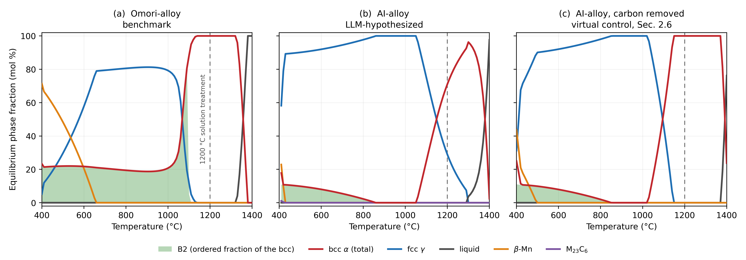
Fig. 9. Calculated equilibrium step diagrams (mpea-02b database) for (a) the benchmark alloy, (b) the LLM-hypothesized alloy and (c) the same LLM-alloy chemistry with carbon deleted and every other element held fixed — the virtual control of Sec. 2.6. Panels (a) and (b) were computed from the measured ICP-AES chemistries of Table 1 converted from wt% to at%: Fe–34.1Mn–15.2Al–7.8Ni–0.04C and Fe–29.8Mn–11.9Al–4.2Ni–2.04Si–0.45C respectively. mpea-02b does not model Si, which was therefore omitted and the remaining elements renormalized (Sec. 2.6). The shaded band is the ordered (B2) portion of the total bcc fraction; it lies beneath the total bcc curve because B2 is an ordered partition of that phase rather than a separate one. The grey curve is the liquid fraction. The dashed line marks the 1200 °C solution-treatment temperature: it lies inside the single-phase α field in (a) and (c), whereas in (b) no such field exists — the alloy is still α + γ at 1290 °C and passes to α + liquid at ≈1295 °C. The carbon-free control is also reported numerically in Tables 3 and 4.

3.5 Response to the abnormal-grain-growth treatment
The bamboo grain structure on which the benchmark’s strain recovery depends is produced by cyclic treatments of the kind described in Sec. 2.2, and both alloys were given such treatments on the schedules stated there: the LLM-alloy as ≈1–1.3 mm rod on the two- and three-cycle 1200 ↔ 900 °C schedules, and as 0.36 mm wire — together with the 0.64 mm benchmark wire — on the quartz-tube 1200 °C cycle. The cyclic treatments and the tests on the treated material were completed before the equilibrium calculations of Sec. 3.4 were made, so the treatment was chosen without knowledge that no single-phase α state was reachable in this alloy; that is a result of this study, not a premise of its design. It was applied because the comparison required the LLM-alloy to see the benchmark’s full route, of which this treatment is the grain-structure step. Bamboo was not a requirement of the hypothesis (Sec. 1), which held that it would be unnecessary; with an α parent assumed, the treatment was expected to behave in this alloy as in the benchmark, so it was applied to see whether the alloy would develop bamboo under the benchmark’s route, and what it did instead. The outcome is the second, and independent, place at which the two alloys separate — and, as this section will show, the place where the benchmark’s route turns out to be one the LLM-alloy could not use even if it were available.
The benchmark responds as the literature reports [12,18]. After cyclic treatment (Sec. 2.2) its 0.64 mm wire is bamboo throughout: individual grains occupy the full width of the section, and their boundaries run across the wire rather than along it, so that a tensile axis intersects few boundaries and each grain can accommodate a transformation shape strain with little constraint from its neighbours.
The LLM-alloy does not respond in the same way. After cyclic treatment (Sec. 2.2) its 0.36 mm wire (Fig. 1d) retains a fine, strongly banded duplex structure across the entire width of the section, and no grain approaches the section width. Bamboo formation did not fall short here — it did not begin. This is a claim about grain shape and span, not about grain size: the diffraction evidence of Sec. 3.3 shows that the treatment does coarsen this alloy. Coarsening and bamboo formation are being distinguished deliberately throughout this section, because in the benchmark they arrive together and in the LLM-alloy only the first of them does.
At larger section size the coarsening is directly visible. Optical metallography of the same alloy given the three-cycle 1200 ↔ 900 °C schedule of Sec. 2.2 as rod stock of ≈1 mm shows that coarsening plainly occurred there: several grains span a large fraction of the section. What it also records is where coarsening stopped. The coarse grains are separated by a continuous band of fine equiaxed grains running along the rod axis, which the advancing boundaries did not consume. Grain growth in this alloy is therefore not absent but arrested, and it is arrested at a band of the second phase.
That is what the equilibrium calculation of Sec. 3.4 predicts, and the two results are worth stating together because neither was fitted to the other. The benchmark is single-phase α at 1200 °C and so has nothing to pin a migrating boundary; the LLM-alloy is calculated to be a two-phase α + γ mixture at that temperature in all three databases (Table 3), and the duplex constitution is observed after quenching from the 40-minute anneal (Fig. 1c) and from the cyclic treatment (Fig. 8, Sec. 3.3). A boundary migrating through it must drag or bypass a second phase that additional time at temperature will not remove, since the calculation places γ at 29–38% of the alloy in equilibrium at 1200 °C whatever its measured fraction after the quench (Sec. 4.1). The cyclic treatment works in the benchmark because repeated crossing of the γ ↔ α boundary leaves a small number of surviving α grains to grow without competition; in the LLM-alloy, calculated to be α + γ at 1200 °C and to enter single-phase α at no temperature below its melting point (Sec. 3.4), no leg of either cycle places the alloy in a single-phase α field — the 1200 ↔ 900 °C schedule runs between α + γ and the fully-γ field calculated for ≈850–1050 °C — so there is no such condition to exploit.
Two further mechanisms plausibly reinforce that pinning, and both are consequences of the same duplex constitution. Repeated cycling into and out of the α + γ field creates numerous transformation interfaces, which act as preferential nucleation sites during each subsequent crossing and so subdivide the prior grains rather than selecting a few to grow; and the partitioning of Mn, Al, Ni and Si between α and γ on every cycle imposes solute drag on migrating boundaries in addition to the second-phase pinning itself. Their combined effect is directly visible in Fig. 1d: grain growth during the final 1200 °C hold of the cyclic treatment is markedly suppressed relative to the straight 40-minute anneal of Fig. 1c, despite the longer accumulated time at temperature.
Coarsening this alloy costs it its ductility, and it does so long before bamboo dimensions are approached. Holding the 0.36 mm wire at 1200 °C for 40 minutes instead of 1 minute — the treatment whose microstructure is Fig. 1c, where grains exceed 100 µm — drops the elongation from 25.5% to 0.8%, with the same 200 °C/3 h age applied to both and on the same 127 mm gauge (one specimen each; Fig. 10a against Fig. 2h); after 80 minutes at 1200 °C it is 0.5% (Fig. 10b). The specimen fractures within its first loading segment, before the first unloading point of the protocol is reached. Bamboo would require coarsening far beyond this, to grains spanning the full section, and there is no reason to expect the trend to reverse on the way.
The cyclically treated rod is mechanically poorer in the same manner, which matters because the coarsened state is the one in which the benchmark is useful. Fig. 10 collects every tensile record of the LLM-alloy in the prolonged-anneal and cyclically treated conditions, plotted from the raw load–extension exports with the gauge of each test stated, since the gauges differ (Sec. 2.4). The two two-cycle rod specimens (≈1.3 mm, 127 mm gauge) failed at 568 and 608 MPa after 1.0% elongation, each surviving a single unloading–reloading cycle (Fig. 10c) — the 40-minute result again, reached by a different route. Of the two three-cycle-plus-age rod specimens, both recorded at 1.06 mm, the one tested on the 127 mm gauge failed at 478 MPa and 0.5% (Fig. 10d), while the one tested on a 6.0 mm gauge reached 1006 MPa and cycled to 11.9% (Fig. 10e); on a 6.0 mm gauge that elongation corresponds to about 0.7 mm of crosshead travel, much of it load-train and grip compliance, so the figure is not a demonstration of ductility and is not compared with the 127 mm elongations. Boundary cracking is visible on the specimen surface, under stereomicroscope examination, after the three-cycle treatment followed by the 200 °C/3 h age. No general claim about the strength of the coarsened condition is made on this evidence; what the record supports is that the treatment introduces boundary cracking and large specimen-to-specimen scatter in the rod without producing the grain structure it was applied to produce. The 0.36 mm wire of the quartz-tube cycle — the stock of Fig. 1d, which did not coarsen — behaves differently: it cycled to 8% and fractured at ≈26% on a 25.4 mm gauge, at 1020 MPa (Fig. 10f), so the loss of ductility follows the coarsening rather than the treatment as such.
Two things the record does not contain should be stated. No loading–unloading–heating test on a cyclically treated specimen of either alloy is reported here; the two specimens of Fig. 3 are the only ones for which that test is reported. The rod specimens fractured at 0.5–1.0% on the 127 mm gauge, below the 3% strain of the heating protocol, and the cyclically treated 0.36 mm wire of Fig. 1d was not given that test. What the cyclic records of Fig. 10 do show is the unloading geometry of Fig. 2: every unloading segment that was recorded — one in each two-cycle rod, eight in the rod tested on the 6.0 mm gauge and eight in the quartz-tube wire — is straight, parallel to the preceding loading line, and returns no strain beyond σ/E. Nor were phase fractions refined for the 40-minute condition of Fig. 1c, which was examined optically only, or for the cyclically treated wire of Fig. 8 (Sec. 3.3); the comparison of phase constitution between Fig. 1a and Fig. 1c is therefore qualitative — both are duplex — and is stated as such.
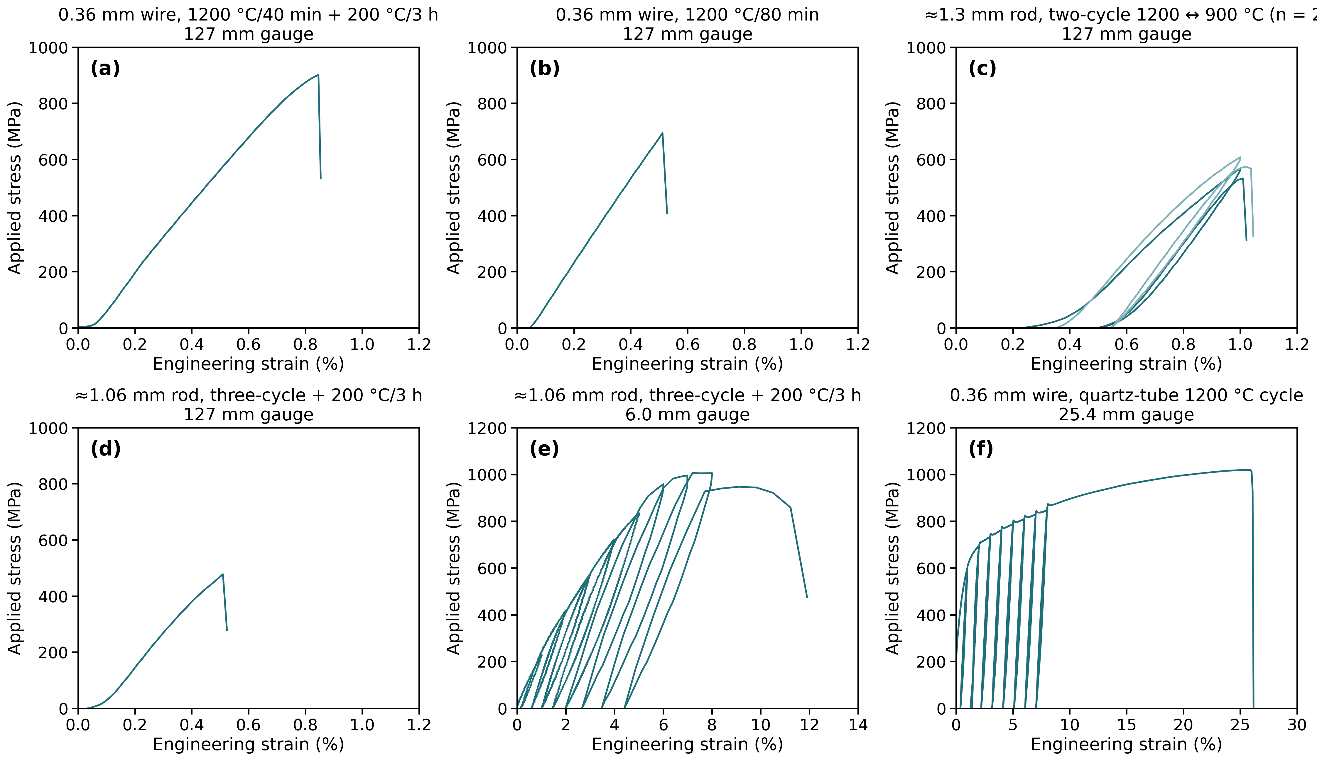
Fig. 10. Cyclic tensile records of the LLM-alloy in the prolonged-anneal and cyclically heat-treated conditions, plotted from the raw load–extension exports, with stress from the measured diameter and strain from crosshead extension over the gauge length of that test, which differs between panels and is stated in each: (a) 0.36 mm wire, 1200 °C/40 min followed by the 200 °C/3 h age; (b) 0.36 mm wire, 1200 °C/80 min; (c) two ≈1.3 mm rod specimens after the two-cycle 1200 ↔ 900 °C schedule of Sec. 2.2; (d) ≈1.06 mm rod after the three-cycle schedule and the 200 °C/3 h age, 127 mm gauge; (e) a second specimen of the same condition tested on a 6.0 mm gauge; (f) 0.36 mm wire after the quartz-tube 1200 °C cycle, 25.4 mm gauge, shown to fracture at ≈26%. Loading was in 1% increments per cycle as in Fig. 2. Strains on the 6.0 and 25.4 mm gauges are not comparable with those on the 127 mm gauge (Sec. 2.4).
Two limits on this comparison should be stated. The two alloys were treated at their respective final sizes, 0.36 mm for the LLM-alloy against 0.64 mm for the benchmark, so quench rates differed and the ratio of surface to boundary area differed with them; and the ≈1 mm LLM-alloy rod is a third size again. Section size is not incidental to abnormal grain growth, and a like-for-like size comparison was not performed. The direction of the effect nevertheless runs against the LLM-alloy’s favour on the conventional argument, since bamboo structures form more readily in thinner sections and it is the thinner of the two wires that failed to coarsen at all.
It should be said plainly that bamboo structure is not a target for this alloy, and the results above are the reason. The treatment was applied because it is the benchmark’s route to super-elasticity and the comparison had to be made; but an alloy that falls below 1% elongation at 100 µm grains (Fig. 10a) cannot be carried to grains of 360 µm and remain a wire anyone can use. The AGG experiment therefore closes a route rather than missing a target. What it returned is the growth of the duplex structure itself — both constituents coarsening together, still interlocked, still pinning each other, as the rod metallography shows directly and as the spottier diffraction pattern of Sec. 3.3 (Fig. 8) confirms.
The more fundamental reason not to pursue the treatment further lies in what abnormal grain growth does and does not do. Bamboo structure does not confer a transformation on a material; it removes the inter-granular constraint that limits one, and so raises the recoverable strain of a material that already transforms. The benchmark demonstrates this within the present data set. The single-anneal condition of Fig. 3b is not a bamboo structure — bamboo requires the cyclic treatment of Sec. 2.2, and that specimen received one anneal — yet the benchmark transforms there: ≈0.5% recoverable strain on heating after 1 minute at 1200 °C (Sec. 3.2), against the 5–8% the same composition reaches once bamboo is developed [12]. The tendency is plainly detectable an order of magnitude below the grain structure that optimises it. In the LLM-alloy no such signal appears in any condition reported here: not on unloading in the seven 1-minute anneals of Fig. 2 (600–1200 °C), not with the 200 °C/3 h age reported to develop pseudo-elasticity in this family (Fig. 2h), not on heating in the one condition given the loading–unloading–heating test (Fig. 3a), and not on unloading in the cyclically treated conditions of Fig. 10. The cyclically treated condition has not been put through the heating test.
Nor can grain size be offered as the explanation for that difference, which is worth stating because the two alloys did not reach the same grain size under the common route: at 1200 °C the LLM-alloy holds a structure well under 20 µm (Fig. 1a) while the benchmark coarsens pronouncedly (Sec. 3.3). The LLM-alloy, however, shows no transformation at the fine end of its own range (the sub-20 µm condition, Figs. 2g and 3a) nor in the coarsened rod that survived a loading cycle (Fig. 10c, e), and the 40-minute wire that takes it past 100 µm (Fig. 1c) fractures before an unloading segment can be recorded (Fig. 10a). A variable that is held at zero across the change in grain size the record covers is not the variable that grain size controls. Abnormal grain growth multiplies a transformation strain; it does not create one, and there is nothing here for it to multiply. Bamboo raises a recoverable strain that already exists; whether it could create one in an alloy that shows none is not tested here, because the LLM-alloy rod does not survive the treatment to the test. That, rather than the difficulty of the treatment or the embrittlement described above, is the reason the route was not carried further.
The consequence for the hypothesis under test is then narrow and specific. That hypothesis (Sec. 1) held that the composition would show super-elasticity without requiring the bamboo grain structure that makes the benchmark difficult to produce industrially. The premise was sound — this alloy indeed cannot use bamboo, and for a reason the hypothesis did not anticipate, namely that coarsening embrittles it. What fails is the conclusion: the alloy does not transform in the fine-grained condition either, so removing the need for bamboo bought nothing. One duplex constitution accounts for both halves of that sentence, stabilising the fine structure against the AGG treatment and suppressing the transformation. An alloy design workflow that had checked phase constitution at the solution-treatment temperature would have raised both, before any metal was melted — a point taken up in Sec. 4.4.

4. Discussion

4.1 Origin of the absence of stress-induced phase transformation
Three levels of evidence run through this section, and they should be kept apart. What was measured is that, in each condition reported here — the seven 1-minute anneals of Fig. 2 at 600, 700, 800, 900, 1000, 1100 and 1200 °C, the 1200 °C anneal followed by the 200 °C/3 h age (Fig. 2h), the loading–unloading–heating test at 1200 °C/1 min (Fig. 3a), and the cyclically treated conditions whose unloading segments were recorded (Fig. 10c, e, f) — the LLM-alloy recovered no strain beyond σ/E on unloading; that after the 1200 °C/1 min anneal it recovered none on heating (Fig. 3a), while the benchmark given the same anneal recovered ≈0.5% (Fig. 3b); and that the diffraction pattern of the 1200 °C/1 min wire was essentially unchanged by 10% strain (Fig. 4a, b). What is calculated is that no solution treatment within the processing window accessible here brings this composition to single-phase α, and that Sec. 3.4 finds no such field in the solid state at all; that statement reaches beyond the conditions reported to the composition itself, but it rests on equilibrium calculation in three databases rather than on measurement. What is not claimed is that the composition is incapable of super-elasticity under any processing: a solution or ageing treatment not tried here is untested (Sec. 4.4), and what this paper evaluates is the potential of this alloy as processed by the one route used here.
The absence of super-elasticity and of a shape-memory response in the LLM-hypothesized alloy (50Fe-30Mn-12Al-4Ni-4Si at% with 1000 ppm C), in the conditions just listed, is attributed to a misalignment between its phase stability and its active deformation mechanisms. In Fe-Mn-Al-Ni shape-memory systems, super-elastic behavior is contingent upon a reversible, stress-induced martensitic transformation from a BCC α parent phase to FCC γ martensite. However, quantitative Rietveld refinement of the synchrotron XRD data reveals that the LLM-alloy is structurally dominated by the γ-phase (≈62%), whereas the α-phase accounts for only ≈34% of the volume fraction, with a further ≈4% present as ordered D0₃ (Sec. 3.3). Compared to the benchmark alloy (43.5Fe-34Mn-15Al-7.5Ni at%), the LLM-alloy has less Mn, Al, and Ni, but higher Fe, Si, and C. It is known that Fe, Si, and Al stabilize the BCC α-phase, while Mn, Ni, and C stabilize the FCC γ-phase [35]. The original hypothesis was that these chemistry changes would not alter the phase constitution or stability, and that the additional C could also increase material strength to impede dislocation slip and promote stress-induced phase transformation. In practice, this chemistry modification favors the FCC crystal structure and raises γ-phase stability, and the equilibrium calculations of Sec. 3.4 identify carbon as the element that closes the single-phase α field at the solution-treatment temperature (Sec. 4.2).
What was and was not anticipated can be stated precisely rather than from recollection, because the design report survives and is supplied as Supplementary Material (Sec. 2.1). For this composition the report specified a BCC parent phase carrying coherent 5–15 nm β precipitates of Ni(Al,Si) type, and predicted 5–8% recoverable strain at a transformation stress of 400–700 MPa. It made no prediction of phase fractions, calculated no phase diagram, and identified no solution-treatment window — it named the microstructure it wanted without establishing that the composition could produce it. The ordered phase that actually formed does not appear in the report at all: D0₃ and Fe₃Al occur nowhere in its forty-one pages. That is not a general blind spot for ordered Fe-Al chemistry, since κ-carbide is discussed at length and one of the report’s six candidate families is built explicitly on κ-(Fe,Mn,Cr)₃AlC in an Fe-Al-Cr-Mn-C alloy at 5–12 wt% Al — a range that brackets the 6.4 wt% eventually melted. The ordering chemistry was present in the report’s reasoning but attached to a different candidate, and was not carried across to the one that was made. The relevant failure is one of transfer rather than of knowledge, which is both a more tractable problem and a more specific caution than an appeal to the model’s general grasp of metallurgy.
The thermodynamic calculations place this argument on a quantitative footing and change its emphasis. The problem is not that the LLM-alloy possesses a BCC parent phase with an insufficient driving force for transformation; it is that, on the calculation, no accessible heat treatment produces that parent phase in the first place. At 1200 °C the alloy is calculated to be a two-phase α + γ mixture in all three databases, and in none of them does a single-phase α field open before the alloy begins to melt — at ≈1240 °C in mc_fe and ≈1295 °C in mpea-02b and PrecHiMn-04 — so the parent state is unreachable in the solid state, independently of the 1200 °C oxidation limit of the process (Sec. 3.4). The duplex constitution that the calculation predicts at the solution-treatment temperature is what is observed in kind, though not in proportion: the interlocked two-phase morphology of Fig. 1b, the Al-rich and Mn-rich EDS partitioning that accompanies it, and the coexisting α and γ reflections of Figs. 4a and 5. It also explains why the constitution is insensitive to annealing time even though the grain size is not: the duplex state is observed after 40 minutes at 1200 °C (Fig. 1c) and after the full cyclic treatment (Sec. 3.3) because both phases are calculated to be in equilibrium at that temperature, so neither is removed by longer holding; what the calculation does not reproduce is the measured proportion of the two, and that discrepancy is taken up next. What prolonged annealing changes is the scale of that state rather than its identity — both constituents coarsen together, at the cost of the ductility reported in Sec. 3.5. That the same calculations independently reproduce the benchmark alloy’s single-phase α field and its ≈20% ordered B2 (Fig. 9a), neither of which was fitted here, is what licenses their application to the test alloy.
One quantitative discrepancy should be stated plainly. The calculations place α in the majority at 1200 °C (62–71%, Table 3), whereas the refinement of the quenched wire places γ in the majority (≈62%); the two agree that the alloy is duplex but not on which phase dominates. The inversion is large — ≈62% γ refined against 29–38% calculated — and it is not peculiar to one pattern, since the pattern of the same wire after deformation is essentially unchanged in relative intensities (Fig. 6a). Two readings are open and the present data do not decide between them. The first is that the γ was present at 1200 °C in more than the calculated amount, either because the databases — which themselves span 62 to 71% α — overestimate α at that temperature, or because the wire, which enters the strand anneal cold-drawn ≈85% after its last process anneal at 1000 °C (Sec. 2.1), a temperature at which the primary database calculates it to be fully austenitic (Fig. 9b), was not carried to the 1200 °C equilibrium in the time available; phase fractions were not measured for the 40-minute condition (Fig. 1c) or for the cyclically treated condition (Sec. 3.3), so this sub-reading is untested here. The second is that part of the α present at temperature transformed to γ on cooling; since γ is the transformation product in this system (Sec. 3.3), a martensitic α → γ reaction during the quench would invert the ratio and would place the martensite start temperature above room temperature. The EDS partitioning of Fig. 1b does not discriminate between the readings. The Al-rich and Mn-rich constituents are the partitioning expected between α and γ at 1200 °C under either reading, and a martensitic γ formed from α on the quench would inherit that α’s Al-rich composition [35] and so would not be separated from α by chemistry alone; the EDS result is reported qualitatively (Sec. 3.1), without a map of composition against crystal structure and without a fraction of either constituent. The microstructural test is a phase map with composition on the same area (EBSD with EDS), in which Al-rich regions indexing as FCC would be the signature of the second reading, or an areal fraction of the Mn-rich constituent on the same mount, which the first reading requires to match the ≈62% γ of the refinement and the second to fall below it; neither was performed. The lath-like appearance of the cyclically treated wire (Fig. 1d, Sec. 3.1) is consistent with either reading. Neither reading alters the conclusion of this section, which rests on the measured unloading and heating behaviour of Sec. 3.2 (Figs. 2 and 3a) and on the duplex constitution calculated for 1200 °C (Sec. 3.4) and observed after quenching from it (Secs. 3.1 and 3.3), not on when the γ formed. The direct test of whether a transformation occurs on cooling is differential scanning calorimetry of the strand-annealed wire through heating and cooling, with the benchmark wire as the control; it has not been performed, and the question is carried as open in Sec. 4.4.
The calculations also clarify the status of the ordered phases. D0₃ is not predicted to be an equilibrium phase at ≈12 at% Al (Sec. 3.4), yet it is observed. Its presence is therefore best understood as a metastable ordering product formed on cooling — exactly the kind of kinetic outcome that a screening step based on composition and equilibrium thermodynamics alone cannot anticipate. It is not, however, peculiar to this heat. Both B2 and D0₃ are documented ordering products in the Fe-Mn-Al-C low-density steels [16], and in the Ni-alloyed members of that family the B2 that does form is only marginally stable at the temperature used here: nanoscale NiAl-type B2 confined to the BCC constituent of a γ-majority Fe-16Mn-9Al-0.9C-5Ni steel coarsens on holding at 1110 °C and breaks up again after 30 min at 1200 °C [17]. The ordering behaviour observed in the LLM-alloy is thus characteristic of the alloy field its chemistry actually places it in, rather than of the shape-memory field it was designed for. Conversely, the ordered bcc that the LLM-alloy can form at equilibrium is small (≤11%) and confined below ≈850 °C. At those temperatures both alloys are calculated to be ordered bcc coexisting with γ; what separates them is the step before. The benchmark can be quenched from a single-phase α field and then aged, so that B2 orders coherently within α before γ has time to nucleate. The LLM-alloy has no accessible single-phase α field to quench from (Sec. 3.4), so there is no α matrix in which coherent B2 could form, and the microstructure the benchmark relies upon is, on the equilibrium calculation of Sec. 3.4, unavailable to this composition at any temperature in the solid state. This is a stronger statement than the absence of a B2 reflection alone would support, and it accounts for the failure of the 200 °C ageing treatment (Fig. 2h) to induce any pseudo-elastic response.
One asymmetry in the experimental design is worth making explicit, because it bears directly on whether the processing route was simply the wrong route for this composition. The two alloys were not treated identically in the respect that matters most for ageing. The LLM-alloy received the 200 °C / 3 h age reported to improve pseudo-elasticity in this family [32,33] and showed no response whatever (Fig. 2h, indistinguishable from the unaged Fig. 2g). The benchmark in Fig. 3b received no age at all — 1200 °C for 1 min and cooling, nothing more — and still showed reverse transformation on heating. Whatever bias the shared route carries therefore runs in the LLM-alloy’s favour rather than against it, and the null result cannot be attributed to an ageing treatment that was withheld. This is not the same as claiming the route was optimal for the LLM composition: no route was optimised for either alloy, and whether some other solution or ageing window could unlock a transformation in this chemistry is untested and is named as such in Sec. 4.4.
Furthermore, mechanical and structural analyses indicate that the LLM-alloy accommodates macroscopic deformation via irreversible dislocation slip rather than phase transitions. Coherent, ordered β-NiAl (B2) precipitates within a BCC matrix contribute to, rather than solely determine, the transformation reversibility of the benchmark [36]; parent-phase stability, transformation temperature, grain size, crystallographic orientation and texture, and the competition between the transformation stress and the plastic yield stress all bear on whether a stress-induced transformation can proceed reversibly. The precipitates are not even a purely mechanical contribution: by drawing Ni and Al out of solution they alter the composition of the matrix that surrounds them, and hence its transformation temperatures, so that the same ageing treatment shifts both the obstacle field and the thermodynamic setting in which the transformation must occur [37]. In the LLM-alloy the ordered phase that forms is D0₃ Fe₃Al, present as a bulk constituent rather than as a fine coherent dispersion, so it does not raise the resistance to plastic flow in the way that B2 does in the benchmark. This is confirmed by the post-deformation synchrotron XRD patterns, where the transition from sharp, discrete spots to broad, partially arced rings reflects dislocation multiplication and sub-grain formation. Thus, the microstructural state of the LLM-alloy remains highly stable at 1200 °C, favoring dislocation- or twinning-mediated plasticity over stress-induced martensitic transformation.

4.2 The role of carbon
Five elements differ between the two alloys, so no comparison of the two cast heats can by itself establish which of them is responsible for the loss of super-elasticity. On a plain atomic-percent basis carbon is the smallest of the five changes, and singling it out — as the original hypothesis did — would otherwise be arbitrary. The virtual carbon-free composition of Sec. 3.4 is the control that resolves this, because it changes carbon alone while holding Fe, Mn, Al, Ni and Si at the values actually measured in the cast wire.
A shortcut is available before that control, and it fails in a way worth recording, because reasoning of exactly this kind is what proposed the alloy. Austenite-stabilising potency is conventionally summarised by a Schaeffler-type nickel equivalent, Ni_eq = Ni + 30C + 0.5Mn in weight percent, in which carbon carries thirty times the weight of nickel and which would appear to settle the question immediately. Evaluated on the measured chemistries it returns 23.9 for the LLM-alloy against 27.5 for the benchmark — ranking the benchmark as the more austenite-stabilised of the two, the opposite of what both the calculations of Sec. 3.4 and the diffraction of Sec. 3.3 show. Two things defeat it. First, the expression carries no aluminium term at all, yet aluminium is the second-largest addition in both alloys (6.2 and 8.0 wt%) and the strongest ferrite stabiliser either of them contains; the difference in aluminium between the two heats is invisible to the formula. Second, the carbon term is a weight-percent term, and the distinction is not cosmetic at these levels: 0.105 wt% carbon contributes 3.2 units, where the same carbon expressed as 0.45 at% would contribute 13.5 and would reverse the ranking. Underlying both is a domain problem that the arithmetic hides: the companion chromium equivalent evaluates to ≈1.7 and ≈0.0 for the two alloys, since neither contains chromium, so both sit far outside the Cr_eq ≈ 15–30 band over which the Schaeffler construction was calibrated. A correlation fitted to Fe-Cr-Ni stainless steels, in which aluminium is absent and chromium supplies the ferrite stabilisation, does not transfer to Fe-Mn-Al. We report the attempt and its failure rather than omitting it, because a tabulated composition–potency heuristic is precisely what a screening step short of a real calculation would supply, and here it points the wrong way. What follows is therefore not a more precise version of this argument but a different kind of argument.
The result is unambiguous and reproduces across all three databases (Table 3). Deleting 0.45 at% (≈0.10 wt%) carbon creates a single-phase α field where none existed — one that opens at ≈1130–1160 °C and extends to the solidus in all three databases — and converts the equilibrium constitution at 1200 °C from a 62–71% α + 29–38% γ mixture into 100% α, the same single-phase state the benchmark alloy reaches at that temperature. Carbon, at a concentration of one part in a thousand by weight, is what closes the solution-treatment window on which the entire processing route depends.
Two elements are exonerated by the same calculation. Silicon was added as a ferrite stabilizer and solid-solution strengthener, and it remains at its measured 2.04 at% in the carbon-free variant of both Si-bearing databases, which nonetheless return 100% α at 1200 °C; silicon therefore does not obstruct the single-phase field, and the shortfall in the as-cast alloy is not attributable to it. The reduction in Ni from 7.8 to 4.2 at% is held at its measured value by the same construction, but nickel deserves more than that, because it is the substitution a reader would most reasonably expect to matter: the benchmark’s super-elasticity depends on NiAl precipitation and the LLM-alloy carries barely half the nickel. The scan reported in Sec. 3.4 addresses it directly, and the separation it produces is clean. Nickel does not create the missing field — with carbon present the alloy is still α + γ at the onset of melting at every nickel content from 4.2 to 7.8 at% — so restoring the benchmark’s own nickel content to this alloy would not have opened the solution-treatment window. What nickel does control is how much ordered bcc can form, 5.5% to 13.9% at 700 °C across the same interval, which is precisely the B2 the design rationale was reaching for. The two elements therefore act on different parts of the problem: nickel sets how much B2 the alloy could form, and carbon sets whether there is ever an α matrix in which to form it coherently. They are not competing explanations of one failure, and the lower nickel content cannot substitute for carbon as its cause.
Exonerating silicon of the primary failure is not the same as finding it inert, and the distinction matters because silicon was one of the two elements the agent added on its own initiative. Recovered at 2.04 at%, half the intended level, it cannot have delivered the solid-solution strengthening of the parent phase it was specified for; the calculation above shows it did not decisively shift α stability either. What it may well have done is contribute to the one ordered phase that did appear. Heo et al. [38] examined precisely this substitution — silicon added to a Fe-Mn-Al-C low-density steel to recover the density benefit of aluminum that had been removed to suppress κ-carbide — and found it undesirable, because silicon instead promotes (Fe,Mn)₅(Si,Al)C together with the (Fe,Mn)₃(Al,Si) D0₃ ordered phase in the ferrite grains, with a serious loss of ductility. D0₃ is the ordered phase observed here (Sec. 3.3), and it is the phase that appears in the α constituent. We cannot separate a silicon contribution to that ordering from an iron-aluminum one with two heats and no silicon-free control, so we do not claim it. The point is narrower and worth making anyway: an addition that the design rationale treated as a strengthener has a documented second role in this compositional field, as a promoter of the very ordering product that was found, and nothing in the reasoning that proposed it engaged with that role.
The limits of this conclusion should be stated as clearly as the conclusion itself. Carbon is decisive at the temperature where the process operates, not across the whole temperature range. Over roughly 850–1020 °C both the as-measured composition (Fig. 9b) and the carbon-free control (Fig. 9c) are calculated to be fully austenitic, so the lower Al and Ni contents of the LLM-alloy do move the α/γ boundary independently of carbon. The defensible claim is therefore narrower and more useful than “carbon caused the failure”: carbon closes the single-phase α field at the solution-treatment temperature, and without that field the alloy cannot be brought into the parent state that super-elasticity requires, whatever the other elements do elsewhere. Nor is a calculated control a substitute for the experiment it stands in for. Casting this composition without carbon and processing it identically remains the direct test; what the calculation contributes is to reduce that test from an open compositional search to a single, well-specified heat.
Carbon was added on the expectation that it would strengthen the parent phase interstitially and, through fine dispersed carbides, raise the resistance to slip enough to favor stress-induced transformation over plasticity. The calculations indicate that neither mechanism was available. Carbides are predicted to be stable only well below the processing range — M₂₃C₆ below ≈420 °C, κ-(Fe,Mn)₃AlC below ≈590 °C and never above ≈2.4% — so no carbide dispersion exists at or near 1200 °C to provide the intended strengthening, and none was observed. This places the LLM-alloy in an unfavorable position with respect to the Fe-Mn-Al-C lightweight-steel family, whose compositional field it otherwise resembles: those alloys derive their strength from κ-carbide precipitation at carbon contents of 1–1.5 wt%, an order of magnitude above the ≈0.10 wt% present here. The LLM-alloy carries enough carbon to incur the γ-stabilization penalty that destroys the shape-memory field, but not enough to collect the precipitation strengthening that would justify it.
The comparison is worth drawing out, because it is the clearest single statement of what this alloy is. The Ni-alloyed Fe-Mn-Al-C low-density steels are built from the same four principal elements as the Fe-Mn-Al-Ni shape-memory alloys, at a similar nickel level, and they are known to produce the same ordered phases — B2 and D0₃ in the ferrite, κ-carbide in the austenite [16,17]. What differs is the purpose those phases are put to. In the shape-memory alloys, coherent B2 within a single-phase α parent raises the resistance to slip so that a reversible transformation can outrun plasticity. In the low-density steels, the same precipitates are strengtheners in an alloy that is never intended to transform: the design objective is specific strength and ductility in a duplex or γ-majority structure, nickel is added specifically to form NiAl-type B2 and to hold it stable above the recrystallization temperature, and the ordering of α to B2 is a liability to be managed for its embrittling effect rather than a mechanism to be exploited [16]. Judged against that second family, the LLM-alloy is neither anomalous nor a failure. It is a γ-majority duplex Fe-Mn-Al-Ni-C alloy that orders and deforms by slip, which is what alloys of that chemistry do. The failure lies in the expectation that was attached to it, and the practical lesson is that a composition can sit in two literatures at once while satisfying the design intent of only one.
Two general points follow. First, the sensitivity of this alloy family to interstitial content is severe enough that carbon must be treated as a primary design variable rather than a minor addition, and specified and controlled accordingly — a 1000 ppm addition is not a perturbation here. Second, the calculation that establishes all of this takes minutes on a desktop computer and uses only openly available databases. Had it been run before melting, it would have rejected the composition at the point where the intended 1200 °C solution treatment was found to lie in a two-phase field that persists up to the alloy’s melting point.

4.3 Anneal-temperature dependence of mechanical properties
Although the LLM-alloy did not show super-elastic behavior, its monotonic tensile behavior varies strongly with annealing temperature, and the trends are exactly those expected for a cold-drawn wire passing through recovery, recrystallization, and grain growth. Reading these as a survey rather than a designed experiment, three regimes emerge.
At the lowest temperatures (600–700 °C) the wire is very strong but essentially brittle: tensile strengths of ≈1876–2254 MPa and yield strengths of ≈1635–1908 MPa, but elongation of only ≈2%. These temperatures are below the recrystallization range of the heavily cold-drawn wire, so annealing here drives only recovery (relief of residual drawing stresses and partial rearrangement of the dislocation substructure) without nucleating new strain-free grains. The high dislocation density retained from cold drawing is what sustains the high strength, and the small ductility gains in this window reflect stress relief rather than any genuine restoration of formability; the wire still fractures soon after yield.
The abrupt change near 800 °C is consistent with the onset of recrystallization. Elongation jumps from 2.2% at 700 °C to 26.1% at 800 °C, while tensile strength falls from 1876 to 1209 MPa and yield strength from 1635 to 1151 MPa. A discontinuity of this kind — rather than a smooth softening — is the signature of recrystallization: new equiaxed, strain-free grains nucleate and consume the deformed matrix, removing most of the stored dislocation content and abruptly restoring ductility. We infer the recrystallization threshold from the mechanical response rather than observe it directly, since micrographs were not taken at every anneal temperature; electron backscatter diffraction across the anneal series would settle it.
From 800 to 1200 °C the behaviour is that of a recrystallized wire in which the dominant process is grain growth. Yield strength falls monotonically with temperature (1151 → 519 MPa) as a result of continuous grain growth; larger grains allow more uniform slip, which raises elongation to a peak of ≈33% near 1000 °C. In other words, across this regime, increasing grain size simultaneously decreases strength and increases ductility — the classic strength–ductility trade-off of a structural metal whose flow stress is grain-size controlled. Above 1000 °C, elongation eases back slightly (29.1% at 1100 °C, 25.6% at 1200 °C), which we attribute to excessive coarsening reducing uniform elongation even as the matrix continues to soften. Throughout the sweep, the elastic modulus stays within ≈150–162 GPa, as expected for a structure-insensitive property of an essentially unchanged multi-phase mixture.
The peak elongation of ≈33% at 1000 °C deserves a comment in its own right. It is a respectable figure but not an exceptional one for a duplex γ + α Fe-Mn-Al alloy, and that is precisely the point: judged on conventional structural criteria this composition performs perfectly creditably, combining ≈675 MPa yield strength with ≈33% elongation. What it does not do is transform. The alloy is therefore best read not as a failed material but as a serviceable structural metal that was hypothesized to be a shape-memory alloy and is not one — a distinction that matters for how AI-proposed compositions should be evaluated (Sec. 4.4). Read against the low-density steels its chemistry places it among (Sec. 4.2), the numbers are ordinary rather than disappointing. That family spans yield strengths of ≈500–940 MPa, tensile strengths of ≈710–1020 MPa and elongations of 8–78% depending on which phases its microstructure contains [16], and the 1000–1200 °C conditions of Table 2 sit inside that envelope on all three measures (σ₀.₂ 519–675 MPa, UTS 968–978 MPa, elongation 25.6–33.0%), with the 900 °C condition just outside it. The colder anneals are far stronger than the envelope allows, but that is a consequence of form rather than chemistry: these are 0.36 mm wires still carrying the substructure of an ≈85% drawing reduction, not annealed plate. What the alloy lacks relative to the low-density steels is the carbon needed for κ-carbide strengthening (Sec. 4.2); what it lacks relative to the shape-memory alloys is an accessible parent phase (Sec. 4.1). It is an unoptimized member of the first family rather than a failed member of the second, which is a more informative outcome than failure alone.

4.4 Implications for AI-guided alloy design
The workflow that produced this alloy should be stated before its outcome is interpreted, because the outcome belongs to that workflow and not to AI-assisted design in general. A deep-research agent was asked for lower-cost Fe-based compositions with the potential for super-elasticity; it returned six ranked candidate families, each with a stated rationale and a performance target (Sec. 2.1); one candidate was chosen and melted; and between the report and the melt no calculation of phase stability was made. As shown in this study, the LLM-hypothesized alloy developed a stable multiphase microstructure consisting mainly of FCC γ and BCC α phases, and neither mechanical testing nor synchrotron diffraction provided evidence of stress-induced martensitic transformation in the conditions reported here; deformation was instead accommodated largely by conventional dislocation slip. The composition appeared reasonable from a strengthening and literature perspective, and the rationale attached to it (Sec. 1) is coherent on its own terms. What that rationale did not contain, and what nothing later in the workflow supplied, was a check that the parent phase it specified could be produced by any treatment within the 1200 °C ceiling of Sec. 2.2. That is the limitation this study documents. It is a limitation of the workflow as it was run — a composition-level rationale carried to the furnace without a phase-stability and processing-window check — and not a demonstrated limit on what an LLM can propose, which one candidate cannot decide.
The calculations reported here allow this limitation to be stated as a concrete and inexpensive remedy rather than a general caution. The screening step that would have caught this composition is a single equilibrium step diagram, evaluated not for the existence of the desired phase but for whether the phase fields required by the intended processing route overlap the temperatures at which that route can actually be run. For a Fe-Mn-Al-Ni shape-memory alloy the test has two parts: does a single-phase α field exist below the practical annealing limit, and does an ordered-precipitate field exist below it within that same α matrix? The LLM-alloy fails the first, and would fail the second even if the first were satisfied. Neither question requires proprietary software or measured data on the candidate itself, and answering both took minutes. What makes this more than a general caution is that the report itself named the missing step. Its recommendations call for “computational tools, such as CALPHAD for phase diagram prediction and precipitate stability, and Density Functional Theory for understanding precipitate–matrix coherency and energetics” to be “employed to guide experimental design” — the only occurrence of CALPHAD in forty-one pages, and a recommendation for future work rather than a calculation performed. The agent thus specified a parent phase it had not shown to be attainable, and in the same document correctly identified the calculation that would have shown it. The failure was not that the model lacked the concept but that the workflow terminated before the concept was applied, in the interval between a report that recommends screening and a melt that proceeds without it. The useful distinction is therefore not between AI-assisted and conventional design but between design workflows that terminate in a verified calculation and those that terminate in a plausible narrative. A generated composition should be treated as a hypothesis to be screened, not as a result — and the screening step is one the agent will often specify itself if asked.
The scope of what a single experiment can support should be stated plainly. One composition, proposed by one agent in one session and processed by one route, is a case study and not an evaluation of AI-assisted alloy design as a practice. Nothing here establishes a failure rate, and a different prompt, a different agent, or a different processing window might well have produced a different outcome; the experimental claims of this paper are bounded accordingly. A second session, given the processing ceiling and asked to screen its own candidates against it, was not run. It would answer a different question from the one this paper asks: a candidate that passes an equilibrium screen has met a necessary condition, not shown that it transforms — the D0₃ that formed here is not an equilibrium prediction either (Sec. 4.1) — so that question would be answered only once such a candidate is melted and tested, which is a further study. Three specific tests remain open, and are named here rather than left implicit. A solution-and-ageing window optimised for this composition, rather than inherited from the benchmark, would establish whether any accessible treatment can produce a transforming state — the route used here was biased in the LLM-alloy’s favour (Sec. 4.1) but was not optimised for it. An in-situ or loading-stage diffraction measurement would observe the material under load instead of after unloading, closing the one gap that ex-situ patterns cannot (Sec. 3.3). And the carbon-free heat of Sec. 4.2 remains the direct experimental form of the control that was performed here in silico. None of the three is expected to overturn the phase-stability diagnosis, which rests on the absence of a single-phase α field below the alloy’s melting point and is therefore a property of the composition rather than of the treatment; but each bounds a different part of the claim, and the paper does not assert what they would show. A fourth test bears on the interpretation of Sec. 4.1 rather than on the diagnosis: differential scanning calorimetry of the strand-annealed wire, with the benchmark as the control, would establish whether a transformation event occurs on heating or on cooling within the range scanned, which is the point on which the two readings of Sec. 4.1 differ; it would not by itself assign an event to α → γ or quantify the γ formed. It has not been performed. Likewise, the loading–unloading–heating protocol of Fig. 3 has not been applied to the cyclically treated 0.36 mm wire (Sec. 3.5); the unloading records of Fig. 10 bound what that test could show but do not replace it. What generalises is narrower, and we think more useful. The failure mode was not exotic or specific to this composition — it was a phase field lying in the wrong place relative to the temperatures at which the alloy can be annealed, and it was diagnosable in minutes by a calculation requiring no proprietary software and no measurement on the candidate itself. A design workflow that terminates in a plausible narrative cannot catch that; one that terminates in a verified calculation can. That claim rests on the diagnosis rather than on the sample size, and it is the claim we make.
What is claimed here can then be listed, together with what is not. First, this is, to our knowledge, the first LLM-hypothesized shape-memory composition carried physically from proposal through melting, processing and heat treatment to mechanical and synchrotron characterization; Sec. 1 gives the reason such tests are rare and published failures rarer. Second, the failure has a diagnosed mechanism with a control. At the solution-treatment temperature the measured chemistry is calculated to be duplex α + γ in three independent databases, the same chemistry with carbon removed is single-phase α in all three, and the benchmark’s single-phase field is reproduced without fitting in the two databases able to carry it (Table 3, Fig. 9a); the duplex constitution the calculation predicts is the one observed in its phases, though not in its majority phase (Secs. 3.1, 3.3 and 4.1). The failure mode is therefore documented rather than surmised: a required phase field lying in the wrong place relative to the processing window, at a carbon content inside the range the agent’s own hypothesis specified — 0.1–0.3 wt%, with the melt at the minimum (Sec. 2.1). Third, the record shows where the workflow stopped: the report recommended a CALPHAD check and the melt proceeded without one. What is not claimed as new is the check itself. Screening a candidate composition against its intended processing window by equilibrium calculation is an established step in conventional alloy design [26], and the report’s own recommendation shows the agent treated it as one. The finding is that an LLM-assisted workflow omitted that established step, that the omission cost the heat and the work reported here, and that it was diagnosable before melting from the nominal composition and the processing ceiling alone (Sec. 3.4).
It is also worth saying what a negative result of this kind is good for, since such results are rarely published in this area. A single validated failure with an identified mechanism does more to constrain the design space than a comparable number of untested proposals: it converts “this family of compositions may or may not work” into “compositions in this family whose single-phase α field lies above the practical annealing limit will not work, and here is how to check in advance.” The value is in the diagnosis being transferable even though the specific alloy is not.
Nevertheless, AI-assisted alloy design is likely to become increasingly successful. As larger experimental databases become available and models begin to incorporate processing history, microstructural evolution, kinetic simulations, and deformation mechanisms alongside thermodynamic calculations, AI will be able to make more physically informed predictions. Future materials-design frameworks that integrate first-principles calculations, phase-field modeling, CALPHAD databases, high-throughput experiments, and machine learning may better capture the conditions required for martensitic transformations and functional properties. Rather than replacing metallurgical expertise, AI is expected to serve as a powerful tool for rapidly narrowing the compositional search space, generating testable hypotheses, and accelerating discovery. The present study should therefore be read not as a failure of AI itself, nor as a measure of what current models can or cannot capture, but as a documented instance of a design workflow that stopped one calculation short of the check its own output recommended.

5. Conclusions
An AI-guided deep-research workflow was used to design a low-cost Fe-Mn-Al-based alloy targeting room-temperature super-elasticity. The proposed alloy was successfully synthesized and compared with the benchmark Fe-Mn-Al-Ni alloy reported by Omori et al. under the same nominal processing route.
What was observed is the following. The LLM-alloy proved readily castable and drew to 0.36 mm wire without difficulty. Across seven anneal temperatures its 0.2% proof stress fell from 1908 to 519 MPa and its elongation peaked at 33%, but in no condition — including after the 200 °C / 3 h age reported to develop pseudo-elasticity in this family — did the unloading curve depart from elastic springback. The benchmark, put through the same nominal anneal and given no age at all, recovered ≈0.5% strain on heating. Synchrotron diffraction found the LLM-alloy to be a duplex FCC γ + BCC α mixture carrying a minor ordered D0₃ Fe₃Al phase, with a pattern unchanged by 10% strain, whereas the benchmark’s diffracted intensities changed markedly with deformation.
What we interpret from this is that the LLM-alloy accommodates deformation by dislocation slip rather than stress-induced martensitic transformation, and that it does so because the parent phase the transformation requires is largely absent rather than because it is present but unwilling to transform.
Equilibrium CALPHAD calculations, performed with three independent open databases and validated against the benchmark alloy, indicate the origin of this failure. The benchmark solution-treats to single-phase α at 1200 °C and orders on cooling below ≈1090 °C to the ≈20% ordered bcc that its processing route requires. The LLM-alloy does neither: at 1200 °C it is a two-phase α + γ mixture, and it begins to melt — at ≈1240–1300 °C depending on the database — before any single-phase α field opens. Removing carbon alone from the measured chemistry, with every other element held fixed, opens that field at ≈1130–1160 °C and restores the single-phase state at 1200 °C in all three databases. A carbon addition of ≈0.10 wt%, the smallest compositional change of the five that distinguish the two alloys, is therefore sufficient to close the processing window on which super-elasticity depends.
The order in which this evidence arrived should be stated, because the interpretation changed with it while the observations did not. The mechanical and diffraction results above were obtained first, and they carry the same conclusion now as they did then: no stress-induced transformation in any of the conditions reported here, a duplex γ + α constitution unchanged by deformation, and a benchmark that transforms under the same protocol. The cause was at first attributed to carbon stabilising γ and lowering the driving force for transformation, on the strength of the two-heat comparison alone. That attribution could not be separated from the four other compositional differences between the heats (Sec. 4.2), and it is withdrawn. The calculations of Sec. 3.4, made afterwards and validated against the benchmark, replace it with a mechanism of a different kind: a single-phase α parent state is not produced at any temperature the wire could be annealed at, so the parent state the processing route requires was never reached; the α that is present (about 34%, Sec. 3.3) sits in a duplex mixture with no accessible field in which to age it (Sec. 4.1). Carbon remains the element implicated, but by the calculated closure of the single-phase α field at the solution-treatment temperature (Sec. 4.2) rather than by an inferred loss of driving force. What was reinterpreted is why the alloy does not transform; that it does not, and what it is instead, are the measurements the study began with.
What these results show about the design workflow is specific. The agent produced a composition with a coherent rationale and a stated performance target, recommended that phase stability be checked by CALPHAD to guide experimental design (Sec. 4.4), and the melt proceeded without that check. The omitted calculation, run afterwards on the measured chemistry — and, in Sec. 3.4, on the nominal composition as well — would have rejected this composition before 2 kg of it was melted: at the 1200 °C ceiling of the process the alloy is calculated to be duplex rather than the single-phase α the route requires, in all three databases (Table 3). The limitation documented here is therefore one of the workflow as it was run — a composition-level rationale carried to the furnace without a processing-window check — and not a demonstrated limit on what an LLM can propose; one candidate cannot establish the latter, and this study does not claim it.
Three limitations bound these conclusions. First, this is a single composition from a single agent session processed by a single route: the experimental findings are a case study, and the generalisable claim is the diagnostic one about pre-screening rather than any statement about how often such workflows fail. Second, the reasoning that produced the composition stopped short of the distinction that decided this case — not whether a phase is stable, but whether the temperature at which it becomes stable can be reached in the equipment available. The report recommended the calculation that resolves that distinction and did not perform it (Sec. 4.4); whether the request put to the agent asked for such a calculation cannot be established, because the verbatim prompt was not preserved (Sec. 2.1); and whether a request that supplied the processing ceiling would have produced a candidate that both passes the screen and transforms was not tested here (Sec. 4.4). Third, whether a different processing window could unlock transformation in this composition is untested here, and casting the carbon-free variant identified in Sec. 4.2 remains the direct experiment that the in-silico control stands in for; the cyclically treated wire has not been given the loading–unloading–heating test, and the transformation temperatures of the alloy have not been measured (Sec. 4.4). Within those bounds, this work demonstrates the value of experimentally validating AI-generated hypotheses and suggests that future models incorporating kinetic effects, phase transformations, and processing history may become powerful tools for accelerated alloy discovery.

Acknowledgments
The authors thank Fort Wayne Metals for providing access to melting, hot-rolling, cold-drawing, and metallography facilities, and for technical guidance throughout alloy synthesis.
S. Cai also thanks his colleagues Andrew Michael for melting the alloys and Todd Darley for SEM analysis. Synchrotron X-ray diffraction was carried out on beamline BL12SW at the Shanghai Synchrotron Radiation Facility (SSRF) under proposal No. 2024-SSRF-PT-505463. The authors acknowledge beamline BL12SW (http://cstr.cn/31124.02.SSRF.BL12SW) of the SSRF for experimental support. Data analysis was performed using the FIT2D and MAUD software.

Declarations
Funding. No external funding was received for this work.
Competing interests. The authors declare no competing interests.
Generative AI use. An LLM deep-research agent (Google Gemini 2.5, Deep Research) was used to hypothesize the LLM-alloy composition under study, as described in Sec. 2.1; this use is a study method and is itself the object of the investigation. No AI system generated experimental data or determined any reported measurement, and the authors reviewed the entire manuscript and take full responsibility for its content.
Data availability. ICP-AES and interstitial-gas (ASTM E1019) chemistry certificates for both heats, raw synchrotron diffraction data, Instron cyclic-tensile export data, and metallographic images are available from the corresponding author on reasonable request. The scripts used to compute the equilibrium step diagrams of Sec. 3.4, together with the resulting phase-fraction tables and the calculation logs, are also available on request; the thermodynamic databases themselves are the property of their respective authors and must be obtained from the sources cited in Sec. 2.6.

[1] A. Merchant, S. Batzner, S.S. Schoenholz, M. Aykol, G. Cheon, E.D. Cubuk, Scaling deep learning for materials discovery, Nature 624 (2023) 80–85. https://doi.org/10.1038/s41586-023-06735-9.
[2] Google DeepMind, Gemini 2.5: Pushing the frontier with advanced reasoning, multimodality, long context, and next-generation agentic capabilities, (2025). https://arxiv.org/abs/2507.06261.
[3] R. Xu, J. Peng, A comprehensive survey of deep research: Systems, methodologies, and applications, (2025). https://arxiv.org/abs/2506.12594.
[4] W. Trehern, R. Ortiz-Ayala, K.C. Atli, R. Arróyave, I. Karaman, Data-driven shape memory alloy discovery using artificial intelligence materials selection (AIMS) framework, Acta Materialia 228 (2022) 117751. https://doi.org/10.1016/j.actamat.2022.117751.
[5] C. Li, P. Dang, Y. Xian, Y. Zhou, B. Shi, X. Ding, J. Sun, D. Xue, Generative inverse design for property-targeted materials design: Application to shape memory alloys, Advanced Functional Materials 36 (2026) 2527774. https://doi.org/10.1002/adfm.202527774.
[6] Q. Hu, R. Han, M.J. Buehler, Beyond designer’s knowledge: Generating materials design hypotheses via large language models, (2024). https://arxiv.org/abs/2409.06756.
[7] K. Otsuka, C.M. Wayman, Physical metallurgy of titanium-nickel-based shape memory alloys, Cambridge University Press, Cambridge, UK, 1998.
[8] D.C. Lagoudas, ed., Shape memory alloys: Modeling and engineering applications, Springer, New York, 2008. https://doi.org/10.1007/978-0-387-47685-8.
[9] T. Duerig, A. Pelton, D. Stöckel, An overview of nitinol medical applications, Materials Science and Engineering: A 273–275 (1999) 149–160. https://doi.org/10.1016/S0921-5093(99)00294-4.
[10] J. Mohd Jani, M. Leary, A. Subic, M.A. Gibson, A review of shape memory alloy research, applications and opportunities, Materials & Design 56 (2014) 1078–1113. https://doi.org/10.1016/j.matdes.2013.11.084.
[11] A. Cladera, B. Weber, C. Leinenbach, C. Czaderski, M. Shahverdi, M. Motavalli, Iron-based shape memory alloys for civil engineering structures: An overview, Construction and Building Materials 63 (2014) 281–293. https://doi.org/10.1016/j.conbuildmat.2014.04.032.
[12] T. Omori, K. Ando, M. Okano, X. Xu, Y. Tanaka, I. Ohnuma, R. Kainuma, K. Ishida, Superelastic effect in polycrystalline ferrous alloys, Science 333 (2011) 68–71. https://doi.org/10.1126/science.1202232.
[13] M. Vollmer, P. Krooß, M.J. Kriegel, V. Klemm, C. Somsen, H. Ozcan, I. Karaman, A. Weidner, D. Rafaja, H. Biermann, T. Niendorf, Cyclic degradation in bamboo-like Fe-Mn-Al-Ni shape memory alloys: The role of grain orientation, Scripta Materialia 114 (2016) 156–160. https://doi.org/10.1016/j.scriptamat.2015.12.007.
[14] W. Abuzaid, Y. Wu, R. Sidharth, F. Brenne, S. Alkan, M. Vollmer, P. Krooß, T. Niendorf, H. Sehitoglu, FeMnNiAl iron-based shape memory alloy: Promises and challenges, Shape Memory and Superelasticity 5 (2019) 384–396. https://doi.org/10.1007/s40830-019-00230-9.
[15] T. Omori, R. Kainuma, Martensitic transformation and superelasticity in fe-mn-al-based shape memory alloys, Shape Memory and Superelasticity 3 (2017) 322–334. https://doi.org/10.1007/s40830-017-0129-9.
[16] A. Rahnama, H. Kotadia, S. Sridhar, Effect of Ni alloying on the microstructural evolution and mechanical properties of two duplex light-weight steels during different annealing temperatures: Experiment and phase-field simulation, Acta Materialia 132 (2017) 627–643. https://doi.org/10.1016/j.actamat.2017.03.043.
[17] M. Saha, M.B. Ponnuchamy, M. Sadhasivam, C. Mahata, G. Vijayaragavan, K. Gururaj, K. Suresh, N. Chandrasekaran, D. Prabhu, K. Kumbhar, K.G. Pradeep, Revealing the localization of NiAl-type nano-scale B2 precipitates within the BCC phase of Ni-alloyed low-density FeMnAlC steel, JOM 74 (2022) 3181–3190. https://doi.org/10.1007/s11837-022-05349-2.
[18] T. Omori, H. Iwaizako, R. Kainuma, Abnormal grain growth induced by cyclic heat treatment in Fe-Mn-Al-Ni superelastic alloy, Materials & Design 101 (2016) 263–269. https://doi.org/10.1016/j.matdes.2016.04.011.
[19] V.F. Viebranz, A. Bauer, T. Hassel, T. Niendorf, H.J. Maier, Abnormal grain growth and pseudoelasticity of industrially processed Fe–Mn–Al–Ni shape memory alloy joined by metal inert gas welding, Metallurgical and Materials Transactions A 55 (2024) 1065–1080. https://doi.org/10.1007/s11661-024-07304-z.
[20] S. Cai, J.E. Schaffer, T. Shi, J. Gao, L. Kadeřávek, Effect of Cu alloying and heat treatment parameters on NiTi alloy phase stability and constitutive behavior, Shape Memory and Superelasticity 10 (2024) 460–472. https://doi.org/10.1007/s40830-024-00504-x.
[21] R.Z. Tai, Z.T. Zhao, Overview of SSRF phase-II beamlines, Nuclear Science and Techniques 35 (2024) 137. https://doi.org/10.1007/s41365-024-01487-1.
[22] K. Yang, Z.-H. Dong, C.-Y. Zhou, Z.-L. Zhao, D.-X. Liang, S.-C. Cao, others, Ultrahard X-ray multifunctional application beamline at the SSRF, Nuclear Science and Techniques 35 (2024) 98. https://doi.org/10.1007/s41365-024-01468-4.
[23] A.P. Hammersley, FIT2D V9.129 reference manual V3.1, (1998).
[24] H.M. Rietveld, A profile refinement method for nuclear and magnetic structures, Journal of Applied Crystallography 2 (1969) 65–71. https://doi.org/10.1107/S0021889869006558.
[25] L. Lutterotti, S. Matthies, H.R. Wenk, A.S. Schultz, J.W. Richardson, Combined texture and structure analysis of deformed limestone from time-of-flight neutron diffraction spectra, Journal of Applied Physics 81 (1997) 594–600. https://doi.org/10.1063/1.364220.
[26] H.L. Lukas, S.G. Fries, B. Sundman, Computational thermodynamics: The calphad method, Cambridge University Press, Cambridge, 2007. https://doi.org/10.1017/CBO9780511804137.
[27] R. Otis, Z.-K. Liu, Pycalphad: CALPHAD-based computational thermodynamics in Python, Journal of Open Research Software 5 (2017) 1. https://doi.org/10.5334/jors.140.
[28] B. Hallstedt, Database for high entropy alloys (mpea), version 2b, (2017).
[29] B. Hallstedt, M. Noori, F. Kies, F. Oppermann, C. Haase, Thermodynamic database for multi-principal element alloys within the system Al–Co–Cr–Fe–Mn–Ni–C, Calphad 83 (2023) 102644. https://doi.org/10.1016/j.calphad.2023.102644.
[30] B. Hallstedt, A.V. Khvan, B.B. Lindahl, M. Selleby, S. Liu, PrecHiMn-4 — a thermodynamic database for high-Mn steels, Calphad 56 (2017) 49–57. https://doi.org/10.1016/j.calphad.2016.11.006.
[31] E. Povoden-Karadeniz, MatCalc thermodynamic steel database mc_fe, version 2.059, (2016).
[32] Y. Tanaka, Y. Himuro, R. Kainuma, Y. Sutou, T. Omori, K. Ishida, Ferrous polycrystalline shape-memory alloy showing huge superelasticity, Science 327 (2010) 1488–1490. https://doi.org/10.1126/science.1183169.
[33] M. Vollmer, T. Arold, M.J. Kriegel, V. Klemm, S. Degener, J. Freudenberger, T. Niendorf, Promoting abnormal grain growth in Fe-based shape memory alloys through compositional adjustments, Nature Communications 10 (2019) 2337. https://doi.org/10.1038/s41467-019-10308-8.
[34] O. Engler, V. Randle, Introduction to texture analysis: Macrotexture, microtexture, and orientation mapping, 2nd ed., CRC Press, Boca Raton, FL, 2010.
[35] H.K.D.H. Bhadeshia, R.W.K. Honeycombe, Steels: Microstructure and properties, Fourth, Elsevier Butterworth-Heinemann, Oxford, 2017.
[36] T. Omori, M. Nagasako, M. Okano, K. Endo, R. Kainuma, Microstructure and martensitic transformation in the Fe-Mn-Al-Ni shape memory alloy with B2-type coherent fine particles, Applied Physics Letters 101 (2012) 231907. https://doi.org/10.1063/1.4769375.
[37] P. La Roca, A. Baruj, C.E. Sobrero, J.A. Malarría, M. Sade, Nanoprecipitation effects on phase stability of Fe-Mn-Al-Ni alloys, Journal of Alloys and Compounds 708 (2017) 422–427. https://doi.org/10.1016/j.jallcom.2017.02.280.
[38] Y.-U. Heo, Y.-Y. Song, S.-J. Park, H.K.D.H. Bhadeshia, D.-W. Suh, Influence of silicon in low density Fe-C-Mn-Al steel, Metallurgical and Materials Transactions A 43 (2012) 1731–1735. https://doi.org/10.1007/s11661-012-1149-x.

