Experimental Validation of an LLM-Hypothesized Fe-Mn-Al-Ni-Si-C Alloy: Phase Stability Governs the Absence of Super-elasticity
Frank Y. Cai¹*, S. Cai², X. Wang³, J. Yan⁴
¹School of Engineering Technologies, Purdue University, West Lafayette, Indiana 47907, USA
²Fort Wayne Metals, Fort Wayne, Indiana [ZIP — confirm], USA
³School of Engineering Technologies, Purdue University, West Lafayette, Indiana 47907, USA
⁴Shanghai Synchrotron Radiation Facility, Shanghai [postal code — confirm], China
*Corresponding author. E-mail: cai485@purdue.edu

Abstract
Iron-based shape memory alloys (Fe-SMAs) offer a low-cost alternative to Nitinol, but their super-elastic response is highly sensitive to composition and processing. Large language model (LLM) deep-research agents can now propose new alloy compositions in seconds, raising the question of whether such proposals survive contact with a furnace. We report what is, to our knowledge, the first experimental test of an LLM-hypothesized shape memory alloy carried from proposal through processing to mechanical and synchrotron characterization. An LLM-hypothesized Fe-Mn-Al-Ni-Si-C composition was benchmarked against an established super-elastic Fe-Mn-Al-Ni alloy processed by the same nominal route — an alloy whose super-elasticity depends on coherent B2 NiAl precipitates within a continuous BCC α parent. The LLM-alloy proved readily castable and mechanically serviceable, with 0.2% proof stress from 1948 to 502 MPa across the anneal series and elongation peaking at 33%, yet it showed no super-elasticity under any condition tested: strain recovery on unloading was indistinguishable from elastic springback, against ≈0.5% recoverable transformation strain in the benchmark. Synchrotron diffraction attributes this to a phase-stability mismatch — a stable FCC γ + BCC α duplex microstructure with a minor ordered Fe₃Al phase, unchanged by deformation. Equilibrium CALPHAD calculations across three independent databases, validated against the benchmark, locate the cause. The benchmark solution-treats to single-phase BCC α at 1200 °C, whereas the LLM-alloy is two-phase there and reaches single-phase α only at ≈1340 °C, above its accessible processing range; deleting carbon alone from the measured chemistry lowers that field to ≈1150 °C and restores the single-phase state. A carbon addition of ≈0.10 wt% is thus sufficient to close the processing window on which super-elasticity depends. LLM-proposed compositions should therefore be screened for competing phase stability and interstitial content before synthesis — a check costing minutes with openly available databases.
Keywords: Fe-based shape memory alloy; super-elasticity; AI-guided alloy design; CALPHAD; synchrotron XRD; abnormal grain growth

1. Introduction
Materials discovery has been advanced by deep-learning models trained on first-principles thermodynamics. For example, DeepMind’s GNoME predicted more than 2.2 million previously unreported crystal structures with high precision against DFT validation [1], and agentic large language models with deep-research capabilities can ingest decades of metallurgical literature and propose compositions in seconds [2,3]. Together these tools raise the possibility of alloy design that supplements intuition-guided iteration with AI-proposed, thermodynamically screened candidates. Computational alloy design of this kind is not a single technique but a family of them, and the family is broader than the LLM agents examined here. Property-targeted screening searches an existing database or surrogate model for compositions meeting a specification, as in the AIMS framework for shape memory alloys [4]; generative inverse design instead learns the composition–property mapping and samples new candidates directly from a target property [5]; and LLM-based hypothesis generation reasons over the published literature in natural language, producing candidates together with a stated rationale [6]. These approaches differ in what they take as input and in how much of their reasoning is inspectable, but they share a common output: a composition that has never been made.
That shared output is where the difficulty lies, and it defines the gap this study addresses. Generating candidate compositions is now cheap and fast, and the literature reporting such candidates is growing quickly. Physically synthesizing one and testing whether it does what was claimed is neither cheap nor fast, and is correspondingly rare. Rarer still is the publication of a candidate that failed, even though a diagnosed failure constrains the design space at least as usefully as a success and is the only way to learn what these workflows systematically miss. Current generative materials models typically optimize for thermodynamic stability (formation energy, convex-hull distance) but may not, in general, explicitly consider the kinetic barriers governing microstructure evolution during processing [1]; nor need they check that the phase fields their target microstructure requires are reachable by any processing route the laboratory can actually run. A composition whose target phase lies on the DFT convex hull might still be difficult to realize in practice. To the best of our knowledge, experimentally validated studies of LLM-hypothesized alloys remain very rare.
SMAs exhibit reversible martensitic transformations that enable two technologically important behaviors: the shape memory effect, in which thermally induced phase changes recover macroscopic deformation, and super-elasticity, in which stress-induced martensite reverts upon unloading [7,8]. As the dominant commercial SMA, Nitinol, a near 50Ni-50Ti alloy, offers large recoverable strains of 6–8%, excellent cyclic stability, and biocompatibility, which make it widely used in medical devices, aerospace actuators, and damping applications [9,10]. However, due to its relatively high manufacturing cost, the application of Nitinol in structural engineering such as prestressing tendons for concrete and seismic dampers remains very limited.
Fe-based shape memory alloys offer a path to lower cost [11]. The work of Omori et al. found that certain Fe-Mn-Al-Ni alloys were capable of large strain recovery at room temperature after abnormal grain growth (AGG) [12], where a bamboo-like grain structure, or single-crystal-diameter grains spanning the wire cross-section, is produced by cyclic heat treatments across the FCC γ ↔ BCC α phase boundary. Subsequent studies have associated such large grains with reduced inter-granular constraint and improved transformation reversibility in the BCC α / FCC γ system [13,14]. However, achieving a bamboo-like grain structure poses significant challenges, especially at industrial scale. In this study, we adopted this alloy system, trained an LLM agent on over 200 published papers on Fe-based SMAs along with other publicly available information, and asked it for lower-cost alternatives with the potential to exhibit super-elasticity with small grain sizes. We processed one of the LLM-hypothesized compositions alongside the alloy reported by Omori et al. [12]. Both alloys were then put through the same nominal processing route. Identical nominal parameters do not guarantee identical recrystallization, grain size, texture or precipitation state in two different compositions, so what follows is a comparison of how each alloy responds to a common route rather than a controlled isolation of composition; the limits of that comparison are stated in Sec. 4.1.
The hypothesis under test is the agent’s own, and it is worth stating in its own terms before it is examined. Reasoning from the Fe-Mn-Al-Ni family, the agent proposed that Ni could be reduced from 7.5 to 4 at% to lower cost, that ≈4 at% Si would compensate by stabilizing the BCC α parent and strengthening it in solid solution, and that ≈1000 ppm C would strengthen the parent further and, through fine carbides, raise the resistance to dislocation slip enough to favour stress-induced transformation over plasticity — all while retaining the α parent phase and the β-NiAl precipitation on which super-elasticity in this family depends, and without requiring the bamboo grain structure that makes the benchmark difficult to produce industrially. Each of these expectations is individually reasonable, and the composition that results is chemically unremarkable. Our objective is to determine not merely whether that hypothesis holds but where precisely it fails: Secs. 3.1–3.3 establish what the alloy did, Secs. 3.4 and 4.2 establish why, and Sec. 4.4 asks what a design workflow would have had to do differently to catch it before any metal was melted.

2. Materials and Experiments

2.1 Alloy design and synthesis
The LLM-hypothesized composition was generated by an LLM deep-research agent (Gemini 2.5 with the Deep Research tool [2]) prompted to propose an Fe-Mn-Al-based composition optimized for room-temperature super-elasticity. The agent was instructed to (i) reason from the Fe-Mn-Al-Ni family established by Omori and co-workers [12,15] as a starting point and search for even cheaper alternatives, (ii) consult thermodynamic-stability data, (iii) target β-NiAl/carbide precipitation as a strengthening pathway, and (iv) minimize cost by excluding cobalt and tantalum. Within one of the AI-suggested composition ranges, we selected a composition of 50Fe-30Mn-12Al-4Ni-4Si (at%) with an additional 1000 ppm C, where the Fe, Mn, Al, and Ni are intended to form a BCC parent phase and β (NiAl-type) precipitates. Ni content is kept moderate to lower cost. Si is added to strengthen the parent BCC matrix through solid-solution strengthening; Si is also known to increase resistance to slip in ferritic structures and could potentially modify the stability or morphology of β precipitates, or influence stacking-fault energy. C is added for interstitial strengthening of the parent phase and possible formation of very fine, dispersed carbides. For direct comparison, a second alloy of composition 43.5Fe-34Mn-15Al-7.5Ni (at%), based on the work of Omori et al. [12], was synthesized under identical conditions. These alloys are hereafter named the LLM-alloy and benchmark alloy, respectively.
Using high-purity raw elements, about 2 kg of each alloy was melted in a vacuum induction furnace and cast into ø50 mm ingots. Measured chemistries, determined by inductively coupled plasma atomic emission spectroscopy (ICP-AES) with carbon by ASTM E1019, are listed in Table 1. The benchmark alloy came out close to its nominal target (42.7Fe-34.1Mn-15.2Al-7.8Ni at% measured against 43.5-34-15-7.5 nominal). The LLM-alloy did not: silicon was recovered at only ≈50% of intent — 1.11 wt% against a nominal 2.2 wt%, or 2.04 at% against 4 at% — a shortfall consistent with oxidation loss during vacuum induction melting. For this reason the LLM-alloy is identified throughout this paper by its measured composition, 51.5Fe-29.8Mn-11.9Al-4.2Ni-2.0Si-0.45C (at%), rather than by the nominal target it was drawn from. It should be recognized at the outset that this composition, whether taken as nominal or as measured, does not lie in the Fe-Mn-Al-Ni shape-memory field alone. At 55.8Fe-31.8Mn-6.2Al-4.8Ni-1.1Si-0.105C (wt%) it carries essentially the same Ni-Al pairing, at essentially the same Ni level, as the Ni-alloyed Fe-Mn-Al-C low-density structural steels — Fe-15Mn-10Al-0.8C-5Ni [16] and Fe-16Mn-9Al-0.9C-5Ni [17] are representative of that family — differing from them chiefly in roughly twice the manganese and about an eighth of the carbon. That the same four principal elements support two quite different design intentions, one transformational and one purely structural, is central to the interpretation developed in Sec. 4.2. The benchmark alloy additionally carries 0.06 wt% (≈0.10 at%) phosphorus, a residual from commercial melting stock. This is below the level at which grain-boundary embrittlement is normally reported in Fe-Mn austenitic and duplex alloys, and the benchmark showed both good ductility and clear stress-induced transformation, so the phosphorus did not preclude the reference behaviour; any effect it had could only have degraded the benchmark, which makes the comparison drawn below conservative. Several ø13 mm rods were cut from the cast ingots by electrical discharge machining (EDM). These rods were homogenized at 1000 °C for 16 hours in argon atmosphere, then hot-rolled at 850 °C in multiple passes to reduce thickness, and subsequently cold-drawn to a final wire diameter of 0.36 mm. Severe work hardening during cold drawing necessitated intermediate annealing at 1000 °C under argon to restore ductility between draw passes. The amount of cold drawing was ≈85% area reduction after the last process anneal.
Table 1. Chemistries (in wt%) of the two alloys as measured by inductively coupled plasma atomic emission spectroscopy (ICP-AES). Carbon was measured by ASTM E1019. Elements present at less than 0.01 wt% are not listed.
Element | LLM-alloy (nominal) | LLM-alloy (actual) | benchmark alloy (nominal) | benchmark alloy (actual)
Fe | 54.5 | 55.83 | 47.08 | 46.51
Mn | 32.3 | 31.78 | 36.43 | 36.49
Al | 6.4 | 6.24 | 7.9 | 8.00
Ni | 4.6 | 4.81 | 8.59 | 8.94
Si | 2.2 | 1.11 | – | <0.01
C | 0.1 | 0.105 | – | 0.01
P | – | – | – | 0.06

2.2 Heat treatments
To test the effect of heat-treating temperature on mechanical properties, cold-drawn wires were heat treated in a strand furnace filled with argon at temperatures between 600 and 1200 °C for a dwell time of 1 to 40 minutes, followed by fast cooling to room temperature. In addition, to produce a bamboo-like microstructure, wires were heat treated at 1200 °C for 30 minutes followed by water quench, then re-heated to 900 °C and held for 15 minutes; this cycle was repeated three times before a final heat treatment at 1200 °C for 60 minutes followed by water quench. The same heat treatment has been used by others to promote abnormal grain growth [18]. Heat treatment above 1200 °C caused severe oxidation or furnace contamination.

2.3 Metallography
Wire cross-sections were embedded in cold-mount epoxy and ground sequentially with silicon-carbide papers from 180 grit through 800 grit. Final polishing used a 0.25 µm OP-S aluminum-oxide suspension on an automated polishing wheel until a scratch-free mirror finish was achieved. Polished cross-sections were imaged on a Clemex Vision PE optical microscope under bright-field illumination at magnifications between 100× and 1000×. In addition, scanning electron microscopy (SEM) and energy-dispersive spectroscopy (EDS) were used to study microstructure and local chemistry.

2.4 Mechanical testing
Room-temperature cyclic tensile testing was performed on an Instron in displacement control. During the test, each specimen was cyclically loaded to fracture with a 1% strain increment for each cycle. The sample gauge length was 13 mm and the strain rate was 1 × 10⁻³ s⁻¹. This test reveals the material’s super-elasticity. A special loading–unloading–heating cyclic tensile test was also conducted to evaluate any potential shape-memory response. In this case, selected samples were loaded to 3% strain and unloaded to zero stress, after which the crosshead was returned to its starting position (nominal zero strain). At the same time, the sample was heated to ≈200 °C to trigger any potential reversal of martensite to austenite. In this test, any shape-memory effect would be revealed during the heating stage, which causes the reloading stress to rise at a lower deformation strain.

2.5 Synchrotron X-ray diffraction
To identify phase constitution and potential phase change, synchrotron XRD measurements were performed at the ultra-hard X-ray multifunctional application beamline BL12SW of the Shanghai Synchrotron Radiation Facility (SSRF) [19,20]. The incident wavelength was λ = 0.12587 Å with a beam size of 0.5 × 0.5 mm². Two-dimensional Debye–Scherrer patterns were collected from each specimen before and after tensile deformation to test for any potential phase transformation. These 2D images were processed using FIT2D [21], where diffraction data were sliced at 5-degree intervals along the 360-degree azimuth and integrated to generate 72 diffraction spectra, which were then fitted by Rietveld refinement [22] in MAUD version 2.33 [23] to identify phase constitutions, volume fractions, and crystal orientations of the different phases. All azimuthal spectra were refined simultaneously against a three-phase model — γ (Fm-3m), α (Im-3m) and D0₃ Fe₃Al (Fm-3m) — with lattice parameters a = 3.6366, 2.8865 and 5.7734 Å respectively. Crystallographic texture was treated explicitly by the E-WIMV orientation-distribution-function algorithm rather than by a preferred-orientation correction; this is necessary here because the cold-drawn wire carries a strong fibre texture, so that no single azimuthal slice is representative of the bulk and the azimuthal dimension must be retained in the fit. Profile residuals are quoted with the corresponding patterns in Sec. 3.3. Quantitative refinement proved feasible for the LLM-alloy only; the reason is microstructural and is given in Sec. 3.3.

2.6 Equilibrium thermodynamic calculations
Equilibrium phase fractions were computed with the CALPHAD method [24] using pycalphad 0.11.2, an open-source Python implementation of the Gibbs-energy-minimization formalism [25]. Isoplethal step diagrams were calculated at 1 atm from 400 to 1400 °C in 10 °C increments; a first pass on a 20 °C grid reproduced every shared point exactly, confirming that the results are grid-independent. Input compositions were the ICP-AES chemistries of Table 1 converted to atomic percent, so that the calculations describe the alloys as actually cast rather than as nominally specified: Fe–29.8Mn–11.9Al–4.2Ni–2.04Si–0.45C for the LLM-alloy and Fe–34.1Mn–15.2Al–7.8Ni–0.10P–0.04C–0.02Si for the benchmark alloy. A third, virtual composition was also evaluated — the measured LLM-alloy chemistry with carbon removed and every other element held at its measured value. This is an in-silico control that isolates the effect of carbon alone, which no pair of physically cast heats can do.
No single publicly available thermodynamic database assesses Fe–Mn–Al–Ni–Si–C simultaneously and models the B2, D0₃ and κ ordered phases relevant here, so three independent assessments were used and only their points of agreement are reported. Agreement between separately assessed databases is stronger evidence than a single calculation. The primary database was mpea-02b [26,27], the only one covering Fe–Mn–Al–Ni–C together, in which B2 is treated as an ordered partition of the disordered A2 lattice; it does not contain Si. PrecHiMn-04 [28] was used as a cross-check because it is the only one that models D0₃ (through a four-sublattice bcc description) and κ-(Fe,Mn)₃AlC while also carrying Si, though it contains no Ni. mc_fe v2.059 [29] provided the broadest element coverage and is the only database able to carry Si, C and the benchmark alloy’s 0.06 wt% P at once, at the cost of the least detailed ordering description. Where a database does not assess an element that is present in the alloy, that element was omitted and the remaining composition renormalized to unity; this shifts the modelled elements by at most 0.6 at% from the chemistries quoted above, so that the composition solved in mpea-02b for the LLM-alloy is Fe–30.5Mn–12.2Al–4.3Ni–0.46C. For partitioned phases the degree of long-range order was evaluated from the refined sublattice site fractions rather than assumed from the phase name, and an ordered structure was reported only where the substitutional sublattice occupancies differed by more than 0.05.
Four limitations should be borne in mind when reading these calculations. First, they describe equilibrium, whereas the wires were annealed for 1 to 40 minutes and cooled rapidly; equilibrium is the destination, not the as-quenched state. Second, Si is absent from the primary database. Because Si is a ferrite stabilizer, omitting it biases that database toward γ, which is the same direction as the conclusion drawn below; the omission is therefore not conservative and must be checked rather than argued away. Both of the other databases carry Si at its measured 2.04 at%, and both return less α at 1200 °C than the Si-free primary database does (Sec. 3.4), so the calculated duplex constitution of the LLM-alloy is not an artifact of the missing element. Third, pycalphad reports that the magnetic contribution to the partitioned B2 description is not fully substituted into the disordered part, so B2 fractions were cross-checked against mc_fe, which models B2 as an independent phase. Fourth, PrecHiMn-04 is assessed for high-Mn steels at far lower Al than the 12 at% present here and returns an unphysical β-Mn-dominated result below ≈600 °C; its use is therefore restricted to the D0₃ and κ questions and to the high-temperature α field. All calculation scripts, database provenance and raw output are archived with the data for this paper.

3. Experiment Results

3.1 Microstructure
Fig. 1a shows the microstructure of the LLM-alloy after heat treatment at 1200 °C for 1 minute. The material exhibits a highly refined, fine-grained equiaxed microstructure with average grain diameters well under 20 µm. Scanning electron microscopy (Fig. 1b) resolves this morphology as an intimately interlocked two-phase mixture of a darker grey constituent and a brighter, blockier one. EDS detected higher Al in the darker constituent and higher Mn in the brighter one, consistent with a duplex structure in which the Al-rich regions are BCC α-phase and the Mn-rich regions are FCC γ-phase. We do not assign either constituent as the matrix and the other as a dispersed second phase: the phase fractions of Sec. 3.3 place γ in the majority, and a two-dimensional section through an interpenetrating duplex structure does not on its own establish which constituent is continuous in three dimensions. Prolonging the annealing duration to 40 minutes at the same temperature (Fig. 1c) induces drastic grain-boundary migration driven by the reduction of total interfacial free energy, resulting in severe grain growth and structural coarsening: the initial fine network is completely replaced by a coarse morphology with individual grains exceeding 100 µm in width. However, the dual-phase nature remains unchanged even after prolonged heat treatment at this temperature, as discussed further below.
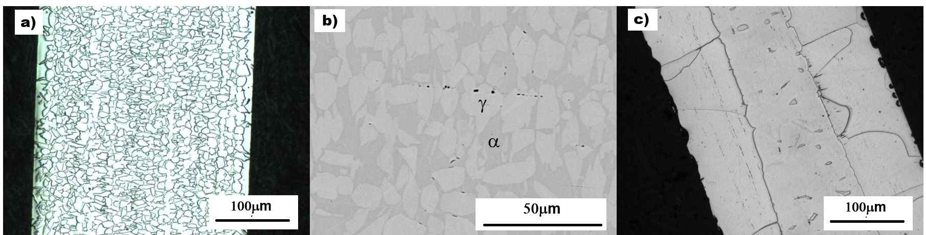
Fig. 1. Microstructure of the LLM-alloy after heat treatment: (a) 1200 °C, 1 min, optical; (b) 1200 °C, 1 min, SEM; (c) 1200 °C, 40 min, optical.

3.2 Cyclic stress–strain response
Cyclic tensile stress–strain curves for the LLM-alloy after heat treatment at different temperatures are shown in Fig. 2, and the corresponding data are listed in Table 2. This information reveals a broad picture of how heat treatment governs the alloy’s mechanical properties. The response is strongly anneal-dependent: low strand-anneal temperatures (600–700 °C) leave the wire high-strength but brittle (tensile strengths of ≈2009–2293 MPa and yield strengths of ≈1683–1948 MPa, but elongation of only ≈2%), reflecting incomplete recrystallization of the cold-drawn wire, whereas annealing at 800–1200 °C progressively softens the wire and restores ductility, with elongation peaking near 33% at 1000 °C. The elastic modulus, E, stays in the ≈150–165 GPa range across the well-annealed conditions. Across all LLM-alloy heat treatments examined, the stress–strain curves rose monotonically with no defined transformation plateau, and the recovered strain on unloading is comparable to the elastic strain (σ/E) expected at the unload stress. In other words, the strain recovery is consistent with elastic springback alone, with no resolvable pseudo-elastic contribution. It has been reported that aging at 200 °C can improve the pseudo-elasticity of Fe-Mn-Al-Ni alloy [30,31]; this was not the case for the LLM-alloy (Fig. 2f).
Read panel by panel, Fig. 2 shows the following. In the as-drawn condition (Fig. 2a) the wire fractures at ≈2% strain with essentially no plastic range. After the 600 °C anneal (Fig. 2b) it is stronger still, reaching ≈2280 MPa, yet fails just as early: the treatment has relieved drawing stresses without restoring formability. At 800 °C (Fig. 2c) the behaviour changes character — a well-defined yield plateau appears near 1200 MPa and the specimen sustains cycling to 10% strain. At 1000 °C (Fig. 2d) yielding falls to ≈670 MPa and is followed by steady work hardening, and at 1200 °C (Fig. 2e) to ≈500 MPa. Fig. 2f repeats the 1200 °C condition with the 200 °C / 3 h age applied and is indistinguishable from Fig. 2e. The feature common to all six panels, and the one that matters here, is the geometry of the unloading segments: in every case they are straight and parallel to the initial elastic loading line, returning toward zero stress without a hysteresis loop and without strain recovery beyond σ/E. This is what a stress–strain curve looks like when no stress-induced transformation is occurring. Table 2 lists eight anneal conditions where Fig. 2 shows six; the 700, 900 and 1100 °C curves interpolate smoothly between the panels shown, add nothing to the argument, and are omitted for space.
Table 2. Mechanical properties of the LLM-alloy after heat treatment for 1 minute at different temperatures.
Temp. (°C) | σ₀.₂ (MPa) | UTS (MPa) | Elong. (%) | E (GPa)
As drawn | 1528 | 1925 | 2.0 | 143.7
600 | 1948 | 2293 | 2.3 | 157.4
700 | 1683 | 2009 | 2.2 | 164.8
800 | 1167 | 1216 | 24.0 | 155.5
900 | 944 | 1078 | 29.7 | 152.2
1000 | 673 | 967 | 33.4 | 155.6
1100 | 556 | 947 | 29.7 | 156.8
1200 | 502 | 938 | 23.9 | 163.0
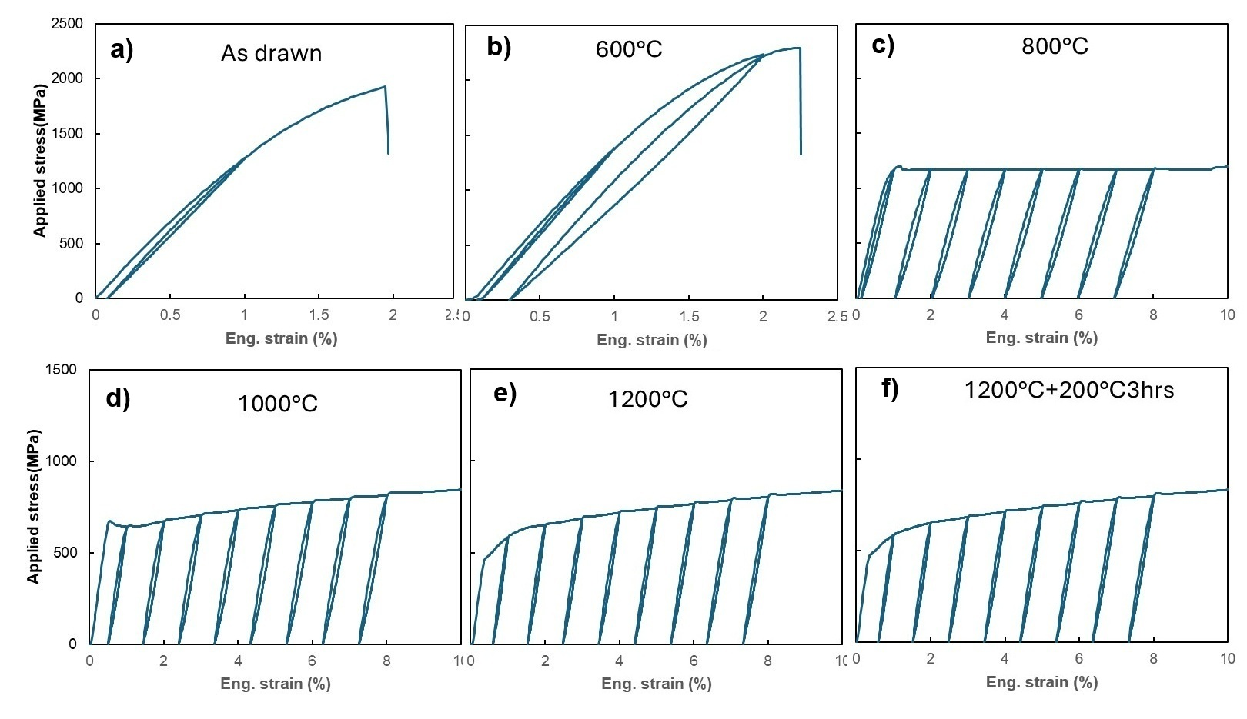
Fig. 2. Cyclic stress–strain curves of the LLM-alloy after annealing for 1 minute at various temperatures. Wire diameter is 0.36 mm. Panel (f) shows the stress–strain response of the annealed-plus-aged sample.
Fig. 3 compares the stress–strain behavior of the LLM- and benchmark alloys during cyclic loading–unloading–heating deformation. In this test, any residual stress-induced martensite present at zero stress should transform back to austenite upon heating, causing the reloading stress to rise at a strain lower than the last unloading strain. This is exactly what happened in the benchmark alloy: Fig. 3b shows that its residual strain after unloading from 3% deformation is ≈2.2%, and upon reloading, stress rises at a strain of ≈1.7%. This 0.5% strain recovery caused by heating is evidence of stress-induced martensite transformation in the benchmark alloy — the stress-induced martensite was stable enough to survive unloading but transformed back to austenite upon heating. By contrast, Fig. 3a shows no strain recovery of the LLM-alloy during this test, indicating that it deforms plastically with no pseudo-elasticity regardless of heat-treating condition. We conclude that the microstructure of the LLM-alloy is very stable and that stress-induced phase transformation is not one of its active deformation mechanisms.
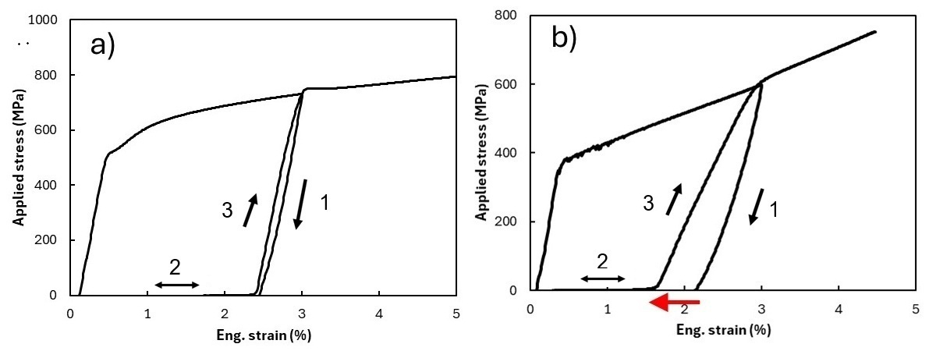
Fig. 3. Loading–unloading–heating tests of (a) the LLM-alloy and (b) the benchmark alloy. Samples were heat treated at 1200 °C for 1 minute. Black arrows show the deformation path; the red arrow highlights the strain recovery caused by heating.

3.3 Synchrotron diffraction and phase identification
Synchrotron XRD of samples before and after deformation is shown in Fig. 4. Fig. 5 shows good overall agreement between the experimental data (lower half of each panel) and the results of Rietveld refinement (upper half), both before deformation (Fig. 5a) and after unloading from 10% strain (Fig. 5b). The fit is measurably better for the deformed specimen (R_wp = 12.5% against 21.4%), and the reason is visible in the patterns themselves: the undeformed wire gives a beaded, spotty ring pattern in which relatively few grains satisfy each Bragg condition, whereas deformation subdivides those grains and produces the more continuous rings on which powder averaging depends. The same grain-statistics argument recurs in a far stronger form for the benchmark alloy, below. Based on this result, the LLM-alloy is estimated to consist of ≈62% FCC γ-phase, ≈34% BCC α-phase, and ≈4% D0₃ Fe₃Al phase. Its diffraction patterns before and after deformation are essentially the same (Fig. 4a, b), and relative peak intensities (Fig. 6a) are essentially unchanged: no new diffraction peaks appear and none disappear. Although an ex-situ measurement made after unloading cannot, on its own, exclude a fully reversible transformation that reverts on unloading, the absence of any mechanical recovery (Figs. 2 and 3) together with the unchanged multi-phase pattern points consistently to deformation by dislocation slip rather than stress-induced phase transformation. The shift from sharp, discrete spotty patterns in the undeformed state (Fig. 4a) to broader, partially arced rings after deformation (Fig. 4b) can be attributed to dislocation activity, which results in peak broadening and/or the formation of tiny sub-grains. In comparison, the benchmark alloy presents a BCC α-dominated pattern with FCC γ-phase and ordered β-NiAl (B2) precipitate diffractions in the undeformed state (Fig. 4c); after 8% applied strain, the {111}γ reflection intensifies and the overlapping {200}α redistributes in intensity (Fig. 4d), consistent with stress-induced γ formation and partial variant activation. The change in peak intensity after deformation of the benchmark alloy is also clearly shown in Fig. 6b.
Two points of nomenclature should be made explicit here, because the convention in this alloy family is the reverse of the one familiar from carbon steels. In Fe-Mn-Al-Ni alloys the parent phase is BCC α and the martensite formed from it is FCC γ. The γ phase is therefore the transformation product, not the parent, and an alloy rich in γ is one in which less parent phase remains available to transform, not one that is closer to transforming. Second, the refinement resolved γ, α and D0₃ Fe₃Al and nothing else: no ε-HCP martensite and no α′ were required to fit any pattern from either alloy, and the γ present in the annealed LLM-alloy is thermally stable retained γ rather than a stress-induced product.
No B2 superlattice reflection was resolved in the LLM-alloy above the detection limit of the present measurement, and that limit can be quantified rather than merely asserted. At the B2-allowed {200} superlattice position the LLM-alloy carries 0.50–1.06% of maximum intensity, against 3.83–7.17% in the benchmark; and the LLM-alloy’s intensity at that position is itself fully accounted for by D0₃, which produces the same reflection. The discriminating measurement is the D0₃-only {111} reflection, present in the LLM-alloy at 0.49–1.02% of maximum with a signal-to-noise ratio of 16–27 across four independent patterns, and absent from the benchmark (0.19–0.28%, S/N 2.3–2.9). The benchmark thus carries the B2-allowed reflection without the D0₃-only one, and the LLM-alloy carries both at comparable strength — the signatures of B2 and D0₃ respectively. Any B2 present in the LLM-alloy is therefore at least four times less abundant than in the benchmark and may be absent altogether. This bounds the claim without over-reaching it: a coherent dispersion finer or more dilute than this limit cannot be excluded by diffraction alone, and transmission electron microscopy or atom-probe tomography would be required to do so.
The two alloys are not equally amenable to quantitative diffraction analysis, and the reason is itself microstructural. After the identical 1200 °C anneal the LLM-alloy retains a fine equiaxed structure with grain diameters well under 20 µm (Fig. 1a), so that a large number of grains is illuminated and the powder-averaging assumption underlying Rietveld quantification is satisfied. The benchmark alloy instead undergoes pronounced grain growth at this temperature: its Debye–Scherrer rings break up into a small number of discrete, intense spots rather than continuous rings (Fig. 4c, d), too few grains contribute to each reflection, and no Rietveld model could be brought into satisfactory agreement with the measured pattern. Phase fractions are therefore reported for the LLM-alloy only, and no attempt is made here to quantify the extent of transformation in the benchmark alloy.
This restriction does not affect the comparison on which the present work rests. That the benchmark alloy undergoes a stress-induced transformation is not in question: the diffracted intensities change markedly with deformation (Fig. 6b), the alloy recovers strain on heating (Fig. 3b), and the transformation behaviour of this composition is well established in the literature [12–14]. What the coarse grain structure withholds is a number for how much of the parent phase transformed, not the fact that it transformed. The question addressed here is the converse one: why the LLM-alloy, processed identically, shows no corresponding change (Fig. 6a) and is instead dominated by the γ phase.
It is worth noting that the LLM-alloy after AGG heat treatment showed an X-ray diffraction pattern similar to Fig. 4a, indicating that the multi-phase microstructure is a stable state of this alloy at 1200 °C.
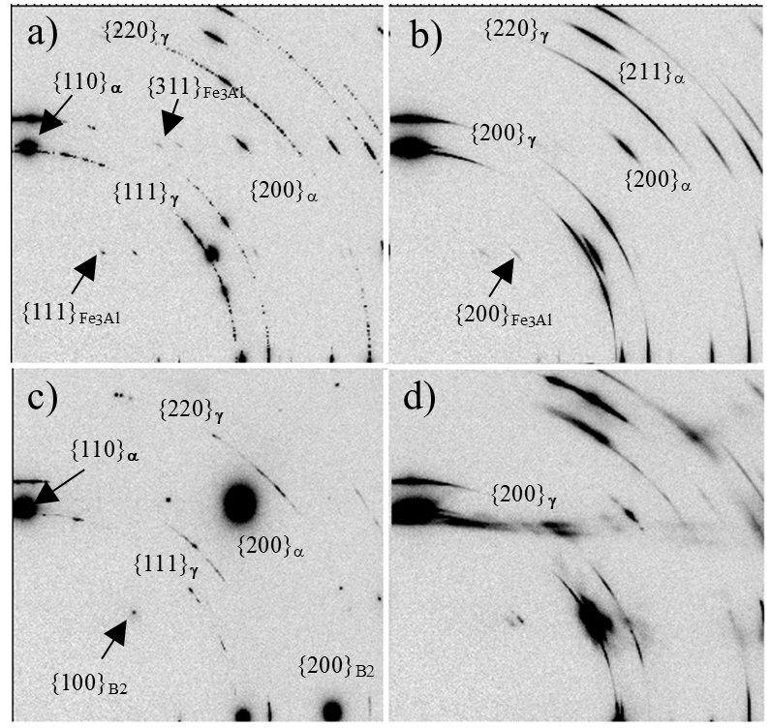
Fig. 4. 2D synchrotron X-ray diffraction images of (a) LLM-alloy annealed at 1200 °C for 1 min, (b) annealed LLM-alloy after 10% tensile strain, (c) benchmark alloy annealed at 1200 °C for 1 min, and (d) annealed benchmark alloy after 8% tensile strain.
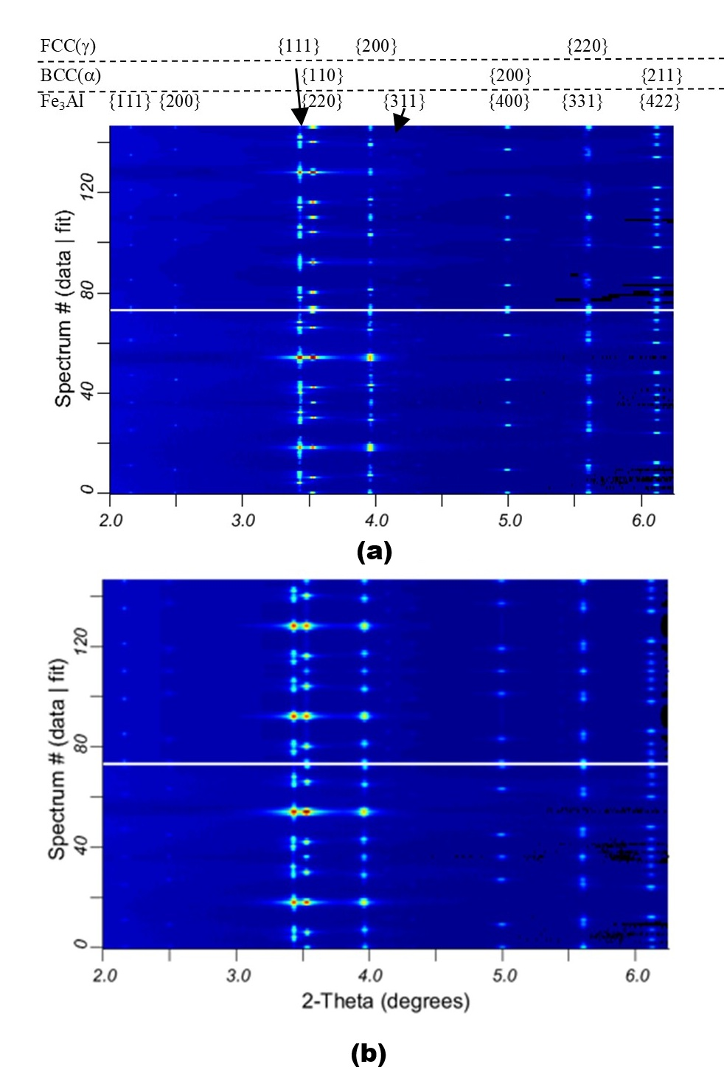
Fig. 5. Comparison between synchrotron X-ray diffraction data (lower half of each panel) and results of Rietveld refinement (upper half of each panel) for the LLM-alloy: (a) heat-treated at 1200 °C for 1 minute (R_wp = 21.4%, R_p = 8.7%), and (b) after unloading from 10% strain (R_wp = 12.5%, R_p = 5.9%). Both refinements used the three-phase model of Sec. 2.5, with lattice parameters fixed at a = 3.6366 Å (γ) and 2.8865 Å (α) in both cases, and 5.7734 Å (a) and 5.7801 Å (b) for D0₃.
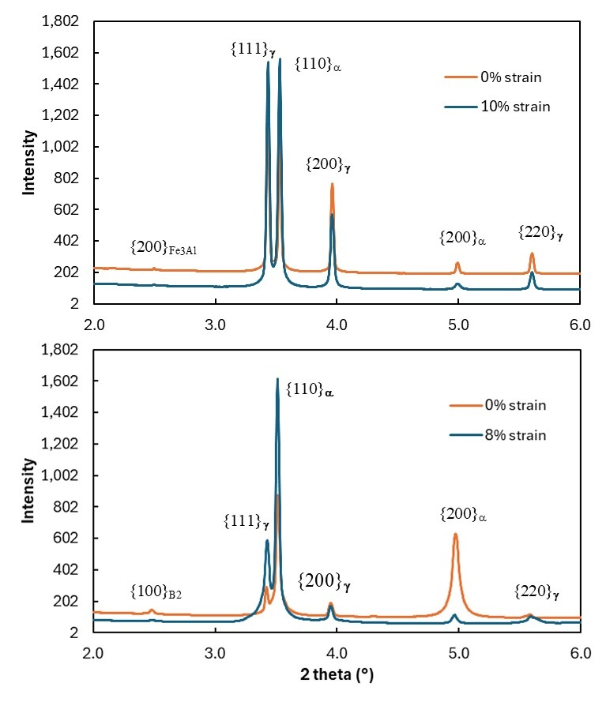
Fig. 6. Azimuthally integrated X-ray diffraction spectra of (a) the LLM-alloy and (b) the benchmark alloy before and after deformation. Samples were heat treated at 1200 °C for 1 minute before deformation.

3.4 Equilibrium phase stability
Fig. 7 shows the calculated equilibrium step diagrams for the two alloys as cast, using the measured chemistries of Table 1. The virtual carbon-free composition described in Sec. 2.6 was evaluated on the same basis; because all three databases agree on it, it is reported numerically in Table 3 rather than plotted.
The benchmark alloy (Fig. 7a) reproduces the phase sequence its processing route assumes. A single-phase disordered bcc α field opens at ≈1140 °C and extends to the top of the calculated range, so the 1200 °C solution treatment of Sec. 2.2 lies inside it. On cooling below ≈1090 °C the bcc orders: between ≈700 and 1000 °C the calculated bcc is fully B2-ordered and accounts for 19–21% of the alloy, the balance being γ. The equilibrium state below ≈1090 °C is thus B2 + γ, and not the coherent B2-in-α nanostructure on which the benchmark’s super-elasticity actually rests; that nanostructure is a kinetically arrested approach to this equilibrium, obtained by quenching the single-phase α and ageing it where B2 can order but γ cannot yet nucleate. What the calculation establishes is that both conditions the processing route requires are available and contiguous: a temperature at which the alloy is single-phase α, and a range immediately below it in which that α has a thermodynamic driving force to order. Nothing about this alloy was fitted here; the calculation is a control, and it recovers the ≈20% ordered bcc that is observed directly in Fig. 4c.
The LLM-alloy behaves differently in every respect that matters (Fig. 7b). At 1200 °C it is not single-phase but a duplex mixture of 71.1% α and 28.9% γ. Its single-phase α field does not open until ≈1340 °C — some 140 °C above the 1200 °C ceiling imposed by oxidation and furnace contamination (Sec. 2.2). The margin is in fact larger than that ceiling alone implies: mc_fe, the only database here carrying all six elements plus P, places the onset of incipient melting in this alloy at ≈1240 °C, so the single-phase α field would be unreachable even if oxidation were not the limiting factor. The databases do not agree on the solidus — mpea-02b returns no liquid at all below 1400 °C — but they agree on what matters here, which is that the temperature at which this composition becomes single-phase α lies outside the window in which it can be annealed. Between ≈850 and ≈1050 °C the alloy is calculated to be fully austenitic. Ordered bcc appears only below ≈850 °C, reaches at most ≈11% at 400 °C, and forms within a γ matrix rather than an α one. There is thus no temperature at which this composition can be solution-treated to single-phase α and subsequently aged into coherent ordered precipitates within that α — the sequence on which the benchmark relies.
Removing carbon and holding every other element fixed restores the missing field, and does so in every database. The single-phase α window opens at ≈1150 °C instead of ≈1340 °C in mpea-02b and at ≈1160 °C instead of ≈1390 °C in PrecHiMn-04, while mc_fe — which returns no single-phase α at all for the carbon-bearing composition below 1400 °C — places it at ≈1130 °C. The 1200 °C solution treatment therefore lands inside the single-phase field once carbon is removed, and the alloy reaches 100% α exactly as the benchmark does, in all three databases and despite their covering different element sets (Table 3).
Table 3. Calculated equilibrium phase fractions (mol%) at 1200 °C, the solution-treatment temperature. The benchmark alloy cannot be evaluated in PrecHiMn-04, which contains no Ni.
Alloy | mpea-02b | PrecHiMn-04 | mc_fe v2.059
benchmark alloy | 100 α | – | 100 α
LLM-alloy | 71.1 α + 28.9 γ | 64.5 α + 35.5 γ | 61.9 α + 38.1 γ
LLM-alloy, C removed | 100 α | 100 α | 100 α
Two further predictions bear on phases reported in Sec. 3.3. Carbide phases are calculated to be stable only well below the processing range: M₂₃C₆ appears in mpea-02b only below ≈420 °C, and κ-(Fe,Mn)₃AlC reaches 0.2–2.4% below ≈590 °C in PrecHiMn-04 and 0.1–0.8% between 510 and 540 °C in mc_fe. Neither is expected at or near 1200 °C. Separately, the ordered bcc of PrecHiMn-04 — the only description here capable of returning D0₃ — refines to the disordered A2 state at every temperature calculated, indicating that at ≈12 at% Al this composition lies below the equilibrium Fe₃Al D0₃ field.
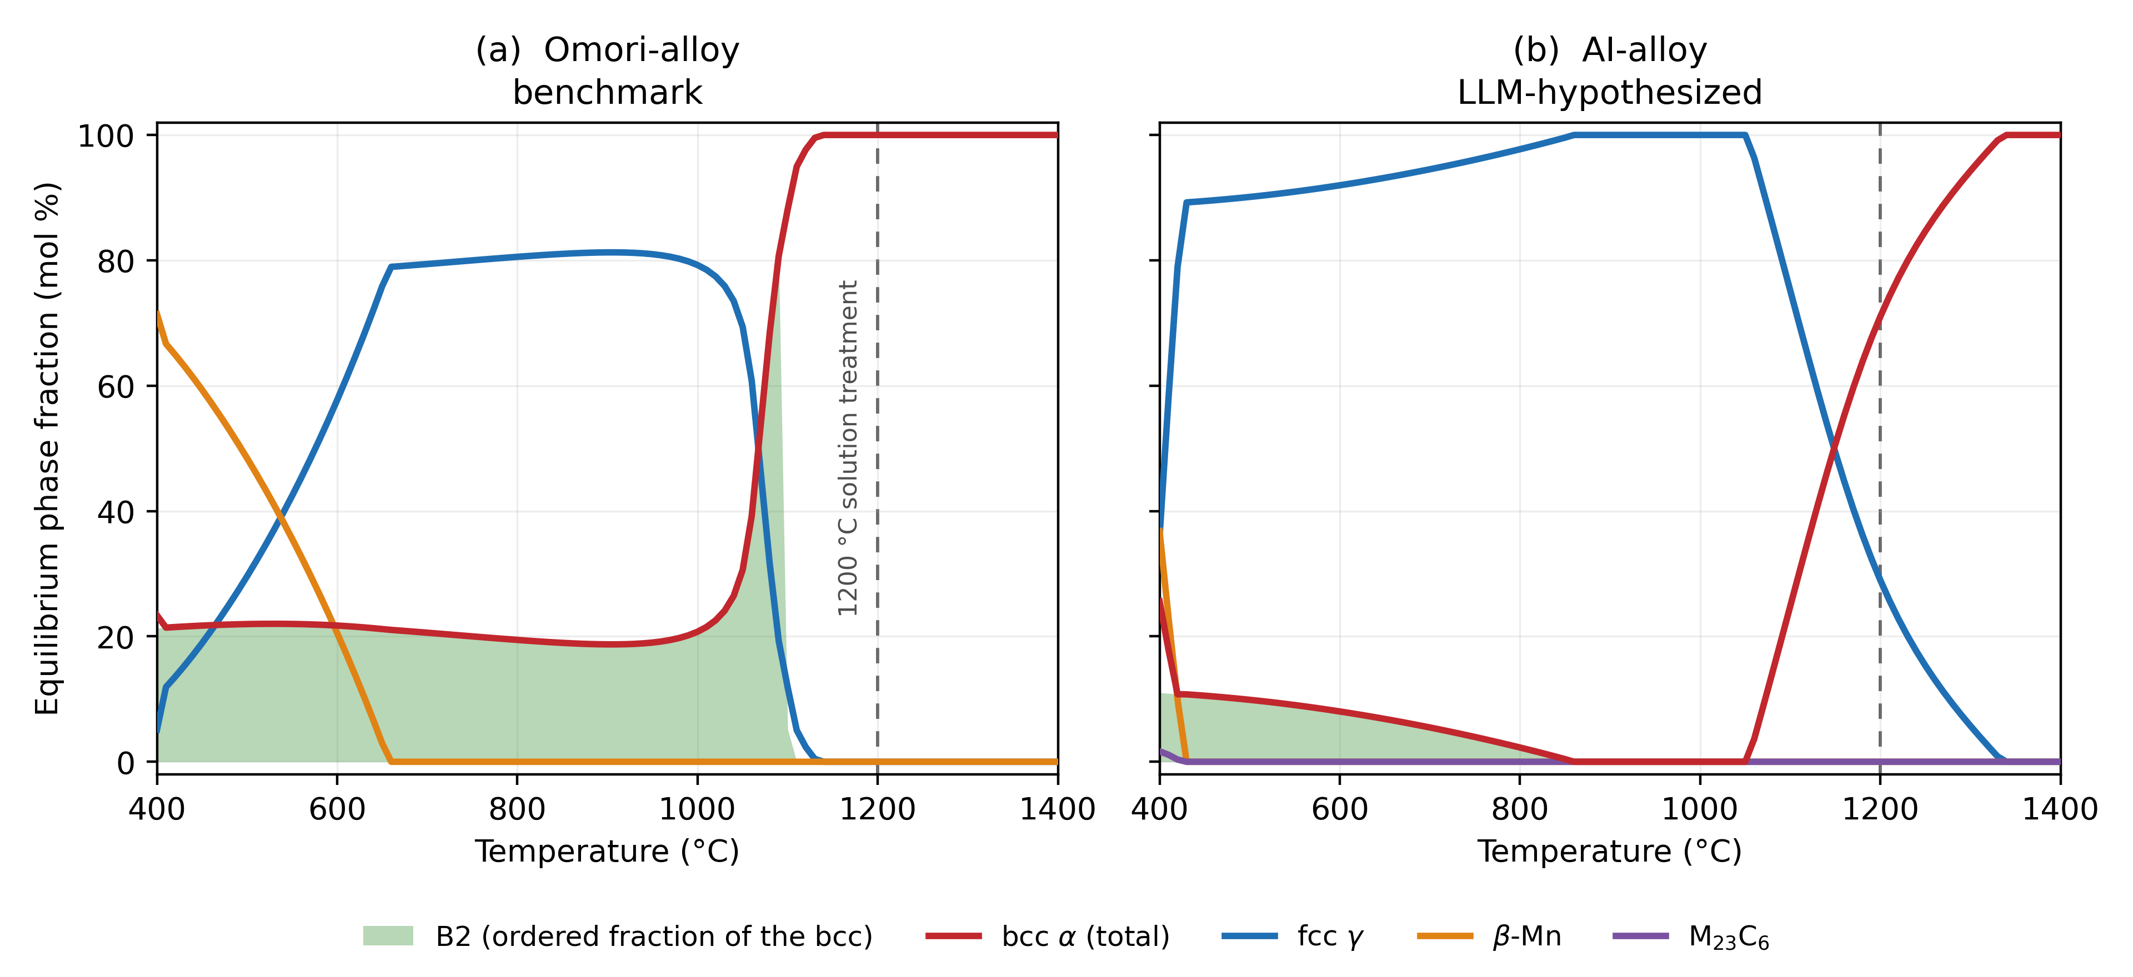
Fig. 7. Calculated equilibrium step diagrams (mpea-02b database) for (a) the benchmark alloy, the benchmark, and (b) the LLM-alloy, the LLM-hypothesized composition. Both were computed from the measured ICP-AES chemistries of Table 1 converted from wt% to at%: Fe–34.1Mn–15.2Al–7.8Ni–0.04C and Fe–29.8Mn–11.9Al–4.2Ni–2.04Si–0.45C respectively. mpea-02b does not model Si, which was therefore omitted and the remaining elements renormalized (Sec. 2.6). The shaded band is the ordered (B2) portion of the total bcc fraction; it lies beneath the total bcc curve because B2 is an ordered partition of that phase rather than a separate one. The dashed line marks the 1200 °C solution-treatment temperature. The carbon-free control composition is reported in Table 3.

4. Discussion

4.1 Origin of the absence of stress-induced phase transformation
The failure of the LLM-hypothesized alloy (50Fe-30Mn-12Al-4Ni-4Si at% with 1000 ppm C) to exhibit super-elasticity or a shape-memory response can be attributed to a fundamental misalignment between its phase stability and its active deformation mechanisms. In Fe-Mn-Al-Ni shape-memory systems, super-elastic behavior is contingent upon a reversible, stress-induced martensitic transformation from a BCC α parent phase to FCC γ martensite. However, quantitative Rietveld refinement of the synchrotron XRD data reveals that the LLM-alloy is structurally dominated by the γ-phase (≈62%), whereas the α-phase accounts for only ≈34% of the volume fraction, with a further ≈4% present as ordered D0₃ (Sec. 3.3). Compared to the benchmark alloy (43.5Fe-34Mn-15Al-7.5Ni at%), the LLM-alloy has less Mn, Al, and Ni, but higher Fe, Si, and C. It is known that Fe, Si, and Al stabilize the BCC α-phase, while Mn, Ni, and C stabilize the FCC γ-phase [32]. The original hypothesis was that these chemistry changes would not alter the phase constitution or stability, and that the additional C could also increase material strength to impede dislocation slip and promote stress-induced phase transformation. In practice, this chemistry modification favors the FCC crystal structure and raises γ-phase stability, and the equilibrium calculations of Sec. 3.4 identify carbon as the element that closes the single-phase α field at the solution-treatment temperature (Sec. 4.2).
The thermodynamic calculations place this argument on a quantitative footing and change its emphasis. The problem is not that the LLM-alloy possesses a BCC parent phase with an insufficient driving force for transformation; it is that no accessible heat treatment produces that parent phase in the first place. At 1200 °C the alloy is calculated to be a two-phase α + γ mixture in all three databases, and its single-phase α field lies at ≈1340 °C, above both the oxidation limit of the process and the ≈1240 °C solidus returned by mc_fe (Sec. 3.4). The duplex constitution that the calculation predicts at the solution-treatment temperature is precisely what is observed: the interlocked two-phase morphology of Fig. 1b, the Al-rich and Mn-rich EDS partitioning that accompanies it, and the coexisting α and γ reflections of Figs. 4a and 5. It also explains why the microstructure is insensitive to annealing time — the duplex state survives 40 minutes at 1200 °C (Fig. 1c) and the full AGG cycle (Sec. 3.3) because it is the equilibrium state at that temperature, not an incompletely transformed one. That the same calculations independently reproduce the benchmark alloy’s single-phase α field and its ≈20% ordered B2 (Fig. 7a), neither of which was fitted here, is what licenses their application to the test alloy.
One quantitative discrepancy should be stated plainly. The calculations place α in the majority at 1200 °C (62–71%), whereas the refinement of the quenched wire places γ in the majority (≈62%); the two agree that the alloy is duplex but not on which phase dominates. Because γ is the transformation product rather than the parent in this system, a partial α → γ transformation during cooling would invert the ratio, which would place the martensite start temperature above room temperature. That reading would supply a more complete account of the absence of super-elasticity than a driving-force argument alone — the transformation would already have run before the specimen was ever loaded, leaving nothing to induce — and it is what elevated carbon content would be expected to produce. The duplex morphology of Sec. 3.1 is consistent with this reading without establishing it, since a two-dimensional section does not reveal which constituent is continuous. We note it as the reading the present data favor rather than as an established result; direct calorimetric measurement of the transformation temperatures is required to confirm it, and is the most informative single experiment remaining on this alloy.
The calculations also clarify the status of the ordered phases. D0₃ is not predicted to be an equilibrium phase at ≈12 at% Al (Sec. 3.4), yet it is observed. Its presence is therefore best understood as a metastable ordering product formed on cooling — exactly the kind of kinetic outcome that a screening step based on composition and equilibrium thermodynamics alone cannot anticipate. It is not, however, peculiar to this heat. Both B2 and D0₃ are documented ordering products in the Fe-Mn-Al-C low-density steels [16], and in the Ni-alloyed members of that family the B2 that does form is only marginally stable at the temperature used here: nanoscale NiAl-type B2 confined to the BCC constituent of a γ-majority Fe-16Mn-9Al-0.9C-5Ni steel coarsens on holding at 1110 °C and breaks up again after 30 min at 1200 °C [17]. The ordering behaviour observed in the LLM-alloy is thus characteristic of the alloy field its chemistry actually places it in, rather than of the shape-memory field it was designed for. Conversely, the ordered bcc that the LLM-alloy can form at equilibrium is small (≤11%) and confined below ≈850 °C. At those temperatures both alloys are calculated to be ordered bcc coexisting with γ; what separates them is the step before. The benchmark can be quenched from a single-phase α field and then aged, so that B2 orders coherently within α before γ has time to nucleate. The LLM-alloy has no accessible single-phase α field to quench from (Sec. 3.4), so there is no α matrix in which coherent B2 could form, and the microstructure the benchmark relies upon is unavailable to this composition at any temperature. This is a stronger statement than the absence of a B2 reflection alone would support, and it accounts for the failure of the 200 °C ageing treatment (Fig. 2f) to induce any pseudo-elastic response.
Furthermore, mechanical and structural analyses indicate that the LLM-alloy accommodates macroscopic deformation via irreversible dislocation slip rather than phase transitions. Coherent, ordered β-NiAl (B2) precipitates within a BCC matrix contribute to, rather than solely determine, the transformation reversibility of the benchmark [33]; parent-phase stability, transformation temperature, grain size, crystallographic orientation and texture, and the competition between the transformation stress and the plastic yield stress all bear on whether a stress-induced transformation can proceed reversibly. The precipitates are not even a purely mechanical contribution: by drawing Ni and Al out of solution they alter the composition of the matrix that surrounds them, and hence its transformation temperatures, so that the same ageing treatment shifts both the obstacle field and the thermodynamic setting in which the transformation must occur [34]. In the LLM-alloy the ordered phase that forms is D0₃ Fe₃Al, present as a bulk constituent rather than as a fine coherent dispersion, so it does not raise the resistance to plastic flow in the way that B2 does in the benchmark. This is confirmed by the post-deformation synchrotron XRD patterns, where the transition from sharp, discrete spots to broad, partially arced rings reflects dislocation multiplication and sub-grain formation. Thus, the microstructural state of the LLM-alloy remains highly stable at 1200 °C, favoring dislocation- or twinning-mediated plasticity over stress-induced martensitic transformation.

4.2 The role of carbon
Five elements differ between the two alloys, so no comparison of the two cast heats can by itself establish which of them is responsible for the loss of super-elasticity. On a plain atomic-percent basis carbon is the smallest of the five changes, and singling it out — as the original hypothesis did — would otherwise be arbitrary. The virtual carbon-free composition of Sec. 3.4 is the control that resolves this, because it changes carbon alone while holding Fe, Mn, Al, Ni and Si at the values actually measured in the cast wire.
The result is unambiguous and reproduces across all three databases (Table 3). Deleting 0.45 at% (≈0.10 wt%) carbon moves the α solvus of the LLM-alloy from ≈1340 °C to ≈1150 °C, a shift of roughly 190 °C, and converts the equilibrium constitution at 1200 °C from a 62–71% α + 29–38% γ mixture into 100% α — the same single-phase state the benchmark alloy reaches at that temperature. Carbon, at a concentration of one part in a thousand by weight, is what closes the solution-treatment window on which the entire processing route depends.
Two elements are exonerated by the same calculation. Silicon was added as a ferrite stabilizer and solid-solution strengthener, and it remains at its measured 2.04 at% in the carbon-free variant of both Si-bearing databases, which nonetheless return 100% α at 1200 °C; silicon therefore does not obstruct the single-phase field, and the shortfall in the as-cast alloy is not attributable to it. The same argument applies to the reduction in Ni from 7.8 to 4.2 at%, which is likewise held at its measured value in the control.
Exonerating silicon of the primary failure is not the same as finding it inert, and the distinction matters because silicon was one of the two elements the agent added on its own initiative. Recovered at 2.04 at%, half the intended level, it cannot have delivered the solid-solution strengthening of the parent phase it was specified for; the calculation above shows it did not decisively shift α stability either. What it may well have done is contribute to the one ordered phase that did appear. Heo et al. [35] examined precisely this substitution — silicon added to a Fe-Mn-Al-C low-density steel to recover the density benefit of aluminum that had been removed to suppress κ-carbide — and found it undesirable, because silicon instead promotes (Fe,Mn)₅(Si,Al)C together with the (Fe,Mn)₃(Al,Si) D0₃ ordered phase in the ferrite grains, with a serious loss of ductility. D0₃ is the ordered phase observed here (Sec. 3.3), and it is the phase that appears in the α constituent. We cannot separate a silicon contribution to that ordering from an iron-aluminum one with two heats and no silicon-free control, so we do not claim it. The point is narrower and worth making anyway: an addition that the design rationale treated as a strengthener has a documented second role in this compositional field, as a promoter of the very ordering product that was found, and nothing in the reasoning that proposed it engaged with that role.
The limits of this conclusion should be stated as clearly as the conclusion itself. Carbon is decisive at the temperature where the process operates, not across the whole temperature range. Over roughly 850–1020 °C both the as-measured composition (Fig. 7b) and the carbon-free control are calculated to be fully austenitic, so the lower Al and Ni contents of the LLM-alloy do move the α/γ boundary independently of carbon. The defensible claim is therefore narrower and more useful than “carbon caused the failure”: carbon closes the single-phase α field at the solution-treatment temperature, and without that field the alloy cannot be brought into the parent state that super-elasticity requires, whatever the other elements do elsewhere. Nor is a calculated control a substitute for the experiment it stands in for. Casting this composition without carbon and processing it identically remains the direct test; what the calculation contributes is to reduce that test from an open compositional search to a single, well-specified heat.
Carbon was added on the expectation that it would strengthen the parent phase interstitially and, through fine dispersed carbides, raise the resistance to slip enough to favor stress-induced transformation over plasticity. The calculations indicate that neither mechanism was available. Carbides are predicted to be stable only well below the processing range — M₂₃C₆ below ≈420 °C, κ-(Fe,Mn)₃AlC below ≈590 °C and never above ≈2.4% — so no carbide dispersion exists at or near 1200 °C to provide the intended strengthening, and none was observed. This places the LLM-alloy in an unfavorable position with respect to the Fe-Mn-Al-C lightweight-steel family, whose compositional field it otherwise resembles: those alloys derive their strength from κ-carbide precipitation at carbon contents of 1–1.5 wt%, an order of magnitude above the ≈0.10 wt% present here. The LLM-alloy carries enough carbon to incur the γ-stabilization penalty that destroys the shape-memory field, but not enough to collect the precipitation strengthening that would justify it.
The comparison is worth drawing out, because it is the clearest single statement of what this alloy is. The Ni-alloyed Fe-Mn-Al-C low-density steels are built from the same four principal elements as the Fe-Mn-Al-Ni shape-memory alloys, at a similar nickel level, and they are known to produce the same ordered phases — B2 and D0₃ in the ferrite, κ-carbide in the austenite [16,17]. What differs is the purpose those phases are put to. In the shape-memory alloys, coherent B2 within a single-phase α parent raises the resistance to slip so that a reversible transformation can outrun plasticity. In the low-density steels, the same precipitates are strengtheners in an alloy that is never intended to transform: the design objective is specific strength and ductility in a duplex or γ-majority structure, nickel is added specifically to form NiAl-type B2 and to hold it stable above the recrystallization temperature, and the ordering of α to B2 is a liability to be managed for its embrittling effect rather than a mechanism to be exploited [16]. Judged against that second family, the LLM-alloy is neither anomalous nor a failure. It is a γ-majority duplex Fe-Mn-Al-Ni-C alloy that orders and deforms by slip, which is what alloys of that chemistry do. The failure lies in the expectation that was attached to it, and the practical lesson is that a composition can sit in two literatures at once while satisfying the design intent of only one.
Two general points follow. First, the sensitivity of this alloy family to interstitial content is severe enough that carbon must be treated as a primary design variable rather than a minor addition, and specified and controlled accordingly — a 1000 ppm addition is not a perturbation here. Second, the calculation that establishes all of this takes minutes on a desktop computer and uses only openly available databases. Had it been run before melting, it would have rejected the composition at the point where the intended 1200 °C solution treatment was found to lie 140 °C below the alloy’s single-phase α field.

4.3 Anneal-temperature dependence of mechanical properties
Although the LLM-alloy did not show super-elastic behavior, its monotonic tensile behavior varies strongly with annealing temperature, and the trends are exactly those expected for a cold-drawn wire passing through recovery, recrystallization, and grain growth. Reading these as a single-specimen survey, three regimes emerge.
At the lowest temperatures (600–700 °C) the wire is very strong but essentially brittle: tensile strengths of ≈2009–2293 MPa and yield strengths of ≈1683–1948 MPa, but elongation of only ≈2%. These temperatures are below the recrystallization range of the heavily cold-drawn wire, so annealing here drives only recovery (relief of residual drawing stresses and partial rearrangement of the dislocation substructure) without nucleating new strain-free grains. The high dislocation density retained from cold drawing is what sustains the high strength, and the small ductility gains in this window reflect stress relief rather than any genuine restoration of formability; the wire still fractures soon after yield.
The abrupt change near 800 °C is consistent with the onset of recrystallization. Elongation jumps from 2.2% at 700 °C to 24.0% at 800 °C, while tensile strength falls from 2009 to 1216 MPa and yield strength from 1683 to 1167 MPa. A discontinuity of this kind — rather than a smooth softening — is the signature of recrystallization: new equiaxed, strain-free grains nucleate and consume the deformed matrix, removing most of the stored dislocation content and abruptly restoring ductility. We infer the recrystallization threshold from the mechanical response rather than observe it directly, since micrographs were not taken at every anneal temperature; electron backscatter diffraction across the anneal series would settle it.
From 800 to 1200 °C the behaviour is that of a recrystallized wire in which the dominant process is grain growth. Yield strength falls monotonically with temperature (1167 → 502 MPa) as a result of continuous grain growth; larger grains allow more uniform slip, which raises elongation to a peak of ≈33% near 1000 °C. In other words, across this regime, increasing grain size simultaneously decreases strength and increases ductility — the classic strength–ductility trade-off of a structural metal whose flow stress is grain-size controlled. Above 1000 °C, elongation eases back slightly (29.7% at 1100 °C, 23.9% at 1200 °C), which we attribute to excessive coarsening reducing uniform elongation even as the matrix continues to soften. Throughout the sweep, the elastic modulus stays within ≈150–165 GPa, as expected for a structure-insensitive property of an essentially unchanged multi-phase mixture.
The peak elongation of ≈33% at 1000 °C deserves a comment in its own right. It is a respectable figure but not an exceptional one for a duplex γ + α Fe-Mn-Al alloy, and that is precisely the point: judged on conventional structural criteria this composition performs perfectly creditably, combining ≈670 MPa yield strength with ≈33% elongation. What it does not do is transform. The alloy is therefore best read not as a failed material but as a serviceable structural metal that was hypothesized to be a shape-memory alloy and is not one — a distinction that matters for how AI-proposed compositions should be evaluated (Sec. 4.4). Read against the low-density steels its chemistry places it among (Sec. 4.2), the numbers are ordinary rather than disappointing. That family spans yield strengths of ≈500–940 MPa, tensile strengths of ≈710–1020 MPa and elongations of 8–78% depending on which phases its microstructure contains [16], and the 1000–1200 °C conditions of Table 2 sit inside that envelope on all three measures (σ₀.₂ 502–673 MPa, UTS 938–967 MPa, elongation 23.9–33.4%), with the 900 °C condition just outside it. The colder anneals are far stronger than the envelope allows, but that is a consequence of form rather than chemistry: these are 0.36 mm wires still carrying the substructure of an ≈85% drawing reduction, not annealed plate. What the alloy lacks relative to the low-density steels is the carbon needed for κ-carbide strengthening (Sec. 4.2); what it lacks relative to the shape-memory alloys is an accessible parent phase (Sec. 4.1). It is an unoptimized member of the first family rather than a failed member of the second, which is a more informative outcome than failure alone.

4.4 Implications for AI-guided alloy design
The AI-guided alloy design did not achieve the intended super-elastic or shape-memory behavior because the model primarily relied on thermodynamic and literature-based correlations rather than a complete understanding of the complex phase-transformation mechanisms required for functional Fe-based SMAs. As shown in this study, the LLM-hypothesized alloy developed a stable multiphase microstructure consisting mainly of FCC γ and BCC α phases, and neither mechanical testing nor synchrotron diffraction provided evidence of stress-induced martensitic transformation; deformation was instead accommodated largely by conventional dislocation slip. Although the composition appeared reasonable from a thermodynamic and strengthening perspective, the AI model was unable to accurately predict the delicate balance among phase stability, transformation driving force, defect structure, precipitation behavior, and processing history that governs pseudo-elasticity. This outcome highlights a current limitation of AI-assisted alloy design: available models are often trained on composition–property relationships and equilibrium thermodynamics, while kinetic effects and microstructure evolution during manufacturing remain insufficiently represented.
The calculations reported here allow this limitation to be stated as a concrete and inexpensive remedy rather than a general caution. The screening step that would have caught this composition is a single equilibrium step diagram, evaluated not for the existence of the desired phase but for whether the phase fields required by the intended processing route overlap the temperatures at which that route can actually be run. For a Fe-Mn-Al-Ni shape-memory alloy the test has two parts: does a single-phase α field exist below the practical annealing limit, and does an ordered-precipitate field exist below it within that same α matrix? The LLM-alloy fails the first, and would fail the second even if the first were satisfied. Neither question requires proprietary software or measured data on the candidate itself, and answering both took minutes. It is notable that the deep-research agent was explicitly instructed to consult thermodynamic-stability data (Sec. 2.1) and nonetheless proposed a composition that fails this test, which suggests that the useful distinction is not between AI-assisted and conventional design but between design workflows that terminate in a verified calculation and those that terminate in a plausible narrative. A generated composition should be treated as a hypothesis to be screened, not as a result.
The scope of what a single experiment can support should be stated plainly. One composition, proposed by one agent in one session and processed by one route, is a case study and not an evaluation of AI-assisted alloy design as a practice. Nothing here establishes a failure rate, and a different prompt, a different agent, or a different processing window might well have produced a different outcome; the experimental claims of this paper are bounded accordingly. What generalises is narrower, and we think more useful. The failure mode was not exotic or specific to this composition — it was a phase field lying in the wrong place relative to the temperatures at which the alloy can be annealed, and it was diagnosable in minutes by a calculation requiring no proprietary software and no measurement on the candidate itself. A design workflow that terminates in a plausible narrative cannot catch that; one that terminates in a verified calculation can. That claim rests on the diagnosis rather than on the sample size, and it is the claim we make.
It is also worth saying what a negative result of this kind is good for, since such results are rarely published in this area. A single validated failure with an identified mechanism does more to constrain the design space than a comparable number of untested proposals: it converts “this family of compositions may or may not work” into “compositions in this family whose single-phase α field lies above the practical annealing limit will not work, and here is how to check in advance.” The value is in the diagnosis being transferable even though the specific alloy is not.
Nevertheless, AI-assisted alloy design is likely to become increasingly successful. As larger experimental databases become available and models begin to incorporate processing history, microstructural evolution, kinetic simulations, and deformation mechanisms alongside thermodynamic calculations, AI will be able to make more physically informed predictions. Future materials-design frameworks that integrate first-principles calculations, phase-field modeling, CALPHAD databases, high-throughput experiments, and machine learning may better capture the conditions required for martensitic transformations and functional properties. Rather than replacing metallurgical expertise, AI is expected to serve as a powerful tool for rapidly narrowing the compositional search space, generating testable hypotheses, and accelerating discovery. The present study should therefore be viewed not as a failure of AI itself, but as evidence that current AI models have not yet fully captured the complexity of structure–processing–property relationships in shape memory alloys.

5. Conclusions
An AI-guided deep-research workflow was used to design a low-cost Fe-Mn-Al-based alloy targeting room-temperature super-elasticity. The proposed alloy was successfully synthesized and compared with the benchmark Fe-Mn-Al-Ni alloy reported by Omori et al. under the same nominal processing route.
What was observed is the following. The LLM-alloy proved readily castable and drew to 0.36 mm wire without difficulty. Across seven anneal temperatures its 0.2% proof stress fell from 1948 to 502 MPa and its elongation peaked at 33%, but in no condition — including after the 200 °C / 3 h age reported to develop pseudo-elasticity in this family — did the unloading curve depart from elastic springback. The benchmark, processed identically and given no age at all, recovered ≈0.5% strain on heating. Synchrotron diffraction found the LLM-alloy to be a duplex FCC γ + BCC α mixture carrying a minor ordered D0₃ Fe₃Al phase, with a pattern unchanged by 10% strain, whereas the benchmark’s diffracted intensities changed markedly with deformation.
What we interpret from this is that the LLM-alloy accommodates deformation by dislocation slip rather than stress-induced martensitic transformation, and that it does so because the parent phase the transformation requires is largely absent rather than because it is present but unwilling to transform.
Equilibrium CALPHAD calculations, performed with three independent open databases and validated against the benchmark alloy, identify the origin of this failure. The benchmark solution-treats to single-phase α at 1200 °C and orders on cooling below ≈1090 °C to the ≈20% ordered bcc that its processing route requires. The LLM-alloy does neither: at 1200 °C it is a two-phase α + γ mixture, and its single-phase α field lies at ≈1340 °C, above the temperature at which the alloy can be annealed without oxidation or incipient melting. Removing carbon alone from the measured chemistry, with every other element held fixed, lowers that field to ≈1150 °C and restores the single-phase state at 1200 °C in all three databases. A carbon addition of ≈0.10 wt%, the smallest compositional change of the five that distinguish the two alloys, is therefore sufficient to close the processing window on which super-elasticity depends.
These results highlight an important limitation of current AI-assisted alloy design. While AI can rapidly generate compositionally plausible alloy candidates based on thermodynamic considerations and literature knowledge, it does not yet fully capture the complex interactions among composition, processing, microstructure evolution, and deformation mechanisms that govern shape-memory performance. They also point to a specific and inexpensive remedy: an equilibrium step diagram, checked for overlap between the phase fields the intended processing route requires and the temperatures at which that route can be run, would have rejected this composition before 2 kg of it was melted.
Three limitations bound these conclusions. First, this is a single composition from a single agent session processed by a single route: the experimental findings are a case study, and the generalisable claim is the diagnostic one about pre-screening rather than any statement about how often such workflows fail. Second, composition-only reasoning of the kind the agent performed is intrinsically blind to the distinction that decided this case — not whether a phase is stable, but whether the temperature at which it becomes stable can be reached in the equipment available; an LLM working from literature correlations has no reliable way to represent that constraint, and instructing it to consult thermodynamic data (Sec. 2.1) did not supply one. Third, whether a different processing window could unlock transformation in this composition is untested here, and casting the carbon-free variant identified in Sec. 4.2 remains the direct experiment that the in-silico control stands in for. Within those bounds, this work demonstrates the value of experimentally validating AI-generated hypotheses and suggests that future models incorporating kinetic effects, phase transformations, and processing history may become powerful tools for accelerated alloy discovery.

Acknowledgments
The authors thank Fort Wayne Metals for providing access to melting, hot-rolling, cold-drawing, and metallography facilities, and for technical guidance throughout alloy synthesis.
S. Cai also thanks his colleagues Andrew Michael for melting the alloys and Todd Darley for SEM analysis. Synchrotron X-ray diffraction was carried out on beamline BL12SW at the Shanghai Synchrotron Radiation Facility (SSRF) under proposal No. 2024-SSRF-PT-505463. The authors acknowledge beamline BL12SW (http://cstr.cn/31124.02.SSRF.BL12SW) of the SSRF for experimental support. Data analysis was performed using the FIT2D and MAUD software.

Declarations
Funding. No external funding was received for this work.
Competing interests. The authors declare no competing interests.
Generative AI use. Generative AI enters this work in two distinct roles, which are reported separately. First, an LLM deep-research agent (Google Gemini 2.5, Deep Research) was used to hypothesize the LLM-alloy composition under study, as described in Sec. 2.1; this use is a study method and is itself the object of the investigation. Second, during preparation of this revision a generative AI assistant (Anthropic Claude) was used to help write and debug the pycalphad scripts underlying Secs. 2.6 and 3.4, to assist in extracting and checking numerical results from the Rietveld refinement output, and to draft and edit portions of the text. No AI system generated experimental data or determined any reported measurement. All calculations were checked against their source databases, all numerical values were verified against the primary records, and the authors reviewed the entire manuscript and take full responsibility for its content.
Data availability. ICP-AES and interstitial-gas (ASTM E1019) chemistry certificates for both heats, raw synchrotron diffraction data, Instron cyclic-tensile export data, and metallographic images are available from the corresponding author on reasonable request. The scripts used to compute the equilibrium step diagrams of Sec. 3.4, together with the resulting phase-fraction tables and the calculation logs, are also available on request; the thermodynamic databases themselves are the property of their respective authors and must be obtained from the sources cited in Sec. 2.6.

[1] A. Merchant, S. Batzner, S.S. Schoenholz, M. Aykol, G. Cheon, E.D. Cubuk, Scaling deep learning for materials discovery, Nature 624 (2023) 80–85. https://doi.org/10.1038/s41586-023-06735-9.
[2] Google DeepMind, Gemini 2.5: Pushing the frontier with advanced reasoning, multimodality, long context, and next-generation agentic capabilities, (2025). https://arxiv.org/abs/2507.06261.
[3] R. Xu, J. Peng, A comprehensive survey of deep research: Systems, methodologies, and applications, (2025). https://arxiv.org/abs/2506.12594.
[4] W. Trehern, R. Ortiz-Ayala, K.C. Atli, R. Arróyave, I. Karaman, Data-driven shape memory alloy discovery using artificial intelligence materials selection (AIMS) framework, Acta Materialia 228 (2022) 117751. https://doi.org/10.1016/j.actamat.2022.117751.
[5] C. Li, P. Dang, Y. Xian, Y. Zhou, B. Shi, X. Ding, J. Sun, D. Xue, Generative inverse design for property-targeted materials design: Application to shape memory alloys, Advanced Functional Materials 36 (2026) 2527774. https://doi.org/10.1002/adfm.202527774.
[6] Q. Hu, R. Han, M.J. Buehler, Beyond designer’s knowledge: Generating materials design hypotheses via large language models, (2024). https://arxiv.org/abs/2409.06756.
[7] K. Otsuka, C.M. Wayman, Physical metallurgy of titanium-nickel-based shape memory alloys, Cambridge University Press, Cambridge, UK, 1998.
[8] D.C. Lagoudas, ed., Shape memory alloys: Modeling and engineering applications, Springer, New York, 2008. https://doi.org/10.1007/978-0-387-47685-8.
[9] T. Duerig, A. Pelton, D. Stöckel, An overview of nitinol medical applications, Materials Science and Engineering: A 273–275 (1999) 149–160. https://doi.org/10.1016/S0921-5093(99)00294-4.
[10] J. Mohd Jani, M. Leary, A. Subic, M.A. Gibson, A review of shape memory alloy research, applications and opportunities, Materials & Design 56 (2014) 1078–1113. https://doi.org/10.1016/j.matdes.2013.11.084.
[11] A. Cladera, B. Weber, C. Leinenbach, C. Czaderski, M. Shahverdi, M. Motavalli, Iron-based shape memory alloys for civil engineering structures: An overview, Construction and Building Materials 63 (2014) 281–293. https://doi.org/10.1016/j.conbuildmat.2014.04.032.
[12] T. Omori, K. Ando, M. Okano, X. Xu, Y. Tanaka, I. Ohnuma, R. Kainuma, K. Ishida, Superelastic effect in polycrystalline ferrous alloys, Science 333 (2011) 68–71. https://doi.org/10.1126/science.1202232.
[13] M. Vollmer, P. Krooß, M.J. Kriegel, V. Klemm, C. Somsen, H. Ozcan, I. Karaman, A. Weidner, D. Rafaja, H. Biermann, T. Niendorf, Cyclic degradation in bamboo-like Fe-Mn-Al-Ni shape memory alloys: The role of grain orientation, Scripta Materialia 114 (2016) 156–160. https://doi.org/10.1016/j.scriptamat.2015.12.007.
[14] W. Abuzaid, Y. Wu, R. Sidharth, F. Brenne, S. Alkan, M. Vollmer, P. Krooß, T. Niendorf, H. Sehitoglu, FeMnNiAl iron-based shape memory alloy: Promises and challenges, Shape Memory and Superelasticity 5 (2019) 384–396. https://doi.org/10.1007/s40830-019-00230-9.
[15] T. Omori, R. Kainuma, Martensitic transformation and superelasticity in fe-mn-al-based shape memory alloys, Shape Memory and Superelasticity 3 (2017) 322–334. https://doi.org/10.1007/s40830-017-0129-9.
[16] A. Rahnama, H. Kotadia, S. Sridhar, Effect of Ni alloying on the microstructural evolution and mechanical properties of two duplex light-weight steels during different annealing temperatures: Experiment and phase-field simulation, Acta Materialia 132 (2017) 627–643. https://doi.org/10.1016/j.actamat.2017.03.043.
[17] M. Saha, M.B. Ponnuchamy, M. Sadhasivam, C. Mahata, G. Vijayaragavan, K. Gururaj, K. Suresh, N. Chandrasekaran, D. Prabhu, K. Kumbhar, K.G. Pradeep, Revealing the localization of NiAl-type nano-scale B2 precipitates within the BCC phase of Ni-alloyed low-density FeMnAlC steel, JOM 74 (2022) 3181–3190. https://doi.org/10.1007/s11837-022-05349-2.
[18] T. Omori, H. Iwaizako, R. Kainuma, Abnormal grain growth induced by cyclic heat treatment in Fe-Mn-Al-Ni superelastic alloy, Materials & Design 101 (2016) 263–269. https://doi.org/10.1016/j.matdes.2016.04.011.
[19] R.Z. Tai, Z.T. Zhao, Overview of SSRF phase-II beamlines, Nuclear Science and Techniques 35 (2024) 137. https://doi.org/10.1007/s41365-024-01487-1.
[20] K. Yang, Z.-H. Dong, C.-Y. Zhou, Z.-L. Zhao, D.-X. Liang, S.-C. Cao, others, Ultrahard X-ray multifunctional application beamline at the SSRF, Nuclear Science and Techniques 35 (2024) 98. https://doi.org/10.1007/s41365-024-01468-4.
[21] A.P. Hammersley, FIT2D V9.129 reference manual V3.1, (1998).
[22] H.M. Rietveld, A profile refinement method for nuclear and magnetic structures, Journal of Applied Crystallography 2 (1969) 65–71. https://doi.org/10.1107/S0021889869006558.
[23] L. Lutterotti, S. Matthies, H.R. Wenk, A.S. Schultz, J.W. Richardson, Combined texture and structure analysis of deformed limestone from time-of-flight neutron diffraction spectra, Journal of Applied Physics 81 (1997) 594–600. https://doi.org/10.1063/1.364220.
[24] H.L. Lukas, S.G. Fries, B. Sundman, Computational thermodynamics: The calphad method, Cambridge University Press, Cambridge, 2007. https://doi.org/10.1017/CBO9780511804137.
[25] R. Otis, Z.-K. Liu, Pycalphad: CALPHAD-based computational thermodynamics in Python, Journal of Open Research Software 5 (2017) 1. https://doi.org/10.5334/jors.140.
[26] B. Hallstedt, Database for high entropy alloys (mpea), version 2b, (2017).
[27] B. Hallstedt, M. Noori, F. Kies, F. Oppermann, C. Haase, Thermodynamic database for multi-principal element alloys within the system Al–Co–Cr–Fe–Mn–Ni–C, Calphad 83 (2023) 102644. https://doi.org/10.1016/j.calphad.2023.102644.
[28] B. Hallstedt, A.V. Khvan, B.B. Lindahl, M. Selleby, S. Liu, PrecHiMn-4 — a thermodynamic database for high-Mn steels, Calphad 56 (2017) 49–57. https://doi.org/10.1016/j.calphad.2016.11.006.
[29] E. Povoden-Karadeniz, MatCalc thermodynamic steel database mc_fe, version 2.059, (2016).
[30] Y. Tanaka, Y. Himuro, R. Kainuma, Y. Sutou, T. Omori, K. Ishida, Ferrous polycrystalline shape-memory alloy showing huge superelasticity, Science 327 (2010) 1488–1490. https://doi.org/10.1126/science.1183169.
[31] M. Vollmer, T. Arold, M.J. Kriegel, V. Klemm, S. Degener, J. Freudenberger, T. Niendorf, Promoting abnormal grain growth in Fe-based shape memory alloys through compositional adjustments, Nature Communications 10 (2019) 2337. https://doi.org/10.1038/s41467-019-10308-8.
[32] H.K.D.H. Bhadeshia, R.W.K. Honeycombe, Steels: Microstructure and properties, Fourth, Elsevier Butterworth-Heinemann, Oxford, 2017.
[33] T. Omori, M. Nagasako, M. Okano, K. Endo, R. Kainuma, Microstructure and martensitic transformation in the Fe-Mn-Al-Ni shape memory alloy with B2-type coherent fine particles, Applied Physics Letters 101 (2012) 231907. https://doi.org/10.1063/1.4769375.
[34] P. La Roca, A. Baruj, C.E. Sobrero, J.A. Malarría, M. Sade, Nanoprecipitation effects on phase stability of Fe-Mn-Al-Ni alloys, Journal of Alloys and Compounds 708 (2017) 422–427. https://doi.org/10.1016/j.jallcom.2017.02.280.
[35] Y.-U. Heo, Y.-Y. Song, S.-J. Park, H.K.D.H. Bhadeshia, D.-W. Suh, Influence of silicon in low density Fe-C-Mn-Al steel, Metallurgical and Materials Transactions A 43 (2012) 1731–1735. https://doi.org/10.1007/s11661-012-1149-x.

