Absence of Superelasticity in an LLM-Hypothesized Fe-Mn-Al-Ni-Si-C Alloy: Tensile, Synchrotron and CALPHAD Assessment
Frank Y. Cai¹*, S. Cai², X. Wang¹, J. Yan³
¹School of Engineering Technologies, Purdue University, West Lafayette, Indiana 47907, USA
²Fort Wayne Metals, Fort Wayne, Indiana, USA
³Shanghai Synchrotron Radiation Facility, Shanghai, China
*Corresponding author: Frank Y. Cai, School of Engineering Technologies, Purdue University, West Lafayette, Indiana 47907, USA. E-mail: cai485@purdue.edu

Abstract
Iron-based shape memory alloys (Fe-SMAs) offer a low-cost alternative to Nitinol, but their superelastic response is sensitive to composition and processing. Large language model (LLM) deep-research agents can propose alloy compositions in seconds, but whether such proposals work once synthesized is rarely tested. We synthesized and tested one Fe-Mn-Al-Ni-Si-C composition drawn from an LLM proposal, alongside an Fe-Mn-Al-Ni reference alloy of established superelastic composition processed in parallel. The LLM-hypothesized alloy showed no superelasticity where unloading was recorded and no shape-memory recovery on heating in the one condition tested, whereas the reference alloy recovered ≈0.5%. After a 1200 °C anneal, ex-situ synchrotron X-ray diffraction with semi-quantitative Rietveld refinement indicates a γ-majority FCC γ + BCC α structure with a minor ordered phase indexed as D0₃ Fe₃Al, unchanged after 10% strain. Equilibrium calculations in three CALPHAD databases find no single-phase α field below the alloy’s melting point; one opens when its 0.1 wt% carbon is removed, making carbon a plausible contributor rather than a demonstrated cause. The workflow omitted the phase-stability check its own report recommended. This single-composition case study does not rate LLM alloy design generally; proposed compositions should be screened for competing phase stability before synthesis.
Keywords: abnormal grain growth; alloy design; CALPHAD; Fe-based shape memory alloy; large language model; superelasticity; synchrotron XRD

1. Introduction
Materials discovery has been advanced by deep-learning models trained on first-principles thermodynamics. For example, DeepMind’s GNoME predicted more than 2.2 million previously unreported crystal structures with high precision against DFT validation (Ref 1), and agentic large language models with deep-research capabilities can ingest decades of metallurgical literature and propose compositions in seconds (Ref 2,3). Together these tools raise the possibility of alloy design that supplements intuition-guided iteration with machine-proposed candidates — some screened against first-principles thermodynamics, as GNoME’s are against DFT, and some, like the LLM proposal examined here, screened by no calculation at all (Sec. 2.1). Recent studies have begun applying such AI methods specifically to shape memory alloys, including data-driven composition screening (Ref 4), generative inverse design (Ref 5), and LLM-based hypothesis generation (Ref 6). However, experimental tests of such proposals, and of LLM-generated ones in particular, remain few. Current generative materials models typically optimize for thermodynamic stability (formation energy, convex-hull distance) but may not, in general, explicitly consider the kinetic barriers governing microstructure evolution during processing (Ref 1). A composition whose target phase lies on the DFT convex hull might still be difficult to realize in practice. It is our interest to examine a large language model (LLM)-hypothesized shape memory alloy (SMA). To the best of our knowledge, experimentally validated studies on this topic remain very rare.
SMAs exhibit reversible martensitic transformations that enable two technologically important behaviors: the shape memory effect, in which thermally induced phase changes recover macroscopic deformation, and superelasticity, in which stress-induced martensite reverts upon unloading (Ref 7,8). As the dominant commercial SMA, Nitinol, a near 50Ni-50Ti alloy, offers large recoverable strains of 6–8%, excellent cyclic stability, and biocompatibility, which make it widely used in medical devices, aerospace actuators, and damping applications (Ref 9,10). However, due to its relatively high manufacturing cost, the application of Nitinol in structural engineering such as prestressing tendons for concrete and seismic dampers remains very limited.
Fe-based shape memory alloys offer a path to lower cost (Ref 11). The work of Omori et al. found that certain Fe-Mn-Al-Ni alloys were capable of large strain recovery at room temperature after abnormal grain growth (AGG) (Ref 12), where a bamboo-like grain structure, or single-crystal-diameter grains spanning the wire cross-section, is produced by cyclic heat treatments across the FCC γ ↔ BCC α phase boundary. Subsequent studies have associated such large grains with reduced inter-granular constraint and improved transformation reversibility in the BCC α / FCC γ system (Ref 13,14). However, achieving a bamboo-like grain structure poses significant challenges, especially at industrial scale. In this study, we adopted this alloy system and asked an LLM deep-research agent, which retrieves and reads published and web sources at query time rather than being trained on a curated corpus, for lower-cost alternatives with the potential to exhibit superelasticity; its report draws on 76 sources (Sec. 2.1). We processed one of the LLM-hypothesized compositions alongside the alloy reported by Omori et al. (Ref 12); preliminary results were reported at SMST 2026 (Ref 15). Both alloys were put through the same nominal processing route. Identical nominal parameters do not guarantee identical recrystallization, grain size, texture or precipitation in two different compositions, so what follows compares how each alloy responds to a common route rather than isolating composition as the only variable (Sec. 4.1). The work is an exploratory case study of one LLM-assisted hypothesis, not an evaluation of LLM alloy design as a class.

2. Materials and Experiments

2.1 Alloy design and synthesis
The LLM-hypothesized composition originated in a Gemini 2.5 Deep Research session (Ref 2), in which the agent searches for and reads sources at query time; no model was trained or fine-tuned for this work. The agent was asked for iron-based compositions that might approach Nitinol-like pseudoelasticity at substantially lower cost, reasoning from the Fe-Mn-Al-Ni family established by Omori and co-workers (Ref 12,16) and excluding expensive additions such as cobalt and tantalum. Its report, New Fe-SMA Alloy Hypotheses (41 pages drawing on 76 sources, all accessed 19 May 2025, exported 4 June 2025), is supplied unedited as Online Resource 1. The verbatim prompt was not preserved and the report does not embed it, so the report is the complete surviving record of the session. The agent ran no thermodynamic or first-principles calculation; its report recommends CALPHAD and DFT calculations as future steps (Sec. 4.3). The report proposes six candidate families and ranks them for experimental priority: three Fe-Mn-Al-(Ni) variants, two Fe-Mn-Si-Cr variants, and one Fe-Al-Cr-Mn interstitial alloy.
The composition made here was drawn from Hypothesis A2, Fe-Mn-Al-Si-Ni-(B/C), which the report ranked joint second of the six; its first-ranked candidate, an Fe-Mn-Si-Cr-V-C alloy, was not synthesized. A2’s proposed range is Fe (bal.), Mn 20–30, Al 8–12, Si 1–4, Ni 3–6, and either B 0.005–0.05 or C 0.1–0.3, all in wt%. From it we selected a composition specified in atomic percent, 50Fe-30Mn-12Al-4Ni-4Si (at%) with an additional 1000 ppm C, equivalently 54.5Fe-32.3Mn-6.4Al-4.6Ni-2.2Si-0.1C (wt%), taking A2’s carbon option rather than its boron one. This composition lies inside A2 in silicon, nickel and carbon but outside it in manganese (32.3 wt% against a ceiling of 30) and aluminum (6.4 wt% against a floor of 8). Both deviations lie in the austenite-forming direction, toward the outcome actually observed. The experiments therefore test the composition that was made and not Hypothesis A2 as a whole; the A2 range is examined only by calculation (Sec. 3.4).
In the report’s rationale for A2, Fe, Mn, Al, and Ni are intended to form a BCC parent phase and β (NiAl-type) precipitates, with Ni kept moderate to lower cost. Si is added to strengthen the parent BCC matrix through solid-solution strengthening; Si is also known to increase resistance to slip in ferritic structures and could potentially modify the stability or morphology of β precipitates, or influence stacking-fault energy. C is added for interstitial strengthening of the parent phase and possible formation of very fine, dispersed carbides. The report’s stated performance target for A2 was 5–8% recoverable strain at a transformation stress of 400–700 MPa. For direct comparison, a second alloy of composition 43.5Fe-34Mn-15Al-7.5Ni (at%), based on the work of Omori et al. (Ref 12), was synthesized and processed in parallel. These alloys are hereafter named the LLM alloy and the Omori alloy, respectively. The Omori alloy serves as a reference composition processed in parallel, not as a superelastic control whose treatment was optimized: it received the same nominal route as the LLM alloy and is compared in the 1200 °C/1 min condition used throughout the anneal series, not after the abnormal-grain-growth and aging route by which this composition reaches its superelasticity (Ref 12). The transformation it showed under the common route (Sec. 3.2) is used as evidence that the route and the tests can detect one, not as a demonstration of that superelasticity.
Using high-purity raw elements, about 2 kg of each alloy was melted in a vacuum induction furnace and cast into ø50 mm ingots. Alloy chemistries, measured by inductively coupled plasma atomic emission spectroscopy (ICP-AES) with carbon by ASTM E1019, are listed in Table 1 in wt% and at%. The Omori alloy came out close to its nominal composition (42.7Fe-34.1Mn-15.2Al-7.8Ni at% measured). In the LLM alloy, silicon was recovered at only about half the intended level, 1.11 wt% against 2.2 wt% (2.04 against 4.0 at%), a shortfall consistent with oxidation loss during vacuum induction melting; its effect on phase stability is examined by calculation in Sec. 3.4. The measured LLM alloy is therefore 51.5Fe-29.8Mn-11.9Al-4.2Ni-2.0Si-0.45C (at%), and this measured composition is used in all calculations. Each heat was analyzed once, on one sample (Table S1, Online Resource 2), so chemical homogeneity within a heat was not checked. The Omori alloy also contains 0.06 wt% (≈0.10 at%) phosphorus of unknown origin, most plausibly a residual from the melting stock. Phosphorus can segregate to grain boundaries and embrittle them; its effect on the Omori alloy was not examined, but any such effect could only have degraded the reference behavior, and the Omori alloy still showed a stress-induced transformation (Sec. 3.2). Several ø13 mm rods were cut from the cast ingots by electrical discharge machining (EDM). These rods were homogenized at 1000 °C for 16 hours in argon atmosphere, then hot-rolled at 850 °C in multiple passes to reduce thickness, and subsequently cold-drawn to wire, 0.36 mm in diameter for the LLM alloy and 0.64 mm for the Omori alloy (the heating-test specimen of the Omori alloy measured 0.54 mm in its test record). Severe work hardening during cold drawing necessitated intermediate annealing at 1000 °C under argon to restore ductility between draw passes. The amount of cold drawing was ≈85% area reduction after the last process anneal.
Table 1. Chemistries of the two alloys (LLM alloy analyzed on the finished wire, Omori alloy as cast), in wt% with at% in parentheses, measured by inductively coupled plasma atomic emission spectroscopy (ICP-AES); carbon by ASTM E1019. Atomic percentages are converted from the weight percentages shown and normalized to the elements listed. Each actual value is a single analysis of one sample per heat (Table S1), and no analytical uncertainty is reported. For the Omori alloy, Fe is by difference and further residual elements, each below 0.01 wt%, are not listed; the ICP-AES analysis of the LLM alloy covered only Al, Fe, Mn, Ni and Si, so a dash in its actual column means not determined.
Element | LLM alloy (nominal) | LLM alloy (actual) | Omori alloy (nominal) | Omori alloy (actual)
Fe | 54.5 (49.6) | 55.83 (51.5) | 47.08 (43.3) | 46.51 (42.7)
Mn | 32.3 (29.9) | 31.78 (29.8) | 36.43 (34.1) | 36.49 (34.1)
Al | 6.4 (12.1) | 6.24 (11.9) | 7.9 (15.1) | 8.00 (15.2)
Ni | 4.6 (4.0) | 4.81 (4.2) | 8.59 (7.5) | 8.94 (7.8)
Si | 2.2 (4.0) | 1.11 (2.04) | – | <0.01 (<0.02)
C | 0.1 (0.42) | 0.105 (0.45) | – | 0.01 (0.04)
P | – | – | – | 0.06 (0.10)

2.2 Heat treatments
To test the effect of heat-treating temperature on mechanical properties, cold-drawn 0.36 mm LLM-alloy wires were heat treated in a strand furnace filled with argon at temperatures between 600 and 1200 °C for a nominal dwell of 1 minute, followed by fast cooling to room temperature; the cooling rate on leaving the furnace was not measured. The 1-minute treatments were strand passes through the hot zone, at 4 ft min⁻¹ for the specimens whose records give the pass speed; the remaining specimens of Table 2 are recorded as given the same 1-minute treatment (Table S1). “1 minute” is the nominal dwell, the time at temperature set by the pass speed and the hot-zone length not having been measured separately. The Omori alloy wire used in Figs. 3, 4 and 6 received the same 1200 °C/1 min treatment. Static holds of 40 and 80 minutes at 1200 °C were also applied to the LLM-alloy wire. The aged condition of Fig. 2f was produced by aging the 1200 °C/1 min wire at 200 °C for 3 hours. Heat treatment above 1200 °C (static holds at 1250 °C and a cyclic exposure at 1300 °C) caused severe oxidation or furnace contamination, and those conditions are not reported further; 1200 °C was therefore the practical upper limit of the processing window. Surface oxidation and decarburization during the treatments at or below 1200 °C were not measured.
Cyclic heat treatments of the type used to produce abnormal grain growth and a bamboo-like grain structure in this alloy family (Ref 17) were also applied to the LLM alloy. Rod of ≈1–1.3 mm diameter was held at 1200 °C for 30 minutes, water quenched, and re-heated to 900 °C for 15 minutes; this cycle was applied twice, followed by a final 1200 °C/30 min hold and water quench, or three times, followed by a final 1200 °C/60 min hold and water quench, and the three-cycle specimens tested mechanically also received the 200 °C/3 h age. In a separate run, 0.36 mm wire sealed in a quartz tube under argon was given four 30-minute holds at 1200 °C, each of the first three followed by 10 minutes in the cold zone of the furnace and the fourth by a water quench.

2.3 Metallography
Wire cross-sections were embedded in cold-mount epoxy and ground sequentially with silicon-carbide papers from 180 grit through 800 grit. Final polishing used a 0.25 µm OP-S aluminum-oxide suspension on an automated polishing wheel until a scratch-free mirror finish was achieved. Polished cross-sections were imaged on a Clemex Vision PE optical microscope under bright-field illumination at magnifications between 100× and 1000×. In addition, scanning electron microscopy (SEM) and energy-dispersive spectroscopy (EDS) were used to study microstructure and local chemistry; EDS was used qualitatively (Sec. 3.1).

2.4 Mechanical testing
Room-temperature cyclic tensile testing was performed on an Instron in displacement control. Each specimen was loaded in successive increments of nominally 1% strain, with an unloading after each, up to ≈8–12% strain or earlier fracture, and then loaded to fracture. Specimen handling and the monotonic-tension elements of the procedure broadly follow ASTM E8/E8M; the cyclic protocol itself is not a standardized test but a purpose-designed method for evaluating reversible transformation and strain recovery in fine superelastic wire, used in our previous work (Ref 18). Unless stated otherwise, the gauge length was 127 mm (5.000 in), and the crosshead speed, where the record states it (Table S1), was 0.25 in min⁻¹, a nominal strain rate of 8.3 × 10⁻⁴ s⁻¹. Engineering stress was computed from the specimen diameter entered in the instrument record, and engineering strain is crosshead extension divided by the gauge length, without extensometry. No correction for load-train compliance or grip slip was applied, so the elastic portion of each curve carries the compliance of the load train and the moduli in Table 2 are apparent rather than true. The protocol is designed to reveal superelasticity, which appears as strain recovered on unloading beyond the elastic springback. Three specimens were tested for each condition of Table 2; every value there is the mean of the three, and the quoted uncertainty is one standard deviation. These properties were read from the incrementally cycled specimens rather than from separate monotonic tests, so they depend on the protocol. The aged condition (Fig. 2f) was tested on a single specimen, and each prolonged-anneal and cyclically treated condition on one or two specimens (Table S1).
The strain rate is quasi-static. Superelastic alloys are rate-sensitive chiefly because the latent heat of transformation warms the specimen when it cannot be conducted away fast enough, raising the stress needed to continue the transformation (Ref 19); this alters the stress–strain response of an alloy that transforms rather than suppressing the transformation, and it is expected to be weaker in Fe-Mn-Al-Ni, whose transformation stress depends only weakly on temperature (0.53 MPa °C⁻¹ (Ref 12)). The strain rate is therefore not expected to bear on the absence of transformation reported here.
A special loading–unloading–heating test was also conducted to evaluate any potential shape-memory response, on one specimen of each alloy in the 1200 °C/1 min condition. The specimen was loaded to 3% strain and unloaded to zero stress, after which the crosshead was returned to its starting position (nominal zero strain). At the same time, the specimen was heated to ≈200 °C at ≈50 °C s⁻¹ and held for ≈10 s to trigger any potential reversal of martensite to austenite, and it was then reloaded. Any shape-memory effect would be revealed during the heating stage, which causes the reloading stress to rise at a strain lower than the residual strain after unloading.

2.5 Synchrotron X-ray diffraction
To identify phase constitution and potential phase change, synchrotron XRD measurements were performed at the ultra-hard X-ray multifunctional application beamline BL12SW of the Shanghai Synchrotron Radiation Facility (SSRF) (Ref 20,21). The incident wavelength was λ = 0.12587 Å with a beam size of 0.5 × 0.5 mm². Patterns were recorded in transmission on a 4288 × 4288-pixel area detector with 100 µm pixels, ≈1.83 m from the specimen; the beam center and the distance were fitted from the Debye–Scherrer rings themselves, consistent to better than 0.1% across six indexed rings, and a CeO₂ calibrant frame gives the same beam center. Two-dimensional Debye–Scherrer patterns, one or two frames per specimen, were collected from separate specimens of each alloy before and after tensile deformation (10% strain for the LLM alloy, 8% for the Omori alloy), the deformed specimens being measured after unloading, at zero load, and from the cyclically treated LLM-alloy rod (Sec. 3.3); one specimen was measured per alloy and condition (Table S1). These 2D images were processed using FIT2D (Ref 22), where diffraction data were sliced at 5-degree intervals along the 360-degree azimuth and integrated to generate 72 diffraction spectra, which were then fitted by Rietveld refinement (Ref 23) in MAUD version 2.33 (Ref 24).
All 72 spectra of each LLM-alloy pattern, undeformed and after 10% strain, were refined simultaneously against a three-phase model — γ (Fm-3m), α (Im-3m) and D0₃ Fe₃Al (Fm-3m) — with lattice parameters fixed at a = 3.6366, 2.8865 and 5.7734 Å, respectively (5.7801 Å for D0₃ in the refinement of the deformed specimen). Crystallographic texture, which is strong in the cold-drawn wire, was treated with the E-WIMV orientation-distribution algorithm rather than by a preferred-orientation correction, so the azimuthal dimension was retained in the fit; its resolution was 2° for the undeformed pattern and 5° for the deformed one. Peak profiles were pseudo-Voigt, with the instrumental contribution described by a d-dependent Caglioti function and the specimen contribution by Popa’s anisotropic crystallite-size model; the background of each spectrum was described by interpolated points, with a sixth-order polynomial also refined for the deformed specimen. In the final refinement of the undeformed pattern the refined variables were the incident-intensity scale, seven detector-geometry terms (among them the sample-to-detector distance, refined to 1827.4 mm) and four crystallite-size terms; in that of the deformed pattern they were the seven background coefficients and four crystallite-size terms. The crystallite-size terms serve only to describe peak shape and are not interpreted. The phase fractions were not varied in either final refinement: those of the undeformed pattern were held at 0.62, 0.34 and 0.04, the values of an earlier refinement stage, and those of the deformed pattern at 0.608, 0.351 and 0.041, so neither set carries a least-squares uncertainty, and the second is not an independent measurement of the deformed specimen. Refinement proved feasible for the LLM alloy only; the reason is given in Sec. 3.3.

2.6 Equilibrium thermodynamic calculations
Equilibrium phase fractions and phase compositions were computed with the CALPHAD method (Ref 25) using pycalphad 0.11.2 (Ref 26), at 1 atm over 400–1400 °C (temperature grids in Table S2), on the measured chemistries of Table 1 converted to atomic percent: Fe–29.8Mn–11.9Al–4.2Ni–2.04Si–0.45C for the LLM alloy and Fe–34.1Mn–15.2Al–7.8Ni–0.10P–0.04C–0.02Si for the Omori alloy. No single open database assesses Fe–Mn–Al–Ni–Si–C and also models the B2, D0₃ and κ ordered phases, so three independently assessed databases were used: mpea-02b (Ref 27,28), which carries Fe–Mn–Al–Ni–C but not Si; PrecHiMn-04 (Ref 29), which carries Si and models D0₃ and κ-carbide but contains no Ni; and mc_fe v2.059 (Ref 30), which carries all six elements and P. Where a database does not assess an element present in the alloy, that element was omitted and the remainder renormalized. Omitting Si, a ferrite stabilizer, biases mpea-02b toward γ; both Si-bearing databases return less α at 1200 °C than mpea-02b does (Table 3), so the calculated two-phase constitution is not an artifact of that omission. PrecHiMn-04 is assessed for high-Mn steels at far lower Al than here and returns an unphysical β-Mn-dominated result below ≈600 °C, so its low-temperature results are used only with that caveat. Results shared by the databases able to evaluate them are distinguished in Sec. 3.4 from results that rest on one database. To separate the roles of the alloying elements, the calculations were repeated for the measured LLM-alloy chemistry with carbon removed and every other element held fixed, with nickel raised stepwise to the Omori alloy’s 7.8 at%, and for the nominal composition, the nominal composition with aluminum raised stepwise to the A2 ceiling of 12 wt%, and three points of the A2 range. Settings and phase lists are given in Table S2 (Online Resource 2). The calculations describe equilibrium, whereas the wires were annealed briefly and cooled; they indicate which phases are stable at the treatment temperature, not the as-quenched state.

3. Experiment Results

3.1 Microstructure
Fig. 1a shows the microstructure of the LLM alloy after heat treatment at 1200 °C for 1 minute. The material exhibits a fine-grained equiaxed microstructure with grain diameters well under 20 µm; this and the other grain sizes quoted here are visual estimates from the micrographs, not stereological measurements. Scanning electron microscopy (Fig. 1b) resolves this morphology as an intimately interlocked mixture of a darker gray constituent and brighter, blocky islands. EDS detected higher Al in the darker constituent and higher Mn in the brighter one, consistent with a dual-phase structure in which the Al-rich areas are BCC α-phase and the Mn-rich areas are FCC γ-phase. EDS was used qualitatively: it cannot quantify carbon, and chemistry alone does not identify a crystal structure, so the assignment of the two constituents to α and γ rests jointly on this partitioning, on the diffraction of Sec. 3.3 and on the calculated partitioning of Sec. 3.4. Prolonging the anneal to 40 minutes at the same temperature (Fig. 1c) produces severe coarsening: the initial fine structure is replaced by a coarse one with individual grains exceeding 100 µm in width, in which two constituents remain visible. The 0.36 mm wire after the quartz-tube cyclic treatment of Sec. 2.2 (Fig. 1d) retains a fine, banded two-constituent structure across the whole section, and no grain approaches the wire diameter, so no bamboo structure formed. Its lath-like appearance may reflect products of a transformation on quenching rather than true grains; electron backscatter diffraction would be needed to tell them apart.

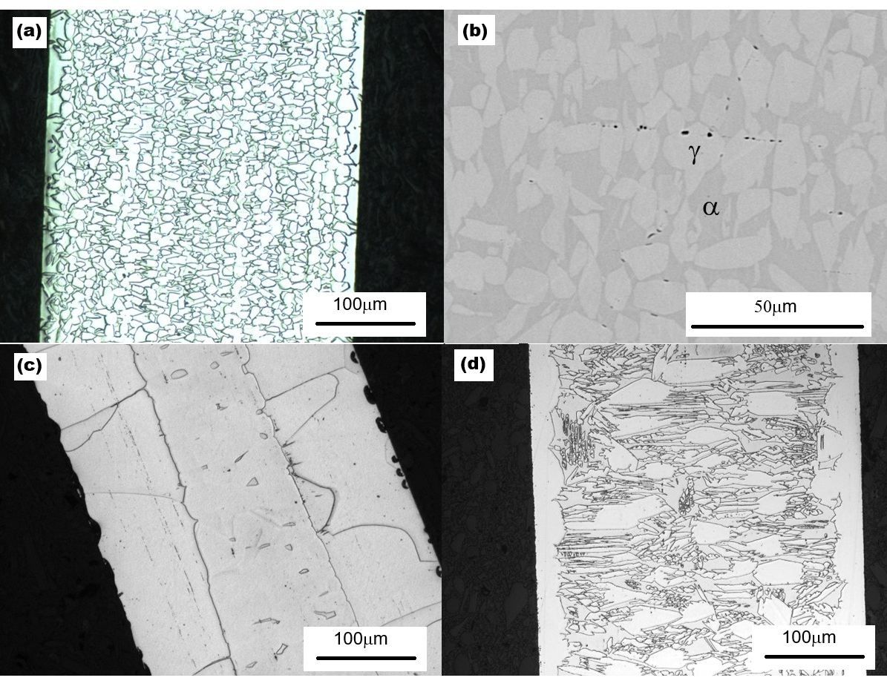
Fig. 1. Microstructure of the LLM alloy after heat treatment: (a) 1200 °C, 1 min, optical; (b) 1200 °C, 1 min, SEM; (c) 1200 °C, 40 min, optical; (d) 0.36 mm wire after the quartz-tube cyclic treatment of Sec. 2.2, optical.

3.2 Cyclic stress–strain response
Cyclic tensile stress–strain curves for the LLM alloy after heat treatment at different temperatures are shown in Fig. 2, and the corresponding data are listed in Table 2. This information reveals a broad picture of how heat treatment governs the alloy’s mechanical properties. The response is strongly anneal-dependent: low strand-anneal temperatures (600–700 °C) leave the wire with high strength but little ductility (tensile strengths of ≈1876–2254 MPa and yield strengths of ≈1635–1908 MPa, but elongation of only ≈2%), consistent with incomplete recrystallization of the cold-drawn wire, whereas annealing at 800–1200 °C progressively softens the wire and restores ductility, with elongation peaking near 33% at 1000 °C. The apparent elastic modulus, E, stays in the ≈150–162 GPa range across the annealed conditions. In the recrystallized conditions (800–1200 °C, Fig. 2c–e) the unloading segments are straight and parallel to the initial loading line and return no strain beyond the elastic strain (σ/E) expected at the unload stress: the strain recovery is consistent with elastic springback alone, with no pseudoelastic contribution resolvable at the scale of Fig. 2. The flat flow stress that follows yielding at 800 °C (Fig. 2c) is therefore plastic flow without work hardening rather than a transformation plateau, since no strain is recovered on unloading from it. In the unrecrystallized wire (as drawn and 600 °C, Fig. 2a, b), loading is non-linear and the unloading line from the highest load is less steep than the initial loading line, so that it returns up to ≈0.3% more strain than σ/E, with a narrow unloading–reloading loop and no plateau; this small non-linearity of the heavily cold-worked wire is reported but not interpreted here, and these conditions fracture at ≈2% strain. Because E is an apparent crosshead modulus (Sec. 2.4), these are statements about the shape of the unloading curves rather than measured recovery limits. It has been reported that aging at 200 °C can improve the pseudoelasticity of Fe-Mn-Al-Ni alloys (Ref 31,32); this was not the case for the LLM alloy (Fig. 2f).
Table 2. Mechanical properties of the LLM alloy (0.36 mm wire) after heat treatment for 1 minute at different temperatures, tested on a 127 mm gauge (Sec. 2.4); E is the apparent modulus from crosshead strain. Each value is the mean of three specimens; the uncertainty is one standard deviation.
Temp. (°C) | σ₀.₂ (MPa) | UTS (MPa) | Elong. (%) | E (GPa)
As drawn | 1587.9 ± 63.7 | 1936.6 ± 19.2 | 2.0 ± 0.1 | 138.5 ± 5.1
600 | 1908.0 ± 29.2 | 2254.3 ± 27.3 | 2.2 ± 0.1 | 155.7 ± 2.2
700 | 1635.3 ± 35.9 | 1876.0 ± 9.4 | 2.2 ± 0.0 | 156.1 ± 2.0
800 | 1151.1 ± 11.3 | 1208.6 ± 5.2 | 26.1 ± 1.7 | 151.4 ± 2.9
900 | 936.3 ± 5.5 | 1081.5 ± 2.5 | 30.6 ± 0.6 | 153.1 ± 1.4
1000 | 674.8 ± 1.5 | 977.8 ± 7.7 | 33.0 ± 0.3 | 156.0 ± 2.0
1100 | 570.6 ± 10.3 | 970.3 ± 16.5 | 29.1 ± 0.6 | 161.9 ± 3.6
1200 | 518.7 ± 11.8 | 968.3 ± 21.4 | 25.6 ± 1.2 | 161.2 ± 5.5
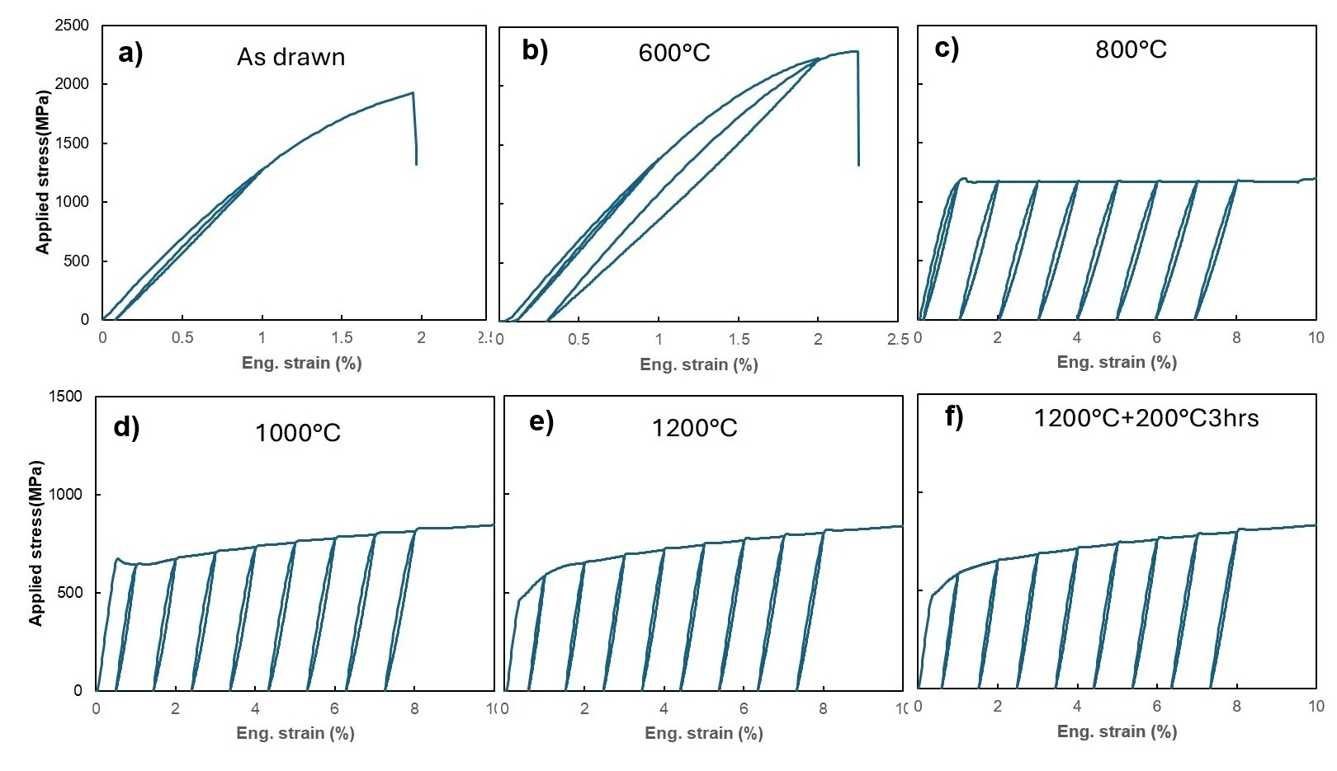
Fig. 2. Cyclic stress–strain curves of the LLM alloy (a) as drawn and after annealing for 1 minute at (b) 600, (c) 800, (d) 1000 and (e) 1200 °C, and (f) after the 1200 °C anneal followed by aging at 200 °C for 3 hours. Wire diameter is 0.36 mm (nominal); strain is crosshead extension over the 127 mm gauge (Sec. 2.4). Each panel shows a single specimen; Table 2 gives the means of three specimens per anneal condition.
Fig. 3 compares the stress–strain behavior of the LLM and Omori alloys during the loading–unloading–heating test. In this test, any residual stress-induced martensite present at zero stress should transform back to austenite upon heating, causing the reloading stress to rise at a strain lower than the last unloading strain. This is what happened in the Omori alloy, in the single test made on it: Fig. 3b shows that its residual strain after unloading from 3% deformation is ≈2.2%, and upon reloading, stress rises at a strain of ≈1.7%. This 0.5% heating-induced (shape-memory) recovery, a single observation, is evidence of stress-induced martensite in the Omori alloy that was stable enough to survive unloading but transformed back to austenite upon heating. By contrast, Fig. 3a shows no strain recovery of the LLM alloy in this test. The test was made on one specimen in the 1200 °C/1 min condition, and what it shows is confined to that state: no stress-induced martensite stable enough to survive unloading was present to revert on heating. The unloading evidence is broader, since no condition of Fig. 2 shows a transformation plateau or recovery beyond σ/E, apart from the small non-linearity of the unrecrystallized wire noted above. Within the conditions reported here, no stress-induced phase transformation was detected in the LLM alloy.
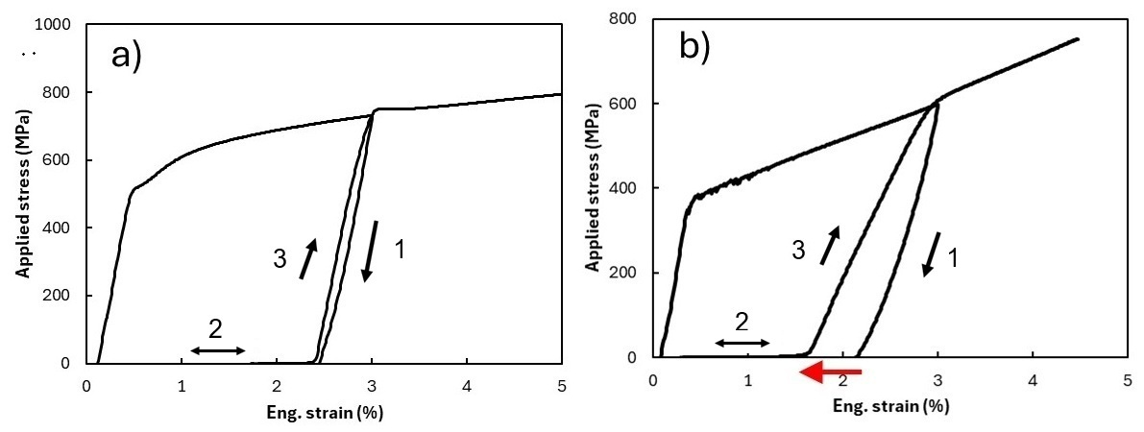
Fig. 3. Loading–unloading–heating tests of (a) the LLM alloy and (b) the Omori alloy, both heat treated at 1200 °C for 1 minute. Wire diameters 0.35 mm (a) and 0.54 mm (b); strain is crosshead extension over the 127 mm gauge (Sec. 2.4). Black arrows show the deformation path: 1, unloading from 3% strain; 2, return of the crosshead at zero stress while the specimen is heated; 3, reloading. The red arrow highlights the strain recovery caused by heating.
The longer and cyclic treatments of Sec. 2.2 did not change this result, and the coarsened conditions were brittle. After the 40-minute hold at 1200 °C of Fig. 1c, followed by the 200 °C/3 h age, the wire failed at 0.8% elongation, and after 80 minutes at 1200 °C the wire failed at 0.5%, in both cases within the first loading segment, before any unloading. The two-cycle rod specimens failed after 1.0% elongation and the three-cycle rod specimen tested on the 127 mm gauge after 0.5%. Every unloading segment recorded on the cyclically treated material — one in each two-cycle rod specimen, eight in a three-cycle rod specimen tested on a 6.0 mm gauge, and eight in the quartz-tube wire of Fig. 1d, tested on a 25.4 mm gauge — is straight and returns no strain beyond σ/E (Table S1; records not shown). On the 6.0 mm gauge, crosshead strain is dominated by load-train and grip compliance, so the strains of that specimen are not compared with those on the 127 mm gauge. No loading–unloading–heating test is reported on cyclically treated material: the rod specimens tested on the 127 mm gauge fractured at 0.5–1.0%, below the 3% strain of that protocol, and the quartz-tube wire was not given that test.

3.3 Synchrotron diffraction and phase identification
Synchrotron XRD of samples before and after deformation is shown in Fig. 4. Fig. 5 compares the experimental data (lower half of each panel) with the results of Rietveld refinement (upper half) for the LLM alloy before deformation (Fig. 5a, R_wp = 21.4%, R_p = 8.7%) and after unloading from 10% strain (Fig. 5b, R_wp = 12.5%, R_p = 5.9%). The fit is better for the deformed specimen, and the reason is visible in the patterns: the undeformed wire gives a beaded, spotty ring pattern in which relatively few grains satisfy each Bragg condition, whereas deformation subdivides those grains and gives the more continuous rings on which powder averaging depends. The refinement of the undeformed pattern is therefore limited by grain statistics as well as by the strong drawing texture. The orientation distribution from the refinement shows that texture along the wire axis: {111} and {100} fiber components in γ and a {110} fiber component in α, the components characteristic of cold-drawn FCC and BCC metals (Ref 33). With that limitation, the LLM alloy is estimated from the undeformed pattern (Fig. 5a) to consist of ≈62% FCC γ-phase, ≈34% BCC α-phase, and ≈4% of an ordered phase indexed as D0₃ Fe₃Al, by volume; these fractions are semi-quantitative, were held fixed in the final refinement (Sec. 2.5) and carry no uncertainty. The fractions were also held fixed in the refinement of the deformed pattern (Fig. 5b), so no fraction is reported as a measurement for that specimen. Its diffraction patterns before and after deformation are essentially the same (Fig. 4a, b), and relative peak intensities (Fig. 6a) are essentially unchanged: no new diffraction peaks appear and none disappear.
An ex-situ measurement made after unloading cannot, on its own, exclude a fully reversible transformation that reverts as the load is removed, and the diffraction data are therefore not the primary evidence here. A transformation reversible enough to leave no diffraction signature after unloading would still have had to produce recoverable strain during that unloading, and the unloading segments of the 1200 °C/1 min condition (Fig. 2e), the condition of the diffraction specimens, return no strain beyond σ/E. The heating test of Fig. 3a narrows the remaining route in that state, since stress-induced martensite retained after unloading and able to revert on heating to ≈200 °C would have appeared as strain recovery. The unchanged pattern corroborates this mechanical evidence and describes the state retained after unloading; a loading-stage or in-situ measurement would be the direct test for a transient transformation (Sec. 4.3). The shift from sharp, discrete spotty patterns in the undeformed state (Fig. 4a) to broader, partially arced rings after deformation (Fig. 4b) is consistent with dislocation activity, which broadens peaks and can form sub-grains; it was not quantified by line-profile analysis, and texture evolution and the different grains illuminated in a separate specimen may also contribute.
In comparison, the Omori alloy presents a BCC α-dominated pattern with FCC γ reflections and a B2 superlattice reflection, attributed to β-NiAl-type ordering whose spatial scale was not examined, in the undeformed state (Fig. 4c); after 8% applied strain, the {111}γ reflection intensifies and the overlapping {200}α redistributes in intensity (Fig. 4d), consistent with stress-induced γ formation and partial variant activation. The change in peak intensity after deformation of the Omori alloy is also shown in Fig. 6b. Unlike the LLM alloy, which retains grains well under 20 µm after the 1200 °C/1 min anneal (Fig. 1a), the Omori alloy coarsens at this temperature: its rings break up into a small number of discrete, intense spots (Fig. 4c, d), too few grains contribute to each reflection, and no Rietveld model could be brought into satisfactory agreement with its patterns. Phase fractions are therefore reported for the LLM alloy only, and the intensity changes of Fig. 6b are read qualitatively. No micrograph of the Omori alloy in the 1200 °C/1 min condition is available, so its grain size relative to the wire diameter, its grain morphology and its orientation are known only from this coarse, spotty diffraction; it received no aging treatment. That the Omori alloy transformed under this route therefore rests on three observations, each limited on its own: the intensity changes of Fig. 6b, the single 0.5% heating recovery of Fig. 3b, and the established transformation behavior of this composition (Ref 12–14).

No B2 superlattice reflection was resolved in the LLM alloy above the detection limit of the present measurement. At the B2-allowed {200} superlattice position the LLM alloy carries 0.50–1.06% of maximum intensity, against 3.83–7.17% in the Omori alloy, and that intensity is accounted for by D0₃, which produces the same reflection. The discriminating reflection is the D0₃-only {111}, present in the LLM alloy at 0.49–1.02% of maximum with a signal-to-noise ratio of 16–27 across four patterns (the 1200 °C/1 min wire before and after deformation, and two frames of the cyclically treated rod), and absent from the Omori alloy (0.19–0.28%, signal-to-noise ratio 2.3–2.9). The assignment of the ordered phase in the LLM alloy to D0₃ rests on these intensities. Its spatial scale is not established: whether it is a coarse constituent, an intragranular precipitate or long-range order within the α itself cannot be decided from these patterns, and transmission electron microscopy or atom-probe tomography would be required. Nor can a B2 dispersion finer or more dilute than the detection limit be excluded. κ-carbide was not included in an alternative refinement model, so it is not excluded at a small fraction.
The ≈1 mm LLM-alloy rod after the three-cycle treatment of Sec. 2.2 gave a pattern (not shown; Table S1) containing the same γ, α and D0₃ reflections as Fig. 4a, with the ring intensity resolved into more discrete spots. The dual-phase constitution is therefore retained at room temperature after that treatment as after the single anneal; whether it is also the constitution at 1200 °C cannot be established from room-temperature diffraction and is taken up in Sec. 4.1.
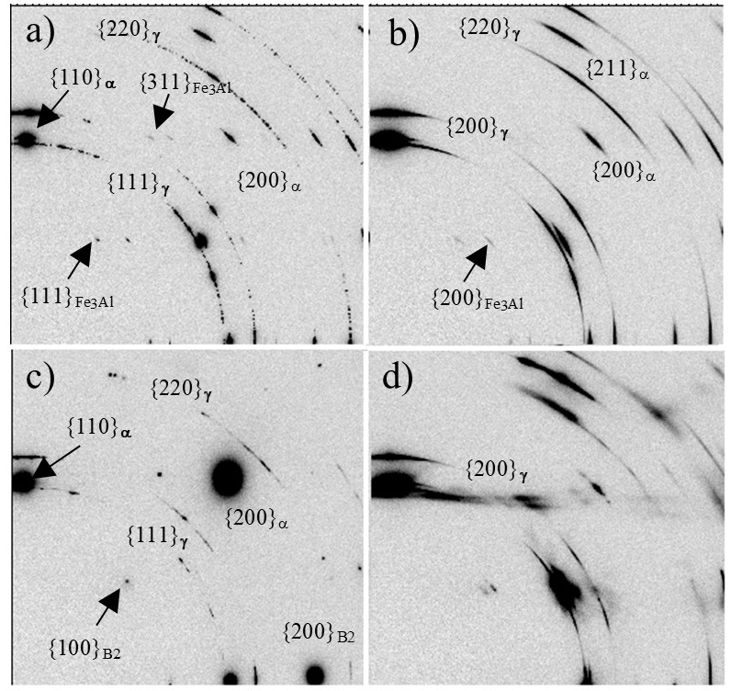
Fig. 4. 2D synchrotron X-ray diffraction images of (a) LLM alloy annealed at 1200 °C for 1 min, (b) annealed LLM alloy after 10% tensile strain, (c) Omori alloy annealed at 1200 °C for 1 min, and (d) annealed Omori alloy after 8% tensile strain. Each image is from a single specimen; (a) and (b), and (c) and (d), are separate specimens.

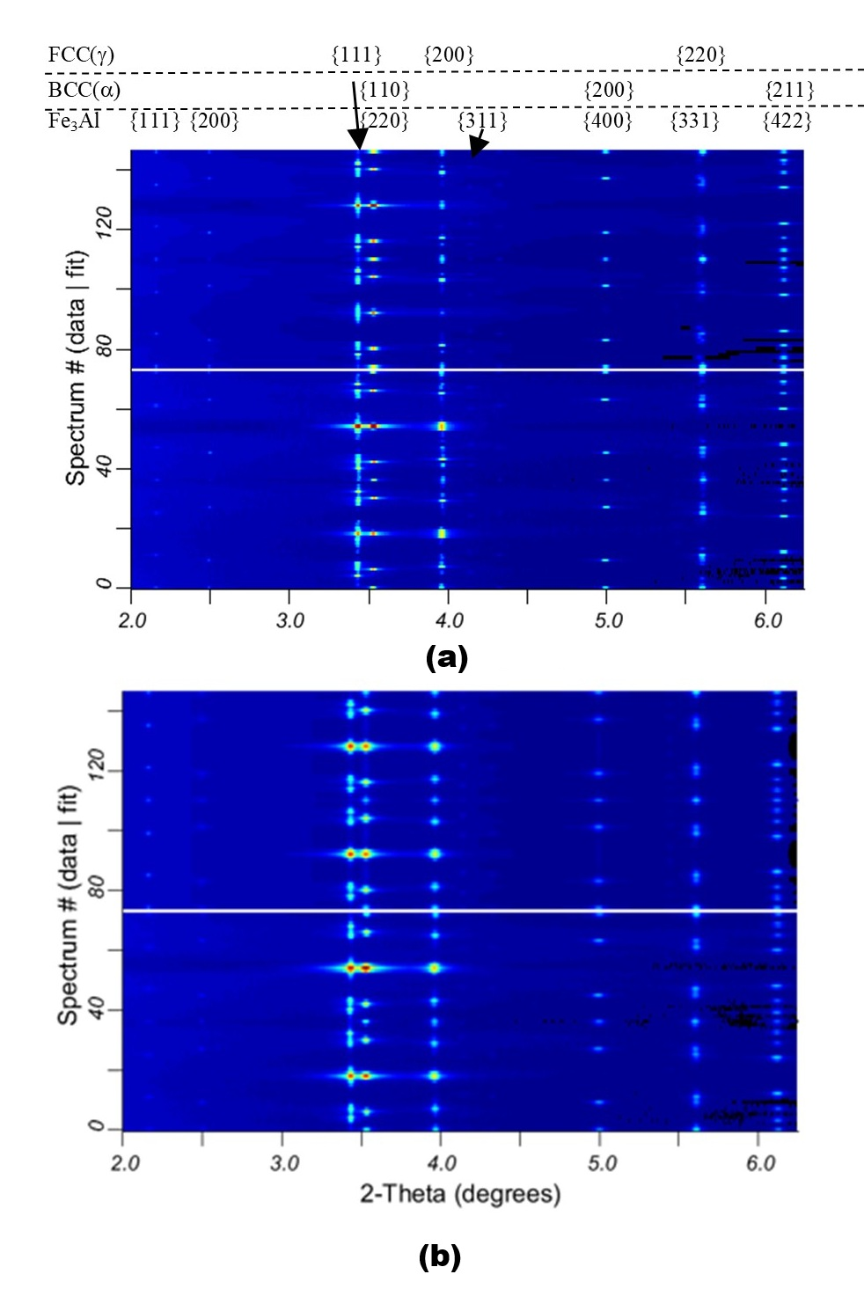
Fig. 5. Comparison between synchrotron X-ray diffraction data (lower half of each panel) and results of Rietveld refinement (upper half of each panel) for the LLM alloy: (a) heat treated at 1200 °C for 1 minute (R_wp = 21.4%, R_p = 8.7%), and (b) after unloading from 10% strain (R_wp = 12.5%, R_p = 5.9%). Both refinements used the three-phase model of Sec. 2.5, with lattice parameters fixed at a = 3.6366 Å (γ) and 2.8865 Å (α), and for D0₃ at 5.7734 Å in (a) and 5.7801 Å in (b).

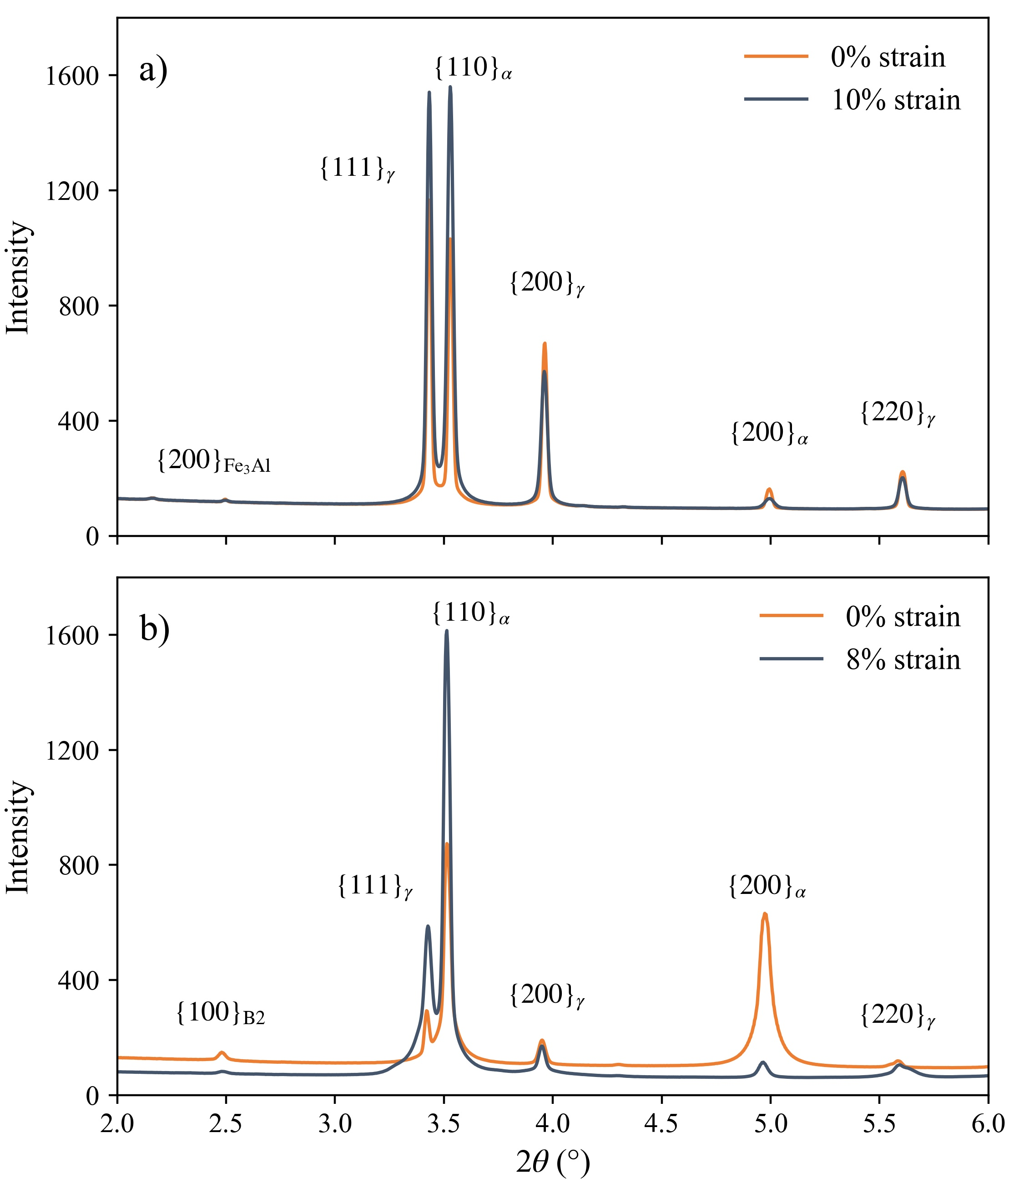
Fig. 6. Azimuthally integrated X-ray diffraction spectra of (a) the LLM alloy and (b) the Omori alloy before and after deformation to 10% (a) and 8% (b) strain. Samples were heat treated at 1200 °C for 1 minute before deformation. In (b) the spectrum after deformation is divided by 1.625 (= 2.6/1.6), the exposure normalization recorded with the data; the other three spectra are shown as integrated, without offset.

3.4 Equilibrium phase stability
Table 3 gives the calculated equilibrium constitution at 1200 °C, the solution-treatment temperature. The Omori alloy is calculated to be single-phase α at that temperature in both databases able to carry it, inside a single-phase α field that extends from ≈1140 °C to the onset of melting in mpea-02b (≈950–1360 °C in mc_fe), and its α orders to B2 on cooling below ≈1090 °C. This reproduces, without fitting, the single-phase solution treatment and B2 ordering on which this composition’s processing route is built (Ref 17,34), and it is the control for applying the same databases to the LLM alloy.
The LLM alloy is calculated to be a two-phase α + γ mixture at 1200 °C in all three databases (62–71% α), and in none of them does a single-phase α field open before melting begins (≈1240 °C in mc_fe, ≈1295 °C in mpea-02b and PrecHiMn-04). On the calculation, no solution temperature in the solid state brings this composition to single-phase α, independently of the 1200 °C limit of the process. Removing carbon from the measured chemistry, with every other element held fixed, opens a single-phase α field at ≈1130–1160 °C and gives 100% α at 1200 °C in all three databases. The other elements were varied in the same way. Raising nickel stepwise to the Omori alloy’s 7.8 at% does not open the field while carbon is present (mpea-02b, with the endpoints confirmed in mc_fe). Silicon at its measured level does not obstruct the field: with carbon removed, both databases that carry silicon return 100% α at 1200 °C. Whether the intended silicon would have opened the field with carbon present cannot be answered from these calculations, because mc_fe, the only database in which the nominal composition was evaluated with its silicon, places it partly molten at 1200 °C (27.9% liquid). Raising aluminum alone to the A2 ceiling of 12 wt% raises the α fraction at 1200 °C from 76.0 to 97.3% without making the alloy single-phase there (mpea-02b). None of the three carbon-bearing points sampled inside the A2 range (its midpoint and its most ferrite- and austenite-favoring corners) reaches disordered single-phase α at 1200 °C in either database able to evaluate them; the two databases disagree on the constitution of these silicon-rich compositions (mc_fe places the midpoint and the ferrite-favoring corner partly molten at 1200 °C and the austenite-favoring corner fully austenitic), and inside the range mc_fe does not make carbon the controlling element (Table S2). These calculations identify carbon as the element whose removal restores the α field for the measured chemistry; they do not show that the missing field is the cause of the absence of transformation (Sec. 4.1).
Carbide phases are calculated to be stable only well below the processing range: M₂₃C₆ only below ≈420 °C (mpea-02b) and κ-(Fe,Mn)₃AlC, at no more than 2.4%, only below ≈590 °C (PrecHiMn-04 and mc_fe). At 1200 °C both silicon and carbon are therefore in solid solution, and both are calculated to concentrate in γ: carbon strongly, at 1.0–1.3 at% in γ against ≈0.1 at% in α in all three databases, and silicon mildly, at 2.6–2.7 against 1.7–1.8 at% in the two databases that carry it. Aluminum is calculated to partition to α (13.0–13.8 against 9.9–10.0 at%) and manganese to γ (31.5–33.3 against 28.8–29.9 at%), the direction of the EDS contrast of Fig. 1b. These are equilibrium values at the solution-treatment temperature; the partitioning was not measured, and carbon in particular may redistribute during cooling. Finally, the ordered bcc of PrecHiMn-04, the only description here able to return D0₃, refines to disordered A2 at every temperature calculated for the Ni-free composition that database can evaluate; given its limitations below ≈600 °C (Sec. 2.6), this does not establish whether the D0₃ observed in Sec. 3.3 is an equilibrium phase.
Table 3. Calculated equilibrium phase fractions (mol%) at 1200 °C, the solution-treatment temperature. The Omori alloy cannot be evaluated in PrecHiMn-04, which contains no Ni. Settings in Table S2.
Alloy | mpea-02b | PrecHiMn-04 | mc_fe v2.059
Omori alloy | 100 α | – | 100 α
LLM alloy | 71.1 α + 28.9 γ | 64.5 α + 35.5 γ | 61.9 α + 38.1 γ
LLM alloy, C removed | 100 α | 100 α | 100 α

4. Discussion

4.1 Interpreting the absence of stress-induced phase transformation
What was measured is that the LLM alloy showed no transformation plateau and no recovery beyond elastic springback on unloading in any condition in which unloading was recorded, apart from a non-linearity of at most ≈0.3% in the unrecrystallized wire (Sec. 3.2), and none on heating in the one condition given the heating test (Fig. 3a), whereas the Omori alloy given the same anneal recovered ≈0.5% on heating (Fig. 3b); and that its diffraction pattern after the 1200 °C/1 min anneal, γ-majority after cooling, was essentially unchanged by 10% strain. What is not claimed is that the composition is incapable of superelasticity under any processing. Identical nominal processing does not guarantee identical microstructures in two compositions, and the route used here was the Omori alloy’s rather than one optimized for the LLM alloy, so the processing may have contributed to the result. Two observations bound that possibility without removing it. First, the LLM alloy was given a wider range of treatments than the Omori alloy (Secs. 2.2 and 3.2), including the 200 °C/3 h age reported to develop pseudoelasticity in this family (Ref 31,32), which the Omori specimen of Fig. 3b did not receive, and none produced recovery. Second, the calculations of Sec. 3.4 find no temperature in the solid state at which the composition is single-phase α, so no choice of solution temperature reproduces the starting state of the Omori alloy’s route. A solution-and-aging window optimized for this composition remains untested (Sec. 4.3).
The absence of superelasticity and of a shape-memory response in the LLM alloy (measured composition 51.5Fe-29.8Mn-11.9Al-4.2Ni-2.0Si-0.45C at%) is interpreted here in terms of a misalignment between its phase stability and its active deformation mechanisms. In Fe-Mn-Al-Ni shape-memory systems, superelastic behavior is contingent upon a reversible, stress-induced martensitic transformation from a BCC α parent phase to FCC γ martensite. However, semi-quantitative Rietveld refinement of the synchrotron XRD data indicates that the LLM alloy, as cooled from 1200 °C, is dominated by the γ-phase (≈62%), whereas the α-phase accounts for only ≈34% of the volume, with a further ≈4% indexed as ordered D0₃ (Sec. 3.3). Compared to the Omori alloy (43.5Fe-34Mn-15Al-7.5Ni at%), the LLM alloy has less Mn, Al, and Ni, but higher Fe, Si, and C. Element by element these changes pull in opposite directions — Fe, Si, and Al are conventionally ferrite stabilizers, and Mn, Ni, and C austenite stabilizers (Ref 35) — so such rules cannot decide the balance in a six-element alloy. The hypothesis in the agent’s report (Sec. 2.1) was that these chemistry changes would not alter the phase constitution or stability, and that the additional C could also increase material strength to impede dislocation slip and promote stress-induced phase transformation. The multicomponent calculations of Sec. 3.4, made on the measured chemistry, find instead that the alloy is two-phase α + γ at the solution-treatment temperature and has no single-phase α field below its melting point, and that removing its carbon restores that field at 1200 °C, whereas restoring the Omori alloy’s nickel or raising aluminum to the top of the proposed range does not, and silicon at its measured level does not obstruct it. Carbon is therefore one plausible contributor to the outcome. It is not a demonstrated cause: the five alloying additions change together between the two heats, the calculation describes equilibrium rather than the cooled wire, and casting a carbon-free heat of this composition is the direct test.
The calculation and the measurement agree that the alloy is dual-phase but not on which phase dominates: α is calculated to be the majority at 1200 °C (62–71%, Table 3), whereas the refinement of the cooled wire places γ in the majority (≈62%; the calculated fractions are molar and the refined ones by volume). Room-temperature diffraction does not establish the constitution at 1200 °C, and two readings are open. In the first, γ was present at 1200 °C in more than the calculated amount, because the databases overestimate α or because the 1-minute anneal did not bring the cold-drawn wire to equilibrium. In the second, part of the α present at temperature transformed to γ on cooling, which would place a transformation temperature above room temperature. The present data do not decide between them: no transformation temperatures were measured for these conditions, and the qualitative EDS partitioning of Fig. 1b is expected under either reading. Differential scanning calorimetry of the strand-annealed wire, with the Omori alloy as the control, or a phase map combined with composition on the same area (EBSD with EDS) would discriminate. Attributing the absence of transformation to the missing single-phase parent state is therefore an interpretation consistent with both readings, not a demonstrated mechanism.
Mechanical and structural analyses further indicate that the LLM alloy accommodates macroscopic deformation via irreversible dislocation slip rather than phase transformation. Coherent, ordered β-NiAl (B2) precipitates within the BCC parent contribute to the transformation reversibility of the Omori alloy (Ref 34), alongside parent-phase stability, transformation temperature, grain size, crystallographic orientation, and the balance between transformation stress and yield stress. In the LLM alloy the ordered phase observed is D0₃ Fe₃Al, ≈4% and of unknown spatial scale (Sec. 3.3), which is not predicted by the one database able to model it (Sec. 3.4) and may be a metastable ordering product formed on cooling; there is no evidence that it raises the resistance to plastic flow in the way that B2 does in the Omori alloy. The post-deformation synchrotron patterns are consistent with this interpretation: the change from sharp, discrete spots to broader, partially arced rings is what dislocation multiplication and sub-grain formation would produce, although it was not quantified and texture evolution could contribute to it. Thus, as processed here, the dual-phase LLM alloy is interpreted to deform by dislocation slip rather than by stress-induced martensitic transformation.

4.2 Anneal-temperature dependence of mechanical properties
Although the LLM alloy did not show superelastic behavior, its tensile properties vary strongly with annealing temperature, and the trends are consistent with those expected for a cold-drawn wire passing through recovery, recrystallization, and grain growth. Microstructures were examined only after the 1200 °C anneals (Sec. 3.1), so the regimes below are interpretations of the mechanical trends rather than observed microstructural stages; and because the values of Table 2 come from incrementally cycled specimens with crosshead strain (Sec. 2.4), they are compared with monotonic data only with that qualification. Reading these as an exploratory survey rather than a designed experiment, three regimes emerge.
At the lowest temperatures (600–700 °C) the wire is very strong but essentially brittle: tensile strengths of ≈1876–2254 MPa and yield strengths of ≈1635–1908 MPa, but elongation of only ≈2%. These temperatures are interpreted as lying below the recrystallization range of the heavily cold-drawn wire, so that annealing here drives only recovery (relief of residual drawing stresses and partial rearrangement of the dislocation substructure) without nucleating new strain-free grains. On that reading, the high dislocation density retained from cold drawing sustains the high strength, and the small ductility gains in this window reflect stress relief rather than any genuine restoration of formability; the wire still fractures soon after yield.
The abrupt change near 800 °C is consistent with the onset of recrystallization. Elongation jumps from 2.2% at 700 °C to 26.1% at 800 °C, while tensile strength falls from 1876 to 1209 MPa and yield strength from 1635 to 1151 MPa. A discontinuity of this kind, rather than a smooth softening, is characteristic of recrystallization, in which new equiaxed, strain-free grains nucleate and consume the deformed matrix, removing most of the stored dislocation content and abruptly restoring ductility. The onset of recrystallization is inferred from the mechanical response rather than observed, since micrographs were not taken at every anneal temperature.
From 800 to 1200 °C the behavior is consistent with a recrystallized wire in which grain growth dominates. Yield strength falls at each successive anneal temperature (1151 → 519 MPa), which we interpret as grain growth, and elongation rises to a peak of ≈33% near 1000 °C. Between 800 and 1000 °C strength and ductility therefore trade against each other in the way expected when flow stress is controlled by grain size. In this dual-phase wire, however, the phase fractions, ordering and drawing texture may also change across the series (they were measured only after the 1200 °C anneal), and the residual effect of the prior cold work is not separated, so grain size need not be the only variable. Above 1000 °C, elongation decreases (29.1% at 1100 °C, 25.6% at 1200 °C), by more than the specimen-to-specimen scatter of Table 2 (one standard deviation ≤1.2% at these temperatures). The present data do not identify the cause: coarsening, surface oxidation or decarburization of the 0.36 mm wire at the higher temperatures, quench effects, grain-boundary phases, and changes in phase fractions are all possible, and none was measured across the series. Throughout the sweep, the apparent modulus stays within ≈150–162 GPa; because it is measured from crosshead strain (Sec. 2.4), it is not used to infer any change of structure.

4.3 Implications for AI-guided alloy design
The workflow that produced this alloy should be stated before its outcome is interpreted, because the outcome belongs to that workflow and not to AI-assisted design in general. A deep-research agent was asked for lower-cost Fe-based compositions with the potential for superelasticity; it returned six ranked candidate families, each with a stated rationale and a performance target (Sec. 2.1); one family was chosen and a composition drawn from it, outside its stated range in manganese and aluminum, was melted; and between the report and the melt no calculation of phase stability was made. In this study the LLM-hypothesized alloy developed a multiphase microstructure consisting mainly of FCC γ and BCC α phases, and neither mechanical testing nor synchrotron diffraction provided evidence of stress-induced martensitic transformation in the conditions reported; deformation was instead accommodated largely by dislocation slip. The composition appeared reasonable from a strengthening and literature perspective. What its rationale did not contain, and what nothing later in the workflow supplied, was a check that the parent phase it specified could be produced by any treatment within the 1200 °C limit of the process.
The failure chain can be followed link by link, and the links do not carry equal weight. The first is the proposal itself: the carbon-bearing compositions sampled inside A2’s range reach no single-phase disordered α at 1200 °C in either database able to evaluate them (Sec. 3.4), so on the calculation the obstacle is not peculiar to the point that was melted (A2’s boron option was not evaluated). The second is the human down-selection: the composition melted lies outside A2 in manganese and aluminum, on the austenite-favoring side (Sec. 2.1); raising aluminum alone to the top of the range raises the calculated α fraction at 1200 °C but does not make the alloy single-phase α there (Sec. 3.4), and the manganese deviation was not evaluated separately, so the down-selection moved the alloy in the direction observed without, on the calculation, deciding the outcome. The third is synthesis: silicon was recovered at half its intended level (Sec. 2.1), but at its measured level silicon does not obstruct the α field once carbon is removed, and the calculations cannot say whether the intended silicon would have opened it with carbon present (Sec. 3.4). The fourth is processing: the route was the Omori alloy’s rather than one optimized for this composition, and whether another solution or aging treatment could produce a transforming state is untested. What can be attributed to the language model is therefore the first link, a proposed range whose sampled carbon-bearing compositions cannot, on the calculation, be solution-treated to the parent phase the proposal itself specified. The check that would have exposed it was omitted by the workflow rather than by the model, which recommended it: the report calls for “computational tools, such as CALPHAD for phase diagram prediction and precipitate stability, and Density Functional Theory for understanding precipitate–matrix coherency and energetics” to be “employed to guide experimental design”, and the melt proceeded without that calculation.
The workflow examined here sits at one end of a range of AI-assisted alloy-design approaches. Domain-trained language models learn composition–property relationships from explicit datasets and report quantitative test-set errors, as AlloyBERT does for elastic modulus and yield strength (Ref 36) and as AlloyGPT, trained on CALPHAD-generated records of Al-based alloys for additive manufacturing, does for forward prediction and inverse design (Ref 37); neither reports new experiments. LLM agents have also been given physics tools: in AtomAgents the agents call atomistic simulations while designing alloys (Ref 38), and a multi-agent system evaluates proposed additive-manufacturing alloys with thermophysical properties calculated in Thermo-Calc (Ref 39). Adaptive and active-learning loops close on experiment: Xue et al. synthesized 36 predicted NiTi-based compositions over nine feedback loops in a search for low thermal hysteresis (Ref 40), and Rao et al. combined machine learning, density-functional theory, thermodynamic calculations and 17 newly made alloys to identify high-entropy Invar alloys (Ref 41); the AIMS framework of Sec. 1 selected a NiTiCu shape memory alloy together with its processing and confirmed it experimentally (Ref 4). In the agent and loop workflows, a calculation or an experiment stands between a proposed composition and the decision to pursue it. The single-shot, tool-free workflow tested here had no such step: the equilibrium check that its own report recommended was not run before melting.
The scope of what this study supports should be stated plainly. One composition, drawn from one agent’s proposal in one session and processed by one route, is a case study of that composition. It is not an experimental test of Hypothesis A2 as a whole, and still less an evaluation of AI-assisted alloy design as a practice. Run-to-run variation in the agent’s output was not tested, so nothing here establishes a failure rate, and a different prompt, agent or processing window might have produced a different outcome. Four tests remain open: a solution-and-aging treatment optimized for this composition; an in-situ or loading-stage diffraction measurement, which would observe the material under load instead of after unloading; differential scanning calorimetry, which would show whether a transformation occurs on cooling (Sec. 4.1); and a cast carbon-free heat, the experimental form of the calculated control of Sec. 3.4. What generalizes is narrower and, we think, more useful. The screening step that would have flagged this composition is a single equilibrium step diagram, evaluated not for the existence of the desired phase but for whether the phase field required by the intended processing route lies within the temperatures at which that route can be run. It requires no proprietary software and no measurement on the candidate itself. A generated composition should be treated as a hypothesis to be screened, not as a result.
Nevertheless, AI-assisted alloy design is likely to become increasingly successful. As larger experimental databases become available and models begin to incorporate processing history, microstructural evolution, kinetic simulations, and deformation mechanisms alongside thermodynamic calculations, AI will be able to make more physically informed predictions. Future materials-design frameworks that integrate first-principles calculations, phase-field modeling, CALPHAD databases, high-throughput experiments, and machine learning may better capture the conditions required for martensitic transformations and functional properties. Rather than replacing metallurgical expertise, AI is expected to serve as a powerful tool for rapidly narrowing the compositional search space, generating testable hypotheses, and accelerating discovery. The present study should therefore be read not as a failure of AI itself, nor as a measure of what current models can or cannot capture, but as a documented instance of a design workflow that stopped one calculation short of the check its own output recommended.

5. Conclusions
An LLM deep-research workflow was asked for a lower-cost Fe-Mn-Al-based alloy targeting room-temperature superelasticity; cost was the objective of that request and is not evaluated here. One composition drawn from the proposal, outside the proposed range in Mn and Al, was synthesized and compared with the Fe-Mn-Al-Ni alloy reported by Omori et al., a reference composition processed in parallel under the same nominal route. After the 1200 °C/1 min anneal, the LLM alloy had a γ-majority dual-phase FCC/BCC microstructure (semi-quantitative Rietveld refinement) with a minor ordered phase indexed as D0₃, and in the conditions tested it is interpreted to deform by dislocation slip rather than stress-induced martensitic transformation. Superelasticity was not observed in any condition in which unloading was recorded, nor shape-memory recovery on heating in the one condition tested, whereas the reference alloy recovered ≈0.5% on heating in a single test. The diffraction is ex situ, so a transformation reversing on unloading is bounded by the unloading curves, which show no transformation plateau and no recovery beyond elastic springback in the recrystallized conditions, rather than by diffraction.
Equilibrium calculations in three independent open databases, two of which reproduce the reference alloy’s single-phase α field without fitting, find the LLM alloy two-phase α + γ at the 1200 °C solution-treatment temperature, with no single-phase α field below its melting point; removing its ≈0.10 wt% carbon in the calculation restores that field at 1200 °C, whereas restoring the reference alloy’s nickel or raising aluminum to the top of the proposed range does not. Carbon is therefore one plausible contributor to the outcome, not a demonstrated cause, and whether the missing single-phase parent state is the operative reason for the absence of transformation remains open, because the calculated and measured constitutions disagree on which phase dominates.
These results document a limitation of the workflow as it was run, not a demonstrated limit on what an LLM can propose: the agent’s report recommended a CALPHAD check, and the melt proceeded without one. This single-composition case study cannot establish how often such workflows fail. Its experimental conclusions are confined to the conditions reported and remain valid if another processing route is later found to produce superelasticity in this composition, while the calculated absence of a single-phase α field is a property of the composition rather than of the route. Nevertheless, this work demonstrates the value of experimentally validating AI-generated hypotheses, and of screening them for phase stability against the intended processing route before synthesis, and suggests that future models incorporating kinetic effects, phase transformations, and processing history may become powerful tools for accelerated alloy discovery.

Acknowledgments
The authors thank Fort Wayne Metals for providing access to melting, hot-rolling, cold-drawing, and metallography facilities, and for technical guidance throughout alloy synthesis.
S. Cai also thanks his colleagues Andrew Michael for melting the alloys and Todd Darley for SEM analysis. Synchrotron X-ray diffraction was carried out on beamline BL12SW at the Shanghai Synchrotron Radiation Facility (SSRF) under proposal No. 2024-SSRF-PT-505463. The authors acknowledge beamline BL12SW (http://cstr.cn/31124.02.SSRF.BL12SW) of the SSRF for experimental support. Data analysis was performed using the FIT2D and MAUD software.

Declarations
Funding. No external funding was received for this work.
Conflicts of interest/Competing interests. S. Cai is employed by Fort Wayne Metals, which provided the melting, hot-rolling, cold-drawing and metallography facilities used in this work. The authors have no other relevant financial or non-financial interests to disclose.
Author contributions. F.Y. Cai conceived the study, carried out the LLM-assisted alloy design, the experiments (processing, heat treatment, mechanical testing and metallography), the data collection and analysis and the equilibrium calculations, and wrote the manuscript. S. Cai and X. Wang supervised the work throughout. J. Yan carried out the synchrotron X-ray diffraction experiments. S. Cai reviewed and edited the manuscript. All authors read and approved the final manuscript.
Ethics approval. Not applicable.
Generative AI use. An LLM deep-research agent (Google Gemini 2.5, Deep Research) was used to hypothesize the LLM-alloy composition under study, as described in Sec. 2.1; this use is a study method and is itself the object of the investigation. No AI system generated experimental data or determined any reported measurement, and the authors reviewed the entire manuscript and take full responsibility for its content. Anthropic Claude was used to assist with writing and editing the manuscript text, under the authors’ direction; the authors checked all resulting text against the experimental records and take full responsibility for it.
Data availability. Every specimen behind the figures and tables is listed in Table S1 (Online Resource 2), with its heat, form, heat treatment and test and, where applicable, its measured diameter, gauge length and number of specimens; every thermodynamic calculation is listed in Table S2. The chemistry certificates for both heats, the raw synchrotron detector frames and their azimuthal integrations, the load–extension exports of the tensile tests, and the metallographic images are available from the corresponding author on reasonable request. The calculation scripts, input compositions and raw output behind Secs. 2.6 and 3.4 are likewise available on request; the thermodynamic databases are third-party assessments that are not redistributed and must be obtained from the sources cited in Sec. 2.6.

References
1. A. Merchant, S. Batzner, S.S. Schoenholz, M. Aykol, G. Cheon, and E.D. Cubuk, Scaling Deep Learning for Materials Discovery, Nature, 2023, 624, p 80–85. https://doi.org/10.1038/s41586-023-06735-9
2. Gemini Team, Google, Gemini 2.5: Pushing the Frontier with Advanced Reasoning, Multimodality, Long Context, and Next Generation Agentic Capabilities, arXiv:2507.06261, 2025. https://doi.org/10.48550/arXiv.2507.06261
3. R. Xu and J. Peng, A Comprehensive Survey of Deep Research: Systems, Methodologies, and Applications, arXiv:2506.12594, 2025. https://doi.org/10.48550/arXiv.2506.12594
4. W. Trehern, R. Ortiz-Ayala, K.C. Atli, R. Arróyave, and I. Karaman, Data-Driven Shape Memory Alloy Discovery Using Artificial Intelligence Materials Selection (AIMS) Framework, Acta Mater., 2022, 228, p 117751. https://doi.org/10.1016/j.actamat.2022.117751
5. C. Li, P. Dang, Y. Xian, Y. Zhou, B. Shi, X. Ding, J. Sun, and D. Xue, Generative Inverse Design for Property-Targeted Materials Design: Application to Shape Memory Alloys, Adv. Funct. Mater., 2026, 36(46), p e27774. https://doi.org/10.1002/adfm.202527774
6. Q. Liu, M.P. Polak, S.Y. Kim, M.A.A. Shuvo, H.S. Deodhar, J. Han, D. Morgan, and H. Oh, Beyond Designer’s Knowledge: Generating Materials Design Hypotheses via a Large Language Model, Acta Mater., 2025, 297, p 121307. https://doi.org/10.1016/j.actamat.2025.121307
7. K. Otsuka and X. Ren, Physical Metallurgy of Ti–Ni-Based Shape Memory Alloys, Prog. Mater. Sci., 2005, 50(5), p 511–678. https://doi.org/10.1016/j.pmatsci.2004.10.001
8. D.C. Lagoudas, Ed., Shape Memory Alloys: Modeling and Engineering Applications, Springer, 2008. https://doi.org/10.1007/978-0-387-47685-8
9. T. Duerig, A. Pelton, and D. Stöckel, An Overview of Nitinol Medical Applications, Mater. Sci. Eng. A, 1999, 273–275, p 149–160. https://doi.org/10.1016/S0921-5093(99)00294-4
10. J. Mohd Jani, M. Leary, A. Subic, and M.A. Gibson, A Review of Shape Memory Alloy Research, Applications and Opportunities, Mater. Des., 2014, 56, p 1078–1113. https://doi.org/10.1016/j.matdes.2013.11.084
11. A. Cladera, B. Weber, C. Leinenbach, C. Czaderski, M. Shahverdi, and M. Motavalli, Iron-Based Shape Memory Alloys for Civil Engineering Structures: An Overview, Constr. Build. Mater., 2014, 63, p 281–293. https://doi.org/10.1016/j.conbuildmat.2014.04.032
12. T. Omori, K. Ando, M. Okano, X. Xu, Y. Tanaka, I. Ohnuma, R. Kainuma, and K. Ishida, Superelastic Effect in Polycrystalline Ferrous Alloys, Science, 2011, 333(6038), p 68–71. https://doi.org/10.1126/science.1202232
13. M. Vollmer, P. Krooß, M.J. Kriegel, V. Klemm, C. Somsen, H. Ozcan, I. Karaman, A. Weidner, D. Rafaja, H. Biermann, and T. Niendorf, Cyclic Degradation in Bamboo-Like Fe-Mn-Al-Ni Shape Memory Alloys: The Role of Grain Orientation, Scr. Mater., 2016, 114, p 156–160. https://doi.org/10.1016/j.scriptamat.2015.12.007
14. W. Abuzaid, Y. Wu, R. Sidharth, F. Brenne, S. Alkan, M. Vollmer, P. Krooß, T. Niendorf, and H. Sehitoglu, FeMnNiAl Iron-Based Shape Memory Alloy: Promises and Challenges, Shape Mem. Superelasticity, 2019, 5, p 263–277. https://doi.org/10.1007/s40830-019-00230-9
15. F. Cai and S. Cai, AI-Driven Exploration of Cost-Effective Fe-Based Shape Memory Alloys: Bridging the Gap Between Prediction and Processability, SMST 2026: Extended abstracts from the international conference on shape memory and superelastic technologies, ASM International, 2026, p 11–13. https://doi.org/10.31399/asm.cp.smst2026p0011
16. T. Omori and R. Kainuma, Martensitic Transformation and Superelasticity in Fe-Mn-Al-Based Shape Memory Alloys, Shape Mem. Superelasticity, 2017, 3, p 322–334. https://doi.org/10.1007/s40830-017-0129-9
17. T. Omori, H. Iwaizako, and R. Kainuma, Abnormal Grain Growth Induced by Cyclic Heat Treatment in Fe-Mn-Al-Ni Superelastic Alloy, Mater. Des., 2016, 101, p 263–269. https://doi.org/10.1016/j.matdes.2016.04.011
18. S. Cai, J.E. Schaffer, T. Shi, J. Gao, and L. Kadeřávek, Effect of Cu Alloying and Heat Treatment Parameters on NiTi Alloy Phase Stability and Constitutive Behavior, Shape Mem. Superelasticity, 2024, 10, p 460–472. https://doi.org/10.1007/s40830-024-00504-x
19. J.A. Shaw and S. Kyriakides, Thermomechanical Aspects of NiTi, J. Mech. Phys. Solids, 1995, 43(8), p 1243–1281. https://doi.org/10.1016/0022-5096(95)00024-D
20. R.Z. Tai and Z.T. Zhao, Overview of SSRF Phase-II Beamlines, Nucl. Sci. Tech., 2024, 35, p 137. https://doi.org/10.1007/s41365-024-01487-1
21. K. Yang, Z.-H. Dong, C.-Y. Zhou, Z.-L. Zhao, D.-X. Liang, S.-C. Cao, and A.-G. Li, Ultrahard X-ray Multifunctional Application Beamline at the SSRF, Nucl. Sci. Tech., 2024, 35, p 98. https://doi.org/10.1007/s41365-024-01468-4
22. A.P. Hammersley, “FIT2D V9.129 Reference Manual V3.1,” ESRF98HA01T, ESRF, Grenoble, 1998.
23. H.M. Rietveld, A Profile Refinement Method for Nuclear and Magnetic Structures, J. Appl. Crystallogr., 1969, 2, p 65–71. https://doi.org/10.1107/S0021889869006558
24. L. Lutterotti, S. Matthies, H.R. Wenk, A.S. Schultz, and J.W. Richardson, Combined Texture and Structure Analysis of Deformed Limestone from Time-of-Flight Neutron Diffraction Spectra, J. Appl. Phys., 1997, 81, p 594–600. https://doi.org/10.1063/1.364220
25. H.L. Lukas, S.G. Fries, and B. Sundman, Computational Thermodynamics: The Calphad Method, Cambridge University Press, 2007. https://doi.org/10.1017/CBO9780511804137
26. R. Otis and Z.-K. Liu, pycalphad: CALPHAD-Based Computational Thermodynamics in Python, J. Open Res. Softw., 2017, 5(1), p 1. https://doi.org/10.5334/jors.140
27. B. Hallstedt, Database for High Entropy Alloys (mpea), Version 2b, RWTH Aachen University, 2017. https://github.com/pycalphad/binder/tree/develop/multicomponent-databases. Accessed 28 September 2026
28. B. Hallstedt, M. Noori, F. Kies, F. Oppermann, and C. Haase, Thermodynamic Database for Multi-Principal Element Alloys Within the System Al–Co–Cr–Fe–Mn–Ni–C, Calphad, 2023, 83, p 102644. https://doi.org/10.1016/j.calphad.2023.102644
29. B. Hallstedt, A.V. Khvan, B.B. Lindahl, M. Selleby, and S. Liu, PrecHiMn-4—A Thermodynamic Database for High-Mn Steels, Calphad, 2017, 56, p 49–57. https://doi.org/10.1016/j.calphad.2016.11.006
30. E. Povoden-Karadeniz, MatCalc Thermodynamic Steel Database mc_fe, Version 2.059, TU Wien, 2016. https://www.matcalc.at/index.php/databases/open-databases. Accessed 28 September 2026
31. Y. Tanaka, Y. Himuro, R. Kainuma, Y. Sutou, T. Omori, and K. Ishida, Ferrous Polycrystalline Shape-Memory Alloy Showing Huge Superelasticity, Science, 2010, 327, p 1488–1490. https://doi.org/10.1126/science.1183169
32. M. Vollmer, T. Arold, M.J. Kriegel, V. Klemm, S. Degener, J. Freudenberger, and T. Niendorf, Promoting Abnormal Grain Growth in Fe-Based Shape Memory Alloys Through Compositional Adjustments, Nat. Commun., 2019, 10, p 2337. https://doi.org/10.1038/s41467-019-10308-8
33. O. Engler and V. Randle, Introduction to Texture Analysis: Macrotexture, Microtexture, and Orientation Mapping, 2nd ed., CRC Press, 2010.
34. T. Omori, M. Nagasako, M. Okano, K. Endo, and R. Kainuma, Microstructure and Martensitic Transformation in the Fe-Mn-Al-Ni Shape Memory Alloy with B2-Type Coherent Fine Particles, Appl. Phys. Lett., 2012, 101(23), p 231907. https://doi.org/10.1063/1.4769375
35. H.K.D.H. Bhadeshia and R.W.K. Honeycombe, Steels: Microstructure and Properties, 4th ed., Elsevier Butterworth-Heinemann, 2017.
36. A. Chaudhari, C. Guntuboina, H. Huang, and A. Barati Farimani, AlloyBERT: Alloy Property Prediction with Large Language Models, Comput. Mater. Sci., 2024, 244, p 113256. https://doi.org/10.1016/j.commatsci.2024.113256
37. B. Ni, B. Glaser, and S.M. Taheri-Mousavi, End-to-End Prediction and Design of Additively Manufacturable Alloys Using a Generative AlloyGPT Model, npj Comput. Mater., 2025, 11(1), p 294. https://doi.org/10.1038/s41524-025-01768-2
38. A. Ghafarollahi and M.J. Buehler, Automating Alloy Design and Discovery with Physics-Aware Multimodal Multiagent AI, Proc. Natl. Acad. Sci. U.S.A., 2025, 122(4), p e2414074122. https://doi.org/10.1073/pnas.2414074122
39. P. Pak, A. Chandrasekhar, and A. Barati Farimani, Agentic Additive Manufacturing Alloy Evaluation, Addit. Manuf. Lett., 2026, 17, p 100355. https://doi.org/10.1016/j.addlet.2026.100355
40. D. Xue, P.V. Balachandran, J. Hogden, J. Theiler, D. Xue, and T. Lookman, Accelerated Search for Materials with Targeted Properties by Adaptive Design, Nat. Commun., 2016, 7, p 11241. https://doi.org/10.1038/ncomms11241
41. Z. Rao, P.-Y. Tung, R. Xie, Y. Wei, H. Zhang, A. Ferrari, T.P.C. Klaver, F. Körmann, P.T. Sukumar, A. Kwiatkowski da Silva, Y. Chen, Z. Li, D. Ponge, J. Neugebauer, O. Gutfleisch, S. Bauer, and D. Raabe, Machine Learning–Enabled High-Entropy Alloy Discovery, Science, 2022, 378(6615), p 78–85. https://doi.org/10.1126/science.abo4940

