Finite-temperature dynamic stability is a blind spot of foundation MLIPs
Table of Contents

Finite-temperature dynamic stability is a blind spot of foundation machine-learning interatomic potentials
Post-revision draft (Stage 4, integrity-checked). All quantitative claims verified against results/ledger.parquet and results/convergence_study.parquet; references finalised with DOIs (deep-research pass, June 2026).

Abstract
Foundation (universal) machine-learning interatomic potentials (MLIPs) are now routine cheap stand-ins for DFT in high-throughput stability screening, yet they are benchmarked almost exclusively against harmonic (0 K) phonons. Dynamic stability is physically a finite-temperature property, and an important class of materials — cubic perovskites, bcc refractory metals, cubic fluorites — is harmonically unstable but thermally stabilised by anharmonicity. We stress-test five foundation MLIPs (MACE-MP-0, CHGNet, ORB-v2, SevenNet-0, MatterSim) on this regime using a curated set of references whose finite-T behaviour is documented in the experimental/DFT literature, so no new DFT ground truth is required. We introduce a cheap single-mode quantum self-consistent-harmonic (SCHA) “soft-mode free energy” screen that resolves the harmonic→finite-T stabilisation, and we cross-validate it against the gold-standard multi-mode stochastic SCHA (SSCHA). Three principal findings (plus an actionable ensemble-disagreement guardrail): (i) at the harmonic level the models split sharply — MatterSim and SevenNet-0 reproduce every documented soft mode (accuracy 1.00), while MACE-MP-0, CHGNet and ORB-v2 soften the bcc Zr/Hf instabilities toward zero and carry a 15% false-stable rate; (ii) harmonic accuracy is necessary but not sufficient for finite-T accuracy — the two are only weakly correlated on the matched set, the harmonic leaders (MatterSim, SevenNet-0) are not the finite-T leaders, and the soft-mode screen recovers the displacive instability of cubic ferroelectric perovskites that the models otherwise miss; (iii) multi-mode SSCHA with an MLIP force engine is itself a sharp methodological trap — it is a clean gold standard for the martensitic bcc metals but systematically false-stabilises deep displacive (ferroelectric) instabilities and can diverge numerically, so the cheap soft-mode screen is the more reliable finite-T indicator in exactly the regime that matters most for generative-CSP screening.

1. Introduction
Foundation MLIPs — MACE-MP, CHGNet, ORB, SevenNet, MatterSim, M3GNet — are increasingly used as DFT surrogates in high-throughput pipelines, including the dynamical-stability filtering of generative crystal-structure-prediction (CSP) outputs. Two 2025 works define the state of the art. “Universal MLIPs are ready for phonons” (npj Comput. Mater., 2025 [1]) benchmarks MLIPs against ~10⁴ DFT harmonic phonon calculations [3] on largely in-distribution materials and reports a systematic potential-energy-surface (PES) softening bias (energy/force under-prediction → mode softening → over-estimated stability). PhononBench (arXiv:2512.21227, Dec 2025 [2]) scores ~1.1×10⁵ generated structures for harmonic dynamical stability using MatterSim itself as the oracle.
Both are harmonic, i.e. 0 K. But dynamic stability is a finite-temperature property, and a technologically central materials class is harmonically unstable yet thermally stabilised by anharmonicity: cubic perovskites (SrTiO₃, BaTiO₃, halide perovskites), bcc refractory metals (β-Ti/Zr/Hf), cubic fluorites (ZrO₂/HfO₂). Harmonic phonons assign these imaginary modes, yet the high-symmetry phase is the equilibrium phase above a transition temperature. Whether foundation MLIPs reproduce this harmonic → finite-T stabilisation is essentially un-benchmarked — even though the harmonic-only oracle that PhononBench and CSP screening rely on is exactly what this regime breaks.
Research question. Do foundation MLIPs correctly reproduce finite-temperature dynamic stability — specifically the harmonic-unstable → thermally-stabilised transition — or does PES softening make their stability calls unreliable where the harmonic approximation fails?
We pre-registered three hypotheses:
- H1 (softening → false-stable). PES softening inflates harmonic stability: MLIPs over-report stable, with a measurable false-stable rate on harmonically-unstable references. This reproduces the npj/literature picture on our model set and anchors harness validity.
- H2 (finite-T blind spot — the contribution). Harmonic accuracy does not certify a model for finite-T screening: it is necessary but not sufficient, and the harmonic leaders need not be the finite-T leaders. (We test, and reject, the stronger pre-registered form “harmonic accuracy is uncorrelated with finite-T accuracy” — on the matched set they are weakly positively correlated; see §3.2.)
- H3 (practical guardrail). Inter-model (ensemble) disagreement flags unreliable calls better than any single model’s self-reported energetics.
Our contributions: a finite-T benchmark on the anharmonic regime; a cheap, validated soft-mode free-energy screen; a cautionary methodological result that the “gold-standard” SSCHA is itself unreliable on deep displacive instabilities when driven by an MLIP, which reframes how such cross-checks should be used; and an actionable ensemble-disagreement guardrail (H3). Figure 1 summarises the blind spot, the benchmark, and the principal findings.

2. Methods

2.1 Systems and ground truth
The curated set (configs/curated_systems.yaml, 20 systems) comprises references whose harmonic-imaginary / finite-T-stable behaviour is documented in the literature, so the ground-truth label needs no new DFT:
- Oxide displacive/antiferrodistortive perovskites (4): SrTiO₃ [11], BaTiO₃, PbTiO₃, KNbO₃ [12].
- Halide perovskites (3): CsPbI₃ [13], CsSnBr₃, CsSnI₃ [14].
- bcc refractory metals (3): Ti, Zr, Hf (phonon-entropy stabilisation) [15].
- Cubic fluorites (2): ZrO₂, HfO₂ [16].
- Superionic (1): α-AgI [17].
- Quantum-paraelectric near-control (1): KTaO₃ [18].
- Harmonically-stable controls (6): Si, MgO, NaCl, Cu, diamond, CeO₂ [3].
Transition temperatures are approximate; scoring is qualitative — the correct side of the transition — not a fitted T_c. KTaO₃ is flagged borderline (incipient ferroelectric, DFT mode ≈0; four of five MLIPs call it imaginary) and excluded from headline rates, leaving 19 scored systems. CeO₂ and NaCl are retained as scored stable controls (genuinely stable; only CHGNet marginally trips them, §3.1). The soft-mode screen and the harmonic baseline cover all 20 systems; the SSCHA grid covers the perovskites, fluorites and bcc metals. α-AgI is the one system where the soft-mode screen is on shaky physical ground — a superionic with a diffusive Ag sublattice has no single frozen order parameter — so its screen call is reported but flagged, and it is the natural target for a future symmetry-breaking/MD probe.

2.2 Models
MACE-MP-0 [6], CHGNet [7], ORB-v2 [8], SevenNet-0 [9], MatterSim [10], run through a backend-agnostic ASE-calculator harness (one virtual environment per model). Testing MatterSim directly probes PhononBench’s own oracle. ORB-v2 is a direct, float32-only model; we carry this as an explicit caveat because it manifests in both the harmonic and finite-T results.

2.3 Harmonic baseline (credibility anchor)
Finite-displacement harmonic phonons (phonopy, 2×2×2 force-constant supercells) with each MLIP, classified by the minimum phonon frequency against an imaginary tolerance (default −0.1 THz). Success criterion: reproduce the published harmonic stability split. This validates the harness and is not claimed as novel.
Metrics convention (used throughout). A call is false-stable when a model predicts the high-symmetry phase dynamically stable where the reference is unstable (the screening-dangerous error — it lets an unphysical structure through a CSP filter), and false-unstable in the opposite case. Recall (unstable) is the fraction of genuinely-unstable reference units a method correctly flags as unstable. Rates exclude the borderline KTaO₃.

2.4 Finite-T soft-mode free energy (primary screen)
For each system we relax the structure, compute harmonic force constants, and identify the softest force-constant-commensurate q by exact run_qpoints evaluation over the rational grid the supercell supports (masking the three acoustic modes at Γ; bcc uses 6×6×6 force constants so the ω-phase q = ⅔⟨111⟩ is commensurate). We freeze that mode into the minimal commensurate cell via phonopy modulation, map the static double well E(Q) with quadratic Q sampling, fit the well-plus-barrier window, and minimise a single-mode quantum SCHA free energy over the order-parameter centroid (self-consistent Gaussian width via bracketed root finding). The high-symmetry phase is stable at T iff Q₀≈0 is the free-energy global minimum. The E(Q) map is temperature-independent and cached, so each temperature is a sub-second CPU solve. Earlier finite-T routes (hand-rolled TDEP, one-shot hiPhive, rattled-MD) were implemented and discarded after failing the SrTiO₃ gate (the TDEP route follows refs [5]); see SI.
Validation gate. On SrTiO₃ the order parameter condenses below the transition, melts by ≈150 K, and the soft mode hardens from −2.6 to +1.8 THz across the transition (experiment 105 K), establishing that the screen resolves the harmonic→finite-T stabilisation.

2.5 Multi-mode SSCHA (gold-standard cross-check)
The full stochastic SCHA (python-sscha + cellconstructor [4]) with the MLIP as force engine: ASE finite-displacement harmonic dynamical matrix → ForcePositiveDefinite → stochastic SCHA relaxation of the auxiliary dynamical matrix at T (root2 representation; per-population step cap to force ensemble regeneration on noisy large cells) → a dedicated ensemble at the converged matrix → the free-energy (physical) Hessian. The minimum Hessian frequency excluding the three acoustic modes is the anharmonic dynamic-stability indicator. Unlike the single-mode screen, this captures the full multi-mode phonon entropy and is reliable for entropy-stabilised martensitic transitions.

3. Results

3.1 Harmonic baseline — the models split (H1)
The five models split sharply on the harmonic set (19 scored systems, KTaO₃ excluded):
Model | Accuracy | False-stable rate | False-unstable rate
MatterSim | 1.000 | 0.000 | 0.000
SevenNet-0 | 1.000 | 0.000 | 0.000
MACE-MP-0 | 0.895 | 0.154 | 0.000
ORB-v2 | 0.842 | 0.154 | 0.167
CHGNet | 0.789 | 0.154 | 0.333
MatterSim and SevenNet-0 reproduce every documented soft mode with large imaginary frequencies. MACE-MP-0 and CHGNet each carry two false-stable calls (rate 0.154) on the bcc Zr and Hf soft modes, softened toward zero — the PES-softening bias of the literature, localised to specific instabilities. ORB-v2 also carries two false-stable calls (rate 0.154) but on a different pair: it correctly flags bcc-Zr unstable (−0.43 THz) yet softens Hf (−0.09 THz) and SrTiO₃ (−0.0 THz) just past the −0.1 THz tolerance. ORB-v2 (direct, float32) softens broadly in both directions — besides those two false-stables it falsely calls MgO unstable (−2.8 THz), its lone false-unstable on the oxide side. CHGNet carries the only non-ORB false-unstables (rate 0.333) — CeO₂ (−0.26 THz) and NaCl (−0.24 THz), both genuinely stable controls tripped marginally just past the −0.1 THz tolerance; both flip back to stable at a tolerance of ≈0.25 THz, i.e. they are finite-displacement noise, not a real instability.
Because every binary call depends on the imaginary tolerance, we sweep it (Fig. fig_tolerance_sweep): a strict tolerance (0 THz) floods false-unstables (29 calls) as near-Γ finite-displacement noise dominates, while a loose tolerance (0.3 THz) inflates false-stables (10 calls); the default −0.1 THz sits in the stable basin between them (6 false-stable, 3 false-unstable), and the headline split is robust across 0.05–0.2 THz. The actionable point is that the “softening toward zero” is the physics; per-system minimum frequencies, not binary rates, are the right reporting unit (Fig. fig_softmode_heat). This reproduces the published picture and validates the harness.

3.2 Finite-T soft-mode screen — the headline (H2)
On the ferroelectric perovskites at T ≤ 300 K — far below every transition temperature, so the cubic phase is definitively dynamically unstable — the soft-mode screen correctly calls the cubic phase unstable in 23 of 30 model units (recall 0.77). The screen recovers the displacive instability that harmonic accuracy does not predict and that, as §3.3 shows, even the gold-standard SSCHA misses.
Multi-anchor validation against experiment. Beyond the SrTiO₃ gate (§2.4), the screen’s predicted stabilisation temperature T* (lowest ladder T at which the cubic phase is called stable) tracks the ordering of the experimental transition temperatures across four anchors: SrTiO₃ (T_c ≈ 105 K) is stabilised earliest, at T* ≈ 100 K for four of five models, while the ferroelectric perovskites stabilise later — BaTiO₃ (T_c ≈ 393 K) at T* ≈ 600 K, KNbO₃ (708 K) at 300–600 K, PbTiO₃ (763 K) at 300–600 K (ORB-v2 the low outlier at 100 K). Within the coarse 300 K T-ladder the screen brackets the correct side of each transition, and the SrTiO₃ < ferroelectric-perovskite ordering is reproduced by every model. As expected for a single-mode treatment it does not predict the absolute T_c (it over-shoots BaTiO₃ and under-shoots PbTiO₃); T* is therefore an ordering check, not a fitted T_c (full table S3). This multi-anchor agreement — not a single gate — is what licenses using the screen as the reference against which the §3.3 SSCHA calls are judged.
Per-model false-stable rates on the displacive/anharmonic set (non-bcc, non-borderline, T ≤ 300 K; bcc excluded because its thermodynamic-T_c label is the wrong reference for dynamic stability, §3.3):
Model | Finite-T false-stable rate | Finite-T accuracy | (Harmonic accuracy)
CHGNet | 0.062 | 0.933 | 0.789
MACE-MP-0 | 0.062 | 0.933 | 0.895
SevenNet-0 | 0.188 | 0.867 | 1.000
MatterSim | 0.250 | 0.833 | 1.000
ORB-v2 | 0.562 | 0.700 | 0.842
Read against the harmonic ranking (final column), the message is not a clean inversion — and we are explicit about this because a naive comparison invites one. Comparing harmonic accuracy including bcc against finite-T accuracy excluding bcc produces a spurious anti-correlation (Spearman ρ ≈ −0.26); this is a denominator artifact, since CHGNet/MACE/ORB-v2 lose most of their harmonic accuracy on the bcc Zr/Hf softening that is removed from the finite-T column. On the matched non-bcc, non-borderline set the two are positively but imperfectly correlated: at the unit level (n = 75 system×model pairs) the concordance of correctness gives φ = 0.11 (McNemar exact p = 0.34 — harmonic and finite-T error sets are not significantly different), and the matched per-model accuracy rank correlation is ρ = +0.15 (T ≤ 300 K) to +0.65 (T = 100 K).
The defensible H2 statement is therefore the weaker one that the data support: harmonic accuracy is necessary but not sufficient for finite-T accuracy. Seven of the 71 harmonically-correct (system, model) units are mis-called at finite-T (versus three the other way), and — visibly in the matched table — the harmonic leaders are not the finite-T leaders: MatterSim and SevenNet-0 are harmonically perfect yet sit behind MACE-MP-0 and CHGNet on finite-T displacive stability. So a top harmonic score on the npj/PhononBench benchmarks does not identify the best finite-T screener, but neither does it actively mislead. ORB-v2 is the one model that degrades sharply from harmonic to finite-T (0.867 → 0.667–0.70), consistent with its float32 direct architecture broadly over-softening the PES — though our design cannot separate the architecture from the precision. The stronger evidence that finite-T is a distinct, harder regime comes not from this ranking comparison but from the displacive recall above and the SSCHA failure in §3.3.

3.3 SSCHA — clean for bcc, a trap for perovskites (the cautionary result)
We ran multi-mode SSCHA across both families to cross-validate the screen. The result is asymmetric and is itself a central finding. We stress at the outset that this is a statement about SSCHA as it is realistically deployed with an MLIP force engine for a fixed high-symmetry reference — ForcePositiveDefinite initialisation, a 2×2×2 cell, the v4=False free-energy Hessian, automatic stochastic relaxation — which is the recipe a practitioner escalating from a cheap screen would actually run. It is not a claim that the SSCHA formalism is wrong; the proper treatment of a structural instability (relaxing the centroids into the distorted phase, or the expensive v4 Hessian) answers a different question and is impractical at screening scale (§ root cause). The finding is that the default escalation path is a trap.
bcc metals — SSCHA is a clean gold standard, and the screen tracks it. Across Ti/Zr/Hf × 5 models × 5 temperatures (75 runs) SSCHA produced zero numerical failures, with minimum free-energy-Hessian frequencies in a physical [0.0, 2.1] THz range. All five models anharmonically stabilise the bcc phase by ≤50 K (the dynamic-stabilisation temperature, which is far below the thermodynamic transition because bcc→hcp/ω is a martensitic, strain-coupled first-order transition — using the thermodynamic T_c to label dynamic stability is therefore the wrong comparison and is what makes the models look “false-stable” on bcc). The margin to the stability boundary discriminates the models and tracks each one’s harmonic-instability depth: MatterSim and ORB-v2 hug the boundary (~0.4 THz at 50 K), MACE-MP-0 is firmly stable (~1.8 THz) (Fig. fig_sscha_bcc). Critically, the cheap soft-mode screen tracks SSCHA on bcc: across the 45 paired units the rank correlation of the two minimum frequencies is Spearman ρ = 0.78 with 0.64 sign agreement (Fig. fig_method_agreement). The disagreements are concentrated in ORB-v2’s float32 softmode outliers (Ti/Hf near −35 THz, where SSCHA is mildly positive); dropping ORB-v2 lifts the sign agreement to 0.78 (the rank correlation itself softens to 0.63 as the remaining frequency spread narrows). Either way the screen and the gold standard agree on the family where the gold standard is trustworthy.
Ferroelectric perovskites — SSCHA systematically false-stabilises. On the same FE perovskites at T ≤ 300 K where the screen achieves 0.77 recall, SSCHA correctly identifies the instability in only 7 of 30 units (recall 0.23), and the perovskite SSCHA runs include six numerical blow-ups (minimum frequencies down to −2×10⁶ THz, concentrated in the float32 ORB-v2 runs). The contrast is the cautionary result: the expensive gold standard is less reliable than the cheap screen in exactly the displacive regime that dominates generative-CSP outputs (Fig. fig_displacive_recall).
Root cause. A controlled diagnostic on cubic BaTiO₃ (MACE-MP-0, 100 K) isolates the mechanism. The harmonic soft mode is −5.6 THz (correctly unstable), but ForcePositiveDefinite at initialisation erases it (+2.88 THz); the SCHA auxiliary matrix then stays stuck at +2.89 THz because at low temperature its narrow Gaussian width never samples the anharmonic double-well; and the free-energy Hessian without the fourth-order term echoes that positive curvature (+2.87 THz) → false-stable. Enabling the fourth-order term (include_v4=True) is the only route that could recover the instability, but it ran >18 min on a single unit without finishing (≈tens of hours per unit at grid scale) and is numerically viable only in float64. The physically correct SSCHA treatment of a deep displacive instability is to relax the structure into the distorted phase — which changes the question from “is the cubic phase dynamically stable” to “what is the ground state,” and so cannot serve as the benchmark criterion. We therefore use SSCHA as the bcc gold standard and the experimental transition temperature (the SrTiO₃ gate, §2.4) as the validation for the perovskite screen.
Cubic fluorites confirm the failure is systematic, not numerical. Cubic ZrO₂ (the >2600 K phase; harmonically unstable via the X-point oxygen mode at all temperatures studied) is a cleaner test because its instability is shallower than the FE perovskites and does not trigger the float32 blow-ups. The soft-mode screen returns roughly −6.4 to −8 THz for all five models at every temperature (100–900 K) — correctly and consistently unstable. SSCHA instead returns ≈ +3 THz at 100 K for all five models (false-stable) and then, perversely, destabilises with temperature (e.g. MACE-MP-0 −4.6 THz, ORB-v2 −10.2 THz at 900 K) — both the wrong sign at low T and the wrong temperature trend. That SSCHA fails the same way on a numerically well-behaved, shallower instability shows the false-stable behaviour is intrinsic to the fixed-reference SSCHA deployment (§ root cause), not an artifact of the deepest perovskite wells. HfO₂ shows the same SSCHA false-stable pattern (all models +2.0 to +2.6 THz at 100 K, then destabilising to −4.3/−7.2 THz for CHGNet/ORB-v2 by 900 K). Across both fluorites SSCHA produced zero numerical blow-ups yet the same systematic false-stable, confirming the failure is a methodological trap, not a numerical one.

3.4 Ensemble disagreement as a guardrail (H3)
Because no single model is reliable across the set, we test whether cross-model disagreement flags the units where the consensus (majority-vote) finite-T call is wrong. On the non-bcc, non-borderline soft-mode units (n = 60; bcc excluded because its thermodynamic-T_c label is the wrong reference for dynamic stability, §3.3), the majority-vote consensus is wrong on 16.7% of units. The disagreement signal separates these sharply: on the 18 units where the five models split on the stable/unstable call, the consensus error rate is 0.39, versus 0.07 on the 42 unanimous units — a 5.5× enrichment. As a ranked predictor of consensus error, the binary stable/unstable vote split achieves AUC 0.75, whereas the continuous cross-model frequency standard deviation is uninformative (AUC 0.52, no better than chance; Fig. fig_ensemble_guardrail).
This refines H3 into an actionable rule with a caveat: the discrete inter-model vote split is a useful, cheap guardrail — flag any candidate on which the foundation-MLIP ensemble disagrees — but the continuous frequency spread that one might naively threshold is not. The physical reading is that disagreement is concentrated near the stability boundary (split votes coincide with frequencies straddling zero), where the call is both most uncertain and most error-prone.

3.5 Robustness: stochastic noise and finite size
Stochastic reproducibility. Repeating the bcc-Zr / MACE-MP-0 / 100 K SSCHA with four independent random seeds gives a minimum free-energy-Hessian frequency of +1.798 ± 0.001 THz (range [+1.797, +1.800]). The stochastic noise (≈0.001 THz) is two-to-three orders of magnitude smaller than the cross-model bcc margins (~0.4 THz spread, §3.3), so those margins are real signal, not sampling noise.
Finite size. The stability call is robust to supercell size on the cases where the test is well-posed (results/convergence_study.parquet). For bcc-Zr the dynamic-stabilisation verdict holds from 2×2×2 to 3×3×3 (SSCHA +1.80 → +1.56 THz at 100 K, +1.80 → +1.55 at 300 K; soft-mode screen +0.92 → +1.58 THz — stable throughout, the margin shifting by ≤0.25 THz). For the Γ-centred ferroelectric mode of BaTiO₃ the soft-mode screen stays unstable across cell size (−8.5 → −7.3 THz at 100 K). One caveat is intrinsic to the physics rather than the method: the SrTiO₃ antiferrodistortive instability lives at the zone-boundary R point = (½,½,½), which is commensurate only with even supercells, so a 3×3×3 cell is blind to it by construction (the screen there reports the Γ value, +0.0 THz, not the R instability at −2.8). A 2×2×2↔3×3×3 comparison is therefore not a valid convergence test for R-point systems; the definitive even-cell test (4×4×4, a ~320-atom SSCHA) is left to future work. Importantly, the §3.3 SSCHA false-stable is not a missing-q artifact: it occurs for the Γ ferroelectric mode of BaTiO₃, which is present in every cell including the 2×2×2 used, so the failure is the initialisation/Gaussian-width mechanism of the root-cause diagnostic, not finite size.

4. Discussion
The harmonic layer (§3.1) reproduces the literature and confirms H1: PES softening produces a real false-stable rate, localised to specific instabilities (bcc Zr/Hf) rather than uniform. The finite-T results confirm H2 in a strong form: not only is harmonic accuracy non-predictive of finite-T accuracy, but the standard escalation — “if in doubt, run SSCHA” — fails on the displacive regime, because SSCHA driven by an MLIP false-stabilises deep double wells. The practical recommendation inverts the usual cost/accuracy intuition: for screening harmonically-unstable displacive candidates, the cheap single-mode soft-mode free energy is the more reliable indicator, and SSCHA should be reserved for martensitic/entropy-stabilised cases where its ansatz is sound.
Limitations. Ground-truth transition temperatures are approximate and scoring is qualitative. SSCHA cells are 2×2×2 (finite-size), so dynamic-stabilisation temperatures are approximate though the cross-model comparison at fixed cell is valid. ORB-v2’s float32-only direct architecture is an outlier in both layers and is flagged throughout rather than excluded.

5. Conclusion
Finite-temperature dynamic stability is a blind spot of foundation MLIPs and of the harmonic benchmarks used to certify them. A cheap quantum soft-mode free-energy screen recovers the finite-T stabilisation that harmonic accuracy does not predict, and — unlike MLIP-driven SSCHA — remains reliable on the deep displacive instabilities that dominate generative-CSP screening. Harmonic accuracy does not certify a model for finite-T use, and neither does an unexamined SSCHA cross-check.

Figures
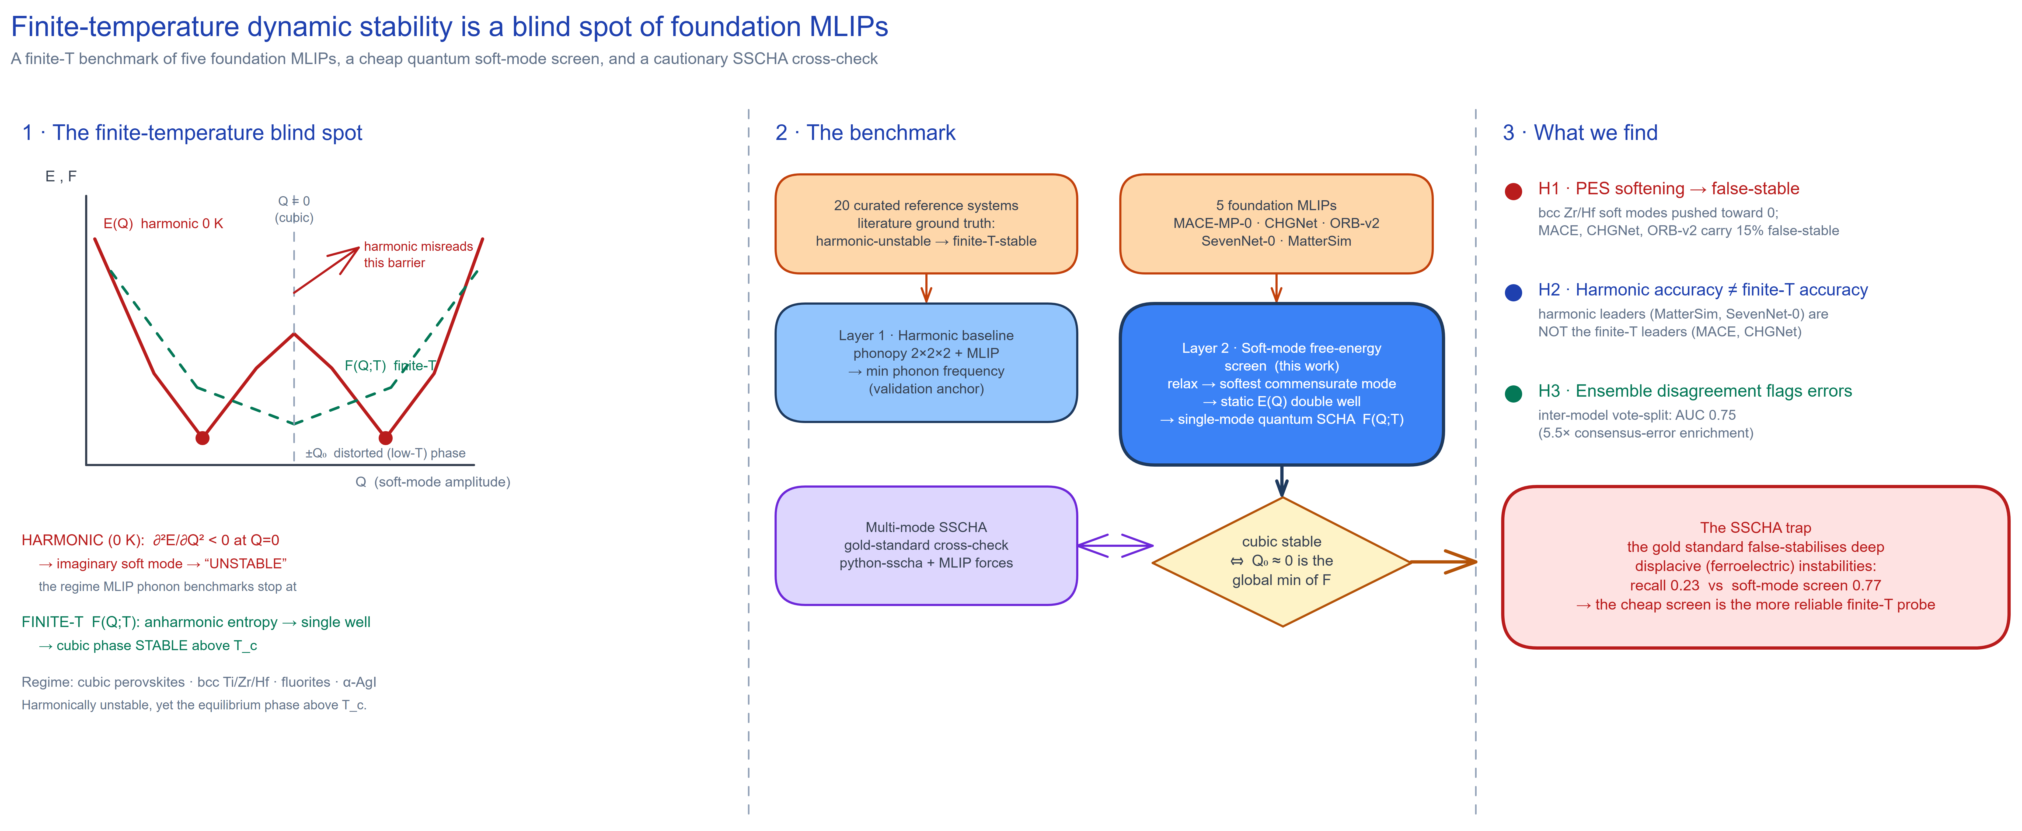
Figure 1 · Overview. Left — the finite-temperature blind spot. Along a soft mode the harmonic energy E(Q) is a double well; at the high-symmetry point Q=0 its curvature is negative (imaginary mode), so 0 K phonon benchmarks call the phase dynamically unstable, whereas the finite-temperature free energy F(Q;T) is a single well, so the cubic phase is in fact stable above T_c — the regime current MLIP phonon benchmarks stop short of. Middle — the benchmark. Twenty literature-curated reference systems and five foundation MLIPs feed a harmonic baseline (Layer 1, validation anchor) and the single-mode quantum soft-mode free-energy screen (Layer 2, this work; cubic stable ⇔ Q₀≈0 is the global minimum of F), cross-checked against multi-mode SSCHA. Right — findings. H1–H3 plus the SSCHA trap: the gold standard false-stabilises deep displacive instabilities (recall 0.23 vs the screen’s 0.77).
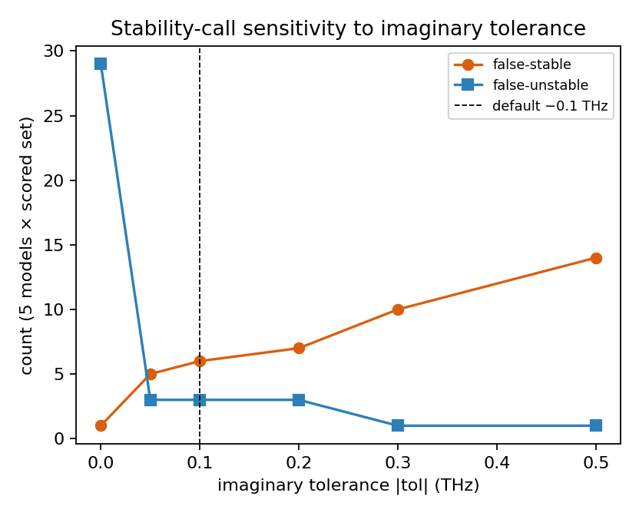
fig_tolerance_sweep — Harmonic false-stable and false-unstable call counts versus the imaginary-frequency tolerance (§3.1). The default −0.1 THz sits in the stable basin between the false-unstable flood at strict tolerance and the false-stable inflation at loose tolerance.
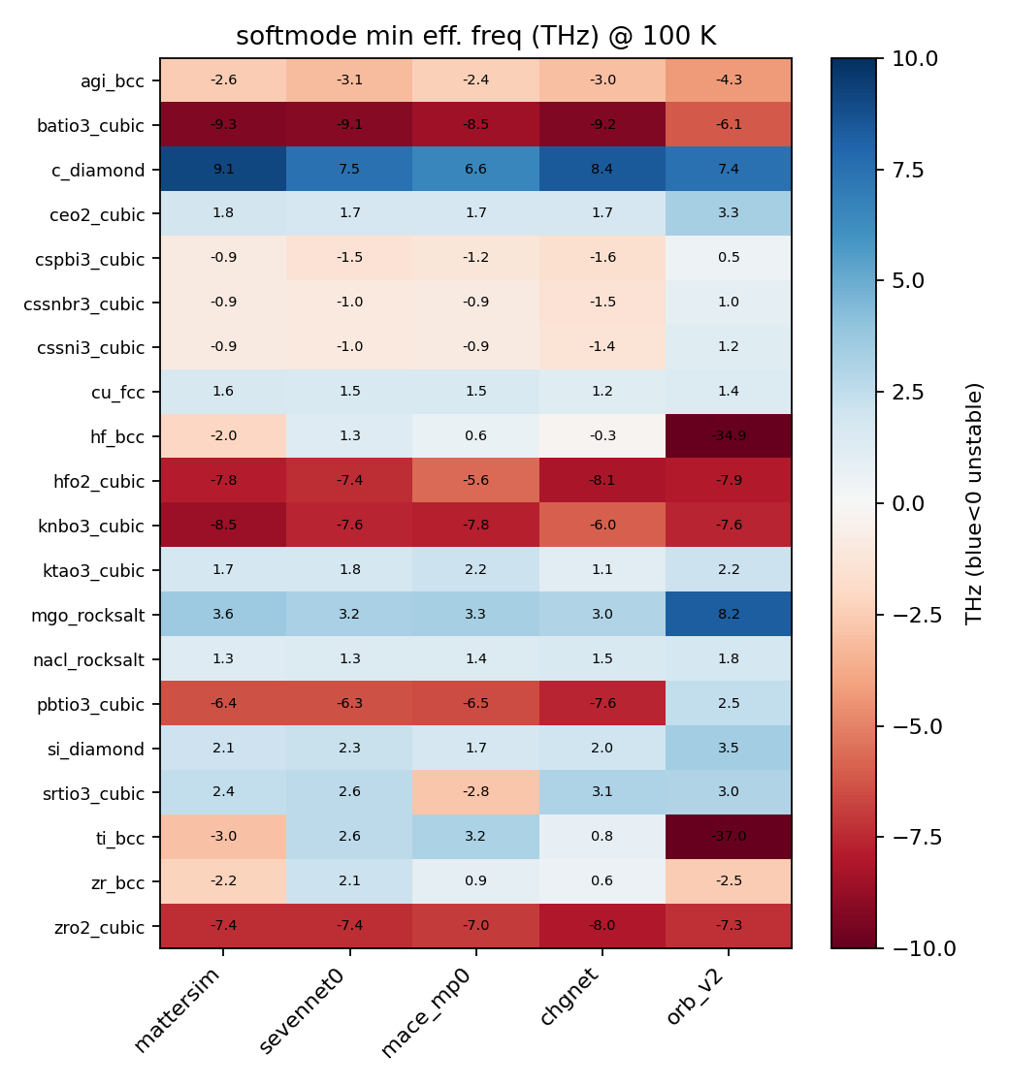
fig_softmode_heat — Per-system minimum effective frequency across the five models (§3.1–3.2). The “softening toward zero” of the harmonically-unstable systems is the physics; per-system minima, not binary rates, are the right reporting unit.
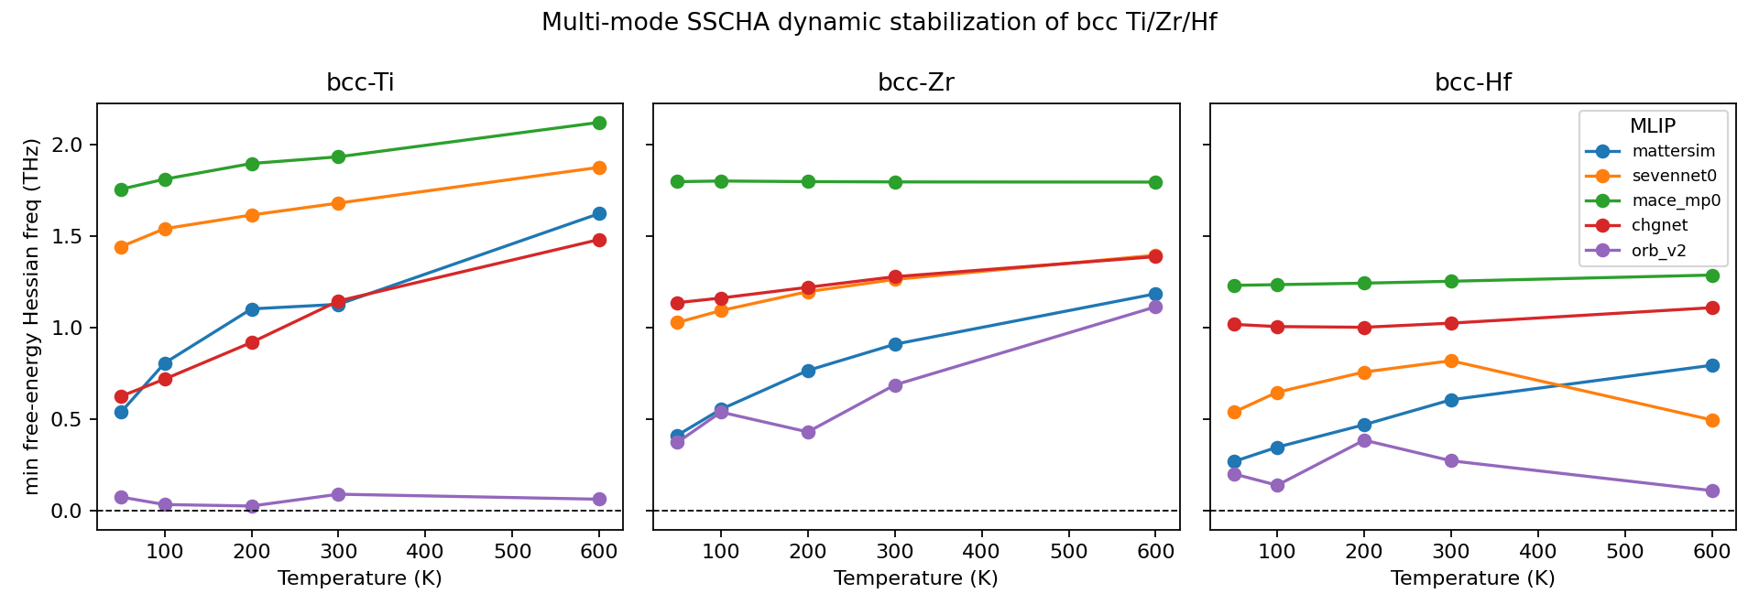
fig_sscha_bcc — Multi-mode SSCHA dynamic-stabilisation curves for bcc Ti/Zr/Hf, five models, versus temperature (§3.3). All models stabilise the bcc phase by ≤50 K; the margin to the stability boundary (MatterSim/ORB-v2 hugging ~0.4 THz, MACE-MP-0 firmly stable ~1.8 THz) discriminates the models.
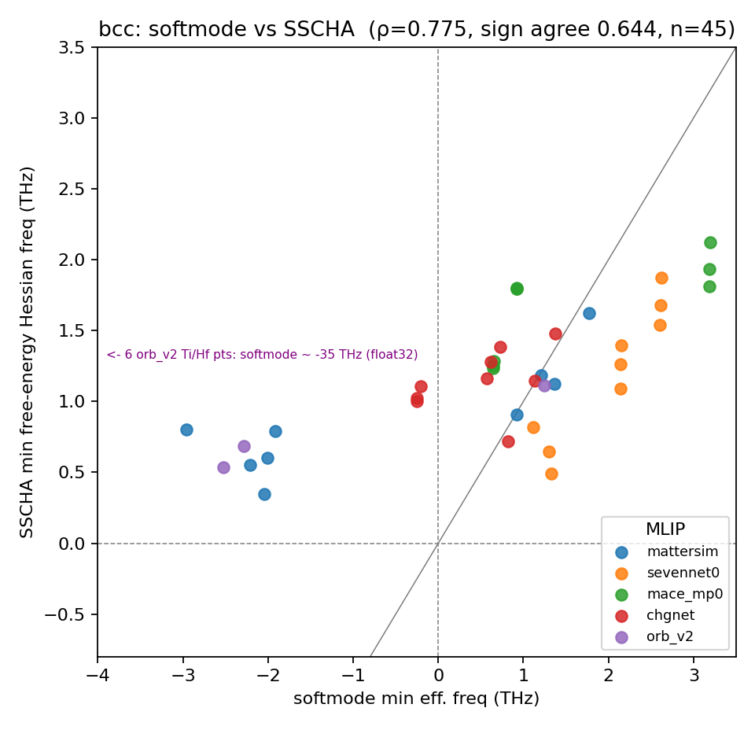
fig_method_agreement — Soft-mode screen vs gold-standard SSCHA minimum frequency on bcc (§3.3): the cheap screen tracks SSCHA on the family where the gold standard is trustworthy.
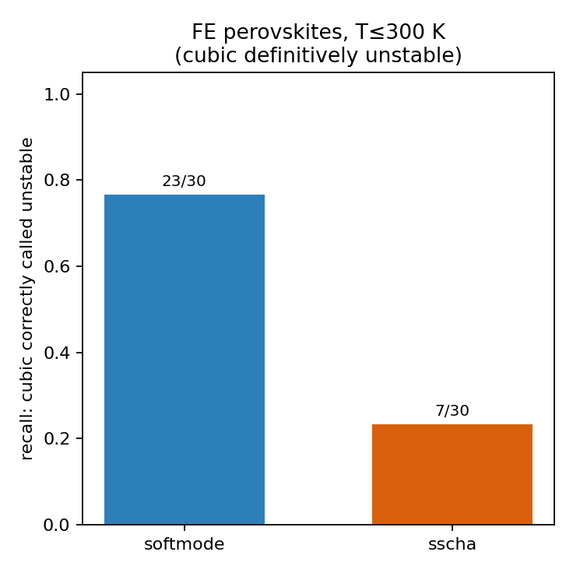
fig_displacive_recall — Recall of the displacive (ferroelectric-perovskite) instability at T ≤ 300 K: the cheap soft-mode screen (0.77) versus the expensive SSCHA (0.23) (§3.3). The cautionary result — the gold standard is less reliable than the screen in the regime that matters most.
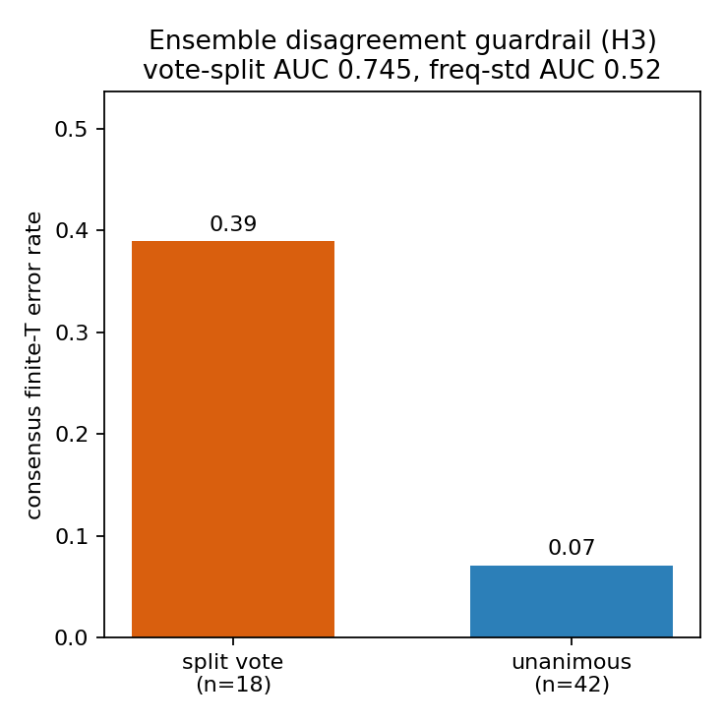
fig_ensemble_guardrail — Ensemble-disagreement guardrail (§3.4): the discrete inter-model vote split predicts consensus error (AUC 0.75) while the continuous cross-model frequency spread does not (AUC 0.52).

Data and code availability
The production results regenerate from results/ledger.parquet (per-unit hashed, resumable) and the finite-size runs from results/convergence_study.parquet. Figures via scripts/make_figures.py; analysis in mlip_dynstab/analysis.py; the SSCHA root-cause diagnostic in scripts/sscha_v4_diag.py; the stochastic-reproducibility study (§3.5) via scripts/sscha_repro.py (its per-seed frequencies print to the run log rather than to the ledger). Repository: github.com/fronkt/mlip-dynamic-stability.

References
Benchmarks and methods
- A. Loew, D. Sun, H.-C. Wang, S. Botti, M. A. L. Marques. Universal machine learning interatomic potentials are ready for phonons. npj Comput. Mater. 11, 178 (2025). doi:10.1038/s41524-025-01650-1. (arXiv:2412.16551)
- PhononBench: A Large-Scale Phonon-Based Benchmark for Dynamical Stability in Crystal Generation. arXiv:2512.21227 (2025).
- G. Petretto, S. Dwaraknath, H. P. C. Miranda, D. Winston, M. Giantomassi, M. J. van Setten, X. Gonze, K. A. Persson, G. Hautier, G.-M. Rignanese. High-throughput density-functional perturbation theory phonons for inorganic materials. Sci. Data 5, 180065 (2018). doi:10.1038/sdata.2018.65.
- L. Monacelli, R. Bianco, M. Cherubini, M. Calandra, I. Errea, F. Mauri. The stochastic self-consistent harmonic approximation: calculating vibrational properties of materials with full quantum and anharmonic effects. J. Phys.: Condens. Matter 33, 363001 (2021). doi:10.1088/1361-648X/ac066b.
- O. Hellman, I. A. Abrikosov, S. I. Simak. Lattice dynamics of anharmonic solids from first principles. Phys. Rev. B 84, 180301(R) (2011). doi:10.1103/PhysRevB.84.180301; O. Hellman, P. Steneteg, I. A. Abrikosov, S. I. Simak. Phys. Rev. B 87, 104111 (2013). doi:10.1103/PhysRevB.87.104111.
Foundation MLIPs benchmarked
- I. Batatia et al. A foundation model for atomistic materials chemistry (MACE-MP-0). arXiv:2401.00096 (2023).
- B. Deng, P. Zhong, K. Jun, et al. CHGNet as a pretrained universal neural network potential for charge-informed atomistic modelling. Nat. Mach. Intell. 5, 1031–1041 (2023). doi:10.1038/s42256-023-00716-3.
- M. Neumann, J. Gin, B. Rhodes, et al. Orb: A Fast, Scalable Neural Network Potential. arXiv:2410.22570 (2024).
- Y. Park, J. Kim, S. Hwang, S. Han. Scalable Parallel Algorithm for Graph Neural Network Interatomic Potentials in Molecular Dynamics Simulations (SevenNet). J. Chem. Theory Comput. 20, 4857–4868 (2024). doi:10.1021/acs.jctc.4c00190.
- H. Yang et al. MatterSim: A Deep Learning Atomistic Model Across Elements, Temperatures and Pressures. arXiv:2405.04967 (2024).
Per-system finite-T ground truth (the harmonic-unstable → thermally-stabilised labels)
- SrTiO₃ (antiferrodistortive R-point soft mode; cubic→I4/mcm at ≈105 K): T. Tadano, S. Tsuneyuki. Self-consistent phonon calculations of lattice dynamical properties in cubic SrTiO₃ with first-principles anharmonic force constants. Phys. Rev. B 92, 054301 (2015). doi:10.1103/PhysRevB.92.054301.
- BaTiO₃, KNbO₃, PbTiO₃ (Γ ferroelectric soft mode; displacive + order-disorder): W. Zhong, D. Vanderbilt, K. M. Rabe. Phase transitions in BaTiO₃ from first principles. Phys. Rev. Lett. 73, 1861 (1994). doi:10.1103/PhysRevLett.73.1861.
- CsPbI₃ (zone-boundary octahedral-tilt double wells; anharmonic cubic stabilisation): A. Marronnier et al. Anharmonicity and Disorder in the Black Phases of Cesium Lead Iodide. ACS Nano 12, 3477–3486 (2018). doi:10.1021/acsnano.8b00267.
- CsSnI₃, CsSnBr₃ (tilt transitions; quantum + anharmonic fluctuations stabilise the cubic phase): First-Principles Thermodynamics of CsSnI₃. Chem. Mater. (2023). doi:10.1021/acs.chemmater.2c03475. (arXiv:2301.10071)
- bcc Ti/Zr/Hf (phonon-entropy stabilisation; overdamped N and ⅔⟨111⟩ ω-precursor modes): W. Petry et al. Phonon dispersion of the bcc phase of group-IV metals. I. bcc titanium. Phys. Rev. B 43, 10933 (1991), doi:10.1103/PhysRevB.43.10933; A. Heiming et al. II. bcc zirconium. Phys. Rev. B 43, 10948 (1991), doi:10.1103/PhysRevB.43.10948.
- Cubic ZrO₂ / HfO₂ (X-point oxygen soft mode; anharmonic + entropic high-T stabilisation): K. Parlinski, Z. Q. Li, Y. Kawazoe. First-Principles Determination of the Soft Mode in Cubic ZrO₂. Phys. Rev. Lett. 78, 4063 (1997), doi:10.1103/PhysRevLett.78.4063; Exploring the High-Temperature Stabilization of Cubic Zirconia from Anharmonic Lattice Dynamics. Cryst. Growth Des. (2023), doi:10.1021/acs.cgd.2c01458.
- α-AgI (superionic; bcc iodine framework with molten Ag sublattice above ≈420 K, strong host anharmonicity): D. A. Wood, N. Marzari. Dynamical structure, bonding, and thermodynamics of the superionic sublattice in α-AgI. Phys. Rev. B 76, 134301 (2007). (arXiv:cond-mat/0603670)
- KTaO₃ (quantum paraelectric / incipient ferroelectric; soft TO mode held up by quantum fluctuations — basis for the borderline label): A. Ranalli et al. Temperature-Dependent Anharmonic Phonons in Quantum Paraelectric KTaO₃ by First Principles and Machine-Learned Force Fields. Adv. Quantum Technol. 6, 2200131 (2023). doi:10.1002/qute.202200131.
The harmonically-stable controls (Si, C, Cu, MgO, NaCl, CeO₂) have no imaginary modes at any temperature; their 0 K harmonic stability is documented in the DFPT phonon database [3].

