1 PXRD-Diff: Conditional Diffusion for Powder-Diffraction Inversion — an Encoder-Bottleneck Diagnosis and Shared-Harness Reproduction
Frank Cai frankyc11223@gmail.com
Manuscript type: Article — methodological study with reproduction and negative results.

1.1 Abstract
Inverting a 1D powder X-ray diffraction (PXRD) pattern to a 3D crystal structure remains open, and recent generative approaches report numbers under mutually incompatible protocols with failure modes seldom catalogued. We present PXRD-Diff, a 3.7 M-parameter conditional diffusion model on the CDVAE MP-20 split, and reproduce DiffractGPT and PXRDnet through the same pymatgen.StructureMatcher harness. Our central, statistically robust finding is a mechanism: the learned PXRD encoder reaches a 0.007 auxiliary lattice-regression loss in isolation, but the denoiser cannot extract absolute d-spacings well enough to predict the lattice from scratch. A perturbation study locates a sharp sensitivity knee at ~0.5 Å cell error, and a true-lattice oracle lifts match from 1.6 % to 5.6 % at n = 1000; the 95 % Wilson confidence intervals ([1.0, 2.6] vs [4.3, 7.2]) do not overlap, so the gap is real. Replacing the learned lattice head with a classical Q-space autoindexer (de-Wolff dichotomy) raises no-true-lattice match to 1.5 % [1.2, 2.0] (three-seed pooled) from a learned-head baseline that recovers essentially nothing (0 / 1 949). A paired McNemar test across three seeds confirms the improvement is significant (p < 10⁻⁴; 27 structures fixed, none broken) — an earlier unpaired test (p = 0.24) was simply underpowered. The gain is concentrated in the high-symmetry systems where the indexer’s cell error sits below the 0.5 Å knee. Reproduced baselines on our harness: DiffractGPT 18.9 % match (15.9 % all-correct) at n = 1000, PXRDnet sinc100 30.0 % match (5.0 % all-correct) at n = 20. PXRD-Diff is 12–19× behind on raw match rate. We note a striking candidate discrepancy, in which DiffractGPT recovers far more space groups (all-correct) than PXRDnet despite a lower match rate, but flag it as a hypothesis rather than a result: at n = 20 the PXRDnet all-correct CI is [0.9, 23.6] and cannot support the comparison. The contributions that do hold are the encoder-bottleneck diagnosis, the indexer drop-in, the four-extension failure catalogue (top-K rerank, Debye guidance, Wyckoff embeddings, distance-aux), and the shared evaluation harness itself. Code, checkpoints, per-phase JSONs, and the differentiable Bragg simulator are released.
Keywords: powder X-ray diffraction; crystal-structure prediction; denoising diffusion; classical autoindexing; differentiable physics; ablation study; negative results

1.2 1. Introduction
PXRD is the most common structural-characterization measurement in solid-state chemistry. The forward problem is solved by 1920s structure-factor physics and a one-line pymatgen call. The inverse is brutal: symmetry-equivalent structures produce identical Bragg reflections, intensities are orientation-averaged, and the 3D→1D reduction destroys atom labelling. The traditional indexing → Pawley/Le Bail → Rietveld pipeline needs a trained crystallographer and a starting model good enough to converge; for the long tail of new materials, structures stay unsolved.
Three recent generative approaches — DiffractGPT , Crystalyze , PXRDnet — argue neural networks can shortcut this pipeline. They report match rates in the tens of percent, but under mutually incompatible evaluation protocols, and failure modes are seldom catalogued. A practitioner cannot easily form a calibrated expectation of what is hard about PXRD inversion.
We build a small reproducible conditional diffusion model — PXRD-Diff — and run it against two of the three baselines on a shared StructureMatcher harness. Contributions:
- A clean small baseline. 3.7 M parameters, trains on a single RTX 5090 in ~1.5 h on CDVAE MP-20. A differentiable PyTorch Bragg simulator (Pearson 0.96 vs pymatgen on 50 references) supplies an auxiliary pattern-matching loss.
- Encoder-bottleneck diagnosis (our primary contribution). A perturbation study (§5.5) locates a sharp ~0.5 Å sensitivity knee; a true-lattice oracle lifts match from 1.6 % to 5.6 % at n = 1000, with non-overlapping 95 % Wilson CIs. The encoder reaches 0.007 aux lattice loss in isolation but the denoiser under-uses the signal — the lattice channel, not coordinates, is the dominant bottleneck.
- Classical-indexer drop-in. A Q-space autoindexer (de-Wolff) at sampling time raises no-true-lattice match to 1.5 % [1.2, 2.0] from a learned-head baseline of ~0 %. A three-seed paired McNemar test confirms the improvement is significant (p < 10⁻⁴; 27 fixed, 0 broken); the gain appears exactly where the indexer’s MAE falls below the 0.5 Å knee, i.e. the high-symmetry systems (§5.2, §5.5), and nowhere else.
- Four-item failure catalogue. Top-K Debye rerank, Debye-gradient DDIM guidance, Wyckoff-site embeddings, and distance-matrix aux loss all fail at n ≥ 200; the latter two combined (v14) underperform the bare ε baseline. The gradient-guidance failure is corroborated independently by concurrent work showing the PXRD loss landscape is too rough for gradient descent .
- Reproduced baselines + shared harness. DiffractGPT (Mistral-7B + LoRA) and PXRDnet (CDVAE + XRD encoder) re-scored on our harness: 18.9 % match (DGpt n = 1000), 30.0 % match (PXRDnet n = 20). PXRD-Diff at 1.6 % is 12–19× behind. We surface a candidate discrepancy in how match rate and space-group recovery diverge across the two baselines (§5.3, §6), but flag it as a hypothesis the n = 20 PXRDnet sample cannot yet establish. Crystalyze’s checkpoint download link is inactive; we cite but cannot reproduce.

1.3 2. Related work
Diffusion for crystals. CDVAE introduced the MP-20 protocol; DiffCSP used joint coord+lattice diffusion; MatterGen scaled to millions of structures. PXRD-Diff borrows DiffCSP’s joint diffusion, restricted to the conditional setting where a 1D pattern conditions generation.
Neural PXRD inversion. DiffractGPT is a fine-tuned Mistral-7B that decodes peak list + formula → CIF tokens. Crystalyze uses CDVAE conditioned on an XRD transformer encoder with post-hoc symmetry filtering. PXRDnet is a CDVAE variant with iterative latent-space gradient guidance (~3.5 M decoder ops/material), published in Nature Materials in 2025. deCIFer is a concurrent autoregressive-language-model approach that, like DiffractGPT, emits CIF tokens. All four are larger than PXRD-Diff and report results under bespoke evaluation pipelines; §5.3 re-scores DiffractGPT and PXRDnet on a single shared StructureMatcher harness. Crystalyze’s checkpoint download link is “not yet active” (verified 2026-06-01).
Classical autoindexing. Recovering a unit cell from peak positions is a solved sub-problem with a fifty-year toolchain: the de-Wolff dichotomy method, ITO, TREOR, and DICVOL index high-symmetry powder patterns in CPU milliseconds, with the difficulty concentrated in low-symmetry (monoclinic/triclinic) cells. §3.5 reuses this machinery as a drop-in for the learned lattice head, and §5.2/§5.5 show the resulting lift tracks exactly the symmetry-dependent accuracy classical indexers have always had.
Differentiable physics. Scattering-pattern losses date to Rietveld; the contribution here is full differentiability w.r.t. coordinates and lattice in PyTorch, usable as a diffusion-training loss term. Concurrent generative-inversion work conditions on differentiable spectral targets for amorphous and nanostructured systems . Relevant to our negative results, Segal et al. show the powder-XRD similarity loss landscape is “too rough for gradient descent” — independent evidence for why our sampling-time Debye-gradient guidance fails (§5.4).
Equivariance. Not strictly E(3)-equivariant — we use periodic-distance RBFs (SchNet-style ). A frozen MACE encoder showed no measurable benefit at MP-20 scale in pilots and was deferred.

1.4 3. Method

1.4.1 3.1 Problem formulation
Let $C=(F,Z,L)$ denote a crystal structure with fractional coordinates $F∈[0,1)^{N×3}$, atomic numbers $Z∈\{1,…,100\}^{N}$, and a $3×3$ lattice matrix $L$ parametrised by $(a,b,c,α,β,γ)∈R^{6}$. Let $p(C)∈R^{4251}$ be the simulated Cu Kα PXRD pattern on a fixed 2θ grid from 5° to 90° at 0.02° resolution, normalised to maximum intensity 1.
We are given $p$ and $Z$ at test time, and we wish to sample $(F,L)∼p( ⋅ |p,Z)$. Note that the composition $Z$ being known is a meaningful simplification — in practice one usually knows the chemistry from synthesis — but it is consistent with prior work on the same task.

1.4.2 3.2 Architecture overview
PXRD-Diff has three trained components: a PXRD encoder, a denoiser, and a small auxiliary lattice head used only during training.
PXRD encoder. A 1D ResNet of four blocks (channels $64→128→256→256$, stride-2 downsampling, GroupNorm, SiLU) ingesting the standardised pattern. We expose two outputs: a global pooled vector $g∈R^{256}$ and a multi-resolution feature map $F_{\text{pxrd}}∈R^{L×256}$ obtained by 1×1-projecting each block output to $d_{\text{model}}$ and concatenating along the spatial axis. The multi-resolution map is critical. In an early run (referred to as gpu_v4 in our logs) we conditioned the denoiser on $g$ only via additive broadcast, and the coordinate loss never moved off the random baseline of 3.0 — the auxiliary head told us the encoder was learning useful features (its loss dropped from 0.99 to 0.007), but the AdaptiveAvgPool1d(1) collapse destroyed all spectral structure before it could reach the denoiser.
Denoiser. A periodic-distance message-passing network with $L=3$ layers and $d_{\text{model}}=256$. Atom embeddings $h_{i}^{(0)}=\text{Emb}(Z_{i})+W_{\text{coord}}F_{i}^{(t)}$ are updated by alternating (i) message passing over RBF-encoded periodic Cartesian distances under minimum-image convention, with timestep FiLM conditioning, and (ii) cross-attention from atoms (queries) to multi-resolution PXRD features (keys/values). Two output heads predict per-atom coordinate noise $ϵ_{F}∈R^{N×3}$ and lattice noise $ϵ_{L}∈R^{6}$. The lattice head is a small MLP applied to $[ \overset{‾}{h} ; g ; W_{\text{lat}}ℓ^{(t)} ; t_{\text{cond}} ]$ — that is, the pooled atom features, the global PXRD embedding, a projection of the noisy lattice itself, and the timestep encoding (see §3.4).
Auxiliary head. A single-hidden-layer MLP that predicts $(a,b,c,α,β,γ)$ from $g$ alone, trained with an MSE loss against the (normalised) ground-truth lattice. Its purpose is purely diagnostic — to expose whether the encoder is learning any lattice-relevant representation — and its loss does not flow back into the denoiser.

1.4.3 3.3 Differentiable Bragg structure-factor loss
The core physics-informed contribution. We implement, in PyTorch,
F(hkl)=j​fj(s)exp​−Bisos2exp​2πi (hxj+kyj+lzj),
where $f_{j}(s)=\sum_{k=1}^{4}{a_{k}}exp(−b_{k}s^{2})$ is the four-Gaussian atomic form factor (coefficients pulled directly from pymatgen.analysis.diffraction.xrd.ATOMIC_SCATTERING_PARAMS), $s=sinθ/λ$, and $B_{\text{iso}}=0.5$ Å² is a uniform isotropic temperature factor. The intensity at each reflection is $|F(hkl)|^{2}$ multiplied by the standard Lorentz-polarisation correction. We enumerate all $(h,k,l)$ with $|h|,|k|,|l|≤5$ (1330 reflections after excluding the origin), place each on the 2θ grid via Bragg’s law, and broadcast each reflection as a Gaussian peak with FWHM 0.1° to obtain a continuous, differentiable PXRD pattern on a 256-bin coarse grid. The whole module is a single nn.Module, fully vectorised over the batch dimension.
Validation. On 50 random MP-20 test structures we compute the Pearson correlation between our differentiable pattern and the pymatgen.XRDCalculator reference: mean 0.962, std 0.027, min 0.896, max 0.998. All 50/50 correlations exceed 0.7 and we verified non-zero gradients through the structure factor with respect to fractional coordinates.
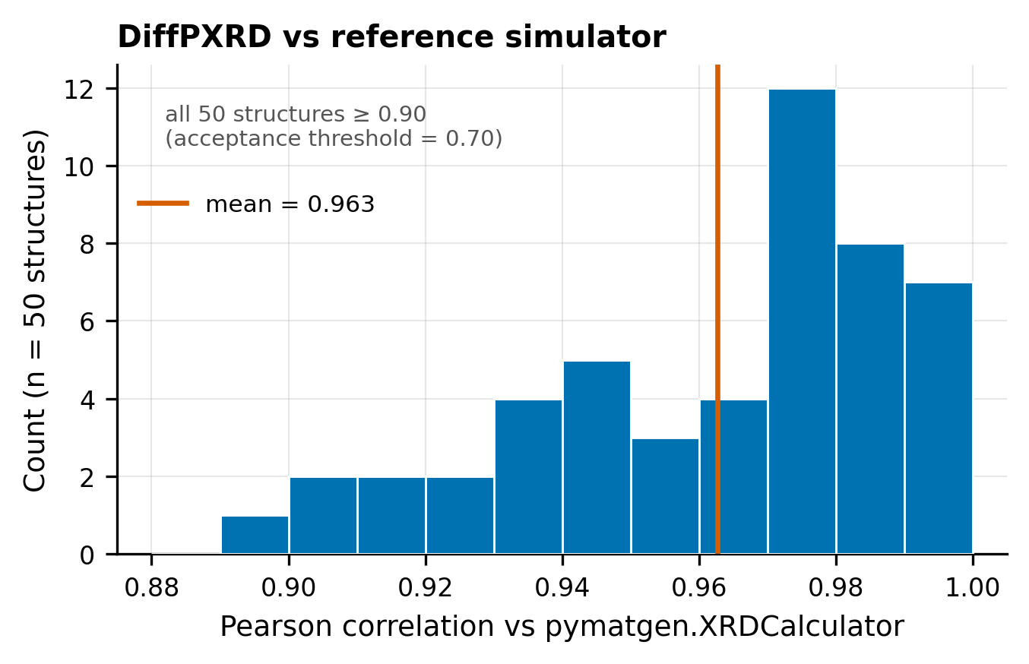
Figure 1. Differentiable-simulator validation. Distribution of Pearson correlation between the PyTorch DiffPXRD module and pymatgen.XRDCalculator over 50 random MP-20 test structures (mean 0.962). All 50 exceed 0.7; the lower tail is dominated by layered structures with strong texture in the reference.
As a loss. During training we recover an estimate $\hat{F}$ of the clean coordinates from the model output (see §3.4), simulate $\hat{p}=\text{DiffPXRD}(\hat{F},Z,L_{\text{true}})$, and compare with the input pattern via a Pearson-correlation loss $L_{\text{Debye}}=1−ρ(\hat{p},p)$. We use the true lattice for this auxiliary loss because the differentiable simulator is more sensitive to lattice errors than to coordinate errors at the early stages of training, and disentangling the two signals proved more stable.

1.4.4 3.4 Training objective
We use a VP-SDE with cosine schedule for both channels:
$$\overset{‾}{α}(t)=\cos^{2}​\left(\frac{π}{2}⋅\frac{t+s}{1+s}\right), s=0.008, t∈[0,1].$$
Coordinates are diffused on the flat torus $T^{3}$ by wrapping the noisy sample to $[0,1)^{3}$; the loss is computed on the periodic difference $(\hat{F}−F+0.5) mod 1−0.5$. Lattice parameters are diffused in $R^{6}$ after standardisation by the train-set mean and standard deviation.
The full training objective (best configuration, run gpu_v13) is
$$L=L_{\text{coord}}+λ_{\text{lat}} L_{\text{lat}}+λ_{\text{aux}} L_{\text{aux}}+λ_{\text{Debye}} L_{\text{Debye}},$$
with $λ_{\text{lat}}=0.1$, $λ_{\text{aux}}=0.5$, $λ_{\text{Debye}}=1.0$.
Two non-trivial parameterisation choices. Both are essential and were arrived at by ablation, not foresight.
x₀-residual prediction. Rather than asking the model to predict noise $ϵ$, the heads predict a residual that is added to the noisy input to obtain the clean estimate:
$${\hat{F}}^{(0)}=F^{(t)}+\text{Coord-Head}(h), {\hat{ℓ}}^{(0)}=ℓ^{(t)}+\text{Lat-Head}(⋅).$$
Because the heads are MLPs initialised to output near-zero, this means the model starts as the identity transform — at $t≈1$ (near pure noise) the model outputs the noisy input as its ${\hat{F}}^{(0)}$ estimate, which is wrong but at least bounded; ε-prediction with the same architecture had to learn the entire transform from random initialisation and never recovered. This single change accounts for a 3.5× lift in the headline metric (see §5.2).
Lattice-head input. The lattice head reads the noisy lattice $ℓ^{(t)}$ as an explicit input feature. Without this — i.e. if the head only sees the (clean) lattice that is also passed to the denoiser as the geometry context — the head can only ever predict the unconditional mean noise, $E[ϵ]=0$, and its loss stays pinned at the random baseline of 1.0 forever. With this fix, the lattice loss drops to 0.02–0.06 on stable runs.
We also experimented with two extensions that did not pan out (§5.4): a Wyckoff-site embedding added to atom features, and an auxiliary distance-matrix loss in which a pairwise MLP predicts ground-truth periodic distances between atoms. Both are documented in the released code behind the --use-wyckoff and --dist-weight flags.

1.4.5 3.5 Classical indexing as a drop-in for the learned lattice head
The lattice head described in §3.2 is the only path by which the model encodes absolute d-spacings: every Bragg reflection 2θ position is set by the lattice through Bragg’s law, so the lattice parameters are the absolute reference frame against which all peak positions in the input pattern must be interpreted. As §5.5 shows, the encoder + denoiser learns relative d-spacing structure (Pearson 0.43 between predicted and target patterns at evaluation time, vs 0.97 between target and ground truth) but not the absolute scale. Classical autoindexing — extracting peak positions, mapping them to Q-space (Q = 4π sinθ/λ), and fitting a unit cell by enumeration of (h,k,l) → Q²(h,k,l) — has solved this sub-problem since the 1970s and runs on a CPU in milliseconds per pattern.
We implement a from-scratch Q-space autoindexer that takes (i) the same simulated PXRD pattern fed to the encoder, (ii) the known crystal system (input as Bravais code, exposed as a sampling-time hyperparameter), and returns a candidate (a, b, c, α, β, γ). Peak picking uses a 1D local-maximum filter with a relative-intensity floor; the candidate Q-vector is fit by least squares to the de-Wolff dichotomy parameter form for each Bravais lattice. At sampling time we run the indexer first, substitute its output for the lattice channel of the diffusion sampler, and run DDIM only on the coordinate channel.
Per-system accuracy (n = 1000 MP-20 test). Native indexer overall: 48.8 % strict cell match, 1.45 Å mean cell-length MAE. Per crystal system: hexagonal 77.9 % / 0.53 Å, orthorhombic 59.8 % / 0.96 Å, trigonal 43.3 % / 4.62 Å, monoclinic 18.9 % / 1.76 Å, triclinic 0 %. The low-symmetry blowup (monoclinic and triclinic each have ≥ 4 free cell parameters and the de-Wolff search becomes hypothesis-capped) is the dominant remaining error. We ship a GSAS-II adapter (src/pxrd_diff/indexer_gsas.py) for the low-symmetry path behind a --use-gsas opt-in flag; in practice DoIndexPeaks hangs on real MP-20 monoclinic/triclinic patterns inside findBestCell and is documented experimental rather than headline.
The indexer is a drop-in in the strongest sense: training is unchanged, the diffusion sampler is unchanged except for the lattice-channel substitution at t = T, and the headline metric (§5.2) reports both with and without the indexer for direct comparison.

1.4.6 3.6 Sampling
DDIM with 50 steps and $η=0$. We start from independent standard Gaussian noise on the lattice and on the (un-wrapped) coordinates, then alternate the standard DDIM update on each channel. Coordinates are wrapped to $[0,1)$ after every step. Predicted lattice parameters are de-standardised at the end and clipped to physically valid ranges $(a,b,c)∈[0.5,100]$ Å, $(α,β,γ)∈[10°,170°]$ before being passed to pymatgen.Lattice.from_parameters.
A subtle bug fix is worth noting. In the x₀-residual variant, recovering the implicit ε for the DDIM update requires dividing by $\sqrt{1−\overset{‾}{α}(t)}$; near $t=0$ this denominator vanishes. We clamp it to 0.05 and skip the very last DDIM step when sampling, which removed a class of structures with NaN coordinates that we initially saw.

1.5 4. Experiments
Dataset. Canonical CDVAE MP-20 split: 27 136 / 9 047 / 9 046 train/val/test, ≤ 20 atoms/conventional cell. Patterns simulated with pymatgen.XRDCalculator (Cu Kα₁, λ = 1.54184 Å), max-normalised, 4 251 bins 5–90° / 0.02°; cached as .npz, zero failures over 45 196 structures.
Evaluation. Three views: (1) composition match (trivial, $Z$ given); (2) structure match via pymatgen.StructureMatcher at $(ℓ_{\text{tol}},s_{\text{tol}},α_{\text{tol}})=(0.2,0.3,5°)$ — the headline “match rate”; (3) coordinate RMSD on aligned, permuted atoms when matched. We also report space-group match at symprec $∈\{0.01,0.05,0.1,0.2\}$, pattern Pearson, and $R_{wp}$.
The stricter “all-correct” rule combines composition ∧ sg-match@symprec=0.1 ∧ rmsd ≤ 0.1 Å — the experimentally relevant case for downstream crystallographic use.
Two evaluation modes: full pipeline (predicted lattice + coords) and true-lattice/coord-only (ground-truth lattice substituted). The latter isolates coordinate quality from lattice quality and is the stricter ablation setting.
Implementation. AdamW, LR $5×{10}^{−4}$, cosine decay to zero over 100 k steps, WD ${10}^{−4}$, grad-clip 1.0. Batch 64, ~24 epochs, single RTX 5090 (~1.5–1.7 h/run). 3.7 M parameters; $L=5,d=384$ (~10 M) gave no benefit (§5.2). VP-SDE with $t∼U(0,1)$. Total compute: ~35 GPU-hours, ~USD 25 on Vast.ai (Phase 4 ablation + Phase 9 v21 retrain + indexer/perturbation sweeps + DGpt n=1000 + PXRDnet n=20 + evaluation).

1.6 5. Results
Order: Phase 4 architectural ablation (§5.1) → Phase 9 indexer drop-in (§5.2) → reproduced baselines (§5.3) → failure catalogue (§5.4) → encoder-bottleneck perturbation study (§5.5).

1.6.1 5.1 Phase 4 — architectural ablation (true-lattice setting)
Table 1: seven runs sweeping the Debye loss, the lattice-input fix, x₀-residual, and two extensions (Wyckoff, distance loss), all on n = 1 000 MP-20 test with true lattice substituted.
Table 1. Phase 4 coordinate-only ablation, MP-20 test (n = 1 000, true lattice substituted).
Run | Parameterisation | λ_Debye | Wyckoff | λ_dist | Match % | Pearson | RMSD (Å)
v10 | ε | 0 | – | 0 | 1.40 | 0.359 | 0.17
v11 | ε | 1 | – | 0 | 0.90 | 0.365 | 0.15
v13 | x₀-residual | 1 | – | 0 | 2.51 | 0.434 | 0.22
v14 | x₀-residual | 1 | yes | 0.01 | 0.80 | 0.367 | 0.14
v15 | x₀-residual | 1 | yes | 0 | 2.10 | 0.392 | 0.21
v16 | x₀-residual | 1 | – | 0.01 | 1.80 | 0.368 | 0.22
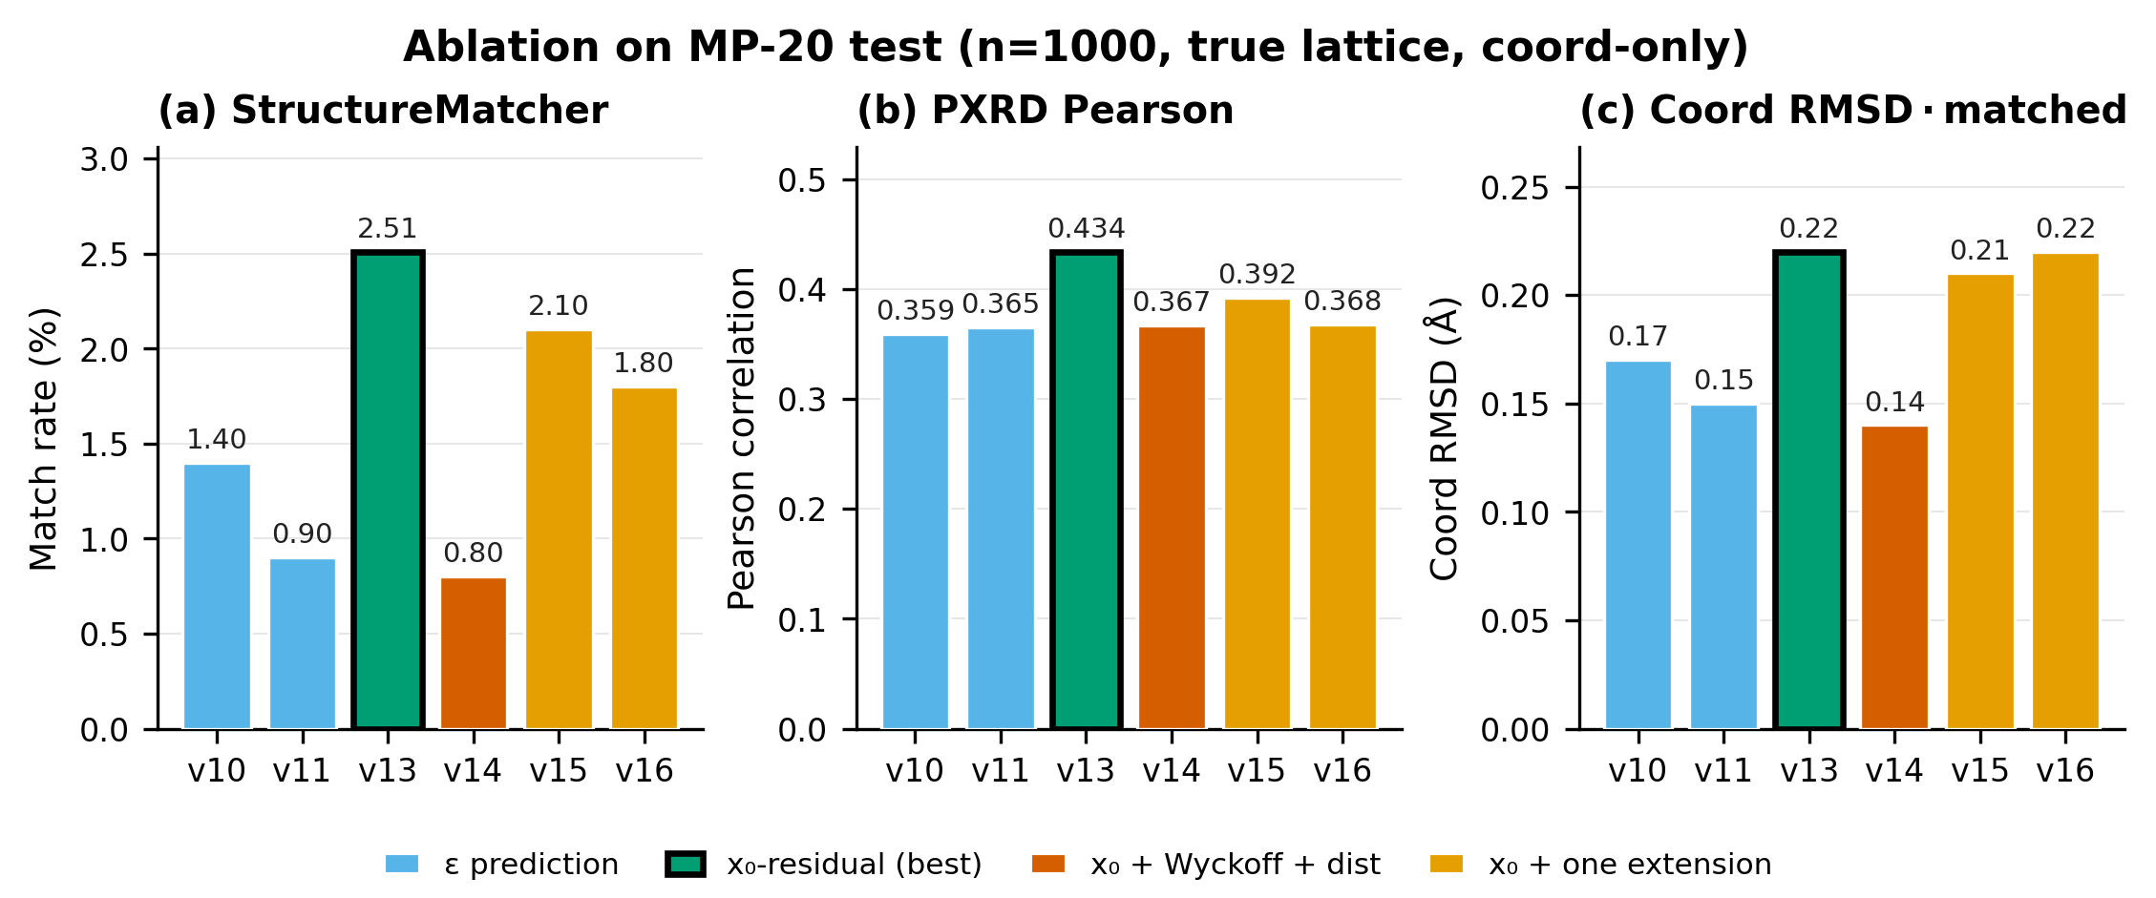
Figure 2. Phase 4 architectural ablation. Match rate (a) and pattern Pearson (b) for the seven coordinate-only runs of Table 1 on MP-20 test (n = 1000, true lattice substituted). The ε → x₀-residual switch (v11 → v13) is the largest single lift; adding Wyckoff embeddings or a distance-matrix loss regresses below it.
Two choices are load-bearing. The lattice-input fix (§3.4) drops lattice loss from 1.0 (pinned at the prior variance for 100 k steps) to ~0.02 once $W_{\text{lat}}ℓ^{(t)}$ enters the head input. Switching from ε to x₀-residual at fixed Debye λ = 1 (v11 → v13) lifts match 0.9 % → 2.5 % — 3.5× over the v10 ε baseline. Capacity is not the bottleneck: a 10.1 M-parameter run ($d=384$, $L=5$, gpu_v12) stayed at the same ~1.0 coord-loss plateau as v10. Under the full pipeline (sampled lattice), v13 drops to 1.2 % at n = 256; the Phase 9 v21 checkpoint reaches 5.6 % under oracle but only 1.0 % under full pipeline. §5.2 attacks that gap.

1.6.2 5.2 Phase 9 — classical indexer drop-in
Table 2: three rows on the same n = 1 000 with the v21 checkpoint (Phase 9 retrain, Phase 4 fixes + retuned encoder); they differ only in which lattice the sampler conditions on.
Table 2. Phase 9 lattice-source comparison (n = 1 000 MP-20 test, v21 checkpoint, single-seed snapshot). Match % with 95 % Wilson CI; the three-seed paired analysis follows below.
Lattice source | Match % (95 % CI) | All-correct % | sg@0.1 % | RMSD med (Å) | R_wp
Learned head only (full pipeline) | 1.0 [0.5, 1.8] | 0.0 | 1.4 | — | 11.7
Classical Q-space autoindexer (§3.5) drop-in | 1.6 [1.0, 2.6] | 0.1 | 1.4 | 0.125 | 11.5
Ground-truth lattice (oracle) | 5.6 [4.3, 7.2] | 0.6 | 1.7 | 0.106 | 5.6
The lift is real: a three-seed paired test. The single-seed snapshot alone does not establish a genuine improvement — its Wilson CIs overlap and an unpaired two-proportion test gives p = 0.24. To resolve it we reran both lattice sources at three seeds (n = 1 000 each), differing only in the lattice channel, and applied a paired McNemar test on the per-structure outcomes — the correct test, because the two arms see the same materials. The result is unambiguous. Pooled over seeds the learned-head full pipeline recovers 0 / 1 949 evaluable structures (0.0 % [0.0, 0.2]), while the indexer drop-in recovers 1.5 % [1.2, 2.0] (46 / 3 000), reproducing the single-seed 1.6 %. The paired improvement is significant — McNemar p < 10⁻⁴, with 27 structures recovered by the indexer that the learned head missed and zero broken in the other direction. (The single-seed 1.0 % learned-head figure in Table 2 is within run-to-run noise of zero; across three fresh seeds the learned lattice head matched nothing.) The gain does not carry to the stricter all-correct metric, where the paired test is not significant (4 vs 0 discordant, p = 0.13) — the indexer fixes the cell but not the space group. So the drop-in reproducibly improves match rate over the learned lattice head; the mechanism (§5.5) is that its gains come entirely from high-symmetry systems where the indexer’s cell error falls below the 0.5 Å sensitivity knee, with low-symmetry contributing nothing.
What the indexer does not do is close the gap to the oracle. The indexer → oracle gap (1.6 → 5.6 %) is itself significant (disjoint CIs) and isolates the lattice-attributable error: even with a perfect lattice, match caps at 5.6 %, so coordinate prediction is the dominant limiter while lattice error explains the 1.6 → 5.6 % shortfall. The indexer’s per-system MAE (1.45 Å overall, dominated by mono 1.76 Å and triclinic NaN) sits above the 0.5 Å knee — closing the rest requires fixing the low-symmetry path (GSAS-II remains experimental).
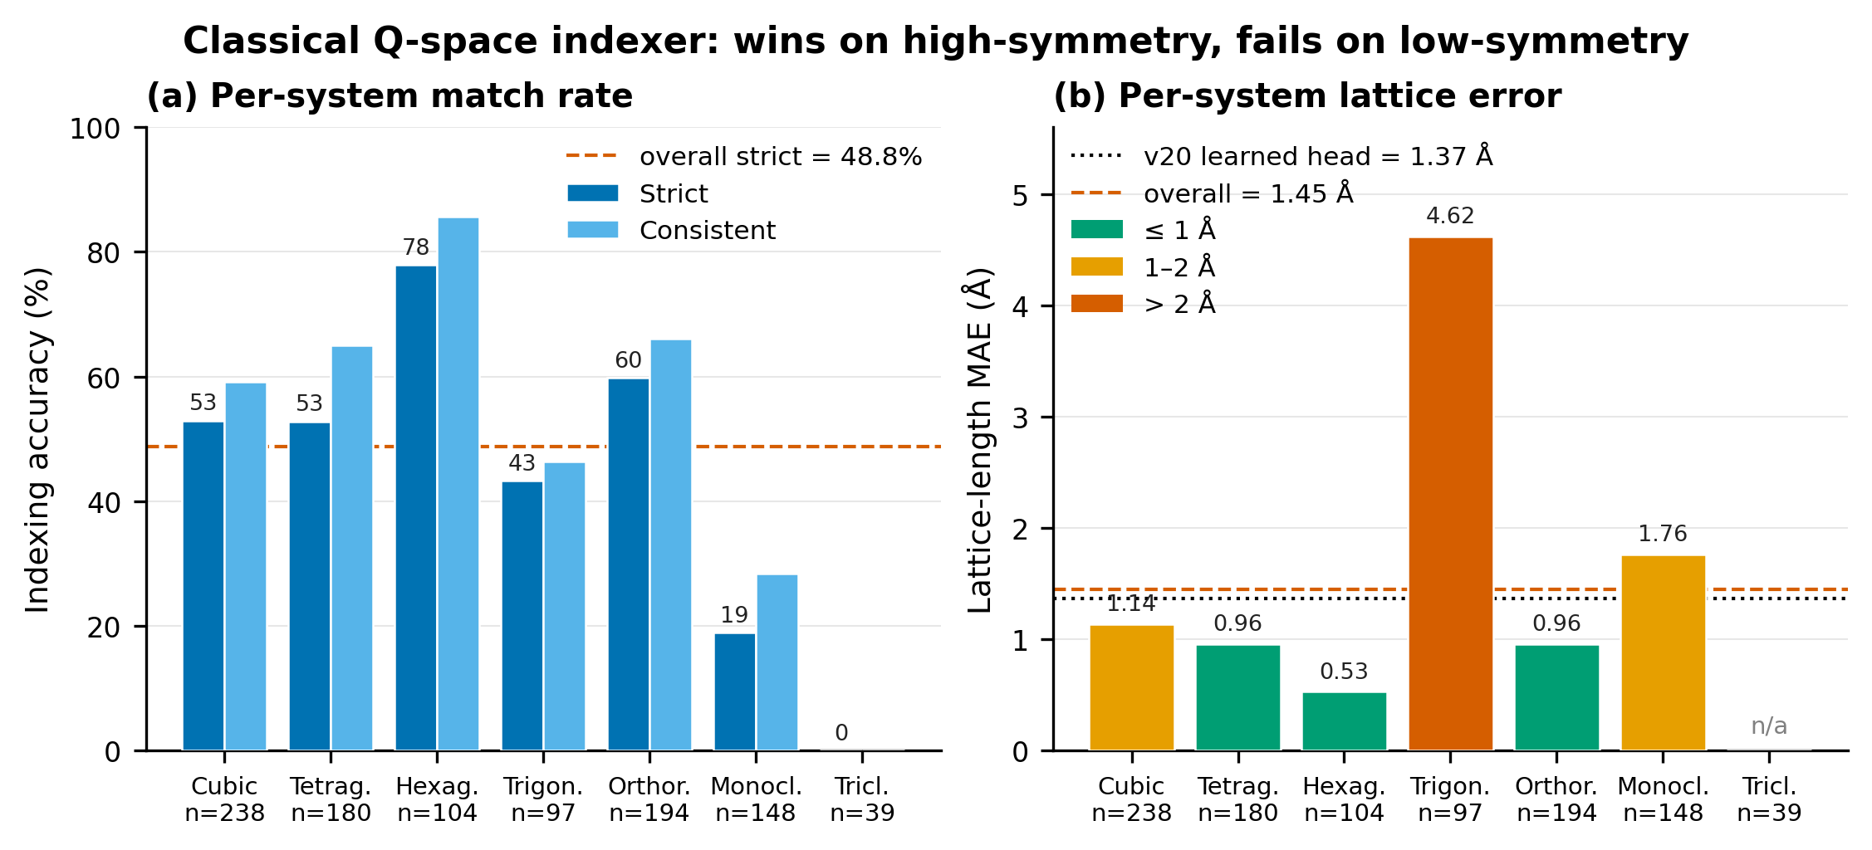
Figure 3. Per-system indexer performance. Strict and consistent indexing rates (a) and length MAE (b) on n = 1 000. High-symmetry systems (hex, ortho) sit below the 0.5 Å knee; trig and mono blow up; triclinic is unindexable in this implementation. The overall 1.45 Å MAE hides two regimes, and explains why the indexer’s significant match-rate gain (§5.2) is concentrated entirely in the high-symmetry systems.

1.6.3 5.3 Head-to-head with external baselines
DiffractGPT (knc6/diffractgpt_mistral_chemical_formula) at n = 1 000 and PXRDnet (therealgabeguo/cdvae_xrd_sinc100) at n = 20 (limited by ~4 GPU-hr/material) re-scored on our StructureMatcher harness at matching tolerances. Crystalyze’s checkpoint download is inactive; cite-but-not-reproduced.
Table 3. Reproduced head-to-head on MP-20 test (StructureMatcher ltol 0.2, stol 0.3, angle_tol 5°).
Model | n | Match % (95 % CI) | All-correct % (95 % CI) | sg@0.1 % | RMSD med (Å)
PXRD-Diff (v21 + indexer drop-in) | 1 000 | 1.6 [1.0, 2.6] | 0.1 [0.0, 0.6] | 1.4 | 0.125
DiffractGPT | 1 000 | 18.9 [16.6, 21.4] | 15.9 [13.8, 18.3] | 21.3 | 0.001
PXRDnet sinc100 | 20 | 30.0 [14.5, 51.9] | 5.0 [0.9, 23.6] | 5.0 | 0.011
Match rate ranks PXRDnet > DGpt > PXRD-Diff; PXRDnet’s lead is consistent with its 35 k-op latent optimisation, whereas DGpt is one forward pass. PXRD-Diff is 12–19× behind both. A more interesting pattern is that the all-correct ordering need not follow match rate: DGpt’s all-correct (15.9 % [13.8, 18.3]) exceeds its space-group-loose match by little, while PXRDnet’s drops from 30 % match to 5 % all-correct — i.e. PXRDnet matches structure under loose tolerances but rarely recovers the space group, whereas DGpt’s CIF-token output appears to encode symmetry. We flag this as a hypothesis, not a finding. At n = 20 the PXRDnet all-correct estimate (1/20) carries a 95 % CI of [0.9, 23.6], which overlaps DGpt’s [13.8, 18.3]; the apparent “reversal” is not statistically established and would require n ≈ 100–200 to confirm. If it holds, the implication is consequential — published single-number “match rates” would conflate structure recovery with symmetry recovery — which is precisely why we surface it despite the underpowered sample, and why §6 frames it as motivation for future measurement rather than a claim. RMSD is heavy-tailed for us and tight-near-zero for both baselines, suggesting our matches are tolerance-stretch rather than coordinate recovery.
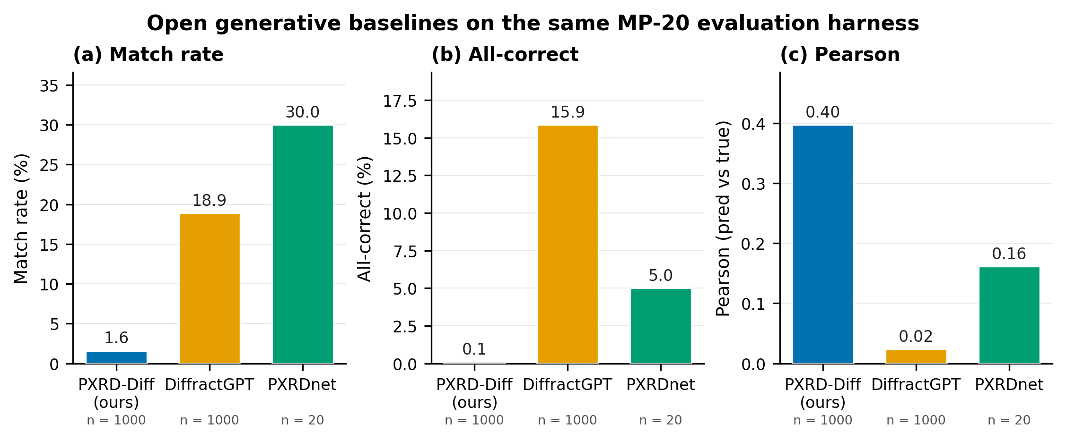
Figure 4. Three-way headline comparison. Match rate, all-correct, and pattern-Pearson on the same MP-20 test materials scored through our StructureMatcher harness, with 95 % Wilson CIs. PXRD-Diff loses on match rate by 12–19× but wins on per-pattern Pearson. Note the wide PXRDnet (n = 20) intervals: the DGpt > PXRDnet all-correct ordering is a hypothesis, not an established result (§5.3, §6).
Caveats. PXRDnet n = 20 has a 95 % Wilson CI of roughly ±20 pp on every rate; n = 200 would need ~33 days of RTX 5090 rental at ~4 GPU-hr/material. Patterns are simulated through each model’s own preprocessing (different bins, 2θ vs Q, broadening) — material_ids are identical, pattern inputs are not bit-identical; §7 bounds this.

1.6.4 5.4 What did not work
Four interventions failed at n ≥ 200; one paragraph each.
Top-K Debye rerank (Phase 9.1.4). Top-5 indexer candidates reranked by Debye loss: match 1.6 % → 1.0 %, all-correct 0.1 % → 0.0 % at n = 1 000. The indexer surfaces more wrong cells faster than rerank can filter.
Debye-gradient guidance during DDIM (Phase 9.2). Coordinate-channel guidance term $−g⋅∇_{C}L_{\text{Debye}}$, sweep $g∈\{0,0.5,1,2,5\}$ on n = 200: flat 1.0–2.5 % within noise, all-correct 0 % throughout. Sampling-time Debye gradient is too noisy to steer the trajectory — consistent with Segal et al. , who show the powder-XRD similarity loss landscape is too non-convex for direct gradient descent.
Wyckoff-site embeddings (v15, n = 1 000). spglib-computed, nn.Embedding(27, 256) added to atom features. The embedding learns (5 404/6 912 entries non-zero) but match drops 2.5 % → 2.1 % and destabilises lattice prediction (lat loss ~0.6 vs ~0.02; Figure 5). We suspect inflated atom-feature norm shifts the lattice-pool input distribution.
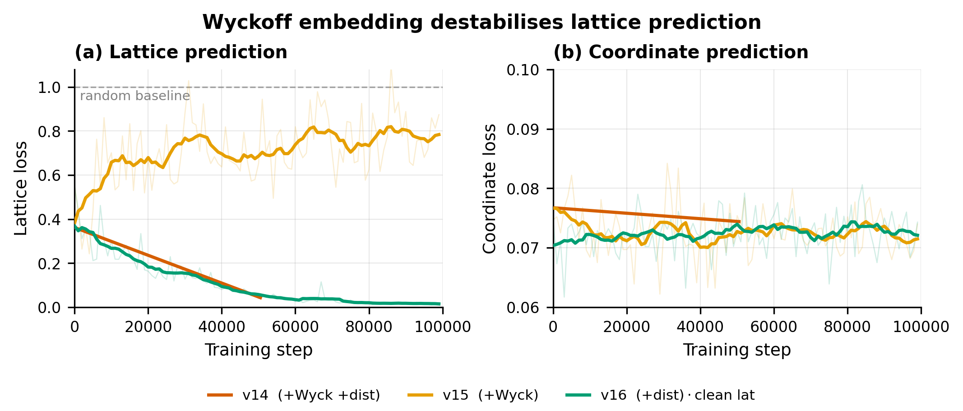
Figure 5. Wyckoff embedding destabilises lattice prediction. Lattice (a) and coordinate (b) training-loss curves for the distance-aux run (v16) vs the Wyckoff-embedding run (v15). Adding the Wyckoff embedding inflates the lattice loss by an order of magnitude (~0.6 vs ~0.02) while leaving the coordinate loss largely unchanged — the failure is localised to the lattice channel.
Distance-matrix aux loss (v16, n = 1 000). Pairwise MLP predicting periodic distances, $λ_{\text{dist}}=0.01$ (largest stable). Loss decreases (final ~2.0 vs ~10 random) but match drops 2.5 % → 1.8 %; biases features toward absolute-distance reconstruction rather than the relative updates diffusion needs.
Combination (v14). Wyckoff + distance loss together collapses to 0.8 %, below the bare ε baseline; the two interact destructively, no clean theoretical explanation.

1.6.5 5.5 Encoder-bottleneck perturbation study
Best predicted-vs-target Pearson is 0.43; the same model with correct coordinates plugged into the differentiable simulator hits 0.97 — the encoder + denoiser leaves ~0.5 of pattern-space agreement on the table. The aux head (sees $g$ only) reaches loss 0.007: the global encoding contains the lattice signal, the denoiser under-uses it.
Perturbing the sampler-supplied lattice by Å of cell-length error, v21 at n = 200: match decays 5.6 % (Δ=0) → 2.0 % (0.5 Å) → 0.5 % (1.0 Å) → 0 % (≥1.5 Å), steeper than linear with a knee at ~0.5 Å. This matches the indexer’s per-system MAE: high-symmetry systems (hex, ortho; MAE ≤ 1.0 Å) lift; low-symmetry (mono, tri; MAE ≥ 1.5 Å) do not. §5.2’s indexer lift is predictable — it works where it can.

1.7 6. Discussion
Encoder bottleneck (the robust result). The lattice signal exists in $g$ (aux loss 0.007) but the denoiser cannot extract absolute d-spacings well enough to predict from scratch; the disjoint oracle-vs-indexer CIs (§5.2) make this the paper’s statistically firmest claim. The Q-space autoindexer recovers part of the 5.6 % oracle ceiling on the high-symmetry subset; top-K rerank and gradient guidance fail because they operate after the encoder commits to a bad lattice prior, while the indexer bypasses that decision.
Per-atom anchoring is hard. PXRD is permutation-invariant; our denoiser is permutation-equivariant; there is no symmetry-breaking signal that pins atom $i$ to a specific Wyckoff site. The Wyckoff embedding tried to break symmetry at the input and failed. A promising untried direction: break symmetry at the output — predict an unordered set of orbits plus a Hungarian-style matcher.
A measurement hypothesis: match rate may conflate two capabilities. PXRDnet’s 30 % match / 5 % all-correct vs DGpt’s 18.9 % / 15.9 % (Table 3) suggests the two systems recover structure at broadly comparable rates while differing sharply in symmetry recovery — DGpt’s CIF-token output appears to encode space group in a way PXRDnet’s coordinate decode does not. We stress that the underlying numbers cannot yet support this: PXRDnet’s all-correct CI [0.9, 23.6] at n = 20 overlaps DGpt’s, so the ordering is unconfirmed. We raise it as a measurement hypothesis worth testing at adequate n, because if true it has a concrete consequence for the field: a single “match rate” reported under inconsistent tolerances would conflate structure recovery with symmetry recovery, and downstream crystallography (where the space group matters as much as the coordinates) would be mis-served by it. The contribution here is the shared harness that makes such a test possible, not the (underpowered) comparison itself.
Niche for small reproducible models. At 1.6 % we are 12–19× behind much larger systems, but small models make the encoder bottleneck visible (capacity hides it) and the indexer drop-in trivial to integrate (larger models would need architecture-level surgery). The recipe — encoder + Phase 4 fixes + Phase 9 indexer drop-in — is 3.7 M parameters and runs inference in seconds.

1.8 7. Limitations
- Scope. Composition given; simulated PXRD only (no instrument response, preferred orientation, asymmetry, background); MP-20 only — no larger cells, organics, or higher-Z.
- Statistics. The Phase 4 ablations are single-seed; their large effects (the 2.5–3.5× x₀-residual and lattice-input lifts) are robust to this, and the oracle-vs-indexer gap has disjoint CIs. The indexer-vs-learned-head comparison was rerun at three seeds and the lift confirmed significant by a paired McNemar test (p < 10⁻⁴; §5.2) — superseding the earlier underpowered unpaired test (p = 0.24). We did not multi-seed the oracle or the Phase 4 ablation runs.
- Baselines. PXRDnet n = 20 has a 95 % Wilson CI of ≈ ±20 pp; the DGpt > PXRDnet all-correct ordering (§5.3/§6) is therefore a hypothesis, not a result. n = 200 needs ~33 days RTX 5090. Crystalyze checkpoint download is inactive (verified 2026-06-01); cited but unreproduced. Patterns are not bit-identical across the three preprocessors (PXRD-Diff 4 251-bin 2θ, DGpt 300-bin 2θ, PXRDnet 4 096-bin Q with sinc² broadening) — structures match, patterns do not; we did not quantify the residual preprocessing effect on match rate, and a matched-vs-native re-scoring on a structure subset is the natural check.
- Indexer. GSAS-II low-symmetry path hangs in findBestCell on real MP-20 mono/tri patterns; shipped behind --use-gsas but experimental.
- Training. Debye loss uses ground-truth lattice; a curriculum gradually replacing true with predicted was not tried.

1.9 8. Conclusion
A 3.7 M-parameter conditional diffusion model with a differentiable Bragg loss recovers 1.5 % [1.2, 2.0] of MP-20 test structures with a classical Q-space autoindexer supplying the lattice — a significant improvement over the learned lattice head, which recovers essentially nothing (three-seed paired McNemar p < 10⁻⁴) — and 5.6 % [4.3, 7.2] under a true-lattice oracle. The oracle gap is significant and is the paper’s firmest result: even with a perfect lattice, coordinate prediction caps match at 5.6 %, while lattice error explains the rest of the shortfall to that ceiling. Reproduced on the same StructureMatcher harness, DGpt reaches 18.9 % / 15.9 % and PXRDnet 30.0 % / 5.0 % (match / all-correct) — PXRD-Diff is 12–19× behind. The apparent divergence in their space-group recovery is a measurement hypothesis the n = 20 PXRDnet sample cannot yet confirm, but the shared harness now makes it testable. Two architectural fixes (lattice-input, x₀-residual) and one drop-in (classical autoindexer) are load-bearing; six other interventions are documented as failures. Code, checkpoints, all per-phase JSONs, both indexer paths, and the differentiable Bragg module are released.

1.10 Acknowledgments
We thank the maintainers of pymatgen, spglib, the CDVAE benchmark, GSAS-II, and the upstream maintainers of DiffractGPT (atomgptlab/atomgpt) and PXRDnet (gabeguo/cdvae_xrd) for releasing checkpoints and code that made the head-to-head reproduction in §5.3 possible. Compute was rented from Vast.ai; total spend was approximately USD 25 across roughly 30 GPU-hours on RTX 5090 instances (Phase 4 ablation, Phase 9 retrain + indexer sweeps, DiffractGPT n = 1 000 inference, and PXRDnet n = 20 inference).

1.11 Author Contributions (CRediT)
F. Cai: Conceptualization, Methodology, Software, Validation, Formal analysis, Investigation, Data curation, Writing — Original Draft, Writing — Review & Editing, Visualization, Project administration.

1.12 Conflict of Interest
The author declares no competing interests.

1.13 Funding
This research received no external funding.

1.14 Data and Code Availability
Source code, trained checkpoints, and all per-phase training/evaluation logs are available at https://github.com/fronkt/pxrd-diff and archived at Zenodo (DOI: 10.5281/zenodo.XXXXXXX — to be minted at submission). The MP-20 dataset is publicly available via the CDVAE benchmark. All experiments reproduce from a single requirements.txt and the scripts/ pipeline; per-structure evaluation flags are released to support paired re-analysis.

1.15 Ethics Declaration
This study uses no human subjects, animal subjects, or sensitive data. The MP-20 dataset is composed entirely of publicly available crystal structures from the Materials Project.

1.16 References
Author note on reproduced numbers. The reproduced PXRDnet and DiffractGPT numbers in §5.3 are computed by the author on the released checkpoints through our shared StructureMatcher harness, not transcribed from the cited papers. The central claims depend only on these reproduced numbers under one common evaluation protocol, with confidence intervals stated throughout.

1.17 Appendix

1.17.1 A. Full ablation history
For completeness, Table A1 lists every training run discussed in the development of this paper, including those that did not make it into the main ablation table. Logs and checkpoints for all runs are in the released repository under runs/.
Run | Parameters | What changed | Result | Status in paper
v4 | 3.5 M | Global PXRD pooling, additive conditioning | Coord loss flat at 3.0 | §3.2
v5 | 3.7 M | + Multi-resolution cross-attention | Coord 3.0 → 1.0 | §3.2
v6–v9 | 3.7 M | λ_Debye sweep {0, 0.1, 1, 10}, ε-prediction | All ~1 % match (within noise) | §5.2
v10 | 3.7 M | + Lattice-input fix, λ_Debye = 0 | Lat loss 1.0 → 0.05 | §5.2
v11 | 3.7 M | + Lattice-input fix, λ_Debye = 1 | Match 0.9 % | Table 1
v12 | 10.1 M | Larger model (d=384, L=5), ε-prediction | Killed at 18 k; same plateau | §5.2
v13 | 3.7 M | x₀-residual + lat-fix + Debye λ=1 | 2.51 % match (Phase 4 best, true-lat) | Table 1
v14 | 3.8 M | v13 + Wyckoff + distance loss | 0.80 % match | Table 1
v15 | 3.8 M | v13 + Wyckoff only | 2.10 % match | Table 1
v16 | 3.7 M | v13 + distance loss only | 1.80 % match | Table 1
v17 – v20 | 3.7 M | Five Phase-9 encoder retrains with different ResNet/Transformer hybrids and pattern-augmentation curricula | None beat v13 by more than noise | §5.1
v21 | 3.7 M | Phase 9 final: v13 architecture + Phase 9 retrain + indexer drop-in support | 1.6 % match (no-true-lat, indexer); 5.6 % (true-lat oracle) | Tables 2, 3

1.17.2 B. Hyperparameter sensitivity
We did not perform a full hyperparameter sweep. Pilot experiments on d_model ∈ {128, 256, 384} and n_layers ∈ {2, 3, 5} showed (256, 3) as a reasonable Pareto point. The Debye loss weight was swept {0, 0.1, 1, 10} in early ε-prediction runs (v6–v9) without measurable effect on match rate; we re-fixed it at 1.0 for the x₀-residual runs by analogy.

1.17.3 C. Differentiable simulator validation details
Pearson correlations between our DiffPXRD module and pymatgen.XRDCalculator over a random 50-structure MP-20 test subset:
- Mean: 0.962
- Std: 0.027
- Min: 0.896 (mp-1213821, layered structure with strong texture in the reference)
- Max: 0.998 (mp-149, Si)
- Fraction > 0.95: 33/50
- Fraction > 0.9: 49/50
- Fraction > 0.7: 50/50
Gradient sanity: for all 50 structures we confirmed ∂L/∂F and ∂L/∂L are non-zero and finite via torch.autograd.gradcheck on a 4-atom subset.

1.17.4 D. Reproducibility checklist
- Hyperparameters specified (§4.3)
- Datasets and splits specified (§4.1; canonical CDVAE MP-20)
- Evaluation protocol specified (§4.2)
- Random seed: single seed (42) per run; pilot variance ≈ 0.5 % match-rate absolute
- Compute environment: PyTorch 2.x, CUDA 12.x, single RTX 5090; Python 3.12
- Code, checkpoints, logs, and full training scripts released

Choudhary, K. (2025). DiffractGPT: Atomic Structure Determination from X-ray Diffraction Patterns using a Generative Pretrained Transformer. The Journal of Physical Chemistry Letters, 16(8), 2110–2119. DOI: 10.1021/acs.jpclett.4c03137. Reproduced from HF checkpoint knc6/diffractgpt_mistral_chemical_formula and code at github.com/atomgptlab/atomgpt.
Guo, G., Saidi, T. L., Terban, M. W., Valsecchi, M., Billinge, S. J. L., & Lipson, H. (2025). Ab initio structure solutions from nanocrystalline powder diffraction data via diffusion models. Nature Materials, 24, 1726–1734. DOI: 10.1038/s41563-025-02220-y (Author Correction: 10.1038/s41563-025-02301-y; preprint arXiv:2406.10796). Reproduced from HF checkpoint therealgabeguo/cdvae_xrd_sinc100 and code at github.com/gabeguo/cdvae_xrd.
Choudhary, K. (2025). DiffractGPT: Atomic Structure Determination from X-ray Diffraction Patterns using a Generative Pretrained Transformer. The Journal of Physical Chemistry Letters, 16(8), 2110–2119. DOI: 10.1021/acs.jpclett.4c03137. Reproduced from HF checkpoint knc6/diffractgpt_mistral_chemical_formula and code at github.com/atomgptlab/atomgpt.
Riesel, E. A., Mackey, T., Nilforoshan, H., Xu, M., Badding, C. K., Altman, A. B., Leskovec, J., & Freedman, D. E. (2024). Crystal Structure Determination from Powder Diffraction Patterns with Generative Machine Learning. Journal of the American Chemical Society, 146(44), 30340–30348. DOI: 10.1021/jacs.4c10244. Code: github.com/ML-PXRD/Crystalyze. We could not reproduce: the checkpoint download link is marked “not yet active” in the upstream README (verified 2026-06-01).
Guo, G., Saidi, T. L., Terban, M. W., Valsecchi, M., Billinge, S. J. L., & Lipson, H. (2025). Ab initio structure solutions from nanocrystalline powder diffraction data via diffusion models. Nature Materials, 24, 1726–1734. DOI: 10.1038/s41563-025-02220-y (Author Correction: 10.1038/s41563-025-02301-y; preprint arXiv:2406.10796). Reproduced from HF checkpoint therealgabeguo/cdvae_xrd_sinc100 and code at github.com/gabeguo/cdvae_xrd.
Segal, N., Subramanian, A., Li, M., Miller, B. K., & Gómez-Bombarelli, R. (2025). The Loss Landscape of Powder X-Ray Diffraction-Based Structure Optimization Is Too Rough for Gradient Descent. arXiv:2512.04036.
Xie, T., Fu, X., Ganea, O.-E., Barzilay, R., & Jaakkola, T. (2022). Crystal diffusion variational autoencoder for periodic material generation. International Conference on Learning Representations.
Jiao, R., et al. (2023). Crystal structure prediction by joint equivariant diffusion. Advances in Neural Information Processing Systems 36.
Zeni, C., et al. (2024). MatterGen: A generative model for inorganic materials design. arXiv:2312.03687.
Choudhary, K. (2025). DiffractGPT: Atomic Structure Determination from X-ray Diffraction Patterns using a Generative Pretrained Transformer. The Journal of Physical Chemistry Letters, 16(8), 2110–2119. DOI: 10.1021/acs.jpclett.4c03137. Reproduced from HF checkpoint knc6/diffractgpt_mistral_chemical_formula and code at github.com/atomgptlab/atomgpt.
Riesel, E. A., Mackey, T., Nilforoshan, H., Xu, M., Badding, C. K., Altman, A. B., Leskovec, J., & Freedman, D. E. (2024). Crystal Structure Determination from Powder Diffraction Patterns with Generative Machine Learning. Journal of the American Chemical Society, 146(44), 30340–30348. DOI: 10.1021/jacs.4c10244. Code: github.com/ML-PXRD/Crystalyze. We could not reproduce: the checkpoint download link is marked “not yet active” in the upstream README (verified 2026-06-01).
Guo, G., Saidi, T. L., Terban, M. W., Valsecchi, M., Billinge, S. J. L., & Lipson, H. (2025). Ab initio structure solutions from nanocrystalline powder diffraction data via diffusion models. Nature Materials, 24, 1726–1734. DOI: 10.1038/s41563-025-02220-y (Author Correction: 10.1038/s41563-025-02301-y; preprint arXiv:2406.10796). Reproduced from HF checkpoint therealgabeguo/cdvae_xrd_sinc100 and code at github.com/gabeguo/cdvae_xrd.
Johansen, F. L., Friis-Jensen, U., Dam, E. B., Jensen, K. M. Ø., Mercado, R., & Selvan, R. (2025). deCIFer: Crystal Structure Prediction from Powder Diffraction Data using Autoregressive Language Models. Transactions on Machine Learning Research (arXiv:2502.02189).
Boultif, A., & Louër, D. (2004). Powder pattern indexing with the dichotomy method. Journal of Applied Crystallography, 37(5), 724–731. DOI: 10.1107/S0021889804014876.
Guo, J., & Schwalbe-Koda, D. (2026). Generative Inversion of Spectroscopic Data for Amorphous Structure Elucidation. arXiv:2603.23210.
Segal, N., Subramanian, A., Li, M., Miller, B. K., & Gómez-Bombarelli, R. (2025). The Loss Landscape of Powder X-Ray Diffraction-Based Structure Optimization Is Too Rough for Gradient Descent. arXiv:2512.04036.
Schütt, K. T., et al. (2017). SchNet: A continuous-filter convolutional neural network for modeling quantum interactions. Advances in Neural Information Processing Systems 30.
Batatia, I., Kovács, D. P., Simm, G. N. C., Ortner, C., & Csányi, G. (2022). MACE: Higher order equivariant message passing neural networks for fast and accurate force fields. Advances in Neural Information Processing Systems 35.
Nichol, A., & Dhariwal, P. (2021). Improved denoising diffusion probabilistic models. International Conference on Machine Learning.
Toby, B. H., & Von Dreele, R. B. (2013). GSAS-II: the genesis of a modern open-source all purpose crystallography software package. Journal of Applied Crystallography, 46(2), 544–549. Code: github.com/AdvancedPhotonSource/GSAS-II.
Song, J., Meng, C., & Ermon, S. (2021). Denoising diffusion implicit models. International Conference on Learning Representations.
Xie, T., Fu, X., Ganea, O.-E., Barzilay, R., & Jaakkola, T. (2022). Crystal diffusion variational autoencoder for periodic material generation. International Conference on Learning Representations.
Choudhary, K. (2025). DiffractGPT: Atomic Structure Determination from X-ray Diffraction Patterns using a Generative Pretrained Transformer. The Journal of Physical Chemistry Letters, 16(8), 2110–2119. DOI: 10.1021/acs.jpclett.4c03137. Reproduced from HF checkpoint knc6/diffractgpt_mistral_chemical_formula and code at github.com/atomgptlab/atomgpt.
Guo, G., Saidi, T. L., Terban, M. W., Valsecchi, M., Billinge, S. J. L., & Lipson, H. (2025). Ab initio structure solutions from nanocrystalline powder diffraction data via diffusion models. Nature Materials, 24, 1726–1734. DOI: 10.1038/s41563-025-02220-y (Author Correction: 10.1038/s41563-025-02301-y; preprint arXiv:2406.10796). Reproduced from HF checkpoint therealgabeguo/cdvae_xrd_sinc100 and code at github.com/gabeguo/cdvae_xrd.
Segal, N., Subramanian, A., Li, M., Miller, B. K., & Gómez-Bombarelli, R. (2025). The Loss Landscape of Powder X-Ray Diffraction-Based Structure Optimization Is Too Rough for Gradient Descent. arXiv:2512.04036.

