SOLIDIFY: A Real-Time, Browser-Based Phase-Field Instrument for Teaching Dendritic Solidification and Grain Refinement
Frank Cai
Purdue University, West Lafayette, IN, USA; frankyc11223@gmail.com; ORCID 0009-0003-0041-1459
ABSTRACT
Dendritic solidification and grain refinement are core topics across introductory materials science, physical metallurgy, and casting curricula, but they are usually taught through static textbook figures or through research-grade phase-field codes that require installation, meshing, and offline post-processing before a single microstructure can be seen forming. SOLIDIFY is a free, open-source, browser-based instrument that solves the Kobayashi anisotropic phase-field model of dendritic growth, extended to many grains and a dilute alloy solute field, as real-time WebGPU compute shaders — so the browser tab is the interactive laboratory, with no install step. Ten simultaneous rendering views reinterpret the same simulated state the way real characterization instruments would (an incandescent melt view, cross-polarized grain orientation, an etched micrograph with scale bar, a thermal-camera palette, a synchrotron-radiograph view sensitive to solute segregation, and others), and an alloy composer maps user-entered compositions onto real dilute-limit liquidus-slope and partition-coefficient chemistry. A companion page documents, claim by claim, what the instrument reproduces exactly, what is qualitatively emergent, and what is a stylistic display choice — a transparency practice this paper argues should be standard for simulation-based teaching tools generally. As one measured evaluation, under identical nucleation and cooling conditions the instrument produced 369 grains (ASTM G 6.2) for a grain-refined aluminum alloy composition versus 46 grains (ASTM G 2.8) for a nearly pure one, reproducing the Easton–StJohn grain-refinement mechanism as emergent behavior rather than a scripted outcome. The tool and its source are freely available and require no institutional license.
Keywords: materials science education; phase-field simulation; dendritic solidification; WebGPU; grain refinement; interactive simulation
1. INTRODUCTION
Dendritic microstructure formation — why a solidification front breaks up, why the resulting arms lock onto crystal axes, and why alloy composition controls the final grain size — is foundational to how materials scientists think about casting, welding, and additive manufacturing. The phenomenon is also visually striking and conceptually rich enough to motivate students well before they can follow the underlying mathematics in detail.
The equations that produce it, however, are usually encountered by students only secondhand: through static figures reproduced from the original phase-field literature^{1,2}, or through research-oriented simulation packages such as MOOSE/MARMOT³, OpenPhase, or MICRESS, which are built for producing publication-grade microstructure data on institutional hardware, not for a single student to open in a lecture hall and perturb in real time. Installing and configuring any of these packages, choosing a mesh and time step, and post-processing the output into a viewable image is itself a nontrivial exercise — appropriate for a computational-methods course, but a poor fit for a first encounter with the physics of solidification in an introductory materials course.
SOLIDIFY was built to close that gap: a real-time, in-browser instrument that a student or instructor can open with a single link, with no install step, and in which every visible feature — dendrite tip selection, side-branching, grain impingement, alloy-driven grain refinement — is the direct output of the governing equations rather than a pre-rendered illustration of them.
2. THE INSTRUMENT
SOLIDIFY integrates the Kobayashi anisotropic phase-field model for an undercooled melt¹, extended to many grains and a Warren–Boettinger-type dilute alloy solute field². Two coupled fields — an order parameter (liquid/solid) and a temperature — plus a solute concentration and a solidification-age channel are integrated on a uniform grid using explicit Euler time-stepping on a compact 9-point Laplacian stencil, entirely as WGSL compute shaders executed by the WebGPU API. No server-side computation, plugin, or native application is involved; the simulation runs client-side in any WebGPU-capable browser (current Chrome, Edge, Safari, and Firefox), sustaining on the order of 10⁹ cell-updates per second on a mid-range discrete GPU.
Around this solver, the instrument provides ten simultaneous rendering “lenses” that reinterpret the same underlying state fields the way different real characterization instruments would: an incandescent melt view scaled to each material's true melting glow, a cross-polarized grain-orientation view, an etched metallographic micrograph complete with a scale bar, an isotherm/temperature-field view, solidification-time isochrones, a false-color thermal-camera palette, a secondary-electron microscope look, and a synchrotron-radiograph absorption view sensitive to solute segregation. This design choice is deliberately pedagogical: it lets a student connect the abstract order-parameter field directly to the specific instrument outputs — an optical micrograph, an SEM image, a synchrotron radiograph — they will encounter later in a characterization laboratory course, rather than treating the simulation and the laboratory technique as unrelated topics.
Three growth scenarios are provided: free growth into an undercooled melt, directional (Bridgman-type pulled-gradient) solidification, and a steerable laser-weld scenario that remelts and re-solidifies a microstructure in place. A materials picker sets ten qualitative material identities — aluminum, an Fe–C steel, a nickel superalloy, cobalt, copper, an Mg alloy, zinc, ice, and succinonitrile, among others — whose crystal structure sets dendrite symmetry (face- and body-centered cubic structures give four-fold dendrites; hexagonal close-packed structures, including ice, give six-fold dendrites, i.e. snowflakes). An alloy composer lets a user build a custom composition from real per-element dilute-limit binary coefficients (liquidus slope and partition coefficient, drawn from standard solidification references⁴), reporting the liquidus depression and the Easton–StJohn growth-restriction factor⁵ for the resulting mixture before collapsing it onto the model's single pseudo-binary solute field. Foundry-style analysis instruments — a cooling-curve probe, a Scheil-path overlay⁶, and a linear-intercept secondary-dendrite-arm-spacing ruler — mirror techniques used in real metallography and thermal analysis. A built-in ten-chapter guided tour sequences these features into a self-paced curriculum, from the Mullins–Sekerka instability⁷ that initiates dendritic breakup through casting-scale grain refinement and alloying.
3. TRANSPARENCY AS A DESIGN PRINCIPLE
Interactive science-education tools aimed at a general or introductory audience are at particular risk of silently substituting scripted or stylized behavior for the underlying model wherever the real physics would be too slow, too subtle, or too difficult to render convincingly — a substitution a specialist might catch but a student, by definition, cannot. SOLIDIFY addresses this directly with a companion page (linked from the instrument itself) that enumerates, claim by claim, which visible behaviors are canonical (matched against the published Kobayashi figures), which are qualitatively emergent but not quantitatively calibrated (grain impingement statistics, the columnar-to-equiaxed transition, weld epitaxy), which are real chemistry evaluated exactly within a stated approximation (the alloy composer's liquidus shift and growth-restriction factor, computed from real dilute-limit coefficients), and which are purely a display choice with no physical claim attached (the per-material melt-incandescence color). We suggest this kind of explicit, itemized honesty about simulation fidelity is a design practice worth adopting broadly for education-facing simulation tools, independent of the specific domain: it turns the instrument itself into an exercise in distinguishing verified claims from illustrative ones, which is a scientific-literacy skill in its own right.
4. EVALUATION
Two forms of evaluation were used to check that the instrument reproduces correct behavior rather than a plausible-looking approximation of it. First, dendrite and snowflake morphology — tip selection, the number and regularity of primary arms, and noise-seeded side-branching — were checked by eye against the published Kobayashi figures across both four-fold and six-fold symmetry settings, and against the qualitative transition to dense-branching (“seaweed”) morphology as anisotropy is reduced toward zero, all canonical predictions of the underlying model.
Second, a quantitative claim was checked directly inside the instrument rather than asserted from the literature: under identical nucleation density and cooling schedule, a grain-refined A356-type aluminum alloy with a titanium-boride grain refiner added (growth-restriction factor Q ≈ 71 K) froze into 369 grains, ASTM G 6.2⁸, while a nearly pure Al–1Zn composition (Q ≈ 0.9 K) produced only 46 grains, ASTM G 2.8. This is the Easton–StJohn grain-refinement mechanism — that growth restriction, not nucleant count alone, is the primary lever on final grain size — emerging from the coupled phase-field/solute equations as composition alone was varied, rather than being an outcome scripted into the software. We regard this as stronger evidence for classroom use than visual plausibility alone, since it demonstrates the tool gets a specific, checkable, quantitative relationship right.
We have not yet conducted a formal classroom study measuring learning-outcome gains from using SOLIDIFY versus static figures or offline codes; this is identified as future work in Section 6, and any pedagogical claims here should be read as evidence of physical correctness and design intent rather than of measured instructional effectiveness.
5. AVAILABILITY AND SUGGESTED USE IN COURSES
SOLIDIFY is released under the MIT license, requires no account, license fee, or institutional software agreement, and is available at https://solidify.frankcai.dev; source code is at https://github.com/fronkt/solidify. Suggested classroom uses include: a live lecture demonstration of the Mullins–Sekerka instability and the origin of dendrite morphology, projected and manipulated in real time; a take-home exercise in which students use the alloy composer to reproduce the grain-refinement result in Section 4 for a composition of their choosing and relate the growth-restriction factor to the resulting grain count; a directional-solidification exercise exploring the columnar-to-equiaxed transition; and the built-in guided tour as a self-paced introductory module, usable at levels ranging from an intuitive illustration of why snowflakes are six-sided to an undergraduate exercise in constitutional undercooling and the growth-restriction factor.
6. FUTURE WORK
The most direct extension of this work is a classroom pilot pairing SOLIDIFY with a pre/post concept inventory on solidification and grain refinement, to measure learning-outcome gains rather than infer them from design intent. On the software side, a true three-dimensional mode (replacing the current thin-sample two-dimensional model) is planned and would let the instrument address out-of-plane dendrite branching directly, which the present two-dimensional model can only approximate.
7. CONCLUSION
SOLIDIFY demonstrates that a research-grade phase-field solidification model can run as a real-time, zero-install, browser-native instrument rather than an offline research code, and that doing so opens pedagogical possibilities — live manipulation in lecture, self-paced guided exploration, and direct connection to real characterization instrument views — that static figures and desktop simulation packages do not offer. Explicit, itemized transparency about what is quantitatively verified versus qualitatively illustrative is presented as a design principle for this class of tool generally, not specific to solidification. The tool and its source are freely available for classroom use and modification.
ABOUT THE AUTHOR
SOLIDIFY was designed and built independently by the author, a high-school student, as a self-directed open-source project; it is not the output of a funded research program or course assignment.
REFERENCES
1. R. Kobayashi, Modeling and numerical simulations of dendritic crystal growth, Physica D 63, 410 (1993).
2. J.A. Warren, W.J. Boettinger, Prediction of dendritic growth and microsegregation patterns in a binary alloy using the phase-field method, Acta Metall. Mater. 43, 689 (1995).
3. D. Schwen, L.K. Aagesen, J.W. Peterson, M.R. Tonks, Rapid multiphase-field model development using a modular free energy based approach with automatic differentiation in MOOSE/MARMOT, Comput. Mater. Sci. 132, 36 (2017).
4. W. Kurz, D.J. Fisher, Fundamentals of Solidification, Trans Tech Publications, Uetikon-Zuerich, 1998.
5. M. Easton, D. StJohn, Grain refinement of aluminum alloys: Part I, Metall. Mater. Trans. A 30, 1613 (1999).
6. E. Scheil, Bemerkungen zur Schichtkristallbildung, Z. Metallkd. 34, 70 (1942).
7. W.W. Mullins, R.F. Sekerka, Stability of a planar interface during solidification of a dilute binary alloy, J. Appl. Phys. 35, 444 (1964).
8. ASTM International, ASTM E112-13, Standard Test Methods for Determining Average Grain Size, ASTM International, West Conshohocken, 2021.
FIGURE CAPTIONS
Figure 1. Four-fold dendrite grown by the instrument in an undercooled melt (MELT lens, cubic material setting), showing the tip selection and noise-seeded side-branching characteristic of the Kobayashi model.
Figure 2. Six-fold dendritic snowflake grown by the same equations with hexagonal symmetry selected (ORIENT / cross-polarized lens), demonstrating that dendrite symmetry follows directly from the crystal structure setting rather than from separate code paths.

APPENDIX — FIGURES (for reviewer convenience; submitted to the journal as separate image files per JME author guidelines, not embedded in the body)

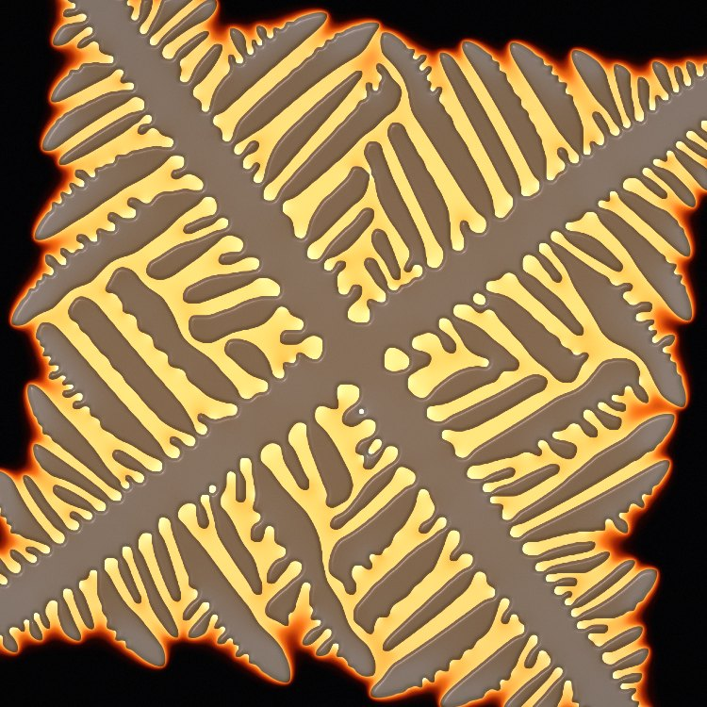
Figure 1. Four-fold dendrite, MELT lens, cubic material.

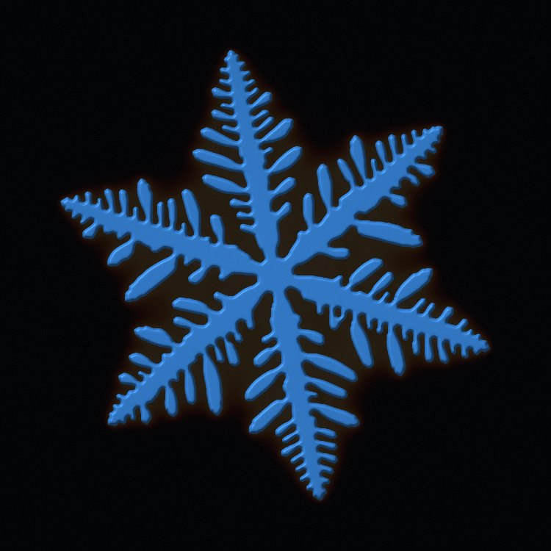
Figure 2. Six-fold snowflake, ORIENT lens, hexagonal material.

