Supplementary Information:
What an SO(3) orientation flow can and cannot learn in molecular-crystal structure prediction
Frank Cai

Method validation on single-block inorganic benchmarks
The orientation analysis in the main text isolates a target obstruction that is specific to multi-copy molecular crystals. To confirm that the underlying SymMC-Flow architecture, training objective, and Runge–Kutta sampler are sound independently of that obstruction, we benchmarked the model on two standard single-block datasets, carbon-24 and MP-20, in which each atom is its own rigid block and the orientation head is inactive ($λ_{\text{orient}}=0$). These results are reported for completeness; they are not the contribution of this paper.

Protocol.
We compare against joint equivariant diffusion(Jiao et al. 2023) using its released models, with matched evaluation: $256$ held-out targets, $20$ samples per target, and the same root-mean-square structure distance routine for both methods. Match rate at $k$ (“match@$k$”) is the fraction of targets for which at least one of $k$ samples matches the reference under StructureMatcher(Ong et al. 2013). SymMC-Flow samples in $50$ Runge–Kutta steps, against roughly $1,000$ steps for the diffusion baseline.

Outcome.
Table 1 shows a mixed result: each method wins two of the four match cells. SymMC-Flow leads on carbon-24 match@1 and on MP-20 match@20, while the diffusion baseline leads on MP-20 match@1 and on carbon-24 match@20 and produces tighter RMSE on matched structures. The honest summary is that SymMC-Flow is competitive at roughly an order of magnitude fewer sampling steps, not a uniform improvement. This is sufficient to establish that the flow and sampler are well-behaved, which is all the main-text analysis requires.
SymMC-Flow versus a diffusion baseline(Jiao et al. 2023) on single-block inorganic CSP under a matched evaluation ($256$ targets, $20$ samples, identical RMSD routine). Match rates in percent; higher is better. Each method wins two of the four cells.
dataset | metric | SymMC-Flow | diffusion baseline
carbon-24 | match@1 | 26.7 | 18.8
carbon-24 | match@20 | 79.7 | 89.1
MP-20 | match@1 | 41.4 | 48.0
MP-20 | match@20 | 80.5 | 76.2

Caveat on benchmarks.
Recent work shows that carbon-24 contains a large fraction of duplicate structures and that match-rate metrics can mislead when identical building blocks exhibit structural variety(Martirossyan et al. 2025). The numbers above should be read as a sanity check on the architecture under the field’s conventional protocol rather than as a definitive ranking.

Is the absolute molecular orientation uniform on SO(3)?
The main-text claim that the free asymmetric-unit pose $R_{\text{asym}}$ carries no learnable signal predicts that the absolute per-molecule orientations should be close to Haar-uniform on $SO(3)$, since a uniform target offers nothing to predict. For Haar-uniform rotations the geodesic angle $θ$ from the identity has density $p(θ)=(1−cosθ)/π$ on $[0,π]$, with mean ${126.5}^{∘}$. Figure 1 compares the empirical distribution of the reference-copy orientations, which equal $R_{\text{asym}}$ up to the operation generating the first-detected copy, to this density. The empirical distribution tracks the Haar curve across the full angular range, with mean ${122.6}^{∘}$ ($n=1,467$). A one-sample Kolmogorov–Smirnov test against the Haar law gives $D=0.04$, a small but nonzero deviation localized to a near-identity excess that comes from the gauge-defining copies, whose self-alignment lands near the identity. The absolute orientation is therefore close to uniform, consistent with the predict-zero floor, and the residual deviation is a gauge artifact rather than a broad packing preference.
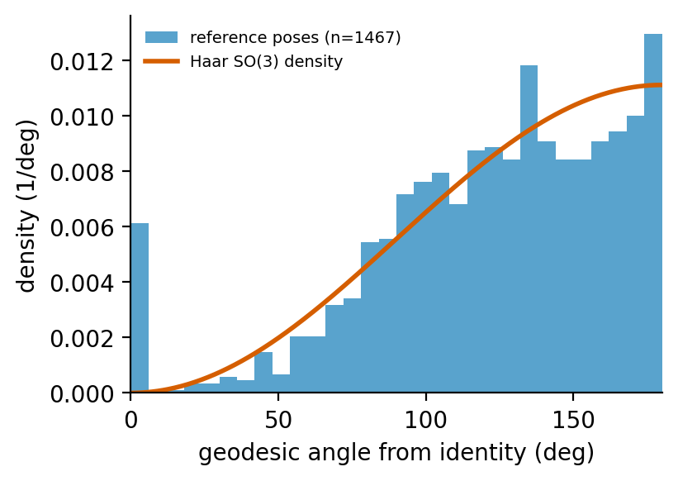
Empirical distribution of absolute reference-copy orientations (geodesic angle from the identity) against the Haar-uniform $SO(3)$ density. The two agree across the range apart from a small near-identity excess from gauge-defining copies.

Is $R_{\text{asym}}$ conditionally predictable from packing?
The uniformity test of the previous section concerns the marginal distribution of $R_{\text{asym}}$. A uniform marginal is necessary but not sufficient for the operational claim that packing carries no signal about the free pose: a weak conditional dependence $p(R_{\text{asym}}∣\text{packing})$ can coexist with a Haar marginal once the packing is marginalized out. We therefore test the conditional directly with a supervised probe. For each species we form a feature vector from the lattice cell parameters, the molecule’s fractional centroid, the mean and spread of all centroids in the cell, the conformer’s intrinsic shape (the gyration-tensor eigenvalues), the molecule and atom counts, and a learned space-group embedding, and we train a three-layer network to regress the reference-copy orientation (a continuous six-dimensional rotation parametrization with a Frobenius loss). The probe sees only composition and packing; the orientation is never an input.
Table 2 reports the held-out geodesic error against two references: the single best feature-free predictor, which is the Fréchet (chordal) mean of the training orientations, and a random-rotation guess. Averaged over three splits the probe attains ${125.2}^{∘}$, which does not improve on the feature-free constant at ${122.4}^{∘}$ and is statistically indistinguishable from the random-guess level of ${123.5}^{∘}$; the probe’s mean “improvement” over the constant is $−2.4\%$, i.e. no improvement. The network can drive its training error well below these values, so the failure is one of generalization, not of capacity. The conditional test thus reaches the same conclusion as the marginal one by an independent route: under the composition-and-packing conditioning available here, $R_{\text{asym}}$ is not predictable, which is the precise, operational sense in which we call it unlearnable.
Conditional-predictability probe for $R_{\text{asym}}$: held-out mean geodesic error (degrees, mean over three splits; lower is better). The probe, given composition and packing, does not beat the feature-free constant and sits at the no-information level.
predictor | held-out geodesic error
random guess (no information) | ${123.5}^{∘}$​
constant (Fréchet mean, feature-free) | ${122.4}^{∘}$​
probe (composition + packing features) | ${125.2}^{∘}$​

StructureMatcher tolerance sweep for the orientation-isolated rate
The main-text reconstruction rate uses a length tolerance of $0.3$, a site tolerance of $0.5$, and an angle tolerance of ${10}^{∘}$. To show the result is not an artifact of that choice, Table 3 sweeps the three StructureMatcher tolerances on a representative trained checkpoint, reporting both a single deterministic draw (match@1) and the best of eight draws (match@8). The match decision uses StructureMatcher.fit (maximum atomic displacement $≤$ the site tolerance), the same strict criterion as the headline; the median root-mean-square displacement is computed only over structures that already pass. The rate rises monotonically from $5.3\%$ at the tightest setting to $20.6\%$ at the loosest, while the oracle that uses the true orientation matches every structure at all four settings, confirming the tolerances are not so loose as to admit spurious matches. The default row ($0.3/0.5/{10}^{∘}$) gives $16.0\%$ match@8 on this checkpoint; the main-text $13.7±2.0\%$ is the mean over three independent training seeds at this row.
Orientation-isolated reconstruction under a StructureMatcher tolerance sweep (single trained checkpoint; $n=131$ held-out multi-copy crystals; true lattice, centroid, and conformer; only $SO(3)$ sampled). The oracle matches every structure at every setting. Match decided by StructureMatcher.fit; RMSD is over matched structures only.
$ℓ$tol | stol | angle | match@1 | match@8 | med. RMSD (Å) | oracle match@8
0.20 | 0.20 | $8^{∘}$​ | $0.0\%$​ | $5.3\%$​ | $0.089$​ | $100\%$​
0.30 | 0.30 | ${10}^{∘}$​ | $1.5\%$​ | $9.9\%$​ | $0.113$​ | $100\%$​
0.30 | 0.50 | ${10}^{∘}$​ | $3.8\%$​ | $16.0\%$​ | $0.128$​ | $100\%$​
0.50 | 0.70 | ${15}^{∘}$​ | $4.6\%$​ | $20.6\%$​ | $0.142$​ | $100\%$​

Leakage-controlled species-grouped split
Because a single conformer registry is shared across crystals, a random train/validation split could place two crystals of the same species on opposite sides, raising the concern that the learnable relative-orientation signal reflects species memorization rather than transferable geometry. We rule this out with a species-grouped split (Methods): crystals sharing any species are grouped by union–find and whole groups are assigned to one side, so no species crosses the partition. Table 4 compares the held-out non-reference orientation drop under the two split regimes over three seeds. The grouped split gives $28.5±2.9\%$, statistically indistinguishable from the random-split $27.5±2.7\%$, so the effect is not species leakage. An orientation-isolated reconstruction read on the grouped split (seed 0) recovers $10.7\%$ of held-out crystals (match@8; $4.6\%$ match@1; median RMSD $0.140$ Å) against $0\%$ for the predict-floor field, confirming the reconstruction also survives the leakage control.
Held-out non-reference orientation drop under random versus species-grouped train/validation splits (three seeds each, mean $±$ s.d.). The grouped split eliminates shared-species overlap; the signal is unchanged.
split | non-reference drop
random (main text) | $27.5±2.7\%$​
species-grouped (no leakage) | $28.5±2.9\%$​

All-atom de-novo baseline
To place the $0\%$ end-to-end rigid-body result in context, we trained an all-atom control that discards the rigid-body factorization: every atom is its own block and the orientation head is disabled ($λ_{\text{orient}}=0$), the representation used by all-atom molecular-crystal generators(Jin et al. 2025; Subramanian et al. 2026). It is trained on the same $964/131$ split and evaluated for de-novo reconstruction (all manifolds sampled from the prior) against both a random-prior floor and the trained field, with match@20 best-of-twenty draws. Its lattice and centroid heads train normally (an $88\%$ drop in flow-matching loss over $8,000$ steps), yet it reconstructs no held-out crystal exactly: match@1 and match@20 are both $0\%$ (Wilson $95\%$ CI $0$–$2.8\%$, $n=131$), identical to the random-prior floor (Table 5). End-to-end molecular-crystal reconstruction at this corpus scale is therefore out of reach for the all-atom representation as well, so the $0\%$ reported for rigid-body generation reflects the corpus scale and compute budget rather than a deficiency unique to the rigid-body factorization. This is our own all-atom flow at the thousand-crystal scale, not one of the published all-atom generators(Jin et al. 2025; Subramanian et al. 2026) trained on far larger corpora; it isolates the effect of the representation at a fixed scale and makes no claim about those larger models.
The best-of-twenty packing-component errors confirm the failure is the same joint packing that bottlenecks the rigid-body model, not a representation-specific pathology: the trained all-atom flow leaves a median lattice-parameter error of $0.33$ and a median fractional-coordinate error of $0.46$ (Table 5), comparable to the rigid-body de-novo errors reported in the main text (lattice $0.46$, centroid $0.35$). Both representations place molecules roughly a third to a half of a cell from their true positions, which is why neither reconstructs a crystal exactly.
De-novo all-atom reconstruction on $131$ held-out crystals (all manifolds sampled, best of twenty draws). The trained all-atom flow does not beat its random-prior floor at this corpus scale, despite its packing heads training normally, and its best-of-twenty packing errors match the rigid-body model’s.
field | match@1 | match@20 | med. lattice-param | med. frac. coord.
random prior (floor) | $0.0\%$​ | $0.0\%$​ | — | —
trained all-atom flow | $0.0\%$​ | $0.0\%$​ | $0.33$​ | $0.46$​
Jiao, Rui, Wenbing Huang, Peijia Lin, et al. 2023. “Crystal Structure Prediction by Joint Equivariant Diffusion.” Advances in Neural Information Processing Systems (NeurIPS).
Jin, Emily, Andrei Cristian Nica, Mikhail Galkin, et al. 2025. “OXtal: An All-Atom Diffusion Model for Organic Crystal Structure Prediction.” arXiv Preprint arXiv:2512.06987.
Martirossyan, Maya M., Thomas Egg, Philipp Hoellmer, et al. 2025. “All That Structure Matches Does Not Glitter.” arXiv Preprint arXiv:2509.12178.
Ong, Shyue Ping, William Davidson Richards, Anubhav Jain, et al. 2013. “Python Materials Genomics (Pymatgen): A Robust, Open-Source Python Library for Materials Analysis.” Computational Materials Science 68: 314–19. https://doi.org/10.1016/j.commatsci.2012.10.028.
Subramanian, Akshay, Elton Pan, Juno Nam, et al. 2026. “PackFlow: Generative Molecular Crystal Structure Prediction via Reinforcement Learning Alignment.” arXiv Preprint arXiv:2602.20140.

