Classical profile matching is the bar for learned powder-diffraction retrieval: a real organic benchmark against 309,080 CSD entries
Frank Caiª
ª Purdue University, West Lafayette, Indiana, USA. E-mail: cai485@purdue.edu. ORCID: 0009-0003-0041-1459

Abstract
Contrastive models embedding powder X-ray diffraction (PXRD) patterns and crystal structures in a shared space have been proposed for structure retrieval, but are mostly tested on simulated queries against baselines that cannot absorb a peak shift. We test one such model, trained on 247,089 molecular crystals from the Cambridge Structural Database (CSD), against classical profile matching on 188 measured patterns of 123 organic compounds from the open opXRD database. Correct answers are fixed by packing similarity, and every pattern is ranked against 309,080 simulated CSD entries. When the answer must be an independent single-crystal determination, the realistic case, the classical scores reach a compound-weighted top-1 of 0.30–0.50 (30 compounds) and the model 0.00; a variable-cell re-rank (VC-GPWDF) reaches 0.50, not resolved from the ln q scan it re-ranks (0.45). When the pattern’s own powder-study entry also counts, the classical scores reach 0.71–0.87 and the model 0.02. Yet on clean simulated patterns of the same targets its top-1 is 0.21 and its median rank 5. Retrained with the measurement effects we could simulate, it handles them in simulation but stays at 0.02 on measured patterns, so the gap lies in effects we did not model. In 34 simulated degradation conditions, each of the shift-tolerant classical scores beats it in at least 32. A more realistic library, a hubness correction (CSLS, +0.01 to +0.04, indistinguishable from zero) and an open replica on the Crystallography Open Database change none of this. We release the benchmark as code, refcode lists and the open replica.

1. Introduction
Powder X-ray diffraction is the routine way to identify which crystalline phase, and for molecular materials which polymorph, a sample contains. The standard approach is search–match: the measured pattern is compared with reference patterns, measured or simulated, from a database such as the Powder Diffraction File¹ or the Cambridge Structural Database (CSD)². For organic crystals the polymorph matters as much as the compound: one in three compounds in the CSD is polymorphic, and the appearance of a new, much less soluble form once threatened the supply of a marketed drug^{3,4}.
Machine learning offers another route. Contrastive models train a pattern encoder and a structure encoder so that a pattern lands near the structure that produced it; retrieval is then a nearest-neighbour search^{5–7}. Generative models build the structure from the pattern^{8,9}. These models are trained on simulated patterns, mostly of inorganic or framework materials, and evaluated mostly on simulated patterns. Tests on measured data are recent and limited: two framework case studies⁵, a zero-shot test on 773 inorganic opXRD patterns⁶, and four inorganic samples for a generative model¹⁰. Where learned and simple methods have been compared on measured patterns, the simple ones have held up. On measured patterns that are mostly minerals and inorganic or hybrid entries, with a minority of molecular crystals, a model-free correlation reached 82.8 % recall@10 against 34.4 % for a contrastive model trained on simulated patterns with corruption augmentation¹¹. On experimental patterns of pharmaceutical solid forms, de Gelder’s weighted cross-correlation gave a better accuracy and F1 score than a Siamese network, which won on ranking metrics¹². A hand-crafted peak-feature index outperformed element-constrained commercial search–match on measured mineral patterns, with different reference libraries¹³, and a classifier trained on synthetic crystals lost much of its accuracy on measured diffractograms¹⁴. Other fields report similar results: simple heuristics often outperformed six of the seven neural recommenders that could be reproduced¹⁵, fair comparison left little of the reported progress in deep metric learning¹⁶, and in a mass-spectrometry benchmark, ranking candidates by their forward-simulated spectra exceeded the best spectrum-to-fingerprint retrieval model¹⁷.
We previously trained a contrastive model of this kind on molecular crystals from the CSD (xrd-clip)¹⁸. Within families of polymorphs it was more robust to a 2θ zero offset and to lattice strain than fixed-grid Pearson correlation and a peak-list match. Neither of those baselines can absorb a peak shift, so the comparison says little about the methods crystallographers use. A 2θ zero-offset scan, de Gelder’s triangle-weighted cross-correlation¹⁹ and a lag scan on a ln q axis each absorb a shift or an isotropic strain at little cost, and variable-cell methods also absorb anisotropic strain^{20–22}.
This paper asks whether our model beats these methods, first on simulated and then on measured patterns. It does not, on either. We make five contributions.
- A simulated stress test of the model against shift-tolerant classical scores over 34 degradation conditions (Section 4.1).
- A real benchmark for organic PXRD retrieval: 188 measured opXRD patterns²³ identified in the CSD by packing similarity^{24,25}, two definitions of the correct answer, and a library of 309,080 simulated entries (Sections 2, 4.2 and 4.3). It is released as code and refcode lists, since CSD structures cannot be redistributed, and as an open replica built from the Crystallography Open Database (Sections 2.6 and 4.7).
- A test of the published variable-cell method on the hard single-crystal case (Section 4.2).
- A diagnosis of the model’s failure: it retrieves simulated versions of the same targets but not the measured patterns, and neither the measurement effects we could simulate nor a retrain that includes them closes that gap (Section 4.5).
- Checks of whether hubness, the tendency of a few library entries to be the nearest neighbour of many queries²⁶, or the fidelity of the simulated library limits classical retrieval (Sections 4.4 and 4.6).

2. Benchmark

2.1 Measured patterns
The opXRD database collects experimental powder patterns with their labelled phases (CC BY 4.0; the source data from the Crystallography Open Database are CC0)^{23,27}. Its CNRS contribution holds 1,052 patterns taken from COD entries that deposit powder data, most with the refined structure as a full atom list. We kept patterns whose phase contains C and H and no element outside {C, H, N, O, S, P, F, Cl, Br, I, B, Si}, which left 196. Of the 188 patterns used in the end (Section 2.2), 120 were measured with Cu Kα radiation, 61 with synchrotron radiation (0.34–1.30 Å) and 7 at Mo, Co or other wavelengths. opXRD records no wavelength for 3 of the 120, and we assumed Cu Kα. Every pattern was converted to a Cu Kα1 2θ axis through its d-spacings and interpolated onto the grid used throughout this work: 5–50° 2θ in 0.02° steps (2,251 points). The Kα2 component was not removed. In 31 of the 188 refined structures the H atoms are omitted.

2.2 Correct answers by packing similarity
A cell match is not enough to identify a compound: unrelated compounds with the same elements can have similar reduced cells. We therefore identified every pattern from its deposited structure (Fig. 1).
- Candidates. A CSD reduced-cell search on the deposited structure’s primitive Niggli cell (1.5 % in lengths and 2° in angles, the CCDC defaults), keeping every hit with the same non-H element set.
- Anchors. CCDC packing similarity^{24,25} between the deposited structure and each candidate, over a 15-molecule shell (distance tolerance 20 %, angle tolerance 20°, H positions ignored). A candidate that matches 15 of 15 molecules is an anchor. Structures rebuilt from bare coordinates sometimes perceive bonds differently from curated CSD molecules, so when no candidate passes, a lenient pass ignores bond types, H counts and the smallest components. 154 patterns were anchored in the strict pass and 35 in the lenient pass.
- Same-form set. Each anchor compared with every entry of its CSD refcode family, CSD against CSD with the strict settings. An entry that matches 15 of 15 molecules is the same solid form, whatever its temperature or pressure. Entries that cannot be compared are set aside and never scored as errors (134 entries, affecting 57 patterns).
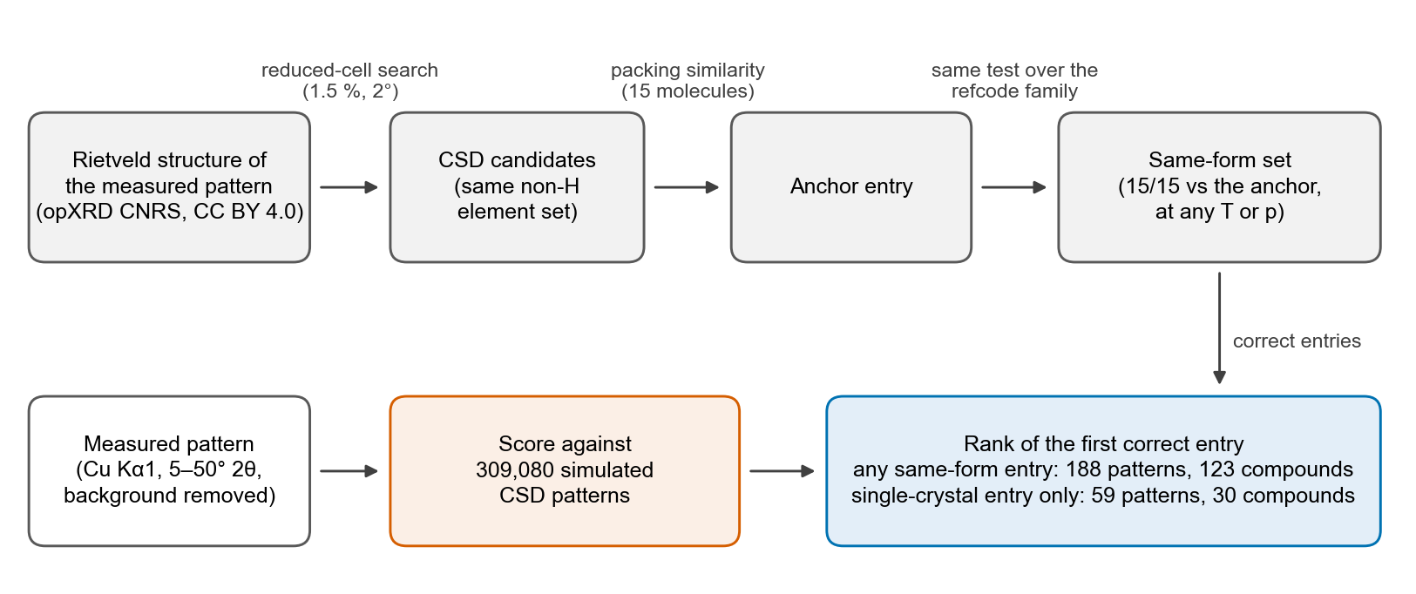
Fig. 1 Construction of the benchmark. Top: each measured pattern is identified from its own deposited structure. CSD candidates from a reduced-cell search are compared with that structure by packing similarity, and the matching anchor entry is compared with its refcode family to collect every entry of the same solid form. Bottom: the measured pattern (on a Cu Kα1 2θ axis, Kα2 retained) is scored against all 309,080 simulated library patterns, and the rank of the first correct entry is recorded under two answer sets.
189 of the 196 patterns were identified. The other seven are three Si frameworks or silsesquioxanes that passed the element filter and four patterns with no packing match. One identified pattern was excluded because its 2θ axis runs from 0.01 to 0.83, probably radians. That leaves 188 patterns of 123 compounds. Most compounds have one pattern (110 of 123), but a few have many: ZZZUWK has 20 (a variable-temperature series), ZZZIZM 12 and NAPHTA 10.
Same-form sets were built within the anchor’s refcode family, so a same-form entry deposited under another refcode would be scored as an error. To check, we compared every wrong first-ranked entry of the classical scores (454 cases over both answer sets) with the pattern’s anchors by packing similarity. One entry, GOFWUV, is the same form as the anchor of one QQQAUJ pattern; correcting it would raise every classical score’s per-pattern top-1 by 1/188. We leave the labels as built and report this here.

2.3 Two definitions of the correct answer
For 184 of the 188 patterns, the CSD contains a powder-study entry that reproduces the deposited structure to within 0.05 Å RMSD (150 strict and 34 lenient anchors), so the pattern is the data that entry was refined against²⁸. Finding that entry tests whether a method can read a measured pattern, but it is close to self-retrieval. We therefore score two answer sets.
- Single-crystal entry only (59 patterns, 30 compounds): same-form entries that are powder studies are set aside, so the answer must be an independent single-crystal determination. This is the realistic case of a new measurement checked against a database, and we treat it as the headline.
- Any same-form entry (188 patterns, 123 compounds): any entry in the pattern’s same-form set is correct. This is an upper bound on what a method can do with these patterns.
We also report within-family retrieval, the rank of the correct form among the compound’s own forms in the library (51 patterns of 35 compounds; chance 0.40), which is the polymorph-identification question in isolation.

2.4 Library
The library holds 309,080 simulated patterns: the 308,862 molecular crystals of the xrd-clip corpus (organic CSD entries without disorder, R ≤ 7.5 %, Z′ ≤ 2, after removing duplicate redeterminations)¹⁸ and 218 same-form or polymorph entries of the benchmark compounds that the corpus filter had removed; 28 further entries have no coordinates in the CSD. Stick patterns (Cu Kα1) were computed with the XRDCalculator module of pymatgen²⁹; recomputing 296 randomly drawn entries with pymatgen 2026.4.16 reproduces the stored sticks exactly. The sticks were rendered with one pseudo-Voigt profile (Caglioti-type width, U = 0.002, V = −0.001, W = 0.004 deg², η = 0.5)³⁰, without Debye–Waller factors, texture, background or noise; a library closer to the measurements is tested in Sections 3.7 and 4.6. For disordered entries whose CIF fails a strict parse, coincident sites are merged by rescaling occupancies; the own entry of 28 patterns (9 compounds) is disordered.

2.5 Metrics
For each pattern and score, the rank of the first correct entry is 1 plus the number of entries that are neither correct nor set aside and that score strictly higher than the best correct entry; ties therefore favour the correct entry. Top-k is the fraction of patterns with rank ≤ k. Because some compounds contribute many patterns, per-pattern averages mostly measure those compounds, so our headline is the compound-weighted top-k: the mean over compounds of each compound’s top-k rate. Confidence intervals (95 %) come from 2,000 bootstrap resamples of compounds³¹, so the patterns of one compound move together; for the single-crystal set only its 30 compounds are resampled. Differences between scores and the effect of a correction are paired: both are computed on the same resampled compounds.

2.6 An open replica
The CSD licence does not allow the library or the answer sets to be redistributed. So that the results can be checked without a licence, we rebuilt the benchmark from the Crystallography Open Database (COD; CC0)^{32,33}, the source of the opXRD patterns themselves. The queries are unchanged. The library applies the corpus filter of Section 2.4 to the COD metadata (C-containing entries with coordinates, no disorder flag, R ≤ 7.5 %, Z′ of 1–2, no element outside H, C, N, O, F, S, Cl, Br, I and P), which keeps 108,716 entries, and adds 854 candidate entries of the queries (below) that the filter removes. Of these 109,570 entries, 108,902 gave stick patterns, computed and rendered exactly as for the CSD library.
The answer sets follow Section 2.2 with two changes. First, the COD has no refcode families. Candidates are COD entries with the same non-H element set whose primitive reduced cell lies within 5 % of the deposited structure’s in each length and within 6 % in volume, a wider window than in the CSD search so that temperature series are not lost. The two closest anchors are then compared with every other candidate, COD entry against COD entry with the strict settings, to give the same-form set. Second, the COD candidates include other compounds, which the CSD family search never returned. A candidate whose reduced non-H formula differs from that of every same-form entry stays an ordinary library entry, and so counts as an error when it ranks above the answer; setting the 2,670 such candidates aside, as the rule of Section 2.2 would, would remove the hardest decoys and flatter every score. Same-formula candidates that cannot be compared (23) are set aside as before. Powder or single-crystal is read from the COD method field, else from the powder tags of the CIF. This rule was fixed before any replica result was computed.
191 of the 196 patterns are identified in the COD: all 189 identified in the CSD and two more. Without the pattern with a radian axis (Section 2.2), 190 patterns of 125 compounds are scored. 35 patterns of 9 compounds have a single-crystal same-form entry, against 59 patterns of 30 compounds in the CSD, so the replica’s single-crystal set is small and its intervals are wide. Compounds are labelled as in the main benchmark. The replica is scored with the scores of Section 3.2 and the model, without the corrections of Sections 3.5 and 3.7.

3. Methods

3.1 Preprocessing
The measured patterns were scored in two forms: raw, shifted to a zero minimum and scaled to a unit maximum, and background-subtracted, in which a rolling minimum over 2° smoothed by a 2° moving average is removed before scaling. Library patterns are scored as simulated.

3.2 Classical scores
- Pearson, fixed grid. The Pearson correlation of the two patterns on the common grid, the main baseline of our earlier work¹⁸.
- Zero scan. Each score below is maximised over a constant 2θ offset of ±0.5° in 0.02° steps. This absorbs a zero error exactly and a sample-displacement error, which varies as cos θ, approximately. For converted synchrotron patterns a native zero error becomes a slightly angle-dependent shift on the Cu axis.
- WCC. de Gelder’s weighted cross-correlation¹⁹ with a triangular weight of half-width l = 1° or 2°, which makes the score degrade gradually rather than abruptly with peak shifts, plus the zero scan. With l = 0 the weight is a delta and WCC reduces to the cosine of the two patterns (cosine + zero scan). These widths are large compared with the simulated peak width (FWHM about 0.06°); the simulated sweep also includes l = 0.5°.
- ln q lag scan. Both patterns are resampled onto a ln q axis with 2,251 points, on which an isotropic lattice strain is a translation; each ln q bin takes the mean of the pattern over its width, so peak areas are kept where the bins are wider than the 2θ step. The score is a WCC with l = 0.01 in ln q, maximised over lags up to ±3 % strain and over 17 zero offsets from −0.32° to +0.32° in 0.04° steps, applied before resampling. A first version of this score sampled the ln q axis at points and used 16 offsets that skipped zero (nearest ±0.02°), which cost it accuracy on clean simulated queries (within-family top-1 0.88 rather than 1.00); we found both problems in an internal review, corrected them, and report the first version in the ESI.† The offset grid is still 0.04°, so on simulated queries the score depends on whether an applied offset falls on the grid (Section 4.1).
In the simulated sweep the l = 0 variant was applied to standardised patterns, which makes it Pearson + zero scan; on the measured patterns it is cosine + zero scan. A variable-cell method²² was also tried in the sweep but is not reported, because our reimplementation has not been validated against the reference code; on the measured patterns we run the reference code itself (Section 3.8).

3.3 Exact scores on a GPU
The full-library ranks were first computed on CPUs. The hubness analysis (Section 4.4) needs every score, not only ranks, so we ported the scores to PyTorch³⁴. Folding the triangle weight into the reference turns every zero offset into one matrix product: for weights w_k and shift d, Σ_k w_k Σ_x q(x) r(x + d + k) = Σ_x q(x) r_w(x + d), with r_w the reference convolved with w. On one RTX 4090 the scores of 8,188 rows (benchmark patterns and probes) against all 309,080 entries took 761 s. The GPU scores agree with the CPU scores to 4 × 10⁻⁶ and reproduce the CPU ranks with no top-1 change (ESI†). The corrected ln q scan of Section 3.2 was rescored alone (405 s) and reproduces its CPU ranks with no top-1 change.

3.4 Learned model
The model is the xrd-clip checkpoint of ref.¹⁸ (6.1 million parameters). A one-dimensional residual convolutional network encodes the pattern on the grid above; a Transformer over the atoms of the asymmetric unit, with a lattice token, encodes the structure; both map to a 256-dimensional unit vector. It was trained once (one seed) for 60 epochs with a symmetric InfoNCE loss^{35,36}, batch size 512 and polymorph hard-negative batches (sibling polymorphs placed in the same batch), on 247,089 CSD structures of a scaffold- and polymorph-family split. Patterns were simulated on the fly with random zero offset, isotropic strain, Caglioti and crystallite-size broadening, March–Dollase texture³⁷, background and Poisson noise, but without Kα2. The checkpoint was chosen by in-batch validation top-1. A measured pattern is scored against the library by the cosine between its pattern embedding and each entry’s structure embedding. We also test the model as a shortlist, re-ranking its top 100 or 1,000 entries with a classical score. Further details are in the ESI.†
Three diagnostics probe the failure reported in Section 4.5. (i) Effect ladder. Each pattern’s own library entry is rendered cleanly and then with one effect of the measurement at a time, each estimated from the measured pattern: its 2θ coverage, its peak width, Kα2 (lab Cu patterns), its own background followed by the background subtraction of Section 3.1, noise at its noise level, and the zero offset that best aligns it with its entry; then with all six, and with all six plus an overall Debye–Waller factor (B = 4.45 Å², from the library, Section 3.7), log-normal intensity jitter per reflection (σ = 0.3 or 0.5), or both (σ = 0.3). Every variant is scored with the answer sets of the measured pattern. Two of the effects use the own entry, so the ladder diagnoses the model and is not a method. (ii) Pattern to pattern. The clean library patterns are passed through the model’s pattern encoder, so measured patterns are matched against simulated patterns in the learned space without the structure encoder. (iii) Realism retrain. The model was retrained once with the design and a prediction fixed before training (repository commit 3b77818): the same split, architecture, hyperparameters, epochs, hard-negative batches and checkpoint rule, with the training simulation extended by a Kα2 copy (probability 0.6, I₂/I₁ = 0.5), an overall Debye–Waller factor with B drawn uniformly from 0–8 Å², log-normal intensity jitter per reflection with σ drawn uniformly from 0–0.5, a cut of the 2θ range (probability 0.25; start 5–12°, end 30–50°), and the background subtraction applied to the measured patterns. The retrained model is scored like the original, including the ladder.

3.5 Hubness diagnosis and correction
A hub is a library entry that scores highly against many unrelated queries. We measured hubness with probe patterns rather than the benchmark patterns: 4,000 library entries simulated cleanly and 4,000 simulated with the training-time degradations and then background-subtracted like the measured patterns, drawn only from compounds outside the benchmark, with pairs from the same compound excluded. For each score we report the skewness of N₁₀, the number of probes that have an entry among their ten best matches²⁶. With 4,000 probes and 309,080 entries the mean N₁₀ is 0.13, so these skewness values are not comparable with those of the hubness literature.
The analysis is exploratory: it was prompted by one entry that was the wrong first answer for many patterns (Section 4.4). The correction itself was fixed before any corrected number was computed (repository commit 2a2ad8a): cross-domain similarity local scaling (CSLS)³⁸ on the library side, s′(q, r) = s(q, r) − h₁₀(r)/2, where h₁₀(r) is the mean of entry r’s ten highest scores against the degraded probes. The query-side term of CSLS is the same for every entry and does not change ranks. As sensitivity checks we report k = 1–100, clean probes, library-side z-normalisation and mutual proximity³⁹ (ESI†); none was selected after seeing the results.

3.6 Simulated sweep
The sweep reuses the within-family test of ref.¹⁸: 1,077 held-out polymorph families with 2,835 query structures, where the query is one form’s simulated and degraded pattern and the candidates are the clean patterns of the family’s forms (composition-only chance 0.38). In the clean condition the query is the candidate’s own rendering, so every profile score that can align it exactly scores 1.00; the sweep measures how far each method falls from that starting point. Each condition varies one degradation: zero offset up to 0.3°, isotropic strain up to 1.2 %, crystallite size down to 10 nm, March–Dollase r down to 0.5 and counting noise; or an anisotropic thermal strain for a temperature change of 50–200 K, with per-axis expansion coefficients drawn so that the mean volumetric coefficient (about 1.65 × 10⁻⁴ K⁻¹) matches the CSD survey of ref.⁴⁰; or combinations with random offsets and strains. Every method scores the same rendered queries, and CIs come from a bootstrap over families. The sweep has 34 distinct conditions (a zero offset of 0° is the clean condition). Each condition’s random draws are seeded from a checksum of its name, so the sweep can be regenerated exactly. (A first run seeded them from Python’s salted string hash, which cannot be regenerated; every sweep number here is from the rerun.)

3.7 A library closer to the measurements
The library of Section 2.4 leaves out several features of the measured patterns. As a robustness check, all classical scores were recomputed with one package of changes, fixed before scoring (repository commit 4d4dae3). (a) An overall Debye–Waller factor on the library intensities, I exp(−2Bs²) with s = sin θ/λ and B = 4.45 Å², which is 8π² times the median mean non-H U_eq of 5,000 random library entries measured at 283–303 K. (b) For the 68 patterns not measured with Cu Kα, the Lorentz–polarisation factor converted from the measurement to Cu Kα1, with polarisation (1 + cos² 2θ)/2 for laboratory tubes and none for synchrotrons (an assumption). (c) For the 125 laboratory-tube patterns, Kα2 as a nuisance: the score is the higher of those against a Kα1 library and a Kα1 + Kα2 library (I₂/I₁ = 0.5), because opXRD does not record whether the beam was monochromated. (d) For the 46 patterns that do not cover 5–50°, comparison over the measured range only (reference norms over the query’s coverage, not shifted with the zero scan). Each change was also removed on its own to give one-off ablations. None of the four was selected after seeing results.

3.8 Variable-cell re-rank
Single-crystal references fail mainly when their cell differs from the measured one (Section 4.2), which variable-cell comparison is designed to absorb. We re-ranked shortlists with VC-GPWDF²² as implemented in critic2 1.4⁴¹, which compares a candidate structure with a measured pattern while varying the candidate’s cell (±10 % in lengths and ±5° in angles in its quick mode). We ran the published pipeline: background fit with 20 knots, peak fit with the default settings, and the global quick comparison with α = 1 as in the paper (the code’s default is 0.5) and the measurement wavelength; it applies no zero-offset correction. One step was added: each pattern was cut to the d-spacing window that the other scores see (Cu Kα1 2θ of 5–50°). The shortlist of each single-crystal pattern is the 50 best entries of ln q, with set-aside entries excluded; a pattern whose answer is not in its shortlist counts as a miss, and a comparison that fails or runs past a 4-hour limit counts as maximally dissimilar. We had planned a shortlist of 100, but the shortlist holds the answer for the same 36 of the 59 patterns at 50 as at 100, so the further entries could only have added competitors; the shorter list is, if anything, favourable to the re-rank. A comparison took a median of 2.2 CPU-minutes and up to 3.0 CPU-hours for the largest cells; one of the 2,950 comparisons reached the limit, in a shortlist that does not hold the answer, so it changes no result.

4. Results

4.1 Simulated queries: the model loses in every condition
Across the 34 conditions the model scores 0.47–0.57 within-family top-1 and the best classical score 0.64–1.00 (Fig. 2). The best classical score leads by 0.12 to 0.48, and the 95 % CIs never overlap. The result does not depend on picking the best score per condition: WCC (each of l = 0.5°, 1° and 2°) and the ln q scan beat the model with non-overlapping CIs in all 34 conditions, and Pearson + zero scan in 32.
The fixed-grid Pearson baseline of our earlier work behaves as reported there: it falls to chance by a 0.15° zero offset or a 0.8 % strain, while the model is flat (Fig. 2a and b). The zero scan removes that weakness: Pearson + zero scan scores 1.00 at every offset that is a multiple of the 0.02° step; the dips at 0.05° and 0.15° are offsets that fall between grid points. The ln q scan, whose offsets are 0.04° apart, also dips at 0.1° and 0.3° (0.88 at both). It holds 0.89 at 1.2 % isotropic strain. The model’s curves are flat, but they are flat at about 0.55; its clean within-family top-1 is 0.56. The smallest gap, −0.12, comes from large anisotropic thermal strain combined with a degraded profile. Even there, WCC (l = 0.5°) leads, 0.64 against 0.52, with WCC (l = 1°) and the ln q scan within 0.01 of it.
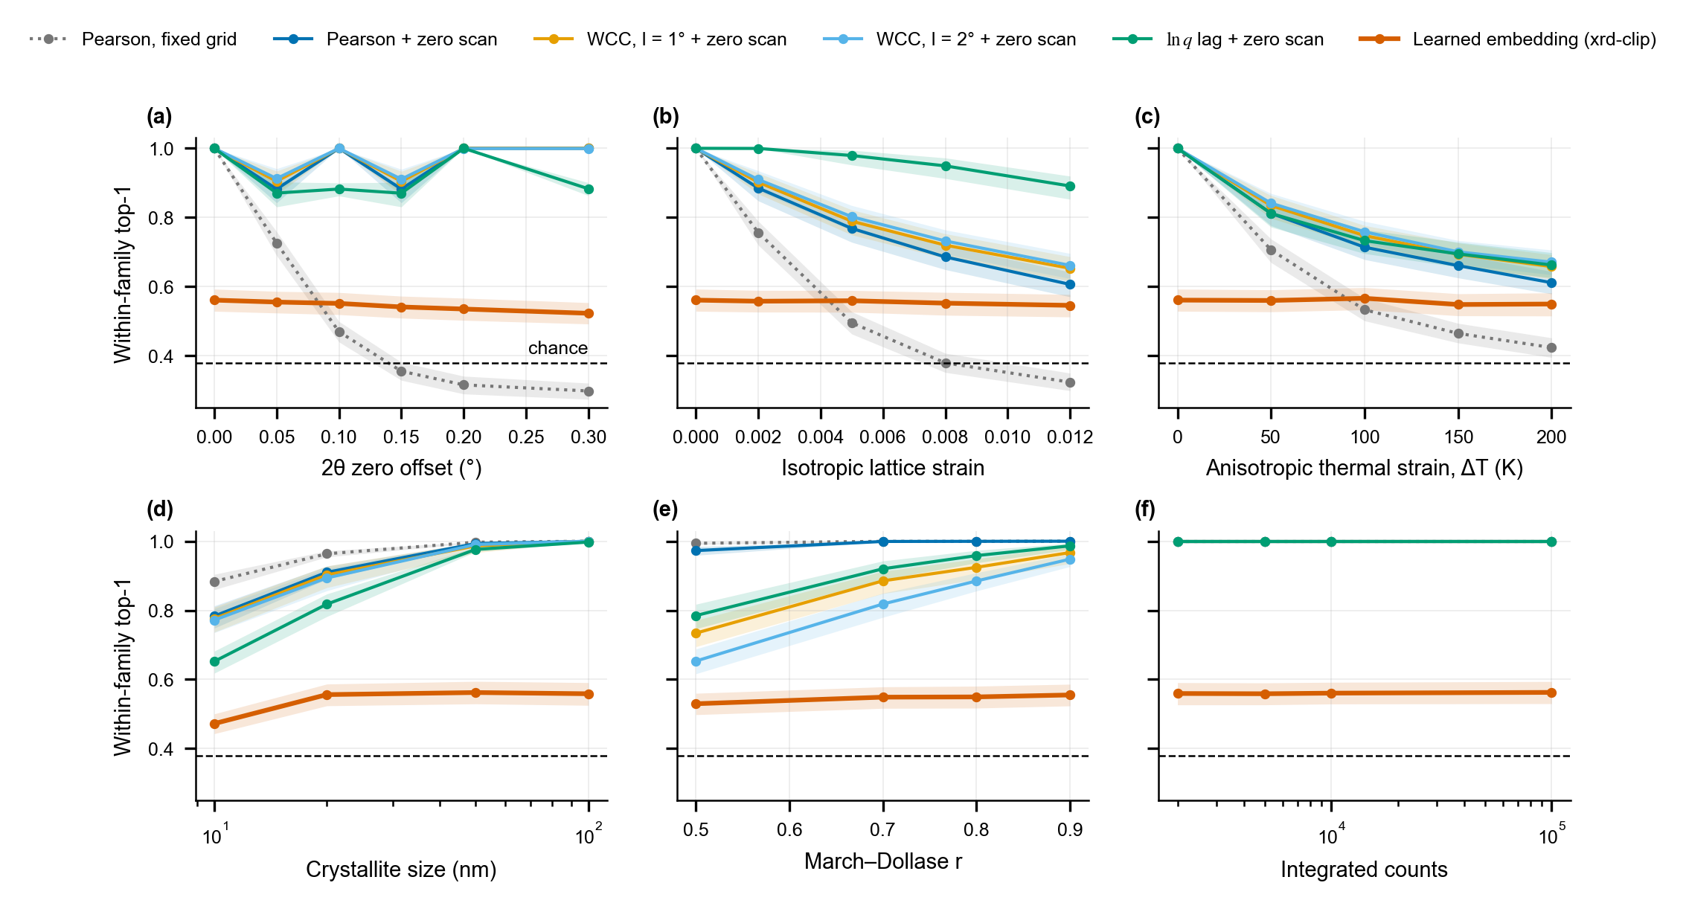
Fig. 2 Simulated stress test: within-family top-1 over 1,077 polymorph families (2,835 queries). Bands are 95 % family-bootstrap CIs; the dashed line is composition-only chance (0.38). (a) 2θ zero offset, (b) isotropic lattice strain, (c) anisotropic thermal strain, (d) crystallite size, (e) March–Dollase preferred orientation, (f) counting statistics. The l = 0 score is Pearson + zero scan here (cosine + zero scan on the measured patterns). In (a), the zero-scan scores dip at offsets that fall between the points of their 0.02° offset grid (0.05° and 0.15°), and the ln q score at offsets off its 0.04° grid (0.05°, 0.1°, 0.15° and 0.3°).

4.2 The realistic case: independent single-crystal references
When the pattern’s own powder-study entry is set aside and only independent single-crystal determinations count, the classical scores reach 0.30–0.50 compound-weighted top-1 (Table 1, Fig. 3a) and the model 0.00. For 34–47 % of these patterns the first correct entry lies beyond rank 1,000 for every classical score.
Strain tolerance helps here, although the intervals are wide. Paired over compounds, WCC (l = 1°) beats fixed-grid Pearson by 0.20 [0.03, 0.36]; the ln q scan (+0.15 [0.00, 0.31]), cosine + zero scan (+0.10 [−0.05, 0.24]) and WCC (l = 2°, +0.16 [−0.03, 0.35]) are not resolved. The ln q scan has the best median rank, 7.
What separates success from failure is how well the cells agree. Where the closest single-crystal entry has every cell length within 1 % of the powder-study entry’s, the ln q scan ranks it first for 0.68 of patterns (34 patterns); where they differ by more, for 0.08 (25 patterns). Thermal expansion is the obvious suspect, since a typical molecular crystal expands by about 3 % in volume between 100 K and room temperature⁴⁰, but the recorded temperatures of the two entries differ by a median of 3 K for the 36 patterns where both are known, so it explains few of these mismatches. Pressure, refinement differences and the low precision of some early determinations are other candidates; we did not resolve them. The ln q scan absorbs isotropic strain up to 3 %, so its failures beyond 1 % suggest anisotropic cell differences, which variable-cell comparison is designed to absorb.
Variable-cell re-rank. Re-ranking the ln q top 50 with VC-GPWDF (Section 3.8) gives a compound-weighted top-1 of 0.50 [0.32, 0.67], against 0.45 [0.28, 0.63] for the ln q scan on the same patterns; the paired difference, +0.05 [−0.11, 0.20], does not resolve them, and at top-10 the re-rank is no better (0.59 against 0.61). Per pattern, the re-rank ranks the answer first for 26 of the 59 patterns and the ln q scan for 25. Of the 36 patterns whose shortlist holds the answer, the re-rank moves it to first place for 4 (from ln q ranks 2, 3, 7 and 9) and moves ln q’s correct first choice down for 3 (to ranks 2, 22 and 50, the last of its shortlist). Where the cells differ by more than 1 %, it ranks the answer first for 4 of the 25 patterns, against 2 for the ln q scan; where they agree, for 22 of 34, against 23. Variable-cell comparison recovers a few of the mismatched cells, but most single-crystal failures remain: for 23 of the 59 patterns the answer is not among the 50 entries re-ranked, and 21 of the 25 patterns with mismatched cells still fail.
Table 1 Retrieval of 188 measured opXRD patterns from 309,080 simulated CSD entries (background-subtracted queries, no hubness correction). Compound-weighted top-1 and top-10, with 95 % compound-bootstrap CIs for top-1; per-pattern top-1; median rank of the first correct entry over patterns. The variable-cell re-rank exists for the single-crystal set only; a pattern whose answer is not in its shortlist counts as a miss, and its median rank falls inside the shortlist.
Score | Single-crystal entry only (30 compounds): top-1 | top-10 | median rank | Any same-form entry (123 compounds): top-1 | top-10 | per-pattern top-1 | median rank
VC-GPWDF re-rank of the ln q top 50 | 0.50 [0.32, 0.67] | 0.59 | 3 | – | – | – | –
ln q lag + zero scan | 0.45 [0.28, 0.63] | 0.61 | 7 | 0.87 [0.82, 0.93] | 0.93 | 0.72 | 1
WCC, l = 1° + zero scan | 0.50 [0.32, 0.67] | 0.57 | 50 | 0.83 [0.76, 0.89] | 0.89 | 0.68 | 1
WCC, l = 2° + zero scan | 0.47 [0.30, 0.63] | 0.53 | 350 | 0.71 [0.63, 0.78] | 0.81 | 0.57 | 1
Cosine + zero scan | 0.40 [0.24, 0.57] | 0.46 | 31 | 0.84 [0.78, 0.90] | 0.94 | 0.72 | 1
Pearson, fixed grid | 0.30 [0.15, 0.48] | 0.32 | 131 | 0.83 [0.77, 0.89] | 0.88 | 0.82 | 1
Learned embedding | 0.00 [0.00, 0.00] | 0.00 | 18,725 | 0.02 [0.00, 0.04] | 0.04 | 0.01 | 5,988.5

4.3 When the pattern’s own entry counts
With every same-form entry correct, the classical scores reach a compound-weighted top-1 of 0.71–0.87: the ln q scan 0.87, cosine + zero scan 0.84, Pearson and WCC (l = 1°) 0.83, and WCC (l = 2°) 0.71. Paired over compounds, only WCC (l = 2°) differs from fixed-grid Pearson (−0.12 [−0.21, −0.03]); the others are within ±0.05 of it with CIs spanning zero. Top-10 is 0.88–0.94 for all but WCC (l = 2°). The learned model reaches 0.02, and 0.04 at top-10; its median rank for the first correct entry is about 6,000.
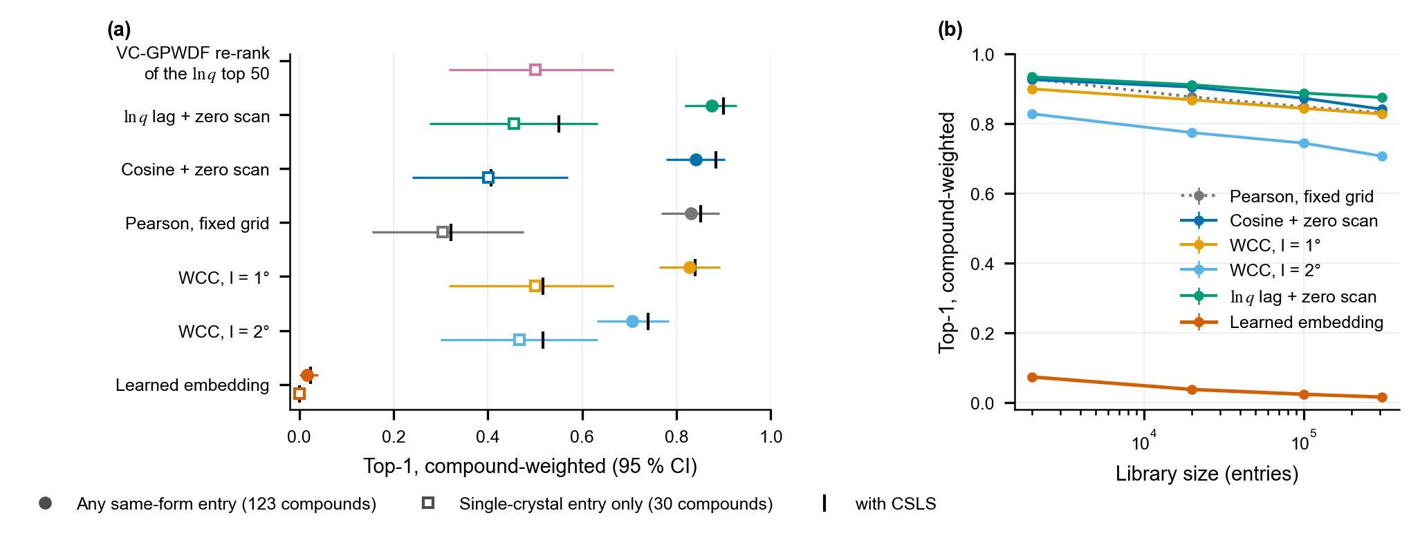
Fig. 3 Retrieval of 188 measured patterns from 309,080 simulated CSD entries (background-subtracted queries). (a) Compound-weighted top-1 with 95 % compound-bootstrap CIs when any same-form entry is correct (filled circles, 123 compounds) and when only independent single-crystal entries are correct (open squares, 30 compounds); vertical bars mark the value with the CSLS hubness correction. The top row is the variable-cell re-rank of the ln q top 50, which exists for the single-crystal set only. (b) Compound-weighted top-1 against library size (any same-form entry; random decoy subsets; the s.d. over five draws is below 0.02).
Background subtraction matters. Without it, compound-weighted top-1 drops to 0.78 for Pearson, 0.72 for cosine + zero scan, 0.39 for WCC l = 1° and 0.27 for WCC l = 2°. The loss is much larger with a triangle weight (0.44 for both widths) than without one (0.12 for cosine + zero scan), presumably because a triangle averages each comparison over neighbouring points, so a slowly varying background contributes to every overlap. Our background removal is a simple rolling minimum, and a better one may help further.
Per-pattern and compound-weighted rankings differ. Per pattern, fixed-grid Pearson leads (0.82) and the zero-scan scores trail (0.57–0.72). Pearson ranks 28 patterns first that cosine + zero scan misses, and cosine + zero scan 10 that Pearson misses; 12 of the net difference of 18 come from one compound, ZZZUWK, which contributes 20 of the 188 patterns (Section 4.4). Without ZZZUWK, Pearson still leads per pattern (0.85 against 0.81 for cosine + zero scan and the ln q scan).
Disordered entries are harder. For the 28 patterns (9 compounds) whose own entry is disordered, the classical scores reach 0.56–0.78 compound-weighted top-1, against 0.71–0.88 for the other 160 patterns. Our simulation treats these entries only approximately (Section 2.4). Converted non-Cu patterns are not harder than Cu patterns (ESI†).
Library size. All classical scores lose 0.06–0.12 in compound-weighted top-1 between a 2,000-entry library and the full one (Fig. 3b): Pearson 0.93 → 0.83, cosine + zero scan 0.93 → 0.84, WCC l = 1° 0.90 → 0.83, WCC l = 2° 0.83 → 0.71 and ln q 0.93 → 0.87. Results on small libraries overstate accuracy at database scale.
Within families, with only the compound’s own forms as candidates (chance 0.40), the classical scores reach 0.94–0.98 top-1 and the model 0.71 (51 patterns).

4.4 One compound, twenty patterns, and the hubness correction
Hubness. In the probe population, hubness depends on the score. The skewness of N₁₀ over degraded probes is 18.7 for cosine + zero scan, 12.6 for ln q, 8.0 for Pearson and 3.6 for both WCC widths.
ZZZUWK. One entry, GUSRIV, was the wrong first answer of cosine + zero scan for 20 of its 52 misses, which looks like a hub. All 20 are patterns of ZZZUWK, propan-1-aminium chloride, measured as a variable-temperature series; each pattern belongs to its own CSD powder-study entry, ZZZUWK01–20. The confusion is a property of this compound, not of a hub. Two things make it hard (Fig. 4a).
- A sparse pattern. The tetragonal salt has 24 reflections between 5° and 50° 2θ, where the median same-form entry of the benchmark has about 130; fewer than 1 % of those entries have fewer.
- Poorly reproduced intensities. The measured relative intensities differ strongly from the simulated pattern of the pattern’s own entry: (001) at 12.0° is 0.36 of the maximum against 0.07 simulated, (101) at 18.6° 0.32 against 1.00, and (110) at 20.1° 0.11 against 0.53. The changes do not follow the angle to the c axis, as March–Dollase texture along c would require, so preferred orientation alone does not explain them. All 20 own entries are disordered, omit H atoms and were anchored only in the lenient pass, so our simulation of them is the more likely culprit. The own entry consequently matches poorly: WCC l = 1° gives it a median score of 0.79, against 0.97 for the other patterns’ own entries.
Unrelated entries with strong reflections near ZZZUWK’s two strongest measured peaks (23.5° and 28.6°), such as GUSRIV and ZZZLWW01, then outscore the own entry. The zero scan contributes but is not the root cause. Without it, cosine already prefers GUSRIV for 9 of the 20 patterns (with it, all 20), and GUSRIV’s best offset is close to zero (median +0.03°); under WCC l = 1°, three decoys beat the own entry at zero offset in all 20 patterns. The more peak-tolerant the score, the more decoys pass the own entry: one decoy beats it in all 20 patterns under cosine + zero scan and seven do under WCC l = 1°. Fixed-grid Pearson, the least tolerant score, ranks the own entry first for 12 of the 20 patterns (Fig. 4b).
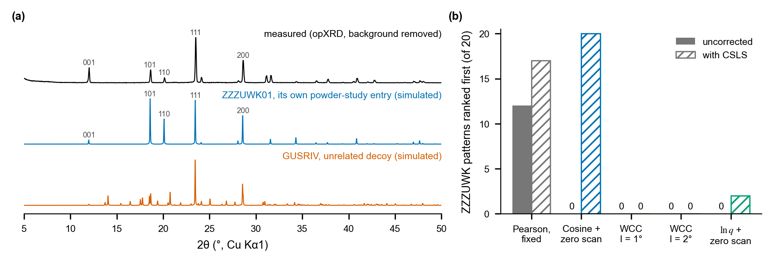
Fig. 4 The ZZZUWK case. (a) The measured pattern of propan-1-aminium chloride whose CSD entry, ZZZUWK01, was refined at 303 K (background removed), the simulated pattern of that entry, and the unrelated entry GUSRIV that cosine + zero scan ranks first. The measured and simulated relative intensities of the main reflections differ strongly. (b) Number of the compound’s 20 patterns for which each score ranks a same-form entry first, without and with CSLS.
CSLS. The correction fixes ZZZUWK for cosine + zero scan (0 → 20 of 20) and raises it for Pearson (12 → 17) and ln q (0 → 2); for WCC it only exchanges one decoy for another. Per pattern, cosine + zero scan rises from 0.72 to 0.88. Compound-weighted, the change is +0.01 to +0.04 for the classical scores, and no 95 % CI of the paired difference excludes zero; gains of up to 0.10 are not excluded (ESI†). For single-crystal references the change is +0.01 to +0.10, with upper CI bounds up to 0.20, and for the learned model it is 0.02 → 0.02. We detect no compound-level gain from the correction; it is a cheap option that removes hub-like confusions when they occur.

4.5 Why the learned model fails
The model ranks the first correct entry at a median of about 6,000 of 309,080 (Fig. 5a). Four diagnostics locate the failure.
It retrieves simulated patterns. For the 4,000 clean simulated probes of Section 3.5, the model ranks the probe’s own entry first for 0.42 of probes and within the top 10 for 0.84 (median rank 2); with the training-time degradations, for 0.28 and 0.67 (median rank 4). For the clean simulated patterns of the benchmark’s own entries, scored with the same answer sets as the measured patterns, it reaches top-1 0.21 and top-10 0.56, with a median rank of 5. On the measured patterns of the same targets it reaches 0.01 and 0.03. (A classical score would rank a clean rendering of a library entry first by construction, so this test only diagnoses the model.) The model can discriminate among 309,080 entries; what it cannot do is carry that ability from simulated to measured patterns.
Seeing the structure in training does not help. For the 81 patterns that have a same-form entry in the model’s training split, the median rank is 6,396 and top-1 is 0.01; for the 101 patterns whose same-form entries are all outside the corpus, 5,617 and 0.00 (the other 6 have entries in the validation or test split).
No single measured effect explains the gap. Rendering each pattern’s own entry with the effects of its measurement (Section 3.4) shows where the model loses ground (Fig. 6). Clean, it reaches a compound-weighted top-1 of 0.27 with a median rank of 5. One effect at a time costs it little except Kα2 (0.18, median rank 33) and the background with its subtraction (0.24, median rank 130). With all six effects it reaches 0.15 (median rank 176), and with the Debye–Waller factor added 0.05 (median rank 744), against 0.02 and about 6,000 on the measured patterns. Fixed-grid Pearson shows the contrast: with all six effects, the Debye–Waller factor and jitter its ladder ends at 0.83, the value it reaches on the measured patterns (0.83), whereas for the model the same simulated patterns leave the median rank at about 750, against about 6,000 on the measured ones.
A retrain with these effects fixes them in simulation only. We retrained the model with Kα2, a Debye–Waller factor, intensity jitter, range cuts and the background subtraction in its training simulation (Section 3.4). It learned them: on its own entries with all six effects and the Debye–Waller factor, top-1 rises from 0.05 to 0.23 and the median rank falls from 744 to 34 (Fig. 6); Kα2 alone is the exception (0.18 to 0.11). On the measured patterns the retrained model reaches a compound-weighted top-1 of 0.02 [0.00, 0.06], against 0.02 [0.00, 0.04] before, and 0.00 for single-crystal references, although its median rank halves, to about 3,000. Before training we had predicted a measured per-pattern top-1 of 0.05–0.20, and that a value below 0.03 would mean the remaining gap is not the modelled effects; it is 0.02. For this model, what separates the measured patterns from their simulations is something we did not model.
Pattern to pattern. Matching the measured patterns to the simulated library patterns in the model’s pattern space, without the structure encoder, reaches a compound-weighted top-1 of 0.13 (median rank about 1,600), and 0.21 (about 270) with the retrained encoder. The classical scores do the same task, measured pattern against simulated pattern, at 0.71–0.87. The pattern encoder itself, not only the step to the structure encoder, places measured patterns away from simulations of the same structures.
Within families, where it only has to separate a compound’s forms, the model reaches 0.71 against 0.94–0.98 for the classical scores. As a shortlist it caps any re-ranker: its top 1,000 contains a correct entry for only 0.28 of patterns, and re-ranking that list with a classical score gives 0.19–0.26 per-pattern top-1, against 0.57–0.82 for the same scores on the full library.
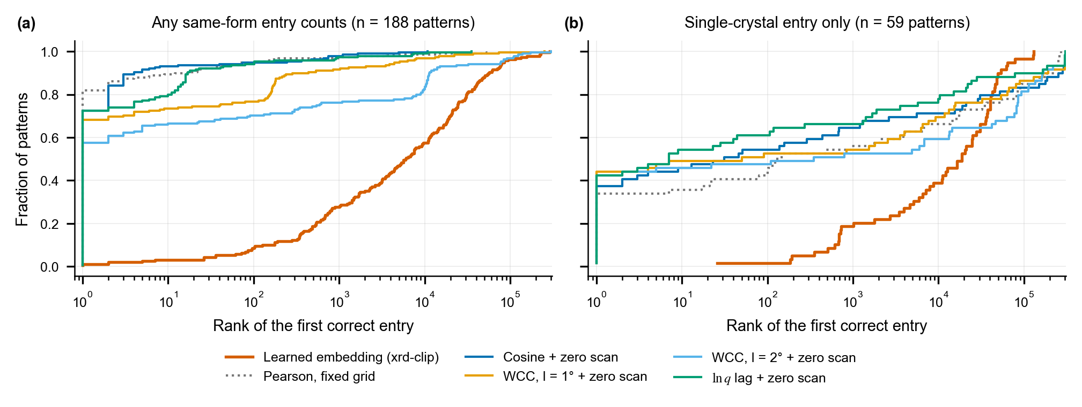
Fig. 5 Cumulative distribution of the rank of the first correct entry over the full library when (a) any same-form entry is correct and (b) only independent single-crystal entries are correct. Background-subtracted queries, no hubness correction.
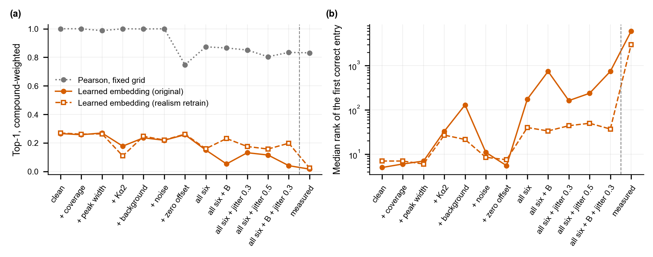
Fig. 6 Effect ladder. Each pattern’s own library entry is rendered cleanly, with one effect of its measurement at a time, with all six, and with an overall Debye–Waller factor (B), log-normal intensity jitter per reflection (σ = 0.3 or 0.5) or both added; the last point is the measured patterns themselves (Section 3.4). Answer set: any same-form entry (188 patterns, 123 compounds). (a) Compound-weighted top-1 for fixed-grid Pearson, the original model and the model retrained with these effects; (b) median rank of the first correct entry for the two models.

4.6 A library closer to the measurements
With the package of Section 3.7, the classical scores change by −0.04 to +0.04 in compound-weighted top-1, paired against the main benchmark (Table 2). Only one change is resolved: cosine + zero scan rises by 0.04 [0.01, 0.08] when any same-form entry counts. The one-off ablations, each change removed alone and paired against the full package, attribute that gain to the Kα2 nuisance (−0.03 [−0.07, −0.01] without it) and show that restricting the comparison to the measured range costs WCC (l = 2°) when any same-form entry counts (+0.05 [0.02, 0.09] without it). We had expected every single-crystal score to rise; they move by −0.04 to +0.04, with every interval including zero. The learned model scores 0.00 with this library on both sets. The classical results are therefore robust to these choices of library simulation, and the single-crystal failures are not caused by them.

4.7 The open replica
Against the 108,902 COD entries, the 190 patterns reproduce the main result (Table 2). When any same-form entry counts, the classical scores reach a compound-weighted top-1 of 0.77–0.90 (125 compounds; ln q 0.90 [0.85, 0.95]) and the model 0.02 [0.00, 0.04]. The single-crystal set has 35 patterns but only 9 compounds; there the classical scores reach 0.26–0.58 and the model 0.00, with intervals too wide to order the classical scores. The COD library is about a third of the size of the CSD library, and smaller libraries favour every score (Fig. 3b). All numbers in this section can be regenerated without a CSD licence.
Table 2 Compound-weighted top-1 on the main benchmark (CSD library, Table 1), with the library of Section 3.7 (CSD, realistic) and on the open replica (COD library, Section 2.6). The single-crystal set has 30 compounds in the CSD and 9 in the COD; the any-same-form set has 123 and 125. Intervals are in the ESI.†
Score | Single-crystal: CSD | CSD, realistic | COD | Any same-form: CSD | CSD, realistic | COD
ln q lag + zero scan | 0.45 | 0.49 | 0.56 | 0.87 | 0.86 | 0.90
WCC, l = 1° + zero scan | 0.50 | 0.52 | 0.56 | 0.83 | 0.81 | 0.88
WCC, l = 2° + zero scan | 0.47 | 0.50 | 0.44 | 0.71 | 0.69 | 0.77
Cosine + zero scan | 0.40 | 0.44 | 0.58 | 0.84 | 0.88 | 0.89
Pearson, fixed grid | 0.30 | 0.27 | 0.26 | 0.83 | 0.81 | 0.87
Learned embedding | 0.00 | 0.00 | 0.00 | 0.02 | 0.00 | 0.02

5. Discussion
What a learned retrieval method has to beat. On measured organic patterns searched against the CSD, the bar is set by simple classical scores on background-subtracted patterns: a compound-weighted top-1 of about 0.5 when the reference is an independent single-crystal structure, reached by the strain-tolerant WCC and ln q scans and by a variable-cell re-rank, and of 0.83–0.87 when the pattern’s own powder-study entry is in the library, where even fixed-grid Pearson correlation reaches 0.83. We suggest that learned PXRD retrieval be reported (i) on measured patterns, (ii) against a library of realistic size, (iii) against shift- and strain-tolerant correlation scores with background subtraction, (iv) with compound-weighted metrics and a compound-level bootstrap whenever compounds repeat, and (v) separately for queries whose reference is an independent determination. The benchmark released with this paper supports all five, and its open replica lets them be checked without a CSD licence.
Speed is the model’s one advantage. With precomputed library embeddings, the model searches 309,080 entries in about 5 ms per query on a CPU. From the per-pair costs of the simulated sweep, one CPU core needs about 0.4 s per query for fixed-grid Pearson, about 20 s for a zero scan and about 6 min for the ln q scan. On one GPU, all five classical scores of 8,188 patterns against the full library took 761 s, and the corrected ln q scan alone 405 s. The variable-cell re-rank is much slower: a median of 2.2 CPU-minutes per comparison and about 400 CPU-hours for the 2,950 comparisons of 59 shortlists. Speed only matters once accuracy does, and a shortlist from this model loses most correct entries (Section 4.5).
Where learning could still help. Two problems remain open, and both concern the gap between simulated and measured patterns. For independent single-crystal references, retrieval fails once the cells differ by more than about 1 %. The published variable-cell method²² recovers few of these cases and is bounded by the shortlist it re-ranks, so the case stays open for classical methods too, and it is where a learned method could show its value. For the learned model, the failure is the transfer from simulated to measured patterns, not the size of the library, and it survives a retrain with every measurement effect we could simulate. Full-profile generative models have shown the same sensitivity to how realistic the training patterns are⁹. A learned method aimed at that transfer, for example one adapted with measured patterns rather than with more simulated effects, is the more promising use of learning than a stand-alone retriever.
Limitations. We tested one learned model, trained once and retrained once with a more realistic simulation; another architecture, loss or training strategy could do better, and our conclusions about learning are about this model. The benchmark has 123 compounds, all organic, from one contributor to opXRD, and most patterns are the data their own entry was refined against; the single-crystal set has 30 compounds, so its intervals are wide, and that of the open replica only 9. The main library is simulated with one peak profile and without Debye–Waller factors or Kα2; a package of such changes moved little (Section 4.6) but does not exhaust them, and disordered entries are simulated only approximately. The measured patterns have a simple background removal. The zero scans use fixed offset grids (0.02°, and 0.04° for the ln q scan), and the variable-cell re-rank covers a shortlist of 50 with a 4-hour limit per comparison. The correct answers rely on packing similarity, set aside entries that cannot be compared, and contain one known error (Section 2.2). Retrieval identifies known forms only; crystal structure prediction combined with pattern matching can identify forms that no database contains⁴².

6. Conclusions
On 188 measured organic patterns searched against 309,080 simulated CSD entries, a contrastive PXRD–structure model reaches a compound-weighted top-1 of 0.02, against 0.71–0.87 for classical profile matching; with independent single-crystal references, 0.00 against 0.30–0.50, and 0.50 for a variable-cell re-rank, which is not resolved from the ln q scan it re-ranks. The model retrieves clean simulated patterns of the same targets, and a retrain with the measurement effects we could simulate fixes those effects in simulation but not on the measured patterns, so its failure lies in a part of the step from simulated to measured data that we did not model. A more realistic library and an open replica built from the COD give the same picture. The hard open case is a measured pattern whose only reference is an independent single-crystal structure with a cell that differs by more than about 1 %. We release the benchmark so that learned methods can be compared with these numbers on measured data.

Data availability
The code, the benchmark definition and all results are available at [GitHub URL] and archived at Zenodo ([DOI]). The deposit contains: the opXRD pattern identifiers with their CSD refcodes, same-form sets and packing-similarity results; the corpus refcode list and the training splits; the per-pattern ranks of every score and correction, including the learned model’s and the variable-cell re-rank’s; the scripts that build the library from a CSD installation, compute the scores (CPU and GPU) and regenerate every table and figure; and results/paper_numbers.json, from which every number in this article is checked by scripts/verify_claims.py. The open replica of Section 2.6 is included in full: the COD identifiers, the simulated COD library, its answer sets and the ranks of every score, from which Section 4.7 and Table 2 can be reproduced without a CSD licence. The measured patterns are from opXRD²⁷ under CC BY 4.0, and the COD structures are CC0. CSD structures and the simulated patterns derived from them cannot be redistributed; users with a CSD licence regenerate them from the refcode lists. The model checkpoints, the original and the retrained one, were trained on CSD data and are not distributed.

Author contributions
F. C. conceived the study, wrote the code, ran the computations and analysis, and wrote the manuscript.

Conflicts of interest
There are no conflicts to declare.

Acknowledgements
The author thanks the opXRD and COD contributors whose deposited powder data made the benchmark possible, and the CCDC for the CSD and its Python API. GPU time was rented from commercial cloud providers. This research received no specific grant from any funding agency in the public, commercial, or not-for-profit sectors. [AI-use statement: FRANK, in his own words; RSC asks for it here.]

Notes and references
1 S. Gates-Rector and T. Blanton, Powder Diffr., 2019, 34, 352–360.
2 C. R. Groom, I. J. Bruno, M. P. Lightfoot and S. C. Ward, Acta Crystallogr., Sect. B, 2016, 72, 171–179.
3 J. Bauer, S. Spanton, R. Henry, J. Quick, W. Dziki, W. Porter and J. Morris, Pharm. Res., 2001, 18, 859–866.
4 A. J. Cruz-Cabeza, S. M. Reutzel-Edens and J. Bernstein, Chem. Soc. Rev., 2015, 44, 8619–8635.
5 Q. Lai, F. Xu, L. Yao, Z. Gao, S. Liu, H. Wang, S. Lu, D. He, L. Wang, L. Zhang, C. Wang and G. Ke, Adv. Sci., 2025, 12, 2410722.
6 C. Xu, T. Su, J. Xiong, Y. Wu, S. Dong, T. Jiang, M. He, S. Chen and T.-Y. Zhang, npj Comput. Mater., 2026, 12, 144.
7 Z. Yang, C. M. Collins, B. Peng, L. M. Daniels, M. J. Rosseinsky and V. V. Gusev, arXiv, 2026, arXiv:2610.10653.
8 F. L. Johansen, U. Friis-Jensen, E. B. Dam, K. M. Ø. Jensen, R. Mercado and R. Selvan, Trans. Mach. Learn. Res., 2026, https://openreview.net/forum?id=LftFQ35l47.
9 N. Segal, M. Li, B. K. Miller and R. Gómez-Bombarelli, arXiv, 2026, arXiv:2606.14003.
10 F. L. Johansen, A. F. Sapnik, E. B. Dam, R. Selvan and K. M. Ø. Jensen, Digital Discovery, 2026, 5, 3871–3882.
11 P. Srivastava, ChemRxiv, 2026, DOI: 10.26434/chemrxiv.15009668/v2.
12 J. Lange, L. Komissarov, R. Lang, D. D. Enkelmann and A. Anelli, arXiv, 2024, arXiv:2411.03308.
13 H. Wang, M. Chen, H. Luo, W. Yin, F. Qi, X. Chai, M. Liu and F. Hou, arXiv, 2026, arXiv:2607.20880.
14 H. Schopmans, P. Reiser and P. Friederich, Digital Discovery, 2023, 2, 1414–1424.
15 M. Ferrari Dacrema, P. Cremonesi and D. Jannach, in Proceedings of the 13th ACM Conference on Recommender Systems (RecSys ’19), 2019, pp. 101–109.
16 K. Musgrave, S. Belongie and S.-N. Lim, in Computer Vision – ECCV 2020, Springer, 2020, pp. 681–699.
17 R. Bushuiev, A. Bushuiev, N. F. de Jonge, A. Young, F. Kretschmer, R. Samusevich, J. Heirman, F. Wang, L. Zhang, K. Dührkop, M. Ludwig, N. Haupt, A. Kalia, C. Brungs, R. Schmid, R. Greiner, B. Wang, D. Wishart, L.-P. Liu, J. Rousu, W. Bittremieux, H. Rost, T. Mak, S. Hassoun, F. Huber, J. J. J. van der Hooft, M. Stravs, S. Böcker, J. Sivic and T. Pluskal, in Advances in Neural Information Processing Systems 37 (Datasets and Benchmarks Track), 2024, pp. 110010–110027.
18 F. Cai, in 2026 IEEE MIT Undergraduate Research Technology Conference (URTC), 2026.
19 R. de Gelder, R. Wehrens and J. A. Hageman, J. Comput. Chem., 2001, 22, 273–289.
20 R. A. Mayo, A. Otero-de-la-Roza and E. R. Johnson, CrystEngComm, 2022, 24, 8326–8338.
21 R. A. Mayo, K. M. Marczenko and E. R. Johnson, Chem. Sci., 2023, 14, 4777–4785.
22 A. Otero-de-la-Roza, J. Appl. Crystallogr., 2024, 57, 1401–1414.
23 D. Hollarek, H. Schopmans, J. Östreicher, J. Teufel, B. Cao, A. Alwen, S. Schweidler, M. Singh, T. Kodalle, H. Hu, G. Heymans, M. Abdelsamie, A. Hardiagon, A. Wieczorek, S. Zhuk, R. Schwaiger, S. Siol, F.-X. Coudert, M. Wolf, C. M. Sutter-Fella, B. Breitung, A. M. Hodge, T. Zhang and P. Friederich, Adv. Intell. Discov., 2025, 2, e202500044.
24 J. A. Chisholm and S. Motherwell, J. Appl. Crystallogr., 2005, 38, 228–231.
25 C. F. Macrae, I. J. Bruno, J. A. Chisholm, P. R. Edgington, P. McCabe, E. Pidcock, L. Rodriguez-Monge, R. Taylor, J. van de Streek and P. A. Wood, J. Appl. Crystallogr., 2008, 41, 466–470.
26 M. Radovanović, A. Nanopoulos and M. Ivanović, J. Mach. Learn. Res., 2010, 11, 2487–2531.
27 D. Hollarek and P. Friederich, Zenodo, 2025, DOI: 10.5281/zenodo.15298026.
28 H. M. Rietveld, J. Appl. Crystallogr., 1969, 2, 65–71.
29 S. P. Ong, W. D. Richards, A. Jain, G. Hautier, M. Kocher, S. Cholia, D. Gunter, V. L. Chevrier, K. A. Persson and G. Ceder, Comput. Mater. Sci., 2013, 68, 314–319.
30 G. Caglioti, A. Paoletti and F. P. Ricci, Nucl. Instrum., 1958, 3, 223–228.
31 C. A. Field and A. H. Welsh, J. R. Stat. Soc. Ser. B, 2007, 69, 369–390.
32 S. Gražulis, D. Chateigner, R. T. Downs, A. F. T. Yokochi, M. Quirós, L. Lutterotti, E. Manakova, J. Butkus, P. Moeck and A. Le Bail, J. Appl. Crystallogr., 2009, 42, 726–729.
33 A. Vaitkus, A. Merkys and S. Gražulis, J. Appl. Crystallogr., 2021, 54, 661–672.
34 A. Paszke, S. Gross, F. Massa, A. Lerer, J. Bradbury, G. Chanan, T. Killeen, Z. Lin, N. Gimelshein, L. Antiga, A. Desmaison, A. Köpf, E. Yang, Z. DeVito, M. Raison, A. Tejani, S. Chilamkurthy, B. Steiner, L. Fang, J. Bai and S. Chintala, in Advances in Neural Information Processing Systems 32, 2019.
35 A. van den Oord, Y. Li and O. Vinyals, arXiv, 2018, arXiv:1807.03748.
36 A. Radford, J. W. Kim, C. Hallacy, A. Ramesh, G. Goh, S. Agarwal, G. Sastry, A. Askell, P. Mishkin, J. Clark, G. Krueger and I. Sutskever, in Proceedings of the 38th International Conference on Machine Learning, 2021, vol. 139, pp. 8748–8763.
37 W. A. Dollase, J. Appl. Crystallogr., 1986, 19, 267–272.
38 A. Conneau, G. Lample, M. Ranzato, L. Denoyer and H. Jégou, in International Conference on Learning Representations (ICLR), 2018.
39 D. Schnitzer, A. Flexer, M. Schedl and G. Widmer, J. Mach. Learn. Res., 2012, 13, 2871–2902.
40 A. D. Bond, Acta Crystallogr., Sect. B, 2021, 77, 357–364.
41 A. Otero-de-la-Roza, E. R. Johnson and V. Luaña, Comput. Phys. Commun., 2014, 185, 1007–1018.
42 Z. L. Glick, D. P. Metcalf and S. F. Swarthout, arXiv, 2025, arXiv:2507.16218.

