Polymorph-Resolving Retrieval of Molecular Crystals from Powder X-Ray Diffraction

Frank Cai
Purdue University
West Lafayette, IN, USA
frankyc11223@gmail.com
Abstract—We show that a contrastive pattern-structure model retrieves the correct polymorph of a molecular crystal from its powder X-ray diffraction (PXRD) pattern, a task on which composition- and symmetry-based methods are pinned at chance by construction, because polymorphs share a formula and often a space group. Training a CLIP-style dual encoder (a 1D residual network over the diffractogram against an atom-set Transformer over the crystal graph) on 247,089 molecular crystals from the Cambridge Structural Database with physics-grounded on-the-fly augmentation, the model attains within-family top-1 retrieval of 0.561 against a composition-only chance of 0.380 over 1,077 held-out polymorph families (2,835 same-molecule siblings). The result that matters for deployment is robustness: under the mid-angle regime where a sample-displacement shift and a thermal-strain shift reinforce rather than cancel, both classical full-profile correlation and peak-list matching fall to composition-only chance while the learned embedding is unmoved. Two ablations separate the mechanism: zeroing shift/strain augmentation costs nothing (peak-position invariance is architectural), whereas removing all augmentation collapses the model to chance under realistic instrument profile (measurement-profile robustness is learned, not memorized fingerprint). The learned embedding is a genuine sign-independent invariance that classical search-match cannot guarantee.
Keywords—powder X-ray diffraction, crystal structure, contrastive learning, polymorphism, retrieval

Introduction
Powder X-ray diffraction is the workhorse for identifying which crystalline phase produced a sample. The classical solution is search-match: correlate the measured diffractogram against a library of reference patterns [1]. This works when the discriminating signal is coarse: a different composition or a different space group moves peaks far apart. It fails, however, on the case that matters most in pharmaceutical and materials manufacturing: polymorphs. Polymorphs are distinct crystal packings of the same molecule; they share a chemical formula and frequently a space group, so the only signal that distinguishes them is the packing itself, expressed as subtle shifts in peak position and intensity. Polymorph control is not academic: the marketed form of ritonavir was withdrawn when a more stable, less soluble polymorph appeared in production [2], and polymorphism is pervasive across drug substances [3].
Recent contrastive models align PXRD patterns with crystal structures in a shared embedding for retrieval: XCCP on 155,003 inorganic Materials Project crystals [4] and XtalNet's CPCP module on hypothetical MOFs [5]. Both lean, implicitly or explicitly, on composition and space-group cues: XCCP reports 93.4% space-group identification and uses a symmetry-oriented encoder branch. That cue is exactly what vanishes for molecular polymorphs. No prior work evaluates PXRD retrieval where composition is held fixed and only the packing varies.
We make that the task. Our contributions are:
- A polymorph-resolving retrieval benchmark on molecular crystals from the Cambridge Structural Database (CSD) [6]: within-family retrieval among same-molecule siblings, where a composition/space-group retriever is at chance by construction (Sec. III).
- A robustness result with a sign-cancellation control. Under realistic instrument perturbations the learned embedding holds while classical correlation and peak-list matching degrade; in the mid-angle regime where two common shifts reinforce, both classical methods fall to chance while the model is unmoved (Sec. IV).
- Two ablations that separate the source of robustness: peak-position invariance is architectural (emergent), whereas measurement-profile robustness is learned from physics-grounded augmentation and is not simulated-fingerprint leakage (Sec. V).

Method

Dual encoder and objective
We use a CLIP-style contrastive model [7]. A diffraction encoder maps a 1D diffractogram (5–50° 2θ, 0.02° step, 2251 points, Cu-Kα₁) to a unit vector; a structure encoder maps the crystal to a unit vector in the same space. The diffraction side is a 1D residual CNN: a diffractogram is a translation-sensitive signal whose local peak shape carries the physics, so a wide-kernel convolution with global average pooling is the right inductive bias. The structure side is a permutation-invariant Transformer over atoms (element embedding plus a periodic sin/cos encoding of fractional coordinates) with an explicit lattice token prepended, since peak positions are a function of the unit cell. Both project to a 256-dimensional L2-normalized embedding.
Training minimizes the symmetric InfoNCE loss [7], [8] over each batch: the positive for pattern i is structure i, and the other B−1 structures are negatives, so the batch size is the negative count. The temperature is learnable and clamped away from collapse.

Physics-grounded augmentation
Every pattern is simulated on the fly from its structure with pymatgen sticks convolved through a randomized measurement model, so the encoder never sees the same realization twice. The model draws: a 2θ zero offset (sample displacement); an isotropic lattice strain (thermal/compositional); Caglioti angular broadening [9] and a Scherrer crystallite-size term; March–Dollase preferred orientation [10]; a Chebyshev-plus-hump background; and Poisson counting noise. This augmentation is the defense against the central risk that the conditioning pattern is simulated from the target; Sec. V quantifies exactly how much of the model's robustness it buys.

Polymorph-aware training
Two changes adapt the standard recipe to the polymorph task without touching the architecture. First, a hard-negative sampler co-locates sibling polymorphs of the same molecule in each batch, so the contrastive loss is forced to resolve fine packing→pattern differences rather than coarse composition. Second, whole polymorph families are assigned to a single split, on top of a Bemis–Murcko scaffold split [11], so that no sibling of a test structure is ever seen in training. We verified that 0 of 10,795 polymorph families cross a split boundary.

Data
From the CSD [6] we extract 315,060 molecular crystals (organic, no disorder, R≤7.5, Z′≤2). Collapsing redetermination duplicates but keeping true polymorphs apart yields 10,795 polymorph families (28,251 distinct polymorph structures). Splits are 247,089 / 30,887 / 30,886. The held-out test set contains 1,077 polymorph families with ≥2 resolvable siblings, giving 2,835 retrieval targets. We train for 60 epochs at batch size 512 (best in-batch validation top-1 0.914, no embedding collapse).

The task and headline result
Within-family retrieval: the query is one polymorph's (augmented) pattern and the library is its sibling polymorphs only; the model must pick the packing that produced the pattern. This is precisely the query a composition- or space-group-based retriever cannot answer: every sibling has the same formula and often the same space group, so such a retriever scores at the family-size chance rate of 0.380.
On clean patterns the model reaches within-family top-1 0.561 (top-2 0.843, top-5 0.949, MRR 0.738), a 1.48× lift over composition-only chance. At zero degradation, trivial baselines win (a clean query is a byte-identical self-match for full-profile correlation, top-1 →1.0); that is the context, not the result. The result is what happens when the query carries the realistic perturbations a reference library lacks.

Robustness
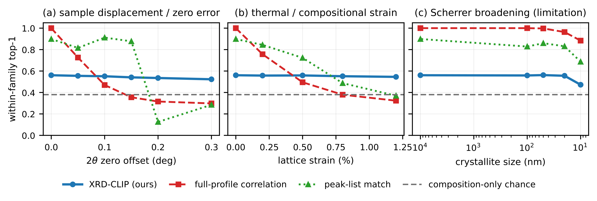
- One-dial degradation of the query pattern (library stays clean-simulated). The learned embedding (blue) is flat under peak-position degradations, (a) 2θ zero offset and (b) lattice strain, where full-profile correlation (red) collapses; it concedes (c) severe Scherrer broadening, the one position-preserving axis, to correlation. Grey dashed line is composition-only chance.
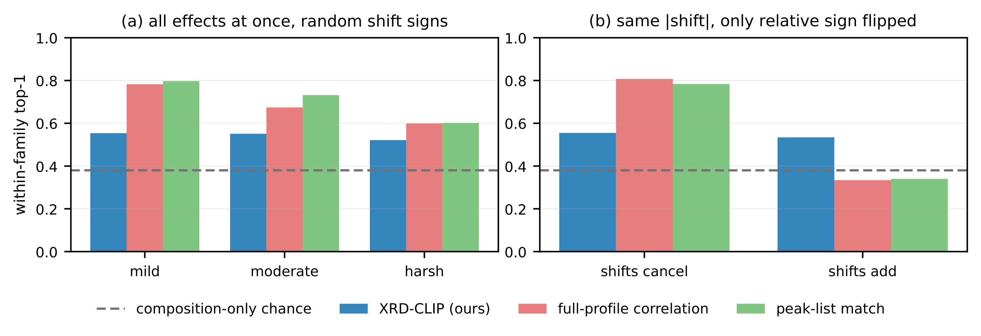
- (a) All measurement effects applied at once with per-crystal random shift signs: the model (blue) stays near 0.55 mild→harsh while both classical methods fall. (b) The sign-cancellation control: holding the shift magnitudes fixed (0.10° displacement, 0.6% strain) and flipping only the relative sign, correlation and peak-list drop from ≈0.80 to composition-only chance while the model holds.
Peak-position degradations are where the model earns its keep. Figure 1 degrades one physical dial at a time, perturbing only the query. Under a 2θ zero offset (sample displacement), the model is flat (0.561→0.523) while full-profile correlation collapses (1.0→0.298) and overtakes both classical methods beyond 0.15°. Under lattice strain the model is again flat (0.561→0.546) versus correlation (1.0→0.323). These two axes (sample displacement, thermal expansion, and zero/wavelength error) are the real-world killers of search-match. The model's honest limitation is the one position-preserving axis: at a 10 nm crystallite size, Scherrer broadening smears peaks and correlation (0.884) beats the model (0.472).
A sign-cancellation control isolates the underlying invariance. Stacking every dial at fixed same-sign values would be misleading: a positive displacement pushes peaks up in 2θ while cell expansion pushes them down, so at fixed magnitudes the two partially cancel and artificially rescue the correlation baseline. Figure 2(a) instead draws per-crystal random shift signs on top of a fixed broadening/texture/noise/background base; the model holds 0.554→0.521 mild→harsh while correlation falls 0.782→0.599 and peak-list 0.797→0.601. Figure 2(b) is the control: fixing the shift magnitudes and flipping only the relative sign, correlation drops from 0.807 (cancel) to 0.334 (add) and peak-list from 0.784 to 0.340, both at composition-only chance, while the model holds (0.555→0.534). For the ~50% of real samples where the two shifts reinforce, classical search-match is no better than knowing the formula; it cannot know in advance which half a sample falls in. The learned embedding's invariance is sign-independent; the baselines' apparent robustness is a coincidental cancellation.

Ablations: emergent vs. learned robustness
- Ablating training-time augmentation (within-family top-1; composition-only chance = 0.380). Two twins, identical architecture, data, and 60-epoch schedule; only the augmentation changes.
 | full aug (main) | no shift/strain aug | no aug (clean)
clean within-family | 0.561 | 0.553 | 0.557
pure shift @ 0.1° | 0.552 | 0.549 | 0.552
field (mild) | 0.554 | 0.560 | 0.380
field (harsh) | 0.521 | 0.528 | 0.379
sign: add | 0.534 | 0.530 | 0.379

Two ablations settle where the robustness comes from (Table I). First, zeroing the shift and strain augmentation ranges while keeping the rest (no shift/strain aug) changes nothing: the twin tracks the main model within 1% on every axis, including pure shift and the sign-add regime. Peak position invariance is therefore emergent: a 1D CNN with global pooling is intrinsically tolerant to peak translation, and small strain is locally translation-like, not something the shift augmentation taught. Second, removing all augmentation and training on perfectly clean patterns (no aug) is the decisive control. That twin still retrieves cleanly (0.557) and is still flat under a pure shift (0.552 at 0.1°), but it collapses to chance the moment any realistic instrument profile is present: full-field retrieval is 0.380/0.381/0.379 (mild/moderate/harsh), and the crystallite-size sweep alone walks it down 0.557→0.410→0.395→0.390 (100/50/20 nm).
This is the direct answer to the natural objection: “isn't within-family retrieval just simulated-fingerprint leakage, since the query is simulated from the target?” If it were, the clean-trained twin would retrieve fine under realistic conditions. It does not: a clean-trained encoder cannot retrieve at all once broadening, texture, noise, and background appear. The physics-grounded augmentation is generalizing from simulation to realistic conditions, not memorizing; measurement-profile robustness is learned, while peak-position invariance is architectural.

A sim-to-real spot check
Every result above evaluates the model on the same physics-based simulator it was trained with. As an initial check of transfer beyond the simulator, we retrieved three real experimental PXRD patterns against the full 30,887-structure test library, digitized point-by-point from the Rietveld powder-refinement data deposited as supporting information with the structures' original determination papers (Cu-Kα₁, matching our simulation exactly). For racemic ibuprofen (IBPRAC04) [12] (whose structure is a corpus entry, but whose real measured pattern the model has never seen in any form), the true structure ranks 1,872 of 30,887 by cosine similarity (top 6.1%): well above the library midpoint on a single real query, though not top-1. For two real patterns of phenobarbital polymorphs Form I/II [13], the specific determination is not itself a corpus structure (only sibling PHBARB polymorphs are), so no retrieval rank applies; nearest-neighbour inspection surfaced no chemically plausible match, which confirms that retrieval scoring requires the query's true structure to be a library candidate. This remains a small-N spot check, not a systematic real-data benchmark; scaling it to the tens of real molecular patterns available in the powder-diffraction literature is the natural next step.

Limitations
The sim-to-real check above is a single-digit-N spot check, not a systematic benchmark; the bulk of our evaluation remains on the physics-grounded simulator, for which our augmentation and the sign-cancellation control are designed as diagnostics. The model concedes severe Scherrer broadening to full-profile correlation, and within-family top-1 of 0.561, while well above the 0.380 chance floor, leaves clear headroom: an explicit low-angle/wide-angle encoder split [4] and light Rietveld reranking are natural next steps. Our benchmark is molecular (CSD); the inorganic and MOF regimes are already served by composition/symmetry-aware retrieval [4], [5].

Conclusion
Molecular polymorph discrimination is the regime where composition- and symmetry-based PXRD retrieval is structurally blind, and it is exactly where a pattern↔packing contrastive model earns its keep. On a family-safe CSD benchmark the learned embedding resolves same-molecule siblings above chance and, more importantly, holds its accuracy under the peak-position perturbations that send classical search-match to chance, a sign-independent invariance the classical methods cannot guarantee. Ablations show this robustness is part architectural and part learned from physics-grounded augmentation, and is not fingerprint leakage. The same contrastive retriever is the natural candidate ranker for PXRD-conditioned generative crystal structure prediction [5], [14] on molecular crystals, which we leave to future work.

References
- S. Gates-Rector and T. Blanton, “The Powder Diffraction File: a quality materials characterization database,” Powder Diffraction, vol. 34, no. 4, pp. 352–360, 2019.
- J. Bauer, S. Spanton, R. Henry et al., “Ritonavir: An Extraordinary Example of Conformational Polymorphism,” Pharmaceutical Research, vol. 18, no. 6, pp. 859–866, 2001.
- A. J. Cruz-Cabeza, S. M. Reutzel-Edens, and J. Bernstein, “Facts and fictions about polymorphism,” Chemical Society Reviews, vol. 44, no. 23, pp. 8619–8635, 2015.
- C. Xu, T. Su, J. Xiong, Y. Wu et al., “KAN-Enhanced Contrastive Learning Accelerating Crystal Structure Identification from XRD Patterns,” arXiv:2511.04055, 2025.
- Q. Lai, F. Xu, L. Yao, Z. Gao, S. Liu, H. Wang et al., “End-to-End Crystal Structure Prediction from Powder X-Ray Diffraction,” Advanced Science, 2025, arXiv:2401.03862.
- C. R. Groom, I. J. Bruno, M. P. Lightfoot, and S. C. Ward, “The Cambridge Structural Database,” Acta Crystallographica Section B, vol. 72, no. 2, pp. 171–179, 2016.
- A. Radford, J. W. Kim, C. Hallacy, A. Ramesh et al., “Learning Transferable Visual Models From Natural Language Supervision,” in Proc. Int. Conf. Machine Learning (ICML), 2021.
- A. van den Oord, Y. Li, and O. Vinyals, “Representation Learning with Contrastive Predictive Coding,” arXiv:1807.03748, 2018.
- G. Caglioti, A. Paoletti, and F. P. Ricci, “Choice of collimators for a crystal spectrometer for neutron diffraction,” Nuclear Instruments, vol. 3, no. 4, pp. 223–228, 1958.
- W. A. Dollase, “Correction of intensities for preferred orientation in powder diffractometry: application of the March model,” Journal of Applied Crystallography, vol. 19, no. 4, pp. 267–272, 1986.
- G. W. Bemis and M. A. Murcko, “The Properties of Known Drugs. 1. Molecular Frameworks,” Journal of Medicinal Chemistry, vol. 39, no. 15, pp. 2887–2893, 1996.
- P. Derollez, E. Dudognon, F. Affouard, F. Danède, N. T. Correia, and M. Descamps, “Ab initio structure determination of phase II of racemic ibuprofen by X-ray powder diffraction,” Acta Crystallographica Section B, vol. 66, no. 1, pp. 76–80, 2010.
- C. Platteau, J. Lefebvre, S. Hemon, C. Baehtz, F. Danède, and D. Prevost, “Structure determination of forms I and II of phenobarbital from X-ray powder diffraction,” Acta Crystallographica Section B, vol. 61, no. 1, pp. 80–88, 2005.
- F. L. Johansen, U. Friis-Jensen, E. B. Dam et al., “deCIFer: Crystal Structure Prediction from Powder Diffraction Data using Autoregressive Language Models,” arXiv:2502.02189, 2025.

