详细设计文档

修改记录
日期 | 版本 | 描述 | 作者 | 审核
2025.9.22 | V1 | 详细设计文档

1. 引言

1.1 文档目的
本详细设计文档的主要目的是对软件系统的设计进行说明，明确系统的模块划分、功能职责、架构设计、性能和安全要求，为后续开发和实施提供参考依据。本文件面向开发人员、测试人员以及运维人员，帮助各方理解系统的整体结构和设计思路。

1.2 范围
本次设计文档覆盖以下系统模块：
OEE模块：包括OEE数据报表、设备PPM分析、OEE数据填报、KPI看板
设备模块：包括设备台账、点检、巡检、保养
备品备件模块：包括备件台账、PMC调拨、备件领用、备件采购、备件使用记录
AI模块：包括智能问答对话
工装模块：包括维修、保养、报废、出库、入库
文档范围包括系统架构设计、模块分解、异常处理、性能和安全策略等内容，但不包括具体代码实现。

1.3 术语和缩略语
列出文档中使用的术语、定义和缩写。
OEE，Overall Equipment Effectiveness，设备综合效率
KPI，Key Performance Indicator，关键绩效指标
AI，Artificial Intelligence，人工智能
DB，Database，数据库
1.4 参考资料
《软件需求规格说明书》
《概要设计文档》
系统架构设计规范
数据库设计规范

2. 系统概览

2.1 系统架构简要回顾
本文档对软件系统的总体架构、主要模块及其相互关系、关键数据流与非功能性要求进行简要回顾，旨在为后续详细设计、开发实现与运维部署提供统一参考。系统覆盖OEE分析、设备全生命周期管理、备品备件管理、工装管理与AI智能问答服务等能力，面向车间生产线业务流程驱动、分析展示与运维支撑。

一、总体架构（分层视角）：系统采用分层微服务化设计，主要分为以下层次：
表现层：Web 前端与移动端。REST API 层，为第三方系统与前端提供统一访问入口。
服务层：各子系统拆分为职责明确的微服务：OEE服务、设备台账、点检、巡检、保养、备件服务、工装服务、AI问答服务等。每个微服务负责自身的数据模型、业务规则与外部接口。公共服务包括认证授权、权限管理、系统配置。
集成与消息层：API 网关负责统一路由、鉴权。
数据层：关系型数据库MySQL存储业务主数据。文档/文件存储MinIO，保存附件。缓存Redis：用于热点数据、会话与临时锁。
AI/模型层：智能对话机器人，通过自然语言处理和机器学习技术，实现与用户的智能交互。通过收集用户反馈和数据，不断优化机器人的性能和功能，提升用户体验。用于智能问答、故障诊断建议等。

二、以下以功能块说明模块边界与核心职责：
OEE 模块：OEE 数据报表、设备 PPM 分析、OEE 数据填报、KPI 看板等。关键指标：DT、DT率、MTTR、MTBF、MTTA、自主维护率、OEE、时间稼动率、性能稼动率、FTY等。职责：实时计算/汇总设备关键指标；支持按班次/产线/物料/设备分组钻取；提供历史趋势、根因分析与 PPM异常洞察等。
设备模块：设备台账：台账管理、状态管理、设备履历、设备BOM。设备点检：点检项目、点检计划、点检执行、点检提醒。设备巡检：巡检项目、巡检计划、巡检执行、巡检提醒、临时巡检、巡检汇总。设备保养：保养项目、保养计划制定、保养执行、保养确认、保养提醒、保养计划汇总。设备维修：故障报修、报维修工单、维修处理、维修查询、委外维修。职责：覆盖设备全生命周期管理，支撑从预防性保养到响应式维修的闭环流转，提供设备健康画像与历史履历查询等。
备品备件模块：核心功能：备件台账、PMC 调拨、备件领用、备件采购、备件使用记录。职责：精细化管理备件库存、库存占用与消耗等。
工装模块：功能：维修、保养、报废、出库、入库等。职责：管理工装工具的状态与使用历史，确保维修/保养作业的工具合规与可追溯。
AI 模块：功能：智能问答对话、分析设备故障、自动创建备件领用工单以及设备指标分析。职责：为一线人员提供快速问题解答、维修建议与经验检索，降低人工寻求知识的成本；可逐步引入预测性维护能力。

三、关键数据流与典型业务流程
OEE 指标计算（示例）：OEE 服务基于预设公式按班次/设备粒度计算稼动率、性能、一次合格率等。展示/告警：KPI 看板读取指标并按阈值触发告警；支持工单或设备履历追踪问题根因。
设备故障->维修工单闭环（示例）：故障上报→ 创建维修工单→工单分派→ 维修执行→维修确认→ 工单关闭并写入设备履历→统计/分析：MTTR/MTBF 等指标从工单与时间序列数据计算。
备件消耗流程（示例）：备件申请→ 出库/领用→ 库存变更并记录出入库流水→ 触发PMC 调拨流程或采购申请流程→采购到货→ 入库并完成领用补齐。

2.2 系统资源说明
描述系统需要的硬件、操作系统、依赖软件等。
硬件：标准服务器，CPU 4核以上，内存16GB以上，存储500GB以上
操作系统：Linux
依赖软件：MySQL数据库、Redis缓存、中间件服务、Web服务器（Nginx）、Python/JAVA运行环境

2.3 模块分解概览
一、OEE 模块
核心功能涵盖 OEE 数据报表生成、设备 PPM 分析、OEE 数据填报管理及 KPI 看板展示，可全面支撑设备效率相关的数据处理与可视化需求。
关键监测指标包括：DT（停机时间）、DT 率（停机率）、MTTR（平均修复时间）、MTBF（平均无故障时间）、MTTA（平均故障检测时间）、自主维护率、OEE（设备综合效率）、时间稼动率、性能稼动率、FTY（首次通过率），可多维度评估设备运行状态与效率水平。
二、设备模块
设备台账：包含 台账管理、状态管理、设备履历记录及 设备 BOM（物料清单） 维护，实现设备基础信息的全生命周期管控。
设备点检：覆盖 点检项目设定、点检计划制定、点检执行跟踪与 点检提醒推送，保障设备日常点检工作规范落地。
设备巡检：涵盖 巡检项目配置、巡检计划编排、巡检执行监控、巡检提醒触发、临时巡检发起及 巡检汇总分析，确保设备巡检无遗漏。
设备保养：包含 保养项目定义、保养计划制定、保养执行跟踪、保养确认审核、保养提醒通知及 保养计划汇总管理，延长设备使用寿命。
设备维修：支持 故障报修提交、维修工单创建、维修处理跟进、维修查询检索及 委外维修管理，高效解决设备故障问题。
三、备品备件模块
核心功能包括 备件台账管理、PMC 调拨操作、备件领用审核、备件采购执行及 备件使用记录追踪，实现备品备件的精细化管控，保障设备维修与生产需求。
四、工装模块
核心功能涵盖 工装维修处理、工装保养执行、工装报废审批、工装备件出库管理及 工装备件入库登记，确保工装设备的正常运转与高效利用。
五、AI 模块
核心功能包括 智能问答对话交互（解答设备相关疑问）、设备故障分析（辅助定位故障原因）、自动创建备件领用工单（简化备件领用流程）及 设备指标分析（深度挖掘设备运行数据），以智能化技术提升设备管理效率。

3. 模块设计

3.1 oee功能概述
oee模块的功能主要包括设备 PPM 分析、OEE 数据填报、KPI 看板等。关键指标：DT、DT率、MTTR、MTBF、MTTA、自主维护率、OEE、时间稼动率、性能稼动率、FTY等。职责：实时计算/汇总设备关键指标；支持按班次/产线/物料/设备分组钻取；提供历史趋势、根因分析与 PPM异常洞察等。

3.1.1 oee模块详细设计

3.1.1.1 数据库设计
表：oee_equipment_dt_target
编号 | 名称 | 数据类型 | 长度 | 小数位 | 允许空值 | 默认值 | 说明
1 | id | bigint | 19 | 0 | N | 无 | 主键ID
2 | equipment_id | bigint | 19 | 0 | N | 无 | 设备ID
3 | dt_target | double | 22 |  | Y | 无 | DT目标值
4 | parameter_effective_time | datetime |  |  | Y | 无 | 参数生效时间
5 | parameter_notes | varchar | 500 |  | Y | 无 | 参数备注
6 | create_time | datetime |  |  | Y | CURRENT_TIMESTAMP | 创建时间
7 | update_time | datetime |  |  | Y | CURRENT_TIMESTAMP | 更新时间
8 | create_by | varchar | 100 |  | Y | 无 | 创建人
9 | update_by | varchar | 100 |  | Y | 无 | 修改人
10 | deleted | tinyint | 3 | 0 | Y | 0 | 是否删除 0-未删除 1-已删除

表：oee_equipment_ppm
编号 | 名称 | 数据类型 | 长度 | 小数位 | 允许空值 | 默认值 | 说明
1 | id | bigint | 19 | 0 | N | 无 | 主键ID
2 | equipment_id | bigint | 19 | 0 | Y | 无 | 设备ID
3 | design_ppm | double | 22 |  | Y | 无 | 设计PPM
4 | actual_ppm | double | 22 |  | Y | 无 | 实际PPM
5 | oee_target | double | 22 |  | Y | 无 | OEE目标
6 | parameter_effective_time | datetime |  |  | Y | 无 | 参数生效时间
7 | parameter_notes | varchar | 255 |  | Y | 无 | 参数备注
8 | create_time | datetime |  |  | Y | 无 | 创建时间
9 | create_by | varchar | 255 |  | Y | 无 | 创建人
10 | update_time | datetime |  |  | Y | 无 | 更新时间
11 | update_by | varchar | 255 |  | Y | 无 | 更新人
12 | planned_downtime_target | double | 22 |  | Y | 无 | 计划停机目标(min/班)
13 | organizational_loss_target | double | 22 |  | Y | 无 | 组织损失目标(min/班)
14 | quality_loss_target | double | 22 |  | Y | 无 | 质量损失目标(min/班)
15 | changeover_and_startup_target | double | 22 |  | Y | 无 | 换型和启动目标(min/班)
16 | efficiency_loss_target | double | 22 |  | Y | 无 | 效率损失目标(min/班)
17 | technical_loss_target | double | 22 |  | Y | 无 | 技术损失目标(min/班)
18 | unknown_loss_target | double | 22 |  | Y | 无 | 未知损失目标(min/班)
19 | undefined_loss_target | double | 22 |  | Y | 无 | 未定义损失目标(min/班)

表：oee_loss_record
编号 | 名称 | 数据类型 | 长度 | 小数位 | 允许空值 | 默认值 | 说明
1 | id | bigint | 19 | 0 | N | 无 | 主键编号
2 | repair_order_id | bigint | 19 | 0 | Y | 无 | 维修工单ID
3 | shift | varchar | 50 |  | Y | 无 | 班次
4 | factory | varchar | 100 |  | Y | 无 | 工厂
5 | factory_name | varchar | 100 |  | Y | 无 | 工厂名称
6 | line | varchar | 100 |  | Y | 无 | 线体
7 | line_name | varchar | 100 |  | Y | 无 | 线体名称
8 | process | varchar | 100 |  | Y | 无 | 工序
9 | process_name | varchar | 100 |  | Y | 无 | 工序名称
10 | parent_id | int | 10 | 0 | Y | 0 | 上级Id
11 | other_apartment_assist | int | 10 | 0 | Y | 无 | 其他部门协助
12 | equipment_status_code | varchar | 255 |  | Y | 无 | 设备运行状态编码（1：未投产，2：在产，3：停机，4：报废）
13 | equipment_status | varchar | 50 |  | Y | 无 | 设备运行状态（未投产，在产，停机，报废）
14 | downtime_start_time | datetime |  |  | Y | 无 | 停机开始时间
15 | downtime_end_time | datetime |  |  | Y | 无 | 停机结束时间
16 | downtime_duration | bigint | 19 | 0 | Y | 无 | 停机时长(秒)
17 | loss_category1 | varchar | 100 |  | Y | 无 | 损失分类1
18 | loss_category2 | varchar | 100 |  | Y | 无 | 损失分类2
19 | loss_category3 | varchar | 100 |  | Y | 无 | 损失分类3
20 | downtime_details | text | 65535 |  | Y | 无 | 停机详情
21 | alarm_details | text | 65535 |  | Y | 无 | 报警详情
22 | responsible_department | varchar | 100 |  | Y | 无 | 责任部门
23 | responsible_person | varchar | 50 |  | Y | 无 | 责任人
24 | downtime_type | varchar | 50 |  | Y | 无 | 停机类型（计划内停机，计划外停机）
25 | abnormal_reason | text | 65535 |  | Y | 无 | 异常原因
26 | handling_measures | text | 65535 |  | Y | 无 | 处理措施
27 | create_time | datetime |  |  | N | CURRENT_TIMESTAMP | 创建时间
28 | update_time | datetime |  |  | N | CURRENT_TIMESTAMP | 更新时间
29 | create_by | varchar | 64 |  | Y | 无 | 创建人
30 | update_by | varchar | 64 |  | Y | 无 | 更新人
31 | responsible_department_id | bigint | 19 | 0 | Y | 无 | 责任部门ID
32 | responsible_person_id | bigint | 19 | 0 | Y | 无 | 责任人ID
33 | cancel | int | 10 | 0 | Y | 0 | 取消标识
34 | equipment_code | varchar | 255 |  | Y | 无 | 设备编码
35 | equipment_name | varchar | 255 |  | Y | 无 | 设备名称
36 | source | int | 10 | 0 | Y | 1 | 来源1 IOT ,  2 HUMAN
37 | accept_order_time | datetime |  |  | Y | 无 | 接收工单时间
38 | order_generate_time | datetime |  |  | Y | 无 | 工单生成时间
39 | big_department_code | varchar | 255 |  | Y | 无 | 大部门编码
40 | big_department_name | varchar | 255 |  | Y | 无 | 大部门名称

表：oee_loss_type
编号 | 名称 | 数据类型 | 长度 | 小数位 | 允许空值 | 默认值 | 说明
1 | id | bigint | 19 | 0 | N | 无 | 主键编号
2 | name | varchar | 255 |  | Y | 无 | 名称
3 | picked | int | 10 | 0 | Y | 1 | 挑选标记  1是  0否
4 | weight | double | 22 |  | Y | 1 | 权重
5 | create_time | datetime |  |  | Y | 无 | 创建时间
6 | create_by | varchar | 255 |  | Y | 无 | 创建人
7 | update_time | datetime |  |  | Y | 无 | 修改时间
8 | update_by | varchar | 255 |  | Y | 无 | 修改人
9 | is_leaf | int | 10 | 0 | Y | 0 | 是否叶子节点（1表示叶子节点，0表示非叶子节点）
10 | parent_id | bigint | 19 | 0 | Y | 无 | 父节点Id
11 | charge_dept_id | bigint | 19 | 0 | Y | 无 | 责任部门ID
12 | charge_dept_name | varchar | 255 |  | Y | 无 | 责任部门名称
13 | charge_character_id | bigint | 19 | 0 | Y | 无 | 责任人ID
14 | charge_character_name | varchar | 255 |  | Y | 无 | 责任人名称
15 | device_type_code | varchar | 255 |  | Y | 无 | 设备类型编码
16 | device_type_name | varchar | 255 |  | Y | 无 | 设备类型名称
17 | type | int | 10 | 0 | Y | 1 | 子类型  类型1  类型2

表：oee_production_metrics_by_equipment
编号 | 名称 | 数据类型 | 长度 | 小数位 | 允许空值 | 默认值 | 说明
1 | id | bigint | 19 | 0 | N | 无 | 数据ID
2 | date | date |  |  | Y | 无 | 日期
3 | shift | varchar | 255 |  | Y | 无 | 班次
4 | start_time | datetime |  |  | Y | 无 | 开始时间
5 | end_time | datetime |  |  | Y | 无 | 结束时间
6 | equipment_code | varchar | 255 |  | Y | 无 | 设备编码
7 | fty | double | 22 |  | Y | 无 | 一次合格率
8 | first_pass_qty | double | 22 |  | Y | 无 | 一次合格数
9 | first_defect_qty | double | 22 |  | Y | 无 | 一次不良数
10 | actual_production | double | 22 |  | Y | 无 | 实际产量

表：oee_production_metrics_by_factory_instance
编号 | 名称 | 数据类型 | 长度 | 小数位 | 允许空值 | 默认值 | 说明
1 | id | bigint | 19 | 0 | N | 无 | 数据ID
2 | date | date |  |  | Y | 无 | 日期
3 | shift | varchar | 255 |  | Y | 无 | 班次
4 | start_time | datetime |  |  | Y | 无 | 开始时间
5 | end_time | datetime |  |  | Y | 无 | 结束时间
6 | fty | double | 22 |  | Y | 无 | 一次合格率
7 | first_pass_qty | double | 22 |  | Y | 无 | 一次合格数
8 | first_defect_qty | double | 22 |  | Y | 无 | 一次不良数
9 | actual_production | double | 22 |  | Y | 无 | 实际产量
10 | factory_instance_code | varchar | 255 |  | Y | 无 | 企业层级编码
11 | factory_instance_name | varchar | 255 |  | Y | 无 | 企业层级名称
12 | factory_instance_full_path_name | varchar | 255 |  | Y | 无 | 企业层级整路径名称

表：oee_snapshot
编号 | 名称 | 数据类型 | 长度 | 小数位 | 允许空值 | 默认值 | 说明
1 | id | bigint | 19 | 0 | N | 无 | 主键ID
2 | factory | varchar | 100 |  | Y | 无 | 工厂编码
3 | factory_name | varchar | 100 |  | Y | 无 | 工厂名称
4 | line | varchar | 100 |  | Y | 无 | 线体
5 | line_name | varchar | 100 |  | Y | 无 | 线体名称
6 | process | varchar | 100 |  | Y | 无 | 工序
7 | process_name | varchar | 100 |  | Y | 无 | 工序名称
8 | space_code | varchar | 255 |  | N | 无 | 空间编码
9 | space_name | varchar | 255 |  | Y | 无 | 空间名称
10 | time | varchar | 255 |  | N | 无 | 时间维度值
11 | scale | varchar | 50 |  | Y | 无 | 时间维度类型（QUARTER，季）（YEAR，年）（WEEK，周）（MONTH，月）（SHIFT，班次）
12 | space_type | varchar | 50 |  | Y | EQUIPMENT | 空间类型（EQUIPMENT，"PROCESS"; "LINE". "FACTORY"; "BASE";）
13 | start_time | datetime |  |  | Y | 无 | 开始时间
14 | end_time | datetime |  |  | Y | 无 | 结束时间
15 | snapshot | text | 65535 |  | N | 无 | OEE快照数据JSON
16 | create_time | datetime |  |  | N | CURRENT_TIMESTAMP | 创建时间
17 | update_time | datetime |  |  | N | CURRENT_TIMESTAMP | 更新时间
18 | create_by | varchar | 64 |  | Y | 无 | 创建人
19 | update_by | varchar | 64 |  | Y | 无 | 更新人
20 | deleted | tinyint | 3 | 0 | N | 0 | 是否删除（1是0否）
21 | archived | int | 10 | 0 | Y | 0 | 是否归档（1是0否）

表：oee_snapshot_audit
编号 | 名称 | 数据类型 | 长度 | 小数位 | 允许空值 | 默认值 | 说明
1 | id | bigint | 19 | 0 | N | 无 | 主键ID
2 | factory | varchar | 100 |  | Y | 无 | 工厂编码
3 | factory_name | varchar | 100 |  | Y | 无 | 工厂名称
4 | line | varchar | 100 |  | Y | 无 | 线体编码
5 | line_name | varchar | 100 |  | Y | 无 | 线体名称
6 | process | varchar | 100 |  | Y | 无 | 工序
7 | process_name | varchar | 100 |  | Y | 无 | 工序名称
8 | space_code | varchar | 255 |  | N | 无 | 空间编码
9 | space_name | varchar | 255 |  | Y | 无 | 空间名称
10 | time | varchar | 255 |  | N | 无 | 时间维度值
11 | scale | varchar | 50 |  | Y | 无 | 时间维度类型（QUARTER，季）（YEAR，年）（WEEK，周）（MONTH，月）（SHIFT，班次）
12 | space_type | varchar | 50 |  | Y | EQUIPMENT | 空间类型（EQUIPMENT，"PROCESS"; "LINE". "FACTORY"; "BASE";）
13 | start_time | datetime |  |  | Y | 无 | 开始时间
14 | end_time | datetime |  |  | Y | 无 | 结束时间
15 | snapshot | text | 65535 |  | N | 无 | OEE快照数据JSON
16 | create_time | datetime |  |  | N | CURRENT_TIMESTAMP | 创建时间
17 | update_time | datetime |  |  | N | CURRENT_TIMESTAMP | 更新时间
18 | create_by | varchar | 64 |  | Y | 无 | 创建人
19 | update_by | varchar | 64 |  | Y | 无 | 更新人
20 | deleted | tinyint | 3 | 0 | N | 0 | 是否删除（1是0否）
21 | archived | int | 10 | 0 | Y | 0 | 是否归档（1归档 , 0未归档）

3.1.1.2 流程图
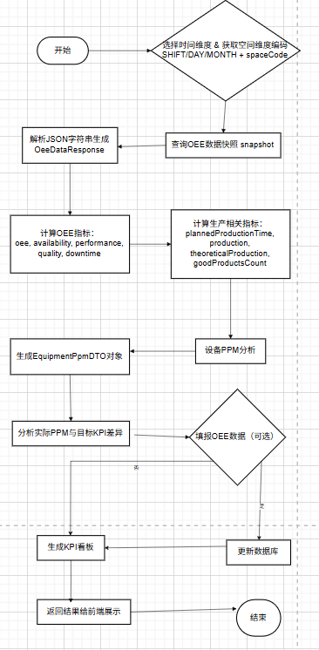

3.1.1.3 类设计
OEE 指标响应对象，包含综合效率、稼动率、良品率、产量等信息，并支持下钻明细。
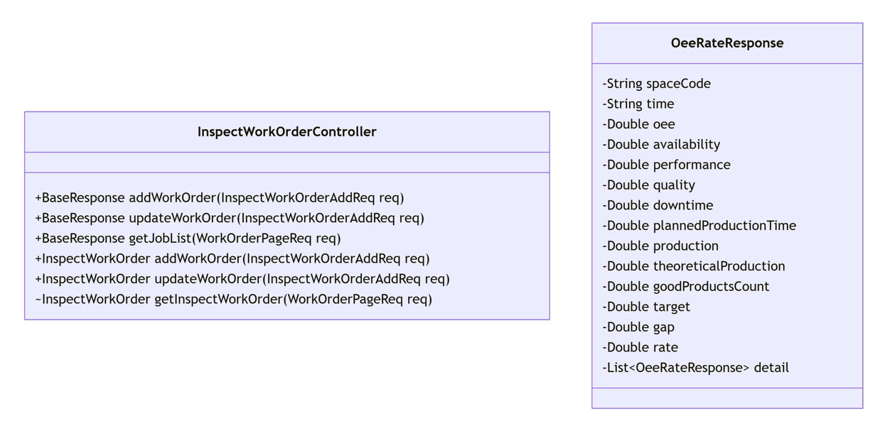
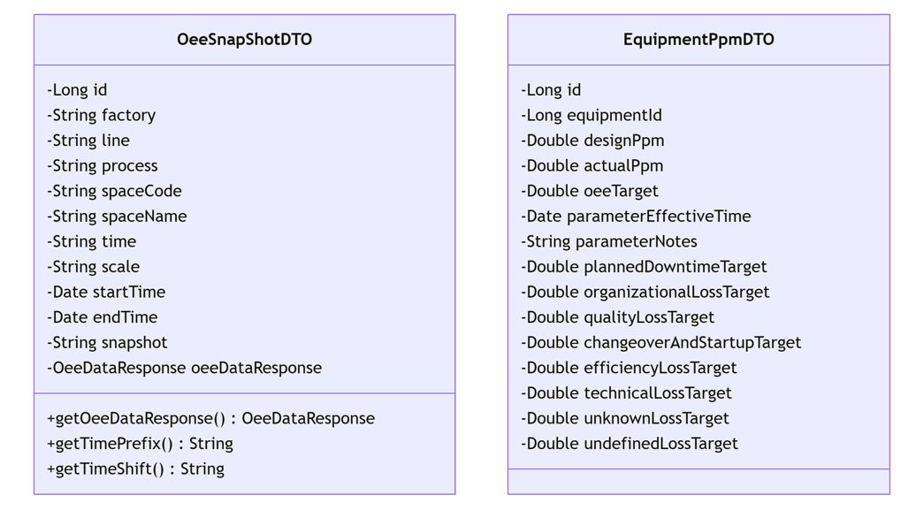

3.1.1.4 时序图
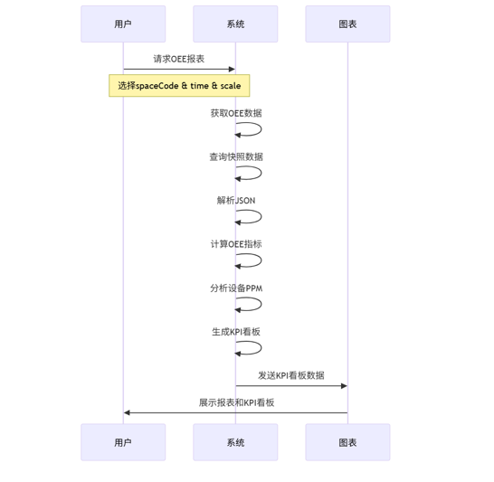

3.1.1.5 内部接口定义
/**
* 根据时间获取所有设备产量
* @param startTime 开始时间
* @param endTime 结束时间
* @return Map<String, Double> 设备编码/产量
*/
@GetMapping(value = "/feign/insider/oee/getAllEquipmentProductionMetrics")
Map<String, Double> getAllEquipmentProductionMetrics(@RequestParam("startTime") Date startTime, @RequestParam ("endTime") Date endTime);

3.1.1.6 外部接口定义
"/api/equipment/oee/metrics/excel/cleanCache": {
"post": {
"tags": [
"oee-metrics-excel-controller"
],
"summary": "cleanCache",
"operationId": "cleanCacheUsingPOST",
"consumes": [
"application/json"
],
"produces": [
"*/*"
],
"responses": {
"200": {
"description": "OK",
"schema": {
"type": "array",
"items": {
"originalRef": "OeeMetricsExcelRow",
"$ref": "#/definitions/OeeMetricsExcelRow"
}
}
}
},
"security": [
{
"Authorization": [
"global"
]
}
],
"deprecated": false,
"x-order": "2147483647"
}
},
"/api/equipment/oee/metrics/excel/dddtest": {
"post": {
"tags": [
"oee-metrics-excel-controller"
],
"summary": "test",
"operationId": "testUsingPOST",
"consumes": [
"application/json"
],
"produces": [
"*/*"
],
"responses": {
"200": {
"description": "OK",
"schema": {
"type": "array",
"items": {
"originalRef": "OeeMetricsExcelRow",
"$ref": "#/definitions/OeeMetricsExcelRow"
}
}
}
},
"security": [
{
"Authorization": [
"global"
]
}
],
"deprecated": false,
"x-order": "2147483647"
}
},
"/api/equipment/oee/metrics/excel/getFakeData": {
"post": {
"tags": [
"oee-metrics-excel-controller"
],
"summary": "getFakeData",
"operationId": "getFakeDataUsingPOST",
"consumes": [
"application/json"
],
"produces": [
"*/*"
],
"responses": {
"200": {
"description": "OK",
"schema": {
"type": "array",
"items": {
"originalRef": "OeeMetricsExcelRow",
"$ref": "#/definitions/OeeMetricsExcelRow"
}
}
}
},
"security": [
{
"Authorization": [
"global"
]
}
],
"deprecated": false,
"x-order": "2147483647"
}
},
"/api/equipment/oee/metrics/excel/import": {
"post": {
"tags": [
"oee-metrics-excel-controller"
],
"summary": "importExcel",
"operationId": "importExcelUsingPOST_4",
"consumes": [
"multipart/form-data"
],
"produces": [
"*/*"
],
"parameters": [
{
"name": "file",
"in": "formData",
"description": "file",
"required": true,
"type": "file"
}
],
"responses": {
"200": {
"description": "OK",
"schema": {
"type": "array",
"items": {
"originalRef": "OeeMetricsExcelRow",
"$ref": "#/definitions/OeeMetricsExcelRow"
}
}
}
},
"security": [
{
"Authorization": [
"global"
]
}
],
"deprecated": false,
"x-order": "2147483647"
}
},
"/api/equipment/oee/metrics/excel/import2": {
"post": {
"tags": [
"oee-metrics-excel-controller"
],
"summary": "import2",
"operationId": "import2UsingPOST",
"consumes": [
"multipart/form-data"
],
"produces": [
"*/*"
],
"parameters": [
{
"name": "file",
"in": "formData",
"description": "file",
"required": true,
"type": "file"
}
],
"responses": {
"200": {
"description": "OK",
"schema": {
"type": "array",
"items": {
"originalRef": "OeeMetricsExcelRow",
"$ref": "#/definitions/OeeMetricsExcelRow"
}
}
}
},
"security": [
{
"Authorization": [
"global"
]
}
],
"deprecated": false,
"x-order": "2147483647"
}
},

3.2 设备台账功能概述
设备台账包括台账管理、状态管理、设备履历、设备BOM。

3.2.1 设备台账模块详细设计

3.2.1.1 数据库设计
表：eq_acceptance_record
编号 | 名称 | 数据类型 | 长度 | 小数位 | 允许空值 | 默认值 | 说明
1 | id | bigint | 19 | 0 | N | 无 | 主键ID
2 | equipment_id | bigint | 19 | 0 | N | 无 | 设备ID
3 | code | varchar | 255 |  | Y | 无 | 验收单编号
4 | name | varchar | 255 |  | Y | 无 | 验收单名称
5 | type | varchar | 255 |  | Y | 无 | 验收单类型（待验收，已验收）
6 | acceptor | varchar | 255 |  | Y | 无 | 验收人
7 | finish_time | timestamp |  |  | Y | 无 | 完成时间
8 | enclosures | text | 65535 |  | Y | 无 | 附件
9 | remark | varchar | 255 |  | Y | 无 | 备注
10 | create_time | datetime |  |  | Y | 无 | 创建时间
11 | create_by | varchar | 255 |  | Y | 无 | 创建人
12 | update_time | datetime |  |  | Y | 无 | 更新时间
13 | update_by | varchar | 255 |  | Y | 无 | 更新人

表：eq_alarm_setting
编号 | 名称 | 数据类型 | 长度 | 小数位 | 允许空值 | 默认值 | 说明
1 | id | bigint | 19 | 0 | N | 无 | id
2 | task_type | int | 10 | 0 | Y | 无 | 任务类型 ("点检任务", 1)  （"保养任务", 2),  ("维修任务", 3);
3 | frequency_num | int | 10 | 0 | Y | 无 | 任务频次数值
4 | frequency_unit | int | 10 | 0 | Y | 无 | 任务频次单位("年", 1),  ("季度", 2),  ("月", 3),  ("周", 4),  ("天", 5),  ("小时", 6),  ("分钟", 7);
5 | item_type | int | 10 | 0 | Y | 无 | 点检/保养类别("普通", 1),  ("特种设备点检", 2),  ("计量设备校验", 3);
6 | send_flag | tinyint | 3 | 0 | Y | 无 | 是否通知（1是0否）
7 | tool | varchar | 255 |  | Y | 无 | 收发途径
8 | setting_list | text | 65535 |  | Y | 无 | 配置
9 | create_time | datetime |  |  | Y | 无 | 创建时间
10 | create_by | varchar | 255 |  | Y | 无 | 创建人
11 | update_time | datetime |  |  | Y | 无 | 更新时间
12 | update_by | varchar | 255 |  | Y | 无 | 更新人

表：eq_enclosure
编号 | 名称 | 数据类型 | 长度 | 小数位 | 允许空值 | 默认值 | 说明
1 | id | bigint | 19 | 0 | N | 无 | id
2 | equipment_id | bigint | 19 | 0 | N | 无 | 设备id
3 | file | text | 65535 |  | N | 无 | 文件路径
4 | file_name | varchar | 255 |  | Y | 无 | 文件名称
5 | file_type | varchar | 255 |  | Y | 无 | 文件类型（综合管理：1，  安全手册：2，  维修流程：3，  学习手册：4）
6 | file_size | varchar | 255 |  | Y | 无 | 文件大小
7 | file_explain | varchar | 255 |  | Y | 无 | 文件描述
8 | remark | varchar | 255 |  | Y | 无 | 备注
9 | create_time | datetime |  |  | Y | 无 | 创建时间
10 | create_by | varchar | 255 |  | Y | 无 | 创建人
11 | update_time | datetime |  |  | Y | 无 | 更新时间
12 | update_by | varchar | 255 |  | Y | 无 | 更新人

表：eq_equipment_bom
编号 | 名称 | 数据类型 | 长度 | 小数位 | 允许空值 | 默认值 | 说明
1 | id | bigint | 19 | 0 | N | 无 | 主键id
2 | equipment_id | bigint | 19 | 0 | N | 无 | 设备id
3 | pid | bigint | 19 | 0 | Y | 无 | 父级id
4 | part_model | varchar | 255 |  | Y | 无 | 部件型号
5 | part_code | varchar | 255 |  | Y | 无 | 部件编码
6 | part_name | varchar | 255 |  | Y | 无 | 部件名称
7 | part_type | varchar | 255 |  | Y | 无 | 部件类型（备件：1）
8 | part_manufacturer | varchar | 255 |  | Y | 无 | 部件制造商
9 | part_number | int | 10 | 0 | Y | 无 | 部件数量
10 | part_unit | varchar | 255 |  | Y | 无 | 部件单位
11 | picture_url | varchar | 255 |  | Y | 无 | 图片
12 | life_expectancy | int | 10 | 0 | Y | 无 | 理论寿命天数
13 | life_expectancy_production | double | 22 |  | Y | 无 | 理论寿命产量
14 | create_time | datetime |  |  | Y | 无 | 创建时间
15 | create_by | varchar | 255 |  | Y | 无 | 创建人
16 | update_time | datetime |  |  | Y | 无 | 更新时间
17 | update_by | varchar | 255 |  | Y | 无 | 更新人

表：eq_equipment_factory
编号 | 名称 | 数据类型 | 长度 | 小数位 | 允许空值 | 默认值 | 说明
1 | id | bigint | 19 | 0 | N | 无 | 主键id
2 | factory_id | bigint | 19 | 0 | N | 无 | 工厂id
3 | factory_code | varchar | 255 |  | Y | 无 | 工厂编码
4 | factory_name | varchar | 255 |  | Y | 无 | 工厂名称
5 | equipment_id | bigint | 19 | 0 | N | 无 | 设备id
6 | create_time | datetime |  |  | Y | 无 | 创建时间
7 | create_by | varchar | 255 |  | Y | 无 | 创建人
8 | update_time | datetime |  |  | Y | 无 | 更新时间
9 | update_by | varchar | 255 |  | Y | 无 | 更新人

表：eq_equipment_group
编号 | 名称 | 数据类型 | 长度 | 小数位 | 允许空值 | 默认值 | 说明
1 | id | bigint | 19 | 0 | N | 无 | id
2 | code | varchar | 255 |  | Y | 无 | 编号
3 | name | varchar | 255 |  | Y | 无 | 名称
4 | abbr | varchar | 255 |  | Y | 无 | 简称

表：eq_equipment_person_in_charge
编号 | 名称 | 数据类型 | 长度 | 小数位 | 允许空值 | 默认值 | 说明
1 | id | bigint | 19 | 0 | N | 无 | id
2 | equipment_code | varchar | 255 |  | Y | 无 | 设备编码
3 | shift_no | char | 1 |  | Y | 无 | 班组
4 | person_in_charge | varchar | 255 |  | Y | 无 | 责任人

表：eq_equipment_project
编号 | 名称 | 数据类型 | 长度 | 小数位 | 允许空值 | 默认值 | 说明
1 | id | bigint | 19 | 0 | N | 无 | 主键id
2 | code | varchar | 255 |  | Y | 无 | 项目编号
3 | name | varchar | 255 |  | Y | 无 | 项目名称
4 | department_id | bigint | 19 | 0 | Y | 无 | 提报部门ID
5 | type | varchar | 50 |  | Y | 无 | 项目类型EQUIPMENT_ADD("设备新增"),  EQUIPMENT_ALLOCATION("设备调拨"),  EQUIPMENT_SCRAPPED("设备报废"),  EQUIPMENT_VACANT("设备闲置"),  EQUIPMENT_UPGRADE("升级改造");
6 | overview | varchar | 255 |  | Y | 无 | 项目概述
7 | file_list | varchar | 255 |  | Y | 无 | 补充附件
8 | status | varchar | 50 |  | Y | 无 | 签核节点状态  APPLY("申请"),  DEMAND_APPLY("项目需求提报"),  OA_SIGN_END("OA签核完成确认"),  AOG_ACCEPTANCE("到货验收"),  TRIAL_OPERATION("试运行验收"),  EQUIPMENT_MANAGER("设备转固"),  PROJECT_ACCEPTANCE("项目验收"),  //END("已完成"),  PROJECT_OTHER("其他");
9 | sign_id | int | 10 | 0 | Y | 无 | 签核节点ID
10 | executor | varchar | 255 |  | Y | 无 | 当前签核人
11 | executor_id | bigint | 19 | 0 | Y | 无 | 当前签核人Id
12 | to_start | timestamp |  |  | Y | 无 | 签核节点实际开始时间
13 | start | timestamp |  |  | Y | 无 | 签核节点计划开始时间
14 | end | timestamp |  |  | Y | 无 | 签核节点计划截止时间
15 | sign_list | varchar | 1000 |  | Y | 无 | 项目阶段
16 | equipment_add_list | varchar | 255 |  | Y | 无 | 新增设备信息列表
17 | equipment_change_list | varchar | 255 |  | Y | 无 | 设备变动信息列表
18 | equipment_num | bigint | 19 | 0 | Y | 无 | 设备数目
19 | process_list | varchar | 255 |  | Y | 无 | 节点流转记录
20 | note | varchar | 255 |  | Y | 无 | 备注
21 | is_end | int | 10 | 0 | Y | 无 | 是否结束（1是0否）
22 | is_equipment | int | 10 | 0 | Y | 无 | 是否设备管理（1是0否）
23 | if_overdue | int | 10 | 0 | Y | 无 | 是否逾期（1是0否）
24 | is_delete | int | 10 | 0 | Y | 无 | 是否删除（1是0否）
25 | create_time | datetime |  |  | Y | 无 | 创建时间
26 | create_by | varchar | 255 |  | Y | 无 | 创建人
27 | update_time | datetime |  |  | Y | 无 | 更新时间
28 | update_by | varchar | 255 |  | Y | 无 | 更新人

表：eq_equipment_type
编号 | 名称 | 数据类型 | 长度 | 小数位 | 允许空值 | 默认值 | 说明
1 | id | bigint | 19 | 0 | N | 无 | 主键id
2 | type_code | varchar | 255 |  | N | 无 | 设备编号
3 | type_name | varchar | 255 |  | Y | 无 | 类型名称
4 | equipment_usage | varchar | 255 |  | Y | 无 | 设备用途
5 | manufacturer | varchar | 255 |  | Y | 无 | 设备厂商
6 | model | varchar | 255 |  | Y | 无 | 设备型号
7 | create_time | datetime |  |  | Y | 无 | 创建时间
8 | create_by | varchar | 255 |  | Y | 无 | 创建人
9 | update_time | datetime |  |  | Y | 无 | 更新时间
10 | update_by | varchar | 255 |  | Y | 无 | 更新人

表：eq_fault_info
编号 | 名称 | 数据类型 | 长度 | 小数位 | 允许空值 | 默认值 | 说明
1 | id | bigint | 19 | 0 | N | 无 | id
2 | fault_code | varchar | 255 |  | N | 无 | 故障代码
3 | fault_type | bigint | 19 | 0 | Y | 无 | 故障类别id
4 | fault_level | bigint | 19 | 0 | Y | 无 | 故障等级id
5 | is_typical_faults | tinyint | 3 | 0 | Y | 无 | 是否为典型故障（1是0否）
6 | equipment_type | bigint | 19 | 0 | Y | 无 | 设备类型id
7 | working_hours | int | 10 | 0 | Y | 无 | 标准工时
8 | time_unit | int | 10 | 0 | Y | 无 | 工时单位("年", 1),  ("季度", 2),  ("月", 3),  ("周", 4),  ("天", 5),  ("小时", 6),  ("分钟", 7);
9 | is_shutdown | tinyint | 3 | 0 | Y | 无 | 是否停机维修（1是0否）
10 | details | varchar | 255 |  | Y | 无 | 描述
11 | keyword | varchar | 255 |  | Y | 无 | 关键词
12 | items | text | 65535 |  | Y | 无 | 项目
13 | create_time | datetime |  |  | Y | 无 | 创建时间
14 | create_by | varchar | 255 |  | Y | 无 | 创建人
15 | update_time | datetime |  |  | Y | 无 | 更新时间
16 | update_by | varchar | 255 |  | Y | 无 | 更新人

表：eq_fault_type
编号 | 名称 | 数据类型 | 长度 | 小数位 | 允许空值 | 默认值 | 说明
1 | id | bigint | 19 | 0 | N | 无 | id
2 | info | varchar | 255 |  | N | 无 | 内容
3 | remark | varchar | 255 |  | Y | 无 | 备注
4 | type | int | 10 | 0 | N | 无 | 类型 1.故障等级，2.故障类别
5 | sort | int | 10 | 0 | N | 无 | 排序
6 | create_time | datetime |  |  | Y | 无 | 创建时间
7 | create_by | varchar | 255 |  | Y | 无 | 创建人
8 | update_time | datetime |  |  | Y | 无 | 更新时间
9 | update_by | varchar | 255 |  | Y | 无 | 更新人

表：eq_file_info
编号 | 名称 | 数据类型 | 长度 | 小数位 | 允许空值 | 默认值 | 说明
1 | id | int | 10 | 0 | N | 无 | id
2 | title | varchar | 255 |  | Y | 无 | 标题
3 | details | varchar | 255 |  | Y | 无 | 描述
4 | type | int | 10 | 0 | Y | 无 | 类型 ("综合管理", 1),  "安全手册", 2),  ("维修流程", 3),  ("学习手册", 4);
5 | enclosure | varchar | 255 |  | Y | 无 | 附件url
6 | create_time | datetime |  |  | Y | 无 | 创建时间
7 | create_by | varchar | 255 |  | Y | 无 | 创建人
8 | update_time | datetime |  |  | Y | 无 | 更新时间
9 | update_by | varchar | 255 |  | Y | 无 | 更新人

表：eq_information
编号 | 名称 | 数据类型 | 长度 | 小数位 | 允许空值 | 默认值 | 说明
1 | id | bigint | 19 | 0 | N | 无 | id
2 | equipment_code | varchar | 255 |  | N | 无 | 设备编码
3 | asset_code | varchar | 255 |  | Y | 无 | 资产编号
4 | equipment_name | varchar | 255 |  | N | 无 | 设备名称
5 | brand | varchar | 255 |  | Y | 无 | 品牌
6 | abbr | varchar | 255 |  | Y | 无 | 简称
7 | equipment_power | varchar | 255 |  | Y | 无 | 设备功率
8 | equipment_group_id | bigint | 19 | 0 | Y | 无 | 设备组
9 | type_code | varchar | 255 |  | N | 无 | 设备类型编码
10 | equipment_usage | varchar | 255 |  | Y | 无 | 设备用途
11 | manufacturer | varchar | 255 |  | Y | 无 | 设备厂商
12 | model | varchar | 255 |  | Y | 无 | 设备型号
13 | pid | bigint | 19 | 0 | Y | 无 | 父设备
14 | line | bigint | 19 | 0 | Y | 无 | 线体
15 | line_name | varchar | 255 |  | Y | 无 | 线体名称
16 | line_code | varchar | 255 |  | Y | 无 | 线体编号
17 | responsible_team | varchar | 255 |  | Y | 无 | 责任班组
18 | equipment_specification | varchar | 255 |  | Y | 无 | 设备规格
19 | department | varchar | 255 |  | Y | 无 | 所属组织
20 | equipment_level | varchar | 255 |  | Y | 无 | 设备等级
21 | responsible_person | varchar | 255 |  | Y | 无 | 负责人
22 | location | varchar | 255 |  | Y | 无 | 设备位置
23 | status | varchar | 255 |  | Y | 无 | 设备状态(启用停用)
24 | supplier | varchar | 255 |  | Y | 无 | 供应商
25 | supplier_phone | varchar | 255 |  | Y | 无 | 供应商电话
26 | producing_area | varchar | 255 |  | Y | 无 | 产地
27 | producing_area_id | bigint | 19 | 0 | Y | 无 | 产地id
28 | purchase_time | datetime |  |  | Y | 无 | 购置时间
29 | production_number | varchar | 255 |  | Y | 无 | 出产编号
30 | production_time | datetime |  |  | Y | 无 | 投产时间
31 | purchase_amount | decimal | 10 | 2 | Y | 无 | 购入金额
32 | present_value | decimal | 10 | 2 | Y | 无 | 现值
33 | service_life | varchar | 255 |  | Y | 无 | 使用寿命
34 | property_number | varchar | 255 |  | Y | 无 | 财产编码
35 | production_flag | tinyint | 3 | 0 | Y | 无 | 是否生产设备（1是0否）
36 | special_flag | tinyint | 3 | 0 | Y | 无 | 是否特种设备（1是0否）
37 | measurement_flag | tinyint | 3 | 0 | Y | 无 | 是否计量设备（1是0否）
38 | picture | text | 65535 |  | Y | 无 | 设备图片
39 | repair_team | varchar | 255 |  | Y | 无 | 维修责任班组
40 | maintain_team | varchar | 255 |  | Y | 无 | 保养责任班组
41 | production_value | text | 65535 |  | Y | 无 | 生产属性
42 | special_value | text | 65535 |  | Y | 无 | 特种属性
43 | measurement_value | text | 65535 |  | Y | 无 | 计量属性
44 | create_time | datetime |  |  | Y | 无 | 创建时间
45 | create_by | varchar | 255 |  | Y | 无 | 创建人
46 | update_time | datetime |  |  | Y | 无 | 更新时间
47 | update_by | varchar | 255 |  | Y | 无 | 更新人
48 | unit | varchar | 255 |  | Y | 无 | 设备单位
49 | organization | varchar | 255 |  | Y | 无 | 所属组织
50 | use_organization | varchar | 255 |  | Y | 无 | 使用组织
51 | production_date | datetime |  |  | Y | 无 | 生产日期
52 | remark | varchar | 255 |  | Y | 无 | 备注
53 | design_ppm | double | 22 |  | Y | 无 | 设计PPM
54 | actual_ppm | double | 22 |  | Y | 无 | 实际PPM
55 | oee_target | double | 22 |  | Y | 无 | OEE目标
56 | parameter_effective_time | timestamp |  |  | Y | 无 | 参数生效时间
57 | parameter_notes | varchar | 255 |  | Y | 无 | 参数备注
58 | asset_status | varchar | 255 |  | Y | 无 | 资产状态（在用，闲置，报废）
59 | size | varchar | 255 |  | Y | 无 | 尺寸
60 | weight | varchar | 255 |  | Y | 无 | 重量
61 | main_parameters | varchar | 255 |  | Y | 无 | 主要技术性能参数

3.2.1.2 流程图
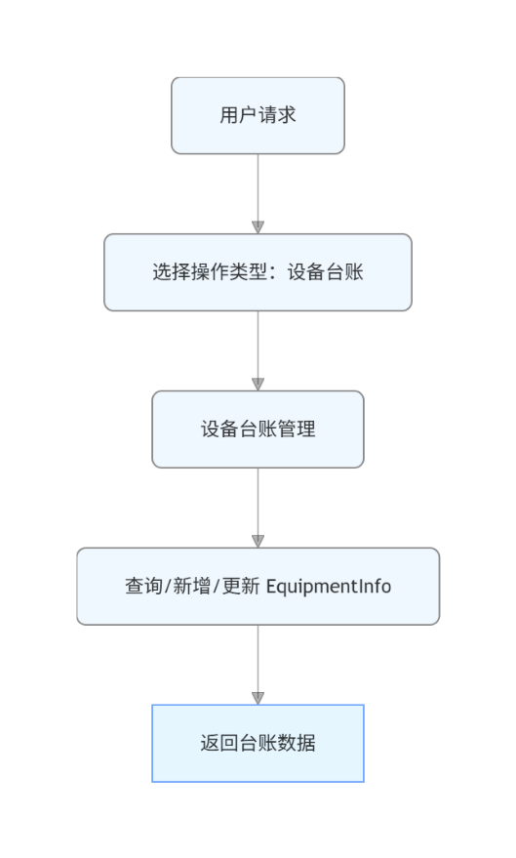

3.2.1.3 类设计
列出模块涉及的类及其职责。
提供类的详细定义，包括属性、方法及其说明。
用 UML 类图表示类之间的关系。

设备台账类，记录设备基础信息、PPM/OEE目标、资产状态、规格及维护相关属性。

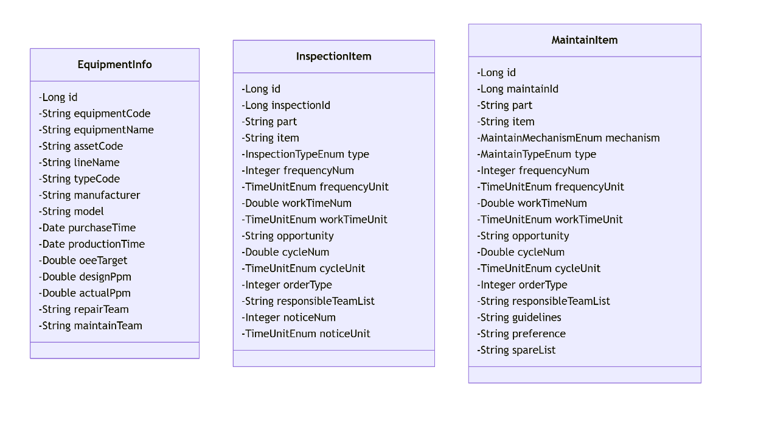

3.2.1.4 时序图
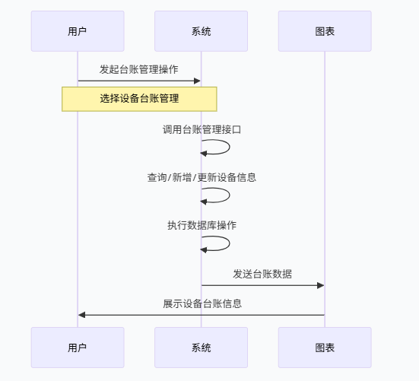

3.2.1.5 内部接口定义
/**
* 获取设备列表
* @param name 设备名称
* @param code 设备编号
* @return 设备列表
*/
@GetMapping(value = "/feign/insider/equipment/list")
List<EquipmentInfoVO> list(@RequestParam("name") String name, @RequestParam("code") String code);
@ApiOperation("设备code和工序code关系")
@PostMapping("/equipmentCodeFactoryCodeList")
public Result<List<EquipmentCodeFactoryCode>> equipmentCodeFactoryCodeList(@RequestBody(required = false) EquipmentCodeFactoryCodeQuery query) {
return Result.success(equipmentFactoryMapper.equipmentCodeFactoryCodeList(query));
}
@ApiOperation("查询父设备信息")
@GetMapping("/findParent")
public Result findParent(@ApiParam(name = "id", value = "id")
@RequestParam Long id) {
return Result.success(equipmentInfoService.getParent(id));
}
@ApiOperation("获取设备bom树")
@GetMapping("/getBomTree")
public Result getBomTree(EquipmentBomParam param) {
return Result.success(equipmentBomService.tree(param.getEquipmentId()));
}

3.2.1.6 外部接口定义
"/equipmentInfo/delete": {
"post": {
"tags": [
"设备台账"
],
"summary": "删除设备",
"operationId": "deleteUsingPOST_2",
"consumes": [
"application/json"
],
"produces": [
"*/*"
],
"parameters": [
{
"in": "body",
"name": "ids",
"description": "ids",
"required": true,
"schema": {
"type": "array",
"items": {
"type": "integer",
"format": "int64"
}
}
}
],
"responses": {
"200": {
"description": "OK",
"schema": {
"originalRef": "Result",
"$ref": "#/definitions/Result"
}
}
},
"security": [
{
"Authorization": [
"global"
]
}
],
"deprecated": false,
"x-order": "2147483647"
}
},
"/equipmentInfo/deleteAcceptanceRecord": {
"post": {
"tags": [
"设备台账"
],
"summary": "删除履历",
"operationId": "updateAcceptanceRecordUsingPOST",
"consumes": [
"application/json"
],
"produces": [
"*/*"
],
"parameters": [
{
"in": "body",
"name": "ids",
"description": "ids",
"required": true,
"schema": {
"type": "array",
"items": {
"type": "integer",
"format": "int64"
}
}
}
],
"responses": {
"200": {
"description": "OK",
"schema": {
"originalRef": "Result",
"$ref": "#/definitions/Result"
}
}
},
"security": [
{
"Authorization": [
"global"
]
}
],
"deprecated": false,
"x-order": "2147483647"
}
},
"/equipmentInfo/deleteBom": {
"post": {
"tags": [
"设备台账"
],
"summary": "删除bom",
"operationId": "updateBomUsingPOST_2",
"consumes": [
"application/json"
],
"produces": [
"*/*"
],
"parameters": [
{
"in": "body",
"name": "ids",
"description": "ids",
"required": true,
"schema": {
"type": "array",
"items": {
"type": "integer",
"format": "int64"
}
}
}
],
"responses": {
"200": {
"description": "OK",
"schema": {
"originalRef": "Result",
"$ref": "#/definitions/Result"
}
}
},
"security": [
{
"Authorization": [
"global"
]
}
],
"deprecated": false,
"x-order": "2147483647"
}
},
"/equipmentInfo/downloadAllCode": {
"get": {
"tags": [
"设备台账"
],
"summary": "导出全部二维码",
"operationId": "downloadAllCodeUsingGET",
"produces": [
"*/*"
],
"parameters": [
{
"name": "brand",
"in": "query",
"description": "品牌",
"required": false,
"type": "string"
},
{
"name": "equipmentCode",
"in": "query",
"description": "设备编号",
"required": false,
"type": "string"
},
{
"name": "equipmentLevel",
"in": "query",
"description": "设备等级",
"required": false,
"type": "string"
},
{
"name": "equipmentName",
"in": "query",
"description": "设备名称",
"required": false,
"type": "string"
},
{
"name": "keyword",
"in": "query",
"description": "关键词",
"required": false,
"type": "string"
},
{
"name": "line",
"in": "query",
"description": "线体",
"required": false,
"type": "array",
"items": {
"type": "integer",
"format": "int64"
},
"collectionFormat": "multi"
},
{
"name": "model",
"in": "query",
"description": "型号",
"required": false,
"type": "string"
},
{
"name": "pageNum",
"in": "query",
"description": "页码",
"required": false,
"type": "integer",
"format": "int32"
},
{
"name": "pageSize",
"in": "query",
"description": "页面大小",
"required": false,
"type": "integer",
"format": "int32"
},
{
"name": "typeCode",
"in": "query",
"description": "类型code",
"required": false,
"type": "string"
},
{
"name": "usage",
"in": "query",
"description": "用途",
"required": false,
"type": "string"
},
{
"name": "workshop",
"in": "query",
"description": "车间",
"required": false,
"type": "string"
}
],
"responses": {
"200": {
"description": "OK"
}
},
"security": [
{
"Authorization": [
"global"
]
}
],
"deprecated": false,
"x-order": "2147483647"
}
},
"/equipmentInfo/downloadCode": {
"post": {
"tags": [
"设备台账"
],
"summary": "导出二维码",
"operationId": "downloadCodeUsingPOST",
"consumes": [
"application/json"
],
"produces": [
"*/*"
],
"parameters": [
{
"in": "body",
"name": "param",
"description": "param",
"required": true,
"schema": {
"originalRef": "ExportParam",
"$ref": "#/definitions/ExportParam"
}
}
],
"responses": {
"200": {
"description": "OK"
}
},
"security": [
{
"Authorization": [
"global"
]
}
],
"deprecated": false,
"x-order": "2147483647"
}
},
"/equipmentInfo/exportExcel": {
"post": {
"tags": [
"设备台账"
],
"summary": "导出数据",
"operationId": "exportExcelUsingPOST",
"consumes": [
"application/json"
],
"produces": [
"*/*"
],
"parameters": [
{
"in": "body",
"name": "param",
"description": "param",
"required": true,
"schema": {
"originalRef": "ExportParam",
"$ref": "#/definitions/ExportParam"
}
}
],
"responses": {
"200": {
"description": "OK"
}
},
"security": [
{
"Authorization": [
"global"
]
}
],
"deprecated": false,
"x-order": "2147483647"
}
},
"/equipmentInfo/exportTemplate": {
"get": {
"tags": [
"设备台账"
],
"summary": "导出模板",
"operationId": "exportTemplateUsingGET",
"produces": [
"*/*"
],
"responses": {
"200": {
"description": "OK"
}
},
"security": [
{
"Authorization": [
"global"
]
}
],
"deprecated": false,
"x-order": "2147483647"
}
},
"/equipmentInfo/find": {
"get": {
"tags": [
"设备台账"
],
"summary": "查询设备信息",
"operationId": "findUsingGET_2",
"produces": [
"*/*"
],
"parameters": [
{
"name": "id",
"in": "query",
"description": "id",
"required": false,
"type": "integer",
"format": "int64",
"allowEmptyValue": false
}
],
"responses": {
"200": {
"description": "OK",
"schema": {
"originalRef": "Result",
"$ref": "#/definitions/Result"
}
}
},
"security": [
{
"Authorization": [
"global"
]
}
],
"deprecated": false,
"x-order": "2147483647"
}
},
"/equipmentInfo/findChildren": {
"get": {
"tags": [
"设备台账"
],
"summary": "查询子设备信息",
"operationId": "findChildrenUsingGET",
"produces": [
"*/*"
],
"parameters": [
{
"name": "id",
"in": "query",
"description": "id",
"required": false,
"type": "integer",
"format": "int64",
"allowEmptyValue": false
}
],
"responses": {
"200": {
"description": "OK",
"schema": {
"originalRef": "Result",
"$ref": "#/definitions/Result"
}
}
},
"security": [
{
"Authorization": [
"global"
]
}
],
"deprecated": false,
"x-order": "2147483647"
}
},
"/equipmentInfo/findParent": {
"get": {
"tags": [
"设备台账"
],
"summary": "查询父设备信息",
"operationId": "findParentUsingGET",
"produces": [
"*/*"
],
"parameters": [
{
"name": "id",
"in": "query",
"description": "id",
"required": false,
"type": "integer",
"format": "int64",
"allowEmptyValue": false
}
],
"responses": {
"200": {
"description": "OK",
"schema": {
"originalRef": "Result",
"$ref": "#/definitions/Result"
}
}
},
"security": [
{
"Authorization": [
"global"
]
}
],
"deprecated": false,
"x-order": "2147483647"
}
},
"/equipmentInfo/getAcceptanceRecordList": {
"get": {
"tags": [
"设备台账"
],
"summary": "根据获取设备履历信息",
"operationId": "getAcceptanceRecordListUsingGET",
"produces": [
"*/*"
],
"parameters": [
{
"name": "acceptor",
"in": "query",
"description": "验收人",
"required": false,
"type": "string"
},
{
"name": "code",
"in": "query",
"description": "验收单单号",
"required": false,
"type": "string"
},
{
"name": "endTime",
"in": "query",
"description": "结束时间",
"required": false,
"type": "string",
"format": "date-time"
},
{
"name": "equipmentId",
"in": "query",
"description": "设备id",
"required": false,
"type": "integer",
"format": "int64"
},
{
"name": "name",
"in": "query",
"description": "验收单名称",
"required": false,
"type": "string"
},
{
"name": "pageNum",
"in": "query",
"description": "页码",
"required": false,
"type": "integer",
"format": "int32"
},
{
"name": "pageSize",
"in": "query",
"description": "页面大小",
"required": false,
"type": "integer",
"format": "int32"
},
{
"name": "startTime",
"in": "query",
"description": "开始时间",
"required": false,
"type": "string",
"format": "date-time"
},
{
"name": "type",
"in": "query",
"description": "验收单类型",
"required": false,
"type": "string"
}
],
"responses": {
"200": {
"description": "OK",
"schema": {
"originalRef": "Result",
"$ref": "#/definitions/Result"
}
}
},
"security": [
{
"Authorization": [
"global"
]
}
],
"deprecated": false,
"x-order": "2147483647"
}
},
"/equipmentInfo/getBomList": {
"get": {
"tags": [
"设备台账"
],
"summary": "根据获取设备bom信息",
"operationId": "getBomListUsingGET_1",
"produces": [
"*/*"
],
"parameters": [
{
"name": "equipmentId",
"in": "query",
"description": "设备id",
"required": false,
"type": "integer",
"format": "int64"
},
{
"name": "lifeExpectancy",
"in": "query",
"description": "理论寿命（天数）",
"required": false,
"type": "integer",
"format": "int32"
},
{
"name": "lifeExpectancyProduction",
"in": "query",
"description": "理论寿命（产量）",
"required": false,
"type": "number",
"format": "float"
},
{
"name": "pageNum",
"in": "query",
"description": "页码",
"required": false,
"type": "integer",
"format": "int32"
},
{
"name": "pageSize",
"in": "query",
"description": "页面大小",
"required": false,
"type": "integer",
"format": "int32"
},
{
"name": "partCode",
"in": "query",
"description": "部件编码",
"required": false,
"type": "string"
},
{
"name": "partName",
"in": "query",
"description": "部件名称",
"required": false,
"type": "string"
},
{
"name": "partType",
"in": "query",
"description": "部件类型",
"required": false,
"type": "string"
},
{
"name": "pid",
"in": "query",
"required": false,
"type": "integer",
"format": "int64"
}
],
"responses": {
"200": {
"description": "OK",
"schema": {
"originalRef": "Result",
"$ref": "#/definitions/Result"
}
}
},
"security": [
{
"Authorization": [
"global"
]
}
],
"deprecated": false,
"x-order": "2147483647"
}
},
"/equipmentInfo/getEquipmentByFactoryId": {
"get": {
"tags": [
"设备台账"
],
"summary": "根据企业层级id获取设备信息",
"operationId": "getInfoByPositionUsingGET",
"produces": [
"*/*"
],
"parameters": [
{
"name": "factoryId",
"in": "query",
"description": "factoryId",
"required": false,
"type": "integer",
"format": "int64",
"allowEmptyValue": false
}
],
"responses": {
"200": {
"description": "OK",
"schema": {
"originalRef": "Result",
"$ref": "#/definitions/Result"
}
}
},
"security": [
{
"Authorization": [
"global"
]
}
],
"deprecated": false,
"x-order": "2147483647"
}
},
"/equipmentInfo/getInfoByPosition": {
"get": {
"tags": [
"设备台账"
],
"summary": "根据位置获取设备列表",
"operationId": "getInfoByPositionUsingGET_1",
"produces": [
"*/*"
],
"parameters": [
{
"name": "positionId",
"in": "query",
"description": "positionId",
"required": false,
"type": "string",
"allowEmptyValue": false
}
],
"responses": {
"200": {
"description": "OK",
"schema": {
"originalRef": "Result",
"$ref": "#/definitions/Result"
}
}
},
"security": [
{
"Authorization": [
"global"
]
}
],
"deprecated": false,
"x-order": "2147483647"
}
},
"/equipmentInfo/getOperationRecordList": {
"get": {
"tags": [
"设备台账"
],
"summary": "根据获取设备操作日志",
"operationId": "getOperationRecordListUsingGET",
"produces": [
"*/*"
],
"parameters": [
{
"name": "equipmentId",
"in": "query",
"description": "equipmentId",
"required": true,
"type": "integer",
"format": "int64"
},
{
"name": "pageNum",
"in": "query",
"description": "pageNum",
"required": true,
"type": "integer",
"format": "int32"
},
{
"name": "pageSize",
"in": "query",
"description": "pageSize",
"required": true,
"type": "integer",
"format": "int32"
}
],
"responses": {
"200": {
"description": "OK",
"schema": {
"originalRef": "Result",
"$ref": "#/definitions/Result"
}
}
},
"security": [
{
"Authorization": [
"global"
]
}
],
"deprecated": false,
"x-order": "2147483647"
}
},
"/equipmentInfo/importExcel": {
"post": {
"tags": [
"设备台账"
],
"summary": "导入设备台账",
"operationId": "importExcelUsingPOST_1",
"consumes": [
"multipart/form-data"
],
"produces": [
"*/*"
],
"parameters": [
{
"name": "file",
"in": "formData",
"description": "file",
"required": false,
"type": "file"
}
],
"responses": {
"200": {
"description": "OK",
"schema": {
"originalRef": "Result",
"$ref": "#/definitions/Result"
}
}
},
"security": [
{
"Authorization": [
"global"
]
}
],
"deprecated": false,
"x-order": "2147483647"
}
},
"/equipmentInfo/insert": {
"post": {
"tags": [
"设备台账"
],
"summary": "插入设备",
"operationId": "insertUsingPOST_2",
"consumes": [
"application/json"
],
"produces": [
"*/*"
],
"parameters": [
{
"in": "body",
"name": "equipmentInfoDto",
"description": "equipmentInfoDto",
"required": true,
"schema": {
"originalRef": "EquipmentInfoDto",
"$ref": "#/definitions/EquipmentInfoDto"
}
}
],
"responses": {
"200": {
"description": "OK",
"schema": {
"originalRef": "Result",
"$ref": "#/definitions/Result"
}
}
},
"security": [
{
"Authorization": [
"global"
]
}
],
"deprecated": false,
"x-order": "2147483647"
}
},
"/equipmentInfo/insertAcceptanceRecord": {
"post": {
"tags": [
"设备台账"
],
"summary": "新增履历",
"operationId": "insertAcceptanceRecordUsingPOST",
"consumes": [
"application/json"
],
"produces": [
"*/*"
],
"parameters": [
{
"in": "body",
"name": "equipmentAcceptanceRecord",
"description": "equipmentAcceptanceRecord",
"required": true,
"schema": {
"originalRef": "EquipmentAcceptanceRecordDto",
"$ref": "#/definitions/EquipmentAcceptanceRecordDto"
}
}
],
"responses": {
"200": {
"description": "OK",
"schema": {
"originalRef": "Result",
"$ref": "#/definitions/Result"
}
}
},
"security": [
{
"Authorization": [
"global"
]
}
],
"deprecated": false,
"x-order": "2147483647"
}
},
"/equipmentInfo/insertBom": {
"post": {
"tags": [
"设备台账"
],
"summary": "新增bom",
"operationId": "insertBomUsingPOST_1",
"consumes": [
"application/json"
],
"produces": [
"*/*"
],
"parameters": [
{
"in": "body",
"name": "equipmentBom",
"description": "equipmentBom",
"required": true,
"schema": {
"originalRef": "EquipmentBom",
"$ref": "#/definitions/EquipmentBom"
}
}
],
"responses": {
"200": {
"description": "OK",
"schema": {
"originalRef": "Result",
"$ref": "#/definitions/Result"
}
}
},
"security": [
{
"Authorization": [
"global"
]
}
],
"deprecated": false,
"x-order": "2147483647"
}
},
"/equipmentInfo/list": {
"get": {
"tags": [
"设备台账"
],
"summary": "查询设备列表",
"operationId": "listUsingGET_4",
"produces": [
"*/*"
],
"parameters": [
{
"name": "keyword",
"in": "query",
"description": "keyword",
"required": false,
"type": "string"
}
],
"responses": {
"200": {
"description": "OK",
"schema": {
"originalRef": "Result",
"$ref": "#/definitions/Result"
}
}
},
"security": [
{
"Authorization": [
"global"
]
}
],
"deprecated": false,
"x-order": "2147483647"
}
},
"/equipmentInfo/page": {
"get": {
"tags": [
"设备台账"
],
"summary": "分页查询设备",
"operationId": "pageUsingGET_4",
"produces": [
"*/*"
],
"parameters": [
{
"name": "brand",
"in": "query",
"description": "品牌",
"required": false,
"type": "string"
},
{
"name": "equipmentCode",
"in": "query",
"description": "设备编号",
"required": false,
"type": "string"
},
{
"name": "equipmentLevel",
"in": "query",
"description": "设备等级",
"required": false,
"type": "string"
},
{
"name": "equipmentName",
"in": "query",
"description": "设备名称",
"required": false,
"type": "string"
},
{
"name": "keyword",
"in": "query",
"description": "关键词",
"required": false,
"type": "string"
},
{
"name": "line",
"in": "query",
"description": "线体",
"required": false,
"type": "array",
"items": {
"type": "integer",
"format": "int64"
},
"collectionFormat": "multi"
},
{
"name": "model",
"in": "query",
"description": "型号",
"required": false,
"type": "string"
},
{
"name": "pageNum",
"in": "query",
"description": "页码",
"required": false,
"type": "integer",
"format": "int32"
},
{
"name": "pageSize",
"in": "query",
"description": "页面大小",
"required": false,
"type": "integer",
"format": "int32"
},
{
"name": "typeCode",
"in": "query",
"description": "类型code",
"required": false,
"type": "string"
},
{
"name": "usage",
"in": "query",
"description": "用途",
"required": false,
"type": "string"
},
{
"name": "workshop",
"in": "query",
"description": "车间",
"required": false,
"type": "string"
}
],
"responses": {
"200": {
"description": "OK",
"schema": {
"originalRef": "Result",
"$ref": "#/definitions/Result"
}
}
},
"security": [
{
"Authorization": [
"global"
]
}
],
"deprecated": false,
"x-order": "2147483647"
}
},
"/equipmentInfo/update": {
"post": {
"tags": [
"设备台账"
],
"summary": "更新设备",
"operationId": "updateUsingPOST_3",
"consumes": [
"application/json"
],
"produces": [
"*/*"
],
"parameters": [
{
"in": "body",
"name": "equipmentInfoDto",
"description": "equipmentInfoDto",
"required": true,
"schema": {
"originalRef": "EquipmentInfoDto",
"$ref": "#/definitions/EquipmentInfoDto"
}
}
],
"responses": {
"200": {
"description": "OK",
"schema": {
"originalRef": "Result",
"$ref": "#/definitions/Result"
}
}
},
"security": [
{
"Authorization": [
"global"
]
}
],
"deprecated": false,
"x-order": "2147483647"
}
},
"/equipmentInfo/updateAcceptanceRecord": {
"post": {
"tags": [
"设备台账"
],
"summary": "更新履历",
"operationId": "updateAcceptanceRecordUsingPOST_1",
"consumes": [
"application/json"
],
"produces": [
"*/*"
],
"parameters": [
{
"in": "body",
"name": "equipmentAcceptanceRecord",
"description": "equipmentAcceptanceRecord",
"required": true,
"schema": {
"originalRef": "EquipmentAcceptanceRecordDto",
"$ref": "#/definitions/EquipmentAcceptanceRecordDto"
}
}
],
"responses": {
"200": {
"description": "OK",
"schema": {
"originalRef": "Result",
"$ref": "#/definitions/Result"
}
}
},
"security": [
{
"Authorization": [
"global"
]
}
],
"deprecated": false,
"x-order": "2147483647"
}
},
"/equipmentInfo/updateBom": {
"post": {
"tags": [
"设备台账"
],
"summary": "更新bom",
"operationId": "updateBomUsingPOST_3",
"consumes": [
"application/json"
],
"produces": [
"*/*"
],
"parameters": [
{
"in": "body",
"name": "equipmentBom",
"description": "equipmentBom",
"required": true,
"schema": {
"originalRef": "EquipmentBom",
"$ref": "#/definitions/EquipmentBom"
}
}
],
"responses": {
"200": {
"description": "OK",
"schema": {
"originalRef": "Result",
"$ref": "#/definitions/Result"
}
}
},
"security": [
{
"Authorization": [
"global"
]
}
],
"deprecated": false,
"x-order": "2147483647"
}
},
"/equipmentInfo/uploadEnclosure": {
"post": {
"tags": [
"设备台账"
],
"summary": "上传附件",
"operationId": "uploadEnclosureUsingPOST",
"consumes": [
"multipart/form-data"
],
"produces": [
"*/*"
],
"parameters": [
{
"name": "file",
"in": "formData",
"description": "file",
"required": false,
"type": "file"
}
],
"responses": {
"200": {
"description": "OK",
"schema": {
"originalRef": "Result",
"$ref": "#/definitions/Result"
}
}
},
"security": [
{
"Authorization": [
"global"
]
}
],
"deprecated": false,
"x-order": "2147483647"
}
},

3.3 点巡检功能概述
设备点检：点检项目、点检计划、点检执行、点检提醒。设备巡检：巡检项目、巡检计划、巡检执行、巡检提醒、临时巡检、巡检汇总。

3.3.1 点巡检模块详细设计

3.3.1.1 数据库设计
表：eq_inspection_benchmark
编号 | 名称 | 数据类型 | 长度 | 小数位 | 允许空值 | 默认值 | 说明
1 | id | int | 10 | 0 | N | 无 | id
2 | benchmark_code | varchar | 255 |  | N | 无 | 基准编号
3 | benchmark_name | varchar | 255 |  | N | 无 | 基准名称
4 | equipment_type | bigint | 19 | 0 | Y | 无 | 设备类型Id
5 | type | int | 10 | 0 | Y | 无 | 类型1设备类型点检 2设备单件 3设备类型巡检 4设备巡检
6 | equipment_id | bigint | 19 | 0 | Y | 无 | 设备id
7 | create_time | datetime |  |  | Y | 无 | 创建时间
8 | create_by | varchar | 255 |  | Y | 无 | 创建人
9 | update_time | datetime |  |  | Y | 无 | 更新时间
10 | update_by | varchar | 255 |  | Y | 无 | 更新人
11 | inspection_flag | int | 10 | 0 | Y | 无 | 点检1 巡检2

表：eq_inspection_item
编号 | 名称 | 数据类型 | 长度 | 小数位 | 允许空值 | 默认值 | 说明
1 | id | bigint | 19 | 0 | N | 无 | id
2 | inspection_id | bigint | 19 | 0 | N | 无 | 基准id
3 | part | varchar | 255 |  | Y | 无 | 点检部位
4 | illustration_number | varchar | 50 |  | Y | 无 | 图示编号
5 | item | varchar | 255 |  | Y | 无 | 点检项目
6 | type | int | 10 | 0 | Y | 无 | 点检类型("设备点检", 1),  ("生产自检", 2),  ("CNC自检", 3),  ("实验室自检", 4),  ("自动线自检", 5),  ("特种设备自检", 6),  ("特种设备报检", 7),  ("计量设备校验", 8);
7 | frequency_num | int | 10 | 0 | Y | 无 | 点检频次
8 | frequency_unit | int | 10 | 0 | Y | 无 | 点检频次单位("年", 1),  ("季度", 2),  ("月", 3),  ("周", 4),  ("天", 5),  ("小时", 6),  ("分钟", 7);
9 | info | text | 65535 |  | Y | 无 | 点检基准
10 | method | text | 65535 |  | Y | 无 | 点检方法
11 | work_time_num | double | 22 |  | Y | 无 | 工时
12 | work_time_unit | int | 10 | 0 | Y | 无 | 工时单位("年", 1),  ("季度", 2),  ("月", 3),  ("周", 4),  ("天", 5),  ("小时", 6),  ("分钟", 7);
13 | opportunity | varchar | 255 |  | Y | 无 | 点检时机
14 | cycle_num | double | 22 |  | Y | 无 | 执行期限
15 | cycle_unit | int | 10 | 0 | Y | 无 | 期限单位("年", 1),  ("季度", 2),  ("月", 3),  ("周", 4),  ("天", 5),  ("小时", 6),  ("分钟", 7);
16 | order_type | int | 10 | 0 | Y | 无 | 派单类别（设备区域派单：1，生产部班长：2，设备部班长：3，CNC班长：4，实验室班长：5，自动线班长：6，特种设备管理：7，计量设备管理：8）
17 | responsible_team_list | varchar | 255 |  | Y | 无 | 责任班组
18 | notice_num | double | 22 |  | Y | 无 | 提前提醒
19 | notice_unit | int | 10 | 0 | Y | 无 | 单位("年", 1),  ("季度", 2),  ("月", 3),  ("周", 4),  ("天", 5),  ("小时", 6),  ("分钟", 7);
20 | create_time | datetime |  |  | Y | 无 | 创建时间
21 | create_by | varchar | 255 |  | Y | 无 | 创建人
22 | update_time | datetime |  |  | Y | 无 | 更新时间
23 | update_by | varchar | 255 |  | Y | 无 | 更新人

表：eq_inspection_plan
编号 | 名称 | 数据类型 | 长度 | 小数位 | 允许空值 | 默认值 | 说明
1 | id | bigint | 19 | 0 | N | 无 | id
2 | plan_code | varchar | 255 |  | N | 无 | 计划编号
3 | inspection_id | bigint | 19 | 0 | Y | 无 | 基准id
4 | type | int | 10 | 0 | Y | 无 | 点检类型("设备点检", 1),  ("生产自检", 2),  ("CNC自检", 3),  ("实验室自检", 4),  ("自动线自检", 5),  ("特种设备自检", 6),  ("特种设备报检", 7),  ("计量设备校验", 8);
5 | frequency_num | int | 10 | 0 | Y | 无 | 点检频次
6 | frequency_unit | int | 10 | 0 | Y | 无 | 点检频次单位("年", 1),  ("季度", 2),  ("月", 3),  ("周", 4),  ("天", 5),  ("小时", 6),  ("分钟", 7);
7 | order_type | int | 10 | 0 | Y | 无 | 派单类别
8 | responsible_team_list | varchar | 255 |  | Y | 无 | 责任班组列表
9 | cycle_num | double | 22 |  | Y | 无 | 执行期限
10 | cycle_unit | int | 10 | 0 | Y | 无 | 期限单位("年", 1),  ("季度", 2),  ("月", 3),  ("周", 4),  ("天", 5),  ("小时", 6),  ("分钟", 7);
11 | plan_status | tinyint | 3 | 0 | Y | 无 | 计划状态（1启用，0停用）
12 | latest_plan_time | datetime |  |  | Y | 无 | 最近任务时间
13 | index_key | varchar | 255 |  | Y | 无 | 唯一key
14 | item_list | text | 65535 |  | Y | 无 | 项目集合
15 | create_time | datetime |  |  | Y | 无 | 创建时间
16 | create_by | varchar | 255 |  | Y | 无 | 创建人
17 | update_time | datetime |  |  | Y | 无 | 更新时间
18 | update_by | varchar | 255 |  | Y | 无 | 更新人
19 | inspection_flag | int | 10 | 0 | Y | 无 | 点检1 巡检2

表：eq_inspection_task
编号 | 名称 | 数据类型 | 长度 | 小数位 | 允许空值 | 默认值 | 说明
1 | id | bigint | 19 | 0 | N | 无 | id
2 | task_code | varchar | 255 |  | Y | 无 | 工单编号
3 | responsible_team | varchar | 255 |  | Y | 无 | 责任部门ID
4 | responsible_team_name | varchar | 255 |  | Y | 无 | 责任部门
5 | equipment_id | bigint | 19 | 0 | Y | 无 | 设备Id
6 | benchmark_id | bigint | 19 | 0 | Y | 无 | 基准编号
7 | plan_id | bigint | 19 | 0 | Y | 无 | 计划编号
8 | repair_id | bigint | 19 | 0 | Y | 无 | 维修工单ID
9 | assign_task_time | datetime |  |  | Y | 无 | 计划保养时间（任务下发时间）
10 | expect_finish_time | datetime |  |  | Y | 无 | 计划结束时间
11 | shift | varchar | 50 |  | Y | 无 | 班次
12 | accept_time | datetime |  |  | Y | 无 | 应签到时间
13 | type | int | 10 | 0 | Y | 无 | 点检类型("设备点检", 1),  ("生产自检", 2),  ("CNC自检", 3),  ("实验室自检", 4),  ("自动线自检", 5),  ("特种设备自检", 6),  ("特种设备报检", 7),  ("计量设备校验", 8);
14 | frequency_num | int | 10 | 0 | Y | 无 | 频次
15 | frequency_unit | int | 10 | 0 | Y | 无 | 频次单位("年", 1),  ("季度", 2),  ("月", 3),  ("周", 4),  ("天", 5),  ("小时", 6),  ("分钟", 7);
16 | cycle_num | double | 22 |  | Y | 无 | 执行周期
17 | cycle_unit | int | 10 | 0 | Y | 无 | 周期单位("年", 1),  ("季度", 2),  ("月", 3),  ("周", 4),  ("天", 5),  ("小时", 6),  ("分钟", 7);
18 | order_type | int | 10 | 0 | Y | 无 | 派单类别，即责任班组id
19 | working_group_name | varchar | 255 |  | Y | 无 | 责任班组
20 | item_list | text | 65535 |  | Y | 无 | 项目列表
21 | is_special_type | tinyint | 3 | 0 | Y | 无 | 是否特殊设备（1是0否）
22 | is_dismantle | tinyint | 3 | 0 | Y | 无 | 是否拆除安全装置（1是0否）
23 | apply_person | varchar | 255 |  | Y | 无 | 申请人
24 | status | int | 10 | 0 | Y | 无 | 状态("待派单", 1),  ("待接单", 2),  ("待签到", 3),  ("待执行", 4),  ("执行中", 5),  ("待验收", 6),  ("已完成", 7);
25 | executor | varchar | 1000 |  | Y | 无 | 当前执行人
26 | task_executor | varchar | 255 |  | Y | 无 | 任务责任人
27 | order_evaluate | varchar | 255 |  | Y | 无 | 工单处理评价
28 | order_evaluate_picture | varchar | 255 |  | Y | 无 | 工单评价图片
29 | stars | decimal | 10 | 2 | Y | 无 | 星级
30 | order_reject_message | varchar | 255 |  | Y | 无 | 工单驳回原因
31 | order_reject_picture | varchar | 255 |  | Y | 无 | 工单驳回图片
32 | task_start | datetime |  |  | Y | 无 | 开始时间
33 | task_end | datetime |  |  | Y | 无 | 结束时间
34 | task_take | varchar | 255 |  | Y | 无 | 任务用时
35 | if_overdue | varchar | 255 |  | Y | 无 | 是否逾期（1是0否）
36 | overdue_day | varchar | 255 |  | Y | 无 | 逾期天数
37 | finish_time | datetime |  |  | Y | 无 | 工单结束时间
38 | task_item_num | int | 10 | 0 | Y | 无 | 应保项数目
39 | leave_out_item_num | int | 10 | 0 | Y | 无 | 漏保项数目
40 | abnormal_item_num | int | 10 | 0 | Y | 无 | 异常项数目
41 | delay_reason | varchar | 255 |  | Y | 无 | 延时原因
42 | delay_num | double | 22 |  | Y | 无 | 延时数值
43 | delay_unit | int | 10 | 0 | Y | 无 | 延时单位("年", 1),  ("季度", 2),  ("月", 3),  ("周", 4),  ("天", 5),  ("小时", 6),  ("分钟", 7);
44 | process_list | text | 65535 |  | Y | 无 | 节点流转记录
45 | next_assign_task_time | datetime |  |  | Y | 无 | 下次任务下发时间
46 | is_delete | tinyint | 3 | 0 | Y | 无 | 是否删除（1是0否）
47 | create_time | datetime |  |  | Y | 无 | 创建时间
48 | create_by | varchar | 255 |  | Y | 无 | 创建人
49 | update_time | datetime |  |  | Y | 无 | 更新时间
50 | update_by | varchar | 255 |  | Y | 无 | 更新人
51 | inspection_flag | int | 10 | 0 | Y | 无 | 点检1 巡检2

表：eq_inspection_task_report
编号 | 名称 | 数据类型 | 长度 | 小数位 | 允许空值 | 默认值 | 说明
1 | id | bigint | 19 | 0 | N | 无 | id
2 | report_code | varchar | 255 |  | Y | 无 | 报告编号
3 | type | varchar | 255 |  | Y | 无 | 生成方式
4 | position_id | varchar | 255 |  | Y | 无 | 设备线体ID
5 | position_code | varchar | 255 |  | Y | 无 | 设备线体编号
6 | position_leader | varchar | 255 |  | Y | 无 | 设备线体负责人
7 | position_name | varchar | 255 |  | Y | 无 | 设备线体名称
8 | is_special_type | tinyint | 3 | 0 | Y | 无 | 是否特殊设备（1是0否）
9 | result | json |  |  | Y | 无 | 保养结果信息
10 | month_str | varchar | 255 |  | Y | 无 | 月份（字符串类型）
11 | special_result | json |  |  | Y | 无 | 特殊设备结果信息
12 | create_time | datetime |  |  | Y | 无 | 创建时间
13 | create_by | varchar | 255 |  | Y | 无 | 创建人
14 | update_time | datetime |  |  | Y | 无 | 更新时间
15 | update_by | varchar | 255 |  | Y | 无 | 更新人
16 | inspection_flag | int | 10 | 0 | Y | 无 | 点检1 巡检2

表：eq_ins_update_history
编号 | 名称 | 数据类型 | 长度 | 小数位 | 允许空值 | 默认值 | 说明
1 | id | bigint | 19 | 0 | N | 无 | id
2 | content | varchar | 255 |  | Y | 无 | 内容
3 | inspection_id | bigint | 19 | 0 | Y | 无 | 基准id
4 | user_name | varchar | 255 |  | Y | 无 | 更改人
5 | user_code | varchar | 255 |  | Y | 无 | 工号
6 | create_time | datetime |  |  | Y | 无 | 创建时间
7 | create_by | varchar | 255 |  | Y | 无 | 创建人
8 | update_time | datetime |  |  | Y | 无 | 更新时间

3.3.1.2 流程图
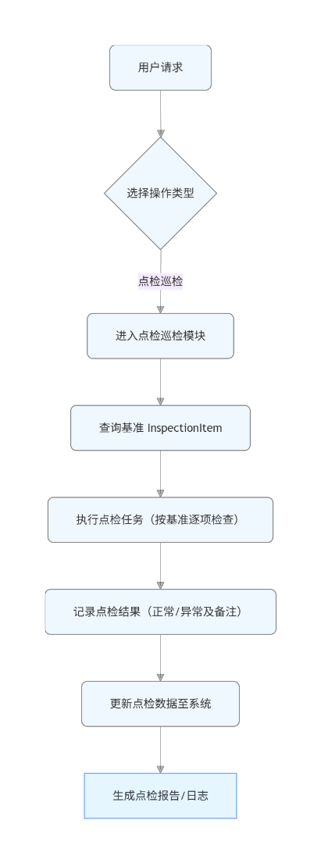

3.3.1.3 类设计
设备点检管理系统的完整实体模型，涵盖了从基准定义、项目配置、计划制定到任务执行的完整业务流程。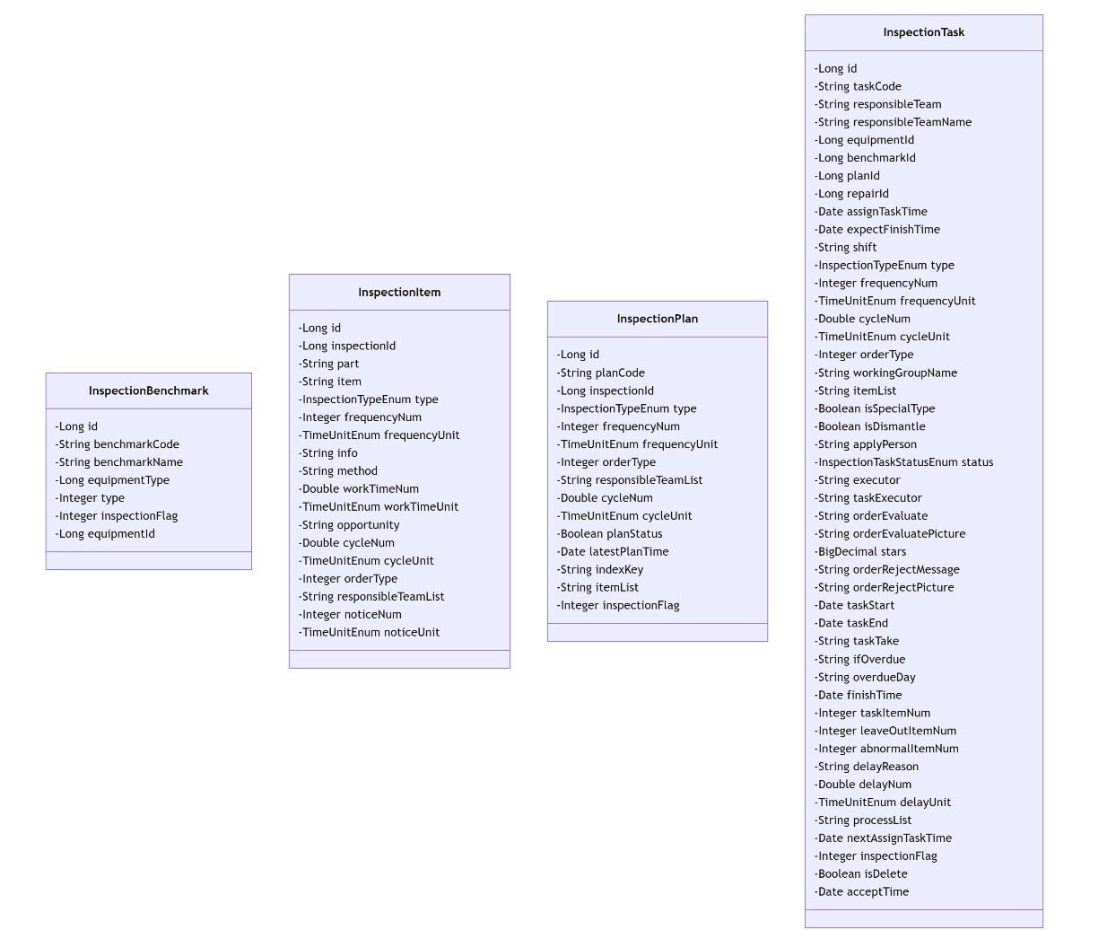

3.3.1.4 时序图
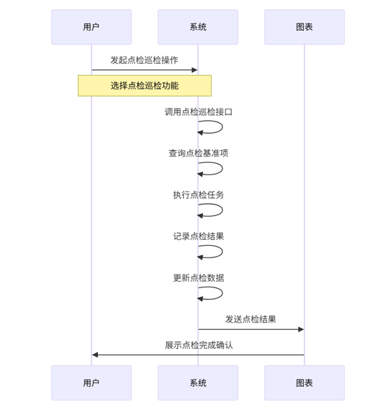

3.3.1.5 内部接口定义
@ApiOperation("接收故障数据")
public Result receiveData(@RequestBody JSONObject request) {
System.out.println("============接收声纹故障数据============");
eqVoiceprintInspectionService.save(request);
return Result.success();
}
@ApiOperation("更新基准信息(特殊设备)")
public Result specialUpdate(@RequestBody InspectionSpecialDto specialDto) {
inspectionBenchmarkService.update(specialDto);
return Result.success();
}
@PostMapping("/report/generate")
public Result generateTaskReport(@Validated InspectionTaskReportGenerateParam reportSelectParam) {
if (reportSelectParam.getIsSpecialType()) {
return Result.success(inspectionTaskService.generateSpecialTaskReport(reportSelectParam));
} else {
return Result.success(inspectionTaskService.generateTaskReport(reportSelectParam));
}
}
//多线程处理list集合,最多10个线程
public List<InspectionTaskVo> list(List<InspectionTask> list) {
//需要处理的list集合,list集合中常用的pojo对象，Map<String,Object>等，根据业务调整
//List<InspectionTask> list = this.list(query);
//这里我们用Callable创建线程，可以获取返回值。--定义接收返回的数据的集合
List<InspectionTaskVo> dataList = new ArrayList<>();
//List<String> list = new ArrayList<>();
this.main(list.size());
//创建线程池,--拥有固定线程数量的线程池（推荐）
//ExecutorService exc = Executors.newFixedThreadPool(threadNum);
//定义可以提交给线程池的任务集合
List<Callable<List<InspectionTaskVo>>> tasks = new ArrayList<>();
//每个线程的任务
Callable<List<InspectionTaskVo>> task = null;
//定义切割总List集合后的集合
List<InspectionTask> cutList = null;
//遍历任务
for (int i = 0; i < this.threadNum; i++) {
//切割list
if (i == this.threadNum - 1) {
cutList = list.subList(i * this.threadSize, list.size());
} else {
cutList = list.subList(i * this.threadSize, (i + 1) * this.threadSize);
}
// Map<String, EquipmentInformation> equipmentS = equipmentInfoService.equipmentS();
final List<InspectionTask> finalCutList = cutList;
task = new Callable<List<InspectionTaskVo>>() {
@Override
public List<InspectionTaskVo> call() throws Exception {
//定义接收业务返回值的集合
List<InspectionTaskVo> newList = new ArrayList<>();
for (InspectionTask a : finalCutList) {
newList.add(inspectionTaskService.convert(a));
//newList.add(inspectionTaskService.convertAsync(a, equipmentS.get(a.getEquipmentId())));
}
return newList;
}
};
//添加任务
tasks.add(task);
}
try {
//执行所有任务并获取结果,捕获异常InterruptedException
List<Future<List<InspectionTaskVo>>> results = executor.invokeAll(tasks);
for (Future<List<InspectionTaskVo>> result : results) {
//调用get方法获取每个返回的结果，将结果添加到定义好的集合中。捕获异常ExecutionException
dataList.addAll(result.get());
}
} catch (InterruptedException | ExecutionException e) {
e.printStackTrace();
}
//关闭线程池
//executor.shutdown();
return dataList;
}

3.3.1.6 外部接口定义
"/inspection/task/report/reportExport": {
"get": {
"tags": [
"点巡检任务管理"
],
"summary": "批量导出点检报告多sheet（根据报告ID，为空代表导出全部）",
"operationId": "reportExportUsingGET",
"produces": [
"*/*"
],
"parameters": [
{
"name": "ids",
"in": "query",
"description": "请求ID,参数值为空代表导出全部；支持多个ID，参考：1,2",
"required": false,
"type": "string",
"allowEmptyValue": false
}
],
"responses": {
"200": {
"description": "OK"
}
},
"security": [
{
"Authorization": [
"global"
]
}
],
"deprecated": false,
"x-order": "2147483647"
}
},
"/inspection/task/run": {
"get": {
"tags": [
"点巡检任务管理"
],
"summary": "runInspection",
"operationId": "runInspectionUsingGET",
"produces": [
"*/*"
],
"responses": {
"200": {
"description": "OK",
"schema": {
"type": "string"
}
}
},
"security": [
{
"Authorization": [
"global"
]
}
],
"deprecated": false,
"x-order": "2147483647"
}
},
"/inspection/task/statistic/lastMonth": {
"get": {
"tags": [
"点巡检任务管理"
],
"summary": "Home上月数据统计",
"operationId": "lastMonthUsingGET_1",
"produces": [
"*/*"
],
"parameters": [
{
"in": "body",
"name": "month",
"description": "月份",
"required": false,
"schema": {
"type": "string",
"format": "date-time"
}
}
],
"responses": {
"200": {
"description": "OK",
"schema": {
"$ref": "#/definitions/Result",
"originalRef": "Result"
}
}
},
"security": [
{
"Authorization": [
"global"
]
}
],
"deprecated": false,
"x-order": "2147483647"
}
},
"/inspection/task/statistic/thisMonth": {
"get": {
"tags": [
"点巡检任务管理"
],
"summary": "Home本月数据统计",
"operationId": "thisMonthUsingGET_1",
"produces": [
"*/*"
],
"parameters": [
{
"in": "body",
"name": "month",
"description": "月份",
"required": false,
"schema": {
"type": "string",
"format": "date-time"
}
}
],
"responses": {
"200": {
"description": "OK",
"schema": {
"$ref": "#/definitions/Result",
"originalRef": "Result"
}
}
},
"security": [
{
"Authorization": [
"global"
]
}
],
"deprecated": false,
"x-order": "2147483647"
}
},
"/inspection/task/updateInspectionResult": {
"post": {
"tags": [
"点巡检任务管理"
],
"summary": "更新点检结果",
"operationId": "updateInspectionResultUsingPOST",
"consumes": [
"application/json"
],
"produces": [
"*/*"
],
"parameters": [
{
"in": "body",
"name": "inspectionTaskItemResultParam",
"description": "inspectionTaskItemResultParam",
"required": true,
"schema": {
"$ref": "#/definitions/点检结果参数",
"originalRef": "点检结果参数"
}
}
],
"responses": {
"200": {
"description": "OK",
"schema": {
"$ref": "#/definitions/Result",
"originalRef": "Result"
}
}
},
"security": [
{
"Authorization": [
"global"
]
}
],
"deprecated": false,
"x-order": "2147483647"
}
},
"/inspection/task/uploadEnclosure": {
"post": {
"tags": [
"点巡检任务管理"
],
"summary": "上传附件",
"operationId": "uploadEnclosureUsingPOST_3",
"consumes": [
"application/json"
],
"produces": [
"*/*"
],
"parameters": [
{
"name": "files",
"in": "formData",
"description": "files",
"required": true,
"type": "array",
"items": {
"type": "file"
},
"collectionFormat": "multi"
}
],
"responses": {
"200": {
"description": "OK",
"schema": {
"$ref": "#/definitions/Result",
"originalRef": "Result"
}
}
},
"security": [
{
"Authorization": [
"global"
]
}
],
"deprecated": false,
"x-order": "2147483647"
}
}
"/inspection/task/pageWithoutPermission": {
"get": {
"tags": [
"点巡检任务管理"
],
"summary": "点检工单分页没权限",
"operationId": "pageWithoutPermissionUsingGET",
"produces": [
"*/*"
],
"parameters": [
{
"name": "benchmarkCode",
"in": "query",
"description": "点检基准编号",
"required": false,
"type": "string"
},
{
"name": "benchmarkName",
"in": "query",
"description": "基准名称",
"required": false,
"type": "string"
},
{
"name": "equipmentCode",
"in": "query",
"description": "设备编号",
"required": false,
"type": "string"
},
{
"name": "equipmentId",
"in": "query",
"description": "设备ID",
"required": false,
"type": "integer",
"format": "int64"
},
{
"name": "executor",
"in": "query",
"description": "责任人",
"required": false,
"type": "string"
},
{
"name": "frequencyNum",
"in": "query",
"description": "点检频次",
"required": false,
"type": "integer",
"format": "int32"
},
{
"name": "frequencyUnit",
"in": "query",
"description": "频次单位",
"required": false,
"type": "integer",
"format": "int32"
},
{
"name": "ifOverdue",
"in": "query",
"description": "是否逾期 Y/N",
"required": false,
"type": "string"
},
{
"name": "inspectionFlag",
"in": "query",
"description": "点巡检类型（1点检,2巡检）",
"required": false,
"type": "integer",
"format": "int32"
},
{
"name": "isFinish",
"in": "query",
"description": "是否完成工单",
"required": false,
"type": "boolean"
},
{
"name": "isSpecialType",
"in": "query",
"description": "是否特殊设备",
"required": false,
"type": "boolean"
},
{
"name": "keyword",
"in": "query",
"description": "关键词:设备编号或设备名称",
"required": false,
"type": "string"
},
{
"name": "line",
"in": "query",
"description": "线体",
"required": false,
"type": "integer",
"format": "int64"
},
{
"name": "pageNum",
"in": "query",
"description": "页码（page分页请求处理，其他请求不处理）",
"required": false,
"type": "integer",
"format": "int32"
},
{
"name": "pageSize",
"in": "query",
"description": "页面大小（page分页请求处理，其他请求不处理）",
"required": false,
"type": "integer",
"format": "int32"
},
{
"name": "planCode",
"in": "query",
"description": "计划编号",
"required": false,
"type": "string"
},
{
"name": "responsibleTeam",
"in": "query",
"description": "部门ID",
"required": false,
"type": "string"
},
{
"name": "sortDesc",
"in": "query",
"description": "是否点检时间降序排列",
"required": false,
"type": "boolean"
},
{
"name": "status",
"in": "query",
"description": "工单状态(优先于isFinish)",
"required": false,
"type": "integer",
"format": "int32"
},
{
"name": "taskCode",
"in": "query",
"description": "任务编号",
"required": false,
"type": "string"
},
{
"name": "timeEnd",
"in": "query",
"description": "点检时间结束",
"required": false,
"type": "string",
"format": "date-time"
},
{
"name": "timeStart",
"in": "query",
"description": "点检时间开始",
"required": false,
"type": "string",
"format": "date-time"
},
{
"name": "type",
"in": "query",
"description": "点检类型",
"required": false,
"type": "integer",
"format": "int32"
}
],
"responses": {
"200": {
"description": "OK",
"schema": {
"$ref": "#/definitions/Result",
"originalRef": "Result"
}
}
},
"security": [
{
"Authorization": [
"global"
]
}
],
"deprecated": false,
"x-order": "2147483647"
}
},
"/inspection/task/pageWithoutPermissionNotDelete": {
"get": {
"tags": [
"点巡检任务管理"
],
"summary": "点检工单分页没权限 未删除的",
"operationId": "pageWithoutPermissionNotDeleteUsingGET",
"produces": [
"*/*"
],
"parameters": [
{
"name": "benchmarkCode",
"in": "query",
"description": "点检基准编号",
"required": false,
"type": "string"
},
{
"name": "benchmarkName",
"in": "query",
"description": "基准名称",
"required": false,
"type": "string"
},
{
"name": "equipmentCode",
"in": "query",
"description": "设备编号",
"required": false,
"type": "string"
},
{
"name": "equipmentId",
"in": "query",
"description": "设备ID",
"required": false,
"type": "integer",
"format": "int64"
},
{
"name": "executor",
"in": "query",
"description": "责任人",
"required": false,
"type": "string"
},
{
"name": "frequencyNum",
"in": "query",
"description": "点检频次",
"required": false,
"type": "integer",
"format": "int32"
},
{
"name": "frequencyUnit",
"in": "query",
"description": "频次单位",
"required": false,
"type": "integer",
"format": "int32"
},
{
"name": "ifOverdue",
"in": "query",
"description": "是否逾期 Y/N",
"required": false,
"type": "string"
},
{
"name": "inspectionFlag",
"in": "query",
"description": "点巡检类型（1点检,2巡检）",
"required": false,
"type": "integer",
"format": "int32"
},
{
"name": "isFinish",
"in": "query",
"description": "是否完成工单",
"required": false,
"type": "boolean"
},
{
"name": "isSpecialType",
"in": "query",
"description": "是否特殊设备",
"required": false,
"type": "boolean"
},
{
"name": "keyword",
"in": "query",
"description": "关键词:设备编号或设备名称",
"required": false,
"type": "string"
},
{
"name": "line",
"in": "query",
"description": "线体",
"required": false,
"type": "integer",
"format": "int64"
},
{
"name": "pageNum",
"in": "query",
"description": "页码（page分页请求处理，其他请求不处理）",
"required": false,
"type": "integer",
"format": "int32"
},
{
"name": "pageSize",
"in": "query",
"description": "页面大小（page分页请求处理，其他请求不处理）",
"required": false,
"type": "integer",
"format": "int32"
},
{
"name": "planCode",
"in": "query",
"description": "计划编号",
"required": false,
"type": "string"
},
{
"name": "responsibleTeam",
"in": "query",
"description": "部门ID",
"required": false,
"type": "string"
},
{
"name": "sortDesc",
"in": "query",
"description": "是否点检时间降序排列",
"required": false,
"type": "boolean"
},
{
"name": "status",
"in": "query",
"description": "工单状态(优先于isFinish)",
"required": false,
"type": "integer",
"format": "int32"
},
{
"name": "taskCode",
"in": "query",
"description": "任务编号",
"required": false,
"type": "string"
},
{
"name": "timeEnd",
"in": "query",
"description": "点检时间结束",
"required": false,
"type": "string",
"format": "date-time"
},
{
"name": "timeStart",
"in": "query",
"description": "点检时间开始",
"required": false,
"type": "string",
"format": "date-time"
},
{
"name": "type",
"in": "query",
"description": "点检类型",
"required": false,
"type": "integer",
"format": "int32"
}
],
"responses": {
"200": {
"description": "OK",
"schema": {
"$ref": "#/definitions/Result",
"originalRef": "Result"
}
}
},
"security": [
{
"Authorization": [
"global"
]
}
],
"deprecated": false,
"x-order": "2147483647"
}
},
"/inspection/task/report/add": {
"post": {
"tags": [
"点巡检任务管理"
],
"summary": "点检报告新增",
"operationId": "addTaskReportUsingPOST",
"consumes": [
"application/json"
],
"produces": [
"*/*"
],
"parameters": [
{
"in": "body",
"name": "reportSelectParam",
"description": "reportSelectParam",
"required": true,
"schema": {
"$ref": "#/definitions/点检报告查询参数",
"originalRef": "点检报告查询参数"
}
}
],
"responses": {
"200": {
"description": "OK",
"schema": {
"$ref": "#/definitions/Result",
"originalRef": "Result"
}
}
},
"security": [
{
"Authorization": [
"global"
]
}
],
"deprecated": false,
"x-order": "2147483647"
}
},
"/inspection/task/report/delete": {
"post": {
"tags": [
"点巡检任务管理"
],
"summary": "点检报告删除",
"operationId": "reportDeleteUsingPOST",
"consumes": [
"application/json"
],
"produces": [
"*/*"
],
"parameters": [
{
"in": "body",
"name": "ids",
"description": "ids",
"required": true,
"schema": {
"type": "array",
"items": {
"type": "integer",
"format": "int64"
}
}
}
],
"responses": {
"200": {
"description": "OK",
"schema": {
"$ref": "#/definitions/Result",
"originalRef": "Result"
}
}
},
"security": [
{
"Authorization": [
"global"
]
}
],
"deprecated": false,
"x-order": "2147483647"
}
},
"/inspection/task/report/downloadReportZip": {
"post": {
"tags": [
"点巡检任务管理"
],
"summary": "批量导出点检报告（根据报告ID）ZIP（报告ID为空数据导出全部）",
"operationId": "downloadReportUsingPOST",
"consumes": [
"application/json"
],
"produces": [
"*/*"
],
"parameters": [
{
"in": "body",
"name": "ids",
"description": "ids",
"required": true,
"schema": {
"type": "array",
"items": {
"type": "integer",
"format": "int64"
}
}
}
],
"responses": {
"200": {
"description": "OK"
}
},
"security": [
{
"Authorization": [
"global"
]
}
],
"deprecated": false,
"x-order": "2147483647"
}
},
"/inspection/task/report/find": {
"get": {
"tags": [
"点巡检任务管理"
],
"summary": "查询点检报告详情信息",
"operationId": "reportFindUsingGET",
"produces": [
"*/*"
],
"parameters": [
{
"name": "id",
"in": "query",
"description": "id",
"required": false,
"type": "integer",
"format": "int64",
"allowEmptyValue": false
}
],
"responses": {
"200": {
"description": "OK",
"schema": {
"$ref": "#/definitions/Result",
"originalRef": "Result"
}
}
},
"security": [
{
"Authorization": [
"global"
]
}
],
"deprecated": false,
"x-order": "2147483647"
}
},
"/inspection/task/report/generate": {
"post": {
"tags": [
"点巡检任务管理"
],
"summary": "点检报告生成（不新增报告）",
"operationId": "generateTaskReportUsingPOST",
"consumes": [
"application/json"
],
"produces": [
"*/*"
],
"parameters": [
{
"name": "equipmentid",
"in": "query",
"description": "设备编号ID",
"required": false,
"type": "integer",
"format": "int64"
},
{
"name": "finishTimeEnd",
"in": "query",
"description": "任务完成时间结束",
"required": false,
"type": "string",
"format": "date-time"
},
{
"name": "finishTimeStart",
"in": "query",
"description": "任务完成时间开始",
"required": false,
"type": "string",
"format": "date-time"
},
{
"name": "isSpecialType",
"in": "query",
"description": "是否特殊设备",
"required": false,
"type": "boolean"
},
{
"name": "positionid",
"in": "query",
"description": "设备位置ID",
"required": false,
"type": "integer",
"format": "int64"
},
{
"name": "responsibleTeam",
"in": "query",
"description": "责任部门Id",
"required": false,
"type": "string"
},
{
"name": "type",
"in": "query",
"description": "点检类型",
"required": false,
"type": "string",
"enum": [
"EQUIPMENT",
"PRODUCTION",
"CNC",
"LABORATORY",
"AUTOMATIC_LINE",
"SPECIAL_EQUIPMENT_SELF",
"SPECIAL_EQUIPMENT_OTHER",
"MEASURING_EQUIPMENT"
]
}
],
"responses": {
"200": {
"description": "OK",
"schema": {
"$ref": "#/definitions/Result",
"originalRef": "Result"
}
}
},
"security": [
{
"Authorization": [
"global"
]
}
],
"deprecated": false,
"x-order": "2147483647"
}
},
"/inspection/task/report/page": {
"post": {
"tags": [
"点巡检任务管理"
],
"summary": "点检报告分页",
"operationId": "reportPageUsingPOST",
"consumes": [
"application/json"
],
"produces": [
"*/*"
],
"parameters": [
{
"name": "createTimeEnd",
"in": "query",
"description": "生成时间结束",
"required": false,
"type": "string",
"format": "date-time"
},
{
"name": "createTimeStart",
"in": "query",
"description": "生成时间开始",
"required": false,
"type": "string",
"format": "date-time"
},
{
"name": "equipmentid",
"in": "query",
"description": "设备编号ID",
"required": false,
"type": "integer",
"format": "int64"
},
{
"name": "inspectionFlag",
"in": "query",
"description": "点巡检类型（1点检,2巡检）",
"required": false,
"type": "integer",
"format": "int32"
},
{
"name": "isSpecialType",
"in": "query",
"description": "是否特殊设备报告",
"required": false,
"type": "boolean"
},
{
"name": "pageNum",
"in": "query",
"description": "页码（page分页请求处理，其他请求不处理）",
"required": false,
"type": "integer",
"format": "int32"
},
{
"name": "pageSize",
"in": "query",
"description": "页面大小（page分页请求处理，其他请求不处理）",
"required": false,
"type": "integer",
"format": "int32"
},
{
"name": "positionid",
"in": "query",
"description": "设备线体ID",
"required": false,
"type": "integer",
"format": "int64"
},
{
"name": "responsibleTeam",
"in": "query",
"description": "责任部门Id",
"required": false,
"type": "string"
},
{
"name": "type",
"in": "query",
"description": "点检类型",
"required": false,
"type": "integer",
"format": "int32"
}
],
"responses": {
"200": {
"description": "OK",
"schema": {
"$ref": "#/definitions/Result",
"originalRef": "Result"
}
}
},
"security": [
{
"Authorization": [
"global"
]
}
],
"deprecated": false,
"x-order": "2147483647"
}
},

3.4 设备保养功能概述
设备保养：保养项目、保养计划制定、保养执行、保养确认、保养提醒、保养计划汇总。

3.4.1 设备保养模块详细设计

3.4.1.1 数据库设计
表：eq_maintain_benchmark
编号 | 名称 | 数据类型 | 长度 | 小数位 | 允许空值 | 默认值 | 说明
1 | id | int | 10 | 0 | N | 无 | id
2 | benchmark_code | varchar | 255 |  | N | 无 | 基准编号
3 | benchmark_name | varchar | 255 |  | N | 无 | 基准名称
4 | equipment_type | bigint | 19 | 0 | N | 无 | 设备类型Id
5 | type | int | 10 | 0 | Y | 无 | 保养类型设备保养”，1 C(CNC保养"，2)，:"实验室保养"，code:3，自动线保养:4，特种设备保养”  5);
6 | equipment_id | bigint | 19 | 0 | Y | 无 | 设备id
7 | create_time | datetime |  |  | Y | 无 | 创建时间
8 | create_by | varchar | 255 |  | Y | 无 | 创建人
9 | update_time | datetime |  |  | Y | 无 | 更新时间
10 | update_by | varchar | 255 |  | Y | 无 | 更新人

表：eq_maintain_item
编号 | 名称 | 数据类型 | 长度 | 小数位 | 允许空值 | 默认值 | 说明
1 | id | bigint | 19 | 0 | N | 无 | id
2 | maintain_id | bigint | 19 | 0 | N | 无 | 基准id
3 | part | varchar | 255 |  | Y | 无 | 保养部位
4 | item | varchar | 255 |  | Y | 无 | 保养项目
5 | mechanism | int | 10 | 0 | Y | 无 | 保养机制("日常保养", 1),  ("周保养", 2),  ("月度保养", 3),  ("季度保养", 4),  ("年度保养", 5);
6 | type | int | 10 | 0 | Y | 无 | 保养类型("设备保养", 1),  ("CNC保养", 2),  ("实验室保养", 3),  ("自动线保养", 4),  ("特种设备保养", 5);
7 | frequency_num | int | 10 | 0 | Y | 无 | 保养频次
8 | frequency_unit | int | 10 | 0 | Y | 无 | 保养频次单位("年", 1),  ("季度", 2),  ("月", 3),  ("周", 4),  ("天", 5),  ("小时", 6),  ("分钟", 7);
9 | info | text | 65535 |  | Y | 无 | 保养标准
10 | method | text | 65535 |  | Y | 无 | 保养方法
11 | work_time_num | double | 22 |  | Y | 无 | 工时
12 | work_time_unit | int | 10 | 0 | Y | 无 | 工时单位("年", 1),  ("季度", 2),  ("月", 3),  ("周", 4),  ("天", 5),  ("小时", 6),  ("分钟", 7);
13 | opportunity | varchar | 255 |  | Y | 无 | 保养时机
14 | cycle_num | double | 22 |  | Y | 无 | 执行期限
15 | cycle_unit | int | 10 | 0 | Y | 无 | 期限单位("年", 1),  ("季度", 2),  ("月", 3),  ("周", 4),  ("天", 5),  ("小时", 6),  ("分钟", 7);
16 | order_type | int | 10 | 0 | Y | 无 | 派单类别
17 | responsible_team_list | varchar | 255 |  | Y | 无 | 责任班组
18 | guidelines | varchar | 255 |  | Y | 无 | 指导书
19 | preference | varchar | 255 |  | Y | 无 | 维保偏好
20 | spare_list | text | 65535 |  | Y | 无 | 建议备件及数量
21 | create_time | datetime |  |  | Y | 无 | 创建时间
22 | create_by | varchar | 255 |  | Y | 无 | 创建人
23 | update_time | datetime |  |  | Y | 无 | 更新时间
24 | update_by | varchar | 255 |  | Y | 无 | 更新人

表：eq_maintain_plan
编号 | 名称 | 数据类型 | 长度 | 小数位 | 允许空值 | 默认值 | 说明
1 | id | bigint | 19 | 0 | N | 无 | id
2 | plan_code | varchar | 255 |  | N | 无 | 计划编号
3 | maintain_id | bigint | 19 | 0 | Y | 无 | 基准id
4 | type | int | 10 | 0 | Y | 无 | 保养类型("设备保养", 1),  ("CNC保养", 2),  ("实验室保养", 3),  ("自动线保养", 4),  ("特种设备保养", 5);
5 | frequency_num | int | 10 | 0 | Y | 无 | 保养频次
6 | frequency_unit | int | 10 | 0 | Y | 无 | 保养频次单位("年", 1),  ("季度", 2),  ("月", 3),  ("周", 4),  ("天", 5),  ("小时", 6),  ("分钟", 7);
7 | order_type | int | 10 | 0 | Y | 无 | 派单类别
8 | responsible_team_list | varchar | 255 |  | Y | 无 | 责任班组
9 | mechanism | int | 10 | 0 | Y | 无 | 保养机制("日常保养", 1),  ("周保养", 2),  ("月度保养", 3),  ("季度保养", 4),  ("年度保养", 5);
10 | cycle_num | double | 22 |  | Y | 无 | 执行期限
11 | cycle_unit | int | 10 | 0 | Y | 无 | 期限单位("年", 1),  ("季度", 2),  ("月", 3),  ("周", 4),  ("天", 5),  ("小时", 6),  ("分钟", 7);
12 | plan_status | tinyint | 3 | 0 | Y | 无 | 计划状态（1启用0停用）
13 | latest_plan_time | datetime |  |  | Y | 无 | 最近任务时间
14 | index_key | varchar | 255 |  | Y | 无 | 唯一key
15 | item_list | text | 65535 |  | Y | 无 | 项目列表
16 | create_time | datetime |  |  | Y | 无 | 创建时间
17 | create_by | varchar | 255 |  | Y | 无 | 创建人
18 | update_time | datetime |  |  | Y | 无 | 更新时间
19 | update_by | varchar | 255 |  | Y | 无 | 更新人

表：eq_maintain_task
编号 | 名称 | 数据类型 | 长度 | 小数位 | 允许空值 | 默认值 | 说明
1 | id | bigint | 19 | 0 | N | 无 | id
2 | task_code | varchar | 255 |  | Y | 无 | 工单编号
3 | responsible_team | varchar | 255 |  | Y | 无 | 责任部门ID
4 | responsible_team_name | varchar | 255 |  | Y | 无 | 责任部门
5 | equipment_id | bigint | 19 | 0 | Y | 无 | 设备Id
6 | benchmark_id | bigint | 19 | 0 | Y | 无 | 基准编号
7 | plan_id | bigint | 19 | 0 | Y | 无 | 计划编号
8 | repair_id | bigint | 19 | 0 | Y | 无 | 维修工单ID
9 | assign_task_time | datetime |  |  | Y | 无 | 计划保养时间（任务下发时间）
10 | expect_finish_time | datetime |  |  | Y | 无 | 计划结束时间
11 | shift | varchar | 50 |  | Y | 无 | 班次
12 | accept_time | datetime |  |  | Y | 无 | 应接单时间
13 | type | int | 10 | 0 | Y | 无 | 保养类型("设备保养", 1),  ("CNC保养", 2),  ("实验室保养", 3),  ("自动线保养", 4),  ("特种设备保养", 5);
14 | mechanism | int | 10 | 0 | Y | 无 | 保养机制("日常保养", 1),  ("周保养", 2),  ("月度保养", 3),  ("季度保养", 4),  ("年度保养", 5);
15 | frequency_num | int | 10 | 0 | Y | 无 | 保养频次
16 | frequency_unit | int | 10 | 0 | Y | 无 | 频次单位("年", 1),  ("季度", 2),  ("月", 3),  ("周", 4),  ("天", 5),  ("小时", 6),  ("分钟", 7);
17 | cycle_num | double | 22 |  | Y | 无 | 执行周期
18 | cycle_unit | int | 10 | 0 | Y | 无 | 周期单位("年", 1),  ("季度", 2),  ("月", 3),  ("周", 4),  ("天", 5),  ("小时", 6),  ("分钟", 7);
19 | order_type | int | 10 | 0 | Y | 无 | 派单类别，即责任班组id
20 | working_group_name | varchar | 255 |  | Y | 无 | 责任班组
21 | item_list | text | 65535 |  | Y | 无 | 保养项项列表
22 | is_special_type | tinyint | 3 | 0 | Y | 无 | 是否特殊设备（1是0否）
23 | is_dismantle | tinyint | 3 | 0 | Y | 无 | 是否拆除安全装置（1是0否）
24 | apply_person | varchar | 255 |  | Y | 无 | 申请人
25 | status | int | 10 | 0 | Y | 无 | 状态("待派单", 1),  ("待接单", 2),  ("待签到", 3),  ("待执行", 4),  ("执行中", 5),  ("待验收", 6),  ("已完成", 7);
26 | executor | varchar | 255 |  | Y | 无 | 当前执行人
27 | task_executor | varchar | 255 |  | Y | 无 | 任务责任人
28 | order_evaluate | varchar | 255 |  | Y | 无 | 工单处理评价
29 | order_evaluate_picture | varchar | 255 |  | Y | 无 | 工单评价图片
30 | stars | decimal | 10 | 2 | Y | 无 | 星级
31 | order_reject_message | varchar | 255 |  | Y | 无 | 工单驳回原因
32 | order_reject_picture | varchar | 255 |  | Y | 无 | 工单驳回图片
33 | task_start | datetime |  |  | Y | 无 | 保养开始时间
34 | task_end | datetime |  |  | Y | 无 | 保养结束时间
35 | task_take | varchar | 255 |  | Y | 无 | 任务用时
36 | if_overdue | varchar | 255 |  | Y | 无 | 是否逾期（1是0否）
37 | overdue_day | varchar | 255 |  | Y | 无 | 逾期天数
38 | finish_time | datetime |  |  | Y | 无 | 工单结束时间
39 | task_item_num | int | 10 | 0 | Y | 无 | 应保项数目
40 | leave_out_item_num | int | 10 | 0 | Y | 无 | 漏保项数目
41 | abnormal_item_num | int | 10 | 0 | Y | 无 | 异常项数目
42 | delay_reason | varchar | 255 |  | Y | 无 | 延时原因
43 | delay_num | double | 22 |  | Y | 无 | 延时数值
44 | delay_unit | int | 10 | 0 | Y | 无 | 延时单位("年", 1),  ("季度", 2),  ("月", 3),  ("周", 4),  ("天", 5),  ("小时", 6),  ("分钟", 7);
45 | process_list | text | 65535 |  | Y | 无 | 节点流转记录
46 | next_assign_task_time | datetime |  |  | Y | 无 | 下次任务下发时间
47 | is_delete | tinyint | 3 | 0 | Y | 无 | 是否删除（1是0否）
48 | create_time | datetime |  |  | Y | 无 | 创建时间
49 | create_by | varchar | 255 |  | Y | 无 | 创建人
50 | update_time | datetime |  |  | Y | 无 | 更新时间
51 | update_by | varchar | 255 |  | Y | 无 | 更新人

表：eq_maintain_task_import
编号 | 名称 | 数据类型 | 长度 | 小数位 | 允许空值 | 默认值 | 说明
1 | id | bigint | 19 | 0 | N | 无 | id
2 | task_code | varchar | 255 |  | N | 无 | 工单编号
3 | workshop | bigint | 19 | 0 | Y | 无 | 车间拉线
4 | workshop_name | varchar | 255 |  | Y | 无 | 车间名称
5 | process | bigint | 19 | 0 | Y | 无 | 工序id
6 | process_name | varchar | 255 |  | Y | 无 | 工序名称
7 | responsible_team | bigint | 19 | 0 | Y | 无 | 责任部门id
8 | responsible_team_name | varchar | 255 |  | Y | 无 | 责任部门名称
9 | equipment_id | bigint | 19 | 0 | Y | 无 | 设备id
10 | equipment_code | varchar | 255 |  | Y | 无 | 设备编号
11 | equipment_name | varchar | 255 |  | Y | 无 | 设备名称
12 | picture | text | 65535 |  | Y | 无 | 附件或者图片
13 | status | varchar | 255 |  | Y | 无 | 状态（已完成、执行中）
14 | executor | varchar | 255 |  | Y | 无 | 当前责任人
15 | task_start | timestamp |  |  | Y | 无 | 任务开始时间
16 | expect_finish_time | timestamp |  |  | Y | 无 | 计划结束时间
17 | task_take | varchar | 255 |  | Y | 无 | 任务用时
18 | if_overdue | varchar | 255 |  | Y | 无 | 是否逾期（1是0否）
19 | overdue_day | varchar | 255 |  | Y | 无 | 逾期天数
20 | finish_time | timestamp |  |  | Y | 无 | 完成时间
21 | matter | text | 65535 |  | Y | 无 | 事项
22 | attention | text | 65535 |  | Y | 无 | 注意事项
23 | spareparts | text | 65535 |  | Y | 无 | 工具备件需求
24 | exception_record | text | 65535 |  | Y | 无 | 异常记录
25 | create_time | datetime |  |  | Y | 无 | 创建时间
26 | create_by | varchar | 255 |  | Y | 无 | 创建人
27 | update_time | datetime |  |  | Y | 无 | 更新时间
28 | update_by | varchar | 255 |  | Y | 无 | 更新人

表：eq_maintain_task_report
编号 | 名称 | 数据类型 | 长度 | 小数位 | 允许空值 | 默认值 | 说明
1 | id | bigint | 19 | 0 | N | 无 | id
2 | report_code | varchar | 255 |  | Y | 无 | 报告编号
3 | type | varchar | 255 |  | Y | 无 | 生成方式system/person
4 | position_id | varchar | 255 |  | Y | 无 | 设备线体ID
5 | position_code | varchar | 255 |  | Y | 无 | 设备线体编号
6 | position_leader | varchar | 255 |  | Y | 无 | 设备线体负责人
7 | position_name | varchar | 255 |  | Y | 无 | 设备线体名称
8 | is_special_type | tinyint | 3 | 0 | Y | 无 | 是否特殊设备（1是0否）
9 | result | json |  |  | Y | 无 | 保养结果信息
10 | month_str | varchar | 255 |  | Y | 无 | 月份
11 | special_result | json |  |  | Y | 无 | 特殊设备结果信息
12 | create_time | datetime |  |  | Y | 无 | 创建时间
13 | create_by | varchar | 255 |  | Y | 无 | 创建人
14 | update_time | datetime |  |  | Y | 无 | 更新时间
15 | update_by | varchar | 255 |  | Y | 无 | 更新人

表：eq_maintain_update_history
编号 | 名称 | 数据类型 | 长度 | 小数位 | 允许空值 | 默认值 | 说明
1 | id | bigint | 19 | 0 | N | 无 | id
2 | content | varchar | 255 |  | Y | 无 | 内容
3 | maintain_id | bigint | 19 | 0 | Y | 无 | 基准id
4 | user_name | varchar | 255 |  | Y | 无 | 更改人
5 | user_code | varchar | 255 |  | Y | 无 | 工号
6 | create_time | datetime |  |  | Y | 无 | 创建时间
7 | create_by | varchar | 255 |  | Y | 无 | 创建人
8 | update_time | datetime |  |  | Y | 无 | 更新时间
9 | update_by | varchar | 255 |  | Y | 无 | 更新人

3.4.1.2 流程图
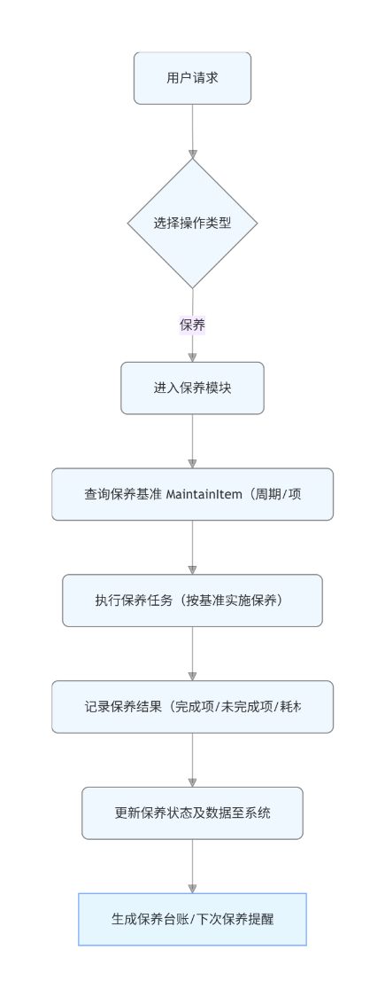

3.4.1.3 类设计
保养类，定义保养基准、保养类型、保养频次、工时、执行时机、执行及评价。

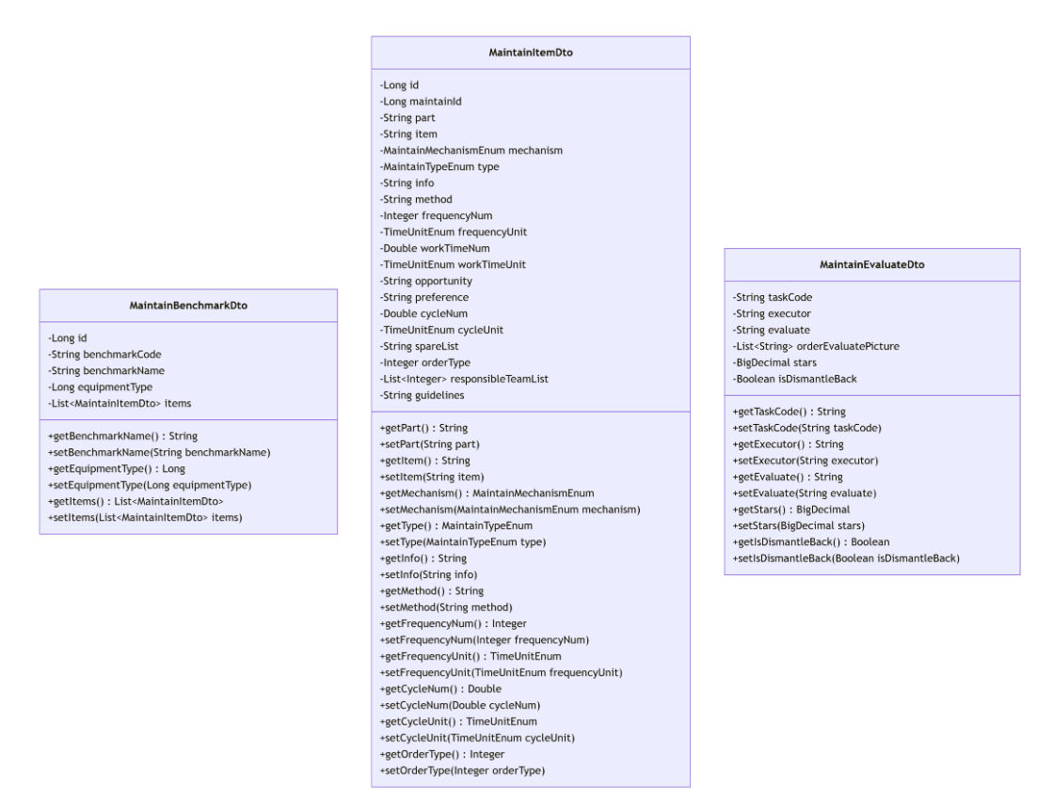

3.4.1.4 时序图
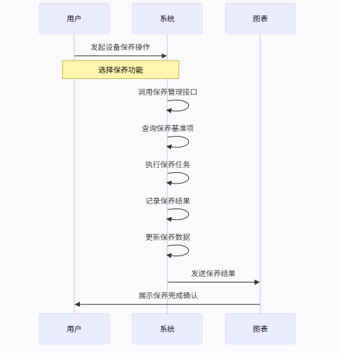

3.4.1.5 内部接口定义
private void main(Integer dataSize) {
//线程数
//int threadNum = MAX_THREAD_NUM;
/*
if (dataSize % threadSize == 0) {
//能整除的话
threadNum = dataSize / threadSize;
} else {
//不能整除的话，多加一条处理多余的数据
threadNum = dataSize / threadSize + 1;
}*/
//if (threadNum > MAX_THREAD_NUM) {
//threadNum = MAX_THREAD_NUM;
if (dataSize % this.threadNum == 0) {
//能整除的话
this.threadSize = dataSize / this.threadNum;
} else {
//不能整除的话，多加一条处理多余的数据
int size = (int) Math.ceil(dataSize / this.threadNum);
if (size < 1) {
this.threadSize = 1;
this.threadNum = dataSize;
} else {
this.threadSize = (int) Math.ceil(dataSize / this.threadNum);
}
}
}
public Result receiveOrders(@RequestBody @Validated MaintainReciveOrdersParam receiveOrdersParam) {
return Result.success(maintainTaskOrderService.receiveOrders(receiveOrdersParam));
}
@ApiOperation("执行")
public Result execute(@RequestBody @Validated OrderParam param) {
return Result.success(maintainTaskOrderService.execute(param.getTaskCode(), param.getExecutor(), param.getIsDismantle()));
}
@ApiOperation("待执行转单")
public Result executeDevote(@RequestBody @Validated OrderParam param) {
return Result.success(maintainTaskOrderService.executeDevote(param.getTaskCode(), param.getExecutor(), param.getStaff(), param.getMessage()));
}
@ApiOperation("执行完成(通用)")
public Result finishWorkSpecial(@RequestBody @Validated MaintainFinishWorkParam finishWorkParam) {
return Result.success(maintainTaskOrderService.finishWork(finishWorkParam.getTaskCode(), finishWorkParam.getExecutor(),
Objects.nonNull(finishWorkParam.getNextAssignTaskTime()) ? finishWorkParam.getNextAssignTaskTime() : null,
Objects.nonNull(finishWorkParam.getIsDismantle()) ? finishWorkParam.getIsDismantle() : null));
}
@ApiOperation("完成延时")
/*执行中未逾期未提交前可任意延时，只记录最后一次延时数据*/
public Result finishWorkDelay(@RequestBody @Validated OrderParam param) {
return Result.success(maintainTaskOrderService.finishWorkDelay(param.getTaskCode(), param.getExecutor(), param.getDeleyNum(), param.getDeleyUnit(), param.getMessage()));
}
@ApiOperation("验收评价")
public Result confirm(@RequestBody @Validated MaintainEvaluateDto maintainEvaluateDto) {
return Result.success(maintainTaskOrderService.evaluate(maintainEvaluateDto));
}
@ApiOperation("验收驳回")
public Result reject(@RequestBody @Validated MaintainRejectDto maintainRejectDto) {
return Result.success(maintainTaskOrderService.reject(maintainRejectDto));
}
@ApiOperation("查询工单签核历史")
public Result getOrderHistory(@ApiParam(name = "taskCode", required = true, value = "工单单号") @RequestParam String taskCode) {
return Result.success(maintainTaskOrderService.getTaskHistory(taskCode));
}

3.4.1.6 外部接口定义
"/maintain/board/lastMonth": {
"get": {
"tags": [
"保养任务看板数据"
],
"summary": "设备看板上月数据统计",
"operationId": "lastMonthUsingGET_2",
"produces": [
"*/*"
],
"parameters": [
{
"in": "body",
"name": "month",
"description": "月份",
"required": false,
"schema": {
"type": "string",
"format": "date-time"
}
}
],
"responses": {
"200": {
"description": "OK",
"schema": {
"$ref": "#/definitions/Result",
"originalRef": "Result"
}
}
},
"security": [
{
"Authorization": [
"global"
]
}
],
"deprecated": false,
"x-order": "2147483647"
}
},
"/maintain/board/listStatusNum": {
"get": {
"tags": [
"保养任务看板数据"
],
"summary": "任务页任务状态数据统计",
"operationId": "listStatusNumUsingGET_2",
"produces": [
"*/*"
],
"parameters": [
{
"name": "benchmarkCode",
"in": "query",
"description": "保养基准编号",
"required": false,
"type": "string"
},
{
"name": "benchmarkName",
"in": "query",
"description": "基准名称",
"required": false,
"type": "string"
},
{
"name": "equipmentCode",
"in": "query",
"description": "设备编号",
"required": false,
"type": "string"
},
{
"name": "equipmentId",
"in": "query",
"description": "设备Id",
"required": false,
"type": "integer",
"format": "int64"
},
{
"name": "executor",
"in": "query",
"description": "责任人",
"required": false,
"type": "string"
},
{
"name": "frequencyNum",
"in": "query",
"description": "保养频次",
"required": false,
"type": "integer",
"format": "int32"
},
{
"name": "frequencyUnit",
"in": "query",
"description": "频次单位",
"required": false,
"type": "integer",
"format": "int32"
},
{
"name": "ifOverdue",
"in": "query",
"description": "是否逾期 Y/N",
"required": false,
"type": "string"
},
{
"name": "isFinish",
"in": "query",
"description": "是否完成工单",
"required": false,
"type": "boolean"
},
{
"name": "isSpecialType",
"in": "query",
"description": "是否特殊设备",
"required": false,
"type": "boolean"
},
{
"name": "keyword",
"in": "query",
"description": "关键词：设备编号或设备名称",
"required": false,
"type": "string"
},
{
"name": "line",
"in": "query",
"description": "线体",
"required": false,
"type": "integer",
"format": "int64"
},
{
"name": "mechanism",
"in": "query",
"description": "保养机制",
"required": false,
"type": "integer",
"format": "int32"
},
{
"name": "pageNum",
"in": "query",
"description": "页码（page分页请求处理，其他请求不处理）",
"required": false,
"type": "integer",
"format": "int32"
},
{
"name": "pageSize",
"in": "query",
"description": "页面大小（page分页请求处理，其他请求不处理）",
"required": false,
"type": "integer",
"format": "int32"
},
{
"name": "planCode",
"in": "query",
"description": "计划编号",
"required": false,
"type": "string"
},
{
"name": "responsibleTeam",
"in": "query",
"description": "部门ID",
"required": false,
"type": "string"
},
{
"name": "sortDesc",
"in": "query",
"description": "是否保养时间降序排列",
"required": false,
"type": "boolean"
},
{
"name": "status",
"in": "query",
"description": "工单状态(优先于isFinish)",
"required": false,
"type": "integer",
"format": "int32"
},
{
"name": "taskCode",
"in": "query",
"description": "任务编号",
"required": false,
"type": "string"
},
{
"name": "timeEnd",
"in": "query",
"description": "保养时间结束",
"required": false,
"type": "string",
"format": "date-time"
},
{
"name": "timeStart",
"in": "query",
"description": "保养时间开始",
"required": false,
"type": "string",
"format": "date-time"
},
{
"name": "type",
"in": "query",
"description": "保养类型",
"required": false,
"type": "integer",
"format": "int32"
}
],
"responses": {
"200": {
"description": "OK",
"schema": {
"$ref": "#/definitions/Result",
"originalRef": "Result"
}
}
},
"security": [
{
"Authorization": [
"global"
]
}
],
"deprecated": false,
"x-order": "2147483647"
}
},
"/maintain/board/listStatusNumApp": {
"get": {
"tags": [
"保养任务看板数据"
],
"summary": "APP主页任务状态数据统计",
"operationId": "listStatusNumAppUsingGET_1",
"produces": [
"*/*"
],
"parameters": [
{
"name": "benchmarkCode",
"in": "query",
"description": "保养基准编号",
"required": false,
"type": "string"
},
{
"name": "benchmarkName",
"in": "query",
"description": "基准名称",
"required": false,
"type": "string"
},
{
"name": "equipmentCode",
"in": "query",
"description": "设备编号",
"required": false,
"type": "string"
},
{
"name": "equipmentId",
"in": "query",
"description": "设备Id",
"required": false,
"type": "integer",
"format": "int64"
},
{
"name": "executor",
"in": "query",
"description": "责任人",
"required": false,
"type": "string"
},
{
"name": "frequencyNum",
"in": "query",
"description": "保养频次",
"required": false,
"type": "integer",
"format": "int32"
},
{
"name": "frequencyUnit",
"in": "query",
"description": "频次单位",
"required": false,
"type": "integer",
"format": "int32"
},
{
"name": "ifOverdue",
"in": "query",
"description": "是否逾期 Y/N",
"required": false,
"type": "string"
},
{
"name": "isFinish",
"in": "query",
"description": "是否完成工单",
"required": false,
"type": "boolean"
},
{
"name": "isSpecialType",
"in": "query",
"description": "是否特殊设备",
"required": false,
"type": "boolean"
},
{
"name": "keyword",
"in": "query",
"description": "关键词：设备编号或设备名称",
"required": false,
"type": "string"
},
{
"name": "line",
"in": "query",
"description": "线体",
"required": false,
"type": "integer",
"format": "int64"
},
{
"name": "mechanism",
"in": "query",
"description": "保养机制",
"required": false,
"type": "integer",
"format": "int32"
},
{
"name": "pageNum",
"in": "query",
"description": "页码（page分页请求处理，其他请求不处理）",
"required": false,
"type": "integer",
"format": "int32"
},
{
"name": "pageSize",
"in": "query",
"description": "页面大小（page分页请求处理，其他请求不处理）",
"required": false,
"type": "integer",
"format": "int32"
},
{
"name": "planCode",
"in": "query",
"description": "计划编号",
"required": false,
"type": "string"
},
{
"name": "responsibleTeam",
"in": "query",
"description": "部门ID",
"required": false,
"type": "string"
},
{
"name": "sortDesc",
"in": "query",
"description": "是否保养时间降序排列",
"required": false,
"type": "boolean"
},
{
"name": "status",
"in": "query",
"description": "工单状态(优先于isFinish)",
"required": false,
"type": "integer",
"format": "int32"
},
{
"name": "taskCode",
"in": "query",
"description": "任务编号",
"required": false,
"type": "string"
},
{
"name": "timeEnd",
"in": "query",
"description": "保养时间结束",
"required": false,
"type": "string",
"format": "date-time"
},
{
"name": "timeStart",
"in": "query",
"description": "保养时间开始",
"required": false,
"type": "string",
"format": "date-time"
},
{
"name": "type",
"in": "query",
"description": "保养类型",
"required": false,
"type": "integer",
"format": "int32"
}
],
"responses": {
"200": {
"description": "OK",
"schema": {
"$ref": "#/definitions/Result",
"originalRef": "Result"
}
}
},
"security": [
{
"Authorization": [
"global"
]
}
],
"deprecated": false,
"x-order": "2147483647"
}
},
"/maintain/board/planPage": {
"get": {
"tags": [
"保养任务看板数据"
],
"summary": "保养看板计划详情",
"operationId": "planPageUsingGET_1",
"produces": [
"*/*"
],
"parameters": [
{
"name": "equipmentId",
"in": "query",
"description": "设备id",
"required": false,
"type": "integer",
"format": "int64",
"allowEmptyValue": false
},
{
"name": "pageNum",
"in": "query",
"description": "页码",
"required": false,
"type": "integer",
"format": "int32",
"allowEmptyValue": false
},
{
"name": "pageSize",
"in": "query",
"description": "页面大小",
"required": false,
"type": "integer",
"format": "int32",
"allowEmptyValue": false
}
],
"responses": {
"200": {
"description": "OK",
"schema": {
"$ref": "#/definitions/Result",
"originalRef": "Result"
}
}
},
"security": [
{
"Authorization": [
"global"
]
}
],
"deprecated": false,
"x-order": "2147483647"
}
},
"/maintain/board/taskDayItemStatistics": {
"get": {
"tags": [
"保养任务看板数据"
],
"summary": "保养看板任务保养项统计分析",
"operationId": "taskDayItemStatisticsUsingGET_1",
"produces": [
"*/*"
],
"parameters": [
{
"in": "body",
"name": "endTime",
"description": "结束时间",
"required": false,
"schema": {
"type": "string",
"format": "date-time"
}
},
{
"in": "body",
"name": "orgId",
"description": "部门id",
"required": false,
"schema": {
"type": "string"
}
},
{
"in": "body",
"name": "startTime",
"description": "开始时间",
"required": false,
"schema": {
"type": "string",
"format": "date-time"
}
}
],
"responses": {
"200": {
"description": "OK",
"schema": {
"$ref": "#/definitions/Result",
"originalRef": "Result"
}
}
},
"security": [
{
"Authorization": [
"global"
]
}
],
"deprecated": false,
"x-order": "2147483647"
}
},
"/maintain/board/taskDayStatistics": {
"get": {
"tags": [
"保养任务看板数据"
],
"summary": "保养看板任务达成趋势图",
"operationId": "taskDayStatisticsUsingGET_1",
"produces": [
"*/*"
],
"parameters": [
{
"in": "body",
"name": "endTime",
"description": "结束时间",
"required": false,
"schema": {
"type": "string",
"format": "date-time"
}
},
{
"in": "body",
"name": "orgId",
"description": "部门id",
"required": false,
"schema": {
"type": "string"
}
},
{
"in": "body",
"name": "startTime",
"description": "开始时间",
"required": false,
"schema": {
"type": "string",
"format": "date-time"
}
}
],
"responses": {
"200": {
"description": "OK",
"schema": {
"$ref": "#/definitions/Result",
"originalRef": "Result"
}
}
},
"security": [
{
"Authorization": [
"global"
]
}
],
"deprecated": false,
"x-order": "2147483647"
}
},
"/maintain/board/taskEndNum": {
"get": {
"tags": [
"保养任务看板数据"
],
"summary": "保养看板保养达成率统计",
"operationId": "taskEndNumUsingGET_1",
"produces": [
"*/*"
],
"parameters": [
{
"in": "body",
"name": "endTime",
"description": "结束时间",
"required": false,
"schema": {
"type": "string",
"format": "date-time"
}
},
{
"in": "body",
"name": "orgId",
"description": "部门id",
"required": false,
"schema": {
"type": "string"
}
},
{
"in": "body",
"name": "startTime",
"description": "开始时间",
"required": false,
"schema": {
"type": "string",
"format": "date-time"
}
}
],
"responses": {
"200": {
"description": "OK",
"schema": {
"$ref": "#/definitions/Result",
"originalRef": "Result"
}
}
},
"security": [
{
"Authorization": [
"global"
]
}
],
"deprecated": false,
"x-order": "2147483647"
}
},
"/maintain/equipmentList": {
"get": {
"tags": [
"保养基准"
],
"summary": "设备基准列表",
"operationId": "equipmentListUsingGET_1",
"produces": [
"*/*"
],
"responses": {
"200": {
"description": "OK",
"schema": {
"$ref": "#/definitions/Result",
"originalRef": "Result"
}
}
},
"security": [
{
"Authorization": [
"global"
]
}
],
"deprecated": false,
"x-order": "2147483647"
}
},
"/maintain/export": {
"post": {
"tags": [
"保养基准"
],
"summary": "设备类型导出",
"operationId": "exportUsingPOST_1",
"consumes": [
"application/json"
],
"produces": [
"*/*"
],
"parameters": [
{
"in": "body",
"name": "param",
"description": "param",
"required": true,
"schema": {
"$ref": "#/definitions/ExportParam",
"originalRef": "ExportParam"
}
}
],
"responses": {
"200": {
"description": "OK"
}
},
"security": [
{
"Authorization": [
"global"
]
}
],
"deprecated": false,
"x-order": "2147483647"
}
},
"/maintain/find": {
"get": {
"tags": [
"保养基准"
],
"summary": "查询单个基准信息",
"operationId": "findUsingGET_8",
"produces": [
"*/*"
],
"parameters": [
{
"name": "id",
"in": "query",
"description": "id",
"required": true,
"type": "integer",
"format": "int64"
}
],
"responses": {
"200": {
"description": "OK",
"schema": {
"$ref": "#/definitions/Result",
"originalRef": "Result"
}
}
},
"security": [
{
"Authorization": [
"global"
]
}
],
"deprecated": false,
"x-order": "2147483647"
}
},
"/maintain/getHistoryList": {
"get": {
"tags": [
"保养基准"
],
"summary": "根据设备类型id查找历史修改记录列表",
"operationId": "getHistoryListUsingGET_1",
"produces": [
"*/*"
],
"parameters": [
{
"name": "id",
"in": "query",
"description": "id",
"required": true,
"type": "integer",
"format": "int64"
}
],
"responses": {
"200": {
"description": "OK",
"schema": {
"$ref": "#/definitions/Result",
"originalRef": "Result"
}
}
},
"security": [
{
"Authorization": [
"global"
]
}
],
"deprecated": false,
"x-order": "2147483647"
}
},
"/maintain/import": {
"post": {
"tags": [
"保养基准"
],
"summary": "设备类型导入",
"operationId": "importDataUsingPOST_1",
"consumes": [
"multipart/form-data"
],
"produces": [
"*/*"
],
"parameters": [
{
"name": "file",
"in": "formData",
"description": "file",
"required": false,
"type": "file"
}
],
"responses": {
"200": {
"description": "OK",
"schema": {
"$ref": "#/definitions/Result",
"originalRef": "Result"
}
}
},
"security": [
{
"Authorization": [
"global"
]
}
],
"deprecated": false,
"x-order": "2147483647"
}
},
"/maintain/insert": {
"post": {
"tags": [
"保养基准"
],
"summary": "新增基准信息(设备类型)",
"operationId": "insertUsingPOST_8",
"consumes": [
"application/json"
],
"produces": [
"*/*"
],
"parameters": [
{
"in": "body",
"name": "maintainBenchmarkDto",
"description": "maintainBenchmarkDto",
"required": true,
"schema": {
"$ref": "#/definitions/设备类型保养基准",
"originalRef": "设备类型保养基准"
}
}
],
"responses": {
"200": {
"description": "OK",
"schema": {
"$ref": "#/definitions/Result",
"originalRef": "Result"
}
}
},
"security": [
{
"Authorization": [
"global"
]
}
],
"deprecated": false,
"x-order": "2147483647"
}
},
"/maintain/itemList": {
"get": {
"tags": [
"保养基准"
],
"summary": "根据基准id查找保养项目列表",
"operationId": "itemListUsingGET_3",
"produces": [
"*/*"
],
"parameters": [
{
"name": "id",
"in": "query",
"description": "id",
"required": true,
"type": "integer",
"format": "int64"
}
],
"responses": {
"200": {
"description": "OK",
"schema": {
"$ref": "#/definitions/Result",
"originalRef": "Result"
}
}
},
"security": [
{
"Authorization": [
"global"
]
}
],
"deprecated": false,
"x-order": "2147483647"
}
},
"/maintain/itemListForTypeOrEquipment": {
"get": {
"tags": [
"保养基准"
],
"summary": "根据设备类型id或者设备id查找保养项目列表",
"operationId": "itemListUsingGET_2",
"produces": [
"*/*"
],
"parameters": [
{
"name": "equipmentId",
"in": "query",
"description": "equipmentId",
"required": false,
"type": "integer",
"format": "int64"
},
{
"name": "typeId",
"in": "query",
"description": "typeId",
"required": false,
"type": "integer",
"format": "int64"
}
],
"responses": {
"200": {
"description": "OK",
"schema": {
"$ref": "#/definitions/Result",
"originalRef": "Result"
}
}
},
"security": [
{
"Authorization": [
"global"
]
}
],
"deprecated": false,
"x-order": "2147483647"
}
},
"/maintain/order/confirm": {
"post": {
"tags": [
"保养任务工单处理"
],
"summary": "验收评价",
"operationId": "confirmUsingPOST_1",
"consumes": [
"application/json"
],
"produces": [
"*/*"
],
"parameters": [
{
"in": "body",
"name": "maintainEvaluateDto",
"description": "maintainEvaluateDto",
"required": true,
"schema": {
"$ref": "#/definitions/设备保养任务评价参数",
"originalRef": "设备保养任务评价参数"
}
}
],
"responses": {
"200": {
"description": "OK",
"schema": {
"$ref": "#/definitions/Result",
"originalRef": "Result"
}
}
},
"security": [
{
"Authorization": [
"global"
]
}
],
"deprecated": false,
"x-order": "2147483647"
}
},
"/maintain/order/confirmOrders": {
"post": {
"tags": [
"保养任务工单处理"
],
"summary": "一键验收评价",
"operationId": "confirmOrdersUsingPOST_1",
"consumes": [
"application/json"
],
"produces": [
"*/*"
],
"parameters": [
{
"in": "body",
"name": "param",
"description": "param",
"required": true,
"schema": {
"$ref": "#/definitions/一键验收参数",
"originalRef": "一键验收参数"
}
}
],
"responses": {
"200": {
"description": "OK",
"schema": {
"$ref": "#/definitions/Result",
"originalRef": "Result"
}
}
},
"security": [
{
"Authorization": [
"global"
]
}
],
"deprecated": false,
"x-order": "2147483647"
}
},
"/maintain/order/dispatch": {
"post": {
"tags": [
"保养任务工单处理"
],
"summary": "开始派单",
"operationId": "dispatchUsingPOST_1",
"consumes": [
"application/json"
],
"produces": [
"*/*"
],
"parameters": [
{
"in": "body",
"name": "param",
"description": "param",
"required": true,
"schema": {
"$ref": "#/definitions/OrderParam",
"originalRef": "OrderParam"
}
}
],
"responses": {
"200": {
"description": "OK",
"schema": {
"$ref": "#/definitions/Result",
"originalRef": "Result"
}
}
},
"security": [
{
"Authorization": [
"global"
]
}
],
"deprecated": false,
"x-order": "2147483647"
}
},
"/maintain/order/dispatchOrders": {
"post": {
"tags": [
"保养任务工单处理"
],
"summary": "一键派单",
"operationId": "dispatchOrdersUsingPOST_1",
"consumes": [
"application/json"
],
"produces": [
"*/*"
],
"parameters": [
{
"in": "body",
"name": "dispatchOrdersParam",
"description": "dispatchOrdersParam",
"required": true,
"schema": {
"$ref": "#/definitions/设备保养任务多任务派单",
"originalRef": "设备保养任务多任务派单"
}
}
],
"responses": {
"200": {
"description": "OK",
"schema": {
"$ref": "#/definitions/Result",
"originalRef": "Result"
}
}
},
"security": [
{
"Authorization": [
"global"
]
}
],
"deprecated": false,
"x-order": "2147483647"
}
},
"/maintain/order/dispatchTransfer": {
"post": {
"tags": [
"保养任务工单处理"
],
"summary": "待派单转单",
"operationId": "dispatchTransferUsingPOST_1",
"consumes": [
"application/json"
],
"produces": [
"*/*"
],
"parameters": [
{
"in": "body",
"name": "param",
"description": "param",
"required": true,
"schema": {
"$ref": "#/definitions/OrderParam",
"originalRef": "OrderParam"
}
}
],
"responses": {
"200": {
"description": "OK",
"schema": {
"$ref": "#/definitions/Result",
"originalRef": "Result"
}
}
},
"security": [
{
"Authorization": [
"global"
]
}
],
"deprecated": false,
"x-order": "2147483647"
}
},
"/maintain/order/execute": {
"post": {
"tags": [
"保养任务工单处理"
],
"summary": "执行",
"operationId": "executeUsingPOST_1",
"consumes": [
"application/json"
],
"produces": [
"*/*"
],
"parameters": [
{
"in": "body",
"name": "param",
"description": "param",
"required": true,
"schema": {
"$ref": "#/definitions/OrderParam",
"originalRef": "OrderParam"
}
}
],
"responses": {
"200": {
"description": "OK",
"schema": {
"$ref": "#/definitions/Result",
"originalRef": "Result"
}
}
},
"security": [
{
"Authorization": [
"global"
]
}
],
"deprecated": false,
"x-order": "2147483647"
}
},

3.5 设备维修功能概述
设备维修：故障报修、报维修工单、维修处理、维修查询、委外维修。

3.5.1 设备维修模块总体设计

3.5.1.1 数据库设计
表：eq_operation_record
编号 | 名称 | 数据类型 | 长度 | 小数位 | 允许空值 | 默认值 | 说明
1 | id | bigint | 19 | 0 | N | 无 | 主键id
2 | equipment_id | bigint | 19 | 0 | N | 无 | 设备id
3 | operation_record | text | 65535 |  | Y | 无 | 操作记录
4 | create_time | datetime |  |  | Y | 无 | 创建时间
5 | create_by | varchar | 255 |  | Y | 无 | 创建人
6 | update_time | datetime |  |  | Y | 无 | 更新时间
7 | update_by | varchar | 255 |  | Y | 无 | 更新人

表：eq_outsourcing_order
编号 | 名称 | 数据类型 | 长度 | 小数位 | 允许空值 | 默认值 | 说明
1 | id | bigint | 19 | 0 | N | 无 | id
2 | order_code | varchar | 255 |  | N | 无 | 委外工单单号
3 | repair_order_code | varchar | 255 |  | N | 无 | 对应的维修工单code
4 | equipment_id | bigint | 19 | 0 | N | 无 | 设备id
5 | fault_code | varchar | 255 |  | Y | 无 | 故障编码
6 | fault_info | varchar | 255 |  | Y | 无 | 故障描述
7 | responsible_team | varchar | 255 |  | Y | 无 | 责任班组id
8 | responsible_team_list | text | 65535 |  | Y | 无 | 责任班组list
9 | supplier_name | varchar | 255 |  | Y | 无 | 供应商名称
10 | supplier_contact | varchar | 255 |  | Y | 无 | 供应商联系方式
11 | remark | varchar | 255 |  | Y | 无 | 备注
12 | status | int | 10 | 0 | Y | 无 | 当前状态("待入场", 1),  ("处理中", 2),  ("已完成", 3);
13 | spend | decimal | 10 | 2 | Y | 无 | 花费
14 | finish_time | datetime |  |  | Y | 无 | 完成时间
15 | process | varchar | 255 |  | Y | 无 | 维修过程
16 | enclosures | text | 65535 |  | Y | 无 | 附件
17 | record_list | text | 65535 |  | Y | 无 | 记录
18 | create_time | datetime |  |  | Y | 无 | 创建时间
19 | create_by | varchar | 255 |  | Y | 无 | 创建人
20 | update_time | datetime |  |  | Y | 无 | 更新时间
21 | update_by | varchar | 255 |  | Y | 无 | 更新人

表：eq_repair_assistance
编号 | 名称 | 数据类型 | 长度 | 小数位 | 允许空值 | 默认值 | 说明
1 | id | bigint | 19 | 0 | N | 无 | 主键id
2 | order_id | bigint | 19 | 0 | N | 无 | 工单id
3 | username | varchar | 255 |  | N | 无 | 协作人工号
4 | nickname | varchar | 255 |  | N | 无 | 姓名
5 | department_id | bigint | 19 | 0 | N | 无 | 部门id
6 | department_name | varchar | 255 |  | Y | 无 | 部门名称
7 | invite_code | varchar | 255 |  | Y | 无 | 邀请人工号
8 | invite_name | varchar | 255 |  | Y | 无 | 邀请人姓名
9 | status | varchar | 255 |  | Y | 无 | 状态（接受/拒绝）
10 | create_time | datetime |  |  | Y | 无 | 创建时间
11 | create_by | varchar | 255 |  | Y | 无 | 创建人
12 | update_time | datetime |  |  | Y | 无 | 更新时间
13 | update_by | varchar | 255 |  | Y | 无 | 更新人

表：eq_repair_order
编号 | 名称 | 数据类型 | 长度 | 小数位 | 允许空值 | 默认值 | 说明
1 | id | bigint | 19 | 0 | N | 无 | 主键id
2 | maintenance_code | varchar | 255 |  | N | 无 | 工单编号
3 | order_origin | int | 10 | 0 | Y | 无 | 工单来源("生产报修", 1),  ("设备报修", 2),  ("CNC报修", 3),  ("实验室报修", 4),  ("自动线报修", 5),  ("安环报修", 6),  ("其他", 7);
4 | equipment_id | bigint | 19 | 0 | Y | 无 | 设备id
5 | fault_type | varchar | 255 |  | Y | 无 | 故障类型1.故障等级，2.故障类别
6 | fault_code | varchar | 255 |  | Y | 无 | 故障编码
7 | fault_info | varchar | 255 |  | Y | 无 | 故障描述
8 | fault_level | varchar | 255 |  | Y | 无 | 故障等级
9 | is_special_type | tinyint | 3 | 0 | Y | 无 | 是否为特种设备（1是0否）
10 | is_dismantle | tinyint | 3 | 0 | Y | 无 | 是否拆除安全装置（1是0否）
11 | responsible_team | bigint | 19 | 0 | Y | 无 | 责任班组
12 | responsible_team_list | text | 65535 |  | Y | 无 | 责任班组列表
13 | repair_person | varchar | 255 |  | Y | 无 | 报修人
14 | expect_time | int | 10 | 0 | Y | 无 | 预计维修时间
15 | time_unit | int | 10 | 0 | Y | 无 | 维修时间单位("年", 1),  ("季度", 2),  ("月", 3),  ("周", 4),  ("天", 5),  ("小时", 6),  ("分钟", 7);
16 | fault_cause | varchar | 255 |  | Y | 无 | 故障原因
17 | solution | varchar | 255 |  | Y | 无 | 建议对策
18 | picture_url | text | 65535 |  | Y | 无 | 图片url
19 | status | int | 10 | 0 | Y | 无 | 状态("待派单", 1),  ("待接单", 2),  ("待签到", 3),  ("待执行", 4),  ("执行中", 5),  ("待验收", 6),  ("已完成", 7);
20 | interval_time | varchar | 11 |  | Y | 无 | 故障间隔时间
21 | response_time | varchar | 11 |  | Y | 无 | 响应时间
22 | repair_time | varchar | 11 |  | Y | 无 | 维修时间
23 | repair_time_duration | bigint | 19 | 0 | Y | 无 | 维修时间(秒)
24 | down_time | varchar | 255 |  | Y | 无 | 停机时间
25 | sign_time | datetime |  |  | Y | 无 | 签到时间
26 | executor | varchar | 255 |  | Y | 无 | 执行人
27 | support | text | 65535 |  | Y | 无 | 支援
28 | order_amount | decimal | 10 | 2 | Y | 无 | 工单金额小计
29 | order_evaluate | varchar | 255 |  | Y | 无 | 工单处理评价
30 | stars | decimal | 10 | 2 | Y | 无 | 星级
31 | finish_time | datetime |  |  | Y | 无 | 完成时间
32 | associated_order_id | bigint | 19 | 0 | Y | 无 | 关联工单id
33 | associated_order_code | varchar | 255 |  | Y | 无 | 关联工单编号
34 | urgent_flag | tinyint | 3 | 0 | Y | 无 | 紧急维修标识
35 | urgent_person | varchar | 255 |  | Y | 无 | 紧急维修人
36 | inspection_or_maintain | varchar | 255 |  | Y | 无 | 点检保养标志位
37 | create_time | datetime |  |  | Y | 无 | 创建时间
38 | create_by | varchar | 255 |  | Y | 无 | 创建人
39 | update_time | datetime |  |  | Y | 无 | 更新时间
40 | update_by | varchar | 255 |  | Y | 无 | 更新人
41 | accept_time | datetime |  |  | Y | 无 | 应接单时间
42 | oee_id | bigint | 19 | 0 | Y | 无 | Oee的id
43 | repair_order_id | bigint | 19 | 0 | Y | 无 | 维修工单id
44 | shift | varchar | 50 |  | Y | 无 | 班次
45 | factory | varchar | 100 |  | Y | 无 | 工厂编码
46 | factory_name | varchar | 100 |  | Y | 无 | 工厂名称
47 | line | varchar | 100 |  | Y | 无 | 线体编码
48 | line_name | varchar | 100 |  | Y | 无 | 线体名称
49 | process | varchar | 100 |  | Y | 无 | 工序编码
50 | process_name | varchar | 100 |  | Y | 无 | 工序名称
51 | parent_id | int | 10 | 0 | Y | 0 | 父id
52 | other_apartment_assist | int | 10 | 0 | Y | 无 | 其他部门协助标识
53 | equipment_status_code | varchar | 255 |  | Y | 无 | 设备状态编码（1：未投产，2：在产，3：停机，4：报废）
54 | equipment_status | varchar | 50 |  | Y | 无 | 设备运行状态（未投产，在产，停机，报废）
55 | downtime_start_time | datetime |  |  | Y | 无 | 停机开始时间
56 | downtime_end_time | datetime |  |  | Y | 无 | 停机结束时间
57 | downtime_duration | bigint | 19 | 0 | Y | 无 | 停机时长(秒)
58 | loss_category1 | varchar | 100 |  | Y | 无 | 损失分类1
59 | loss_category2 | varchar | 100 |  | Y | 无 | 损失分类2
60 | loss_category3 | varchar | 100 |  | Y | 无 | 损失分类3
61 | downtime_details | text | 65535 |  | Y | 无 | 停机详情
62 | alarm_details | text | 65535 |  | Y | 无 | 报警详情
63 | big_department_code | varchar | 100 |  | Y | 无 | 责任部门上层节点code
64 | big_department_name | varchar | 100 |  | Y | 无 | 责任部门上层节点name
65 | responsible_department | varchar | 100 |  | Y | 无 | 责任部门
66 | responsible_person | varchar | 50 |  | Y | 无 | 责任人
67 | downtime_type | varchar | 50 |  | Y | 无 | 停机类型（计划内停机，计划外停机）
68 | abnormal_reason | text | 65535 |  | Y | 无 | 异常原因
69 | handling_measures | text | 65535 |  | Y | 无 | 处理措施
70 | responsible_department_id | bigint | 19 | 0 | Y | 无 | 责任部门ID
71 | responsible_person_id | bigint | 19 | 0 | Y | 无 | 责任人ID
72 | cancel | int | 10 | 0 | Y | 0 | =作废表示记录作废
73 | equipment_code | varchar | 255 |  | Y | 无 | 设备编码
74 | equipment_name | varchar | 255 |  | Y | 无 | 设备名称
75 | source | int | 10 | 0 | Y | 1 | 来源1 IOT ,  2 HUMAN
76 | fault_type1 | varchar | 255 |  | Y | 无 | 一级故障类别
77 | fault_type2 | varchar | 255 |  | Y | 无 | 二级故障类别

表：eq_repair_order_bk
编号 | 名称 | 数据类型 | 长度 | 小数位 | 允许空值 | 默认值 | 说明
1 | id | bigint | 19 | 0 | N | 无 | 主键id
2 | maintenance_code | varchar | 255 |  | N | 无 | 工单编号
3 | order_origin | int | 10 | 0 | Y | 无 | 工单来源("生产报修", 1),  ("设备报修", 2),  ("CNC报修", 3),  ("实验室报修", 4),  ("自动线报修", 5),  ("安环报修", 6),  ("其他", 7);
4 | equipment_id | bigint | 19 | 0 | Y | 无 | 设备id
5 | fault_type | varchar | 255 |  | Y | 无 | 故障类型1.故障等级，2.故障类别
6 | fault_code | varchar | 255 |  | Y | 无 | 故障编码
7 | fault_info | varchar | 255 |  | Y | 无 | 故障描述
8 | fault_level | varchar | 255 |  | Y | 无 | 故障等级
9 | is_special_type | tinyint | 3 | 0 | Y | 无 | 是否为特种设备（1是0否）
10 | is_dismantle | tinyint | 3 | 0 | Y | 无 | 是否拆除安全装置（1是0否）
11 | responsible_team | bigint | 19 | 0 | Y | 无 | 责任班组
12 | responsible_team_list | text | 65535 |  | Y | 无 | 责任班组列表
13 | repair_person | varchar | 255 |  | Y | 无 | 报修人
14 | expect_time | int | 10 | 0 | Y | 无 | 预计维修时间
15 | time_unit | int | 10 | 0 | Y | 无 | 维修时间单位("年", 1),  ("季度", 2),  ("月", 3),  ("周", 4),  ("天", 5),  ("小时", 6),  ("分钟", 7);
16 | fault_cause | varchar | 255 |  | Y | 无 | 故障原因
17 | solution | varchar | 255 |  | Y | 无 | 建议对策
18 | picture_url | text | 65535 |  | Y | 无 | 图片url
19 | status | int | 10 | 0 | Y | 无 | 状态("待派单", 1),  ("待接单", 2),  ("待签到", 3),  ("待执行", 4),  ("执行中", 5),  ("待验收", 6),  ("已完成", 7);
20 | interval_time | varchar | 11 |  | Y | 无 | 故障间隔时间
21 | response_time | varchar | 11 |  | Y | 无 | 响应时间
22 | repair_time | varchar | 11 |  | Y | 无 | 维修时间
23 | repair_time_duration | bigint | 19 | 0 | Y | 无 | 维修时间(秒)
24 | down_time | varchar | 255 |  | Y | 无 | 停机时间
25 | sign_time | datetime |  |  | Y | 无 | 签到时间
26 | executor | varchar | 255 |  | Y | 无 | 执行人
27 | support | text | 65535 |  | Y | 无 | 支援
28 | order_amount | decimal | 10 | 2 | Y | 无 | 工单金额小计
29 | order_evaluate | varchar | 255 |  | Y | 无 | 工单处理评价
30 | stars | decimal | 10 | 2 | Y | 无 | 星级
31 | finish_time | datetime |  |  | Y | 无 | 完成时间
32 | associated_order_id | bigint | 19 | 0 | Y | 无 | 关联工单id
33 | associated_order_code | varchar | 255 |  | Y | 无 | 关联工单编号
34 | urgent_flag | tinyint | 3 | 0 | Y | 无 | 紧急维修标识
35 | urgent_person | varchar | 255 |  | Y | 无 | 紧急维修人
36 | inspection_or_maintain | varchar | 255 |  | Y | 无 | 点检保养标志位
37 | create_time | datetime |  |  | Y | 无 | 创建时间
38 | create_by | varchar | 255 |  | Y | 无 | 创建人
39 | update_time | datetime |  |  | Y | 无 | 更新时间
40 | update_by | varchar | 255 |  | Y | 无 | 更新人
41 | accept_time | datetime |  |  | Y | 无 | 应接单时间
42 | oee_id | bigint | 19 | 0 | Y | 无 | OeeID
43 | repair_order_id | bigint | 19 | 0 | Y | 无 | 维修工单id
44 | shift | varchar | 50 |  | Y | 无 | 班次
45 | factory | varchar | 100 |  | Y | 无 | 工厂编码
46 | factory_name | varchar | 100 |  | Y | 无 | 工厂名称
47 | line | varchar | 100 |  | Y | 无 | 线体编码
48 | line_name | varchar | 100 |  | Y | 无 | 线体名称
49 | process | varchar | 100 |  | Y | 无 | 工序编码
50 | process_name | varchar | 100 |  | Y | 无 | 工序名称
51 | parent_id | int | 10 | 0 | Y | 0 | 父id
52 | other_apartment_assist | int | 10 | 0 | Y | 无 | 其他部门协助
53 | equipment_status_code | varchar | 255 |  | Y | 无 | 设备状态编码（1：未投产，2：在产，3：停机，4：报废）
54 | equipment_status | varchar | 50 |  | Y | 无 | 设备运行状态（未投产，在产，停机，报废）
55 | downtime_start_time | datetime |  |  | Y | 无 | 停机开始时间
56 | downtime_end_time | datetime |  |  | Y | 无 | 停机结束时间
57 | downtime_duration | bigint | 19 | 0 | Y | 无 | 停机时长(秒)
58 | loss_category1 | varchar | 100 |  | Y | 无 | 损失分类1
59 | loss_category2 | varchar | 100 |  | Y | 无 | 损失分类2
60 | loss_category3 | varchar | 100 |  | Y | 无 | 损失分类3
61 | downtime_details | text | 65535 |  | Y | 无 | 停机详情
62 | alarm_details | text | 65535 |  | Y | 无 | 报警详情
63 | responsible_department | varchar | 100 |  | Y | 无 | 责任部门
64 | responsible_person | varchar | 50 |  | Y | 无 | 责任人
65 | downtime_type | varchar | 50 |  | Y | 无 | 停机类型（计划内停机，计划外停机）
66 | abnormal_reason | text | 65535 |  | Y | 无 | 异常原因
67 | handling_measures | text | 65535 |  | Y | 无 | 处理措施
68 | responsible_department_id | bigint | 19 | 0 | Y | 无 | 责任部门ID
69 | responsible_person_id | bigint | 19 | 0 | Y | 无 | 责任人ID
70 | cancel | int | 10 | 0 | Y | 0 | =作废 表示记录已作废
71 | equipment_code | varchar | 255 |  | Y | 无 | 设备编码
72 | equipment_name | varchar | 255 |  | Y | 无 | 设备名称
73 | source | int | 10 | 0 | Y | 1 | 来源1 IOT ,  2 HUMAN
74 | fault_type1 | varchar | 255 |  | Y | 无 | 一级故障类别
75 | fault_type2 | varchar | 255 |  | Y | 无 | 二级故障类别

表：eq_repair_reasons
编号 | 名称 | 数据类型 | 长度 | 小数位 | 允许空值 | 默认值 | 说明
1 | id | bigint | 19 | 0 | N | 无 | 主键
2 | order_id | bigint | 19 | 0 | N | 无 | 工单id
3 | reason | varchar | 255 |  | Y | 无 | 原因
4 | repair_process | varchar | 255 |  | Y | 无 | 维修过程
5 | preventive_measures | varchar | 255 |  | Y | 无 | 预防措施
6 | enclosures | text | 65535 |  | Y | 无 | 附件

表：eq_shutdown_order
编号 | 名称 | 数据类型 | 长度 | 小数位 | 允许空值 | 默认值 | 说明
1 | id | bigint | 19 | 0 | N | 无 | 主键id
2 | shutdown_code | varchar | 255 |  | N | 无 | 停机工单编号
3 | shutdown_cause | varchar | 255 |  | Y | 无 | 停机原因
4 | order_id | bigint | 19 | 0 | N | 无 | 维修工单id
5 | application_start_time | datetime |  |  | Y | 无 | 申请开始时间
6 | application_end_time | datetime |  |  | Y | 无 | 申请结束时间
7 | start_time | datetime |  |  | Y | 无 | 停机开始时间
8 | end_time | datetime |  |  | Y | 无 | 停机结束时间
9 | remark | varchar | 255 |  | Y | 无 | 备注
10 | create_time | datetime |  |  | Y | 无 | 创建时间
11 | create_by | varchar | 255 |  | Y | 无 | 创建人
12 | update_time | datetime |  |  | Y | 无 | 更新时间
13 | update_by | varchar | 255 |  | Y | 无 | 更新人

3.5.1.2 流程图
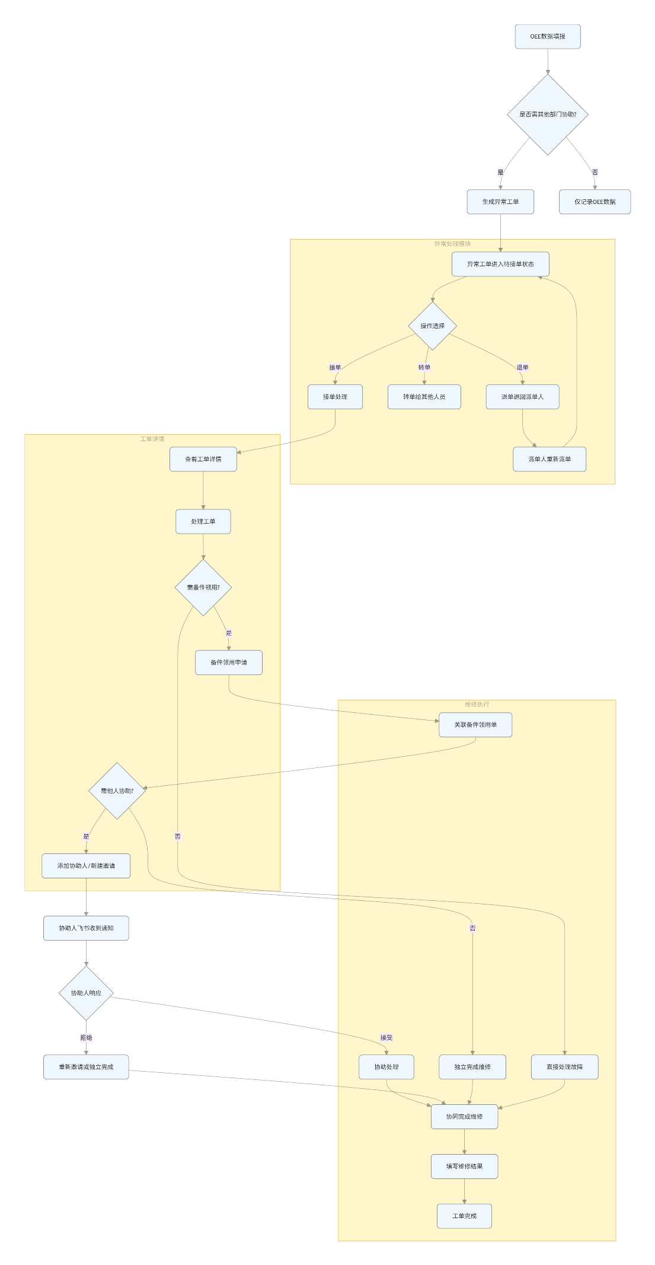

3.5.1.3 类设计
涵盖了从工单创建到数据分析的全流程，支持多种维修场景
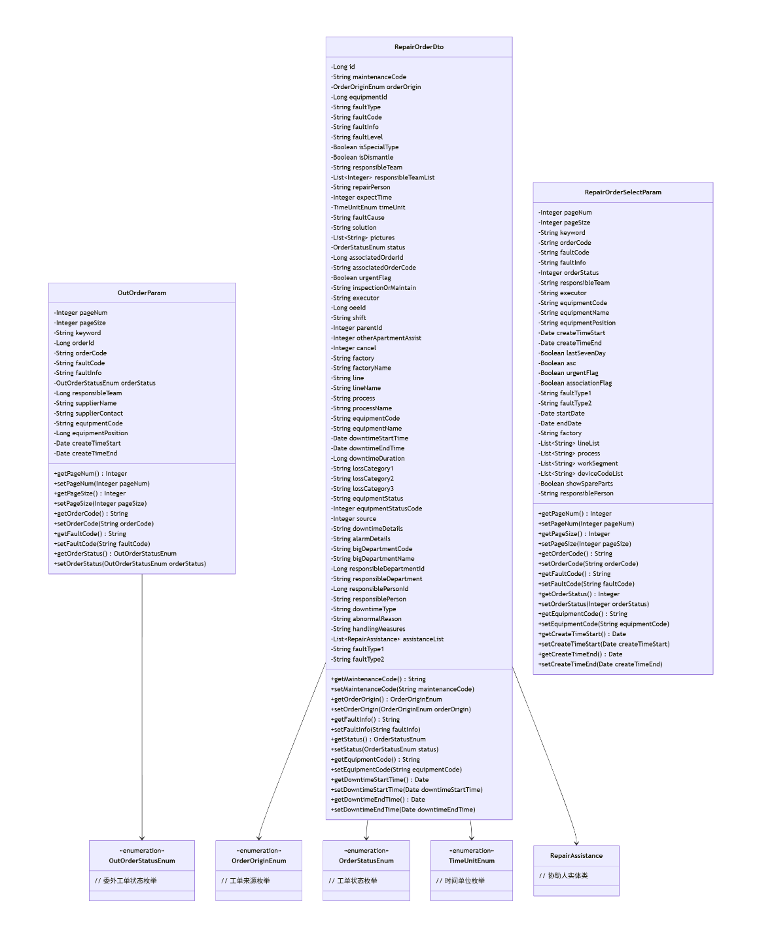

3.5.1.4 时序图
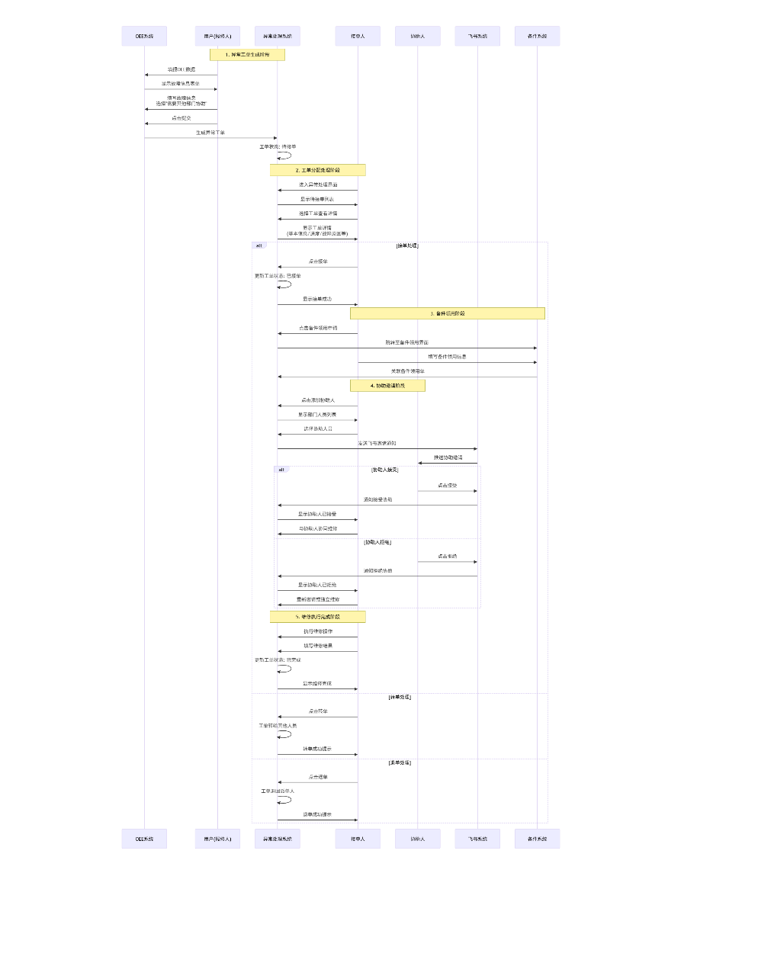

3.5.1.5 内部接口定义
@PostMapping("/receivingOrders")
@ApiOperation("接单")
public Result receivingOrders(@RequestBody @Validated OrderController.OrderParam param) {
return Result.success(urgentOrderService.receivingUrgentOrders(param.getOrderCode(), param.getExecutor()));
}
@PostMapping("/chargeback")
@ApiOperation("退单")
public Result chargeback(@RequestBody @Validated OrderController.OrderParam param) {
urgentOrderService.chargeback(param.getOrderCode(), param.getExecutor(), param.getMessage());
return Result.success();
}
@PostMapping("/transferOrder")
@ApiOperation("转单")
public Result transferOrder(@RequestBody @Validated OrderController.OrderParam param) {
urgentOrderService.transferOrder(param.getOrderCode(), param.getExecutor(), param.getOrgId(), param.getOther(), param.getMessage());
return Result.success();
}
@PostMapping("/dispatchOrder")
@ApiOperation("派单")
public Result dispatchOrder(@RequestBody @Validated OrderController.OrderParam param) {
urgentOrderService.dispatchOrder(param.getOrderCode(), param.getExecutor(), param.getOrgId(), param.getOther(), param.getMessage());
return Result.success();
}
@PostMapping("/signIn")
@ApiOperation("签到")
public Result signIn(@RequestBody @Validated OrderController.OrderParam param) {
return Result.success(urgentOrderService.signIn(param.getOrderCode(), param.getExecutor(), param.getEquipmentCode()));
}
@PostMapping("/finishWork")
@ApiOperation("报工")
public Result finishWork(@RequestBody @Validated OrderController.OrderParam param) {
return Result.success(urgentOrderService.finishWork(param.getOrderCode(), param.getExecutor()));
}
@PostMapping("/updateCause")
@ApiOperation("更新原因以及对策")
public Result updateCause(@Validated @RequestBody List<RepairReasonDto> reasonInsertDtos) {
repairOrderService.updateCause(reasonInsertDtos);
return Result.success();
}
@GetMapping("/getRepairReason")
@ApiOperation("查询原因以及对策")
public Result getRepairReason(@ApiParam(name = "orderId", value = "orderId")
@RequestParam Long orderId) {
return Result.success(repairOrderService.getRepairReason(orderId));
}
@GetMapping("/getShutdownOrder")
@ApiOperation("查询停机单")
public Result getShutdownOrder(@ApiParam(name = "orderId", value = "orderId")
@RequestParam Long orderId) {
return Result.success(shutdownOrderService.list(orderId));
}
@PostMapping("/insertOutOrder")
@ApiOperation("新增委外工单")
public Result insertOutOrder(@Validated @RequestBody OutsourcingOrderDto outsourcingOrderDto) {
outsourcingOrderService.insert(outsourcingOrderDto);
return Result.success();
}
@PostMapping("/updateOutOrder")
@ApiOperation("修改委外工单")
public Result updateOutOrder(@RequestBody OutsourcingOrderDto outsourcingOrderDto) {
outsourcingOrderService.update(outsourcingOrderDto);
return Result.success();
}
@GetMapping("/getOutOrder")
@ApiOperation("查询委外工单")
public Result getOutOrder(@ApiParam(name = "orderId", value = "orderId")
@RequestParam Long orderId) {
return Result.success(outsourcingOrderService.list(orderId));
}

3.5.1.6 外部接口定义
"/maintenance/accept": {
"get": {
"tags": [
"维修"
],
"summary": "接受援助",
"operationId": "acceptUsingGET",
"produces": [
"*/*"
],
"parameters": [
{
"name": "id",
"in": "query",
"description": "id",
"required": false,
"type": "integer",
"format": "int64"
}
],
"responses": {
"200": {
"description": "OK",
"schema": {
"$ref": "#/definitions/Result",
"originalRef": "Result"
}
}
},
"security": [
{
"Authorization": [
"global"
]
}
],
"deprecated": false,
"x-order": "2147483647"
}
},
"/maintenance/delete": {
"post": {
"tags": [
"维修"
],
"summary": "删除工单信息",
"operationId": "deleteUsingPOST_18",
"consumes": [
"application/json"
],
"produces": [
"*/*"
],
"parameters": [
{
"in": "body",
"name": "ids",
"description": "ids",
"required": true,
"schema": {
"type": "array",
"items": {
"type": "integer",
"format": "int64"
}
}
}
],
"responses": {
"200": {
"description": "OK",
"schema": {
"$ref": "#/definitions/Result",
"originalRef": "Result"
}
}
},
"security": [
{
"Authorization": [
"global"
]
}
],
"deprecated": false,
"x-order": "2147483647"
}
},
"/maintenance/deleteAssist": {
"post": {
"tags": [
"维修"
],
"summary": "删除协助人",
"operationId": "deleteAssistUsingPOST",
"consumes": [
"application/json"
],
"produces": [
"*/*"
],
"parameters": [
{
"in": "body",
"name": "ids",
"description": "ids",
"required": true,
"schema": {
"type": "array",
"items": {
"type": "integer",
"format": "int64"
}
}
}
],
"responses": {
"200": {
"description": "OK",
"schema": {
"$ref": "#/definitions/Result",
"originalRef": "Result"
}
}
},
"security": [
{
"Authorization": [
"global"
]
}
],
"deprecated": false,
"x-order": "2147483647"
}
},
"/maintenance/export": {
"get": {
"tags": [
"维修"
],
"summary": "批量导出维修工单",
"operationId": "exportUsingGET_4",
"produces": [
"*/*"
],
"parameters": [
{
"name": "asc",
"in": "query",
"description": "升序或降序(true升序 false降序)",
"required": false,
"type": "boolean"
},
{
"name": "associationFlag",
"in": "query",
"description": "是否为关联工单标识",
"required": false,
"type": "boolean"
},
{
"name": "createTimeEnd",
"in": "query",
"description": "创建时间结束",
"required": false,
"type": "string",
"format": "date-time"
},
{
"name": "createTimeStart",
"in": "query",
"description": "创建时间开始",
"required": false,
"type": "string",
"format": "date-time"
},
{
"name": "deviceCodeList",
"in": "query",
"description": "设备编号",
"required": false,
"type": "array",
"items": {
"type": "string"
},
"collectionFormat": "multi"
},
{
"name": "endDate",
"in": "query",
"description": "结束时间",
"required": false,
"type": "string",
"format": "date-time"
},
{
"name": "equipmentCode",
"in": "query",
"description": "设备编号",
"required": false,
"type": "string"
},
{
"name": "equipmentName",
"in": "query",
"description": "设备名称",
"required": false,
"type": "string"
},
{
"name": "equipmentPosition",
"in": "query",
"description": "设备位置",
"required": false,
"type": "string"
},
{
"name": "executor",
"in": "query",
"description": "执行人",
"required": false,
"type": "string"
},
{
"name": "factory",
"in": "query",
"description": "工厂",
"required": false,
"type": "string"
},
{
"name": "faultCode",
"in": "query",
"description": "故障代码",
"required": false,
"type": "string"
},
{
"name": "faultInfo",
"in": "query",
"description": "故障描述",
"required": false,
"type": "string"
},
{
"name": "faultType1",
"in": "query",
"description": "一级故障类别",
"required": false,
"type": "string"
},
{
"name": "faultType2",
"in": "query",
"description": "二级故障类别",
"required": false,
"type": "string"
},
{
"name": "keyword",
"in": "query",
"description": "关键词",
"required": false,
"type": "string"
},
{
"name": "lastSevenDay",
"in": "query",
"description": "是否近七天(是：true，否：false)",
"required": false,
"type": "boolean"
},
{
"name": "lineList",
"in": "query",
"description": "产线",
"required": false,
"type": "array",
"items": {
"type": "string"
},
"collectionFormat": "multi"
},
{
"name": "lossCategory1",
"in": "query",
"description": "损失分类1",
"required": false,
"type": "string"
},
{
"name": "lossCategory2",
"in": "query",
"description": "损失分类2",
"required": false,
"type": "string"
},
{
"name": "lossCategory3",
"in": "query",
"description": "损失分类3",
"required": false,
"type": "string"
},
{
"name": "orderCode",
"in": "query",
"description": "工单编号",
"required": false,
"type": "string"
},
{
"name": "orderStatus",
"in": "query",
"description": "工单状态",
"required": false,
"type": "integer",
"format": "int32"
},
{
"name": "pageNum",
"in": "query",
"description": "页码",
"required": false,
"type": "integer",
"format": "int32"
},
{
"name": "pageSize",
"in": "query",
"description": "页面大小",
"required": false,
"type": "integer",
"format": "int32"
},
{
"name": "process",
"in": "query",
"description": "工序",
"required": false,
"type": "array",
"items": {
"type": "string"
},
"collectionFormat": "multi"
},
{
"name": "responsiblePerson",
"in": "query",
"description": "责任人",
"required": false,
"type": "string"
},
{
"name": "responsibleTeam",
"in": "query",
"description": "责任班组",
"required": false,
"type": "string"
},
{
"name": "showSpareParts",
"in": "query",
"description": "是否展示备件使用记录",
"required": false,
"type": "boolean"
},
{
"name": "startDate",
"in": "query",
"description": "开始时间",
"required": false,
"type": "string",
"format": "date-time"
},
{
"name": "urgentFlag",
"in": "query",
"description": "紧急维修标识",
"required": false,
"type": "boolean"
},
{
"name": "workSegment",
"in": "query",
"description": "工段",
"required": false,
"type": "array",
"items": {
"type": "string"
},
"collectionFormat": "multi"
}
],
"responses": {
"200": {
"description": "OK"
}
},
"security": [
{
"Authorization": [
"global"
]
}
],
"deprecated": false,
"x-order": "2147483647"
}
},
"/maintenance/exportRepairReport": {
"get": {
"tags": [
"维修"
],
"summary": "导出维修报告",
"operationId": "exportRepairReportUsingGET",
"produces": [
"*/*"
],
"parameters": [
{
"in": "body",
"name": "allData",
"description": "是否全部导出",
"required": false,
"schema": {
"type": "boolean"
}
},
{
"in": "body",
"name": "department",
"description": "接单部门",
"required": false,
"schema": {
"type": "integer",
"format": "int64"
}
},
{
"in": "body",
"name": "endTime",
"description": "结束时间",
"required": false,
"schema": {
"type": "string",
"format": "date-time"
}
},
{
"in": "body",
"name": "startTime",
"description": "开始时间",
"required": false,
"schema": {
"type": "string",
"format": "date-time"
}
}
],
"responses": {
"200": {
"description": "OK"
}
},
"security": [
{
"Authorization": [
"global"
]
}
],
"deprecated": false,
"x-order": "2147483647"
}
},
"/maintenance/fillFaultTypeByIdResult": {
"post": {
"tags": [
"维修"
],
"summary": "ai获取 一级二级故障类别",
"operationId": "fillFaultTypeByIdResultUsingPOST",
"consumes": [
"application/json"
],
"produces": [
"*/*"
],
"parameters": [
{
"name": "date1",
"in": "query",
"description": "date1",
"required": true,
"type": "string"
}
],
"responses": {
"200": {
"description": "OK"
}
},
"security": [
{
"Authorization": [
"global"
]
}
],
"deprecated": false,
"x-order": "2147483647"
}
},
"/maintenance/fillLineAndProcess": {
"get": {
"tags": [
"维修"
],
"summary": "填充维修工单里面的线体和工序字段",
"operationId": "fillLineAndProcessUsingGET",
"produces": [
"*/*"
],
"responses": {
"200": {
"description": "OK"
}
},
"security": [
{
"Authorization": [
"global"
]
}
],
"deprecated": false,
"x-order": "2147483647"
}
},
"/maintenance/find": {
"get": {
"tags": [
"维修"
],
"summary": "查询工单详情信息",
"operationId": "findUsingGET_15",
"produces": [
"*/*"
],
"parameters": [
{
"name": "id",
"in": "query",
"description": "id",
"required": false,
"type": "integer",
"format": "int64",
"allowEmptyValue": false
}
],
"responses": {
"200": {
"description": "OK",
"schema": {
"$ref": "#/definitions/Result",
"originalRef": "Result"
}
}
},
"security": [
{
"Authorization": [
"global"
]
}
],
"deprecated": false,
"x-order": "2147483647"
}
},
"/maintenance/findRepairByEquipment": {
"get": {
"tags": [
"维修"
],
"summary": "获取设备维修情况",
"operationId": "findRepairByEquipmentUsingGET",
"produces": [
"*/*"
],
"parameters": [
{
"name": "equipmentId",
"in": "query",
"description": "equipmentId",
"required": true,
"type": "integer",
"format": "int64"
}
],
"responses": {
"200": {
"description": "OK",
"schema": {
"$ref": "#/definitions/Result",
"originalRef": "Result"
}
}
},
"security": [
{
"Authorization": [
"global"
]
}
],
"deprecated": false,
"x-order": "2147483647"
}
},
"/maintenance/generateRepairReport": {
"get": {
"tags": [
"维修"
],
"summary": "生成维修报告",
"operationId": "generateRepairReportUsingGET",
"produces": [
"*/*"
],
"parameters": [
{
"in": "body",
"name": "department",
"description": "接单部门",
"required": false,
"schema": {
"type": "integer",
"format": "int64"
}
},
{
"in": "body",
"name": "endTime",
"description": "结束时间",
"required": false,
"schema": {
"type": "string",
"format": "date-time"
}
},
{
"name": "pageNum",
"in": "query",
"description": "pageNum",
"required": true,
"type": "integer",
"format": "int32"
},
{
"name": "pageSize",
"in": "query",
"description": "pageSize",
"required": true,
"type": "integer",
"format": "int32"
},
{
"in": "body",
"name": "startTime",
"description": "开始时间",
"required": false,
"schema": {
"type": "string",
"format": "date-time"
}
}
],
"responses": {
"200": {
"description": "OK",
"schema": {
"$ref": "#/definitions/Result",
"originalRef": "Result"
}
}
},
"security": [
{
"Authorization": [
"global"
]
}
],
"deprecated": false,
"x-order": "2147483647"
}
},

3.5.2 故障报修详细设计

3.5.2.1 数据库设计
数据库设计见3.5.1.1

3.5.2.2 流程图
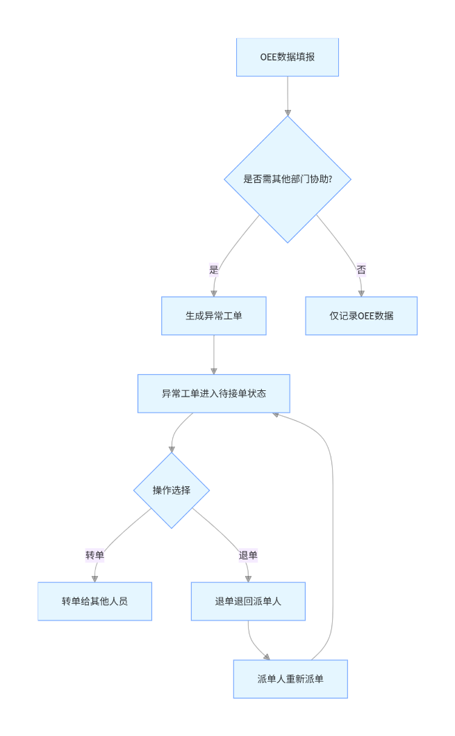

3.5.2.3 类设计
类设计图见3.5.1.3

3.5.2.4 时序图
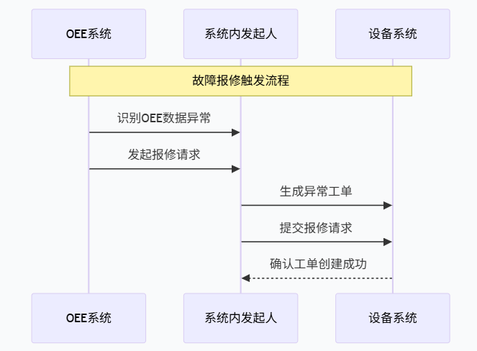

3.5.2.5 内部接口定义
@PostMapping("/repairRequest")
@ApiOperation("叫修申请")
public Result repairRequest(@RequestBody @Validated OrderParam param) {
return Result.success(orderService.repairRequest(param.getOrderCode(), param.getRepairPerson(), param.getResponsibleTeam(), param.getMessage()));
}
@PostMapping("/dispatch")
@ApiOperation("叫修开始派单")
public Result dispatch(@RequestBody @Validated OrderParam param) {
return Result.success(orderService.dispatch(param.getOrderCode(), param.getExecutor()));
}
@PostMapping("/unassignedOrdersReceived")
@ApiOperation("未派单接单")
public Result unassignedOrdersReceived(@RequestBody @Validated OrderParam param) {
return Result.success(orderService.unassignedOrdersReceived(param.getOrderCode(), param.getExecutor()));
}
@PostMapping("/updateShutdownOrder")
@ApiOperation("修改停机申请")
public Result updateShutdownOrder(@RequestBody ShutdownOrderDto shutdownOrderDto) {
shutdownOrderService.update(shutdownOrderDto);
return Result.success();
}
@GetMapping("/getShutdownOrder")
@ApiOperation("查询停机单")
public Result getShutdownOrder(@ApiParam(name = "orderId", value = "orderId")
@RequestParam Long orderId) {
return Result.success(shutdownOrderService.list(orderId));
}

3.5.2.6 外部接口定义
"/order/repairRequest": {
"post": {
"tags": [
"维修"
],
"summary": "叫修申请",
"operationId": "repairRequestUsingPOST",
"consumes": [
"application/json"
],
"produces": [
"*/*"
],
"parameters": [
{
"in": "body",
"name": "param",
"description": "param",
"required": true,
"schema": {
"$ref": "#/definitions/OrderParam",
"originalRef": "OrderParam"
}
}
],
"responses": {
"200": {
"description": "OK",
"schema": {
"$ref": "#/definitions/Result",
"originalRef": "Result"
}
}
},
"security": [
{
"Authorization": [
"global"
]
}
],
"deprecated": false,
"x-order": "2147483647"
}
},
"/order/requestSupport": {
"post": {
"tags": [
"维修"
],
"summary": "请求支援",
"operationId": "requestSupportUsingPOST",
"consumes": [
"application/json"
],
"produces": [
"*/*"
],
"parameters": [
{
"in": "body",
"name": "supportDto",
"description": "supportDto",
"required": true,
"schema": {
"$ref": "#/definitions/SupportDto",
"originalRef": "SupportDto"
}
}
],
"responses": {
"200": {
"description": "OK",
"schema": {
"$ref": "#/definitions/Result",
"originalRef": "Result"
}
}
},
"security": [
{
"Authorization": [
"global"
]
}
],
"deprecated": false,
"x-order": "2147483647"
}
},
"/order/signIn": {
"post": {
"tags": [
"维修"
],
"summary": "签到",
"operationId": "signInUsingPOST",
"consumes": [
"application/json"
],
"produces": [
"*/*"
],
"parameters": [
{
"in": "body",
"name": "param",
"description": "param",
"required": true,
"schema": {
"$ref": "#/definitions/OrderParam",
"originalRef": "OrderParam"
}
}
],
"responses": {
"200": {
"description": "OK",
"schema": {
"$ref": "#/definitions/Result",
"originalRef": "Result"
}
}
},
"security": [
{
"Authorization": [
"global"
]
}
],
"deprecated": false,
"x-order": "2147483647"
}
},
"/order/getOrderHistory": {
"get": {
"tags": [
"维修"
],
"summary": "查询工单签核历史",
"operationId": "getOrderHistoryUsingGET_2",
"produces": [
"*/*"
],
"parameters": [
{
"in": "body",
"name": "param",
"description": "param",
"required": true,
"schema": {
"$ref": "#/definitions/OrderParam",
"originalRef": "OrderParam"
}
}
],
"responses": {
"200": {
"description": "OK",
"schema": {
"$ref": "#/definitions/Result",
"originalRef": "Result"
}
}
},
"security": [
{
"Authorization": [
"global"
]
}
],
"deprecated": false,
"x-order": "2147483647"
}
},

3.5.3 维修处理详细设计

3.5.3.1 数据库设计
数据库设计见3.5.1.1

3.5.3.2 流程图
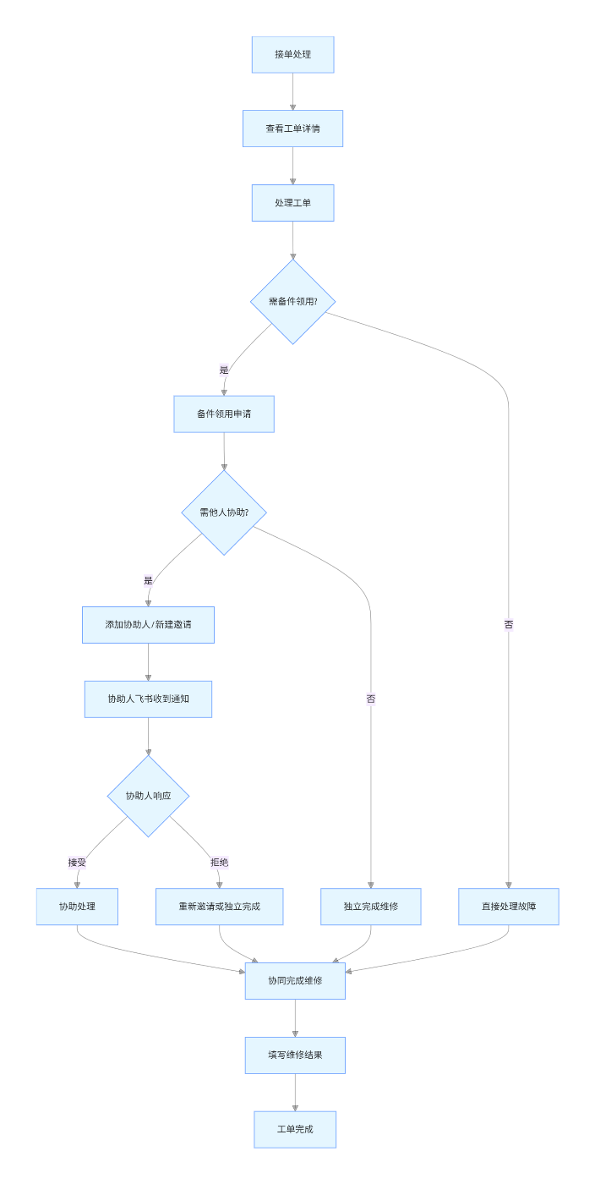

3.5.3.3 类设计
类设计图见3.5.1.3

3.5.3.4 时序图
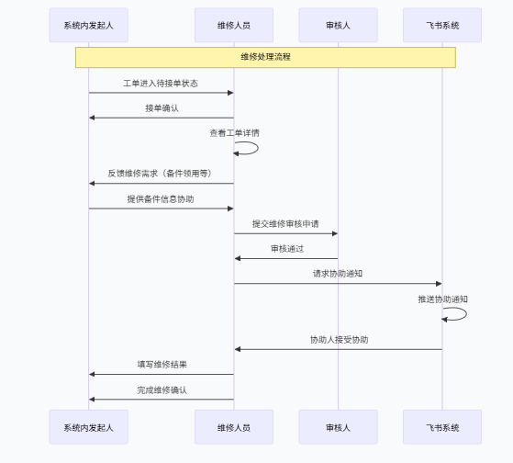

3.5.3.5 内部接口定义
@PostMapping("/dispatch")
@ApiOperation("叫修开始派单")
public Result dispatch(@RequestBody @Validated OrderParam param) {
return Result.success(orderService.dispatch(param.getOrderCode(), param.getExecutor()));
}
@PostMapping("/unassignedOrdersReceived")
@ApiOperation("未派单接单")
public Result unassignedOrdersReceived(@RequestBody @Validated OrderParam param) {
return Result.success(orderService.unassignedOrdersReceived(param.getOrderCode(), param.getExecutor()));
}
@PostMapping("/receivingOrders")
@ApiOperation("接单")
public Result receivingOrders(@RequestBody @Validated OrderParam param) {
return Result.success(orderService.receivingOrders(param.getOrderCode(), param.getExecutor()));
}
@PostMapping("/signIn")
@ApiOperation("签到")
public Result signIn(@RequestBody @Validated OrderParam param) {
return Result.success(orderService.signIn(param.getOrderCode(), param.getExecutor(), param.getEquipmentCode()));
}
@PostMapping("/finishWork")
@ApiOperation("报工")
public Result finishWork(@RequestBody @Validated OrderParam param) {
return Result.success(orderService.finishWork(param.getOrderCode(), param.getExecutor(), false));
}
@PostMapping("/closeCase")
@ApiOperation("结案确认")
public Result closeCase(@RequestBody @Validated OrderParam param) {
return Result.success(orderService.closeCase(param.getOrderCode()));
}
@PostMapping("/evaluate")
@ApiOperation("评价")
public Result evaluate(@RequestBody @Validated OrderParam param) {
return Result.success(orderService.evaluate(param.getOrderCode(), param.getMoney(), param.getEvaluate(), param.getStars()));
}
@PostMapping("/transferOrder")
@ApiOperation("派单转单")
public Result transferOrder(@RequestBody TransferParam param) {
return Result.success(orderService.transferOrder(param.getOrderCode(), param.getOtherTeam(), param.getResponsibleTeamList(), null, param.getMessage()));
}
@PostMapping("/transferOrderBeforeAccept")
@ApiOperation("维修人接单前班组长转单其他组")
public Result transferOrderBeforeAccept(@RequestBody TransferParam param) {
return Result.success(orderService.transferOrderBeforeAccept(param.getOrderCode(), param.getOtherTeam(), param.getResponsibleTeamList(), null, param.getMessage()));
}
@PostMapping("/acceptTransferOrder")
@ApiOperation("接单转单")
public Result acceptTransferOrder(@RequestBody @Validated OrderParam param) {
return Result.success(orderService.transferOrder(param.getOrderCode(), null, null, param.getExecutor(), param.getMessage()));
}
@PostMapping("/transferBeforeAccept")
@ApiOperation("维修人接单前班组长转派")
public Result transferBeforeAccept(@RequestBody @Validated OrderParam param) {
return Result.success(orderService.transferBeforeAccept(param.getOrderCode(), param.getExecutor(), param.getMessage()));
}
@PostMapping("/chargeback")
@ApiOperation("退单")
public Result chargeback(@RequestBody @Validated OrderParam param) {
return Result.success(orderService.chargeback(param.getOrderCode(), param.getMessage()));
}
@PostMapping("/reject")
@ApiOperation("驳回")
public Result reject(@RequestBody @Validated OrderParam param) {
return Result.success(orderService.reject(param.getOrderCode(), param.getMessage()));
}
@PostMapping("/requestSupport")
@ApiOperation("请求支援")
public Result requestSupport(@RequestBody SupportDto supportDto) {
return Result.success(orderService.requestSupport(supportDto.getOrderCode(), supportDto.getExecutor(), supportDto.getSupporter()));
}
@PostMapping("/supportAccept")
@ApiOperation("支援接单")
public Result supportAccept(@RequestBody @Validated OrderParam param) {
return Result.success(orderService.supportAccept(param.getOrderCode(), param.getExecutor()));
}
@PostMapping("/supportSignIn")
@ApiOperation("支援签到")
public Result supportSignIn(@RequestBody @Validated OrderParam param) {
return Result.success(orderService.supportSignIn(param.getOrderCode(), param.getExecutor(), param.getEquipmentCode()));
}
@PostMapping("/supportBack")
@ApiOperation("支援退单")
public Result supportBack(@RequestBody @Validated OrderParam param) {
return Result.success(orderService.supportBack(param.getOrderCode(), param.getMessage(), param.getExecutor(), param.getFlag()));
}
@PostMapping("/insertAssist")
@ApiOperation("新增协助人")
public Result insertAssist(@Validated @RequestBody RepairAssistance assistDto) {
repairAssistanceService.save(assistDto);
return Result.success();
}
@PostMapping("/listAssist")
@ApiOperation("协助人列表")
public Result listAssist(@RequestParam Long orderId) {
repairAssistanceService.getListByOrder(orderId);
return Result.success();
}
@PostMapping("/getEquipmentRepairList")
@ApiOperation("获取设备维修列表")
public Result getEquipmentRepairList(@RequestBody RepairEquipmentParam repairEquipmentParam) {
return Result.success(repairOrderService.getEquipmentRepairList(repairEquipmentParam));
}

3.5.3.6 外部接口定义
"/order/getOrderHistory": {
"get": {
"tags": [
"维修"
],
"summary": "查询工单签核历史",
"operationId": "getOrderHistoryUsingGET_2",
"produces": [
"*/*"
],
"parameters": [
{
"in": "body",
"name": "param",
"description": "param",
"required": true,
"schema": {
"$ref": "#/definitions/OrderParam",
"originalRef": "OrderParam"
}
}
],
"responses": {
"200": {
"description": "OK",
"schema": {
"$ref": "#/definitions/Result",
"originalRef": "Result"
}
}
},
"security": [
{
"Authorization": [
"global"
]
}
],
"deprecated": false,
"x-order": "2147483647"
}
},
"/order/receivingOrders": {
"post": {
"tags": [
"维修"
],
"summary": "接单",
"operationId": "receivingOrdersUsingPOST",
"consumes": [
"application/json"
],
"produces": [
"*/*"
],
"parameters": [
{
"in": "body",
"name": "param",
"description": "param",
"required": true,
"schema": {
"$ref": "#/definitions/OrderParam",
"originalRef": "OrderParam"
}
}
],
"responses": {
"200": {
"description": "OK",
"schema": {
"$ref": "#/definitions/Result",
"originalRef": "Result"
}
}
},
"security": [
{
"Authorization": [
"global"
]
}
],
"deprecated": false,
"x-order": "2147483647"
}
},
"/order/reject": {
"post": {
"tags": [
"维修"
],
"summary": "驳回",
"operationId": "rejectUsingPOST_2",
"consumes": [
"application/json"
],
"produces": [
"*/*"
],
"parameters": [
{
"in": "body",
"name": "param",
"description": "param",
"required": true,
"schema": {
"$ref": "#/definitions/OrderParam",
"originalRef": "OrderParam"
}
}
],
"responses": {
"200": {
"description": "OK",
"schema": {
"$ref": "#/definitions/Result",
"originalRef": "Result"
}
}
},
"security": [
{
"Authorization": [
"global"
]
}
],
"deprecated": false,
"x-order": "2147483647"
}
},
"/order/repairRequest": {
"post": {
"tags": [
"维修"
],
"summary": "叫修申请",
"operationId": "repairRequestUsingPOST",
"consumes": [
"application/json"
],
"produces": [
"*/*"
],
"parameters": [
{
"in": "body",
"name": "param",
"description": "param",
"required": true,
"schema": {
"$ref": "#/definitions/OrderParam",
"originalRef": "OrderParam"
}
}
],
"responses": {
"200": {
"description": "OK",
"schema": {
"$ref": "#/definitions/Result",
"originalRef": "Result"
}
}
},
"security": [
{
"Authorization": [
"global"
]
}
],
"deprecated": false,
"x-order": "2147483647"
}
},
"/order/requestSupport": {
"post": {
"tags": [
"维修"
],
"summary": "请求支援",
"operationId": "requestSupportUsingPOST",
"consumes": [
"application/json"
],
"produces": [
"*/*"
],
"parameters": [
{
"in": "body",
"name": "supportDto",
"description": "supportDto",
"required": true,
"schema": {
"$ref": "#/definitions/SupportDto",
"originalRef": "SupportDto"
}
}
],
"responses": {
"200": {
"description": "OK",
"schema": {
"$ref": "#/definitions/Result",
"originalRef": "Result"
}
}
},
"security": [
{
"Authorization": [
"global"
]
}
],
"deprecated": false,
"x-order": "2147483647"
}
},
"/order/signIn": {
"post": {
"tags": [
"维修"
],
"summary": "签到",
"operationId": "signInUsingPOST",
"consumes": [
"application/json"
],
"produces": [
"*/*"
],
"parameters": [
{
"in": "body",
"name": "param",
"description": "param",
"required": true,
"schema": {
"$ref": "#/definitions/OrderParam",
"originalRef": "OrderParam"
}
}
],
"responses": {
"200": {
"description": "OK",
"schema": {
"$ref": "#/definitions/Result",
"originalRef": "Result"
}
}
},
"security": [
{
"Authorization": [
"global"
]
}
],
"deprecated": false,
"x-order": "2147483647"
}
},
"/order/supportAccept": {
"post": {
"tags": [
"维修"
],
"summary": "支援接单",
"operationId": "supportAcceptUsingPOST",
"consumes": [
"application/json"
],
"produces": [
"*/*"
],
"parameters": [
{
"in": "body",
"name": "param",
"description": "param",
"required": true,
"schema": {
"$ref": "#/definitions/OrderParam",
"originalRef": "OrderParam"
}
}
],
"responses": {
"200": {
"description": "OK",
"schema": {
"$ref": "#/definitions/Result",
"originalRef": "Result"
}
}
},
"security": [
{
"Authorization": [
"global"
]
}
],
"deprecated": false,
"x-order": "2147483647"
}
},
"/order/supportBack": {
"post": {
"tags": [
"维修"
],
"summary": "支援退单",
"operationId": "supportBackUsingPOST",
"consumes": [
"application/json"
],
"produces": [
"*/*"
],
"parameters": [
{
"in": "body",
"name": "param",
"description": "param",
"required": true,
"schema": {
"$ref": "#/definitions/OrderParam",
"originalRef": "OrderParam"
}
}
],
"responses": {
"200": {
"description": "OK",
"schema": {
"$ref": "#/definitions/Result",
"originalRef": "Result"
}
}
},
"security": [
{
"Authorization": [
"global"
]
}
],
"deprecated": false,
"x-order": "2147483647"
}
},
"/order/supportSignIn": {
"post": {
"tags": [
"维修"
],
"summary": "支援签到",
"operationId": "supportSignInUsingPOST",
"consumes": [
"application/json"
],
"produces": [
"*/*"
],
"parameters": [
{
"in": "body",
"name": "param",
"description": "param",
"required": true,
"schema": {
"$ref": "#/definitions/OrderParam",
"originalRef": "OrderParam"
}
}
],
"responses": {
"200": {
"description": "OK",
"schema": {
"$ref": "#/definitions/Result",
"originalRef": "Result"
}
}
},
"security": [
{
"Authorization": [
"global"
]
}
],
"deprecated": false,
"x-order": "2147483647"
}
},
"/order/transferBeforeAccept": {
"post": {
"tags": [
"维修"
],
"summary": "维修人接单前班组长转派",
"operationId": "transferBeforeAcceptUsingPOST",
"consumes": [
"application/json"
],
"produces": [
"*/*"
],
"parameters": [
{
"in": "body",
"name": "param",
"description": "param",
"required": true,
"schema": {
"$ref": "#/definitions/OrderParam",
"originalRef": "OrderParam"
}
}
],
"responses": {
"200": {
"description": "OK",
"schema": {
"$ref": "#/definitions/Result",
"originalRef": "Result"
}
}
},
"security": [
{
"Authorization": [
"global"
]
}
],
"deprecated": false,
"x-order": "2147483647"
}
},
"/order/transferOrder": {
"post": {
"tags": [
"维修"
],
"summary": "派单转单",
"operationId": "transferOrderUsingPOST",
"consumes": [
"application/json"
],
"produces": [
"*/*"
],
"parameters": [
{
"in": "body",
"name": "param",
"description": "param",
"required": true,
"schema": {
"$ref": "#/definitions/TransferParam",
"originalRef": "TransferParam"
}
}
],
"responses": {
"200": {
"description": "OK",
"schema": {
"$ref": "#/definitions/Result",
"originalRef": "Result"
}
}
},
"security": [
{
"Authorization": [
"global"
]
}
],
"deprecated": false,
"x-order": "2147483647"
}
},
"/order/transferOrderBeforeAccept": {
"post": {
"tags": [
"维修"
],
"summary": "维修人接单前班组长转单其他组",
"operationId": "transferOrderBeforeAcceptUsingPOST",
"consumes": [
"application/json"
],
"produces": [
"*/*"
],
"parameters": [
{
"in": "body",
"name": "param",
"description": "param",
"required": true,
"schema": {
"$ref": "#/definitions/TransferParam",
"originalRef": "TransferParam"
}
}
],
"responses": {
"200": {
"description": "OK",
"schema": {
"$ref": "#/definitions/Result",
"originalRef": "Result"
}
}
},
"security": [
{
"Authorization": [
"global"
]
}
],
"deprecated": false,
"x-order": "2147483647"
}
},
"/order/unassignedOrdersReceived": {
"post": {
"tags": [
"维修"
],
"summary": "未派单接单",
"operationId": "unassignedOrdersReceivedUsingPOST",
"consumes": [
"application/json"
],
"produces": [
"*/*"
],
"parameters": [
{
"in": "body",
"name": "param",
"description": "param",
"required": true,
"schema": {
"$ref": "#/definitions/OrderParam",
"originalRef": "OrderParam"
}
}
],
"responses": {
"200": {
"description": "OK",
"schema": {
"$ref": "#/definitions/Result",
"originalRef": "Result"
}
}
},
"security": [
{
"Authorization": [
"global"
]
}
],
"deprecated": false,
"x-order": "2147483647"
}
},
"/outsourcing/changeStatus": {
"post": {
"tags": [
"维修"
],
"summary": "改变状态",
"operationId": "changeStatusUsingPOST",
"consumes": [
"application/json"
],
"produces": [
"*/*"
],
"parameters": [
{
"name": "id",
"in": "query",
"description": "id",
"required": false,
"type": "integer",
"format": "int64"
},
{
"name": "status",
"in": "query",
"description": "status",
"required": false,
"type": "integer",
"format": "int32"
}
],
"responses": {
"200": {
"description": "OK",
"schema": {
"$ref": "#/definitions/Result",
"originalRef": "Result"
}
}
},
"security": [
{
"Authorization": [
"global"
]
}
],
"deprecated": false,
"x-order": "2147483647"
}
},
"/outsourcing/delete": {
"post": {
"tags": [
"维修"
],
"summary": "删除委外工单",
"operationId": "deleteUsingPOST_16",
"consumes": [
"application/json"
],
"produces": [
"*/*"
],
"parameters": [
{
"in": "body",
"name": "ids",
"description": "ids",
"required": true,
"schema": {
"type": "array",
"items": {
"type": "integer",
"format": "int64"
}
}
}
],
"responses": {
"200": {
"description": "OK",
"schema": {
"$ref": "#/definitions/Result",
"originalRef": "Result"
}
}
},
"security": [
{
"Authorization": [
"global"
]
}
],
"deprecated": false,
"x-order": "2147483647"
}
},
"/outsourcing/find": {
"get": {
"tags": [
"维修"
],
"summary": "委外工单详情",
"operationId": "findUsingGET_13",
"produces": [
"*/*"
],
"parameters": [
{
"name": "id",
"in": "query",
"description": "id",
"required": true,
"type": "integer",
"format": "int64"
}
],
"responses": {
"200": {
"description": "OK",
"schema": {
"$ref": "#/definitions/Result",
"originalRef": "Result"
}
}
},
"security": [
{
"Authorization": [
"global"
]
}
],
"deprecated": false,
"x-order": "2147483647"
}
},
"/outsourcing/page": {
"get": {
"tags": [
"维修"
],
"summary": "委外工单分页",
"operationId": "pageUsingGET_21",
"produces": [
"*/*"
],
"parameters": [
{
"name": "createTimeEnd",
"in": "query",
"description": "创建时间结束",
"required": false,
"type": "string",
"format": "date-time"
},
{
"name": "createTimeStart",
"in": "query",
"description": "创建时间开始",
"required": false,
"type": "string",
"format": "date-time"
},
{
"name": "equipmentCode",
"in": "query",
"description": "设备编号",
"required": false,
"type": "string"
},
{
"name": "equipmentPosition",
"in": "query",
"description": "设备位置",
"required": false,
"type": "integer",
"format": "int64"
},
{
"name": "faultCode",
"in": "query",
"description": "故障代码",
"required": false,
"type": "string"
},
{
"name": "faultInfo",
"in": "query",
"description": "故障描述",
"required": false,
"type": "string"
},
{
"name": "keyword",
"in": "query",
"description": "关键词",
"required": false,
"type": "string"
},
{
"name": "orderCode",
"in": "query",
"description": "工单编号",
"required": false,
"type": "string"
},
{
"name": "orderId",
"in": "query",
"description": "维修工单id",
"required": false,
"type": "integer",
"format": "int64"
},
{
"name": "orderStatus",
"in": "query",
"description": "工单状态",
"required": false,
"type": "string",
"enum": [
"WAITING_ADMITTED",
"PROCESSING",
"FINISHED"
]
},
{
"name": "pageNum",
"in": "query",
"description": "页码",
"required": false,
"type": "integer",
"format": "int32"
},
{
"name": "pageSize",
"in": "query",
"description": "页面大小",
"required": false,
"type": "integer",
"format": "int32"
},
{
"name": "responsibleTeam",
"in": "query",
"description": "责任班组",
"required": false,
"type": "integer",
"format": "int64"
},
{
"name": "supplierContact",
"in": "query",
"description": "供应商联系方式",
"required": false,
"type": "string"
},
{
"name": "supplierName",
"in": "query",
"description": "供应商名称",
"required": false,
"type": "string"
}
],
"responses": {
"200": {
"description": "OK",
"schema": {
"$ref": "#/definitions/Result",
"originalRef": "Result"
}
}
},
"security": [
{
"Authorization": [
"global"
]
}
],
"deprecated": false,
"x-order": "2147483647"
}
},

3.5.4 委外维修详细设计

3.5.4.1 数据库设计
数据库设计见3.5.1.1

3.5.4.2 流程图
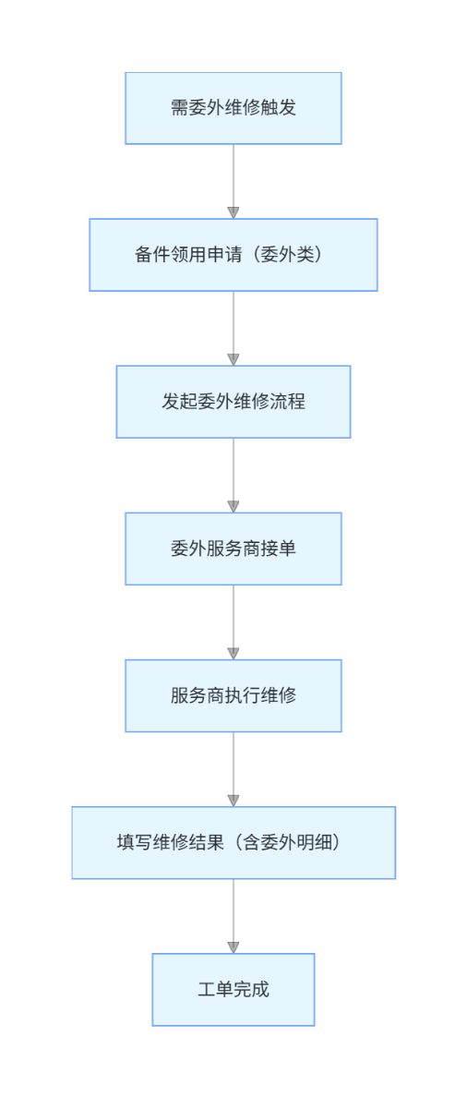

3.5.4.3 类设计
类设计图见3.5.1.3

3.5.4.4 时序图
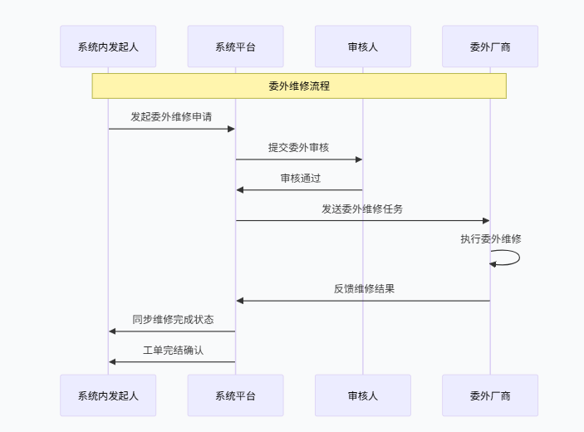

3.5.4.5 内部接口定义
@ApiOperation("委外工单分页")
@GetMapping("/page")
public Result page(@Validated OutOrderParam param) {
return Result.success(outsourcingOrderService.page(param));
}
@ApiOperation("委外工单详情")
@GetMapping("/find")
public Result find(@RequestParam Long id) {
return Result.success(outsourcingOrderService.find(id));
}
@ApiOperation("删除委外工单")
@PostMapping("/delete")
public Result delete(@RequestBody List<Long> ids) {
outsourcingOrderService.delete(ids);
return Result.success();
}
@ApiOperation("改变状态")
@PostMapping("/changeStatus")
public Result changeStatus(Long id, Integer status) {
outsourcingOrderService.changeStatus(id, OutOrderStatusEnum.convert(status));
return Result.success();
}
@PostMapping("/insertOutOrder")
@ApiOperation("新增委外工单")
public Result insertOutOrder(@Validated @RequestBody OutsourcingOrderDto outsourcingOrderDto) {
outsourcingOrderService.insert(outsourcingOrderDto);
return Result.success();
}
@PostMapping("/updateOutOrder")
@ApiOperation("修改委外工单")
public Result updateOutOrder(@RequestBody OutsourcingOrderDto outsourcingOrderDto) {
outsourcingOrderService.update(outsourcingOrderDto);
return Result.success();
}
@GetMapping("/getOutOrder")
@ApiOperation("查询委外工单")
public Result getOutOrder(@ApiParam(name = "orderId", value = "orderId")
@RequestParam Long orderId) {
return Result.success(outsourcingOrderService.list(orderId));
}

3.5.4.6 外部接口定义
"/maintenance/insertOutOrder": {
"post": {
"tags": [
"维修"
],
"summary": "新增委外工单",
"operationId": "insertOutOrderUsingPOST",
"consumes": [
"application/json"
],
"produces": [
"*/*"
],
"parameters": [
{
"in": "body",
"name": "outsourcingOrderDto",
"description": "outsourcingOrderDto",
"required": true,
"schema": {
"$ref": "#/definitions/委外工单",
"originalRef": "委外工单"
}
}
],
"responses": {
"200": {
"description": "OK",
"schema": {
"$ref": "#/definitions/Result",
"originalRef": "Result"
}
}
},
"security": [
{
"Authorization": [
"global"
]
}
],
"deprecated": false,
"x-order": "2147483647"
}
},
"/maintenance/updateOutOrder": {
"post": {
"tags": [
"维修"
],
"summary": "修改委外工单",
"operationId": "updateOutOrderUsingPOST",
"consumes": [
"application/json"
],
"produces": [
"*/*"
],
"parameters": [
{
"in": "body",
"name": "outsourcingOrderDto",
"description": "outsourcingOrderDto",
"required": true,
"schema": {
"$ref": "#/definitions/委外工单",
"originalRef": "委外工单"
}
}
],
"responses": {
"200": {
"description": "OK",
"schema": {
"$ref": "#/definitions/Result",
"originalRef": "Result"
}
}
},
"security": [
{
"Authorization": [
"global"
]
}
],
"deprecated": false,
"x-order": "2147483647"
}
},
"/outsourcing/delete": {
"post": {
"tags": [
"维修"
],
"summary": "删除委外工单",
"operationId": "deleteUsingPOST_16",
"consumes": [
"application/json"
],
"produces": [
"*/*"
],
"parameters": [
{
"in": "body",
"name": "ids",
"description": "ids",
"required": true,
"schema": {
"type": "array",
"items": {
"type": "integer",
"format": "int64"
}
}
}
],
"responses": {
"200": {
"description": "OK",
"schema": {
"$ref": "#/definitions/Result",
"originalRef": "Result"
}
}
},
"security": [
{
"Authorization": [
"global"
]
}
],
"deprecated": false,
"x-order": "2147483647"
}
},
"/outsourcing/find": {
"get": {
"tags": [
"维修"
],
"summary": "委外工单详情",
"operationId": "findUsingGET_13",
"produces": [
"*/*"
],
"parameters": [
{
"name": "id",
"in": "query",
"description": "id",
"required": true,
"type": "integer",
"format": "int64"
}
],
"responses": {
"200": {
"description": "OK",
"schema": {
"$ref": "#/definitions/Result",
"originalRef": "Result"
}
}
},
"security": [
{
"Authorization": [
"global"
]
}
],
"deprecated": false,
"x-order": "2147483647"
}
},
"/outsourcing/page": {
"get": {
"tags": [
"维修"
],
"summary": "委外工单分页",
"operationId": "pageUsingGET_21",
"produces": [
"*/*"
],
"parameters": [
{
"name": "createTimeEnd",
"in": "query",
"description": "创建时间结束",
"required": false,
"type": "string",
"format": "date-time"
},
{
"name": "createTimeStart",
"in": "query",
"description": "创建时间开始",
"required": false,
"type": "string",
"format": "date-time"
},
{
"name": "equipmentCode",
"in": "query",
"description": "设备编号",
"required": false,
"type": "string"
},
{
"name": "equipmentPosition",
"in": "query",
"description": "设备位置",
"required": false,
"type": "integer",
"format": "int64"
},
{
"name": "faultCode",
"in": "query",
"description": "故障代码",
"required": false,
"type": "string"
},
{
"name": "faultInfo",
"in": "query",
"description": "故障描述",
"required": false,
"type": "string"
},
{
"name": "keyword",
"in": "query",
"description": "关键词",
"required": false,
"type": "string"
},
{
"name": "orderCode",
"in": "query",
"description": "工单编号",
"required": false,
"type": "string"
},
{
"name": "orderId",
"in": "query",
"description": "维修工单id",
"required": false,
"type": "integer",
"format": "int64"
},
{
"name": "orderStatus",
"in": "query",
"description": "工单状态",
"required": false,
"type": "string",
"enum": [
"WAITING_ADMITTED",
"PROCESSING",
"FINISHED"
]
},
{
"name": "pageNum",
"in": "query",
"description": "页码",
"required": false,
"type": "integer",
"format": "int32"
},
{
"name": "pageSize",
"in": "query",
"description": "页面大小",
"required": false,
"type": "integer",
"format": "int32"
},
{
"name": "responsibleTeam",
"in": "query",
"description": "责任班组",
"required": false,
"type": "integer",
"format": "int64"
},
{
"name": "supplierContact",
"in": "query",
"description": "供应商联系方式",
"required": false,
"type": "string"
},
{
"name": "supplierName",
"in": "query",
"description": "供应商名称",
"required": false,
"type": "string"
}
],
"responses": {
"200": {
"description": "OK",
"schema": {
"$ref": "#/definitions/Result",
"originalRef": "Result"
}
}
},
"security": [
{
"Authorization": [
"global"
]
}
],
"deprecated": false,
"x-order": "2147483647"
}
},

3.6 工装功能概述
工装模块的功能主要包括功能：维修、保养、报废、出库、入库等。职责：管理工装工具的状态与使用历史，确保维修/保养作业的工具合规与可追溯。

3.6.1 工装模块总体详细设计

3.6.1.1 数据库设计
表：mould_demold
编号 | 名称 | 数据类型 | 长度 | 小数位 | 允许空值 | 默认值 | 说明
1 | id | bigint | 19 | 0 | N | 无 | 自增id
2 | demold_no | varchar | 255 |  | Y | 无 | 退模单号
3 | demold_date | datetime |  |  | Y | 无 | 退模日期
4 | attendance | int | 10 | 0 | Y | 无 | 上机次数
5 | demold_reason | varchar | 255 |  | Y | 无 | 退模原因
6 | applicant | varchar | 255 |  | Y | 无 | 申请人
7 | auditor | varchar | 255 |  | Y | 无 | 审核人
8 | approver | varchar | 255 |  | Y | 无 | 核准人
9 | remark | varchar | 255 |  | Y | 无 | 备注
10 | mould_no | varchar | 255 |  | N | 无 | 模具编号

表：mould_discard
编号 | 名称 | 数据类型 | 长度 | 小数位 | 允许空值 | 默认值 | 说明
1 | id | bigint | 19 | 0 | N | 无 | 自增id
2 | discard_no | varchar | 255 |  | Y | 无 | 报废单号
3 | discard_date | datetime |  |  | Y | 无 | 报废日期
4 | discard_reason | varchar | 255 |  | Y | 无 | 报废原因
5 | applicant | varchar | 255 |  | Y | 无 | 申请人
6 | auditor | varchar | 255 |  | Y | 无 | 审核人
7 | approver | varchar | 255 |  | Y | 无 | 核准人
8 | remark | varchar | 255 |  | Y | 无 | 备注
9 | mould_no | varchar | 255 |  | N | 无 | 模具编号
10 | discard_status | int | 10 | 0 | Y | 无 | 报废状态 (1, "待审核"),  (2, "已报废"),  (3, "驳回"),

表：mould_inbound
编号 | 名称 | 数据类型 | 长度 | 小数位 | 允许空值 | 默认值 | 说明
1 | id | bigint | 19 | 0 | N | 无 | 数据ID
2 | mould_no | varchar | 255 |  | Y | 无 | 模具编号
3 | mould_rack_position_number | varchar | 255 |  | Y | 无 | 架位号
4 | inbound_time | datetime |  |  | Y | 无 | 入库时间
5 | working_shift | varchar | 255 |  | Y | 无 | 班次
6 | inbound_user | varchar | 255 |  | Y | 无 | 入库人
7 | notes | varchar | 255 |  | Y | 无 | 备注
8 | inbound_type | varchar | 255 |  | Y | 无 | 入库类型（待入库，已入库）

表：mould_information
编号 | 名称 | 数据类型 | 长度 | 小数位 | 允许空值 | 默认值 | 说明
1 | id | bigint | 19 | 0 | N | 无 | 自增id
2 | mould_no | varchar | 255 |  | Y | 无 | 模具编号
3 | mould_model_no | varchar | 255 |  | Y | 无 | 模具型号
4 | mould_number | varchar | 255 |  | Y | 无 | 模号
5 | mould_type | int | 10 | 0 | Y | 无 | 模具类型（1刀具，2载具，3夹具，4模具）
6 | manufacturer | varchar | 255 |  | Y | 无 | 厂家
7 | applicable_models | varchar | 255 |  | Y | 无 | 使用机型
8 | mould_specifications | varchar | 255 |  | Y | 无 | 模具规格
9 | mould_rack_position_number | varchar | 255 |  | Y | 无 | 模具架位号
10 | mould_status | varchar | 255 |  | Y | 无 | 模具动态
11 | requisition_date | datetime |  |  | Y | 无 | 请购日期
12 | entry_into_factory_date | datetime |  |  | Y | 无 | 入厂日期
13 | scrap_date | datetime |  |  | Y | 无 | 报废日期
14 | product_name | varchar | 255 |  | Y | 无 | 成品名称
15 | steel_code | varchar | 255 |  | Y | 无 | 钢料代码
16 | mould_life | double | 22 |  | Y | 无 | 模具寿命
17 | extruded_bar_number | int | 10 | 0 | Y | 无 | 已挤压棒数
18 | nitriding_frequency | int | 10 | 0 | Y | 0 | 氮化次数
19 | actual_production | double | 22 |  | Y | 无 | 实际产量
20 | contracted_weight | double | 22 |  | Y | 无 | 包产重量
21 | critical_weight | double | 22 |  | Y | 无 | 临界重量
22 | remark | varchar | 255 |  | Y | 无 | 备注
23 | warehouse_location_status | varchar | 255 |  | Y | 无 | 库位状态（空闲，占用）
24 | extrudable_bars_number | int | 10 | 0 | Y | 无 | 可挤压棒数
25 | new_mould_status | varchar | 255 |  | Y | 无 | 模具状态(1, "闲置"),  (2, "在用"),  (3, "维修中"),  (4, "保养中"),  (5, "报废"),
26 | tool_name | varchar | 255 |  | Y | 无 | 工装名称
27 | tool_position | varchar | 255 |  | Y | 无 | 工装位置
28 | tool_manufacture_date | datetime |  |  | Y | 无 | 工装生产日期
29 | importance_level | int | 10 | 0 | Y | 无 | 重要级别（1重要，2非重要）
30 | activation_date | datetime |  |  | Y | 无 | 启用日期
31 | belonging_organization | varchar | 255 |  | Y | 无 | 归属组织
32 | using_organization | varchar | 255 |  | Y | 无 | 使用组织
33 | responsible_person | varchar | 255 |  | Y | 无 | 责任人
34 | weight | double | 22 |  | Y | 无 | 重量
35 | weight_unit | int | 10 | 0 | Y | 无 | 重量单位（1：KG，2：T）
36 | size | varchar | 255 |  | Y | 无 | 尺寸
37 | main_technical_performance_parameters | varchar | 255 |  | Y | 无 | 主要技术性能参数
38 | main_use | varchar | 255 |  | Y | 无 | 主要用途
39 | factory_number | varchar | 255 |  | Y | 无 | 出厂编号
40 | front_middle_and_rear_sections | int | 10 | 0 | Y | 无 | 前中后段（前段、中段、后段）
41 | process | varchar | 255 |  | Y | 无 | 工序
42 | supplier | varchar | 255 |  | Y | 无 | 供应商
43 | tax_rate | double | 22 |  | Y | 无 | 税率%
44 | pre_tax_price | double | 22 |  | Y | 无 | 税前价格
45 | pre_tax_price_unit | varchar | 255 |  | Y | 无 | 税前价格单位（元，美元，欧元）
46 | tax | double | 22 |  | Y | 无 | 税费
47 | tax_unit | varchar | 255 |  | Y | 无 | 税费单位（元，美元，欧元）
48 | installation_date | datetime |  |  | Y | 无 | 安装日期
49 | installation_price | double | 22 |  | Y | 无 | 安装价格
50 | installation_price_unit | varchar | 255 |  | Y | 无 | 安装价格单位（元，美元，欧元）
51 | useful_life_type | int | 10 | 0 | Y | 无 | 次数/时间
52 | single_product_consumption_life | double | 22 |  | Y | 无 | 单件产品消耗寿命
53 | related_equipment | varchar | 255 |  | Y | 无 | 关联设备
54 | tool_status | int | 10 | 0 | Y | 无 | 工装状态（1:闲置，2：在用，3：维修中，4：保养中，5：报废）
55 | belonging_organization_name | varchar | 255 |  | Y | 无 | 归属组织名称
56 | using_organization_name | varchar | 255 |  | Y | 无 | 使用组织名称
57 | responsible_person_name | varchar | 255 |  | Y | 无 | 责任人姓名
58 | mould_no_serial_number | int | 10 | 0 | Y | 无 | 工装编码的序号

表：mould_machine_model_management
编号 | 名称 | 数据类型 | 长度 | 小数位 | 允许空值 | 默认值 | 说明
1 | id | bigint | 19 | 0 | N | 无 | 主键id
2 | mould_machine_model | varchar | 255 |  | Y | 无 | 模具机型

表：mould_maintain
编号 | 名称 | 数据类型 | 长度 | 小数位 | 允许空值 | 默认值 | 说明
1 | id | bigint | 19 | 0 | N | 无 | 自增id
2 | mould_maintain_no | varchar | 255 |  | Y | 无 | 保养单号
3 | maintain_date | datetime |  |  | Y | 无 | 保养日期
4 | maintain_proj | varchar | 255 |  | Y | 无 | 保养项目
5 | maintainer | varchar | 255 |  | Y | 无 | 养护人
6 | remark | varchar | 255 |  | Y | 无 | 备注
7 | mould_no | varchar | 255 |  | N | 无 | 模具编号
8 | maintain_status | varchar | 255 |  | Y | 无 | 保养状态（待保养，保养完成）

表：mould_model
编号 | 名称 | 数据类型 | 长度 | 小数位 | 允许空值 | 默认值 | 说明
1 | id | bigint | 19 | 0 | N | 无 | 自增id
2 | mould_model_no | varchar | 255 |  | N | 无 | 模具型号
3 | mould_drawing | varchar | 255 |  | Y | 无 | 模具图纸
4 | pre_version_mould_drawing | varchar | 255 |  | Y | 无 | 上一版本模具图纸
5 | drawing_remark | varchar | 255 |  | Y | 无 | 图纸备注
6 | mould_description | varchar | 255 |  | Y | 无 | 模具说明
7 | material_code | varchar | 255 |  | Y | 无 | 物料编码
8 | tool_name | varchar | 255 |  | Y | 无 | 工装名称
9 | tool_type | int | 10 | 0 | Y | 无 | 工装类型（1，刀具，2载具，3夹具，4模具）
10 | mould_specifications | varchar | 255 |  | Y | 无 | 规格型号
11 | manufacturer | varchar | 255 |  | Y | 无 | 厂商
12 | product_model_no | varchar | 255 |  | Y | 无 | 产品型号

表：mould_nitriding
编号 | 名称 | 数据类型 | 长度 | 小数位 | 允许空值 | 默认值 | 说明
1 | id | bigint | 19 | 0 | N | 无 | 自增id
2 | nitriding_no | varchar | 255 |  | Y | 无 | 氮化单号
3 | link_mould_no | varchar | 255 |  | Y | 无 | 模具编号
4 | nitriding_status | varchar | 255 |  | Y | 无 | 氮化状态（已氮化，未氮化）
5 | nitriding_date | datetime |  |  | Y | 无 | 氮化日期
6 | teams_and_groups | varchar | 255 |  | Y | 无 | 班组
7 | heat_no | varchar | 255 |  | Y | 无 | 炉号
8 | blow_on_time | datetime |  |  | Y | 无 | 开炉时间
9 | discharging_time | datetime |  |  | Y | 无 | 出炉时间
10 | inspector | varchar | 255 |  | Y | 无 | 巡检人
11 | remark | varchar | 255 |  | Y | 无 | 备注
12 | nitriding_duration | double | 22 |  | Y | 无 | 氮化时长
13 | data_source_type | varchar | 255 |  | Y | 无 | 数据来源类型（系统推送，手动新增）

表：mould_outbound
编号 | 名称 | 数据类型 | 长度 | 小数位 | 允许空值 | 默认值 | 说明
1 | id | bigint | 19 | 0 | N | 无 | 数据ID
2 | work_order_number | varchar | 255 |  | Y | 无 | 工单编号
3 | mould_no | varchar | 255 |  | Y | 无 | 模具编号
4 | mould_rack_position_number | varchar | 255 |  | Y | 无 | 架位号
5 | outbound_reason | varchar | 255 |  | Y | 无 | 出库原因
6 | outbound_time | datetime |  |  | Y | 无 | 出库时间
7 | working_shift | varchar | 255 |  | Y | 无 | 班次
8 | outbound_user | varchar | 255 |  | Y | 无 | 领用人
9 | notes | varchar | 255 |  | Y | 无 | 备注
10 | wait_inbound_flag | char | 1 |  | Y | 无 | 是否待入库（Y：是 N：否）
11 | outbound_type | varchar | 255 |  | Y | 无 | 出库类型（待出库、已出库）
12 | equipment_code | varchar | 255 |  | Y | 无 | 绑定设备编码

表：mould_refurbish
编号 | 名称 | 数据类型 | 长度 | 小数位 | 允许空值 | 默认值 | 说明
1 | id | bigint | 19 | 0 | N | 无 | 自增id
2 | refurbish_no | varchar | 255 |  | Y | 无 | 返修单号
3 | refurbish_detail | varchar | 255 |  | Y | 无 | 返修内容
4 | refurbish_date | datetime |  |  | Y | 无 | 返修日期
5 | return_factory_date | datetime |  |  | Y | 无 | 回厂日期
6 | repairman | varchar | 255 |  | Y | 无 | 送修人
7 | remark | varchar | 255 |  | Y | 无 | 备注
8 | mould_no | varchar | 255 |  | N | 无 | 模具编号
9 | refurbish_status | varchar | 255 |  | Y | 无 | 返修状态（待接单，维修中，已完成）

表：mould_repair
编号 | 名称 | 数据类型 | 长度 | 小数位 | 允许空值 | 默认值 | 说明
1 | id | bigint | 19 | 0 | N | 无 | 自增id
2 | repair_order_no | varchar | 255 |  | Y | 无 | 维修单号
3 | mould_no | varchar | 255 |  | Y | 无 | 模具编号
4 | link_work_order | varchar | 255 |  | Y | 无 | 关联工单
5 | product_name | varchar | 255 |  | Y | 无 | 成品名称
6 | abnormal_time | datetime |  |  | Y | 无 | 异常时间
7 | abnormal_reason | varchar | 255 |  | Y | 无 | 异常原因
8 | mold_repair_status | varchar | 255 |  | Y | 无 | 修模状态（待接单，维修中，已完成）
9 | link_quality_inspection_no | varchar | 255 |  | Y | 无 | 关联质检单号
10 | repair_content | varchar | 255 |  | Y | 无 | 维修内容
11 | repair_time | datetime |  |  | Y | 无 | 维修时间
12 | repair_personnel | varchar | 255 |  | Y | 无 | 维修人
13 | remark | varchar | 255 |  | Y | 无 | 备注
14 | data_source_type | varchar | 255 |  | Y | 无 | 数据来源类型（系统推送，手动新增）
15 | repair_status | int | 10 | 0 | Y | 无 | 维修状态(1, "待接单"),  (2, "维修中"),  (3, "已完成"),

3.6.1.2 流程图
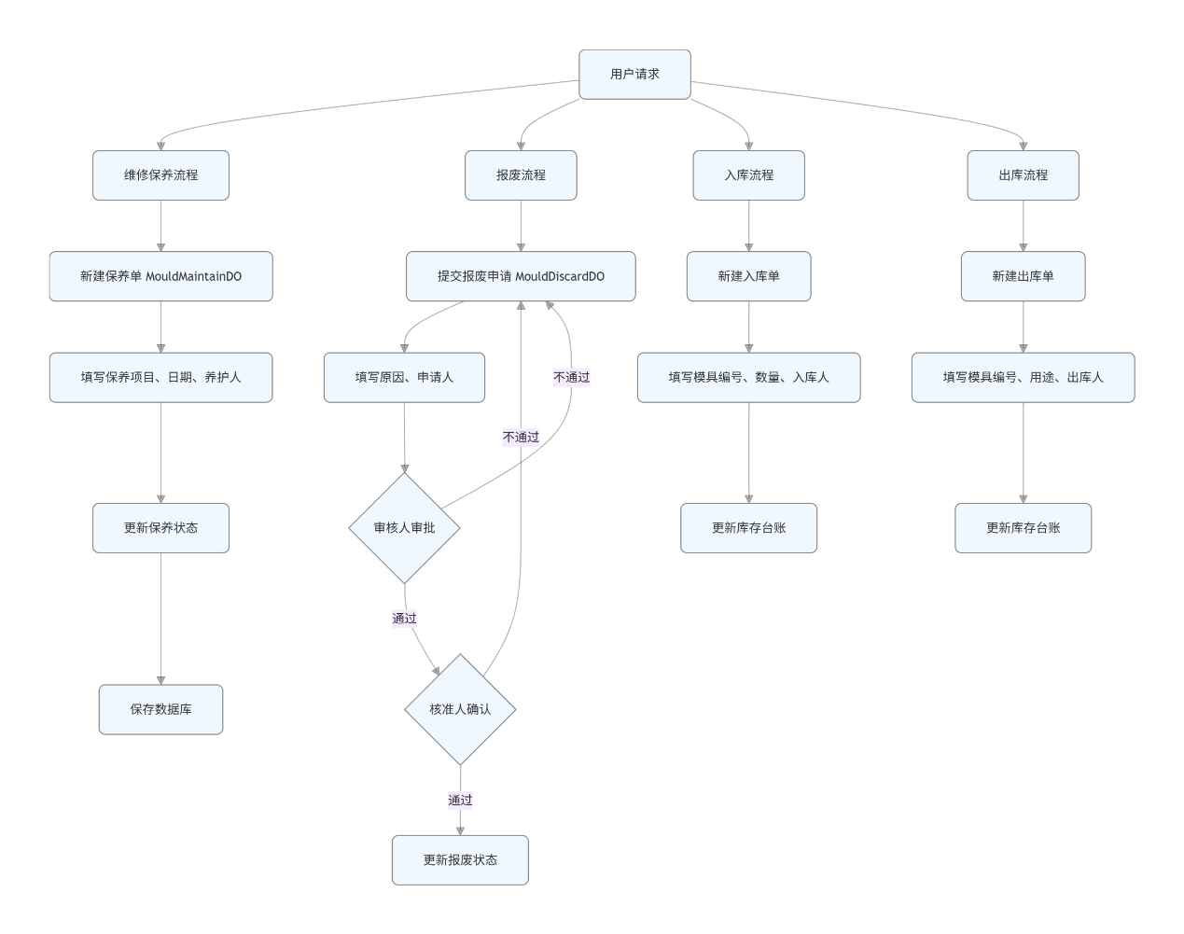

3.6.1.3 类设计
列出模块涉及的类及其职责。
提供类的详细定义，包括属性、方法及其说明。
用 UML 类图表示类之间的关系。
定义模具维修/保养单的数据对象，包括保养单号、状态、日期、项目、养护人等信息。
定义模具报废单的数据对象，包括报废单号、日期、原因、申请人、审核人、核准人等信息。
定义模具入库单的数据对象，包括入库单号、入库日期、模具编号、入库人、数量等。
定义模具出库单的数据对象，包括出库单号、出库日期、模具编号、出库人、用途、数量等。
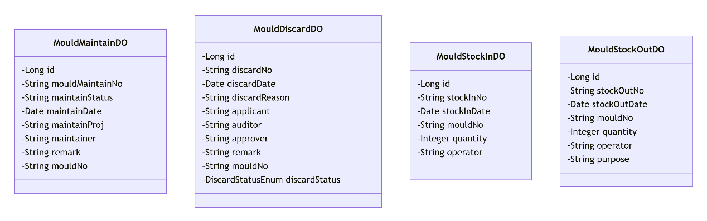

3.6.1.4 时序图
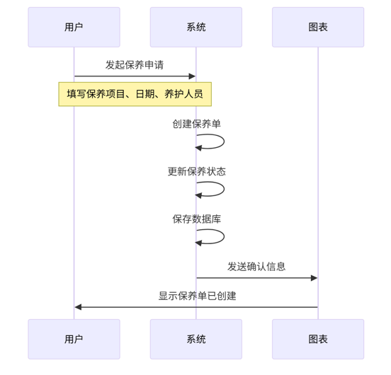
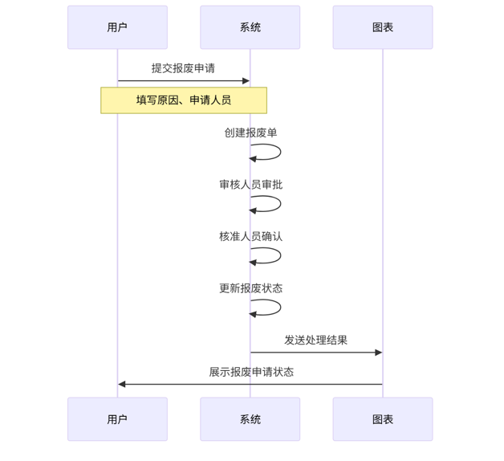
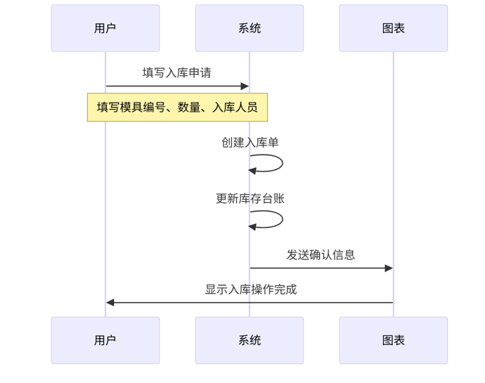
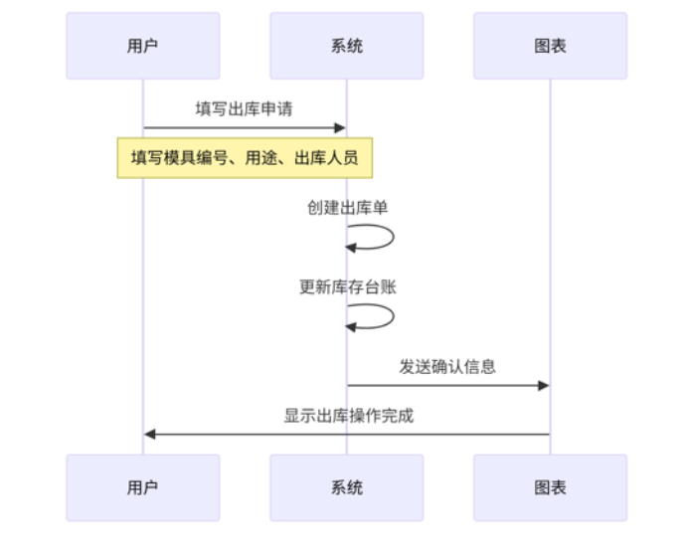

3.6.1.5 内部接口定义
@PostMapping("/save")
@ApiOperation("新增模具入库")
public Result<Boolean> save(@RequestBody MouldInboundDTO mouldInboundDTO) {
return Result.success(mouldInboundService.save(mouldInboundDTO));
}
@PutMapping("/update")
@ApiOperation("更新模具入库")
public Result<Boolean> update(@RequestBody MouldInboundDTO mouldInboundDTO) {
return Result.success(mouldInboundService.update(mouldInboundDTO));
}
@GetMapping("/getByPosition")
@ApiOperation("通过架位号获取模具号")
public Result<List<String>> getByPosition(@RequestParam("mouldRackPositionNumber") String mouldRackPositionNumber) {
return Result.success(mouldInformationService.getByPosition(mouldRackPositionNumber));
}
@GetMapping("/isDuplicateMouldNo")
@ApiOperation("是否是重复的模具编号")
public Result<Boolean> isDuplicateMouldNo(@RequestParam("mouldModelNo") String mouldModelNo, @RequestParam("mouldNumber")String mouldNumber) {
return Result.success(mouldInformationService.isDuplicateMouldNo(mouldModelNo, mouldNumber));
}
@GetMapping("/listFuzzy")
@ApiOperation("模糊搜索")
public Result<List<MouldInformationVO>> listFuzzy(MouldInformationFuzzyQuery query) {
return Result.success(mouldInformationService.listFuzzy(query));
}
@GetMapping("/deleteNitridingSchedulerTask")
@ApiOperation("取消定时氮化出炉任务")
public Result<Void> deleteNitridingSchedulerTask(@RequestParam("nitridingNoList") List<String> nitridingNoList) {
mouldNitridingService.deleteNitridingSchedulerTask(nitridingNoList);
return Result.success();
}
@PostMapping("/getByMouldNo")
@ApiOperation("根据模具编号获取氮化SOP")
public Result<List<NitridingSopVO>> getByMouldNo(@RequestParam("mouldNo") String mouldNo) {
return Result.success(nitridingSopService.getByMouldNo(mouldNo));
}
@PutMapping("/update")
@ApiOperation("编辑库位")
public Result<Void> update(@RequestBody WarehouseLocationManagementDTO warehouseLocationManagementDTO) {
warehouseLocationManagementDTO.setWhlId(warehouseLocationManagementDTO.getWhlId());
warehouseLocationManagementService.update(warehouseLocationManagementDTO);
return Result.success();
}
@Override
public void updateBatch(String mouldNo, List<NitridingSopDTO> nitridingSopDTOList) {
if (mouldNo != null && !mouldNo.isEmpty() && nitridingSopDTOList != null) {
List<NitridingSopDO> nitridingSopDOList = nitridingSopDTOList.stream().map(item -> {
item.setMouldNo(mouldNo);
return BeanConvertUtils.convert(item, NitridingSopDO.class);
}).collect(Collectors.toList());
//删除该模具编号下的所有设置
QueryWrapper<NitridingSopDO> queryWrapper = new QueryWrapper<>();
queryWrapper.lambda().eq(NitridingSopDO::getMouldNo, mouldNo);
this.remove(queryWrapper);
//插入新的设置
this.saveBatch(nitridingSopDOList);
//生成氮化记录
nitridingSopDOList.forEach(item -> mouldNitridingHelper.pushMouldNitridingRecord(item.getMouldNo()));
}
}

3.6.1.6 外部接口定义
"/mould/maintain/delete": {
"delete": {
"tags": [
"模具保养"
],
"summary": "删除模具保养",
"operationId": "deleteUsingDELETE_2",
"produces": [
"*/*"
],
"parameters": [
{
"name": "mouldMaintainNo",
"in": "query",
"description": "mouldMaintainNo",
"required": false,
"type": "string"
}
],
"responses": {
"200": {
"description": "OK",
"schema": {
"$ref": "#/definitions/Result«Void»",
"originalRef": "Result«Void»"
}
}
},
"security": [
{
"Authorization": [
"global"
]
}
],
"deprecated": false,
"x-order": "2147483647"
}
},
"/mould/maintain/downloadToolMaintainTemplate": {
"get": {
"tags": [
"模具保养"
],
"summary": "下载工装保养模板",
"operationId": "downloadToolMaintainTemplateUsingGET",
"produces": [
"*/*"
],
"responses": {
"200": {
"description": "OK"
}
},
"security": [
{
"Authorization": [
"global"
]
}
],
"deprecated": false,
"x-order": "2147483647"
}
},
"/mould/maintain/importToolMaintainData": {
"post": {
"tags": [
"模具保养"
],
"summary": "导入工装保养数据",
"operationId": "importToolMaintainDataUsingPOST",
"consumes": [
"multipart/form-data"
],
"produces": [
"*/*"
],
"parameters": [
{
"name": "file",
"in": "formData",
"description": "file",
"required": true,
"type": "file"
}
],
"responses": {
"200": {
"description": "OK",
"schema": {
"$ref": "#/definitions/Result«ToolInformationImportVO»",
"originalRef": "Result«ToolInformationImportVO»"
}
}
},
"security": [
{
"Authorization": [
"global"
]
}
],
"deprecated": false,
"x-order": "2147483647"
}
},
"/mould/maintain/insert": {
"post": {
"tags": [
"模具保养"
],
"summary": "新增模具保养",
"operationId": "insertUsingPOST_2",
"consumes": [
"application/json"
],
"produces": [
"*/*"
],
"parameters": [
{
"in": "body",
"name": "mouldMaintainDTO",
"description": "mouldMaintainDTO",
"required": true,
"schema": {
"$ref": "#/definitions/MouldMaintainDTO",
"originalRef": "MouldMaintainDTO"
}
}
],
"responses": {
"200": {
"description": "OK",
"schema": {
"$ref": "#/definitions/Result«Void»",
"originalRef": "Result«Void»"
}
}
},
"security": [
{
"Authorization": [
"global"
]
}
],
"deprecated": false,
"x-order": "2147483647"
}
},
"/mould/maintain/page": {
"post": {
"tags": [
"模具保养"
],
"summary": "模具保养分页查询",
"operationId": "pageUsingPOST_2",
"consumes": [
"application/json"
],
"produces": [
"*/*"
],
"parameters": [
{
"in": "body",
"name": "query",
"description": "query",
"required": true,
"schema": {
"$ref": "#/definitions/MouldMaintainQuery",
"originalRef": "MouldMaintainQuery"
}
}
],
"responses": {
"200": {
"description": "OK",
"schema": {
"$ref": "#/definitions/Result«PageResult«MouldMaintainVO»»",
"originalRef": "Result«PageResult«MouldMaintainVO»»"
}
}
},
"security": [
{
"Authorization": [
"global"
]
}
],
"deprecated": false,
"x-order": "2147483647"
}
},
"/mould/maintain/update": {
"put": {
"tags": [
"模具保养"
],
"summary": "编辑模具保养",
"operationId": "updateUsingPUT_3",
"consumes": [
"application/json"
],
"produces": [
"*/*"
],
"parameters": [
{
"in": "body",
"name": "mouldMaintainDTO",
"description": "mouldMaintainDTO",
"required": true,
"schema": {
"$ref": "#/definitions/MouldMaintainDTO",
"originalRef": "MouldMaintainDTO"
}
}
],
"responses": {
"200": {
"description": "OK",
"schema": {
"$ref": "#/definitions/Result«Void»",
"originalRef": "Result«Void»"
}
}
},
"security": [
{
"Authorization": [
"global"
]
}
],
"deprecated": false,
"x-order": "2147483647"
}
},
"/mould/maintain/updateBatch": {
"post": {
"tags": [
"模具保养"
],
"summary": "批量更新",
"operationId": "updateBatchUsingPOST",
"consumes": [
"application/json"
],
"produces": [
"*/*"
],
"parameters": [
{
"in": "body",
"name": "mouldMaintainDTOList",
"description": "mouldMaintainDTOList",
"required": true,
"schema": {
"type": "array",
"items": {
"$ref": "#/definitions/MouldMaintainDTO",
"originalRef": "MouldMaintainDTO"
}
}
}
],
"responses": {
"200": {
"description": "OK",
"schema": {
"$ref": "#/definitions/Result«Void»",
"originalRef": "Result«Void»"
}
}
},
"security": [
{
"Authorization": [
"global"
]
}
],
"deprecated": false,
"x-order": "2147483647"
}
},

"/mould/discard/delete": {
"delete": {
"tags": [
"模具报废"
],
"summary": "删除模具报废",
"operationId": "deleteUsingDELETE_1",
"produces": [
"*/*"
],
"parameters": [
{
"name": "discardNo",
"in": "query",
"description": "discardNo",
"required": false,
"type": "string"
}
],
"responses": {
"200": {
"description": "OK",
"schema": {
"$ref": "#/definitions/Result«Void»",
"originalRef": "Result«Void»"
}
}
},
"security": [
{
"Authorization": [
"global"
]
}
],
"deprecated": false,
"x-order": "2147483647"
}
},
"/mould/discard/downloadToolDiscardTemplate": {
"get": {
"tags": [
"模具报废"
],
"summary": "下载工装报废模板",
"operationId": "downloadToolDiscardTemplateUsingGET",
"produces": [
"*/*"
],
"responses": {
"200": {
"description": "OK"
}
},
"security": [
{
"Authorization": [
"global"
]
}
],
"deprecated": false,
"x-order": "2147483647"
}
},
"/mould/discard/importToolDiscardData": {
"post": {
"tags": [
"模具报废"
],
"summary": "导入工装报废数据",
"operationId": "importToolDiscardDataUsingPOST",
"consumes": [
"multipart/form-data"
],
"produces": [
"*/*"
],
"parameters": [
{
"name": "file",
"in": "formData",
"description": "file",
"required": true,
"type": "file"
}
],
"responses": {
"200": {
"description": "OK",
"schema": {
"$ref": "#/definitions/Result«ToolInformationImportVO»",
"originalRef": "Result«ToolInformationImportVO»"
}
}
},
"security": [
{
"Authorization": [
"global"
]
}
],
"deprecated": false,
"x-order": "2147483647"
}
},
"/mould/discard/insert": {
"post": {
"tags": [
"模具报废"
],
"summary": "新增模具报废",
"operationId": "insertUsingPOST_1",
"consumes": [
"application/json"
],
"produces": [
"*/*"
],
"parameters": [
{
"in": "body",
"name": "mouldDiscardDTO",
"description": "mouldDiscardDTO",
"required": true,
"schema": {
"$ref": "#/definitions/MouldDiscardDTO",
"originalRef": "MouldDiscardDTO"
}
}
],
"responses": {
"200": {
"description": "OK",
"schema": {
"$ref": "#/definitions/Result«Void»",
"originalRef": "Result«Void»"
}
}
},
"security": [
{
"Authorization": [
"global"
]
}
],
"deprecated": false,
"x-order": "2147483647"
}
},
"/mould/discard/page": {
"post": {
"tags": [
"模具报废"
],
"summary": "模具报废分页查询",
"operationId": "pageUsingPOST_1",
"consumes": [
"application/json"
],
"produces": [
"*/*"
],
"parameters": [
{
"in": "body",
"name": "query",
"description": "query",
"required": true,
"schema": {
"$ref": "#/definitions/MouldDiscardQuery",
"originalRef": "MouldDiscardQuery"
}
}
],
"responses": {
"200": {
"description": "OK",
"schema": {
"$ref": "#/definitions/Result«PageResult«MouldDiscardVO»»",
"originalRef": "Result«PageResult«MouldDiscardVO»»"
}
}
},
"security": [
{
"Authorization": [
"global"
]
}
],
"deprecated": false,
"x-order": "2147483647"
}
},
"/mould/discard/update": {
"put": {
"tags": [
"模具报废"
],
"summary": "编辑模具报废",
"operationId": "updateUsingPUT_1",
"consumes": [
"application/json"
],
"produces": [
"*/*"
],
"parameters": [
{
"in": "body",
"name": "mouldDiscardDTO",
"description": "mouldDiscardDTO",
"required": true,
"schema": {
"$ref": "#/definitions/MouldDiscardDTO",
"originalRef": "MouldDiscardDTO"
}
}
],
"responses": {
"200": {
"description": "OK",
"schema": {
"$ref": "#/definitions/Result«Void»",
"originalRef": "Result«Void»"
}
}
},
"security": [
{
"Authorization": [
"global"
]
}
],
"deprecated": false,
"x-order": "2147483647"
}
},
"/mould/discard/viewByMouldDiscardNo": {
"get": {
"tags": [
"模具报废"
],
"summary": "根据报废单号查报废详情",
"operationId": "viewByMouldDiscardNoUsingGET",
"produces": [
"*/*"
],
"parameters": [
{
"name": "discardNo",
"in": "query",
"description": "discardNo",
"required": true,
"type": "string"
}
],
"responses": {
"200": {
"description": "OK",
"schema": {
"$ref": "#/definitions/Result«MouldDiscardVO»",
"originalRef": "Result«MouldDiscardVO»"
}
}
},
"security": [
{
"Authorization": [
"global"
]
}
],
"deprecated": false,
"x-order": "2147483647"
}
},

3.6.2 维修保养详细设计

3.6.2.1 数据库设计
详见3.6.1.1

3.6.2.2 流程图
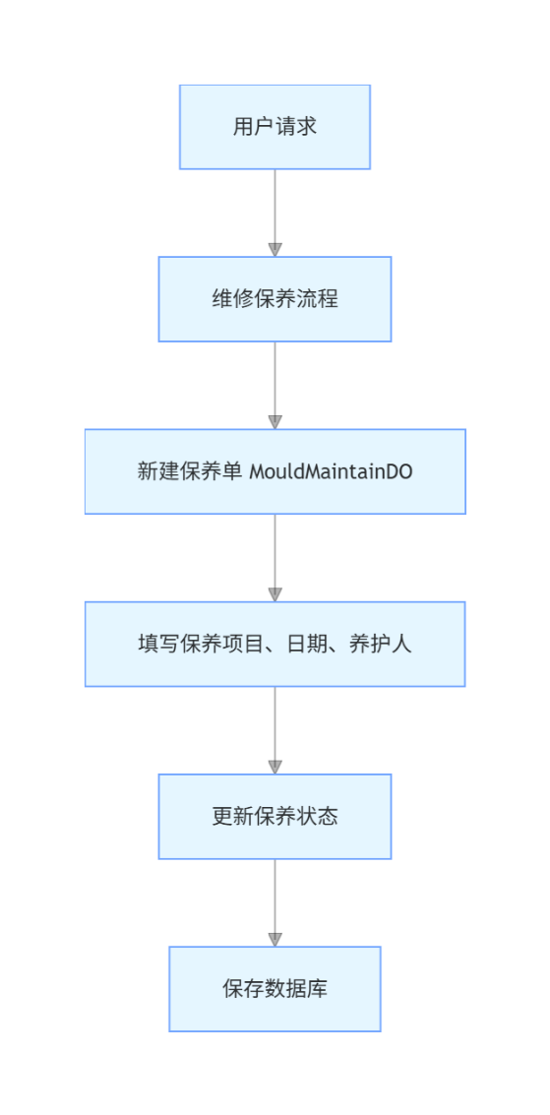

3.6.2.3 类设计
详见3.6.1.3

3.6.2.4 时序图


3.6.2.5 内部接口定义
@PostMapping("/insert")
@ApiOperation("新增模具保养")
public Result<Void> insert(@RequestBody @Valid MouldMaintainDTO mouldMaintainDTO) {
mouldMaintainService.insert(mouldMaintainDTO);
return Result.success();
}
@DeleteMapping("/delete")
@ApiOperation("删除模具保养")
public Result<Void> delete(String mouldMaintainNo) {
mouldMaintainService.delete(mouldMaintainNo);
return Result.success();
}
@PutMapping("/update")
@ApiOperation("编辑模具保养")
public Result<Void> update(@RequestBody MouldMaintainDTO mouldMaintainDTO) {
mouldMaintainService.update(mouldMaintainDTO);
return Result.success();
}
@PostMapping("/page")
@ApiOperation("模具保养分页查询")
public Result<PageResult<MouldMaintainVO>> page(@RequestBody MouldMaintainQuery query) {
return Result.success(mouldMaintainService.page(query));
}
@PostMapping("/updateBatch")
@ApiOperation("批量更新")
public Result<Void> updateBatch(@RequestBody List<MouldMaintainDTO> mouldMaintainDTOList) {
mouldMaintainService.updateBatch(mouldMaintainDTOList);
return Result.success();
}
@PostMapping("/add")
@ApiOperation("新增一笔")
public Result<Void> add(@RequestBody List<MouldMachineModelManagementDTO> mouldMachineModelManagementDTOList) {
mouldMachineModelManagementService.add(mouldMachineModelManagementDTOList);
return Result.success();
}
@GetMapping("/delete")
@ApiOperation("删除")
public Result<Void> delete(Long id) {
mouldMachineModelManagementService.delete(id);
return Result.success();
}
@GetMapping("/listAll")
@ApiOperation("展示全部")
public Result<List<MouldMachineModelManagementDTO>> listAll() {
return Result.success(mouldMachineModelManagementService.listAll());
}
@GetMapping("/view")
@ApiOperation("根据模具型号查询详情信息")
public Result<List<MouldModelVO>> viewByMouldModelNo(@RequestParam("mouldModelNo") String mouldModelNo) {
return Result.success(mouldModelService.viewByMouldModelNo(mouldModelNo));
}
@GetMapping("/getMouldDrawingByMouldModel")
@ApiOperation("通过模具型号获取图纸")
public Result<List<String>> getMouldDrawingByMouldModel(@RequestParam("mouldModelNo") String mouldModelNo) {
return Result.success(mouldModelService.getMouldDrawingByMouldModel(mouldModelNo));
}

3.6.2.6 外部接口定义
"/mould/maintain/delete": {
"delete": {
"tags": [
"模具保养"
],
"summary": "删除模具保养",
"operationId": "deleteUsingDELETE_2",
"produces": [
"*/*"
],
"parameters": [
{
"name": "mouldMaintainNo",
"in": "query",
"description": "mouldMaintainNo",
"required": false,
"type": "string"
}
],
"responses": {
"200": {
"description": "OK",
"schema": {
"$ref": "#/definitions/Result«Void»",
"originalRef": "Result«Void»"
}
}
},
"security": [
{
"Authorization": [
"global"
]
}
],
"deprecated": false,
"x-order": "2147483647"
}
},
"/mould/maintain/downloadToolMaintainTemplate": {
"get": {
"tags": [
"模具保养"
],
"summary": "下载工装保养模板",
"operationId": "downloadToolMaintainTemplateUsingGET",
"produces": [
"*/*"
],
"responses": {
"200": {
"description": "OK"
}
},
"security": [
{
"Authorization": [
"global"
]
}
],
"deprecated": false,
"x-order": "2147483647"
}
},
"/mould/maintain/importToolMaintainData": {
"post": {
"tags": [
"模具保养"
],
"summary": "导入工装保养数据",
"operationId": "importToolMaintainDataUsingPOST",
"consumes": [
"multipart/form-data"
],
"produces": [
"*/*"
],
"parameters": [
{
"name": "file",
"in": "formData",
"description": "file",
"required": true,
"type": "file"
}
],
"responses": {
"200": {
"description": "OK",
"schema": {
"$ref": "#/definitions/Result«ToolInformationImportVO»",
"originalRef": "Result«ToolInformationImportVO»"
}
}
},
"security": [
{
"Authorization": [
"global"
]
}
],
"deprecated": false,
"x-order": "2147483647"
}
},
"/mould/maintain/insert": {
"post": {
"tags": [
"模具保养"
],
"summary": "新增模具保养",
"operationId": "insertUsingPOST_2",
"consumes": [
"application/json"
],
"produces": [
"*/*"
],
"parameters": [
{
"in": "body",
"name": "mouldMaintainDTO",
"description": "mouldMaintainDTO",
"required": true,
"schema": {
"$ref": "#/definitions/MouldMaintainDTO",
"originalRef": "MouldMaintainDTO"
}
}
],
"responses": {
"200": {
"description": "OK",
"schema": {
"$ref": "#/definitions/Result«Void»",
"originalRef": "Result«Void»"
}
}
},
"security": [
{
"Authorization": [
"global"
]
}
],
"deprecated": false,
"x-order": "2147483647"
}
},
"/mould/maintain/page": {
"post": {
"tags": [
"模具保养"
],
"summary": "模具保养分页查询",
"operationId": "pageUsingPOST_2",
"consumes": [
"application/json"
],
"produces": [
"*/*"
],
"parameters": [
{
"in": "body",
"name": "query",
"description": "query",
"required": true,
"schema": {
"$ref": "#/definitions/MouldMaintainQuery",
"originalRef": "MouldMaintainQuery"
}
}
],
"responses": {
"200": {
"description": "OK",
"schema": {
"$ref": "#/definitions/Result«PageResult«MouldMaintainVO»»",
"originalRef": "Result«PageResult«MouldMaintainVO»»"
}
}
},
"security": [
{
"Authorization": [
"global"
]
}
],
"deprecated": false,
"x-order": "2147483647"
}
},
"/mould/maintain/update": {
"put": {
"tags": [
"模具保养"
],
"summary": "编辑模具保养",
"operationId": "updateUsingPUT_3",
"consumes": [
"application/json"
],
"produces": [
"*/*"
],
"parameters": [
{
"in": "body",
"name": "mouldMaintainDTO",
"description": "mouldMaintainDTO",
"required": true,
"schema": {
"$ref": "#/definitions/MouldMaintainDTO",
"originalRef": "MouldMaintainDTO"
}
}
],
"responses": {
"200": {
"description": "OK",
"schema": {
"$ref": "#/definitions/Result«Void»",
"originalRef": "Result«Void»"
}
}
},
"security": [
{
"Authorization": [
"global"
]
}
],
"deprecated": false,
"x-order": "2147483647"
}
},
"/mould/maintain/updateBatch": {
"post": {
"tags": [
"模具保养"
],
"summary": "批量更新",
"operationId": "updateBatchUsingPOST",
"consumes": [
"application/json"
],
"produces": [
"*/*"
],
"parameters": [
{
"in": "body",
"name": "mouldMaintainDTOList",
"description": "mouldMaintainDTOList",
"required": true,
"schema": {
"type": "array",
"items": {
"$ref": "#/definitions/MouldMaintainDTO",
"originalRef": "MouldMaintainDTO"
}
}
}
],
"responses": {
"200": {
"description": "OK",
"schema": {
"$ref": "#/definitions/Result«Void»",
"originalRef": "Result«Void»"
}
}
},
"security": [
{
"Authorization": [
"global"
]
}
],
"deprecated": false,
"x-order": "2147483647"
}
},

3.6.3 报废流程总体详细设计

3.6.3.1 数据库设计
详见3.6.1.1

3.6.3.2 流程图
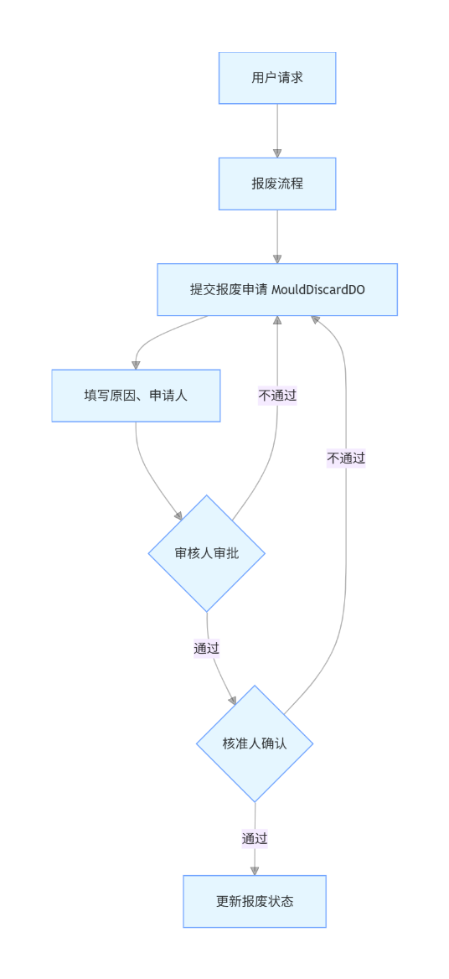

3.6.3.3 类设计
详见3.6.1.3

3.6.3.4 时序图


3.6.3.5 内部接口定义
@ApiOperation("新增模具报废")
public Result<Void> insert(@RequestBody @Valid MouldDiscardDTO mouldDiscardDTO) {
mouldDiscardService.insert(mouldDiscardDTO);
return Result.success();
}
@DeleteMapping("/delete")
@ApiOperation("删除模具报废")
public Result<Void> delete(String discardNo) {
mouldDiscardService.delete(discardNo);
return Result.success();
}
@PutMapping("/update")
@ApiOperation("编辑模具报废")
public Result<Void> update(@RequestBody MouldDiscardDTO mouldDiscardDTO) {
mouldDiscardService.update(mouldDiscardDTO);
return Result.success();
}
@PostMapping("/page")
@ApiOperation("模具报废分页查询")
public Result<PageResult<MouldDiscardVO>> page(@RequestBody MouldDiscardQuery query) {
return Result.success(mouldDiscardService.page(query));
}
@GetMapping("/viewByMouldDiscardNo")
@ApiOperation("根据报废单号查报废详情")
public Result<MouldDiscardVO> viewByMouldDiscardNo(@RequestParam("discardNo") String discardNo) {
return Result.success(mouldDiscardService.viewByMouldDiscardNo(discardNo));
}
@PostMapping(value = "/importToolDiscardData")
@ApiOperation("导入工装报废数据")
public Result<ToolInformationImportVO> importToolDiscardData(@RequestPart("file") MultipartFile file) {
return Result.success(mouldDiscardService.importToolDiscardData(file));
}

3.6.3.6 外部接口定义
"/mould/discard/delete": {
"delete": {
"tags": [
"模具报废"
],
"summary": "删除模具报废",
"operationId": "deleteUsingDELETE_1",
"produces": [
"*/*"
],
"parameters": [
{
"name": "discardNo",
"in": "query",
"description": "discardNo",
"required": false,
"type": "string"
}
],
"responses": {
"200": {
"description": "OK",
"schema": {
"$ref": "#/definitions/Result«Void»",
"originalRef": "Result«Void»"
}
}
},
"security": [
{
"Authorization": [
"global"
]
}
],
"deprecated": false,
"x-order": "2147483647"
}
},
"/mould/discard/downloadToolDiscardTemplate": {
"get": {
"tags": [
"模具报废"
],
"summary": "下载工装报废模板",
"operationId": "downloadToolDiscardTemplateUsingGET",
"produces": [
"*/*"
],
"responses": {
"200": {
"description": "OK"
}
},
"security": [
{
"Authorization": [
"global"
]
}
],
"deprecated": false,
"x-order": "2147483647"
}
},
"/mould/discard/importToolDiscardData": {
"post": {
"tags": [
"模具报废"
],
"summary": "导入工装报废数据",
"operationId": "importToolDiscardDataUsingPOST",
"consumes": [
"multipart/form-data"
],
"produces": [
"*/*"
],
"parameters": [
{
"name": "file",
"in": "formData",
"description": "file",
"required": true,
"type": "file"
}
],
"responses": {
"200": {
"description": "OK",
"schema": {
"$ref": "#/definitions/Result«ToolInformationImportVO»",
"originalRef": "Result«ToolInformationImportVO»"
}
}
},
"security": [
{
"Authorization": [
"global"
]
}
],
"deprecated": false,
"x-order": "2147483647"
}
},
"/mould/discard/insert": {
"post": {
"tags": [
"模具报废"
],
"summary": "新增模具报废",
"operationId": "insertUsingPOST_1",
"consumes": [
"application/json"
],
"produces": [
"*/*"
],
"parameters": [
{
"in": "body",
"name": "mouldDiscardDTO",
"description": "mouldDiscardDTO",
"required": true,
"schema": {
"$ref": "#/definitions/MouldDiscardDTO",
"originalRef": "MouldDiscardDTO"
}
}
],
"responses": {
"200": {
"description": "OK",
"schema": {
"$ref": "#/definitions/Result«Void»",
"originalRef": "Result«Void»"
}
}
},
"security": [
{
"Authorization": [
"global"
]
}
],
"deprecated": false,
"x-order": "2147483647"
}
},
"/mould/discard/page": {
"post": {
"tags": [
"模具报废"
],
"summary": "模具报废分页查询",
"operationId": "pageUsingPOST_1",
"consumes": [
"application/json"
],
"produces": [
"*/*"
],
"parameters": [
{
"in": "body",
"name": "query",
"description": "query",
"required": true,
"schema": {
"$ref": "#/definitions/MouldDiscardQuery",
"originalRef": "MouldDiscardQuery"
}
}
],
"responses": {
"200": {
"description": "OK",
"schema": {
"$ref": "#/definitions/Result«PageResult«MouldDiscardVO»»",
"originalRef": "Result«PageResult«MouldDiscardVO»»"
}
}
},
"security": [
{
"Authorization": [
"global"
]
}
],
"deprecated": false,
"x-order": "2147483647"
}
},
"/mould/discard/update": {
"put": {
"tags": [
"模具报废"
],
"summary": "编辑模具报废",
"operationId": "updateUsingPUT_1",
"consumes": [
"application/json"
],
"produces": [
"*/*"
],
"parameters": [
{
"in": "body",
"name": "mouldDiscardDTO",
"description": "mouldDiscardDTO",
"required": true,
"schema": {
"$ref": "#/definitions/MouldDiscardDTO",
"originalRef": "MouldDiscardDTO"
}
}
],
"responses": {
"200": {
"description": "OK",
"schema": {
"$ref": "#/definitions/Result«Void»",
"originalRef": "Result«Void»"
}
}
},
"security": [
{
"Authorization": [
"global"
]
}
],
"deprecated": false,
"x-order": "2147483647"
}
},
"/mould/discard/viewByMouldDiscardNo": {
"get": {
"tags": [
"模具报废"
],
"summary": "根据报废单号查报废详情",
"operationId": "viewByMouldDiscardNoUsingGET",
"produces": [
"*/*"
],
"parameters": [
{
"name": "discardNo",
"in": "query",
"description": "discardNo",
"required": true,
"type": "string"
}
],
"responses": {
"200": {
"description": "OK",
"schema": {
"$ref": "#/definitions/Result«MouldDiscardVO»",
"originalRef": "Result«MouldDiscardVO»"
}
}
},
"security": [
{
"Authorization": [
"global"
]
}
],
"deprecated": false,
"x-order": "2147483647"
}
},

3.6.4 入库总体详细设计

3.6.4.1 数据库设计
详见3.6.1.1

3.6.4.2 流程图
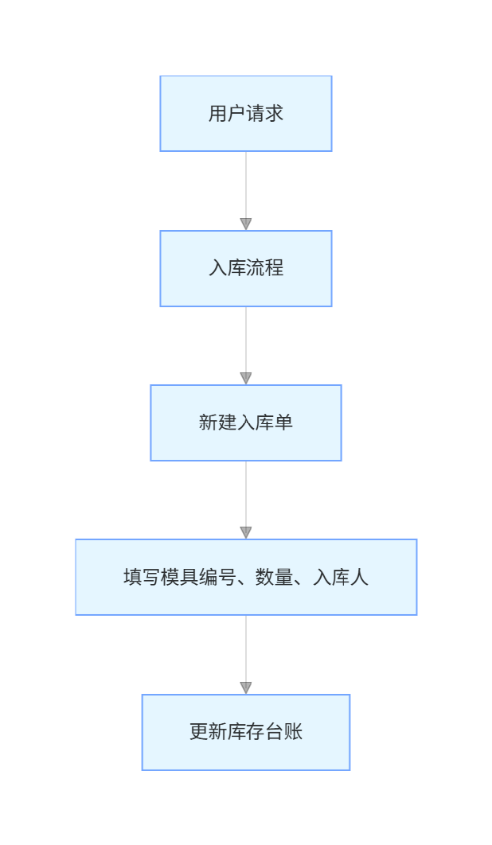

3.6.4.3 类设计
详见3.6.1.3

3.6.4.4 时序图


3.6.4.5 内部接口定义
@PostMapping("/save")
@ApiOperation("新增模具入库")
public Result<Boolean> save(@RequestBody MouldInboundDTO mouldInboundDTO) {
return Result.success(mouldInboundService.save(mouldInboundDTO));
}
@PutMapping("/update")
@ApiOperation("更新模具入库")
public Result<Boolean> update(@RequestBody MouldInboundDTO mouldInboundDTO) {
return Result.success(mouldInboundService.update(mouldInboundDTO));
}
@GetMapping("/pageInbounded")
@ApiOperation("模具已入库分页")
public Result<PageResult<MouldInboundVO>> pageInbounded(MouldInboundQuery mouldInboundQuery) {
PageResult<MouldInboundVO> pageResult = mouldInboundService.pageInbounded(mouldInboundQuery);
pageResult.getData().forEach(
mouldInboundVO -> mouldInboundVO.setInventoryStatus(InventoryStatusEnum.INBOUNDED.getStatus())
);
return Result.success(pageResult);
}
@PostMapping("/insertBatch")
@ApiOperation("批量入库")
public Result<Void> insertBatch(@RequestBody List<MouldInboundDTO> mouldInboundDTOList) {
mouldInboundService.insertBatch(mouldInboundDTOList);
return Result.success();
}
@GetMapping("/getWaitInboundByMouldNo")
@ApiOperation("根据模具编号获取待入库记录")
public Result<List<MouldOutboundVO>> getWaitInboundByMouldNo(@RequestParam("mouldNo") String mouldNo) {
List<MouldOutboundVO> result = mouldInboundService.getWaitInboundByMouldNo(mouldNo);
result.forEach(
mouldInboundVO -> mouldInboundVO.setInventoryStatus(InventoryStatusEnum.WAIT_INBOUND.getStatus())
);
return Result.success(result);
}

3.6.4.6 外部接口定义
"/mould/inbound/getWaitInboundByMouldNo": {
"get": {
"tags": [
"模具入库"
],
"summary": "根据模具编号获取待入库记录",
"operationId": "getWaitInboundByMouldNoUsingGET",
"produces": [
"*/*"
],
"parameters": [
{
"name": "mouldNo",
"in": "query",
"description": "mouldNo",
"required": true,
"type": "string"
}
],
"responses": {
"200": {
"description": "OK",
"schema": {
"$ref": "#/definitions/Result«List«模具出库VO对象»»",
"originalRef": "Result«List«模具出库VO对象»»"
}
}
},
"security": [
{
"Authorization": [
"global"
]
}
],
"deprecated": false,
"x-order": "2147483647"
}
},
"/mould/inbound/importInboundData": {
"post": {
"tags": [
"模具入库"
],
"summary": "导入工装入库数据",
"operationId": "importInboundDataUsingPOST",
"consumes": [
"multipart/form-data"
],
"produces": [
"*/*"
],
"parameters": [
{
"name": "file",
"in": "formData",
"description": "file",
"required": true,
"type": "file"
}
],
"responses": {
"200": {
"description": "OK",
"schema": {
"$ref": "#/definitions/Result«ToolInformationImportVO»",
"originalRef": "Result«ToolInformationImportVO»"
}
}
},
"security": [
{
"Authorization": [
"global"
]
}
],
"deprecated": false,
"x-order": "2147483647"
}
},
"/mould/inbound/insertBatch": {
"post": {
"tags": [
"模具入库"
],
"summary": "批量入库",
"operationId": "insertBatchUsingPOST",
"consumes": [
"application/json"
],
"produces": [
"*/*"
],
"parameters": [
{
"in": "body",
"name": "mouldInboundDTOList",
"description": "mouldInboundDTOList",
"required": true,
"schema": {
"type": "array",
"items": {
"$ref": "#/definitions/模具入库DTO对象",
"originalRef": "模具入库DTO对象"
}
}
}
],
"responses": {
"200": {
"description": "OK",
"schema": {
"$ref": "#/definitions/Result«Void»",
"originalRef": "Result«Void»"
}
}
},
"security": [
{
"Authorization": [
"global"
]
}
],
"deprecated": false,
"x-order": "2147483647"
}
},
"/mould/inbound/pageInbounded": {
"get": {
"tags": [
"模具入库"
],
"summary": "模具已入库分页",
"operationId": "pageInboundedUsingGET",
"produces": [
"*/*"
],
"parameters": [
{
"name": "accurateMouldNo",
"in": "query",
"description": "模具编号（精确匹配）",
"required": false,
"type": "string"
},
{
"name": "endTime",
"in": "query",
"description": "入库日期结束时间",
"required": false,
"type": "string",
"format": "date-time",
"x-example": "2023-09-28"
},
{
"name": "inboundUser",
"in": "query",
"description": "入库人",
"required": false,
"type": "string"
},
{
"name": "mouldModelNo",
"in": "query",
"description": "模具型号",
"required": false,
"type": "string"
},
{
"name": "mouldNo",
"in": "query",
"description": "模具编号（模糊匹配）",
"required": false,
"type": "string"
},
{
"name": "mouldType",
"in": "query",
"description": "模具类型",
"required": false,
"type": "array",
"items": {
"type": "string"
},
"collectionFormat": "multi"
},
{
"name": "pageNum",
"in": "query",
"description": "页码",
"required": false,
"type": "integer",
"format": "int32",
"x-example": 1
},
{
"name": "pageSize",
"in": "query",
"description": "每页大小",
"required": false,
"type": "integer",
"format": "int32",
"x-example": 10
},
{
"name": "startTime",
"in": "query",
"description": "入库日期开始时间",
"required": false,
"type": "string",
"format": "date-time",
"x-example": "2023-09-28"
}
],
"responses": {
"200": {
"description": "OK",
"schema": {
"$ref": "#/definitions/Result«PageResult«模具入库VO对象»»",
"originalRef": "Result«PageResult«模具入库VO对象»»"
}
}
},
"security": [
{
"Authorization": [
"global"
]
}
],
"deprecated": false,
"x-order": "2147483647"
}
},
"/mould/inbound/pageWaitInbound": {
"get": {
"tags": [
"模具入库"
],
"summary": "模具待入库分页",
"operationId": "pageWaitInboundUsingGET",
"produces": [
"*/*"
],
"parameters": [
{
"name": "accurateMouldNo",
"in": "query",
"description": "模具编号（精确匹配）",
"required": false,
"type": "string"
},
{
"name": "endTime",
"in": "query",
"description": "入库日期结束时间",
"required": false,
"type": "string",
"format": "date-time",
"x-example": "2023-09-28"
},
{
"name": "inboundUser",
"in": "query",
"description": "入库人",
"required": false,
"type": "string"
},
{
"name": "mouldModelNo",
"in": "query",
"description": "模具型号",
"required": false,
"type": "string"
},
{
"name": "mouldNo",
"in": "query",
"description": "模具编号（模糊匹配）",
"required": false,
"type": "string"
},
{
"name": "mouldType",
"in": "query",
"description": "模具类型",
"required": false,
"type": "array",
"items": {
"type": "string"
},
"collectionFormat": "multi"
},
{
"name": "pageNum",
"in": "query",
"description": "页码",
"required": false,
"type": "integer",
"format": "int32",
"x-example": 1
},
{
"name": "pageSize",
"in": "query",
"description": "每页大小",
"required": false,
"type": "integer",
"format": "int32",
"x-example": 10
},
{
"name": "startTime",
"in": "query",
"description": "入库日期开始时间",
"required": false,
"type": "string",
"format": "date-time",
"x-example": "2023-09-28"
}
],
"responses": {
"200": {
"description": "OK",
"schema": {
"$ref": "#/definitions/Result«PageResult«模具出库VO对象»»",
"originalRef": "Result«PageResult«模具出库VO对象»»"
}
}
},
"security": [
{
"Authorization": [
"global"
]
}
],
"deprecated": false,
"x-order": "2147483647"
}
},
"/mould/inbound/save": {
"post": {
"tags": [
"模具入库"
],
"summary": "新增模具入库",
"operationId": "saveUsingPOST",
"consumes": [
"application/json"
],
"produces": [
"*/*"
],
"parameters": [
{
"in": "body",
"name": "mouldInboundDTO",
"description": "mouldInboundDTO",
"required": true,
"schema": {
"$ref": "#/definitions/模具入库DTO对象",
"originalRef": "模具入库DTO对象"
}
}
],
"responses": {
"200": {
"description": "OK",
"schema": {
"$ref": "#/definitions/Result«boolean»",
"originalRef": "Result«boolean»"
}
}
},
"security": [
{
"Authorization": [
"global"
]
}
],
"deprecated": false,
"x-order": "2147483647"
}
},
"/mould/inbound/update": {
"put": {
"tags": [
"模具入库"
],
"summary": "更新模具入库",
"operationId": "updateUsingPUT_2",
"consumes": [
"application/json"
],
"produces": [
"*/*"
],
"parameters": [
{
"in": "body",
"name": "mouldInboundDTO",
"description": "mouldInboundDTO",
"required": true,
"schema": {
"$ref": "#/definitions/模具入库DTO对象",
"originalRef": "模具入库DTO对象"
}
}
],
"responses": {
"200": {
"description": "OK",
"schema": {
"$ref": "#/definitions/Result«boolean»",
"originalRef": "Result«boolean»"
}
}
},
"security": [
{
"Authorization": [
"global"
]
}
],
"deprecated": false,
"x-order": "2147483647"
}
},
"PageResult«模具入库VO对象»": {
"type": "object",
"properties": {
"data": {
"type": "array",
"description": "当前页的数据",
"items": {
"$ref": "#/definitions/模具入库VO对象",
"originalRef": "模具入库VO对象"
}
},
"pageNum": {
"type": "integer",
"format": "int32",
"description": "当前是第几页"
},
"pageSize": {
"type": "integer",
"format": "int32",
"description": "每页显示多少条"
},
"totalCount": {
"type": "integer",
"format": "int32",
"description": "总记录数"
},
"totalPage": {
"type": "integer",
"format": "int32",
"description": "总页数"
}
},
"title": "PageResult«模具入库VO对象»"
},
"PageResult«模具出库VO对象»": {
"type": "object",
"properties": {
"data": {
"type": "array",
"description": "当前页的数据",
"items": {
"$ref": "#/definitions/模具出库VO对象",
"originalRef": "模具出库VO对象"
}
},
"pageNum": {
"type": "integer",
"format": "int32",
"description": "当前是第几页"
},
"pageSize": {
"type": "integer",
"format": "int32",
"description": "每页显示多少条"
},
"totalCount": {
"type": "integer",
"format": "int32",
"description": "总记录数"
},
"totalPage": {
"type": "integer",
"format": "int32",
"description": "总页数"
}
},
"title": "PageResult«模具出库VO对象»"
},

3.6.5 出库总体详细设计

3.6.5.1 数据库设计
详见3.6.1.1

3.6.5.2 流程图
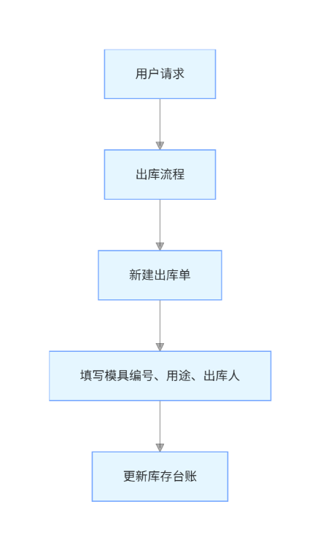

3.6.5.3 类设计
详见3.6.1.3

3.6.5.4 时序图


3.6.5.5 内部接口定义
@PostMapping("/save")
@ApiOperation("新增模具出库")
public Result<Boolean> save(@RequestBody MouldOutboundDTO mouldOutboundDTO) {
return Result.success(mouldOutboundService.save(mouldOutboundDTO));
}
@PutMapping("/update")
@ApiOperation("更新模具出库")
public Result<Boolean> update(@RequestBody MouldOutboundDTO mouldOutboundDTO) {
return Result.success(mouldOutboundService.update(mouldOutboundDTO));
}
@PostMapping("/insertBatch")
@ApiOperation("批量出库")
public Result<Void> insertBatch(@RequestBody List<MouldOutboundDTO> mouldOutboundDTOList) {
mouldOutboundService.insertBatch(mouldOutboundDTOList);
return Result.success();
}
@GetMapping("/getWaitInboundRecordByMouldNo")
@ApiOperation("根据模具编号获取待出库记录")
public Result<List<WorkOrderRecordVO>> getWaitInboundRecordByMouldNo(@RequestParam("mouldNo") String mouldNo) {
return Result.success(mouldOutboundService.getWaitInboundRecordByMouldNo(mouldNo));
}
@GetMapping(value = "/exportMouldOutbound")
@ApiOperation("导出出库信息")
public void exportMouldOutbound(MouldOutboundQuery query, HttpServletResponse response) {
mouldOutboundService.exportMouldOutbound(query, response);
}
@PostMapping(value = "/pushSignFeiShuMessage")
@ApiOperation("推送签核的飞书卡片消息")
public Result<Void> pushSignFeiShuMessage(@RequestBody MouldOutboundDTO mouldOutboundDTO) {
mouldOutboundService.pushSignFeiShuMessage(mouldOutboundDTO);
return Result.success();
}

3.6.5.6 外部接口定义
"/mould/outbound/exportMouldOutbound": {
"get": {
"tags": [
"模具出库"
],
"summary": "导出出库信息",
"operationId": "exportMouldOutboundUsingGET",
"produces": [
"*/*"
],
"parameters": [
{
"name": "accurateMouldNo",
"in": "query",
"description": "模具编号（精确匹配）",
"required": false,
"type": "string"
},
{
"name": "endTime",
"in": "query",
"description": "出库日期结束时间",
"required": false,
"type": "string",
"format": "date-time",
"x-example": "2023-09-28"
},
{
"name": "idList",
"in": "query",
"description": "指定要导出的数据id列表",
"required": false,
"type": "array",
"items": {
"type": "integer",
"format": "int64"
},
"collectionFormat": "multi"
},
{
"name": "inventoryStatus",
"in": "query",
"description": "库位状态",
"required": false,
"type": "string"
},
{
"name": "mouldModelNo",
"in": "query",
"description": "模具型号",
"required": false,
"type": "string"
},
{
"name": "mouldNo",
"in": "query",
"description": "模具编号（模糊匹配）",
"required": false,
"type": "string"
},
{
"name": "mouldType",
"in": "query",
"description": "模具类型",
"required": false,
"type": "array",
"items": {
"type": "string"
},
"collectionFormat": "multi"
},
{
"name": "outboundUser",
"in": "query",
"description": "领用人",
"required": false,
"type": "string"
},
{
"name": "pageNum",
"in": "query",
"description": "页码",
"required": false,
"type": "integer",
"format": "int32",
"x-example": 1
},
{
"name": "pageSize",
"in": "query",
"description": "每页大小",
"required": false,
"type": "integer",
"format": "int32",
"x-example": 10
},
{
"name": "startTime",
"in": "query",
"description": "出库日期开始时间",
"required": false,
"type": "string",
"format": "date-time",
"x-example": "2023-09-28"
},
{
"name": "waitInboundFlag",
"in": "query",
"description": "是否待入库",
"required": false,
"type": "string"
},
{
"name": "workOrderNumber",
"in": "query",
"description": "工单编号",
"required": false,
"type": "string"
}
],
"responses": {
"200": {
"description": "OK"
}
},
"security": [
{
"Authorization": [
"global"
]
}
],
"deprecated": false,
"x-order": "2147483647"
}
},
"/mould/outbound/getWaitInboundRecordByMouldNo": {
"get": {
"tags": [
"模具出库"
],
"summary": "根据模具编号获取待出库记录",
"operationId": "getWaitInboundRecordByMouldNoUsingGET",
"produces": [
"*/*"
],
"parameters": [
{
"name": "mouldNo",
"in": "query",
"description": "mouldNo",
"required": true,
"type": "string"
}
],
"responses": {
"200": {
"description": "OK",
"schema": {
"$ref": "#/definitions/Result«List«工单记录VO对象»»",
"originalRef": "Result«List«工单记录VO对象»»"
}
}
},
"security": [
{
"Authorization": [
"global"
]
}
],
"deprecated": false,
"x-order": "2147483647"
}
},
"/mould/outbound/ignoreWaitOutbound": {
"get": {
"tags": [
"模具出库"
],
"summary": "忽略待出库记录",
"operationId": "ignoreWaitOutboundUsingGET",
"produces": [
"*/*"
],
"parameters": [
{
"in": "body",
"name": "id",
"description": "id",
"required": false,
"schema": {
"type": "integer",
"format": "int64"
}
},
{
"in": "body",
"name": "status",
"description": "status",
"required": false,
"schema": {
"type": "string"
}
}
],
"responses": {
"200": {
"description": "OK",
"schema": {
"$ref": "#/definitions/Result«Void»",
"originalRef": "Result«Void»"
}
}
},
"security": [
{
"Authorization": [
"global"
]
}
],
"deprecated": false,
"x-order": "2147483647"
}
},
"/mould/outbound/importOutboundData": {
"post": {
"tags": [
"模具出库"
],
"summary": "导入工装出库数据",
"operationId": "importMouldInformationUsingPOST_1",
"consumes": [
"multipart/form-data"
],
"produces": [
"*/*"
],
"parameters": [
{
"name": "file",
"in": "formData",
"description": "file",
"required": true,
"type": "file"
}
],
"responses": {
"200": {
"description": "OK",
"schema": {
"$ref": "#/definitions/Result«ToolInformationImportVO»",
"originalRef": "Result«ToolInformationImportVO»"
}
}
},
"security": [
{
"Authorization": [
"global"
]
}
],
"deprecated": false,
"x-order": "2147483647"
}
},
"/mould/outbound/insertBatch": {
"post": {
"tags": [
"模具出库"
],
"summary": "批量出库",
"operationId": "insertBatchUsingPOST_1",
"consumes": [
"application/json"
],
"produces": [
"*/*"
],
"parameters": [
{
"in": "body",
"name": "mouldOutboundDTOList",
"description": "mouldOutboundDTOList",
"required": true,
"schema": {
"type": "array",
"items": {
"$ref": "#/definitions/模具出库DTO对象",
"originalRef": "模具出库DTO对象"
}
}
}
],
"responses": {
"200": {
"description": "OK",
"schema": {
"$ref": "#/definitions/Result«Void»",
"originalRef": "Result«Void»"
}
}
},
"security": [
{
"Authorization": [
"global"
]
}
],
"deprecated": false,
"x-order": "2147483647"
}
},
"/mould/outbound/pageOutbounded": {
"get": {
"tags": [
"模具出库"
],
"summary": "模具已出库分页",
"operationId": "pageOutboundedUsingGET",
"produces": [
"*/*"
],
"parameters": [
{
"name": "accurateMouldNo",
"in": "query",
"description": "模具编号（精确匹配）",
"required": false,
"type": "string"
},
{
"name": "endTime",
"in": "query",
"description": "出库日期结束时间",
"required": false,
"type": "string",
"format": "date-time",
"x-example": "2023-09-28"
},
{
"name": "idList",
"in": "query",
"description": "指定要导出的数据id列表",
"required": false,
"type": "array",
"items": {
"type": "integer",
"format": "int64"
},
"collectionFormat": "multi"
},
{
"name": "inventoryStatus",
"in": "query",
"description": "库位状态",
"required": false,
"type": "string"
},
{
"name": "mouldModelNo",
"in": "query",
"description": "模具型号",
"required": false,
"type": "string"
},
{
"name": "mouldNo",
"in": "query",
"description": "模具编号（模糊匹配）",
"required": false,
"type": "string"
},
{
"name": "mouldType",
"in": "query",
"description": "模具类型",
"required": false,
"type": "array",
"items": {
"type": "string"
},
"collectionFormat": "multi"
},
{
"name": "outboundUser",
"in": "query",
"description": "领用人",
"required": false,
"type": "string"
},
{
"name": "pageNum",
"in": "query",
"description": "页码",
"required": false,
"type": "integer",
"format": "int32",
"x-example": 1
},
{
"name": "pageSize",
"in": "query",
"description": "每页大小",
"required": false,
"type": "integer",
"format": "int32",
"x-example": 10
},
{
"name": "startTime",
"in": "query",
"description": "出库日期开始时间",
"required": false,
"type": "string",
"format": "date-time",
"x-example": "2023-09-28"
},
{
"name": "waitInboundFlag",
"in": "query",
"description": "是否待入库",
"required": false,
"type": "string"
},
{
"name": "workOrderNumber",
"in": "query",
"description": "工单编号",
"required": false,
"type": "string"
}
],
"responses": {
"200": {
"description": "OK",
"schema": {
"$ref": "#/definitions/Result«PageResult«模具出库VO对象»»",
"originalRef": "Result«PageResult«模具出库VO对象»»"
}
}
},
"security": [
{
"Authorization": [
"global"
]
}
],
"deprecated": false,
"x-order": "2147483647"
}
},
"/mould/outbound/pageWaitOutbound": {
"get": {
"tags": [
"模具出库"
],
"summary": "模具待出库分页",
"operationId": "pageWaitOutboundUsingGET",
"produces": [
"*/*"
],
"parameters": [
{
"name": "accurateMouldNo",
"in": "query",
"description": "模具编号（精确匹配）",
"required": false,
"type": "string"
},
{
"name": "endTime",
"in": "query",
"description": "出库日期结束时间",
"required": false,
"type": "string",
"format": "date-time",
"x-example": "2023-09-28"
},
{
"name": "idList",
"in": "query",
"description": "指定要导出的数据id列表",
"required": false,
"type": "array",
"items": {
"type": "integer",
"format": "int64"
},
"collectionFormat": "multi"
},
{
"name": "inventoryStatus",
"in": "query",
"description": "库位状态",
"required": false,
"type": "string"
},
{
"name": "mouldModelNo",
"in": "query",
"description": "模具型号",
"required": false,
"type": "string"
},
{
"name": "mouldNo",
"in": "query",
"description": "模具编号（模糊匹配）",
"required": false,
"type": "string"
},
{
"name": "mouldType",
"in": "query",
"description": "模具类型",
"required": false,
"type": "array",
"items": {
"type": "string"
},
"collectionFormat": "multi"
},
{
"name": "outboundUser",
"in": "query",
"description": "领用人",
"required": false,
"type": "string"
},
{
"name": "pageNum",
"in": "query",
"description": "页码",
"required": false,
"type": "integer",
"format": "int32",
"x-example": 1
},
{
"name": "pageSize",
"in": "query",
"description": "每页大小",
"required": false,
"type": "integer",
"format": "int32",
"x-example": 10
},
{
"name": "startTime",
"in": "query",
"description": "出库日期开始时间",
"required": false,
"type": "string",
"format": "date-time",
"x-example": "2023-09-28"
},
{
"name": "waitInboundFlag",
"in": "query",
"description": "是否待入库",
"required": false,
"type": "string"
},
{
"name": "workOrderNumber",
"in": "query",
"description": "工单编号",
"required": false,
"type": "string"
}
],
"responses": {
"200": {
"description": "OK",
"schema": {
"$ref": "#/definitions/Result«PageResult«模具出库VO对象»»",
"originalRef": "Result«PageResult«模具出库VO对象»»"
}
}
},
"security": [
{
"Authorization": [
"global"
]
}
],
"deprecated": false,
"x-order": "2147483647"
}
},
"/mould/outbound/pushSignFeiShuMessage": {
"post": {
"tags": [
"模具出库"
],
"summary": "推送签核的飞书卡片消息",
"operationId": "pushSignFeiShuMessageUsingPOST",
"consumes": [
"application/json"
],
"produces": [
"*/*"
],
"parameters": [
{
"in": "body",
"name": "mouldOutboundDTO",
"description": "mouldOutboundDTO",
"required": true,
"schema": {
"$ref": "#/definitions/模具出库DTO对象",
"originalRef": "模具出库DTO对象"
}
}
],
"responses": {
"200": {
"description": "OK",
"schema": {
"$ref": "#/definitions/Result«Void»",
"originalRef": "Result«Void»"
}
}
},
"security": [
{
"Authorization": [
"global"
]
}
],
"deprecated": false,
"x-order": "2147483647"
}
},
"/mould/outbound/save": {
"post": {
"tags": [
"模具出库"
],
"summary": "新增模具出库",
"operationId": "saveUsingPOST_1",
"consumes": [
"application/json"
],
"produces": [
"*/*"
],
"parameters": [
{
"in": "body",
"name": "mouldOutboundDTO",
"description": "mouldOutboundDTO",
"required": true,
"schema": {
"$ref": "#/definitions/模具出库DTO对象",
"originalRef": "模具出库DTO对象"
}
}
],
"responses": {
"200": {
"description": "OK",
"schema": {
"$ref": "#/definitions/Result«boolean»",
"originalRef": "Result«boolean»"
}
}
},
"security": [
{
"Authorization": [
"global"
]
}
],
"deprecated": false,
"x-order": "2147483647"
}
},
"/mould/outbound/update": {
"put": {
"tags": [
"模具出库"
],
"summary": "更新模具出库",
"operationId": "updateUsingPUT_5",
"consumes": [
"application/json"
],
"produces": [
"*/*"
],
"parameters": [
{
"in": "body",
"name": "mouldOutboundDTO",
"description": "mouldOutboundDTO",
"required": true,
"schema": {
"$ref": "#/definitions/模具出库DTO对象",
"originalRef": "模具出库DTO对象"
}
}
],
"responses": {
"200": {
"description": "OK",
"schema": {
"$ref": "#/definitions/Result«boolean»",
"originalRef": "Result«boolean»"
}
}
},
"security": [
{
"Authorization": [
"global"
]
}
],
"deprecated": false,
"x-order": "2147483647"
}
},

3.7 备品备件功能概述
备品备件模块的功能主要包括核心功能：备件台账、PMC 调拨、备件领用、备件采购、备件使用记录。职责：精细化管理备件库存、库存占用与消耗等。

3.7.1 备品备件模块详细设计

3.7.1.1 数据库设计
表：spare_parts_po
编号 | 名称 | 数据类型 | 长度 | 小数位 | 允许空值 | 默认值 | 说明
1 | id | bigint | 19 | 0 | N | 无 | hc 备品备件 po
2 | po | varchar | 255 |  | Y | 无 | hc 物料PO单号
3 | material_code | varchar | 255 |  | Y | 无 | hc 物料编码
4 | material_name | varchar | 255 |  | Y | 无 | hc 物料名称
5 | quantity | decimal | 19 | 3 | Y | 无 | hc 数量
6 | purchase_order_status | varchar | 255 |  | Y | 无 | hc 采购单状态（新建）
7 | pr | varchar | 255 |  | Y | 无 | hc PR单编号
8 | arrival_time | date |  |  | Y | 无 | hc 到货时间 yyyy-MM-dd
9 | create_by | varchar | 255 |  | Y | 无 | 创建人
10 | create_time | datetime |  |  | Y | 无 | 创建时间
11 | update_by | varchar | 255 |  | Y | 无 | 更新人
12 | update_time | datetime |  |  | Y | 无 | 更新时间

表：spare_parts_pr_detail
编号 | 名称 | 数据类型 | 长度 | 小数位 | 允许空值 | 默认值 | 说明
1 | id | bigint | 19 | 0 | N | 无 | hc 备品备件 采购单据明细 表身
2 | order_id | bigint | 19 | 0 | N | 无 | 单据 id
3 | code | varchar | 255 |  | Y | 无 | hc 备件 编号
4 | description | varchar | 255 |  | Y | 无 | hc 备件 名称=主数据name=主数据description
5 | name_short | varchar | 255 |  | Y | 无 | hc 品名=主数据name取第一个逗号前
6 | spec | varchar | 255 |  | Y | 无 | hc 规格型号=主数据spec
7 | unit_name | varchar | 255 |  | Y | 无 | hc 基本单位=主数据unit_name
8 | material_class_code | varchar | 255 |  | Y | 无 | hc 物料组=主数据material_class_code
9 | purchase_group | varchar | 255 |  | Y | 无 | hc 采购组=主数据purchase_group
10 | quantity | decimal | 19 | 3 | Y | 无 | hc 申请数量 (19,3)
11 | urgency | varchar | 1 |  | Y | 无 | hc 紧急程度 0正常 1重要 2紧急
12 | delivery_date | date |  |  | Y | 无 | hc 交货日期 yyyy-MM-dd
13 | demand_user_code | varchar | 255 |  | Y | 无 | hc 需求人 工号
14 | demand_user_name | varchar | 255 |  | Y | 无 | hc 需求人 姓名
15 | note | varchar | 255 |  | Y | 无 | hc 备注
16 | create_by | varchar | 255 |  | Y | 无 | 创建人
17 | create_time | datetime |  |  | Y | 无 | 创建时间
18 | update_by | varchar | 255 |  | Y | 无 | 更新人
19 | update_time | datetime |  |  | Y | 无 | 更新时间
20 | pr | varchar | 255 |  | Y | 无 | hc pr单号 同order
21 | process | varchar | 255 |  | Y | 无 | 工序 必填 前端写死下拉框 单选
22 | equipment_code | varchar | 255 |  | Y | 无 | 设备 code
23 | equipment_name | varchar | 255 |  | Y | 无 | 设备 name
24 | serial_number | int | 10 | 0 | Y | 无 | 序号

表：spare_parts_pr_detail_sap
编号 | 名称 | 数据类型 | 长度 | 小数位 | 允许空值 | 默认值 | 说明
1 | id | bigint | 19 | 0 | N | 无 | hc 备品备件 采购申请 sap收货
2 | order_id | bigint | 19 | 0 | N | 无 | hc order 表头 id
3 | detail_id | bigint | 19 | 0 | N | 无 | hc detail 表身 id
4 | pr | varchar | 255 |  | Y | 无 | hc pr单号 同order 同detail
5 | po | int | 10 | 0 | Y | 无 | hc po单号
6 | code | varchar | 255 |  | Y | 无 | hc 备件 编号
7 | quantity_pr | decimal | 19 | 3 | Y | 无 | hc 定时从sap更新的 pr数量
8 | quantity_po | decimal | 19 | 3 | Y | 无 | hc 定时从sap更新的 po数量
9 | quantity_arrive | decimal | 19 | 3 | Y | 无 | hc 定时从sap更新的 到货数量
10 | arrive_date | date |  |  | Y | 无 | hc 定时从sap更新的 到货日期 yyyy-MM-dd
11 | create_by | varchar | 255 |  | Y | 无 | 创建人
12 | create_time | datetime |  |  | Y | 无 | 创建时间
13 | update_by | varchar | 255 |  | Y | 无 | 更新人
14 | update_time | datetime |  |  | Y | 无 | 更新时间

表：spare_parts_pr_order
编号 | 名称 | 数据类型 | 长度 | 小数位 | 允许空值 | 默认值 | 说明
1 | id | bigint | 19 | 0 | N | 无 | hc 备品备件 pr 单据 order 表头
2 | pr | varchar | 255 |  | Y | 无 | hc 物料PR单(OA回传)
3 | title | varchar | 255 |  | Y | 无 | hc 标题
4 | apply_date | date |  |  | Y | 无 | hc 申请日期yyyy-MM-dd 前端传当天
5 | launch_user_code | varchar | 255 |  | Y | 无 | hc 发起人=当前用户=OA创建人 工号
6 | launch_user_name | varchar | 255 |  | Y | 无 | hc 发起人=当前用户=OA创建人 姓名
7 | demand_user_code | varchar | 255 |  | Y | 无 | hc 需求人 工号
8 | demand_user_name | varchar | 255 |  | Y | 无 | hc 需求人 姓名
9 | urgency | varchar | 1 |  | Y | 无 | hc 紧急程度 0正常 1一般紧急 2非常紧急
10 | options | varchar | 2 |  | Y | 无 | hc 需求类选项 PrOrderOptionEnum
11 | purpose | varchar | 1 |  | Y | 无 | hc 领料用途 PrOrderPurposeEnum
12 | demand_user_contact | varchar | 255 |  | Y | 无 | hc 需求人联系方式
13 | status | varchar | 255 |  | Y | 无 | hc 物料需求联络单=wms状态 (list字段)
14 | create_by | varchar | 255 |  | Y | 无 | 创建人
15 | create_time | datetime |  |  | Y | 无 | 创建时间
16 | update_by | varchar | 255 |  | Y | 无 | 更新人
17 | update_time | datetime |  |  | Y | 无 | 更新时间
18 | requestid | bigint | 19 | 0 | Y | 无 | hc oa回传的 requestid

表：spare_parts_transfer_detail
编号 | 名称 | 数据类型 | 长度 | 小数位 | 允许空值 | 默认值 | 说明
1 | id | bigint | 19 | 0 | N | 无 | hc 备品备件 PMC调拨 明细 detail 表身
2 | order_id | bigint | 19 | 0 | N | 无 | 单据 id
3 | code | varchar | 255 |  | Y | 无 | hc 备件 编号
4 | name_short | varchar | 255 |  | Y | 无 | hc 备件 名称=主数据名称第一个逗号前
5 | description | varchar | 255 |  | Y | 无 | hc 备件 描述=主数据长描述
6 | unit_name | varchar | 255 |  | Y | 无 | hc 单位 名称
7 | quantity_inventory_sap | decimal | 19 | 3 | Y | 无 | hc sap库存数量 调sap库存接口 (19,3)
8 | quantity | decimal | 19 | 3 | Y | 无 | hc 需求数量 (19,3)
9 | create_by | varchar | 255 |  | Y | 无 | 创建人
10 | create_time | datetime |  |  | Y | 无 | 创建时间
11 | update_by | varchar | 255 |  | Y | 无 | 更新人
12 | update_time | datetime |  |  | Y | 无 | 更新时间
13 | request | varchar | 255 |  | Y | 无 | hc oa回传的 领料单号 和order一致
14 | arrive_date | date |  |  | Y | 无 | hc oa回传的 PMC仓库到货日期 yyyy-MM-dd
15 | quantity_oa | decimal | 19 | 3 | Y | 无 | hc oa回传的 oa数量
16 | serial_number | int | 10 | 0 | Y | 无 | 序号

表：spare_parts_transfer_order 调拨
编号 | 名称 | 数据类型 | 长度 | 小数位 | 允许空值 | 默认值 | 说明
1 | id | bigint | 19 | 0 | N | 无 | hc 备品备件 PMC调拨 单据 order 表头
2 | title | varchar | 255 |  | Y | 无 | hc 标题
3 | operator_code | varchar | 255 |  | Y | 无 | hc 创建人 工号
4 | operator_name | varchar | 255 |  | Y | 无 | hc 创建人 姓名
5 | urgency | varchar | 1 |  | Y | 无 | hc 紧急程度 0正常 1重要 2紧急
6 | sqr_code | varchar | 255 |  | Y | 无 | hc 发起人 工号
7 | sqr_name | varchar | 255 |  | Y | 无 | hc 发起人 姓名
8 | pick_user_xqr_code | varchar | 255 |  | Y | 无 | hc 领用人=需求人 工号
9 | pick_user_xqr_name | varchar | 255 |  | Y | 无 | hc 领用人=需求人 姓名
10 | cbzx | varchar | 255 |  | Y | 无 | hc SAP成本编号
11 | material_category_children | varchar | 3 |  | Y | 无 | hc 物料子类
12 | note | varchar | 255 |  | Y | 无 | hc 备注
13 | request | varchar | 255 |  | Y | 无 | hc 领料单号 回传 (list字段)
14 | apply_date | date |  |  | Y | 无 | hc 申请日期 yyyy-MM-dd (list字段)
15 | status | varchar | 1 |  | Y | 无 | hc 单据状态 1新增(保存在本地) 2提交(传给OA) 3审核通过 4审核不通过
16 | create_by | varchar | 255 |  | Y | 无 | 创建人
17 | create_time | datetime |  |  | Y | 无 | 创建时间
18 | update_by | varchar | 255 |  | Y | 无 | 更新人
19 | update_time | datetime |  |  | Y | 无 | 更新时间
20 | requestid | bigint | 19 | 0 | Y | 无 | hc oa回传的 requestid
21 | reason | varchar | 255 |  | Y | 无 | hc oa回传的 审核原因

3.7.1.2 流程图
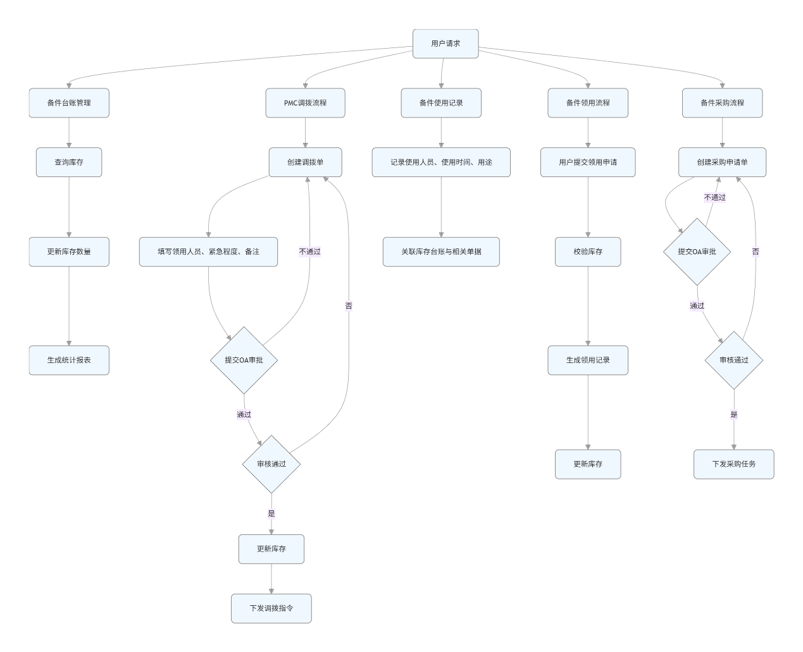

3.7.1.3 类设计
列出模块涉及的类及其职责。
提供类的详细定义，包括属性、方法及其说明。
用 UML 类图表示类之间的关系。

表示备件库存台账，包含库存数量、仓库、库区、物料信息。
表示PMC调拨单，包括标题、申请人、领用人、紧急程度、状态、OA回传信息等。
表示采购申请单，包括PR编号、申请人、需求人、紧急程度、用途、状态、OA回传信息。
表示备件使用记录，包括使用人、使用时间、数量、用途，关联库存和单据。
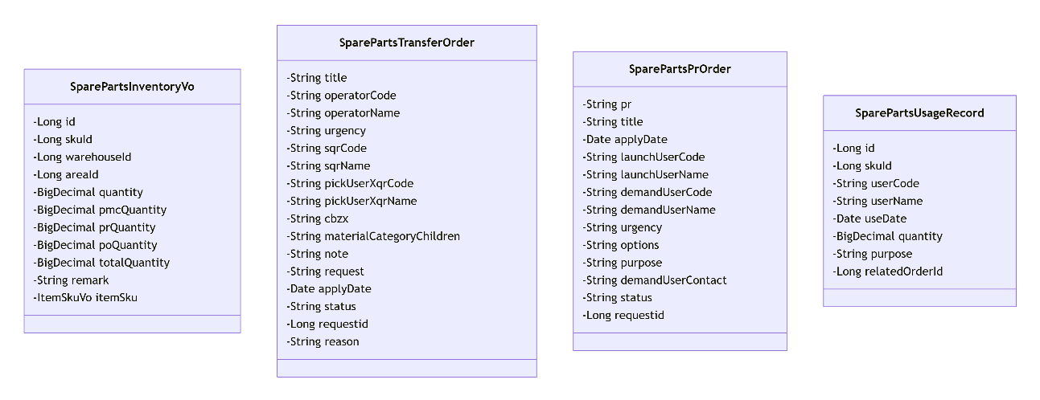

3.7.1.4 时序图
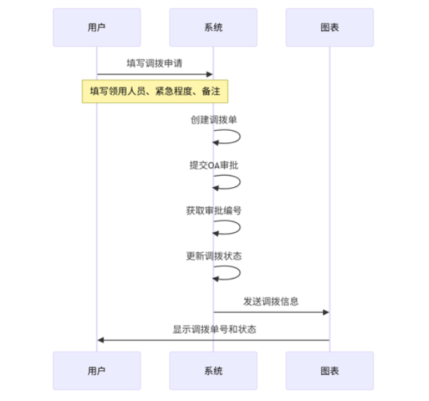
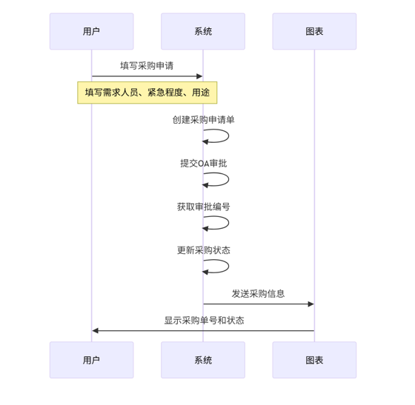
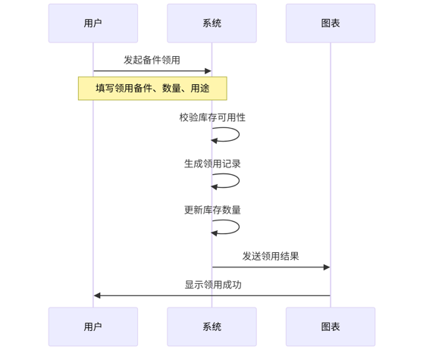
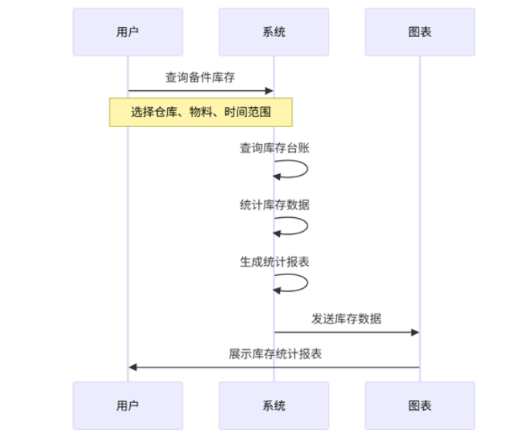

3.7.1.5 内部接口定义
@ApiOperation("当月 物料采购总价格 数量*单价")
@GetMapping(value = "/feign/insider/spareParts/board/thisMonthPrMaterialSumPrice")
List<PrMaterialSumPriceFeign> thisMonthPrMaterialSumPrice(@RequestParam(value = "start", required = false) String start,
@RequestParam(value = "end", required = false) String end);
@ApiOperation("当月 物料采购总数量")
@GetMapping(value = "/feign/insider/spareParts/board/thisMonthPrMaterialSumQuantity")
List<PrMaterialSumQuantityFeign> thisMonthPrMaterialSumQuantity(@RequestParam(value = "start", required = false) String start,
@RequestParam(value = "end", required = false) String end);
@ApiOperation("当年 按月统计 每月采购总数量")
@GetMapping(value = "/feign/insider/spareParts/board/thisYearPrMaterialSumQuantityByMonth")
List<PrMaterialSumQuantityByMonthFeign> thisYearPrMaterialSumQuantityByMonth(@RequestParam(value = "start", required = false) String start,
@RequestParam(value = "end", required = false) String end);
@ApiOperation("最近12个月 按月统计 每月采购总数量")
@GetMapping(value = "/feign/insider/spareParts/board/latestTwelveMonthPrMaterialSumQuantityByMonth")
List<PrMaterialSumQuantityByMonthFeign> latestTwelveMonthPrMaterialSumQuantityByMonth(@RequestParam(value = "start", required = false) String start,
@RequestParam(value = "end", required = false) String end);
@ApiOperation("最近12个月 按月统计 每月采购总价格")
@GetMapping(value = "/feign/insider/spareParts/board/latestTwelveMonthPrMaterialSumPriceByMonth")
List<PrMaterialSumPriceByMonthFeign> latestTwelveMonthPrMaterialSumPriceByMonth(@RequestParam(value = "start", required = false) String start,
@RequestParam(value = "end", required = false) String end);

3.7.1.6 外部接口定义
说明系统与外部系统交互的接口设计。
包括 REST API、文件接口、消息队列等详细规范。
提供 API 文档，包括 URL、HTTP 方法、请求参数、响应格式等。

"/spareParts/transfer/checkStatus": {
"get": {
"tags": [
"备品备件 PMC调拨 pmc"
],
"summary": "状态不为\u003C新建\u003E 不能编辑和删除",
"operationId": "checkStatusUsingGET_1",
"produces": [
"*/*"
],
"parameters": [
{
"in": "body",
"name": "order",
"description": "order",
"required": true,
"schema": {
"originalRef": "hc 备品备件 PMC调拨 单据 order 表头 entity",
"$ref": "#/definitions/hc 备品备件 PMC调拨 单据 order 表头 entity"
}
}
],
"responses": {
"200": {
"description": "OK",
"schema": {
"originalRef": "Result«Void»",
"$ref": "#/definitions/Result«Void»"
}
}
},
"security": [
{
"Authorization": [
"global"
]
}
],
"deprecated": false,
"x-order": "2147483647"
}
},
"/spareParts/transfer/detail/deleteTest": {
"delete": {
"tags": [
"备品备件 transfer detail"
],
"summary": "测试用 删除",
"operationId": "deleteTestUsingDELETE",
"produces": [
"*/*"
],
"parameters": [
{
"in": "body",
"name": "idList",
"description": "idList",
"required": true,
"schema": {
"type": "array",
"items": {
"type": "integer",
"format": "int64"
}
}
}
],
"responses": {
"200": {
"description": "OK",
"schema": {
"originalRef": "Result«Void»",
"$ref": "#/definitions/Result«Void»"
}
}
},
"security": [
{
"Authorization": [
"global"
]
}
],
"deprecated": false,
"x-order": "2147483647"
}
},
"/spareParts/transfer/receive": {
"put": {
"tags": [
"备品备件 PMC调拨 pmc"
],
"summary": "回传 OA回传表头 WMS回传表身 外网测试需要手动填充requestid",
"operationId": "receiveUsingPUT_1",
"consumes": [
"application/json"
],
"produces": [
"*/*"
],
"parameters": [
{
"in": "body",
"name": "receive",
"description": "receive",
"required": true,
"schema": {
"originalRef": "TransferReceive",
"$ref": "#/definitions/TransferReceive"
}
}
],
"responses": {
"200": {
"description": "OK",
"schema": {
"originalRef": "Result«Void»",
"$ref": "#/definitions/Result«Void»"
}
}
},
"security": [
{
"Authorization": [
"global"
]
}
],
"deprecated": false,
"x-order": "2147483647"
}
},
"/spareParts/transfer/transferCommitOut": {
"put": {
"tags": [
"备品备件 PMC调拨 pmc"
],
"summary": "提交 外网 需要手动填充requestid",
"operationId": "transferCommitOutUsingPUT",
"consumes": [
"application/json"
],
"produces": [
"*/*"
],
"parameters": [
{
"name": "orderId",
"in": "query",
"description": "orderId",
"required": true,
"type": "integer",
"format": "int64"
}
],
"responses": {
"200": {
"description": "OK",
"schema": {
"originalRef": "Result«OATransfer»",
"$ref": "#/definitions/Result«OATransfer»"
}
}
},
"security": [
{
"Authorization": [
"global"
]
}
],
"deprecated": false,
"x-order": "2147483647"
}
},
"/spareParts/transfer/transferCommitProduce": {
"put": {
"tags": [
"备品备件 PMC调拨 pmc"
],
"summary": "提交 内网 推给OA 返回requestid 存order",
"operationId": "transferCommitProduceUsingPUT",
"consumes": [
"application/json"
],
"produces": [
"*/*"
],
"parameters": [
{
"name": "orderId",
"in": "query",
"description": "orderId",
"required": true,
"type": "integer",
"format": "int64"
}
],
"responses": {
"200": {
"description": "OK",
"schema": {
"originalRef": "Result«JSONObject»",
"$ref": "#/definitions/Result«JSONObject»"
}
}
},
"security": [
{
"Authorization": [
"global"
]
}
],
"deprecated": false,
"x-order": "2147483647"
}
},
"/spareParts/transfer/transferCommitTest": {
"put": {
"tags": [
"备品备件 PMC调拨 pmc"
],
"summary": "提交 测试环境 推给OA 返回requestid 存order",
"operationId": "transferCommitTestUsingPUT",
"consumes": [
"application/json"
],
"produces": [
"*/*"
],
"parameters": [
{
"name": "orderId",
"in": "query",
"description": "orderId",
"required": true,
"type": "integer",
"format": "int64"
}
],
"responses": {
"200": {
"description": "OK",
"schema": {
"originalRef": "Result«JSONObject»",
"$ref": "#/definitions/Result«JSONObject»"
}
}
},
"security": [
{
"Authorization": [
"global"
]
}
],
"deprecated": false,
"x-order": "2147483647"
}
},
"/spareParts/transfer/transferDelete": {
"delete": {
"tags": [
"备品备件 PMC调拨 pmc"
],
"summary": "删除",
"operationId": "transferDeleteUsingDELETE",
"produces": [
"*/*"
],
"parameters": [
{
"name": "orderIdList",
"in": "query",
"description": "orderIdList",
"required": true,
"type": "array",
"items": {
"type": "integer",
"format": "int64"
},
"collectionFormat": "multi"
}
],
"responses": {
"200": {
"description": "OK",
"schema": {
"originalRef": "Result«Void»",
"$ref": "#/definitions/Result«Void»"
}
}
},
"security": [
{
"Authorization": [
"global"
]
}
],
"deprecated": false,
"x-order": "2147483647"
}
},

"/spareParts/pr/checkStatus": {
"get": {
"tags": [
"备品备件 pr 采购申请"
],
"summary": "状态不为\u003C新建 或 采购推荐\u003E 不能编辑和删除",
"operationId": "checkStatusUsingGET",
"produces": [
"*/*"
],
"parameters": [
{
"in": "body",
"name": "order",
"description": "order",
"required": true,
"schema": {
"originalRef": "hc 备品备件 pr 单据 order 表头 entity",
"$ref": "#/definitions/hc 备品备件 pr 单据 order 表头 entity"
}
}
],
"responses": {
"200": {
"description": "OK",
"schema": {
"originalRef": "Result«Void»",
"$ref": "#/definitions/Result«Void»"
}
}
},
"security": [
{
"Authorization": [
"global"
]
}
],
"deprecated": false,
"x-order": "2147483647"
}
},
"/spareParts/pr/deleteOrderDetailSap": {
"delete": {
"tags": [
"备品备件 pr 采购申请"
],
"summary": "测试用 删除 order detail sap",
"operationId": "deleteOrderDetailSapUsingDELETE",
"produces": [
"*/*"
],
"parameters": [
{
"name": "orderIdList",
"in": "query",
"description": "orderIdList",
"required": true,
"type": "array",
"items": {
"type": "integer",
"format": "int64"
},
"collectionFormat": "multi"
}
],
"responses": {
"200": {
"description": "OK",
"schema": {
"originalRef": "Result«Void»",
"$ref": "#/definitions/Result«Void»"
}
}
},
"security": [
{
"Authorization": [
"global"
]
}
],
"deprecated": false,
"x-order": "2147483647"
}
},
"/spareParts/pr/detail/delete": {
"delete": {
"tags": [
"备品备件 pr detail"
],
"summary": "测试用 删除",
"operationId": "deleteUsingDELETE_3",
"produces": [
"*/*"
],
"parameters": [
{
"in": "body",
"name": "idList",
"description": "idList",
"required": true,
"schema": {
"type": "array",
"items": {
"type": "integer",
"format": "int64"
}
}
}
],
"responses": {
"200": {
"description": "OK",
"schema": {
"originalRef": "Result«Void»",
"$ref": "#/definitions/Result«Void»"
}
}
},
"security": [
{
"Authorization": [
"global"
]
}
],
"deprecated": false,
"x-order": "2147483647"
}
},
"/spareParts/pr/detail/listByPr": {
"get": {
"tags": [
"备品备件 pr detail"
],
"summary": "测试用 listByPr",
"operationId": "listByPrUsingGET",
"produces": [
"*/*"
],
"parameters": [
{
"name": "pr",
"in": "query",
"description": "pr",
"required": true,
"type": "array",
"items": {
"type": "string"
},
"collectionFormat": "multi"
}
],
"responses": {
"200": {
"description": "OK",
"schema": {
"originalRef": "Result«List«hc 备品备件 pr 明细 detail 表身 entity»»",
"$ref": "#/definitions/Result«List«hc 备品备件 pr 明细 detail 表身 entity»»"
}
}
},
"security": [
{
"Authorization": [
"global"
]
}
],
"deprecated": false,
"x-order": "2147483647"
}
},
"/spareParts/pr/detail/page": {
"get": {
"tags": [
"备品备件 pr detail"
],
"summary": "测试用 分页",
"operationId": "pageUsingGET_23",
"produces": [
"*/*"
],
"parameters": [
{
"name": "pageNum",
"in": "query",
"description": "pageNum",
"required": false,
"type": "integer",
"format": "int32"
},
{
"name": "pageSize",
"in": "query",
"description": "pageSize",
"required": false,
"type": "integer",
"format": "int32"
}
],
"responses": {
"200": {
"description": "OK",
"schema": {
"originalRef": "Result«PageResult«hc 备品备件 pr 明细 detail 表身 entity»»",
"$ref": "#/definitions/Result«PageResult«hc 备品备件 pr 明细 detail 表身 entity»»"
}
}
},
"security": [
{
"Authorization": [
"global"
]
}
],
"deprecated": false,
"x-order": "2147483647"
}
},
"/spareParts/pr/detail/pageSapPrDTO": {
"get": {
"tags": [
"备品备件 pr detail"
],
"summary": "分页获取所有pr不为空的detail 构建SapPrDTO 每次最多1000条",
"operationId": "pageSapPrDTOUsingGET",
"produces": [
"*/*"
],
"parameters": [
{
"name": "pageNum",
"in": "query",
"description": "pageNum",
"required": false,
"type": "integer",
"format": "int32"
},
{
"name": "pageSize",
"in": "query",
"description": "pageSize",
"required": false,
"type": "integer",
"format": "int32"
}
],
"responses": {
"200": {
"description": "OK",
"schema": {
"originalRef": "Result«PageResult«SapPrDTO»»",
"$ref": "#/definitions/Result«PageResult«SapPrDTO»»"
}
}
},
"security": [
{
"Authorization": [
"global"
]
}
],
"deprecated": false,
"x-order": "2147483647"
}
},
"/spareParts/pr/detailSap/delete": {
"delete": {
"tags": [
"备品备件 pr detailSap"
],
"summary": "测试用 删除",
"operationId": "deleteUsingDELETE_4",
"produces": [
"*/*"
],
"parameters": [
{
"in": "body",
"name": "idList",
"description": "idList",
"required": true,
"schema": {
"type": "array",
"items": {
"type": "integer",
"format": "int64"
}
}
}
],
"responses": {
"200": {
"description": "OK",
"schema": {
"originalRef": "Result«Void»",
"$ref": "#/definitions/Result«Void»"
}
}
},
"security": [
{
"Authorization": [
"global"
]
}
],
"deprecated": false,
"x-order": "2147483647"
}
},
"/spareParts/pr/detailSap/listByPr": {
"get": {
"tags": [
"备品备件 pr detailSap"
],
"summary": "测试用 listByPr",
"operationId": "listByPrUsingGET_1",
"produces": [
"*/*"
],
"parameters": [
{
"name": "pr",
"in": "query",
"description": "pr",
"required": true,
"type": "array",
"items": {
"type": "string"
},
"collectionFormat": "multi"
}
],
"responses": {
"200": {
"description": "OK",
"schema": {
"originalRef": "Result«List«hc 备品备件 采购申请 明细 detail 表身 sap收货 entity»»",
"$ref": "#/definitions/Result«List«hc 备品备件 采购申请 明细 detail 表身 sap收货 entity»»"
}
}
},
"security": [
{
"Authorization": [
"global"
]
}
],
"deprecated": false,
"x-order": "2147483647"
}
},
"/spareParts/pr/detailSap/page": {
"get": {
"tags": [
"备品备件 pr detailSap"
],
"summary": "测试用 分页",
"operationId": "pageUsingGET_24",
"produces": [
"*/*"
],
"parameters": [
{
"name": "pageNum",
"in": "query",
"description": "pageNum",
"required": false,
"type": "integer",
"format": "int32"
},
{
"name": "pageSize",
"in": "query",
"description": "pageSize",
"required": false,
"type": "integer",
"format": "int32"
}
],
"responses": {
"200": {
"description": "OK",
"schema": {
"originalRef": "Result«PageResult«hc 备品备件 采购申请 明细 detail 表身 sap收货 entity»»",
"$ref": "#/definitions/Result«PageResult«hc 备品备件 采购申请 明细 detail 表身 sap收货 entity»»"
}
}
},
"security": [
{
"Authorization": [
"global"
]
}
],
"deprecated": false,
"x-order": "2147483647"
}
},
"/spareParts/pr/fill": {
"put": {
"tags": [
"备品备件 pr 采购申请"
],
"summary": "测试用 填充4个字段 新增或更新",
"operationId": "fillUsingPUT",
"consumes": [
"application/json"
],
"produces": [
"*/*"
],
"parameters": [
{
"in": "body",
"name": "fillList",
"description": "fillList",
"required": true,
"schema": {
"type": "array",
"items": {
"originalRef": "pr 填充4个字段",
"$ref": "#/definitions/pr 填充4个字段"
}
}
}
],
"responses": {
"200": {
"description": "OK",
"schema": {
"originalRef": "Result«Void»",
"$ref": "#/definitions/Result«Void»"
}
}
},
"security": [
{
"Authorization": [
"global"
]
}
],
"deprecated": false,
"x-order": "2147483647"
}
},
"/spareParts/pr/prCommitOut": {
"put": {
"tags": [
"备品备件 pr 采购申请"
],
"summary": "提交 外网 需要手动填充requestid",
"operationId": "prCommitOutUsingPUT",
"consumes": [
"application/json"
],
"produces": [
"*/*"
],
"parameters": [
{
"name": "orderId",
"in": "query",
"description": "orderId",
"required": true,
"type": "integer",
"format": "int64"
}
],
"responses": {
"200": {
"description": "OK",
"schema": {
"originalRef": "Result«OAPr»",
"$ref": "#/definitions/Result«OAPr»"
}
}
},
"security": [
{
"Authorization": [
"global"
]
}
],
"deprecated": false,
"x-order": "2147483647"
}
},
"/spareParts/pr/prCommitProduce": {
"put": {
"tags": [
"备品备件 pr 采购申请"
],
"summary": "提交 内网 推给OA 返回requestid 存order",
"operationId": "prCommitProduceUsingPUT",
"consumes": [
"application/json"
],
"produces": [
"*/*"
],
"parameters": [
{
"name": "orderId",
"in": "query",
"description": "orderId",
"required": true,
"type": "integer",
"format": "int64"
}
],
"responses": {
"200": {
"description": "OK",
"schema": {
"originalRef": "Result«JSONObject»",
"$ref": "#/definitions/Result«JSONObject»"
}
}
},
"security": [
{
"Authorization": [
"global"
]
}
],
"deprecated": false,
"x-order": "2147483647"
}
},
"/spareParts/pr/prCommitTest": {
"put": {
"tags": [
"备品备件 pr 采购申请"
],
"summary": "提交 测试环境 推给OA 返回requestid 存order",
"operationId": "prCommitTestUsingPUT",
"consumes": [
"application/json"
],
"produces": [
"*/*"
],
"parameters": [
{
"name": "orderId",
"in": "query",
"description": "orderId",
"required": true,
"type": "integer",
"format": "int64"
}
],
"responses": {
"200": {
"description": "OK",
"schema": {
"originalRef": "Result«JSONObject»",
"$ref": "#/definitions/Result«JSONObject»"
}
}
},
"security": [
{
"Authorization": [
"global"
]
}
],
"deprecated": false,
"x-order": "2147483647"
}
},
"/spareParts/pr/prDelete": {
"delete": {
"tags": [
"备品备件 pr 采购申请"
],
"summary": "删除",
"operationId": "prDeleteUsingDELETE",
"produces": [
"*/*"
],
"parameters": [
{
"name": "orderIdList",
"in": "query",
"description": "orderIdList",
"required": true,
"type": "array",
"items": {
"type": "integer",
"format": "int64"
},
"collectionFormat": "multi"
}
],
"responses": {
"200": {
"description": "OK",
"schema": {
"originalRef": "Result«Void»",
"$ref": "#/definitions/Result«Void»"
}
}
},
"security": [
{
"Authorization": [
"global"
]
}
],
"deprecated": false,
"x-order": "2147483647"
}
},

3.7.2 备件台账管理详细设计

3.7.2.1 数据库设计
详见3.7.1.1

3.7.2.2 流程图
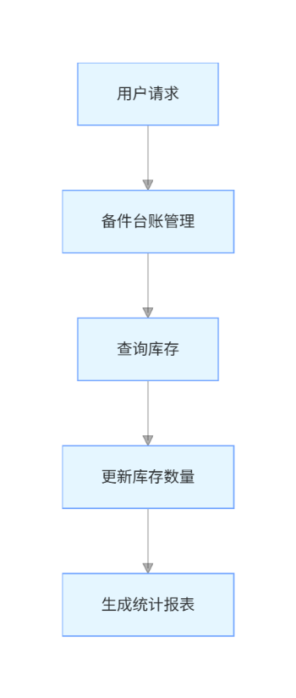

3.7.2.3 类设计
详见3.7.1.3

3.7.2.4 时序图


3.7.2.5 内部接口定义
@ApiOperation("查询详情信息")
@GetMapping("/find")
public Result find(@ApiParam(name = "id", value = "id")
@RequestParam Long id) {
return Result.success(sparepartsInfoService.find(id));
}
@PostMapping("/add")
@ApiOperation("新建信息")
public Result add(@RequestBody @Validated SparepartsInfoParam addParam) {
sparepartsInfoService.add(addParam);
return Result.success();
}
@PostMapping("/uploadEnclosure")
@ApiOperation("上传附件")
public Result uploadEnclosure(@RequestParam("files") MultipartFile[] files) {
return Result.success(sparepartsInfoService.uploadEnclosure(files));
}
@ApiOperation("修改信息")
@PostMapping("/update")
public Result update(@RequestBody SparepartsInfoParam param) {
sparepartsInfoService.update(param);
return Result.success();
}
@PostMapping("/delete")
@ApiOperation("删除备件信息")
public Result delete(@RequestBody List<Long> ids) {
return sparepartsInfoService.delete(ids);
}
@GetMapping("/exportBySearch")
@ApiOperation("根据查询导出备件信息")
public void exportBySearch(HttpServletResponse response, SparepartsInfoSelectParam selectParam) {
List<SparepartsVo> list = sparepartsInfoService.list(selectParam);
Workbook sheets = ExcelExportUtil.exportExcel(new ExportParams(), SparepartsVo.class, list);
PoiUtil.exportExcelWithStream("sparepartsInfo.xls", sheets);
}
@ApiOperation("分页查询")
@GetMapping("/page")
public Result page(@Validated SparepartsTypeSelectParam selectParam) {
return Result.success(sparepartsTypeService.page(selectParam));
}

3.7.2.6 外部接口定义
"/feign/insider/spareParts/materialPrPo/calculateMaterialPrPoFeign": {
"post": {
"tags": [
"备品备件 备件台账的物料的pr和po数量 feign controller"
],
"summary": "备品台账的物料的pr和po数量",
"operationId": "calculateMaterialPrPoFeignUsingPOST",
"consumes": [
"application/json"
],
"produces": [
"*/*"
],
"parameters": [
{
"in": "body",
"name": "materialCodeList",
"description": "materialCodeList",
"required": true,
"schema": {
"type": "array",
"items": {
"type": "string"
}
}
}
],
"responses": {
"200": {
"description": "OK",
"schema": {
"type": "array",
"items": {
"$ref": "#/definitions/备件台账的物料code的pr和po feign",
"originalRef": "备件台账的物料code的pr和po feign"
}
}
}
},
"security": [
{
"Authorization": [
"global"
]
}
],
"deprecated": false,
"x-order": "2147483647"
}
},
"/feign/insider/spareParts/materialPrPo/getSparePartsArrivalTime": {
"post": {
"tags": [
"备品备件 备件台账的物料的pr和po数量 feign controller"
],
"summary": "获取备件的采购到货时间",
"operationId": "getSparePartsArrivalTimeUsingPOST",
"consumes": [
"application/json"
],
"produces": [
"*/*"
],
"parameters": [
{
"in": "body",
"name": "materialCodeList",
"description": "materialCodeList",
"required": true,
"schema": {
"type": "array",
"items": {
"type": "string"
}
}
}
],
"responses": {
"200": {
"description": "OK",
"schema": {
"type": "array",
"items": {
"$ref": "#/definitions/根据物料code获取 平均/最大/最小 采购到货时间",
"originalRef": "根据物料code获取 平均/最大/最小 采购到货时间"
}
}
}
},
"security": [
{
"Authorization": [
"global"
]
}
],
"deprecated": false,
"x-order": "2147483647"
}
},
"/spareparts/add": {
"post": {
"tags": [
"备件台账管理"
],
"summary": "新建信息",
"operationId": "addUsingPOST_5",
"consumes": [
"application/json"
],
"produces": [
"*/*"
],
"parameters": [
{
"in": "body",
"name": "addParam",
"description": "addParam",
"required": true,
"schema": {
"$ref": "#/definitions/备件台账更新参数",
"originalRef": "备件台账更新参数"
}
}
],
"responses": {
"200": {
"description": "OK",
"schema": {
"$ref": "#/definitions/Result",
"originalRef": "Result"
}
}
},
"security": [
{
"Authorization": [
"global"
]
}
],
"deprecated": false,
"x-order": "2147483647"
}
},
"/spareparts/delete": {
"post": {
"tags": [
"备件台账管理"
],
"summary": "删除备件信息",
"operationId": "deleteUsingPOST_19",
"consumes": [
"application/json"
],
"produces": [
"*/*"
],
"parameters": [
{
"in": "body",
"name": "ids",
"description": "ids",
"required": true,
"schema": {
"type": "array",
"items": {
"type": "integer",
"format": "int64"
}
}
}
],
"responses": {
"200": {
"description": "OK",
"schema": {
"$ref": "#/definitions/Result",
"originalRef": "Result"
}
}
},
"security": [
{
"Authorization": [
"global"
]
}
],
"deprecated": false,
"x-order": "2147483647"
}
},
"/spareparts/export": {
"get": {
"tags": [
"备件台账管理"
],
"summary": "导出备件信息",
"operationId": "exportUsingGET_5",
"produces": [
"*/*"
],
"parameters": [
{
"name": "ids",
"in": "query",
"description": "请求ID,参数值为空代表导出全部；支持多个ID，参考：1,2",
"required": false,
"type": "string",
"allowEmptyValue": false
}
],
"responses": {
"200": {
"description": "OK"
}
},
"security": [
{
"Authorization": [
"global"
]
}
],
"deprecated": false,
"x-order": "2147483647"
}
},
"/spareparts/find": {
"get": {
"tags": [
"备件台账管理"
],
"summary": "查询详情信息",
"operationId": "findUsingGET_16",
"produces": [
"*/*"
],
"parameters": [
{
"name": "id",
"in": "query",
"description": "id",
"required": false,
"type": "integer",
"format": "int64",
"allowEmptyValue": false
}
],
"responses": {
"200": {
"description": "OK",
"schema": {
"$ref": "#/definitions/Result",
"originalRef": "Result"
}
}
},
"security": [
{
"Authorization": [
"global"
]
}
],
"deprecated": false,
"x-order": "2147483647"
}
},

3.7.3 PMC调拨详细设计

3.7.3.1 数据库设计
详见3.7.1.1

3.7.3.2 流程图
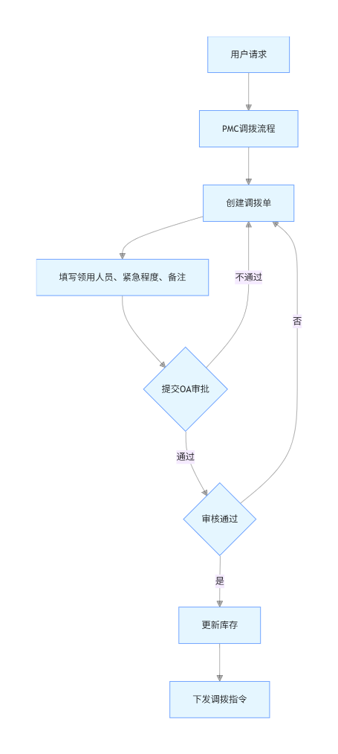

3.7.3.3 类设计
详见3.7.1.3

3.7.3.4 时序图


3.7.3.5 内部接口定义
@ApiOperation("外网 保存 新建和编辑")
@PostMapping("/transferSave")
public Result<OATransfer> transferSave(@Validated @RequestBody SparePartsAggregateTransfer aggregate) {
return Result.success(transferService.save(aggregate));
}
@ApiOperation("测试环境 保存 新建和编辑 cdzt传空字符串")
@PostMapping("/transferSaveTest")
public Result<OATransferTest> transferSaveTest(@Validated @RequestBody SparePartsAggregateTransferTest aggregate) {
return Result.success(transferService.saveTest(aggregate));
}
@ApiOperation("删除")
@DeleteMapping("/transferDelete")
public Result<Void> transferDelete(@RequestParam List<Long> orderIdList) {
transferService.delete(orderIdList);
return Result.success();
}
@ApiOperation("根据 orderId 查")
@GetMapping("/transferGet")
public Result<SparePartsAggregateTransfer> transferGet(@RequestParam Long orderId) {
return Result.success(transferService.get(orderId));
}
@ApiOperation("根据 requestid 查")
@GetMapping("/transferGetByRequestid")
public Result<SparePartsAggregateTransfer> transferGetByRequestid(@RequestParam Long requestid) {
return Result.success(transferService.getByRequestid(requestid));
}
@ApiOperation("分页")
@GetMapping("/transferPage")
public Result<PageResult<SparePartsAggregateTransfer>> transferPage(SparePartsAggregateTransferQuery aggregateQuery) {
return Result.success(transferService.page(aggregateQuery));
}
@ApiOperation("回传 OA回传表头 WMS回传表身 外网测试需要手动填充requestid")
@PutMapping("/receive")
public Result<Void> receive(@Validated @RequestBody TransferReceive receive) {
transferService.receive(receive);
return Result.success();
}
@ApiOperation("模板")
@GetMapping("/transferExcelTemplate")
public void transferExcelTemplate(HttpServletResponse response) {
try {
response.setContentType("application/vnd.openxmlformats-officedocument.spreadsheetml.sheet");
response.setHeader("Content-Disposition", "attachment; filename=SparePartsTransferTemplate.xlsx");
transferService.transferExcelTemplate(response.getOutputStream());
} catch (IOException e) {
throw new RuntimeException("下载模板失败", e);
}
}

3.7.3.6 外部接口定义
"/spareParts/transfer/transferGet": {
"get": {
"tags": [
"备品备件 PMC调拨 pmc"
],
"summary": "根据 orderId 查",
"operationId": "transferGetUsingGET",
"produces": [
"*/*"
],
"parameters": [
{
"name": "orderId",
"in": "query",
"description": "orderId",
"required": true,
"type": "integer",
"format": "int64"
}
],
"responses": {
"200": {
"description": "OK",
"schema": {
"$ref": "#/definitions/Result«备品备件 PMC调拨 聚合»",
"originalRef": "Result«备品备件 PMC调拨 聚合»"
}
}
},
"security": [
{
"Authorization": [
"global"
]
}
],
"deprecated": false,
"x-order": "2147483647"
}
},
"/spareParts/transfer/transferGetByRequestid": {
"get": {
"tags": [
"备品备件 PMC调拨 pmc"
],
"summary": "根据 requestid 查",
"operationId": "transferGetByRequestidUsingGET",
"produces": [
"*/*"
],
"parameters": [
{
"name": "requestid",
"in": "query",
"description": "requestid",
"required": true,
"type": "integer",
"format": "int64"
}
],
"responses": {
"200": {
"description": "OK",
"schema": {
"$ref": "#/definitions/Result«备品备件 PMC调拨 聚合»",
"originalRef": "Result«备品备件 PMC调拨 聚合»"
}
}
},
"security": [
{
"Authorization": [
"global"
]
}
],
"deprecated": false,
"x-order": "2147483647"
}
},
"/spareParts/transfer/transferPage": {
"get": {
"tags": [
"备品备件 PMC调拨 pmc"
],
"summary": "分页",
"operationId": "transferPageUsingGET",
"produces": [
"*/*"
],
"parameters": [
{
"name": "orderIdList",
"in": "query",
"description": "单据 idList",
"required": false,
"type": "array",
"items": {
"type": "integer",
"format": "int64"
},
"collectionFormat": "multi"
},
{
"name": "pageNum",
"in": "query",
"description": "当前页",
"required": false,
"type": "integer",
"format": "int32",
"x-example": 1
},
{
"name": "pageSize",
"in": "query",
"description": "每页大小",
"required": false,
"type": "integer",
"format": "int32",
"x-example": 10
},
{
"name": "request",
"in": "query",
"description": "领料单号",
"required": false,
"type": "string"
},
{
"name": "requestid",
"in": "query",
"description": "hc oa回传的requestid",
"required": false,
"type": "integer",
"format": "int64"
},
{
"name": "status",
"in": "query",
"description": "hc 单据状态 前端不用传 后端默认1 1新建(保存在本地) 2提交(传给OA) 3OA审核通过 4OA审核不通过",
"required": false,
"type": "string"
}
],
"responses": {
"200": {
"description": "OK",
"schema": {
"$ref": "#/definitions/Result«PageResult«备品备件 PMC调拨 聚合»»",
"originalRef": "Result«PageResult«备品备件 PMC调拨 聚合»»"
}
}
},
"security": [
{
"Authorization": [
"global"
]
}
],
"deprecated": false,
"x-order": "2147483647"
}
},
"/spareParts/transfer/transferSave": {
"post": {
"tags": [
"备品备件 PMC调拨 pmc"
],
"summary": "外网 保存 新建和编辑",
"operationId": "transferSaveUsingPOST",
"consumes": [
"application/json"
],
"produces": [
"*/*"
],
"parameters": [
{
"in": "body",
"name": "aggregate",
"description": "aggregate",
"required": true,
"schema": {
"$ref": "#/definitions/备品备件 PMC调拨 聚合",
"originalRef": "备品备件 PMC调拨 聚合"
}
}
],
"responses": {
"200": {
"description": "OK",
"schema": {
"$ref": "#/definitions/Result«OATransfer»",
"originalRef": "Result«OATransfer»"
}
}
},
"security": [
{
"Authorization": [
"global"
]
}
],
"deprecated": false,
"x-order": "2147483647"
}
},
"/spareParts/transfer/transferSaveTest": {
"post": {
"tags": [
"备品备件 PMC调拨 pmc"
],
"summary": "测试环境 保存 新建和编辑 cdzt传空字符串",
"operationId": "transferSaveTestUsingPOST",
"consumes": [
"application/json"
],
"produces": [
"*/*"
],
"parameters": [
{
"in": "body",
"name": "aggregate",
"description": "aggregate",
"required": true,
"schema": {
"$ref": "#/definitions/备品备件 PMC调拨 聚合 test cdzt传空字符串",
"originalRef": "备品备件 PMC调拨 聚合 test cdzt传空字符串"
}
}
],
"responses": {
"200": {
"description": "OK",
"schema": {
"$ref": "#/definitions/Result«OATransferTest»",
"originalRef": "Result«OATransferTest»"
}
}
},
"security": [
{
"Authorization": [
"global"
]
}
],
"deprecated": false,
"x-order": "2147483647"
}
},
"/spareParts/transfer/transferUpdateTest": {
"put": {
"tags": [
"备品备件 PMC调拨 pmc"
],
"summary": "测试用 更新",
"operationId": "transferUpdateTestUsingPUT",
"consumes": [
"application/json"
],
"produces": [
"*/*"
],
"parameters": [
{
"in": "body",
"name": "aggregate",
"description": "aggregate",
"required": true,
"schema": {
"$ref": "#/definitions/备品备件 PMC调拨 聚合",
"originalRef": "备品备件 PMC调拨 聚合"
}
}
],
"responses": {
"200": {
"description": "OK",
"schema": {
"$ref": "#/definitions/Result«Void»",
"originalRef": "Result«Void»"
}
}
},
"security": [
{
"Authorization": [
"global"
]
}
],
"deprecated": false,
"x-order": "2147483647"
}
},
"/spareParts/transfer/receive": {
"put": {
"tags": [
"备品备件 PMC调拨 pmc"
],
"summary": "回传 OA回传表头 WMS回传表身 外网测试需要手动填充requestid",
"operationId": "receiveUsingPUT_1",
"consumes": [
"application/json"
],
"produces": [
"*/*"
],
"parameters": [
{
"in": "body",
"name": "receive",
"description": "receive",
"required": true,
"schema": {
"$ref": "#/definitions/TransferReceive",
"originalRef": "TransferReceive"
}
}
],
"responses": {
"200": {
"description": "OK",
"schema": {
"$ref": "#/definitions/Result«Void»",
"originalRef": "Result«Void»"
}
}
},
"security": [
{
"Authorization": [
"global"
]
}
],
"deprecated": false,
"x-order": "2147483647"
}
},
"/spareParts/transfer/transferCommitOut": {
"put": {
"tags": [
"备品备件 PMC调拨 pmc"
],
"summary": "提交 外网 需要手动填充requestid",
"operationId": "transferCommitOutUsingPUT",
"consumes": [
"application/json"
],
"produces": [
"*/*"
],
"parameters": [
{
"name": "orderId",
"in": "query",
"description": "orderId",
"required": true,
"type": "integer",
"format": "int64"
}
],
"responses": {
"200": {
"description": "OK",
"schema": {
"$ref": "#/definitions/Result«OATransfer»",
"originalRef": "Result«OATransfer»"
}
}
},
"security": [
{
"Authorization": [
"global"
]
}
],
"deprecated": false,
"x-order": "2147483647"
}
},
"/spareParts/transfer/transferCommitProduce": {
"put": {
"tags": [
"备品备件 PMC调拨 pmc"
],
"summary": "提交 内网 推给OA 返回requestid 存order",
"operationId": "transferCommitProduceUsingPUT",
"consumes": [
"application/json"
],
"produces": [
"*/*"
],
"parameters": [
{
"name": "orderId",
"in": "query",
"description": "orderId",
"required": true,
"type": "integer",
"format": "int64"
}
],
"responses": {
"200": {
"description": "OK",
"schema": {
"$ref": "#/definitions/Result«JSONObject»",
"originalRef": "Result«JSONObject»"
}
}
},
"security": [
{
"Authorization": [
"global"
]
}
],
"deprecated": false,
"x-order": "2147483647"
}
},
"/spareParts/transfer/transferCommitTest": {
"put": {
"tags": [
"备品备件 PMC调拨 pmc"
],
"summary": "提交 测试环境 推给OA 返回requestid 存order",
"operationId": "transferCommitTestUsingPUT",
"consumes": [
"application/json"
],
"produces": [
"*/*"
],
"parameters": [
{
"name": "orderId",
"in": "query",
"description": "orderId",
"required": true,
"type": "integer",
"format": "int64"
}
],
"responses": {
"200": {
"description": "OK",
"schema": {
"$ref": "#/definitions/Result«JSONObject»",
"originalRef": "Result«JSONObject»"
}
}
},
"security": [
{
"Authorization": [
"global"
]
}
],
"deprecated": false,
"x-order": "2147483647"
}
},

3.7.4 备件领用流程详细设计

3.7.4.1 数据库设计
详见3.7.1.1

3.7.4.2 流程图
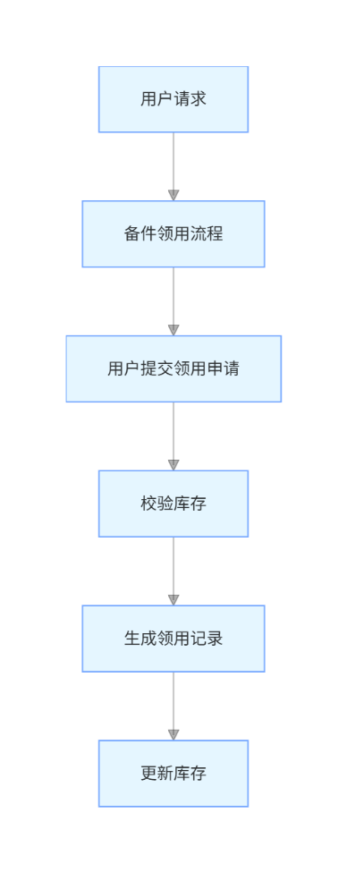

3.7.4.3 类设计
详见3.7.1.3

3.7.4.4 时序图


3.7.4.5 内部接口定义
@ApiOperation("备品备件 po 分页")
@GetMapping("/poPage")
public Result<PageResult<SparePartsPo>> poPage(SparePartsPoQuery query) {
return Result.success(poService.page(query));
}
@ApiOperation("测试 备品备件 po 新增")
@PostMapping("/poAdd")
public Result<Void> poAdd(@Valid @RequestBody SparePartsPo entity) {
poService.add(entity);
return Result.success();
}
@ApiOperation("模板")
@GetMapping("/poExcelTemplate")
public void prExcelTemplate(HttpServletResponse response) {
try {
response.setContentType("application/vnd.openxmlformats-officedocument.spreadsheetml.sheet");
response.setHeader("Content-Disposition", "attachment; filename=SparePartsPoTemplate.xlsx");
poService.poExcelTemplate(response.getOutputStream());
} catch (IOException e) {
throw new RuntimeException("下载模板失败", e);
}
}
@ApiOperation("导入")
@PostMapping("/poExcelImport")
public Result<Void> prExcelImport(@RequestParam("file") MultipartFile file) {
try {
poService.poExcelImport(file.getInputStream());
} catch (ApiException e) {
log.info("Excel 导入失败：{}", e.getMessage());
} catch (Exception e) {
log.info("Excel 导入发生系统异常", e);
}
return Result.success();
}
@ApiOperation("导入")
@PostMapping("/prExcelImport")
public Result<Void> prExcelImport(@RequestParam("file") MultipartFile file) {
try {
prService.prExcelImport(file.getInputStream());
} catch (ApiException e) {
log.info("Excel 导入失败：{}", e.getMessage());
} catch (Exception e) {
log.info("Excel 导入发生系统异常", e);
}
return Result.success();
}

3.7.4.6 外部接口定义
"hc 备品备件 PMC调拨 单据 order 表头 entity": {
"type": "object",
"properties": {
"applyDate": {
"type": "string",
"format": "date-time",
"description": "hc 申请日期 yyyy-MM-dd (list字段)"
},
"cbzx": {
"type": "string",
"description": "hc SAP成本编号 前端传 2200D00023 吗"
},
"createBy": {
"type": "string",
"description": "创建人"
},
"createTime": {
"type": "string",
"format": "date-time",
"description": "创建时间"
},
"id": {
"type": "integer",
"format": "int64",
"description": "主键ID"
},
"materialCategoryChildren": {
"type": "string",
"description": "hc 物料子类"
},
"note": {
"type": "string",
"description": "hc 备注"
},
"operatorCode": {
"type": "string",
"description": "hc 创建人 工号"
},
"operatorName": {
"type": "string",
"description": "hc 创建人 姓名"
},
"pickUserXqrCode": {
"type": "string",
"description": "hc 领用人=需求人 工号"
},
"pickUserXqrName": {
"type": "string",
"description": "hc 领用人=需求人 姓名"
},
"reason": {
"type": "string",
"description": "hc oa回传的 审核原因"
},
"request": {
"type": "string",
"description": "hc 领料单号 回传 (list字段)"
},
"requestid": {
"type": "integer",
"format": "int64",
"description": "hc oa回传的 requestid"
},
"sqrCode": {
"type": "string",
"description": "hc 发起人 工号"
},
"sqrName": {
"type": "string",
"description": "hc 发起人 姓名"
},
"status": {
"type": "string",
"description": "hc 单据状态 前端不用传 后端默认1 1新建(保存在本地) 2提交(传给OA) 3OA审核通过 4OA审核不通过"
},
"title": {
"type": "string",
"description": "hc 标题"
},
"updateBy": {
"type": "string",
"description": "更新人"
},
"updateTime": {
"type": "string",
"format": "date-time",
"description": "更新时间"
},
"urgency": {
"type": "string",
"description": "hc 紧急程度 0正常 1重要 2紧急"
}
},
"title": "hc 备品备件 PMC调拨 单据 order 表头 entity"
},
"hc 备品备件 PMC调拨 单据 order 表头 vo": {
"type": "object",
"properties": {
"applyDate": {
"type": "string",
"format": "date-time",
"description": "hc 申请日期 yyyy-MM-dd (list字段)"
},
"cbzx": {
"type": "string",
"description": "hc SAP成本编号 前端传 2200D00023 吗"
},
"id": {
"type": "integer",
"format": "int64"
},
"materialCategoryChildren": {
"type": "string",
"description": "hc 物料子类"
},
"materialCategoryChildrenName": {
"type": "string"
},
"note": {
"type": "string",
"description": "hc 备注"
},
"operatorCode": {
"type": "string",
"description": "hc 创建人=发起人 工号"
},
"operatorName": {
"type": "string",
"description": "hc 创建人=发起人 姓名"
},
"pickUserXqrCode": {
"type": "string",
"description": "hc 领用人=需求人 工号"
},
"pickUserXqrName": {
"type": "string",
"description": "hc 领用人=需求人 姓名"
},
"reason": {
"type": "string",
"description": "hc oa回传的 审核原因"
},
"request": {
"type": "string",
"description": "hc 领料单号 回传 (list字段)"
},
"requestid": {
"type": "integer",
"format": "int64",
"description": "hc oa回传的 requestid"
},
"sqrCode": {
"type": "string",
"description": "hc 发起人 工号"
},
"sqrName": {
"type": "string",
"description": "hc 发起人 姓名"
},
"status": {
"type": "string",
"description": "hc 单据状态 前端不用传 后端默认1 1新建(保存在本地) 2提交(传给OA) 3OA审核通过 4OA审核不通过"
},
"statusName": {
"type": "string"
},
"title": {
"type": "string",
"description": "hc 标题"
},
"urgency": {
"type": "string",
"description": "hc 紧急程度 0正常 1重要 2紧急"
},
"urgencyName": {
"type": "string"
}
},
"title": "hc 备品备件 PMC调拨 单据 order 表头 vo"
},
"hc 备品备件 PMC调拨 明细 detail 表身 dto": {
"type": "object",
"required": [
"quantity"
],
"properties": {
"arriveDate": {
"type": "string",
"format": "date-time",
"description": "hc oa回传的 PMC仓库到货日期 yyyy-MM-dd"
},
"code": {
"type": "string",
"example": "备件 编号",
"description": "hc 备件 编号"
},
"description": {
"type": "string",
"example": "备件 描述=主数据长描述",
"description": "hc 备件 描述=主数据长描述"
},
"id": {
"type": "integer",
"format": "int64"
},
"nameShort": {
"type": "string",
"example": "备件 名称=主数据名称第一个逗号前",
"description": "hc 备件 名称=主数据名称第一个逗号前"
},
"orderId": {
"type": "integer",
"format": "int64",
"description": "单据 id"
},
"quantity": {
"type": "number",
"example": 1,
"description": "hc 需求数量 (19,3)"
},
"quantityInventorySap": {
"type": "number",
"example": 1,
"description": "hc sap库存数量 调sap库存接口 (19,3)"
},
"quantityOa": {
"type": "number",
"description": "hc oa回传的 oa数量"
},
"request": {
"type": "string",
"description": "hc oa回传的 领料单号 和order一致"
},
"serialNumber": {
"type": "integer",
"format": "int32",
"description": "序号"
},
"unitName": {
"type": "string",
"example": "单位 名称",
"description": "hc 单位 名称"
}
},
"title": "hc 备品备件 PMC调拨 明细 detail 表身 dto"
},

3.7.5 备件采购流程详细设计

3.7.5.1 数据库设计
详见3.7.1.1

3.7.5.2 流程图
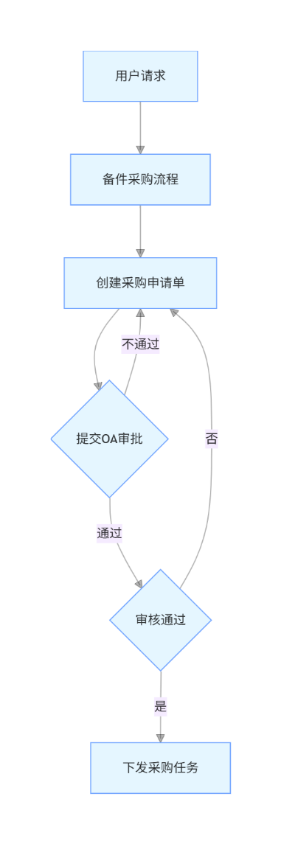

3.7.5.3 类设计
详见3.7.1.3

3.7.5.4 时序图


3.7.5.5 内部接口定义
@ApiOperation("备品备件 po 分页")
@GetMapping("/poPage")
public Result<PageResult<SparePartsPo>> poPage(SparePartsPoQuery query) {
return Result.success(poService.page(query));
}
@ApiOperation("测试 备品备件 po 新增")
@PostMapping("/poAdd")
public Result<Void> poAdd(@Valid @RequestBody SparePartsPo entity) {
poService.add(entity);
return Result.success();
}
@ApiOperation("测试 备品备件 po 删除 不传参数删除所有")
@DeleteMapping("/poDelete")
public Result<Void> poDelete(@RequestParam(required = false) List<Long> idList) {
poService.delete(idList);
return Result.success();
}
@ApiOperation("模板")
@GetMapping("/poExcelTemplate")
public void prExcelTemplate(HttpServletResponse response) {
try {
response.setContentType("application/vnd.openxmlformats-officedocument.spreadsheetml.sheet");
response.setHeader("Content-Disposition", "attachment; filename=SparePartsPoTemplate.xlsx");
poService.poExcelTemplate(response.getOutputStream());
} catch (IOException e) {
throw new RuntimeException("下载模板失败", e);
}
}
@ApiOperation("导入 3")
@PostMapping("/prExcelImport3")
public void prExcelImport3(@RequestParam("file") MultipartFile file) throws IOException {
// try {
prService.prExcelImport3(file.getInputStream());
// } catch (ApiException e) {
// log.info("Excel 导入失败：{}", e.getMessage());
// } catch (Exception e) {
// log.info("Excel 导入发生系统异常", e);
// }
}
@ApiOperation("导入 4")
@PostMapping("/prExcelImport4")
public void prExcelImport4(@RequestParam("file") MultipartFile file) throws IOException {
prService.prExcelImport4(file.getInputStream());
}
@ApiOperation("导入2")
@PostMapping("/prExcelImport2")
public Result<Void> prExcelImport2(@RequestParam("file") MultipartFile file) {
try {
prService.prExcelImport2(file.getInputStream());
} catch (ApiException e) {
log.info("Excel 导入失败：{}", e.getMessage());
} catch (Exception e) {
log.info("Excel 导入发生系统异常", e);
}
return Result.success();
}

3.7.5.6 外部接口定义

"/spareParts/pr/deleteOrderDetailSap": {
"delete": {
"tags": [
"备品备件 pr 采购申请"
],
"summary": "测试用 删除 order detail sap",
"operationId": "deleteOrderDetailSapUsingDELETE",
"produces": [
"*/*"
],
"parameters": [
{
"name": "orderIdList",
"in": "query",
"description": "orderIdList",
"required": true,
"type": "array",
"items": {
"type": "integer",
"format": "int64"
},
"collectionFormat": "multi"
}
],
"responses": {
"200": {
"description": "OK",
"schema": {
"$ref": "#/definitions/Result«Void»",
"originalRef": "Result«Void»"
}
}
},
"security": [
{
"Authorization": [
"global"
]
}
],
"deprecated": false,
"x-order": "2147483647"
}
},
"/spareParts/pr/detail/delete": {
"delete": {
"tags": [
"备品备件 pr detail"
],
"summary": "测试用 删除",
"operationId": "deleteUsingDELETE_3",
"produces": [
"*/*"
],
"parameters": [
{
"in": "body",
"name": "idList",
"description": "idList",
"required": true,
"schema": {
"type": "array",
"items": {
"type": "integer",
"format": "int64"
}
}
}
],
"responses": {
"200": {
"description": "OK",
"schema": {
"$ref": "#/definitions/Result«Void»",
"originalRef": "Result«Void»"
}
}
},
"security": [
{
"Authorization": [
"global"
]
}
],
"deprecated": false,
"x-order": "2147483647"
}
},
"/spareParts/pr/detail/listByPr": {
"get": {
"tags": [
"备品备件 pr detail"
],
"summary": "测试用 listByPr",
"operationId": "listByPrUsingGET",
"produces": [
"*/*"
],
"parameters": [
{
"name": "pr",
"in": "query",
"description": "pr",
"required": true,
"type": "array",
"items": {
"type": "string"
},
"collectionFormat": "multi"
}
],
"responses": {
"200": {
"description": "OK",
"schema": {
"$ref": "#/definitions/Result«List«hc 备品备件 pr 明细 detail 表身 entity»»",
"originalRef": "Result«List«hc 备品备件 pr 明细 detail 表身 entity»»"
}
}
},
"security": [
{
"Authorization": [
"global"
]
}
],
"deprecated": false,
"x-order": "2147483647"
}
},
"/spareParts/pr/detail/page": {
"get": {
"tags": [
"备品备件 pr detail"
],
"summary": "测试用 分页",
"operationId": "pageUsingGET_24",
"produces": [
"*/*"
],
"parameters": [
{
"name": "pageNum",
"in": "query",
"description": "pageNum",
"required": false,
"type": "integer",
"format": "int32"
},
{
"name": "pageSize",
"in": "query",
"description": "pageSize",
"required": false,
"type": "integer",
"format": "int32"
}
],
"responses": {
"200": {
"description": "OK",
"schema": {
"$ref": "#/definitions/Result«PageResult«hc 备品备件 pr 明细 detail 表身 entity»»",
"originalRef": "Result«PageResult«hc 备品备件 pr 明细 detail 表身 entity»»"
}
}
},
"security": [
{
"Authorization": [
"global"
]
}
],
"deprecated": false,
"x-order": "2147483647"
}
},
"/spareParts/pr/detail/pageSapPrDTO": {
"get": {
"tags": [
"备品备件 pr detail"
],
"summary": "分页获取所有pr不为空的detail 构建SapPrDTO 每次最多1000条",
"operationId": "pageSapPrDTOUsingGET",
"produces": [
"*/*"
],
"parameters": [
{
"name": "pageNum",
"in": "query",
"description": "pageNum",
"required": false,
"type": "integer",
"format": "int32"
},
{
"name": "pageSize",
"in": "query",
"description": "pageSize",
"required": false,
"type": "integer",
"format": "int32"
}
],
"responses": {
"200": {
"description": "OK",
"schema": {
"$ref": "#/definitions/Result«PageResult«SapPrDTO»»",
"originalRef": "Result«PageResult«SapPrDTO»»"
}
}
},
"security": [
{
"Authorization": [
"global"
]
}
],
"deprecated": false,
"x-order": "2147483647"
}
},
"/spareParts/pr/detailSap/delete": {
"delete": {
"tags": [
"备品备件 pr detailSap"
],
"summary": "测试用 删除",
"operationId": "deleteUsingDELETE_4",
"produces": [
"*/*"
],
"parameters": [
{
"in": "body",
"name": "idList",
"description": "idList",
"required": true,
"schema": {
"type": "array",
"items": {
"type": "integer",
"format": "int64"
}
}
}
],
"responses": {
"200": {
"description": "OK",
"schema": {
"$ref": "#/definitions/Result«Void»",
"originalRef": "Result«Void»"
}
}
},
"security": [
{
"Authorization": [
"global"
]
}
],
"deprecated": false,
"x-order": "2147483647"
}
},
"/spareParts/pr/detailSap/listByPr": {
"get": {
"tags": [
"备品备件 pr detailSap"
],
"summary": "测试用 listByPr",
"operationId": "listByPrUsingGET_1",
"produces": [
"*/*"
],
"parameters": [
{
"name": "pr",
"in": "query",
"description": "pr",
"required": true,
"type": "array",
"items": {
"type": "string"
},
"collectionFormat": "multi"
}
],
"responses": {
"200": {
"description": "OK",
"schema": {
"$ref": "#/definitions/Result«List«hc 备品备件 采购申请 明细 detail 表身 sap收货 entity»»",
"originalRef": "Result«List«hc 备品备件 采购申请 明细 detail 表身 sap收货 entity»»"
}
}
},
"security": [
{
"Authorization": [
"global"
]
}
],
"deprecated": false,
"x-order": "2147483647"
}
},
"/spareParts/pr/detailSap/page": {
"get": {
"tags": [
"备品备件 pr detailSap"
],
"summary": "测试用 分页",
"operationId": "pageUsingGET_25",
"produces": [
"*/*"
],
"parameters": [
{
"name": "pageNum",
"in": "query",
"description": "pageNum",
"required": false,
"type": "integer",
"format": "int32"
},
{
"name": "pageSize",
"in": "query",
"description": "pageSize",
"required": false,
"type": "integer",
"format": "int32"
}
],
"responses": {
"200": {
"description": "OK",
"schema": {
"$ref": "#/definitions/Result«PageResult«hc 备品备件 采购申请 明细 detail 表身 sap收货 entity»»",
"originalRef": "Result«PageResult«hc 备品备件 采购申请 明细 detail 表身 sap收货 entity»»"
}
}
},
"security": [
{
"Authorization": [
"global"
]
}
],
"deprecated": false,
"x-order": "2147483647"
}
},
"/spareParts/pr/fill": {
"put": {
"tags": [
"备品备件 pr 采购申请"
],
"summary": "测试用 填充4个字段 新增或更新",
"operationId": "fillUsingPUT",
"consumes": [
"application/json"
],
"produces": [
"*/*"
],
"parameters": [
{
"in": "body",
"name": "fillList",
"description": "fillList",
"required": true,
"schema": {
"type": "array",
"items": {
"$ref": "#/definitions/pr 填充4个字段",
"originalRef": "pr 填充4个字段"
}
}
}
],
"responses": {
"200": {
"description": "OK",
"schema": {
"$ref": "#/definitions/Result«Void»",
"originalRef": "Result«Void»"
}
}
},
"security": [
{
"Authorization": [
"global"
]
}
],
"deprecated": false,
"x-order": "2147483647"
}
},
"/spareParts/pr/prCommitOut": {
"put": {
"tags": [
"备品备件 pr 采购申请"
],
"summary": "提交 外网 需要手动填充requestid",
"operationId": "prCommitOutUsingPUT",
"consumes": [
"application/json"
],
"produces": [
"*/*"
],
"parameters": [
{
"name": "orderId",
"in": "query",
"description": "orderId",
"required": true,
"type": "integer",
"format": "int64"
}
],
"responses": {
"200": {
"description": "OK",
"schema": {
"$ref": "#/definitions/Result«OAPr»",
"originalRef": "Result«OAPr»"
}
}
},
"security": [
{
"Authorization": [
"global"
]
}
],
"deprecated": false,
"x-order": "2147483647"
}
},
"/spareParts/pr/prCommitProduce": {
"put": {
"tags": [
"备品备件 pr 采购申请"
],
"summary": "提交 内网 推给OA 返回requestid 存order",
"operationId": "prCommitProduceUsingPUT",
"consumes": [
"application/json"
],
"produces": [
"*/*"
],
"parameters": [
{
"name": "orderId",
"in": "query",
"description": "orderId",
"required": true,
"type": "integer",
"format": "int64"
}
],
"responses": {
"200": {
"description": "OK",
"schema": {
"$ref": "#/definitions/Result«JSONObject»",
"originalRef": "Result«JSONObject»"
}
}
},
"security": [
{
"Authorization": [
"global"
]
}
],
"deprecated": false,
"x-order": "2147483647"
}
},
"/spareParts/pr/prCommitTest": {
"put": {
"tags": [
"备品备件 pr 采购申请"
],
"summary": "提交 测试环境 推给OA 返回requestid 存order",
"operationId": "prCommitTestUsingPUT",
"consumes": [
"application/json"
],
"produces": [
"*/*"
],
"parameters": [
{
"name": "orderId",
"in": "query",
"description": "orderId",
"required": true,
"type": "integer",
"format": "int64"
}
],
"responses": {
"200": {
"description": "OK",
"schema": {
"$ref": "#/definitions/Result«JSONObject»",
"originalRef": "Result«JSONObject»"
}
}
},
"security": [
{
"Authorization": [
"global"
]
}
],
"deprecated": false,
"x-order": "2147483647"
}
},
"/spareParts/pr/prDelete": {
"delete": {
"tags": [
"备品备件 pr 采购申请"
],
"summary": "删除",
"operationId": "prDeleteUsingDELETE",
"produces": [
"*/*"
],
"parameters": [
{
"name": "orderIdList",
"in": "query",
"description": "orderIdList",
"required": true,
"type": "array",
"items": {
"type": "integer",
"format": "int64"
},
"collectionFormat": "multi"
}
],
"responses": {
"200": {
"description": "OK",
"schema": {
"$ref": "#/definitions/Result«Void»",
"originalRef": "Result«Void»"
}
}
},
"security": [
{
"Authorization": [
"global"
]
}
],
"deprecated": false,
"x-order": "2147483647"
}
},
"/spareParts/pr/prDeleteTest": {
"delete": {
"tags": [
"备品备件 pr 采购申请"
],
"summary": "测试用 删除",
"operationId": "prDeleteTestUsingDELETE",
"produces": [
"*/*"
],
"parameters": [
{
"name": "orderIdList",
"in": "query",
"description": "orderIdList",
"required": true,
"type": "array",
"items": {
"type": "integer",
"format": "int64"
},
"collectionFormat": "multi"
}
],
"responses": {
"200": {
"description": "OK",
"schema": {
"$ref": "#/definitions/Result«Void»",
"originalRef": "Result«Void»"
}
}
},
"security": [
{
"Authorization": [
"global"
]
}
],
"deprecated": false,
"x-order": "2147483647"
}
},
"/spareParts/pr/prExcelImport": {
"post": {
"tags": [
"备品备件 pr 采购申请"
],
"summary": "导入",
"operationId": "prExcelImportUsingPOST",
"consumes": [
"multipart/form-data"
],
"produces": [
"*/*"
],
"parameters": [
{
"name": "file",
"in": "formData",
"description": "file",
"required": true,
"type": "file"
}
],
"responses": {
"200": {
"description": "OK",
"schema": {
"$ref": "#/definitions/Result«Void»",
"originalRef": "Result«Void»"
}
}
},
"security": [
{
"Authorization": [
"global"
]
}
],
"deprecated": false,
"x-order": "2147483647"
}
},
"/spareParts/pr/prExcelImport2": {
"post": {
"tags": [
"备品备件 pr 采购申请"
],
"summary": "导入2",
"operationId": "prExcelImport2UsingPOST",
"consumes": [
"multipart/form-data"
],
"produces": [
"*/*"
],
"parameters": [
{
"name": "file",
"in": "formData",
"description": "file",
"required": true,
"type": "file"
}
],
"responses": {
"200": {
"description": "OK",
"schema": {
"$ref": "#/definitions/Result«Void»",
"originalRef": "Result«Void»"
}
}
},
"security": [
{
"Authorization": [
"global"
]
}
],
"deprecated": false,
"x-order": "2147483647"
}
},
"/spareParts/pr/prExcelImport250923": {
"post": {
"tags": [
"备品备件 pr 采购申请"
],
"summary": "250923 导入 九月 有pr号的OA审核通过 没有pr号的提交",
"operationId": "prExcelImport250923UsingPOST",
"consumes": [
"multipart/form-data"
],
"produces": [
"*/*"
],
"parameters": [
{
"name": "file",
"in": "formData",
"description": "file",
"required": true,
"type": "file"
}
],
"responses": {
"200": {
"description": "OK"
}
},
"security": [
{
"Authorization": [
"global"
]
}
],
"deprecated": false,
"x-order": "2147483647"
}
},
"/spareParts/pr/prExcelImport3": {
"post": {
"tags": [
"备品备件 pr 采购申请"
],
"summary": "导入 3",
"operationId": "prExcelImport3UsingPOST",
"consumes": [
"multipart/form-data"
],
"produces": [
"*/*"
],
"parameters": [
{
"name": "file",
"in": "formData",
"description": "file",
"required": true,
"type": "file"
}
],
"responses": {
"200": {
"description": "OK"
}
},
"security": [
{
"Authorization": [
"global"
]
}
],
"deprecated": false,
"x-order": "2147483647"
}
},
"/spareParts/pr/prExcelImport4": {
"post": {
"tags": [
"备品备件 pr 采购申请"
],
"summary": "导入 4",
"operationId": "prExcelImport4UsingPOST",
"consumes": [
"multipart/form-data"
],
"produces": [
"*/*"
],
"parameters": [
{
"name": "file",
"in": "formData",
"description": "file",
"required": true,
"type": "file"
}
],
"responses": {
"200": {
"description": "OK"
}
},
"security": [
{
"Authorization": [
"global"
]
}
],
"deprecated": false,
"x-order": "2147483647"
}
},
"/spareParts/pr/prExcelImport5": {
"post": {
"tags": [
"备品备件 pr 采购申请"
],
"summary": "250917 导入 5",
"operationId": "prExcelImport5UsingPOST",
"consumes": [
"multipart/form-data"
],
"produces": [
"*/*"
],
"parameters": [
{
"name": "file",
"in": "formData",
"description": "file",
"required": true,
"type": "file"
}
],
"responses": {
"200": {
"description": "OK"
}
},
"security": [
{
"Authorization": [
"global"
]
}
],
"deprecated": false,
"x-order": "2147483647"
}
},
"/spareParts/pr/prExcelImport6": {
"post": {
"tags": [
"备品备件 pr 采购申请"
],
"summary": "导入 6",
"operationId": "prExcelImport6UsingPOST",
"consumes": [
"multipart/form-data"
],
"produces": [
"*/*"
],
"parameters": [
{
"name": "file",
"in": "formData",
"description": "file",
"required": true,
"type": "file"
}
],
"responses": {
"200": {
"description": "OK"
}
},
"security": [
{
"Authorization": [
"global"
]
}
],
"deprecated": false,
"x-order": "2147483647"
}
},

3.8 AI功能模块概述
功能：智能问答对话、分析设备故障、自动创建备件领用工单以及设备指标分析。职责：为一线人员提供快速问题解答、维修建议与经验检索，降低人工寻求知识的成本；

3.8.1 AI功能模块详细设计

3.8.1.1 数据库设计
AI主要是其他模块数据库表，见数据库设计文档

3.8.1.2 流程图
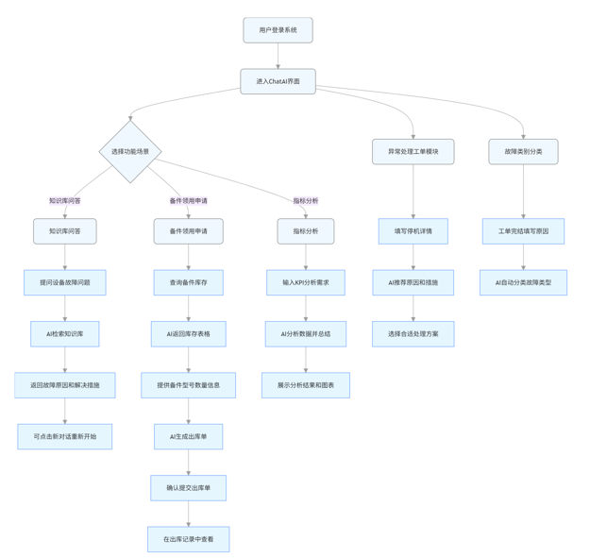

3.8.1.3 类设计
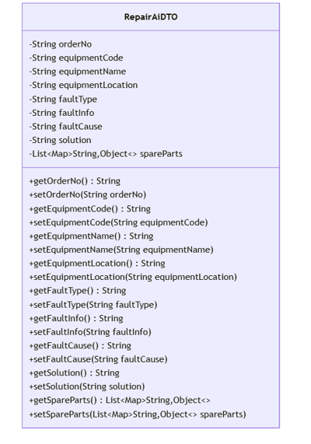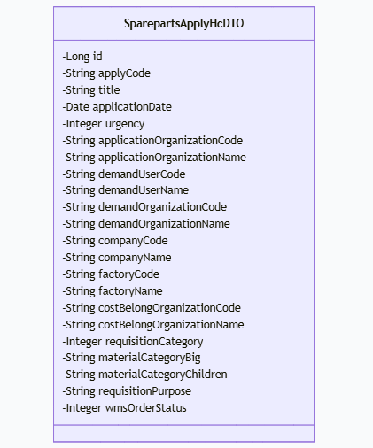
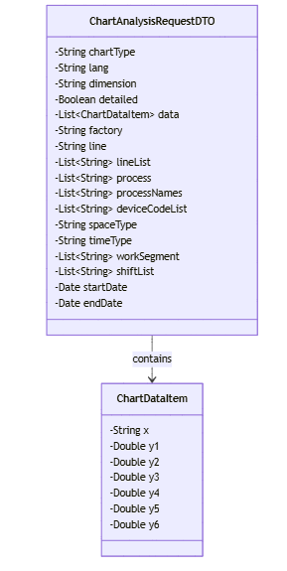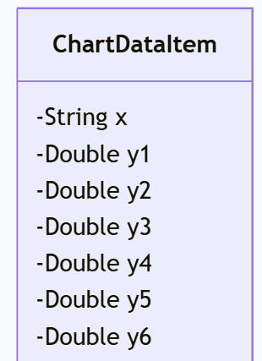

3.8.1.4 时序图
知识库问答、备件领用申请、指标分析、异常处理工单AI推荐、故障类别自动分类。

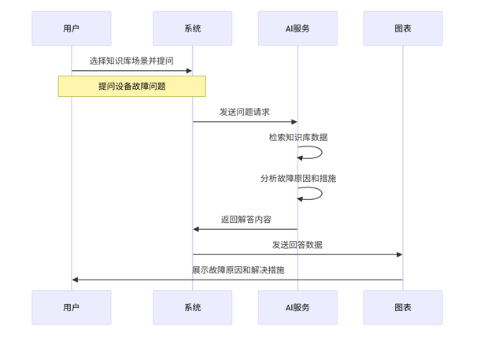
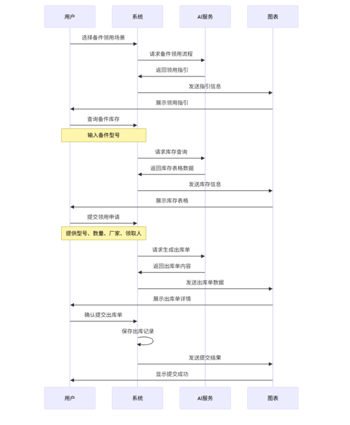
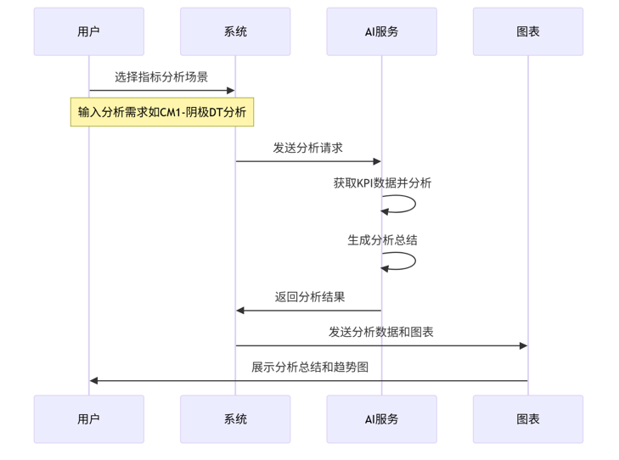
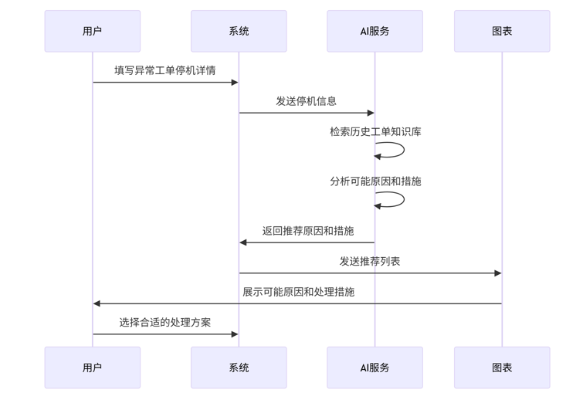
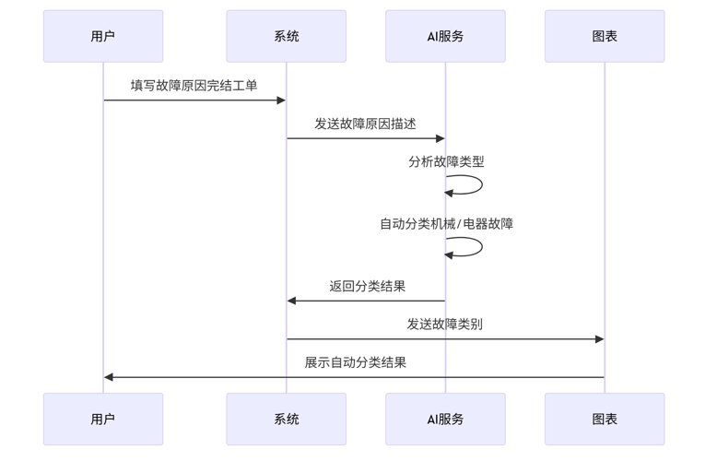

3.8.1.5 内部接口定义
/**
* 分析OEE指标图表数据并提供AI建议
*
* @param request 图表分析请求参数
* @return AI分析结果和建议
*/
@PostMapping("/analyze")
@ApiOperation("分析OEE指标图表数据并提供AI建议")
public Result<String> analyzeChartData(@RequestBody @Validated ChartAnalysisRequestDTO request) {
log.info("接收到OEE指标图表AI分析请求，图表类型：{}，维度：{}", request.getChartType(), request.getDimension());
try {
// 调用服务层进行图表分析
String analysisResult = oeeChartAnalysisService.analyzeChartData(request);
log.info("OEE指标图表AI分析完成，图表类型：{}，维度：{}", request.getChartType(), request.getDimension());
return Result.success(analysisResult);
} catch (Exception e) {
log.error("OEE指标图表AI分析失败", e);
return Result.showFailMsg("分析失败：" + e.getMessage());
}
}
@ApiOperation("AI生成PR单")
@PostMapping("/aiGeneratePr")
public Result<SparePartsAggregatePr> aiGeneratePr(@RequestBody List<AiGeneratePrDTO> aiGeneratePrDTOList) {
return Result.success(prService.aiGeneratePr(aiGeneratePrDTOList));
}
public AlgorithmFeignClient create(Throwable cause) {
return new AlgorithmFeignClient() {
@Override
public ChartAnalysisResponseDTO analyzeChart(ChartAnalysisRequestDTO request) {
log.error("调用图表分析接口失败", cause);
ChartAnalysisResponseDTO response = new ChartAnalysisResponseDTO();
response.setCode(-1);
response.setMsg("服务调用失败: " + cause.getMessage());
return response;
}
};
}

@Transactional(rollbackFor = Exception.class)
@Override
public void aiGeneratePr(List<AiGeneratePrDTOFeign> aiGeneratePrDTOFeignList) {
List<AiGeneratePrDTO> aiGeneratePrDTOList = BeanConvertUtils.copyListProperties(aiGeneratePrDTOFeignList, AiGeneratePrDTO::new);
SparePartsAggregatePr aiGeneratePr = sparePartsAggregatePrService.aiGeneratePr(aiGeneratePrDTOList);
}
@ApiOperation("ai获取工单信息")
@PostMapping("/pushRepairOrder")
public Result pushRepairOrder(@RequestBody RepairOrderSelectParam param) {
Date now = new Date();
Date end = DateUtil.offset(now, DateField.YEAR, -2).toJdkDate();
List<RepairAiDTO> repairOrderPushList = repairOrderService.getRepairOrderPushList(end, now);
System.out.println(repairOrderPushList.size());
Map<String, Object> map = new HashMap<>();
// map.put("faultOrders", repairOrderPushList);
//分割repairOrderPushList 每次发送500条数据
for (int i = 0; i < repairOrderPushList.size(); i += 100) {
map.put("faultOrders", repairOrderPushList.subList(i, i + 100));
HttpRequest.post(baseUrl + "/v1/fault_order/api/push_knowledgebase")
.body(JSON.toJSONString(map))
.execute();
}
// HttpRequest.post(baseUrl + "/v1/fault_order/api/push_knowledgebase")
// .body(JSON.toJSONString(map))
// .execute();
return Result.success();
}
@XxlJob("PushRepairOrderJob")
public void pushRepairOrderJob() {
//查询一段时间内的使用记录
XxlJobHelper.log("PushRepairOrderJob开始执行");
Date end = new Date();
DateTime start = DateUtil.offset(end, DateField.HOUR, -12);
try {
List<RepairAiDTO> list = repairOrderService.getRepairOrderPushList(start, end);
Map<String, Object> map = new HashMap<>();
map.put("faultOrders", list);
HttpRequest.post(baseUrl + "/v1/fault_order/api/push_knowledgebase")
.body(JSON.toJSONString(map))
.execute();
XxlJobHelper.log("PushRepairOrderJob执行完成");
} catch (Exception e) {
XxlJobHelper.log("PushRepairOrderJob执行异常：" + e.getMessage());
throw e;
}
}
@GetMapping("/getAiRecommend")
@ApiOperation("获取ai推荐信息")
public Result getAiRecommend(@RequestParam Long id, @RequestParam String equipmentName, @RequestParam String downtimeDesc) {
Result<Object> success = Result.success(repairOrderService.getAiRecommend(id, equipmentName, downtimeDesc));
Map<String,String> data= (Map<String, String>) success.getData();
if(data.get("errCode")!=null){
return Result.fail(data.get("errCode"), data.get("errStr"));
}
return success;
}

3.8.1.6 外部接口定义
"/oee/chart-analysis/analyze": {
"post": {
"tags": [
"OEE指标图表AI分析"
],
"summary": "分析OEE指标图表数据并提供AI建议",
"operationId": "analyzeChartDataUsingPOST",
"consumes": [
"application/json"
],
"produces": [
"*/*"
],
"parameters": [
{
"in": "body",
"name": "request",
"description": "request",
"required": true,
"schema": {
"$ref": "#/definitions/ChartAnalysisRequestDTO",
"originalRef": "ChartAnalysisRequestDTO"
}
}
],
"responses": {
"200": {
"description": "OK",
"schema": {
"$ref": "#/definitions/Result«string»",
"originalRef": "Result«string»"
}
}
},
"security": [
{
"Authorization": [
"global"
]
}
],
"deprecated": false,
"x-order": "2147483647"
}
},
"/spareParts/pr/aiGeneratePr": {
"post": {
"tags": [
"备品备件 pr 采购申请"
],
"summary": "AI生成PR单",
"operationId": "aiGeneratePrUsingPOST",
"consumes": [
"application/json"
],
"produces": [
"*/*"
],
"parameters": [
{
"in": "body",
"name": "aiGeneratePrDTOList",
"description": "aiGeneratePrDTOList",
"required": true,
"schema": {
"type": "array",
"items": {
"$ref": "#/definitions/AI生成PR单 dto",
"originalRef": "AI生成PR单 dto"
}
}
}
],
"responses": {
"200": {
"description": "OK",
"schema": {
"$ref": "#/definitions/Result«备品备件 pr 聚合»",
"originalRef": "Result«备品备件 pr 聚合»"
}
}
},
"security": [
{
"Authorization": [
"global"
]
}
],
"deprecated": false,
"x-order": "2147483647"
}
},
"/maintenance/getAiRecommend": {
"get": {
"tags": [
"维修"
],
"summary": "获取ai推荐信息",
"operationId": "getAiRecommendUsingGET",
"produces": [
"*/*"
],
"parameters": [
{
"name": "downtimeDesc",
"in": "query",
"description": "downtimeDesc",
"required": true,
"type": "string"
},
{
"name": "equipmentName",
"in": "query",
"description": "equipmentName",
"required": true,
"type": "string"
},
{
"name": "id",
"in": "query",
"description": "id",
"required": true,
"type": "integer",
"format": "int64"
}
],
"responses": {
"200": {
"description": "OK",
"schema": {
"$ref": "#/definitions/Result",
"originalRef": "Result"
}
}
},
"security": [
{
"Authorization": [
"global"
]
}
],
"deprecated": false,
"x-order": "2147483647"
}
},
"/maintenance/getOeeRepairOrder": {
"post": {
"tags": [
"维修"
],
"summary": "ai获取工单信息",
"operationId": "getOeeRepairOrderUsingPOST",
"consumes": [
"application/json"
],
"produces": [
"*/*"
],
"parameters": [
{
"in": "body",
"name": "param",
"description": "param",
"required": true,
"schema": {
"$ref": "#/definitions/工单查询参数",
"originalRef": "工单查询参数"
}
}
],
"responses": {
"200": {
"description": "OK",
"schema": {
"$ref": "#/definitions/Result",
"originalRef": "Result"
}
}
},
"security": [
{
"Authorization": [
"global"
]
}
],
"deprecated": false,
"x-order": "2147483647"
}
},
"/maintenance/getOeeRepairOrderAIPage": {
"post": {
"tags": [
"维修"
],
"summary": "ai获取工单信息 分页",
"operationId": "getOeeRepairOrderPageUsingPOST",
"consumes": [
"application/json"
],
"produces": [
"*/*"
],
"parameters": [
{
"in": "body",
"name": "param",
"description": "param",
"required": true,
"schema": {
"$ref": "#/definitions/工单查询参数",
"originalRef": "工单查询参数"
}
}
],
"responses": {
"200": {
"description": "OK",
"schema": {
"$ref": "#/definitions/Result",
"originalRef": "Result"
}
}
},
"security": [
{
"Authorization": [
"global"
]
}
],
"deprecated": false,
"x-order": "2147483647"
}
},

4. 关键错误处理设计

4.1 异常处理
在系统运行过程中，可能会遇到多种异常情况，如数据库连接异常、数据校验错误、网络中断、第三方服务响应超时或不可用等。为了保证系统的稳定性与可维护性，系统采用统一的异常处理机制，系统提供以下处理措施：
日志记录与追踪：所有异常都会通过日志组件进行详细记录，包括时间戳、用户操作、错误堆栈信息等，并支持通过日志检索快速定位问题。日志系统支持分级别记录（INFO、WARN、ERROR、FATAL），便于后续分析与预警。
输入验证与防御：对用户提交的数据进行严格校验，确保数据完整性与正确性，防止由于非法输入导致的逻辑错误或安全漏洞。校验逻辑包括格式检查、数据范围验证、必填字段校验等。

4.2 恢复策略
自动重试机制：对于临时性的异常（如网络波动、接口调用超时），系统会自动发起多次重试，提升操作成功率。
数据库事务回滚：在数据库写入或更新操作失败时，自动回滚事务，确保数据一致性与完整性，避免出现“部分更新”的错误状态。

5. 性能设计

5.1 性能优化：
为了提升系统的整体性能和用户体验，采取以下优化措施：
缓存机制：对高频访问的数据采用本地缓存加速访问，减少数据库压力。
数据库优化：针对复杂查询建立合适的索引，避免全表扫描，同时优化 SQL 语句，减少不必要的嵌套查询。
分页与延迟加载：对于大批量数据查询，采用分页查询与延迟加载策略，保证前端响应流畅。

5.2 负载设计：
系统架构采用模块化与微服务化部署，支持横向扩展，满足不同阶段的业务负载需求：
负载均衡：通过 Nginx、负载均衡器实现流量分发，提升系统高可用性。
服务隔离：核心服务与非核心服务分离部署，避免因某一模块过载影响整体系统稳定性。

5.3 容量规划：
根据历史数据和未来业务增长预期，对系统资源进行容量规划：
数据库存储：根据历史数据量进行容量估算，预留扩展空间，并支持分库分表策略。
网络带宽：根据并发访问量和大文件传输情况，评估网络带宽需求，确保在高峰期系统响应流畅。

6. 安全设计

6.1 认证与授权：
用户认证：采用账号密码登录，并可扩展支持飞书认证方式。
权限控制：基于角色的访问控制（RBAC），确保不同角色用户只能访问授权范围内的功能和数据。

6.2 数据保护：
对系统中的敏感数据，采取存储和传输双重保护措施：
加密存储：用户密码采用不可逆加密保存，敏感字段采用 AES 加密存储。
安全传输：系统间通信与用户访问统一采用 HTTPS 协议，防止数据在传输过程中被窃听或篡改。

6.3 安全策略：
防止 SQL 注入、XSS 攻击等常见漏洞
配置防火墙和访问控制策略

为防止常见的安全漏洞和攻击，系统采取以下安全措施：
防 SQL 注入：避免拼接 SQL。
防 XSS 攻击：避免跨站脚本攻击。
防火墙与访问控制：限制非法请求与恶意攻击。

