**Manual Driver Signing Steps**

* Go to <https://ubit-gfx.intel.com/dashboard>
* Then go to Ubit tools
  + Under this click on gfx and select Special and select ManualSigning

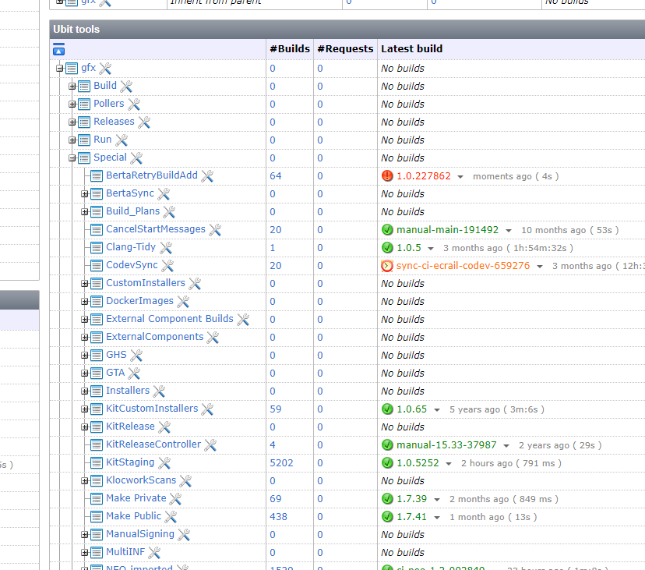

* In Manual Signing select KMCSSigning-Generic as shown below

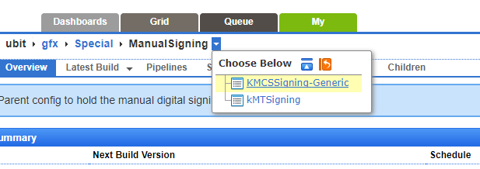

* Select as mentioned below

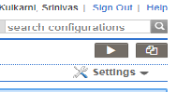

* Please mention the binaries which needs to be signed as shown below

