Codebook for MergedData

Autogenerated data summary from dataMaid

2021-12-13 17:13:32

# Data report overview

The dataset examined has the following dimensions:

| Feature | Result |
| --- | --- |
| Number of observations | 10299 |
| Number of variables | 81 |

# Codebook summary table

| Label | Variable | Class | # unique values | Missing | Description |
| --- | --- | --- | --- | --- | --- |
|  | **subject** | integer | 30 | 0.00 % |  |
|  | **timeDomainBodyAccelerometerMeanX** | numeric | 10292 | 0.00 % |  |
|  | **timeDomainBodyAccelerometerMeanY** | numeric | 10299 | 0.00 % |  |
|  | **timeDomainBodyAccelerometerMeanZ** | numeric | 10293 | 0.00 % |  |
|  | **timeDomainBodyAccelerometerStandardDeviationX** | numeric | 10295 | 0.00 % |  |
|  | **timeDomainBodyAccelerometerStandardDeviationY** | numeric | 10297 | 0.00 % |  |
|  | **timeDomainBodyAccelerometercorrelationY,Z** | numeric | 10299 | 0.00 % |  |
|  | **timeDomainGravityAccelerometerMeanX** | numeric | 10296 | 0.00 % |  |
|  | **timeDomainGravityAccelerometerMeanY** | numeric | 10298 | 0.00 % |  |
|  | **timeDomainGravityAccelerometerMeanZ** | numeric | 10299 | 0.00 % |  |
|  | **timeDomainGravityAccelerometerStandardDeviationX** | numeric | 10288 | 0.00 % |  |
|  | **timeDomainGravityAccelerometerStandardDeviationY** | numeric | 10293 | 0.00 % |  |
|  | **timeDomainGravityAccelerometercorrelationY,Z** | numeric | 10298 | 0.00 % |  |
|  | **timeDomainBodyAccelerometerJerkMeanX** | numeric | 10299 | 0.00 % |  |
|  | **timeDomainBodyAccelerometerJerkMeanY** | numeric | 10299 | 0.00 % |  |
|  | **timeDomainBodyAccelerometerJerkMeanZ** | numeric | 10299 | 0.00 % |  |
|  | **timeDomainBodyAccelerometerJerkStandardDeviationX** | numeric | 10290 | 0.00 % |  |
|  | **timeDomainBodyAccelerometerJerkStandardDeviationY** | numeric | 10296 | 0.00 % |  |
|  | **timeDomainBodyAccelerometerJerkcorrelationY,Z** | numeric | 10297 | 0.00 % |  |
|  | **timeDomainBodyGyroscopeMeanX** | numeric | 10298 | 0.00 % |  |
|  | **timeDomainBodyGyroscopeMeanY** | numeric | 10299 | 0.00 % |  |
|  | **timeDomainBodyGyroscopeMeanZ** | numeric | 10297 | 0.00 % |  |
|  | **timeDomainBodyGyroscopeStandardDeviationX** | numeric | 10292 | 0.00 % |  |
|  | **timeDomainBodyGyroscopeStandardDeviationY** | numeric | 10296 | 0.00 % |  |
|  | **timeDomainBodyGyroscopecorrelationY,Z** | numeric | 10299 | 0.00 % |  |
|  | **timeDomainBodyGyroscopeJerkMeanX** | numeric | 10295 | 0.00 % |  |
|  | **timeDomainBodyGyroscopeJerkMeanY** | numeric | 10299 | 0.00 % |  |
|  | **timeDomainBodyGyroscopeJerkMeanZ** | numeric | 10298 | 0.00 % |  |
|  | **timeDomainBodyGyroscopeJerkStandardDeviationX** | numeric | 10292 | 0.00 % |  |
|  | **timeDomainBodyGyroscopeJerkStandardDeviationY** | numeric | 10295 | 0.00 % |  |
|  | **timeDomainBodyGyroscopeJerkcorrelationY,Z** | numeric | 10299 | 0.00 % |  |
|  | **timeDomainBodyAccelerometerMagnitudeMean** | numeric | 10296 | 0.00 % |  |
|  | **timeDomainBodyAccelerometerMagnitudearCoeff4** | numeric | 10299 | 0.00 % |  |
|  | **timeDomainGravityAccelerometerMagnitudeMean** | numeric | 10296 | 0.00 % |  |
|  | **timeDomainGravityAccelerometerMagnitudearCoeff4** | numeric | 10299 | 0.00 % |  |
|  | **timeDomainBodyAccelerometerJerkMagnitudeMean** | numeric | 10292 | 0.00 % |  |
|  | **timeDomainBodyAccelerometerJerkMagnitudearCoeff4** | numeric | 10298 | 0.00 % |  |
|  | **timeDomainBodyGyroscopeMagnitudeMean** | numeric | 10298 | 0.00 % |  |
|  | **timeDomainBodyGyroscopeMagnitudearCoeff4** | numeric | 10298 | 0.00 % |  |
|  | **timeDomainBodyGyroscopeJerkMagnitudeMean** | numeric | 10293 | 0.00 % |  |
|  | **timeDomainBodyGyroscopeJerkMagnitudearCoeff4** | numeric | 10299 | 0.00 % |  |
|  | **frequencyDomainBodyAccelerometerMeanX** | numeric | 10295 | 0.00 % |  |
|  | **frequencyDomainBodyAccelerometerMeanY** | numeric | 10292 | 0.00 % |  |
|  | **frequencyDomainBodyAccelerometerMeanZ** | numeric | 10295 | 0.00 % |  |
|  | **frequencyDomainBodyAccelerometerStandardDeviationX** | numeric | 10294 | 0.00 % |  |
|  | **frequencyDomainBodyAccelerometerStandardDeviationY** | numeric | 10297 | 0.00 % |  |
|  | **frequencyDomainBodyAccelerometermaxIndsZ** | numeric | 27 | 0.00 % |  |
|  | **frequencyDomainBodyAccelerometerMeanFrequencyX** | numeric | 10299 | 0.00 % |  |
|  | **frequencyDomainBodyAccelerometerMeanFrequencyY** | numeric | 10299 | 0.00 % |  |
|  | **frequencyDomainBodyAccelerometerbandsEnergy25,48** | numeric | 10016 | 0.00 % |  |
|  | **frequencyDomainBodyAccelerometerJerkMeanX** | numeric | 10293 | 0.00 % |  |
|  | **frequencyDomainBodyAccelerometerJerkMeanY** | numeric | 10296 | 0.00 % |  |
|  | **frequencyDomainBodyAccelerometerJerkMeanZ** | numeric | 10294 | 0.00 % |  |
|  | **frequencyDomainBodyAccelerometerJerkStandardDeviationX** | numeric | 10291 | 0.00 % |  |
|  | **frequencyDomainBodyAccelerometerJerkStandardDeviationY** | numeric | 10294 | 0.00 % |  |
|  | **frequencyDomainBodyAccelerometerJerkmaxIndsZ** | numeric | 51 | 0.00 % |  |
|  | **frequencyDomainBodyAccelerometerJerkMeanFrequencyX** | numeric | 10298 | 0.00 % |  |
|  | **frequencyDomainBodyAccelerometerJerkMeanFrequencyY** | numeric | 10299 | 0.00 % |  |
|  | **frequencyDomainBodyAccelerometerJerkbandsEnergy25,48** | numeric | 9989 | 0.00 % |  |
|  | **frequencyDomainBodyGyroscopeMeanX** | numeric | 10297 | 0.00 % |  |
|  | **frequencyDomainBodyGyroscopeMeanY** | numeric | 10296 | 0.00 % |  |
|  | **frequencyDomainBodyGyroscopeMeanZ** | numeric | 10297 | 0.00 % |  |
|  | **frequencyDomainBodyGyroscopeStandardDeviationX** | numeric | 10297 | 0.00 % |  |
|  | **frequencyDomainBodyGyroscopeStandardDeviationY** | numeric | 10293 | 0.00 % |  |
|  | **frequencyDomainBodyGyroscopemaxIndsZ** | numeric | 26 | 0.00 % |  |
|  | **frequencyDomainBodyGyroscopeMeanFrequencyX** | numeric | 10298 | 0.00 % |  |
|  | **frequencyDomainBodyGyroscopeMeanFrequencyY** | numeric | 10299 | 0.00 % |  |
|  | **frequencyDomainBodyGyroscopebandsEnergy25,48** | numeric | 9591 | 0.00 % |  |
|  | **frequencyDomainBodyAccelerometerMagnitudeMean** | numeric | 10296 | 0.00 % |  |
|  | **frequencyDomainBodyAccelerometerMagnitudemaxInds** | numeric | 30 | 0.00 % |  |
|  | **frequencyDomainBodyAccelerometerMagnitudekurtosis** | numeric | 10299 | 0.00 % |  |
|  | **frequencyDomainBodyAccelerometerJerkMagnitudeMean** | numeric | 10290 | 0.00 % |  |
|  | **frequencyDomainBodyAccelerometerJerkMagnitudemaxInds** | numeric | 58 | 0.00 % |  |
|  | **frequencyDomainBodyAccelerometerJerkMagnitudekurtosis** | numeric | 10299 | 0.00 % |  |
|  | **frequencyDomainBodyGyroscopeMagnitudeMean** | numeric | 10297 | 0.00 % |  |
|  | **frequencyDomainBodyGyroscopeMagnitudemaxInds** | numeric | 27 | 0.00 % |  |
|  | **frequencyDomainBodyGyroscopeMagnitudekurtosis** | numeric | 10299 | 0.00 % |  |
|  | **frequencyDomainBodyGyroscopeJerkMagnitudeMean** | numeric | 10293 | 0.00 % |  |
|  | **frequencyDomainBodyGyroscopeJerkMagnitudemaxInds** | numeric | 53 | 0.00 % |  |
|  | **angleZ,gravityMean** | numeric | 10299 | 0.00 % |  |
|  | **activity** | factor | 6 | 0.00 % |  |

# Variable list

## subject

| Feature | Result |
| --- | --- |
| Variable type | integer |
| Number of missing obs. | 0 (0 %) |
| Number of unique values | 30 |
| Median | 17 |
| 1st and 3rd quartiles | 9; 24 |
| Min. and max. | 1; 30 |

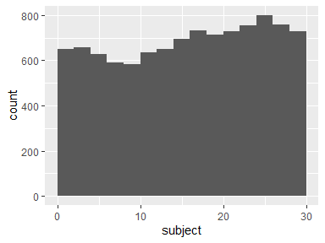

## timeDomainBodyAccelerometerMeanX

| Feature | Result |
| --- | --- |
| Variable type | numeric |
| Number of missing obs. | 0 (0 %) |
| Number of unique values | 10292 |
| Median | 0.28 |
| 1st and 3rd quartiles | 0.26; 0.29 |
| Min. and max. | -1; 1 |

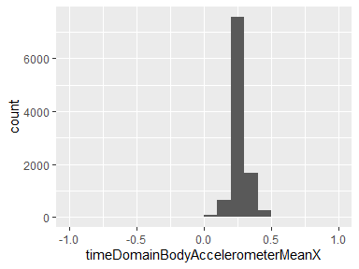

## timeDomainBodyAccelerometerMeanY

| Feature | Result |
| --- | --- |
| Variable type | numeric |
| Number of missing obs. | 0 (0 %) |
| Number of unique values | 10299 |
| Median | -0.02 |
| 1st and 3rd quartiles | -0.02; -0.01 |
| Min. and max. | -1; 1 |

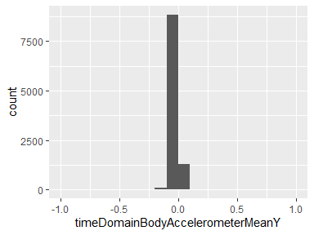

## timeDomainBodyAccelerometerMeanZ

| Feature | Result |
| --- | --- |
| Variable type | numeric |
| Number of missing obs. | 0 (0 %) |
| Number of unique values | 10293 |
| Median | -0.11 |
| 1st and 3rd quartiles | -0.12; -0.1 |
| Min. and max. | -1; 1 |

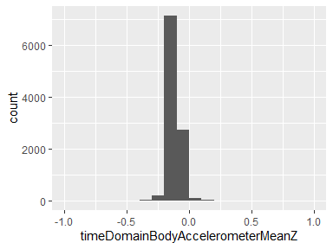

## timeDomainBodyAccelerometerStandardDeviationX

| Feature | Result |
| --- | --- |
| Variable type | numeric |
| Number of missing obs. | 0 (0 %) |
| Number of unique values | 10295 |
| Median | -0.94 |
| 1st and 3rd quartiles | -0.99; -0.25 |
| Min. and max. | -1; 1 |

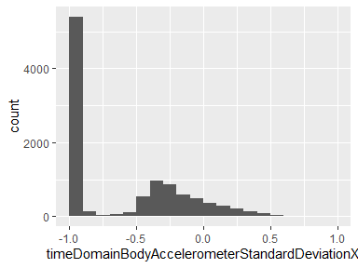

## timeDomainBodyAccelerometerStandardDeviationY

| Feature | Result |
| --- | --- |
| Variable type | numeric |
| Number of missing obs. | 0 (0 %) |
| Number of unique values | 10297 |
| Median | -0.84 |
| 1st and 3rd quartiles | -0.98; -0.06 |
| Min. and max. | -1; 1 |

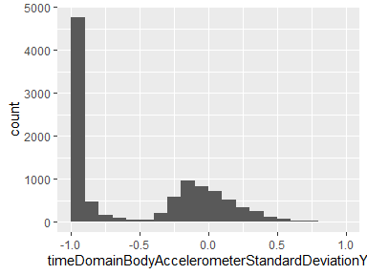

## timeDomainBodyAccelerometercorrelationY,Z

| Feature | Result |
| --- | --- |
| Variable type | numeric |
| Number of missing obs. | 0 (0 %) |
| Number of unique values | 10299 |
| Median | 0.14 |
| 1st and 3rd quartiles | -0.14; 0.37 |
| Min. and max. | -1; 1 |

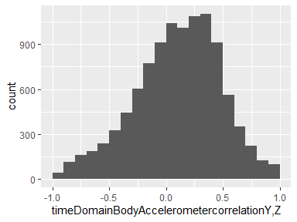

## timeDomainGravityAccelerometerMeanX

| Feature | Result |
| --- | --- |
| Variable type | numeric |
| Number of missing obs. | 0 (0 %) |
| Number of unique values | 10296 |
| Median | 0.92 |
| 1st and 3rd quartiles | 0.81; 0.95 |
| Min. and max. | -1; 1 |

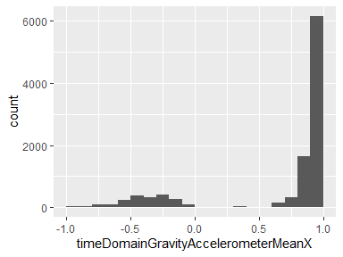

## timeDomainGravityAccelerometerMeanY

| Feature | Result |
| --- | --- |
| Variable type | numeric |
| Number of missing obs. | 0 (0 %) |
| Number of unique values | 10298 |
| Median | -0.14 |
| 1st and 3rd quartiles | -0.24; 0.12 |
| Min. and max. | -1; 1 |

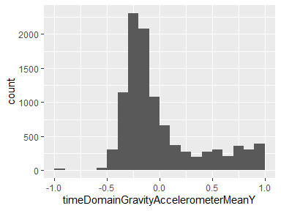

## timeDomainGravityAccelerometerMeanZ

| Feature | Result |
| --- | --- |
| Variable type | numeric |
| Number of missing obs. | 0 (0 %) |
| Number of unique values | 10299 |
| Median | 0.04 |
| 1st and 3rd quartiles | -0.12; 0.22 |
| Min. and max. | -1; 1 |

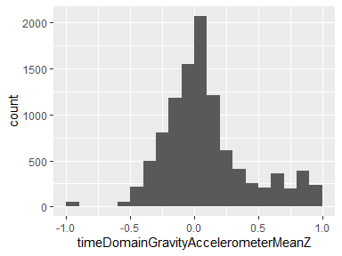

## timeDomainGravityAccelerometerStandardDeviationX

| Feature | Result |
| --- | --- |
| Variable type | numeric |
| Number of missing obs. | 0 (0 %) |
| Number of unique values | 10288 |
| Median | -0.98 |
| 1st and 3rd quartiles | -0.99; -0.96 |
| Min. and max. | -1; 1 |

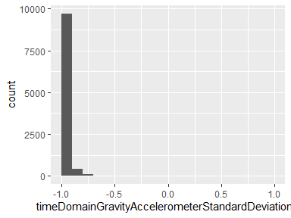

## timeDomainGravityAccelerometerStandardDeviationY

| Feature | Result |
| --- | --- |
| Variable type | numeric |
| Number of missing obs. | 0 (0 %) |
| Number of unique values | 10293 |
| Median | -0.98 |
| 1st and 3rd quartiles | -0.99; -0.95 |
| Min. and max. | -1; 1 |

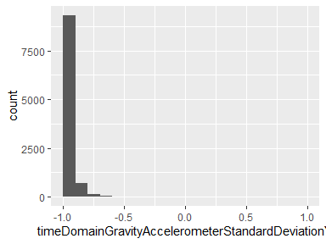

## timeDomainGravityAccelerometercorrelationY,Z

| Feature | Result |
| --- | --- |
| Variable type | numeric |
| Number of missing obs. | 0 (0 %) |
| Number of unique values | 10298 |
| Median | 0.18 |
| 1st and 3rd quartiles | -0.61; 0.78 |
| Min. and max. | -1; 1 |

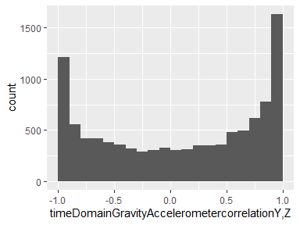

## timeDomainBodyAccelerometerJerkMeanX

| Feature | Result |
| --- | --- |
| Variable type | numeric |
| Number of missing obs. | 0 (0 %) |
| Number of unique values | 10299 |
| Median | 0.08 |
| 1st and 3rd quartiles | 0.06; 0.09 |
| Min. and max. | -1; 1 |

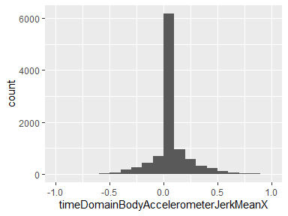

## timeDomainBodyAccelerometerJerkMeanY

| Feature | Result |
| --- | --- |
| Variable type | numeric |
| Number of missing obs. | 0 (0 %) |
| Number of unique values | 10299 |
| Median | 0.01 |
| 1st and 3rd quartiles | -0.02; 0.03 |
| Min. and max. | -1; 1 |

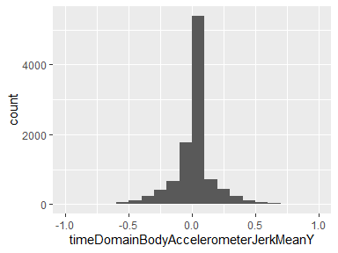

## timeDomainBodyAccelerometerJerkMeanZ

| Feature | Result |
| --- | --- |
| Variable type | numeric |
| Number of missing obs. | 0 (0 %) |
| Number of unique values | 10299 |
| Median | 0 |
| 1st and 3rd quartiles | -0.03; 0.02 |
| Min. and max. | -1; 1 |

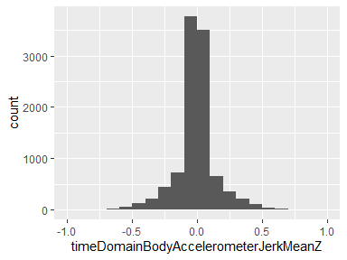

## timeDomainBodyAccelerometerJerkStandardDeviationX

| Feature | Result |
| --- | --- |
| Variable type | numeric |
| Number of missing obs. | 0 (0 %) |
| Number of unique values | 10290 |
| Median | -0.95 |
| 1st and 3rd quartiles | -0.99; -0.29 |
| Min. and max. | -1; 1 |

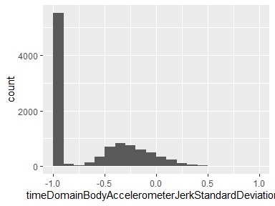

## timeDomainBodyAccelerometerJerkStandardDeviationY

| Feature | Result |
| --- | --- |
| Variable type | numeric |
| Number of missing obs. | 0 (0 %) |
| Number of unique values | 10296 |
| Median | -0.93 |
| 1st and 3rd quartiles | -0.99; -0.22 |
| Min. and max. | -1; 1 |

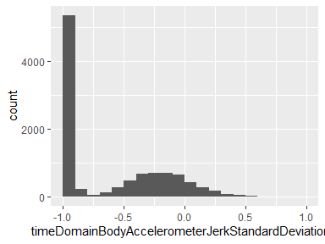

## timeDomainBodyAccelerometerJerkcorrelationY,Z

| Feature | Result |
| --- | --- |
| Variable type | numeric |
| Number of missing obs. | 0 (0 %) |
| Number of unique values | 10297 |
| Median | 0.08 |
| 1st and 3rd quartiles | -0.1; 0.26 |
| Min. and max. | -1; 1 |

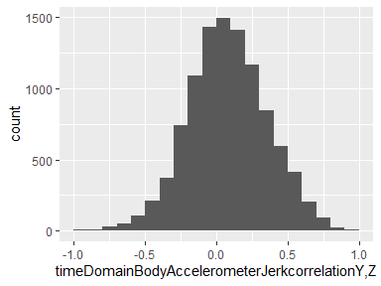

## timeDomainBodyGyroscopeMeanX

| Feature | Result |
| --- | --- |
| Variable type | numeric |
| Number of missing obs. | 0 (0 %) |
| Number of unique values | 10298 |
| Median | -0.03 |
| 1st and 3rd quartiles | -0.05; -0.01 |
| Min. and max. | -1; 1 |

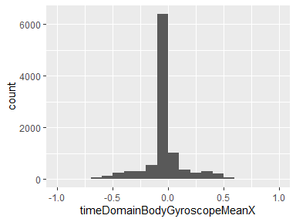

## timeDomainBodyGyroscopeMeanY

| Feature | Result |
| --- | --- |
| Variable type | numeric |
| Number of missing obs. | 0 (0 %) |
| Number of unique values | 10299 |
| Median | -0.07 |
| 1st and 3rd quartiles | -0.1; -0.05 |
| Min. and max. | -1; 1 |

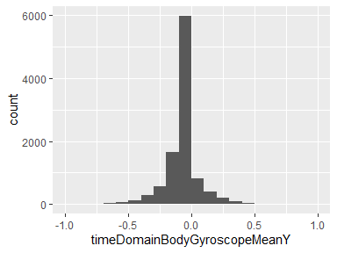

## timeDomainBodyGyroscopeMeanZ

| Feature | Result |
| --- | --- |
| Variable type | numeric |
| Number of missing obs. | 0 (0 %) |
| Number of unique values | 10297 |
| Median | 0.09 |
| 1st and 3rd quartiles | 0.06; 0.11 |
| Min. and max. | -1; 1 |

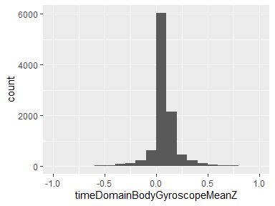

## timeDomainBodyGyroscopeStandardDeviationX

| Feature | Result |
| --- | --- |
| Variable type | numeric |
| Number of missing obs. | 0 (0 %) |
| Number of unique values | 10292 |
| Median | -0.9 |
| 1st and 3rd quartiles | -0.99; -0.48 |
| Min. and max. | -1; 1 |

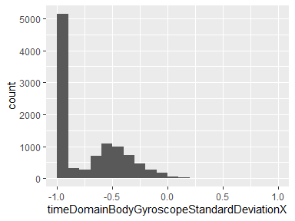

## timeDomainBodyGyroscopeStandardDeviationY

| Feature | Result |
| --- | --- |
| Variable type | numeric |
| Number of missing obs. | 0 (0 %) |
| Number of unique values | 10296 |
| Median | -0.91 |
| 1st and 3rd quartiles | -0.98; -0.45 |
| Min. and max. | -1; 1 |

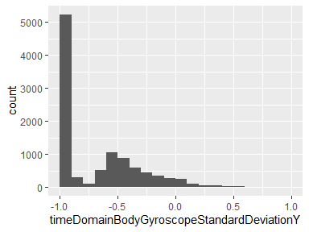

## timeDomainBodyGyroscopecorrelationY,Z

| Feature | Result |
| --- | --- |
| Variable type | numeric |
| Number of missing obs. | 0 (0 %) |
| Number of unique values | 10299 |
| Median | -0.09 |
| 1st and 3rd quartiles | -0.41; 0.19 |
| Min. and max. | -1; 1 |

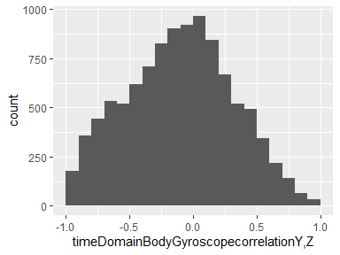

## timeDomainBodyGyroscopeJerkMeanX

| Feature | Result |
| --- | --- |
| Variable type | numeric |
| Number of missing obs. | 0 (0 %) |
| Number of unique values | 10295 |
| Median | -0.1 |
| 1st and 3rd quartiles | -0.12; -0.08 |
| Min. and max. | -1; 1 |

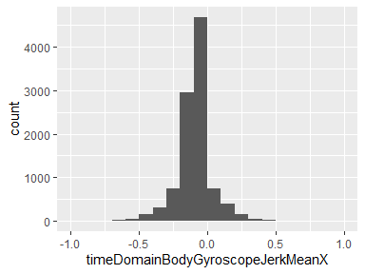

## timeDomainBodyGyroscopeJerkMeanY

| Feature | Result |
| --- | --- |
| Variable type | numeric |
| Number of missing obs. | 0 (0 %) |
| Number of unique values | 10299 |
| Median | -0.04 |
| 1st and 3rd quartiles | -0.06; -0.03 |
| Min. and max. | -1; 1 |

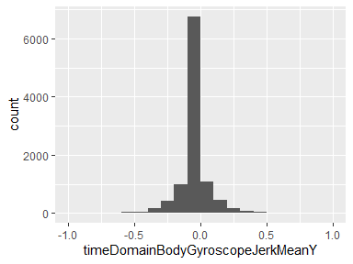

## timeDomainBodyGyroscopeJerkMeanZ

| Feature | Result |
| --- | --- |
| Variable type | numeric |
| Number of missing obs. | 0 (0 %) |
| Number of unique values | 10298 |
| Median | -0.05 |
| 1st and 3rd quartiles | -0.08; -0.03 |
| Min. and max. | -1; 1 |

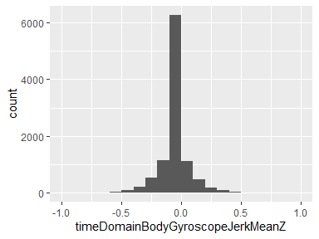

## timeDomainBodyGyroscopeJerkStandardDeviationX

| Feature | Result |
| --- | --- |
| Variable type | numeric |
| Number of missing obs. | 0 (0 %) |
| Number of unique values | 10292 |
| Median | -0.93 |
| 1st and 3rd quartiles | -0.99; -0.49 |
| Min. and max. | -1; 1 |

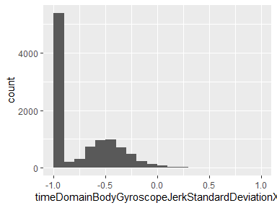

## timeDomainBodyGyroscopeJerkStandardDeviationY

| Feature | Result |
| --- | --- |
| Variable type | numeric |
| Number of missing obs. | 0 (0 %) |
| Number of unique values | 10295 |
| Median | -0.95 |
| 1st and 3rd quartiles | -0.99; -0.63 |
| Min. and max. | -1; 1 |

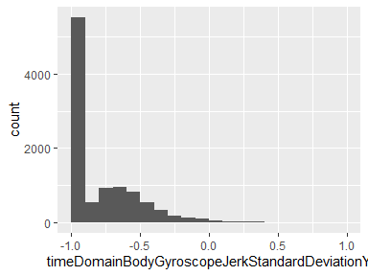

## timeDomainBodyGyroscopeJerkcorrelationY,Z

| Feature | Result |
| --- | --- |
| Variable type | numeric |
| Number of missing obs. | 0 (0 %) |
| Number of unique values | 10299 |
| Median | -0.12 |
| 1st and 3rd quartiles | -0.29; 0.05 |
| Min. and max. | -1; 1 |

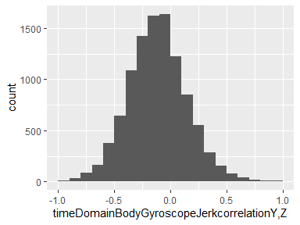

## timeDomainBodyAccelerometerMagnitudeMean

| Feature | Result |
| --- | --- |
| Variable type | numeric |
| Number of missing obs. | 0 (0 %) |
| Number of unique values | 10296 |
| Median | -0.87 |
| 1st and 3rd quartiles | -0.98; -0.12 |
| Min. and max. | -1; 1 |

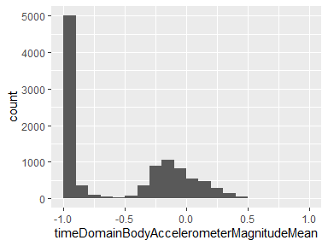

## timeDomainBodyAccelerometerMagnitudearCoeff4

| Feature | Result |
| --- | --- |
| Variable type | numeric |
| Number of missing obs. | 0 (0 %) |
| Number of unique values | 10299 |
| Median | -0.05 |
| 1st and 3rd quartiles | -0.24; 0.12 |
| Min. and max. | -1; 1 |

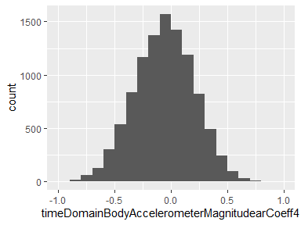

## timeDomainGravityAccelerometerMagnitudeMean

| Feature | Result |
| --- | --- |
| Variable type | numeric |
| Number of missing obs. | 0 (0 %) |
| Number of unique values | 10296 |
| Median | -0.87 |
| 1st and 3rd quartiles | -0.98; -0.12 |
| Min. and max. | -1; 1 |

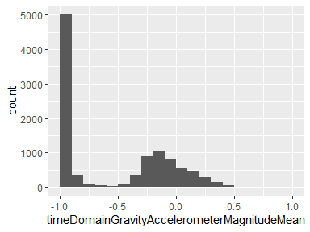

## timeDomainGravityAccelerometerMagnitudearCoeff4

| Feature | Result |
| --- | --- |
| Variable type | numeric |
| Number of missing obs. | 0 (0 %) |
| Number of unique values | 10299 |
| Median | -0.05 |
| 1st and 3rd quartiles | -0.24; 0.12 |
| Min. and max. | -1; 1 |

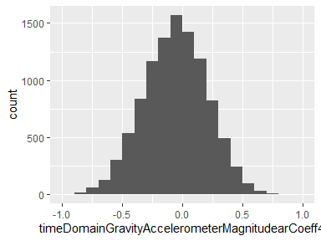

## timeDomainBodyAccelerometerJerkMagnitudeMean

| Feature | Result |
| --- | --- |
| Variable type | numeric |
| Number of missing obs. | 0 (0 %) |
| Number of unique values | 10292 |
| Median | -0.95 |
| 1st and 3rd quartiles | -0.99; -0.3 |
| Min. and max. | -1; 1 |

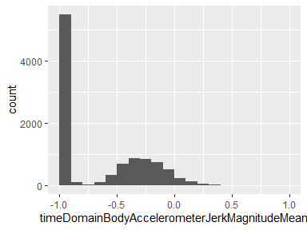

## timeDomainBodyAccelerometerJerkMagnitudearCoeff4

| Feature | Result |
| --- | --- |
| Variable type | numeric |
| Number of missing obs. | 0 (0 %) |
| Number of unique values | 10298 |
| Median | -0.05 |
| 1st and 3rd quartiles | -0.22; 0.13 |
| Min. and max. | -1; 1 |

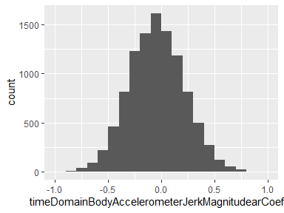

## timeDomainBodyGyroscopeMagnitudeMean

| Feature | Result |
| --- | --- |
| Variable type | numeric |
| Number of missing obs. | 0 (0 %) |
| Number of unique values | 10298 |
| Median | -0.82 |
| 1st and 3rd quartiles | -0.98; -0.25 |
| Min. and max. | -1; 1 |

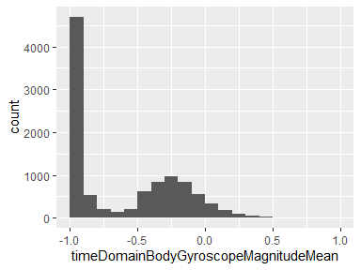

## timeDomainBodyGyroscopeMagnitudearCoeff4

| Feature | Result |
| --- | --- |
| Variable type | numeric |
| Number of missing obs. | 0 (0 %) |
| Number of unique values | 10298 |
| Median | -0.05 |
| 1st and 3rd quartiles | -0.22; 0.11 |
| Min. and max. | -1; 1 |

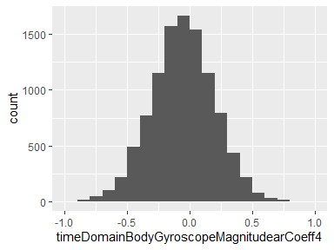

## timeDomainBodyGyroscopeJerkMagnitudeMean

| Feature | Result |
| --- | --- |
| Variable type | numeric |
| Number of missing obs. | 0 (0 %) |
| Number of unique values | 10293 |
| Median | -0.96 |
| 1st and 3rd quartiles | -0.99; -0.55 |
| Min. and max. | -1; 1 |

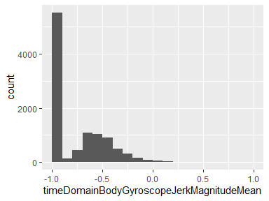

## timeDomainBodyGyroscopeJerkMagnitudearCoeff4

| Feature | Result |
| --- | --- |
| Variable type | numeric |
| Number of missing obs. | 0 (0 %) |
| Number of unique values | 10299 |
| Median | -0.12 |
| 1st and 3rd quartiles | -0.28; 0.05 |
| Min. and max. | -1; 1 |

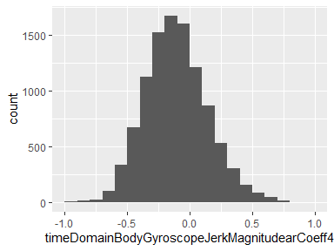

## frequencyDomainBodyAccelerometerMeanX

| Feature | Result |
| --- | --- |
| Variable type | numeric |
| Number of missing obs. | 0 (0 %) |
| Number of unique values | 10295 |
| Median | -0.95 |
| 1st and 3rd quartiles | -0.99; -0.26 |
| Min. and max. | -1; 1 |

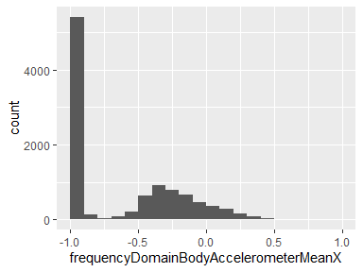

## frequencyDomainBodyAccelerometerMeanY

| Feature | Result |
| --- | --- |
| Variable type | numeric |
| Number of missing obs. | 0 (0 %) |
| Number of unique values | 10292 |
| Median | -0.86 |
| 1st and 3rd quartiles | -0.98; -0.1 |
| Min. and max. | -1; 1 |

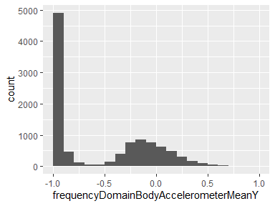

## frequencyDomainBodyAccelerometerMeanZ

| Feature | Result |
| --- | --- |
| Variable type | numeric |
| Number of missing obs. | 0 (0 %) |
| Number of unique values | 10295 |
| Median | -0.9 |
| 1st and 3rd quartiles | -0.98; -0.37 |
| Min. and max. | -1; 1 |

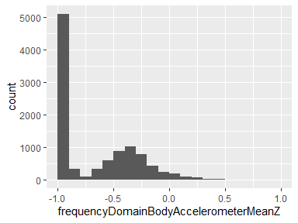

## frequencyDomainBodyAccelerometerStandardDeviationX

| Feature | Result |
| --- | --- |
| Variable type | numeric |
| Number of missing obs. | 0 (0 %) |
| Number of unique values | 10294 |
| Median | -0.94 |
| 1st and 3rd quartiles | -0.99; -0.25 |
| Min. and max. | -1; 1 |

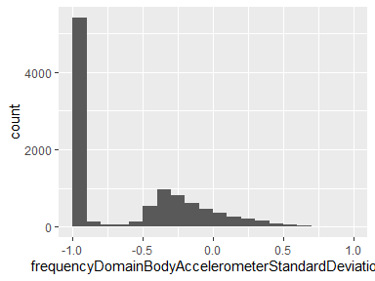

## frequencyDomainBodyAccelerometerStandardDeviationY

| Feature | Result |
| --- | --- |
| Variable type | numeric |
| Number of missing obs. | 0 (0 %) |
| Number of unique values | 10297 |
| Median | -0.83 |
| 1st and 3rd quartiles | -0.98; -0.09 |
| Min. and max. | -1; 1 |

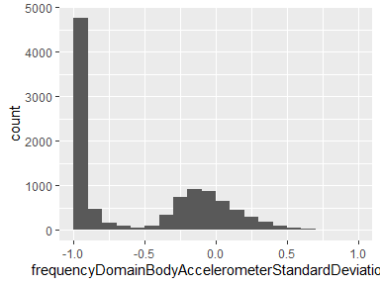

## frequencyDomainBodyAccelerometermaxIndsZ

| Feature | Result |
| --- | --- |
| Variable type | numeric |
| Number of missing obs. | 0 (0 %) |
| Number of unique values | 27 |
| Median | -0.92 |
| 1st and 3rd quartiles | -1; -0.77 |
| Min. and max. | -1; 1 |

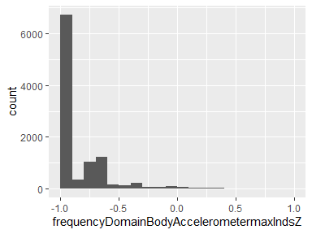

## frequencyDomainBodyAccelerometerMeanFrequencyX

| Feature | Result |
| --- | --- |
| Variable type | numeric |
| Number of missing obs. | 0 (0 %) |
| Number of unique values | 10299 |
| Median | -0.24 |
| 1st and 3rd quartiles | -0.42; -0.02 |
| Min. and max. | -1; 1 |

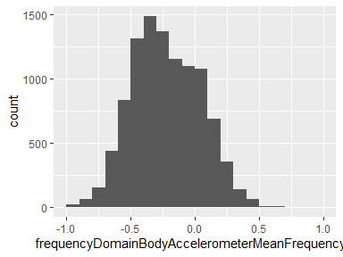

## frequencyDomainBodyAccelerometerMeanFrequencyY

| Feature | Result |
| --- | --- |
| Variable type | numeric |
| Number of missing obs. | 0 (0 %) |
| Number of unique values | 10299 |
| Median | 0 |
| 1st and 3rd quartiles | -0.14; 0.18 |
| Min. and max. | -1; 1 |

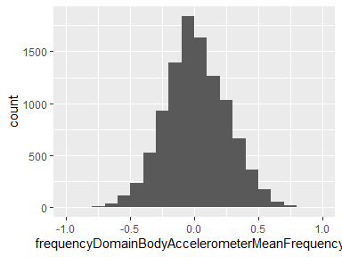

## frequencyDomainBodyAccelerometerbandsEnergy25,48

| Feature | Result |
| --- | --- |
| Variable type | numeric |
| Number of missing obs. | 0 (0 %) |
| Number of unique values | 10016 |
| Median | -1 |
| 1st and 3rd quartiles | -1; -0.95 |
| Min. and max. | -1; 1 |

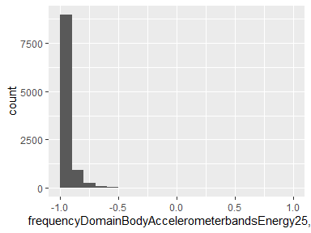

## frequencyDomainBodyAccelerometerJerkMeanX

| Feature | Result |
| --- | --- |
| Variable type | numeric |
| Number of missing obs. | 0 (0 %) |
| Number of unique values | 10293 |
| Median | -0.95 |
| 1st and 3rd quartiles | -0.99; -0.33 |
| Min. and max. | -1; 1 |

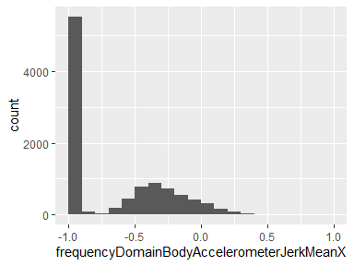

## frequencyDomainBodyAccelerometerJerkMeanY

| Feature | Result |
| --- | --- |
| Variable type | numeric |
| Number of missing obs. | 0 (0 %) |
| Number of unique values | 10296 |
| Median | -0.93 |
| 1st and 3rd quartiles | -0.98; -0.26 |
| Min. and max. | -1; 1 |

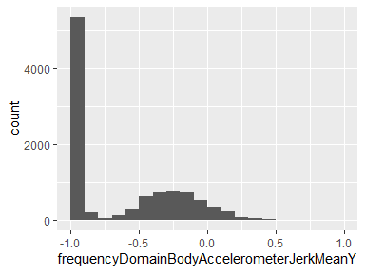

## frequencyDomainBodyAccelerometerJerkMeanZ

| Feature | Result |
| --- | --- |
| Variable type | numeric |
| Number of missing obs. | 0 (0 %) |
| Number of unique values | 10294 |
| Median | -0.95 |
| 1st and 3rd quartiles | -0.99; -0.51 |
| Min. and max. | -1; 1 |

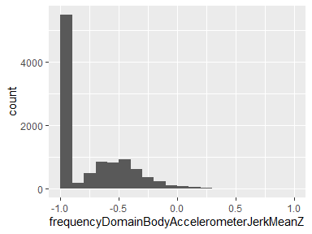

## frequencyDomainBodyAccelerometerJerkStandardDeviationX

| Feature | Result |
| --- | --- |
| Variable type | numeric |
| Number of missing obs. | 0 (0 %) |
| Number of unique values | 10291 |
| Median | -0.96 |
| 1st and 3rd quartiles | -0.99; -0.32 |
| Min. and max. | -1; 1 |

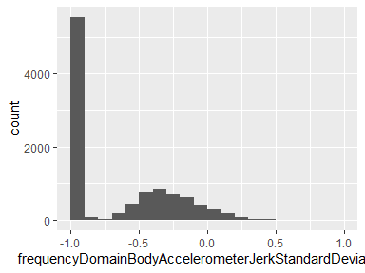

## frequencyDomainBodyAccelerometerJerkStandardDeviationY

| Feature | Result |
| --- | --- |
| Variable type | numeric |
| Number of missing obs. | 0 (0 %) |
| Number of unique values | 10294 |
| Median | -0.93 |
| 1st and 3rd quartiles | -0.99; -0.24 |
| Min. and max. | -1; 1 |

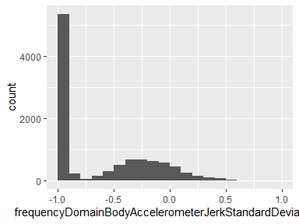

## frequencyDomainBodyAccelerometerJerkmaxIndsZ

| Feature | Result |
| --- | --- |
| Variable type | numeric |
| Number of missing obs. | 0 (0 %) |
| Number of unique values | 51 |
| Median | -0.32 |
| 1st and 3rd quartiles | -0.48; -0.16 |
| Min. and max. | -1; 1 |

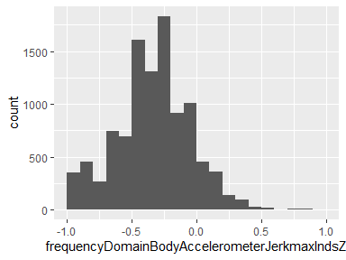

## frequencyDomainBodyAccelerometerJerkMeanFrequencyX

| Feature | Result |
| --- | --- |
| Variable type | numeric |
| Number of missing obs. | 0 (0 %) |
| Number of unique values | 10298 |
| Median | -0.05 |
| 1st and 3rd quartiles | -0.3; 0.2 |
| Min. and max. | -1; 1 |

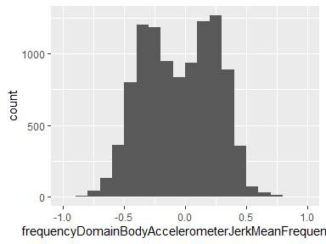

## frequencyDomainBodyAccelerometerJerkMeanFrequencyY

| Feature | Result |
| --- | --- |
| Variable type | numeric |
| Number of missing obs. | 0 (0 %) |
| Number of unique values | 10299 |
| Median | -0.24 |
| 1st and 3rd quartiles | -0.43; 0.01 |
| Min. and max. | -1; 1 |

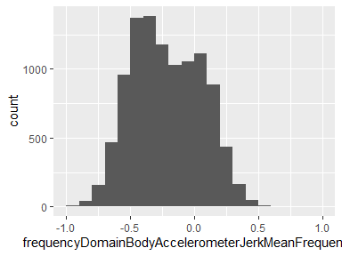

## frequencyDomainBodyAccelerometerJerkbandsEnergy25,48

| Feature | Result |
| --- | --- |
| Variable type | numeric |
| Number of missing obs. | 0 (0 %) |
| Number of unique values | 9989 |
| Median | -1 |
| 1st and 3rd quartiles | -1; -0.95 |
| Min. and max. | -1; 1 |

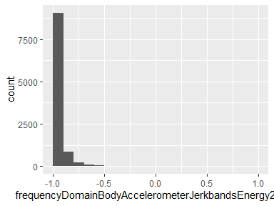

## frequencyDomainBodyGyroscopeMeanX

| Feature | Result |
| --- | --- |
| Variable type | numeric |
| Number of missing obs. | 0 (0 %) |
| Number of unique values | 10297 |
| Median | -0.89 |
| 1st and 3rd quartiles | -0.99; -0.38 |
| Min. and max. | -1; 1 |

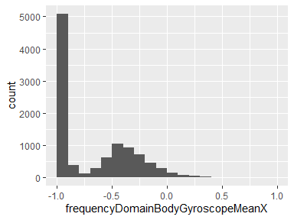

## frequencyDomainBodyGyroscopeMeanY

| Feature | Result |
| --- | --- |
| Variable type | numeric |
| Number of missing obs. | 0 (0 %) |
| Number of unique values | 10296 |
| Median | -0.92 |
| 1st and 3rd quartiles | -0.98; -0.47 |
| Min. and max. | -1; 1 |

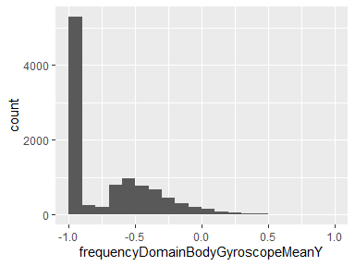

## frequencyDomainBodyGyroscopeMeanZ

| Feature | Result |
| --- | --- |
| Variable type | numeric |
| Number of missing obs. | 0 (0 %) |
| Number of unique values | 10297 |
| Median | -0.89 |
| 1st and 3rd quartiles | -0.99; -0.32 |
| Min. and max. | -1; 1 |

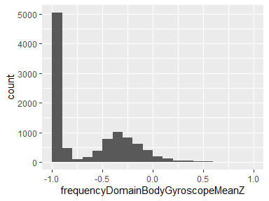

## frequencyDomainBodyGyroscopeStandardDeviationX

| Feature | Result |
| --- | --- |
| Variable type | numeric |
| Number of missing obs. | 0 (0 %) |
| Number of unique values | 10297 |
| Median | -0.91 |
| 1st and 3rd quartiles | -0.99; -0.52 |
| Min. and max. | -1; 1 |

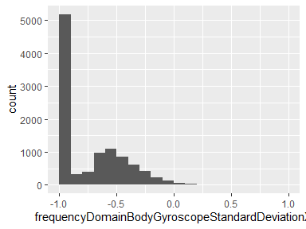

## frequencyDomainBodyGyroscopeStandardDeviationY

| Feature | Result |
| --- | --- |
| Variable type | numeric |
| Number of missing obs. | 0 (0 %) |
| Number of unique values | 10293 |
| Median | -0.91 |
| 1st and 3rd quartiles | -0.98; -0.44 |
| Min. and max. | -1; 1 |

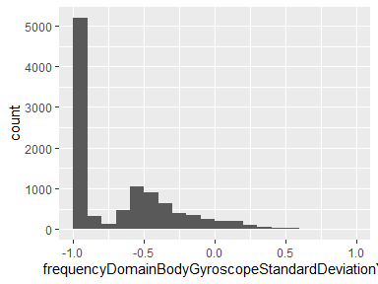

## frequencyDomainBodyGyroscopemaxIndsZ

| Feature | Result |
| --- | --- |
| Variable type | numeric |
| Number of missing obs. | 0 (0 %) |
| Number of unique values | 26 |
| Median | -0.93 |
| 1st and 3rd quartiles | -1; -0.66 |
| Min. and max. | -1; 1 |

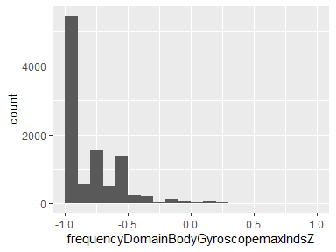

## frequencyDomainBodyGyroscopeMeanFrequencyX

| Feature | Result |
| --- | --- |
| Variable type | numeric |
| Number of missing obs. | 0 (0 %) |
| Number of unique values | 10298 |
| Median | -0.1 |
| 1st and 3rd quartiles | -0.27; 0.07 |
| Min. and max. | -1; 1 |

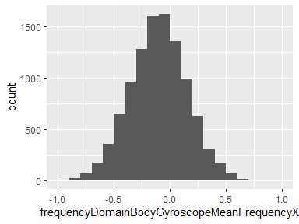

## frequencyDomainBodyGyroscopeMeanFrequencyY

| Feature | Result |
| --- | --- |
| Variable type | numeric |
| Number of missing obs. | 0 (0 %) |
| Number of unique values | 10299 |
| Median | -0.17 |
| 1st and 3rd quartiles | -0.36; 0.01 |
| Min. and max. | -1; 1 |

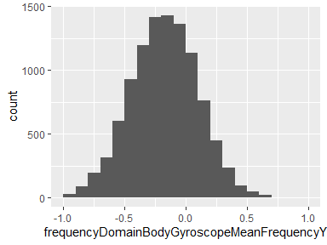

## frequencyDomainBodyGyroscopebandsEnergy25,48

| Feature | Result |
| --- | --- |
| Variable type | numeric |
| Number of missing obs. | 0 (0 %) |
| Number of unique values | 9591 |
| Median | -1 |
| 1st and 3rd quartiles | -1; -0.96 |
| Min. and max. | -1; 1 |

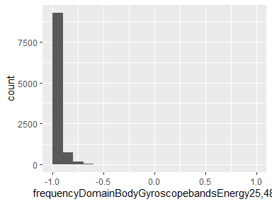

## frequencyDomainBodyAccelerometerMagnitudeMean

| Feature | Result |
| --- | --- |
| Variable type | numeric |
| Number of missing obs. | 0 (0 %) |
| Number of unique values | 10296 |
| Median | -0.88 |
| 1st and 3rd quartiles | -0.98; -0.22 |
| Min. and max. | -1; 1 |

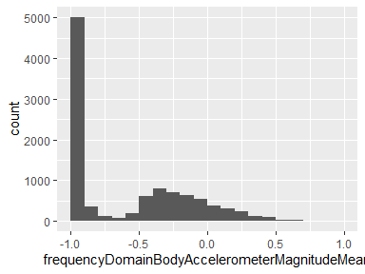

## frequencyDomainBodyAccelerometerMagnitudemaxInds

| Feature | Result |
| --- | --- |
| Variable type | numeric |
| Number of missing obs. | 0 (0 %) |
| Number of unique values | 30 |
| Median | -0.79 |
| 1st and 3rd quartiles | -1; -0.52 |
| Min. and max. | -1; 1 |

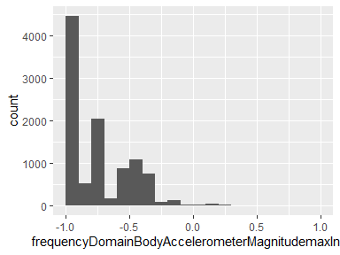

## frequencyDomainBodyAccelerometerMagnitudekurtosis

| Feature | Result |
| --- | --- |
| Variable type | numeric |
| Number of missing obs. | 0 (0 %) |
| Number of unique values | 10299 |
| Median | -0.73 |
| 1st and 3rd quartiles | -0.84; -0.54 |
| Min. and max. | -1; 1 |

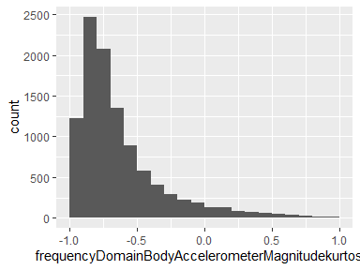

## frequencyDomainBodyAccelerometerJerkMagnitudeMean

| Feature | Result |
| --- | --- |
| Variable type | numeric |
| Number of missing obs. | 0 (0 %) |
| Number of unique values | 10290 |
| Median | -0.93 |
| 1st and 3rd quartiles | -0.99; -0.26 |
| Min. and max. | -1; 1 |

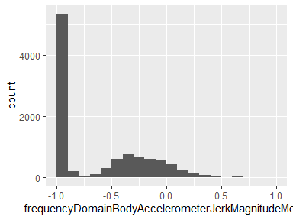

## frequencyDomainBodyAccelerometerJerkMagnitudemaxInds

| Feature | Result |
| --- | --- |
| Variable type | numeric |
| Number of missing obs. | 0 (0 %) |
| Number of unique values | 58 |
| Median | -0.9 |
| 1st and 3rd quartiles | -0.97; -0.87 |
| Min. and max. | -1; 1 |

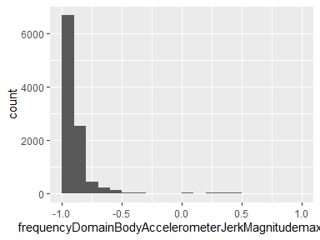

## frequencyDomainBodyAccelerometerJerkMagnitudekurtosis

| Feature | Result |
| --- | --- |
| Variable type | numeric |
| Number of missing obs. | 0 (0 %) |
| Number of unique values | 10299 |
| Median | -0.71 |
| 1st and 3rd quartiles | -0.88; -0.43 |
| Min. and max. | -1; 1 |

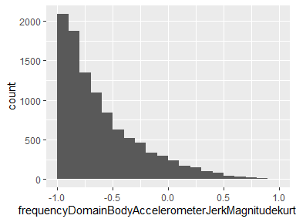

## frequencyDomainBodyGyroscopeMagnitudeMean

| Feature | Result |
| --- | --- |
| Variable type | numeric |
| Number of missing obs. | 0 (0 %) |
| Number of unique values | 10297 |
| Median | -0.88 |
| 1st and 3rd quartiles | -0.98; -0.45 |
| Min. and max. | -1; 1 |

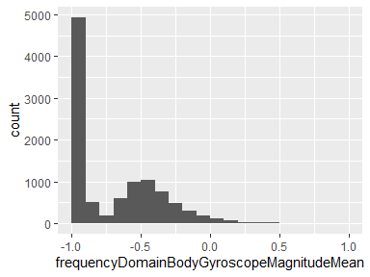

## frequencyDomainBodyGyroscopeMagnitudemaxInds

| Feature | Result |
| --- | --- |
| Variable type | numeric |
| Number of missing obs. | 0 (0 %) |
| Number of unique values | 27 |
| Median | -0.95 |
| 1st and 3rd quartiles | -1; -0.85 |
| Min. and max. | -1; 1 |

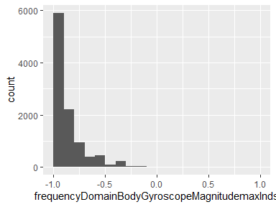

## frequencyDomainBodyGyroscopeMagnitudekurtosis

| Feature | Result |
| --- | --- |
| Variable type | numeric |
| Number of missing obs. | 0 (0 %) |
| Number of unique values | 10299 |
| Median | -0.66 |
| 1st and 3rd quartiles | -0.81; -0.44 |
| Min. and max. | -1; 1 |

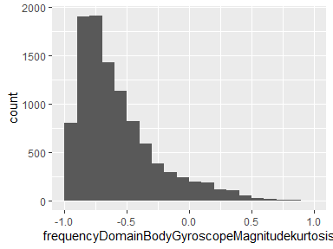

## frequencyDomainBodyGyroscopeJerkMagnitudeMean

| Feature | Result |
| --- | --- |
| Variable type | numeric |
| Number of missing obs. | 0 (0 %) |
| Number of unique values | 10293 |
| Median | -0.95 |
| 1st and 3rd quartiles | -0.99; -0.61 |
| Min. and max. | -1; 1 |

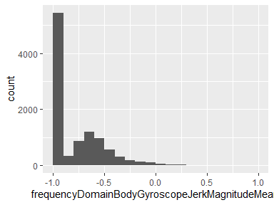

## frequencyDomainBodyGyroscopeJerkMagnitudemaxInds

| Feature | Result |
| --- | --- |
| Variable type | numeric |
| Number of missing obs. | 0 (0 %) |
| Number of unique values | 53 |
| Median | -0.9 |
| 1st and 3rd quartiles | -0.97; -0.87 |
| Min. and max. | -1; 1 |

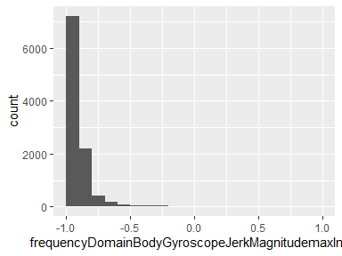

## angleZ,gravityMean

| Feature | Result |
| --- | --- |
| Variable type | numeric |
| Number of missing obs. | 0 (0 %) |
| Number of unique values | 10299 |
| Median | 0 |
| 1st and 3rd quartiles | -0.13; 0.1 |
| Min. and max. | -1; 1 |

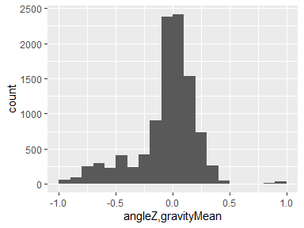

## activity

| Feature | Result |
| --- | --- |
| Variable type | factor |
| Number of missing obs. | 0 (0 %) |
| Number of unique values | 6 |
| Mode | “LAYING” |
| Reference category | WALKING |

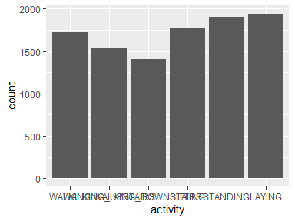

* Observed factor levels: "LAYING", "SITTING", "STANDING", "WALKING", "WALKING_DOWNSTAIRS", "WALKING_UPSTAIRS".

Report generation information:

* Created by: frorup (username: mfror).
* Report creation time: Mon Dec 13 2021 17:13:40
* Report was run from directory: F:/R/Getting-and-Cleaning-Data-Week-4-Project
* dataMaid v1.4.1 [Pkg: 2021-10-08 from CRAN (R 4.1.2)]
* R version 4.1.0 (2021-05-18).
* Platform: x86_64-w64-mingw32/x64 (64-bit)(Windows 10 x64 (build 22000)).
* Function call: dataMaid::makeDataReport(data = MergedData, mode = c("summarize", "visualize", "check"), smartNum = FALSE, file = "codebook_MergedData.Rmd", checks = list(character = "showAllFactorLevels", factor = "showAllFactorLevels", labelled = "showAllFactorLevels", haven_labelled = "showAllFactorLevels", numeric = NULL, integer = NULL, logical = NULL, Date = NULL), listChecks = FALSE, maxProbVals = Inf, codebook = TRUE, reportTitle = "Codebook for MergedData")