CSC500 Module 8 Portfolio Project
Student: Mike Hudson
Pseudocode
Create ItemToPurchase class
Store item name
Store item price
Store item quantity
Store item description
Calculate and print item cost

Create ShoppingCart class
Store customer name
Store current date
Store list of cart items

Add item to cart
Check for duplicate item
Add item to cart if it is not a duplicate

Remove item from cart
Search for item by name
Remove matching item

Modify item
Search for item by name
Update price and quantity

Get number of items
Add the quantities of all cart items
Return total quantity

Get cost of cart
Calculate the cost of each item
Add all item costs together
Return total cost

Print total
Display customer name and date
Display each item and its cost
Display total number of items
Display total cost

Print descriptions
Display each item name and description

Create RetailStore class
Create a shopping cart

Get customer name
Ask user for customer name
Continue until a name is entered

Get purchase date
Ask user for order date
Validate the date
Store the date in the shopping cart

Display menu
Display available menu choices

Process menu choices
a = Add item
r = Remove item
c = Change item quantity
i = Display item descriptions
o = Display shopping cart
q = Quit

Continue displaying menu until user selects q

Create RetailStore object

Get customer information

Run shopping cart menu
Screenshots
shot1.png
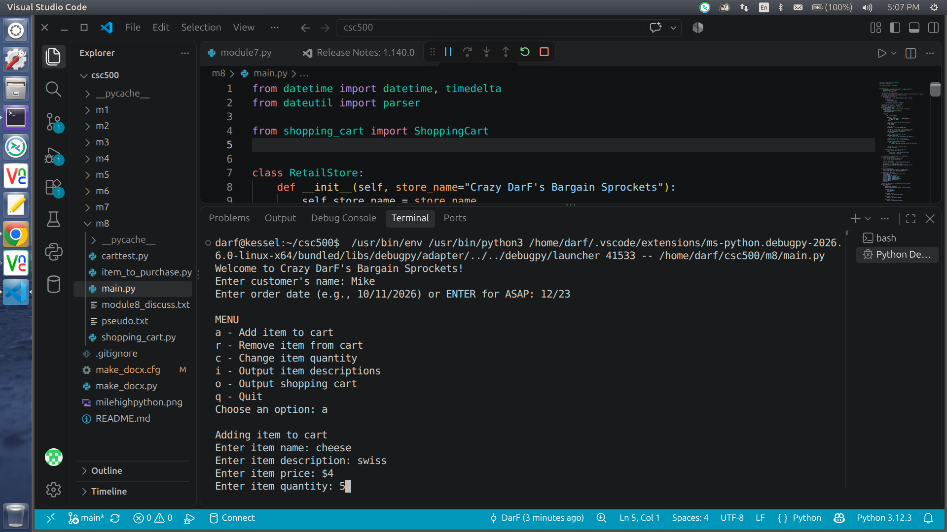
shot2.png
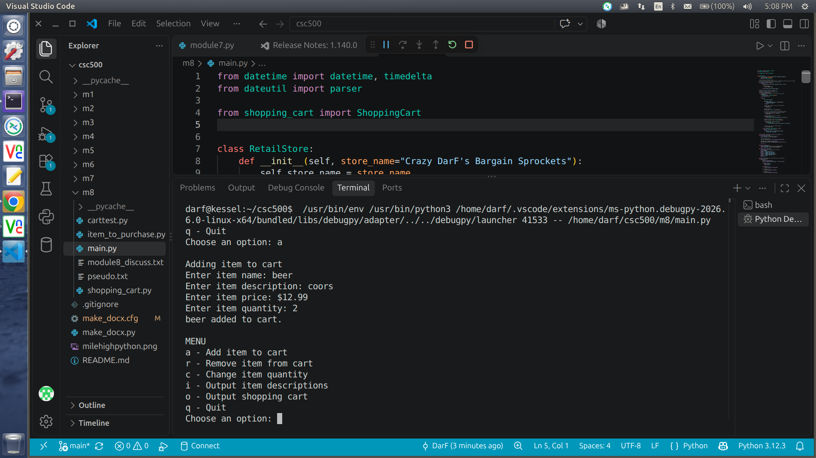
shot3.png
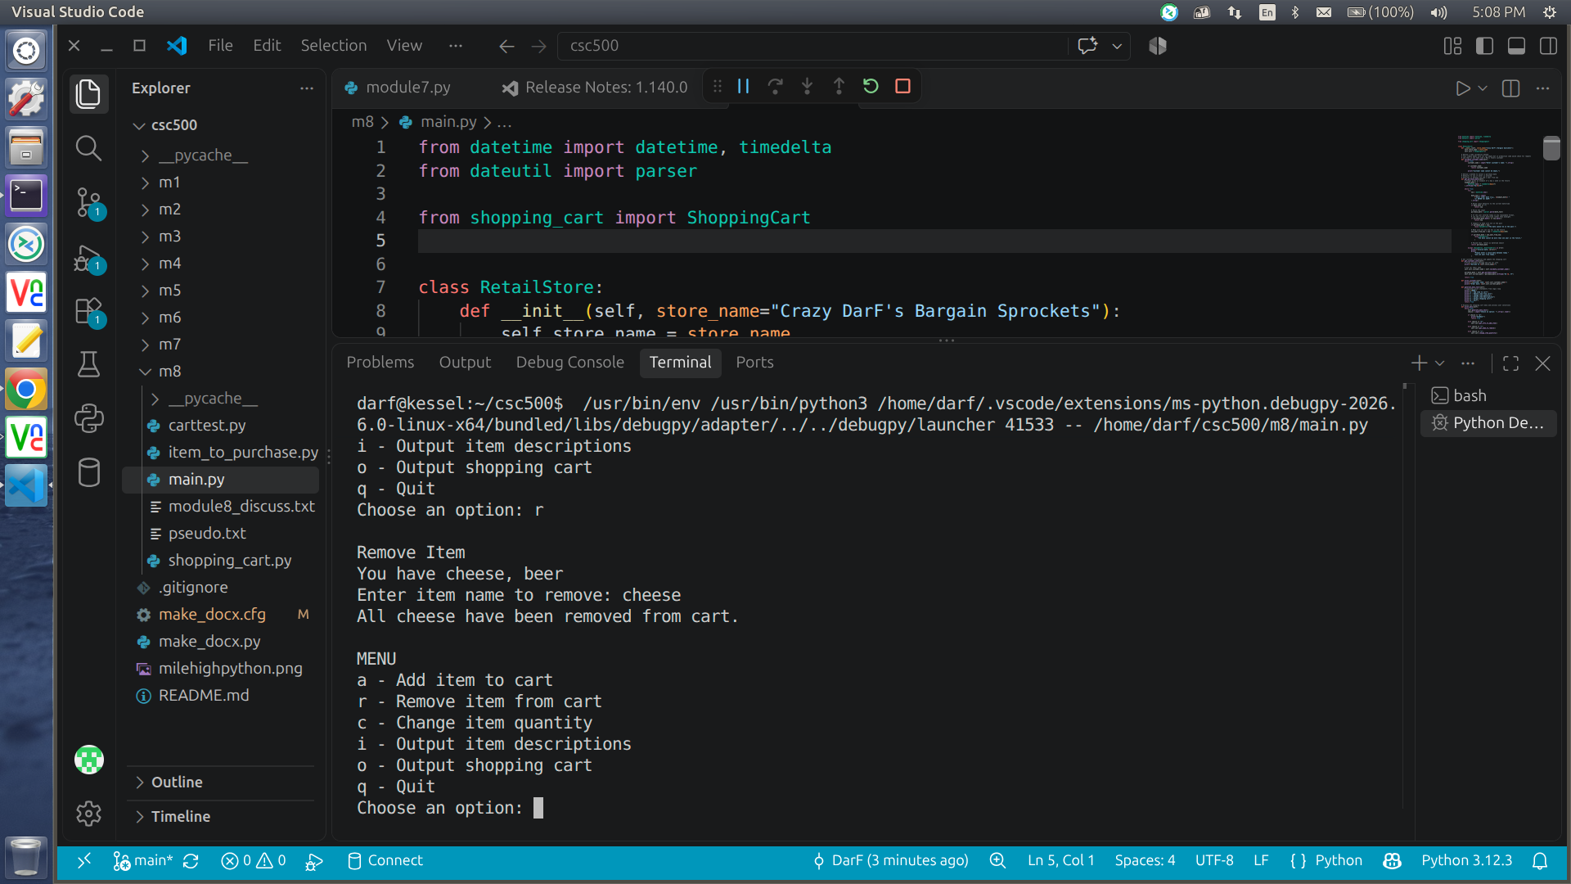
shot4.png
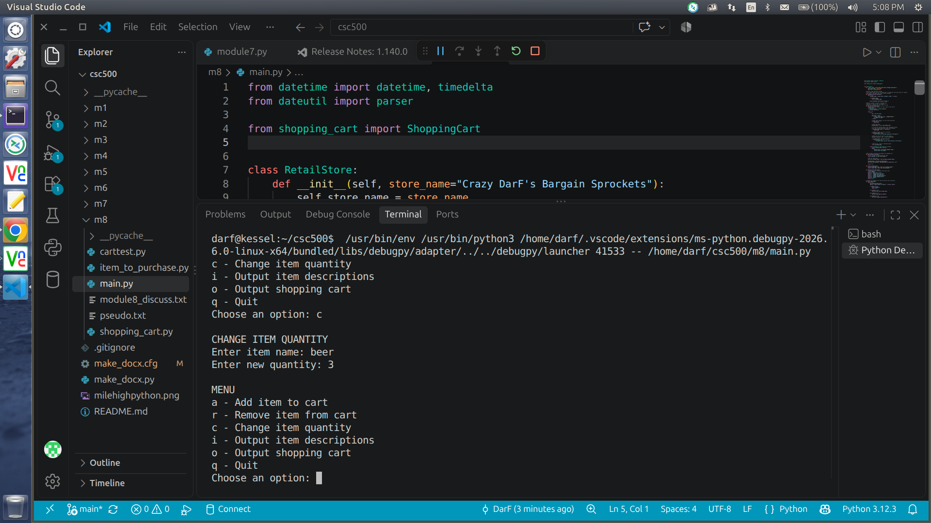
shot5.png
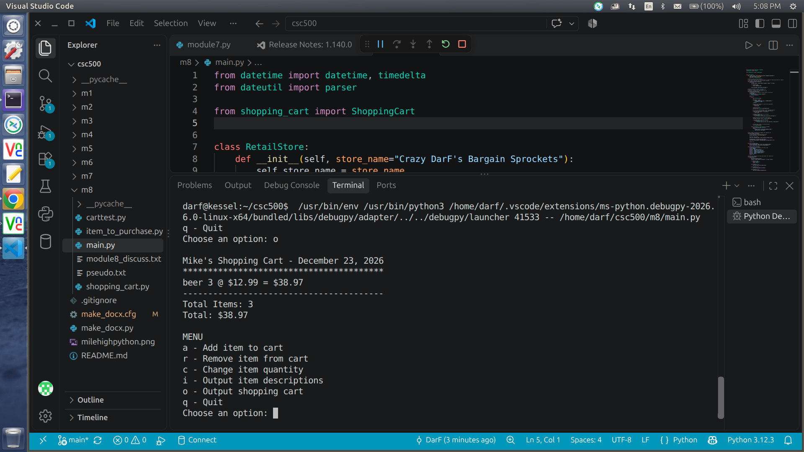
shot6.png
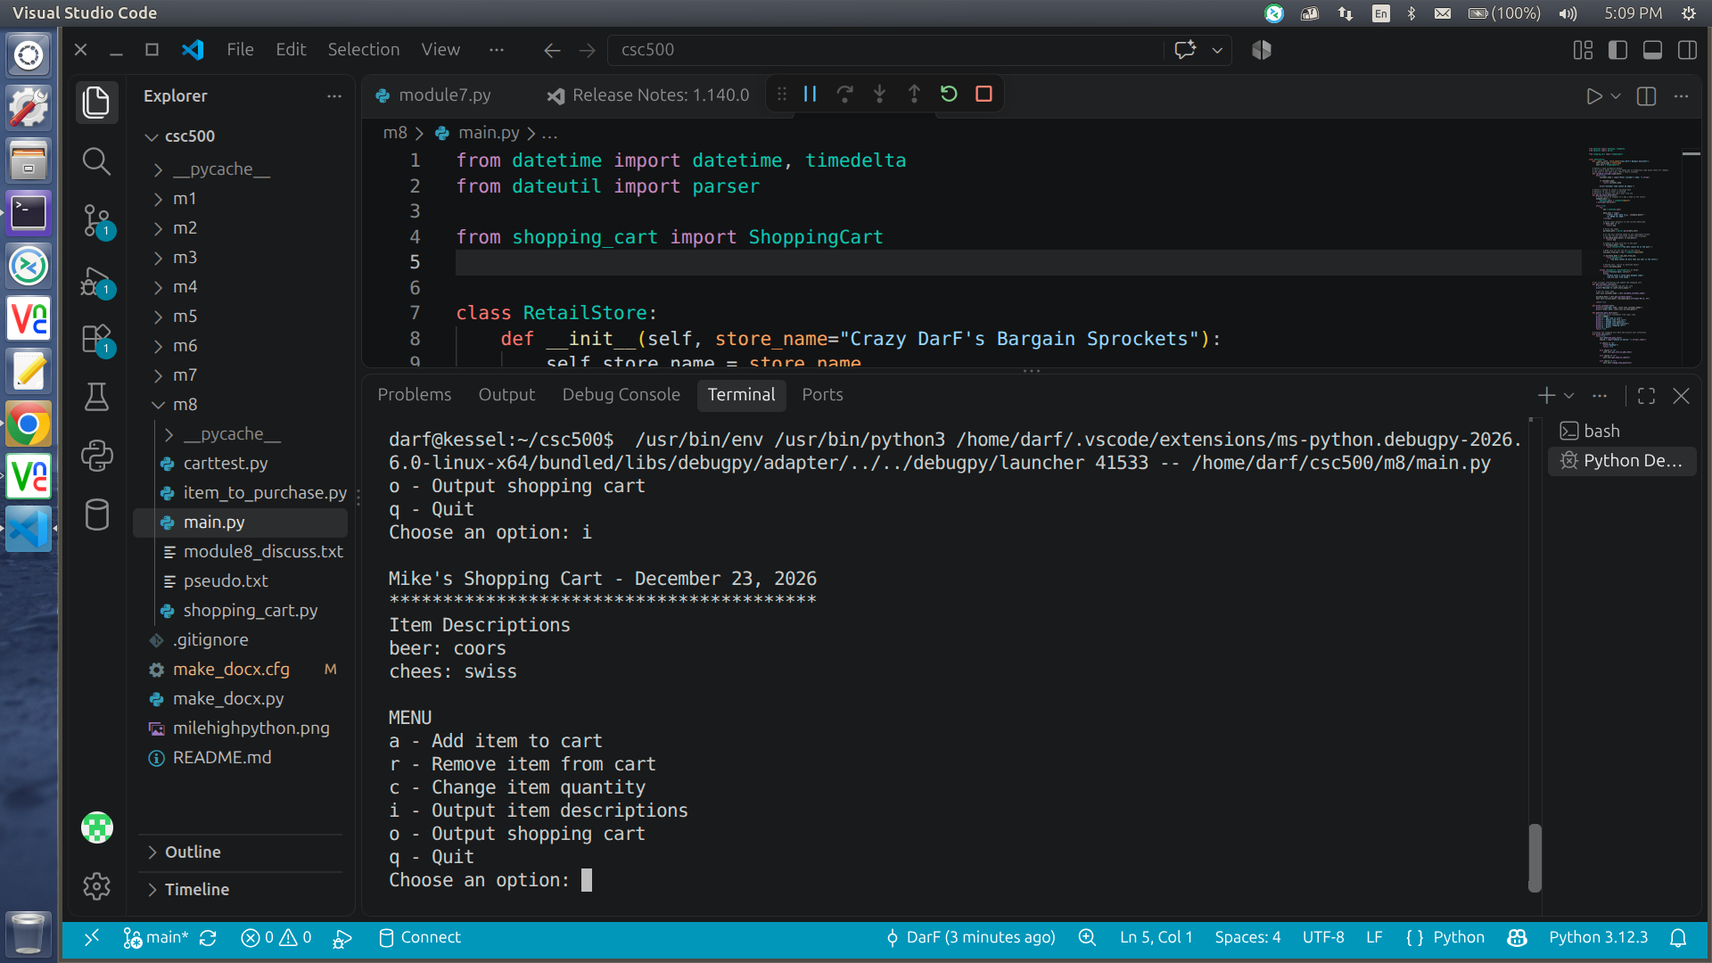
shot7.png
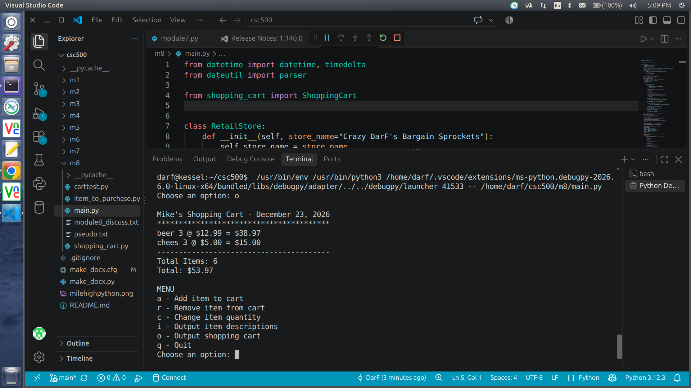
Source Code
https://github.com/frosmear/csc500/blob/main/m8

