Mike Hudson
CSC500 Module 1

Pseudocode
- Ask the user to enter the numbers. Keep doing so until valid.
- Store them as num1 and num2.
- Do the requested math:
  - Add the two numbers and store the result.
  - Subtract the second number from the first number and store the result.
  - Multiply the two numbers and store the result.
  - Divide:
    - Avoid errors checking for zero
    - If not zero divide the first number by the second number and store the result.
- Display the results of addition, subtraction, multiplication, and division.

Critical Analysis
This program is a basic example of how Python can be used to perform mathematical operations based on user inputs. The program asks for two numbers and then uses them to calculate addition, subtraction, multiplication, and division. Using float for the inputs allows the user to enter whole numbers or numbers with decimals.
It was created under the assumption that advanced topics like type checking was beyond the scope of the first assignment, simply had it stop if user entered non numbers. I did check for division because you cannot divide by zero. The program checks for this so it does not produce an error. Overall, this assignment shows how variables, user input, arithmetic operators, and output work together in a simple Python program. It is a basic program, but it covers some of the main concepts needed for writing more useful programs later on.

Screen shots
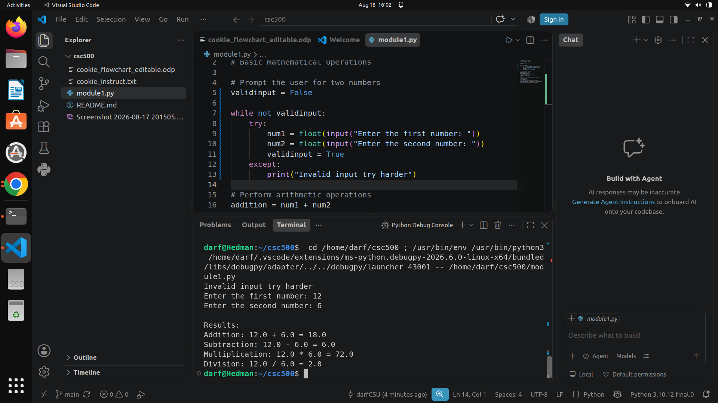
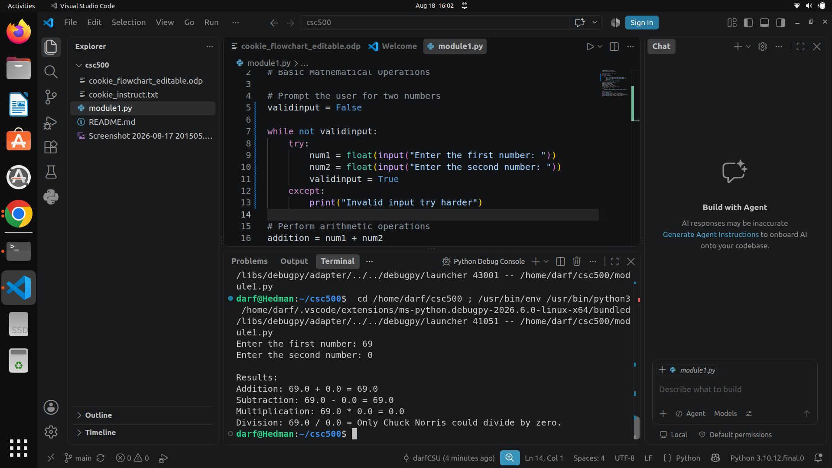

Source Code:
https://github.com/frosmear/csc500/blob/main/module1.py

