CSC500 Module 7 Critical Thinking
Student: Mike Hudson
Pseudocode
Pseudocode file not found: m7/pseudo.txt
Screenshots
Screenshot from 2026-09-28 20-28-54.png
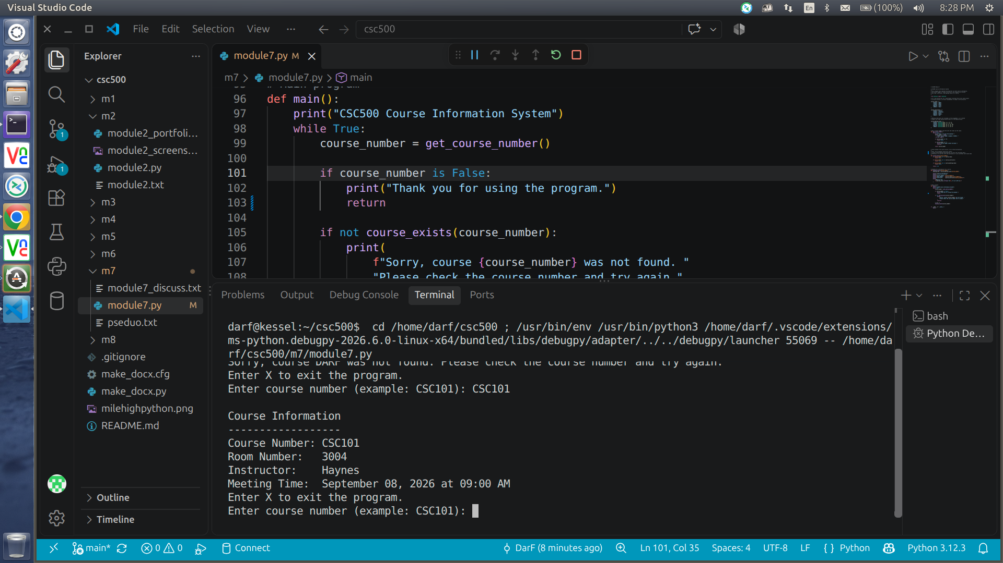
Screenshot from 2026-09-28 20-29-08.png
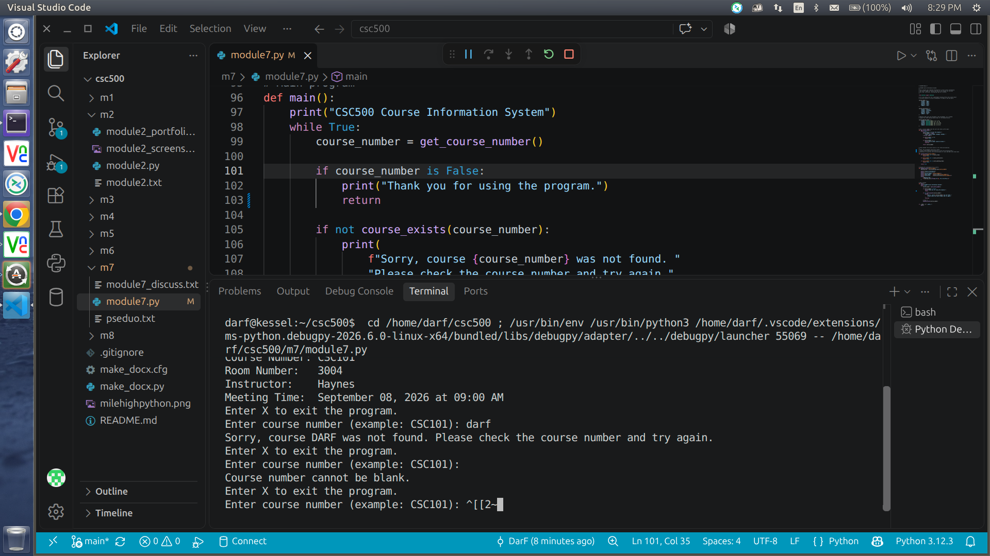
Screenshot from 2026-09-28 20-29-20.png
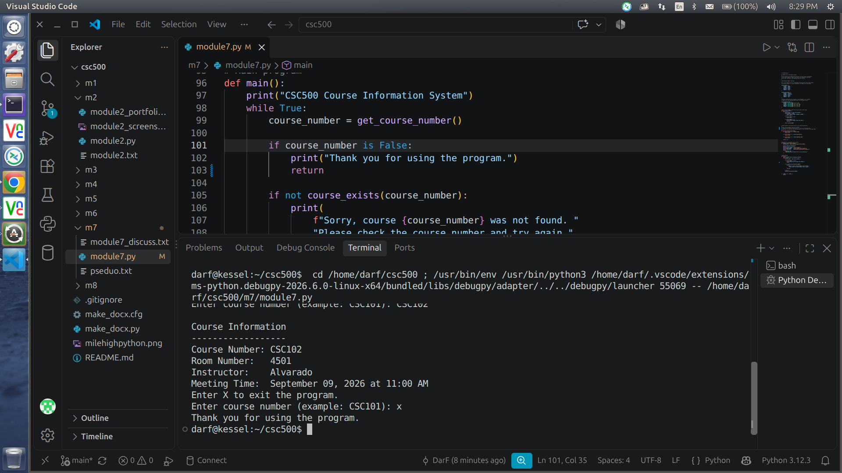
Source Code
https://github.com/frosmear/csc500/blob/main/m7/module7.py

