CSC500 Module 7 Critical Thinking
Student: Mike Hudson
Pseudocode
Start program

Set up dictionaries for course rooms, instructors, and meeting times
Display the CSC500 Course Information System title

Keep asking the user for a course number until they choose X
Clean up the course number entered by the user

If the user enters X
Display a thank you message
End the program

If the course number is blank
Tell the user it cannot be blank
Ask again

Check if the course number exists in all three dictionaries

If the course is not found
Tell the user the course was not found
Ask for another course number

Otherwise
Get the room number
Get the instructor
Get the meeting time
Display all of the course information

End program
Screenshots
Screenshot from 2026-09-28 20-28-54.png
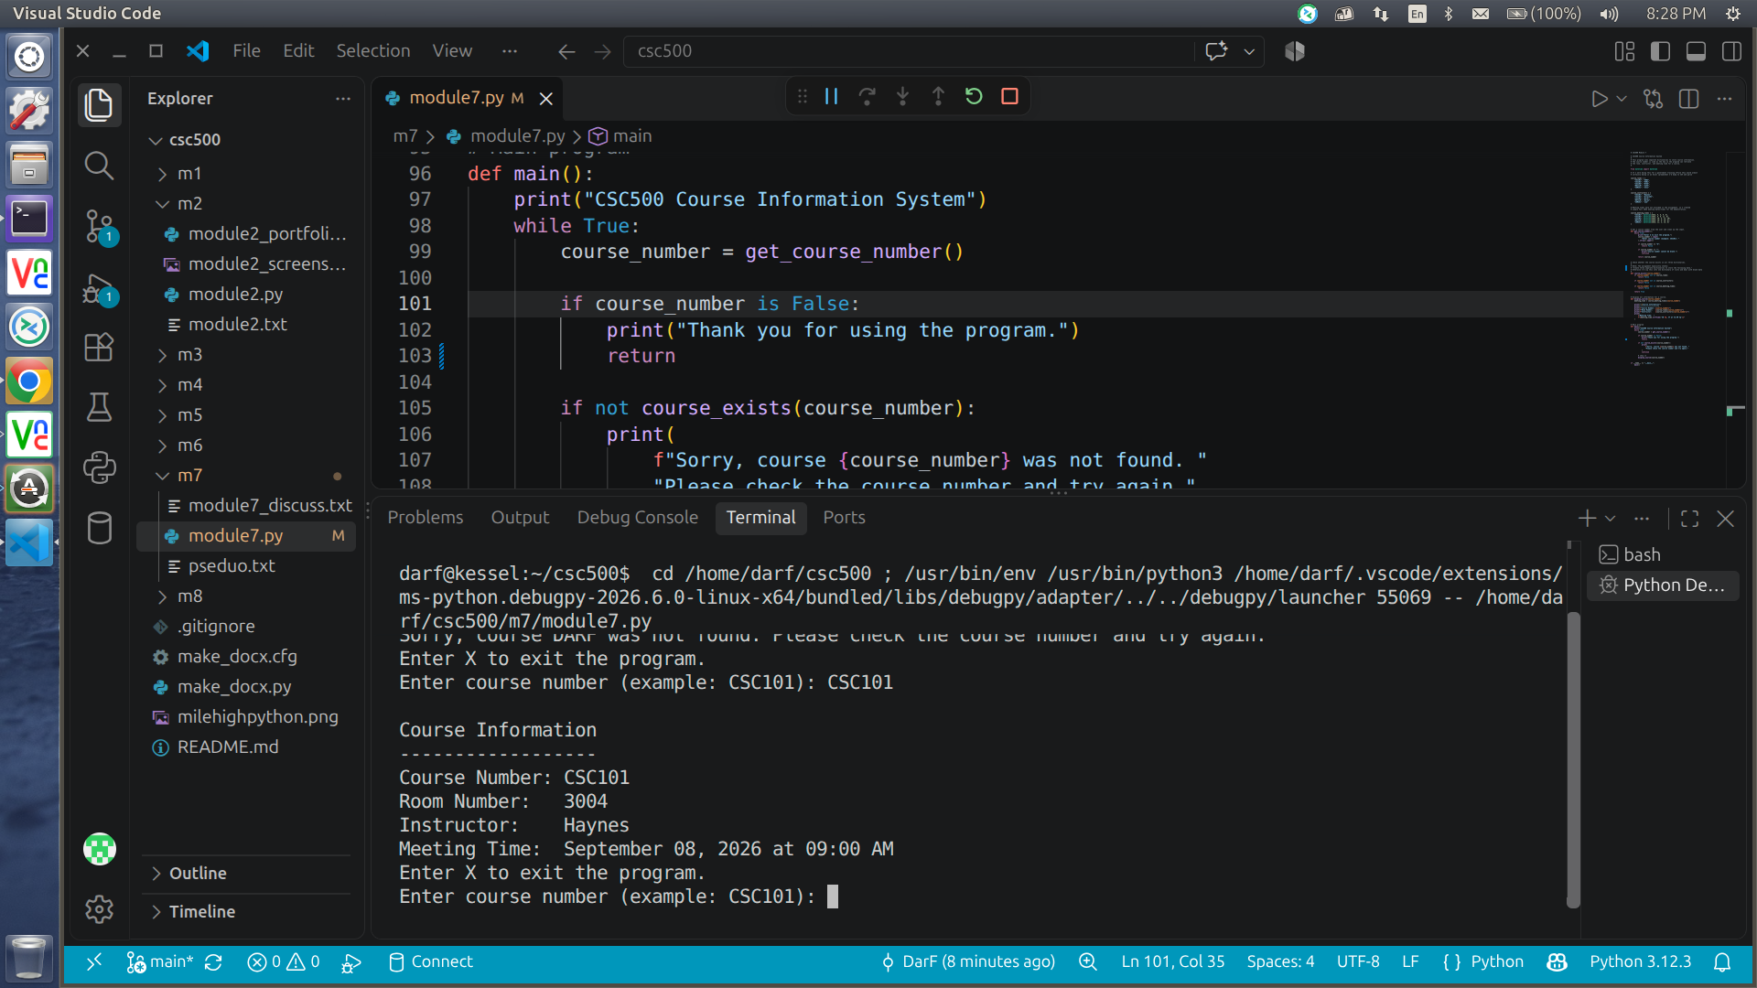
Screenshot from 2026-09-28 20-29-08.png
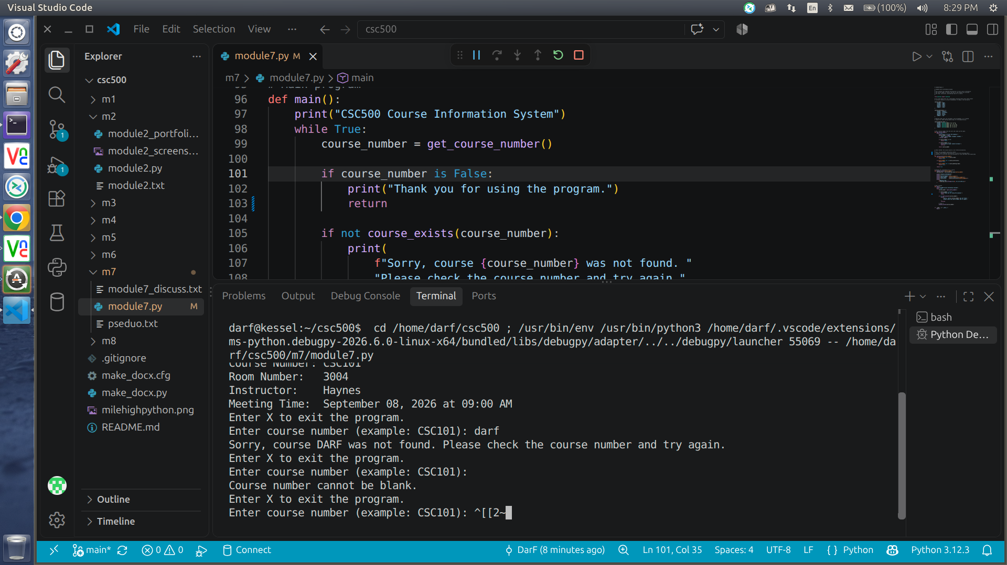
Screenshot from 2026-09-28 20-29-20.png
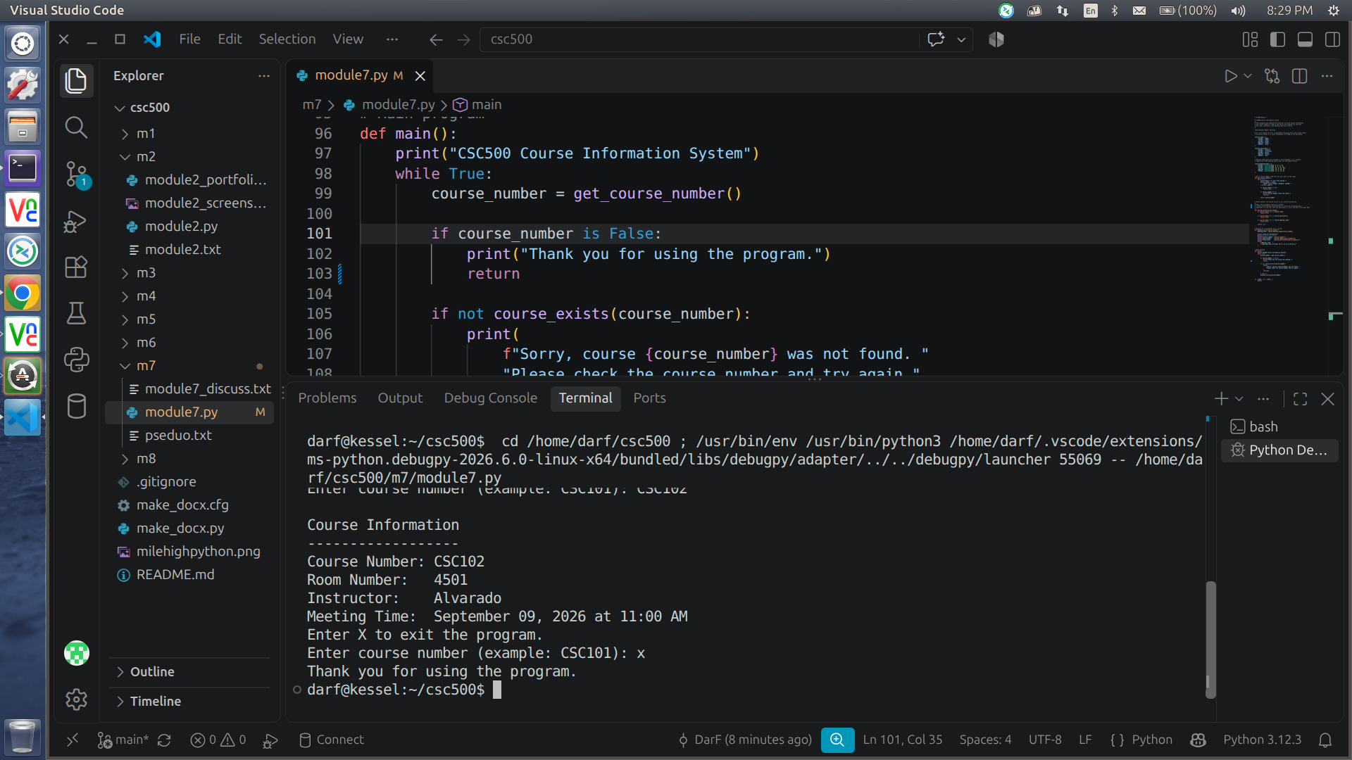
Source Code
https://github.com/frosmear/csc500/blob/main/m7/module7.py

