Mike Hudson
CSC500 Module 4

Pseudocode
- Define two classes – the required ItemToPurchase and a ShoppingCart to do the logic required in main
- Create the ItemToPurchase class
  - Set the default values per instructions
  - Create the print_item_cost method
  - Calculate the item total by multiplying the item price by the item quantity
  - Display the item name, quantity, price, and total cost
- Create the ShoppingCart class
  - Initialize with store name, empty list for cart items and initialize the cart total to 0.0
  - Create the add_items method
    - Reset the item count
    - While the user is entering items
      - Get an item from the user
      - If the user enters "quit" or a blank entry:
        - Exit the loop by returning the item count
      - Otherwise, add the ItemToPurchase object to the cart
      - Increase the item count by one
  - Create the get_shopping_cart_item method
    - Ask the user for the item name
    - If the item name is "quit" or blank
      - Return no item
    - Otherwise, ask the user for the item price
    - Ask the user for the item quantity
    - Instatiate an ItemToPurchase object using the entered values
    - Return the new item
  - Create the calculate total method
    - Reset the cart total to 0.0
    - For each item in the shopping cart
      - Multiply the item price by the item quantity
    - Add the item cost to the cart total
    - Report that the calculation was successful
  - Create the print_cart_contents method
    - Call the cart total method
    - Display the store name
    - Display the "TOTAL COST" heading
    - For each item in the shopping cart
      - Display the item's name, quantity, price, and cost using the item method
    - Display the final cart total
- Create the main function
  - Instantiate a new ShoppingCart object
  - Add items to the shopping cart
  - Display the shopping cart contents and total

Screen shots
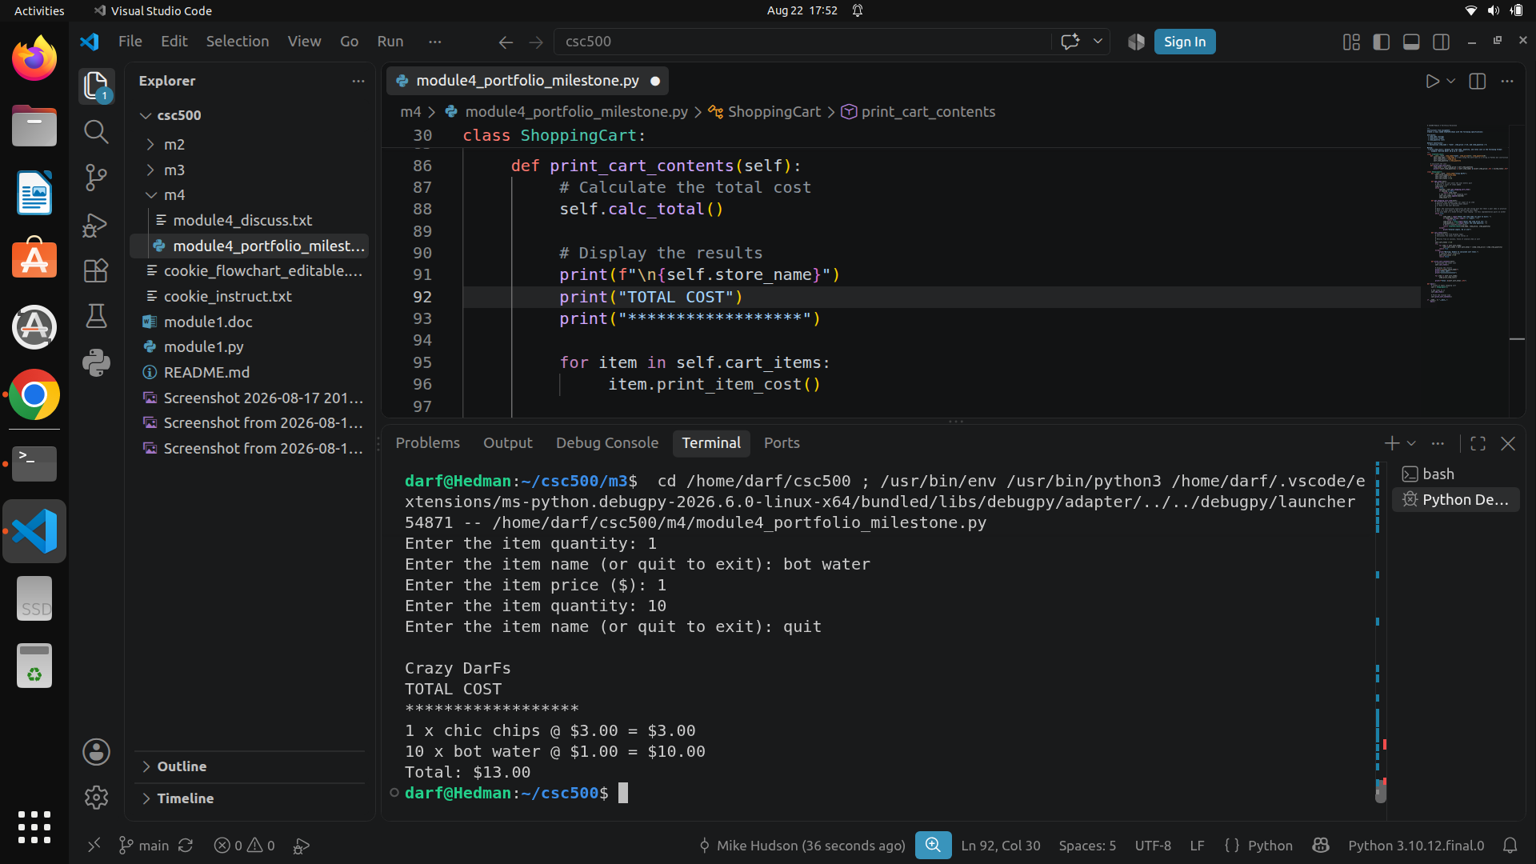
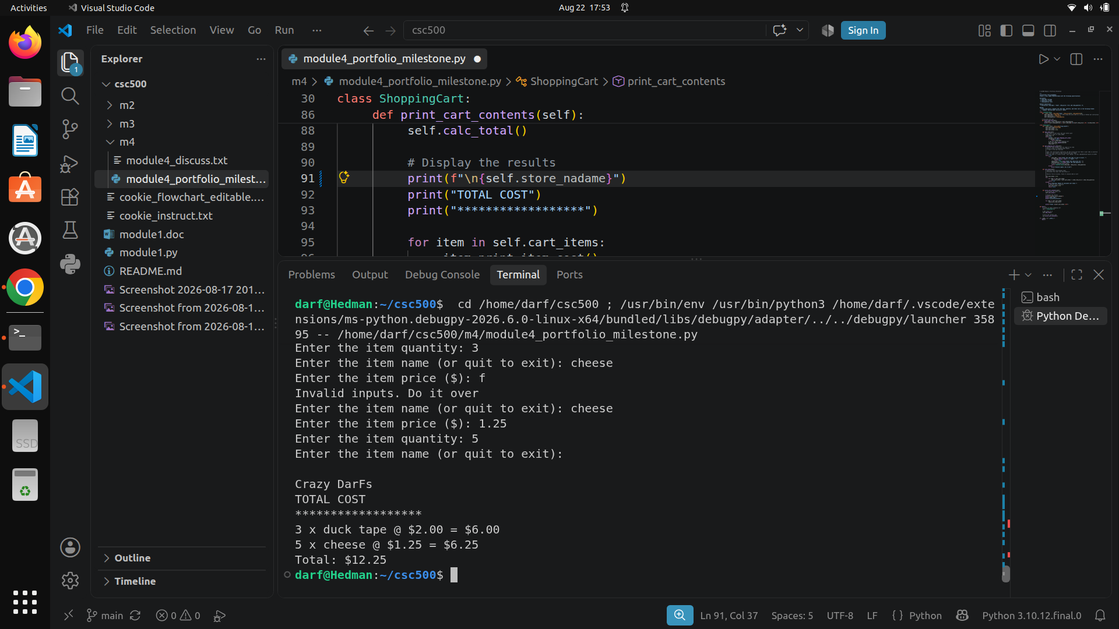

Source Code:
https://github.com/frosmear/csc500/blob/main/m4/module4_portfolio_milestone.py

