Mike Hudson
CSC500 Module 3

Pseudocode

- Import packages
- Set the tip rate to 18% and the tax rate to 8.5%.
- Randomly select either option 1 (Meal Calc) or option 2 (Alarm Clock).
- If option 1 is selected:
  - Display that Python selected the Meal Calculator.
  - Ask the user to enter the meal price.
  - Continue asking until the user enters a valid number.
  - Calculate the tip by multiplying the meal price by 18%.
  - Calculate the tax by multiplying the meal price by 8.5%.
  - Add the meal price, tip, and tax to calculate the total.
  - Display the meal price, tip, tax, and total.
- If option 2 is selected:
  - Display that Python selected the Alarm Clock.
  - Ask the user whether to use the current time as the starting time.
  - If the user chooses the current time, get the current hour.
  - Otherwise, ask the user to enter a starting hour between 0 and 23.
  - Validate the starting hour and continue asking until a valid value is entered.
  - Ask the user how many hours they want to wait.
  - Validate that the number of hours is zero or greater.
  - Add the waiting time to the starting time using the datetime and timedelta functions.
  - Display the starting time and calculated alarm time.
  - Calculate the alarm time again using modulo 24.
  - Calculate how many times midnight occurs during the waiting period.
  - Display the alarm time and number of midnights.

Screen shots
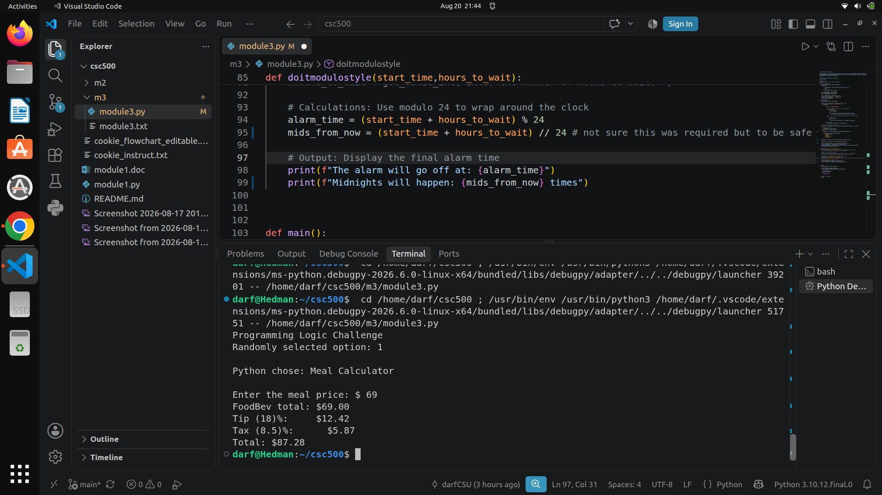
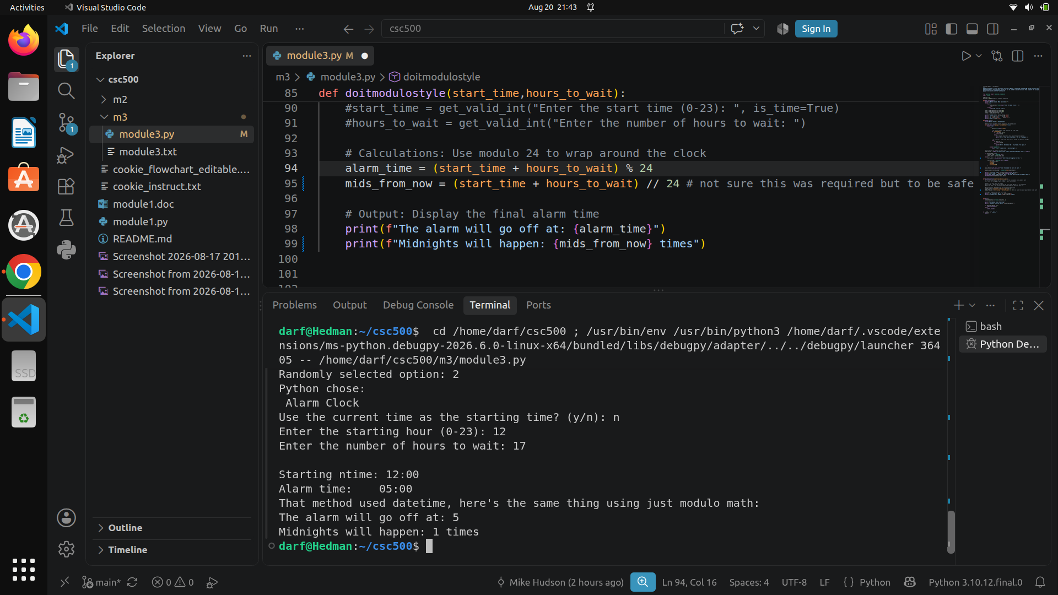
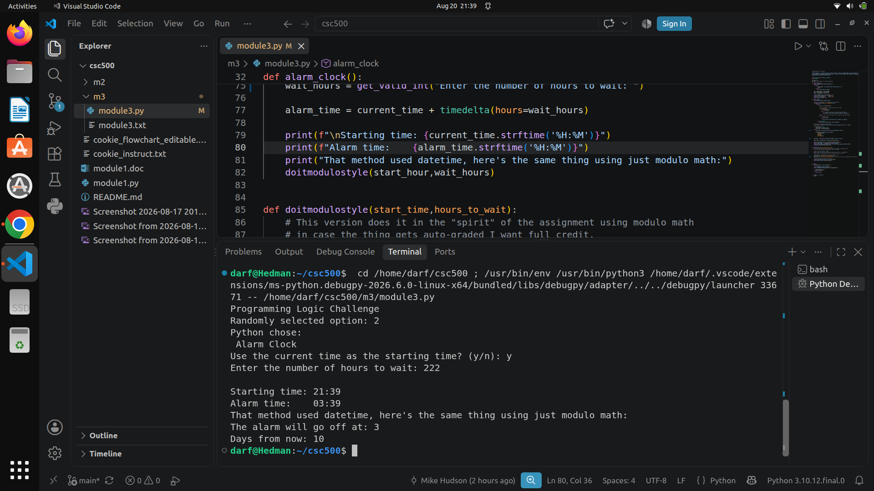

Source Code:
https://github.com/frosmear/csc500/blob/main/m3/module3.py

