EOSC543 Basin Analysis, Exercise 4: Rifting and Backstripping
Due: 3 November 2021

(1) Calculation of thermal subsidence history and stretch factor (β). Read the “Inversion of the stretch factor from thermal subsidence data” (from Allen and Allen “Basin Analysis”, 3rd edition, p. 497–498).

Consider an intracontinental rift that experienced thermal subsidence over the last 100 Myr, following an initial period of extensional faulting. The subsidence history can be understood in terms of the depths of dated horizons over time. These depths are corrected for post-depositional compaction, paleobathymetry, eustasy, and isostatic compensation. The values for one particular case are shown in Table 1. The left column provides the ages/times at which the marker horizon was at the corresponding elevation shown in the right column (negative values are below sea level).

Table 1
Age (Myr before present) Elevation (km)
100 0.217
65 -1.031
55 -1.251
20 -1.704
0 -1.854

Table 2
y_{L} = 110 km y_{c} = 31 km
T_{m} = 1333°C K = 10⁻⁶ m²/s
α = 3.3 x 10⁻⁵ (°C⁻¹) ρ_{m} = 3300 kg/m³
ρ_{s} = 2100 kg/m³ ρ_{w} = 1035 kg/m³
(1A) Plot the data in Table 1 to produce a curve for tectonic (or thermal) subsidence since 100 Ma (5 pts).
(1B) Then use the values in Table 2 to calculate the thermal time constant (τ) for this basin (watch your units) (5 pts).
(1C) Plot the subsidence values from Table 1 against the parameter (1-e^{-t/τ}), remembering that t is time since rifting, not the age (5 pts).
(1D) Fit a curve to this plot, and determine the slope of the curve (5 pts).
Now follow Allen and Allen’s approach to determine E₀ and β (realize that you will need to use the iterative method of solution to determine β).
(1E) Compute the results of E₀ and β for the competing cases in which the basin was:
(1E.1) filled with water vs.
(1E.2) filled with sediment (15 pts).
(1F) Explain the geodynamic reasons for the different values of β that result (15 pts).

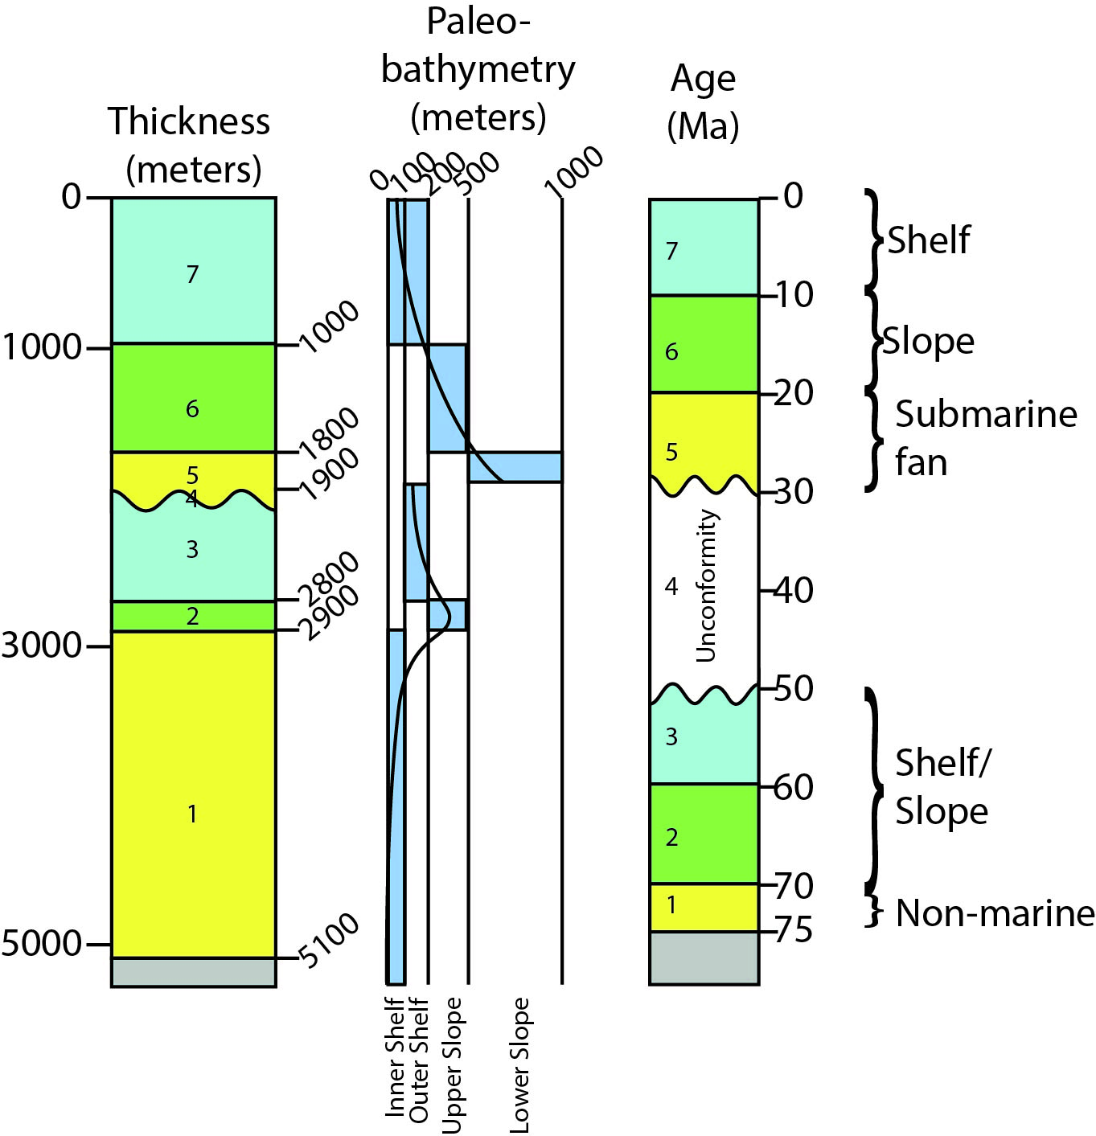

Yellow=Sandstone; Green=Shale, Blue=Limestone

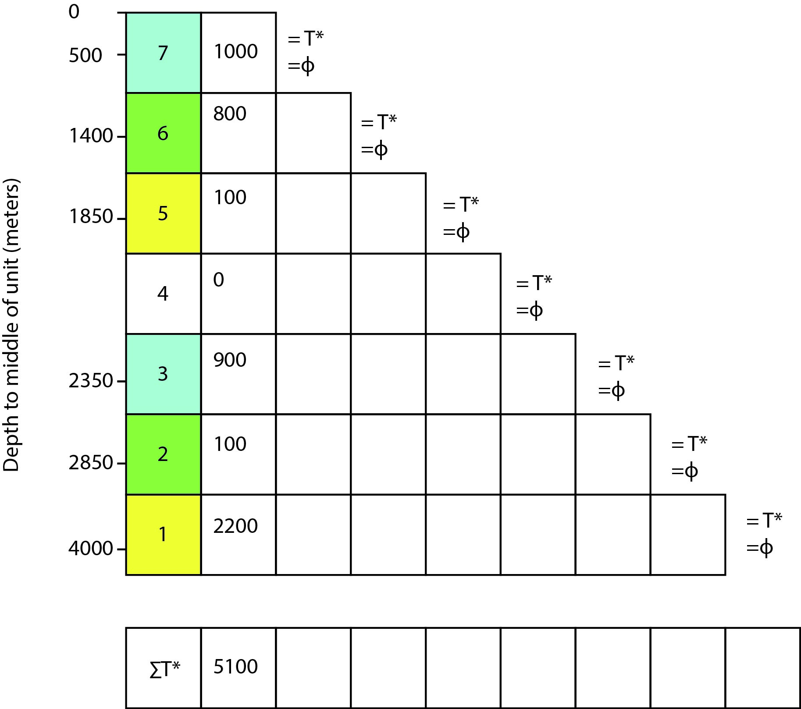

(2) “Geohistory” analysis is a useful procedure for understanding basin evolution in terms of sediment accumulation history and tectonic subsidence. Tectonic subsidence is defined as the vertical (downward) subsidence of a reference horizon (commonly the underlying, pre-basinal basement) in the absence of water and sediment loads. Tectonic subsidence is driven principally by tectonic forces associated with basin evolution.

After deposition, sediments are compacted to varying degrees depending on the lithology and the amount of burial (“overburden”). In order to construct a “geohistory” diagram for a particular basin, geoscientists first need to remove the effects of compaction. Mathematical “decompaction” is accomplished by a technique called “backstripping” in which the effects of water loading and sediment loading are removed. In order to understand the history of tectonic subsidence, further corrections can be made if data are available for the water depth, global sea level, etc.

The following exercises will improve understanding of the techniques involved in backstripping, and the generation of diagrams that depict the history of sediment accumulation and tectonic subsidence during basin evolution.

2(A) Decompaction. Consider the stratigraphic column provided above, consisting of 6 stratigraphic units and 1 unconformity. These 7 elements have a total observed thickness of 5100 meters. Using the methods and equations discussed in class, generate a table listing the original “decompacted” thicknesses for each of the 7 units. The table provided will help visualize the series of steps involved in the backstripping process (15 pts).

2(B) Sediment Accumulation History. Now, consider the stratigraphic ages provided for the 7 elements (6 stratigraphic units and 1 unconformity). First, construct a sediment accumulation diagram based on (1) the compacted (observed) stratigraphic thicknesses and (2) the decompacted stratigraphic thicknesses (10 pts).

2(C) Tectonic subsidence. In order to understand tectonic subsidence, we must consider the original water depths during deposition, and correct the sediment accumulation history calculated in 2(B). For each stratigraphic unit, consider the estimated water depths at the time of deposition. Based on these water depths, modify the sediment accumulation diagram from 2(B). Conduct an Airy isostatic correction at each point in the subsidence curve to estimate the tectonically driven subsidence (15 pts).

2(D) Interpretation. Provide a written summary for the depositional history of this basin (10 pts).

Porosity-depth coefficient "c"; initial porosity; grain density.
c initial porosity lithology grain density references
0.0005 0.5 shale 2720 kg/m3 estimated values (Angevine et al., Fig. 3.11)
0.0003 0.4 sandstone 2650 kg/m3 estimated values (Angevine et al., Fig. 3.11)
0.0007 0.5 limestone 2710 kg/m3 estimated values (Angevine et al., Fig. 3.11)

