- 각 항목별 input 타입
물건이름(문자열text)
가격(숫자number)
제조사이름(문자열text)
유통기한(날짜date)

- 페이지 작동방식

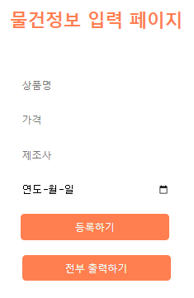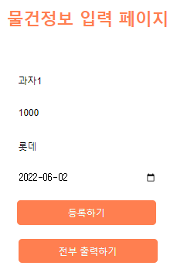
- 각 입력란에 알맞은 정보를 입력하고
- 등록하기를 누르면 배열객체에 저장이 된다

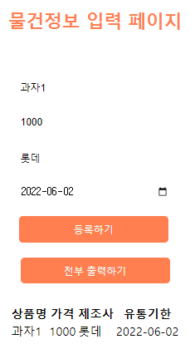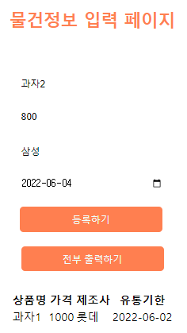
(3) ‘전부 출력하기’를 누르면 저장된 배열객체들이 모두 출력된다
(4) 검증을 위해 또다른 객체 입력

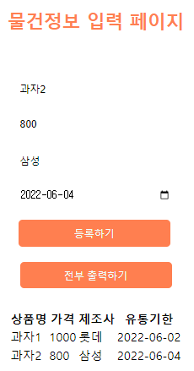
(5) 두번째 객체까지 정상적으로 출력됨

- 소스코드
<index.html>
<!DOCTYPE html>
<html lang="en">
<head>
<meta charset="UTF-8">
<meta http-equiv="X-UA-Compatible" content="IE=edge">
<meta name="viewport" content="width=device-width, initial-scale=1.0">
<script defer type="text/javascript" src="script/index.js?Ver=1"></script>
<style>
h2{color:coral;text-align: center;margin:50px;}
section, div{display: flex;justify-content: center;}
.info{height:25px;width:200px;margin:10px;border:none;}
#button_1, #id_submit{height:35px;width:200px;border:none;background-color: coral;color: azure;margin:10px;border-radius: 5px;}
</style>
<title>Document</title>
</head>
<body>
<h2>물건정보 입력 페이지</h2>
<section>
<form id="form_1" action="" onsubmit="return product_register()">
<input class="info" id="id_product" type="text" placeholder="상품명"><br>
<input class="info" id="id_price" type="nubmer" placeholder="가격"><br>
<input class="info" id="id_maker" type="text" placeholder="제조사"><br>
<input class="info" id="id_due" type="date" placeholder="유통기한"><br>
<input class="info" id="id_submit" type="submit" value="등록하기">
</form>
</section>
<div>
<input id="button_1" type="button" onclick="document.getElementById('display').innerHTML=get_All_Info()" value="전부 출력하기"><br>
</div>
<div>
<p id="display"></p>
</div>
</body>
</html>

<index.js>
let product_info=new Array();

function product_register(){
let temp=new product_temp(document.getElementById('id_product').value,
document.getElementById('id_price').value,
document.getElementById('id_maker').value,
document.getElementById('id_due').value)
product_info[product_info.length]=temp;

return false;
}

function get_All_Info(){
let result='<table><tr><th>상품명</th><th>가격</th><th>제조사</th><th>유통기한</th></tr>'
for(let i=0;i<product_info.length;i++){
result+='<tr><td>'+product_info[i].get_product()+
'</td><td>'+product_info[i].get_price()+
'</td><td>'+product_info[i].get_maker()+
'</td><td>'+product_info[i].get_due()+
'</td></tr>';
}
return result+'</table>';
}

function product_temp(p1, p2, m, d){
this.product=p1;
this.price=p2;
this.maker=m;
this.due=d;
}

product_temp.prototype.set_product=function(p1){
this.product=p1;
}
product_temp.prototype.set_price=function(p2){
this.price=p2;
}
product_temp.prototype.set_maker=function(m){
this.maker=m;
}
product_temp.prototype.set_due=function(d){
this.due=d;
}
product_temp.prototype.get_product=function(){
return this.product;
}
product_temp.prototype.get_price=function(){
return this.price;
}
product_temp.prototype.get_maker=function(){
return this.maker;
}
product_temp.prototype.get_due=function(){
return this.due;
}

