## CS/EE120B Custom Project Report

## **Melodie**

Shuang Wu

Mar.16, 2019

## **Introduction:**

Melodie is a simple rhythm game combines with a digital keyboard (piano). The game allows players to play any music on a keypad, but the main gameplay is to select a song, following that song’s “sheet music” which displays on a screen. During a game, player gets score if the correct key is held at correct time, so that the song will sounds perfectly. Finally the player will get a rank base on the score.

## **Description:**

When the game get started, game logo “MELODIE” flashes and shows up on LED matrix. At this time, a simple menu displays on LCD screen, it tells you pressing which key to start playing which song. For now it has:

A: *Are you sleeping, brother John*? (*Frère Jacques*)

B: *Lemon* (Credit: Yonezu Kenshi)

After song selection, LED matrix displays some patterns about the gameplay for several seconds:

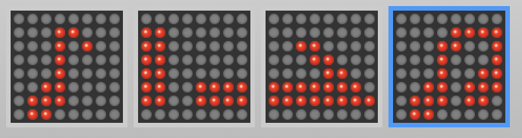

And then it displays “Start: [the_first_key]” for several seconds to make sure players can be prepared.

During the game, “sheet music” shows on LED matrix. Left matrix displays the key to press by now, right side displays the next key. A scrolling bar displays on the middle two matrices shows the holding period, so it scrolls horizontally from left to right and the speed indicates the duration of note visually. The note start and end with placeholder “🎵” because there is no note before and after. LCD displays real-time score now.

After the song, “FIN!!” flashes several seconds on LED, and then it shows “rank = [your_rank]”. The rank scales from E (worst) to S (best), it depends on the score. Press any key and it goes back to the starting stage.

AT ALL TIMES: Sounds generated from the buzzer by pressing key numbers (0 - 9), each number represents a note (C5 - E6). Holding key “D” will initialize the game. Pressing the power button can initialize the program entirely.

## **Guide / Tricks:**

1. Press “A”, “B, “C” to choose song, “A” (Are you sleeping, brother John) is the simplest one.

2. Try to hold the keys instead of just “click”, even the key change rapidly. Holding results higher score.

3. Ranking is calculated base on the comparison between your score and the highest score, which is got by me. “S” means your skill is close to me : )

4. Don’t worry about the music interval (range of notes), sometimes one key represent different note depends on the period of game. For example: “5” is G5 generally, but it generates G4 at the last measures of Are you sleeping, brother John.

5. Easter egg: “*” and “#” can scroll the logo “MELODIE”. (May results in grable).

## **Components:**

1* ATMega1284 microcontroller

4* MAX7219 shift register

1* 3.3V power supply

1* buzzer

1* 4*4 keypad

1* 1602 LCD display

4* 8*8 LED matrix

Multiple Dupont lines

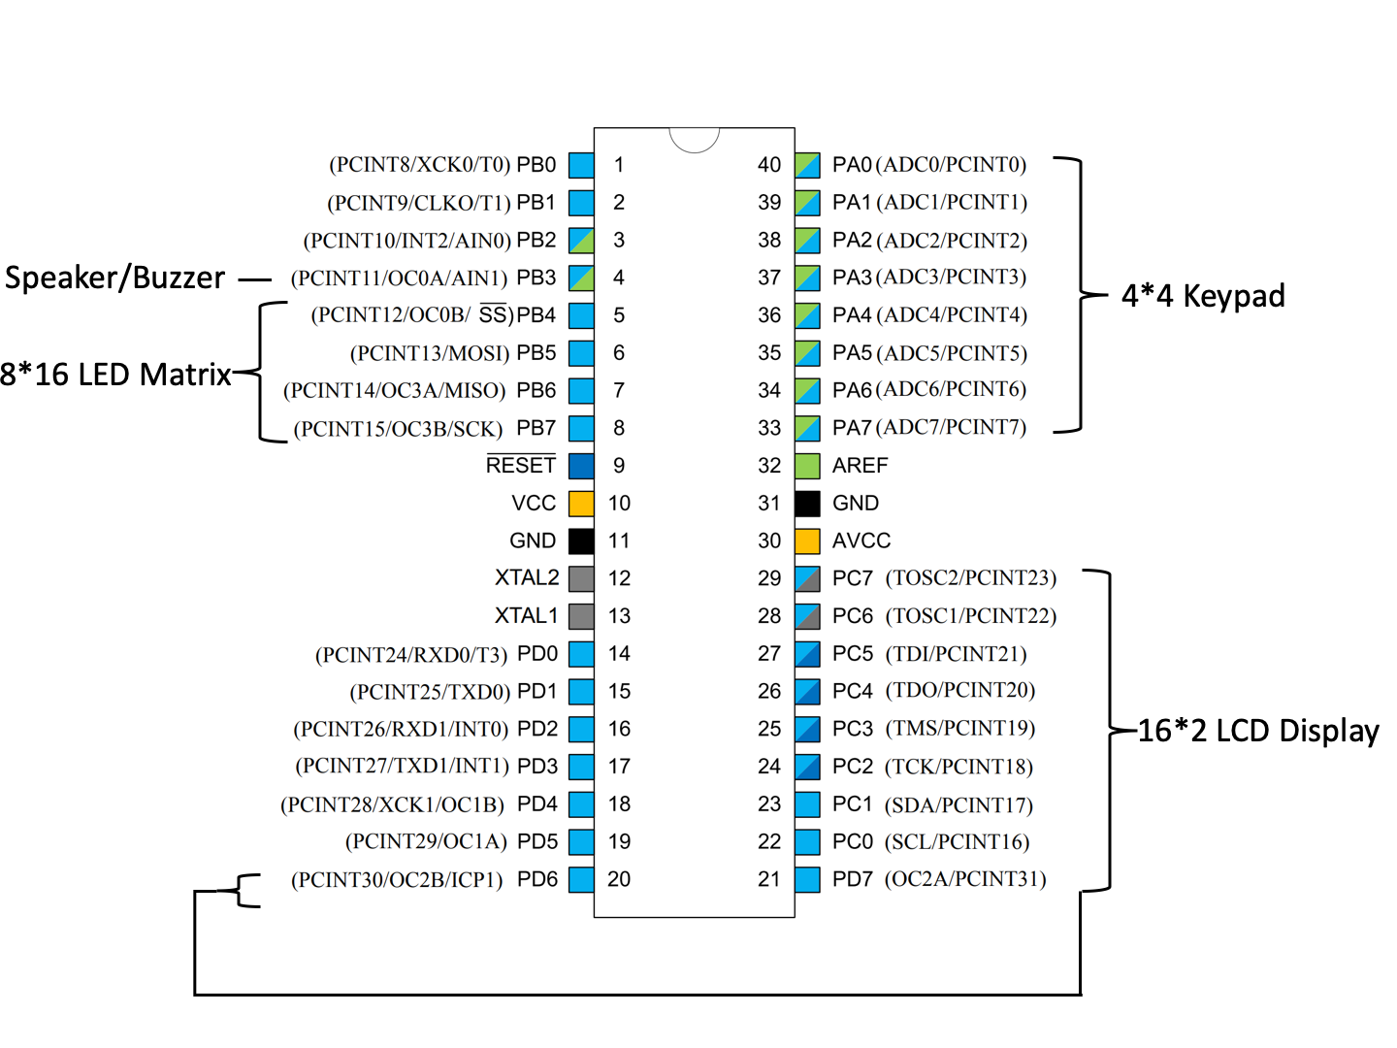

## **Demo video:**

## **Source files links:**

swu166_project

<https://drive.google.com/open?id=1_ILv5EFemWwksO2EzNHoe-C7GBeRys5p>

Main program. Includes the whole game framework, functions for game progress, all songs sequence, keypad to musical notes translation.

MAX7219_Matrix

<https://drive.google.com/open?id=11HuTuQ4OhNoHGhR6Ipdesq6MbOxE1lfn>

<https://drive.google.com/open?id=1LK-VW49i7zmAnSW_U8QMtj2OOtK4dGA8>

Manipulate the LED matrix, including all patterns. (Atoz and numbers credit: <https://xantorohara.github.io/led-matrix-editor/>)

MAX7219

<https://drive.google.com/open?id=1unCXYO3n3mkvfMnsp9gGjIjMsnXv2pss>

<https://drive.google.com/open?id=1Rqw3BxvYMmolAcs9o4sKEm20UlGAtQVH>

Using the shift register. Called by MAX7219_Matrix.

Io

<https://drive.google.com/open?id=173QX__Zm8o-hORj2MrZ1FzA2V98bXz2w>

<https://drive.google.com/open?id=1X8ZV6io4TxMD2UmAQDyhlwRNVvUiLN2m>

Using the LCD display. Derived from laboratory header files.

Other included files:

<https://drive.google.com/open?id=1xwCegQdb08l6aI7pyibY5UYIVCNAgjWh>

From laboratory header files. Including keypad, PWM.