Question No 1

Others:

(1)
chmod 001 demo
chmod 001 demo.txt
ls –lh
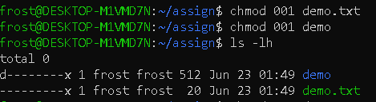
chmod o+x demo
chmod o+x demo.txt
ls –lh
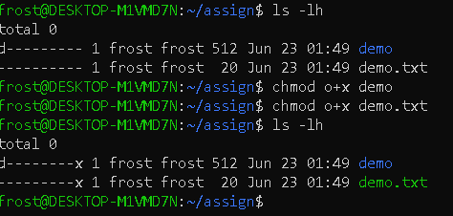

(2)
chmod 002 demo
chmod 002 demo.txt
ls –lh
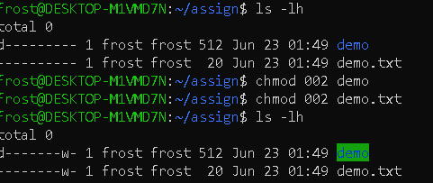
chmod o+w demo
chmod o+w demo.txt
ls –lh
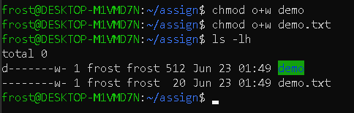

(3)
chmod 004 demo
chmod 004 demo.txt
ls –lh
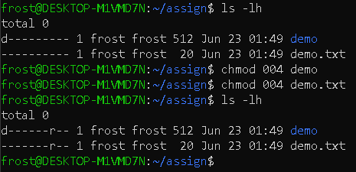
chmod o+r demo
chmod o+r demo.txt
ls –lh
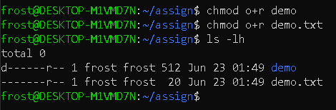

(4)
chmod 007 demo
chmod 007 demo.txt
ls -lh
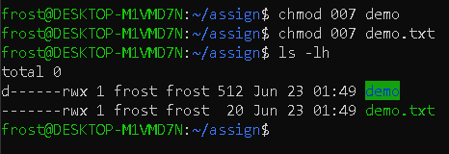
chmod o+wrx demo
chmod o+wrx demo.txt
ls –lh
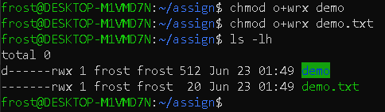

(5)
chmod 000 demo
chmod 000 demo.txt
ls -lh
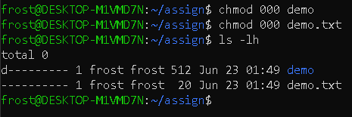
chmod o-wrx demo
chmod o-wrx demo.txt
ls –lh
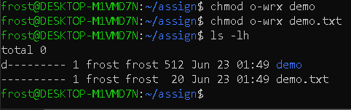

Group:

(1)
chmod 010 demo
chmod 010 demo.txt
ls –lh
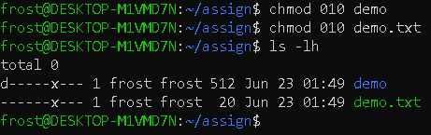
chmod g+x demo
chmod g+x demo.txt
ls –lh
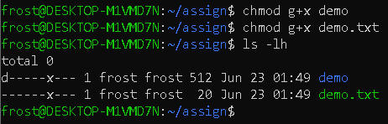

(2)
chmod 020 demo
chmod 020 demo.txt
ls –lh
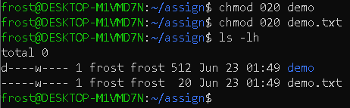
chmod g+w demo
chmod g+w demo.txt
ls –lh
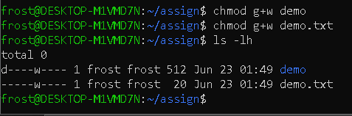

(3)
chmod 040 demo
chmod 040 demo.txt
ls –lh
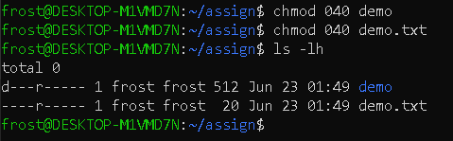
chmod g+r demo
chmod g+r demo.txt
ls –lh
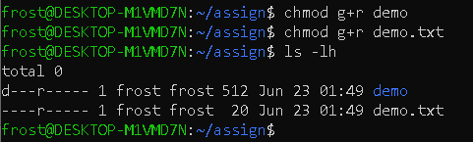

(4)
chmod 070 demo
chmod 070 demo.txt
ls -lh
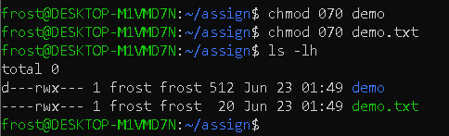
chmod g+wrx demo
chmod g+wrx demo.txt
ls –lh
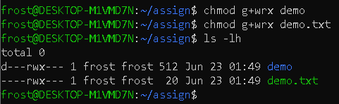

(5)
chmod 000 demo
chmod 000 demo.txt
ls -lh
chmod g-wrx demo
chmod g-wrx demo.txt
ls –lh
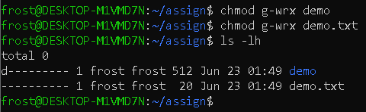

Owner:

(1)
chmod 100 demo
chmod 100 demo.txt
ls –lh
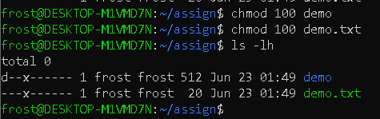
chmod u+x demo
chmod u+x demo.txt
ls –lh
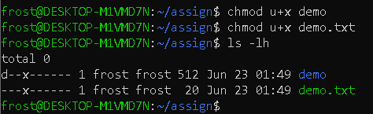

(2)
chmod 200 demo
chmod 200 demo.txt
ls –lh
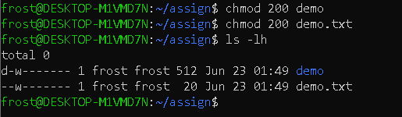
chmod u+w demo
chmod u+w demo.txt
ls –lh
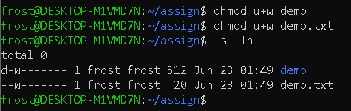

(3)
chmod 400 demo
chmod 400 demo.txt
ls –lh
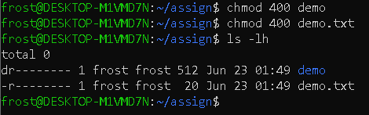
chmod u+r demo
chmod u+r demo.txt
ls –lh
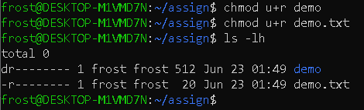

(4)
chmod 700 demo
chmod 700 demo.txt
ls -lh
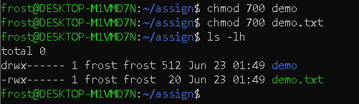
chmod u+wrx demo
chmod u+wrx demo.txt
ls –lh
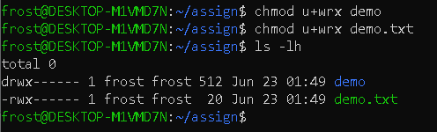

(5)
chmod 000 demo
chmod 000 demo.txt
ls -lh
chmod u-wrx demo
chmod u-wrx demo.txt
ls –lh
